Supplementary material

Culture | growth rate µ (h⁻¹) | CV (%) | goodness of fit (R²) | Time range for  fitting µ | carrying capacity K  (cells/mL) | CV (%) | Time range for fitting K
78R_124Z | 0.39 ± 0.08 | 20.74 | 0.95 | 0 h – 30 h | 3.60 × 10⁸ ± 7.20 × 10⁷ | 20.01 | 41 h – 72 h
78R_124Z | 0.20 ± 0.10 | 47.70 | 0.76 | 0 h – 30 h | 2.38 × 10⁶ ± 1.39 × 10⁶ | 58.48 | 41 h – 72 h
78R_515Z | 0.35 ± 0.02 | 4.41 | 0.94 | 0 h – 30 h | 1.85 × 10⁸ ± 8.12 × 10⁶ | 4.39 | 41 h – 72 h
78R_515Z | 0.31 ± 0.01 | 3.23 | 0.94 | 0 h – 30 h | 2.23 × 10⁸ ± 3.83 × 10⁷ | 17.21 | 41 h – 72 h
78R_1315Z | 0.34 ± 0.02 | 5.09 | 0.94 | 0 h – 30 h | 2.71 × 10⁸ ± 5.41 × 10⁷ | 20.01 | 41 h – 72 h
78R_1315Z | 0.18 ± 0.01 | 5.56 | 0.68 | 0 h – 30 h | 1.55 × 10⁷ ± 9.05 × 10⁶ | 58.57 | 41 h – 72 h
124Z_515Z | 0.25 ± 0.05 | 18.28 | 0.86 | 0 h – 30 h | 6.30 × 10⁶ ± 4.40 × 10⁶ | 69.84 | 41 h – 72 h
124Z_515Z | 0.43 ± 0.07 | 15.25 | 0.92 | 0 h – 41 h | 1.19 × 10⁹ ± 1.12 × 10⁷ | 0.94 | 48 h – 72 h
124Z_1315Z | 0.22 ± 0.02 | 9.32 | 0.98 | 0 h – 41 h | 2.79 × 10⁷ ± 4.28 × 10⁷ | 153.33 | 48 h – 72 h
124Z_1315Z | 0.28 ± 0.02 | 7.35 | 0.96 | 0 h – 41 h | 5.11 × 10⁸ ± 3.81 × 10⁷ | 7.47 | 48 h – 72 h
515Z_1315Z | 0.36 ± 0.07 | 18.33 | 0.94 | 0 h – 30 h | 1.05 × 10⁹ ± 1.12 × 10⁸ | 10.61 | 41 h – 72 h
515Z_1315Z | 0.27 ± 0.10 | 37.75 | 0.69 | 0 h – 41 h | 1.70 × 10⁸ ± 1.93 × 10⁸ | 113.57 | 48 h – 72 h
78R_quadri | 0.42 ± 0.02 | 4.76 | 0.99 | 0 h – 30 h | 1.11 × 10⁸ ± 3.41 × 10⁷ | 30.78 | 41 h – 72 h
124Z_quadri | 0.16 ± 0.07 | 43.30 | 0.67 | 0 h – 30 h | 6.33 × 10⁵ ± 6.32 × 10⁵ | 99.90 | 41 h – 72 h
515Z_quadri | 0.30 ± 0.06 | 18.16 | 0.92 | 0 h – 30 h | 7.01 × 10⁷ ± 1.48 × 10⁷ | 21.05 | 41 h – 72 h
1315Z_quadri | 0.22 ± 0.08 | 34.95 | 0.80 | 0 h – 30 h | 3.78 × 10⁶ ± 3.11 × 10⁶ | 82.34 | 41 h – 72 h
Table S1 Growth rate and carrying capacity values for each strain in bi-culture and in quadri-culture. Strains written in bold in lines 1 to 12 indicate which individual strain’s µ and K values refer to in the corresponding bi-culture. Bold values of µ and K are mean values, given with their standard deviation. The CV (coefficient of variation) is defined as the standard deviation divided by the mean value of µ or K, respectively. The goodness of fit refers to the line fitted in the exponential part of the logarithmic (ln) growth curve (Fig. 2)

Table S2 α and κ values for each interaction in co-culture in exponential and stationary phase. Strains written in bold indicate which individual strain’s α and κ values refer to in the corresponding co-culture. Bold values of α and κ are mean values, given with their standard deviation. A valid interaction arc must have an absolute interaction coefficient value superior to the highest standard deviation value of α (0.163 in bi-culture, 0.459 in quadri-culture) and κ (1.899 in bi-culture, 0.971 in quadri-culture)
culture | value of α | value of κ | valid arc for µ? | valid arc for K?
78R_124Z | -0.193 ± 0.018 | -1.075 ± 0.232 | yes | no
78R_515Z | -0.498 ± 0.041 | -1.940 ± 0.205 | yes | yes
78R_1315Z | -0.517 ± 0.047 | -1.573 ± 0.273 | yes | no
78R_124Z | -0.202 ± 0.023 | -8.437 ± 0.651 | yes | yes
124Z_515Z | -0.038 ± 0.163 | -6.688 ± 0.794 | no | yes
124Z_1315Z | -0.129 ± 0.085 | -6.279 ± 1.899 | no | yes
78R_515Z | -0.304 ± 0.035 | -2.389 ± 0.248 | yes | yes
124Z_515Z | 0.016 ± 0.133 | -0.703 ± 0.192 | no | no
515Z_1315Z | 0.047 ± 0.024 | -1.598 ± 0.221 | no | no
78R_1315Z | -0.405 ± 0.080 | -3.933 ± 0.905 | yes | yes
124Z_1315Z | 0.048 ± 0.091 | -0.286 ± 0.657 | no | no
515Z_1315Z | -0.065 ± 0.074 | -3.344 ± 0.755 | no | yes
78R_quadri | -0.306 ± 0.044 | -2.483 ± 0.339 | no | yes
124Z_quadri | -0.542 ± 0.459 | -9.106 ± 0.896 | yes | yes
515Z_quadri | -0.337 ± 0.168 | -3.549 ± 0.263 | no | yes
1315Z_quadri | -0.267 ± 0.354 | -5.419 ± 0.971 | no | yes

Bi-culture containing the two strains tested | pre-cultures in exponential phase |  | pre-cultures in stationary phase
Bi-culture containing the two strains tested | Strain A | Strain B | Strain A | Strain B
78R_124Z | – | ++ | – | +
78R_1315Z | – | – | – | –
Table S3 Results of antagonism tests carried out on pairs of strains in exponential or stationary phase. Each individual strain mentioned in the table was tested for its capacity to produce antibacterial(s) against the other strain of the pair (+ symbol) or not (– symbol). A double plus (++) indicates that the inhibition zone around the colony of the antibacterial-producing strain has a higher diameter than the one corresponding to a single plus (+)
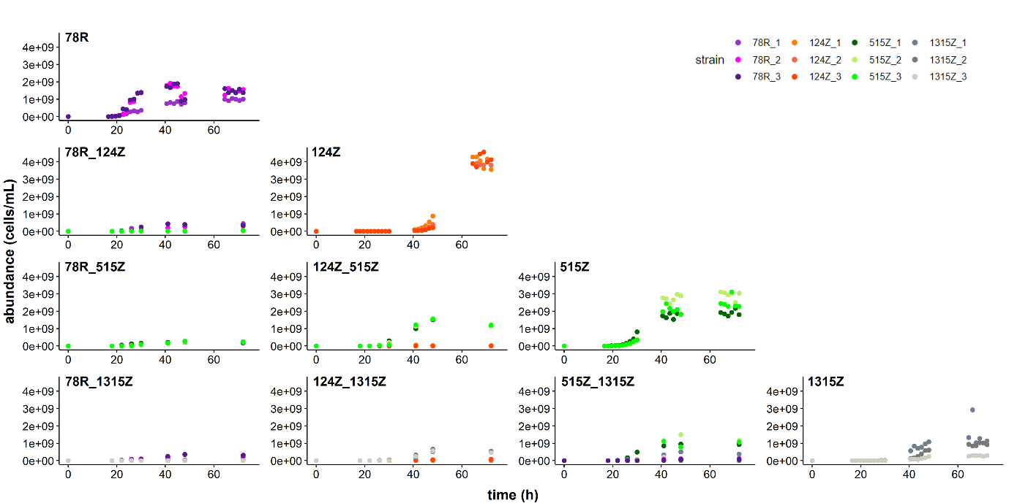
Fig. S1 Time series representing the dynamics of the monocultures (diagonal) and bi-cultures (lower triangle) over 72h. Each culture was carried out in triplicate. Bacterial abundances of each strain (y axis) were calculated as presented in Fig. 1

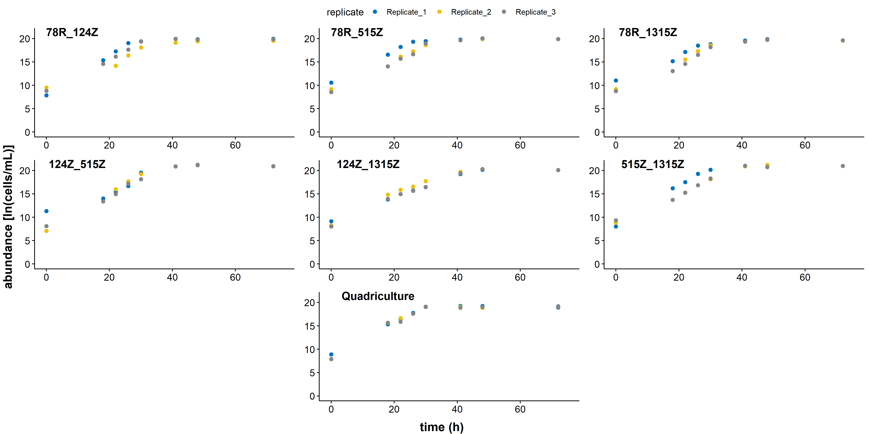
Fig. S2 Time series representing total bacterial abundances in co-cultures measured by flow cytometry over time. Each co-culture was cultured in three biological replicates and sampled 8 times over 72 h

