Supporting Information for
Diurnal Variation in Methane Emission from a Rice Paddy due to Ebullition
Masako Kajiura^{1, †} and Takeshi Tokida¹
¹ Institute for Agro-Environmental Sciences, National Agriculture and Food Research Organization, Tsukuba, Japan.
†Present address: Research Center for Agricultural Information Technology, National Agriculture and Food Research Organization, Tsukuba, Japan.
Corresponding author: Takeshi Tokida (tokida@affrc.go.jp)]

Supplemental Figure S1. Design of the experimental field (38.1 m × 8.4 m). A dot in a plot shows a hill consisting of three seedlings. Data obtained from plots planted with ‘Tupa 121-3’ were not used in this study.

Supplemental Figure S2. Relationships between meteorological factors and CH₄ flux at different growth stages (PF: panicle formation, BT: booting, HD: heading). Solid lines are regression lines.

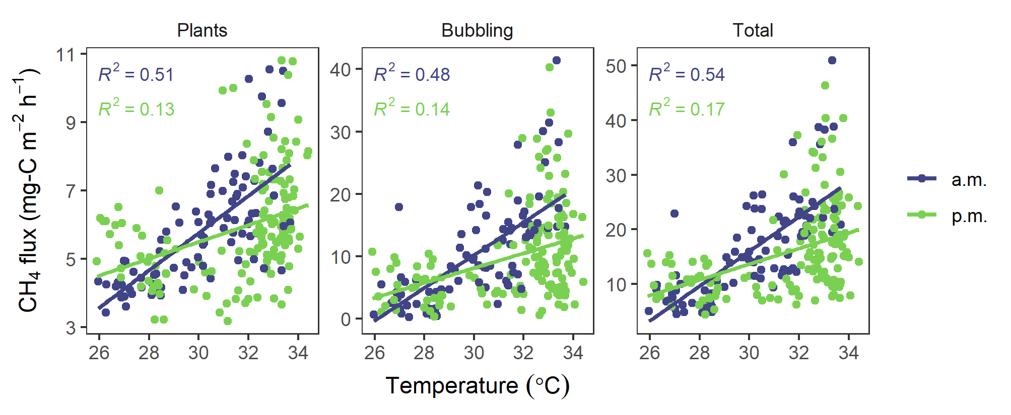

Supplemental Figure S3. Differences in the air temperature versus CH₄ flux relationships between flux-increasing phase in the morning (a.m.) and flux-decreasing phase in the afternoon (p.m.) at the heading stage. Solid lines are regression lines.

Supplemental Figure S4. Hysteresis in the relationship of total CH₄ flux with soil temperature drawn based on data reported in Figure 3 in Iwata et al. (2018) (a) and Figure 1 in Wang et al. (1997) (b). The data was obtained by digitizing the figures using WebPlotDegetizer (https://automeris.io/WebPlotDigitizer/). Different growth stages (a) and varieties (b) are color-coded.

