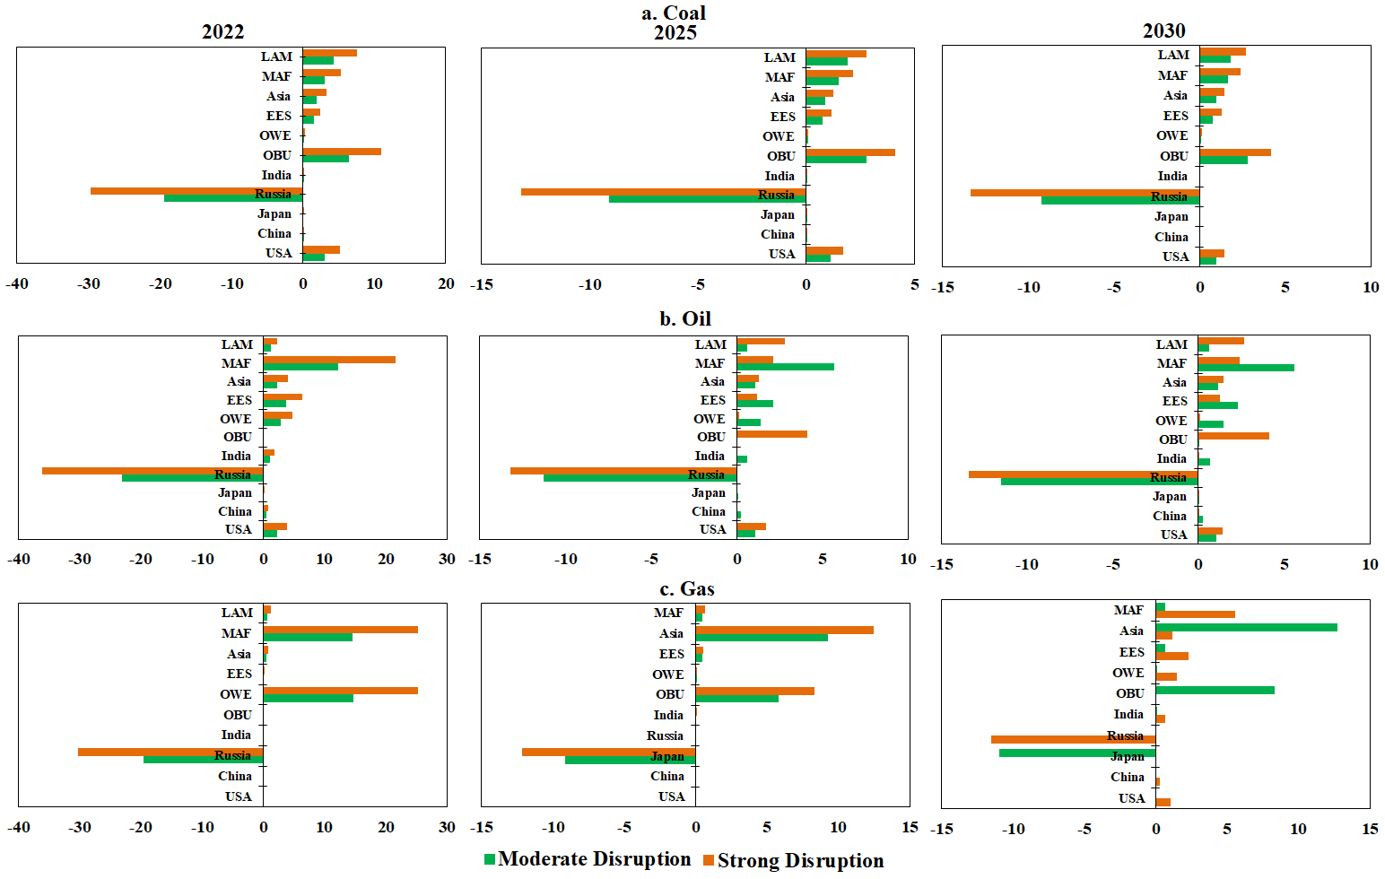
Extended Data Fig.1 The changes in trade dependence of EU under the disruption scenario.
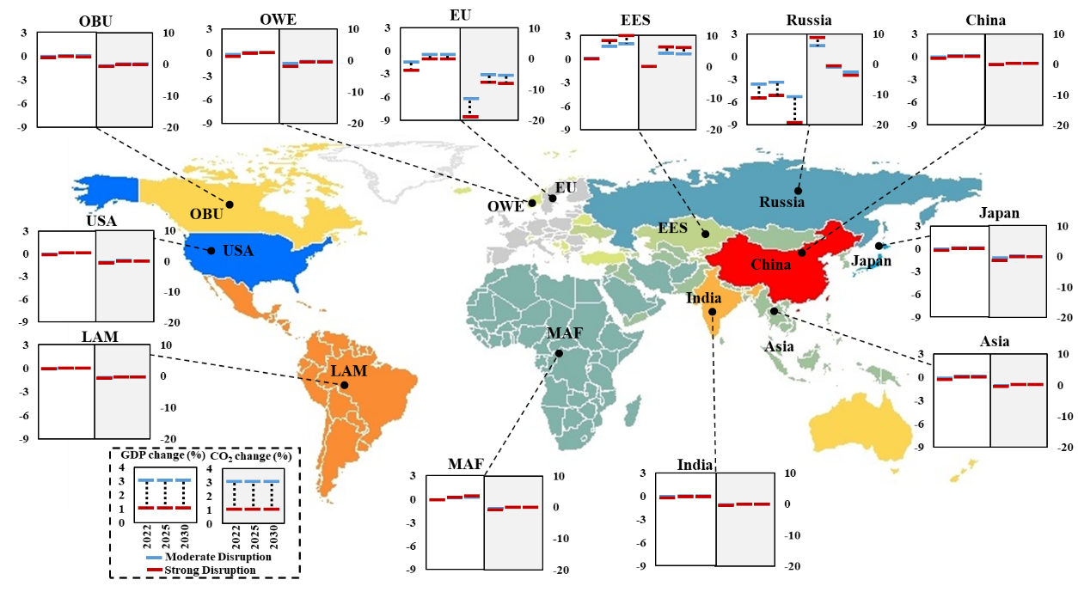
Extended Data Fig.2 The changes in GDP and CO₂ emissions of each region under the supply-chain shift scenario.
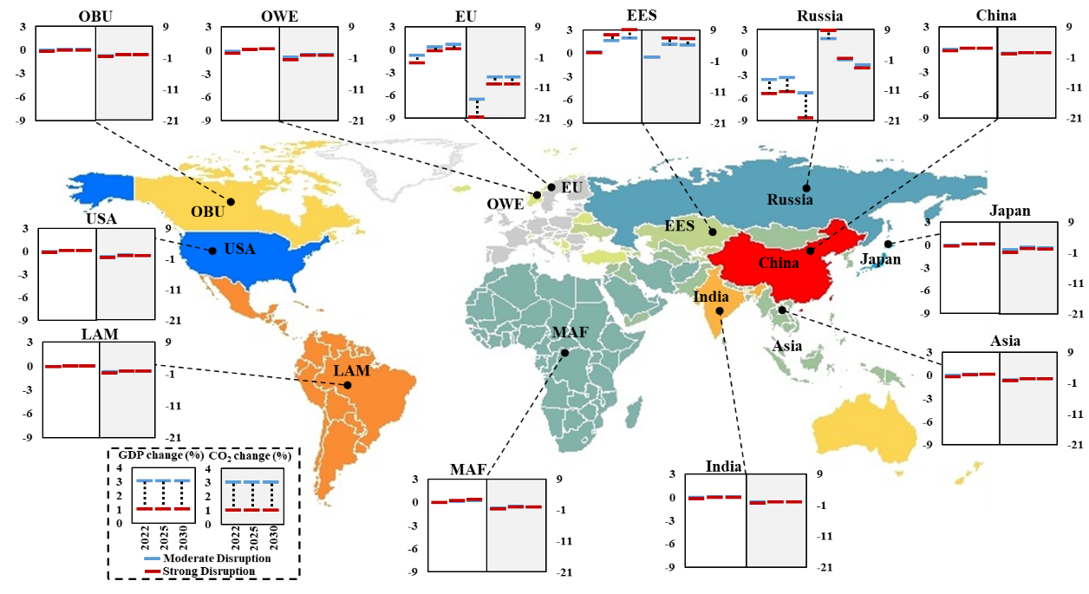
Extended Data Fig.3 The changes in GDP and CO₂ emissions of each region under the demand-side scenario.
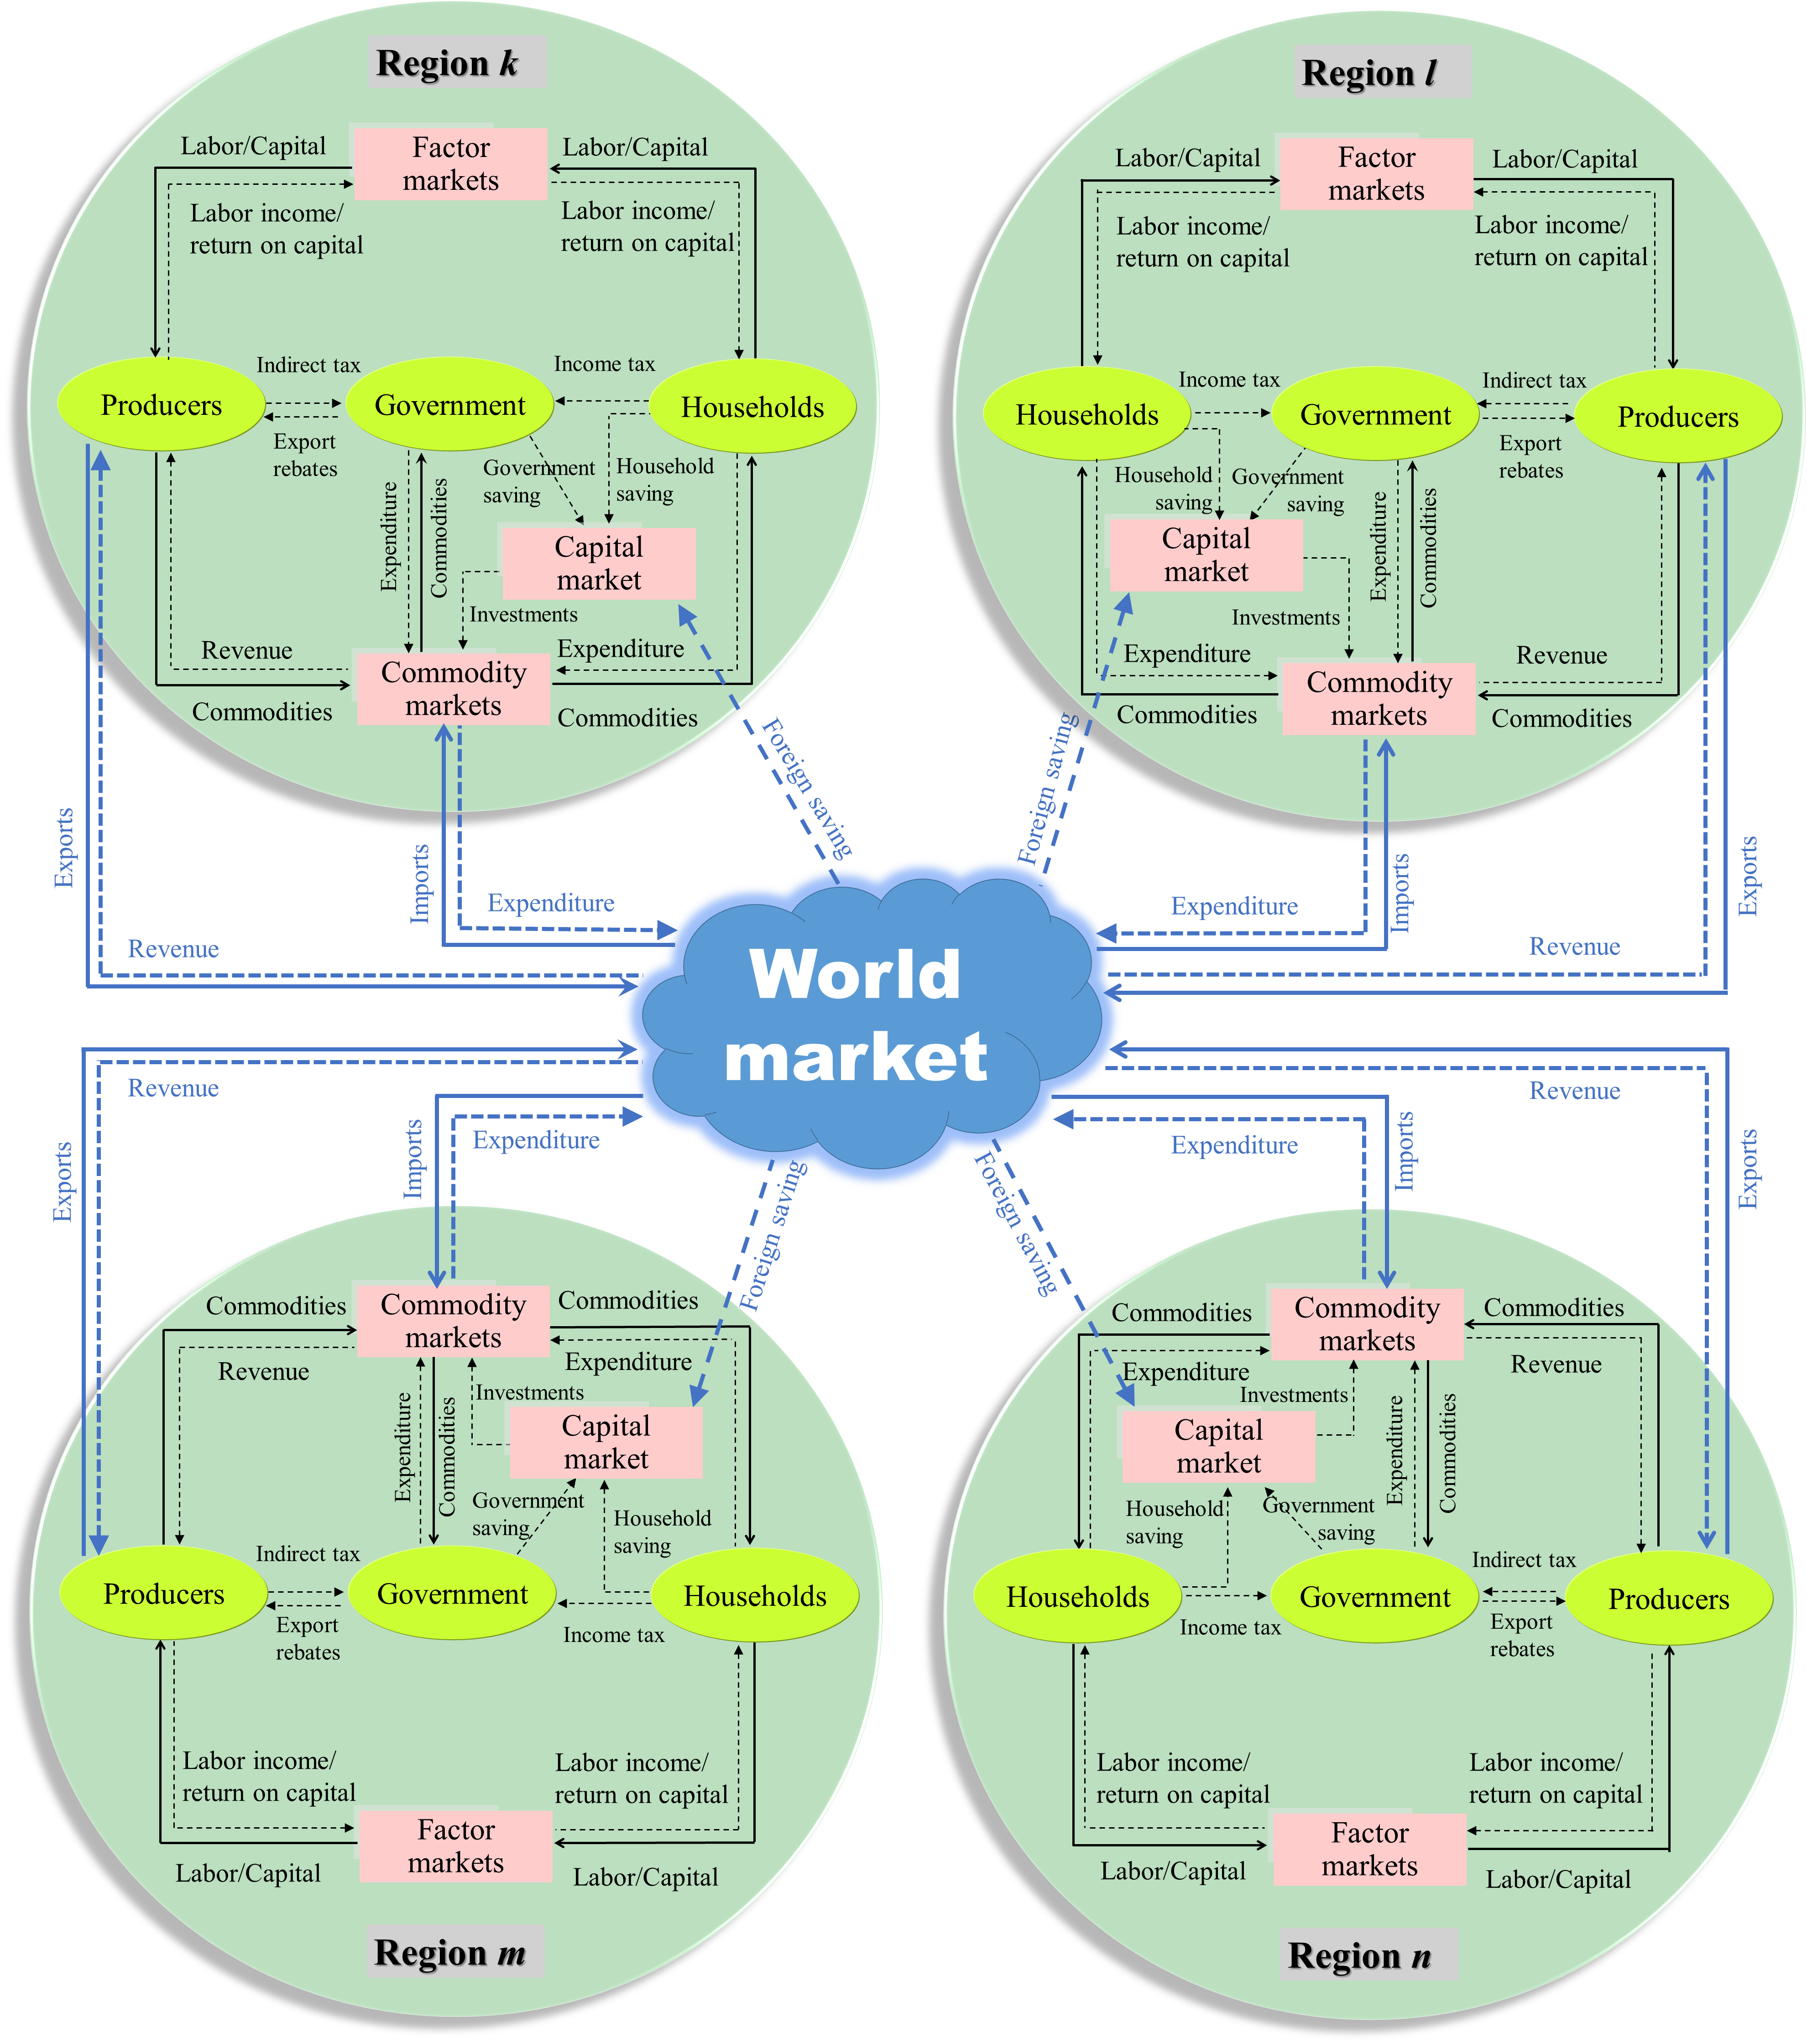
Extended Data Fig.4 The framework of GEEPA (source: Wei et al.¹⁶)

