Table 1: Patient and Donor selection
Patient selection
inclusion criteria | exclusion criteria
Recurrent Glioblastoma | Seeding metastasis
Local metastasis | The impossibility of enrolment due to their emergency conditions
Age: 3-65 year | Not enough Activated NK cell expansion derived from samples
Sex: Both | Creation neurologic lesion after first injection
Lansky performance statue: 70-100% | The impossibility to secondary injection because of hardware failure
Life span expectation: >6 months | Patient death during surgery
Hemoglobin: > 10.0 g/dL | Lack of cooperation in starting or following the study
AGC > 1,500/mm³ | their MRI or MRS scan was suggestive of radio necrosis
Platelet count > 100,000/mm³ | irreversible reservoir blockage or obstruction or clogging for next injection or administration
Serum total bilirubin < 1.5 times upper limit of normal (ULN) | any new neurological sign or systemic complication occurs following the first injection
ALT and AST < 2.5 times ULN | ALT and AST > 2.5 times ULN
Serum creatinine < 1.5 times ULN | Serum creatinine > 1.5 times ULN
No diagnosis of any other invasive cancer within the past 5 years. | Diagnosis of any other invasive cancer within the past 5 years.
No concurrent serious medical or psychiatric illness that may interfere with giving informed consent or conducting this study | concurrent serious medical or psychiatric illness that may interfere with giving informed consent or conducting this study
If a single “Yes” is ticked, the volunteer is not eligible for the trial
Donor selection
inclusion criteria | exclusion criteria
haploidentical donors (parents or son/daughter) | Allogenic donors
Negative for viral infections tests (CMV, HCV, HBV, and HIV) | Positive for at least one viral infection test (CMV, HCV, HBV, and HIV)
HLA typing confirm their kinship | HLA typing doesn’t confirm their kinship
Negative for COVID19 detection test (qRT-PCR) | Negative for COVID19 detection test (qRT-PCR)

Table 2: Quality control
Number | Test | Time | Instrument
1 | Microbial test | before and after NK isolation and post NK activation | BACTech/Alert 3D (Biomerieux)
2 | cell viability assay | during isolation process and post thawing cells | NucloeoCounter, Chemomet
3 | cell count | during isolation process and post thawing cells | Sysmex, KX21N
4 | Immunophenotyping cell analysis using antibodies against CD3, CD16, CD56, CD45, CD19, NKG2D, NKG2A, NKp44 and NKp30 | prior and post activation of isolated NK cells | BD Calibure

Table 3: Follow up
Events | Time
Fever | 48 hours after each injection
New seizure or changed pattern | 48 hours after each injection
New neurological symptoms | 48 hours after each injection
Level of consciousness | 48 hours after each injection
Meningismus | 48 hours after each injection
Any stimulatory symptoms that did not appear before injections | 48 hours after each injection
appearance of new seizure and neurological adverse events | 1 week after injection
MRI | 1,3,6, and 12 months after the first injection
Clinically follow up | 1, 2, 3, 6, 12 and until the end of their life
Note: the interval between NK cell therapy and radiotherapy was adjusted in the way to prevent destroying of NK cells by radiation.

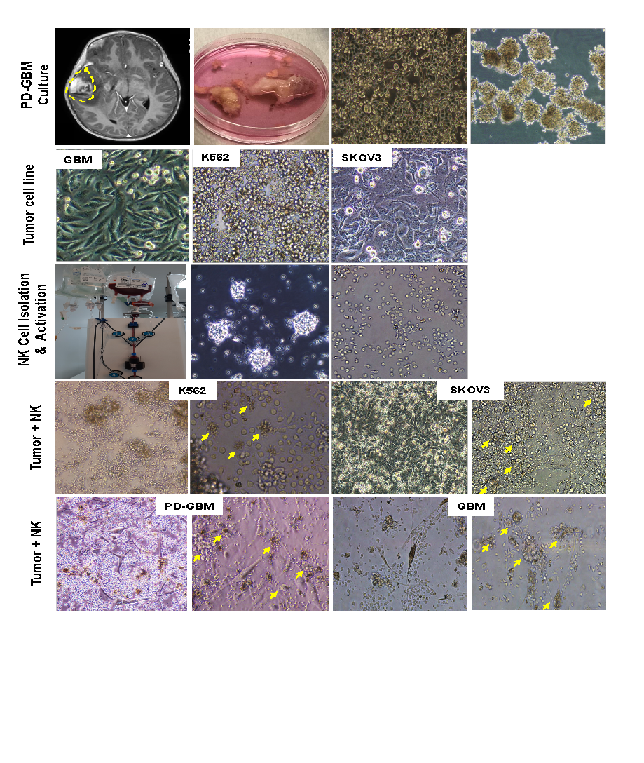
Figure 1: The Morphology of cells pre/post purification and activation, in coculture with different cancer cell line (K562, SKOV3, U251 and PD-GBM). In three cases who had surgery to remove tumor, Patient-derived tumor cells were prepared using tumor using mechanical digestion and cultivating of tumor biopsies post-surgery (First row).
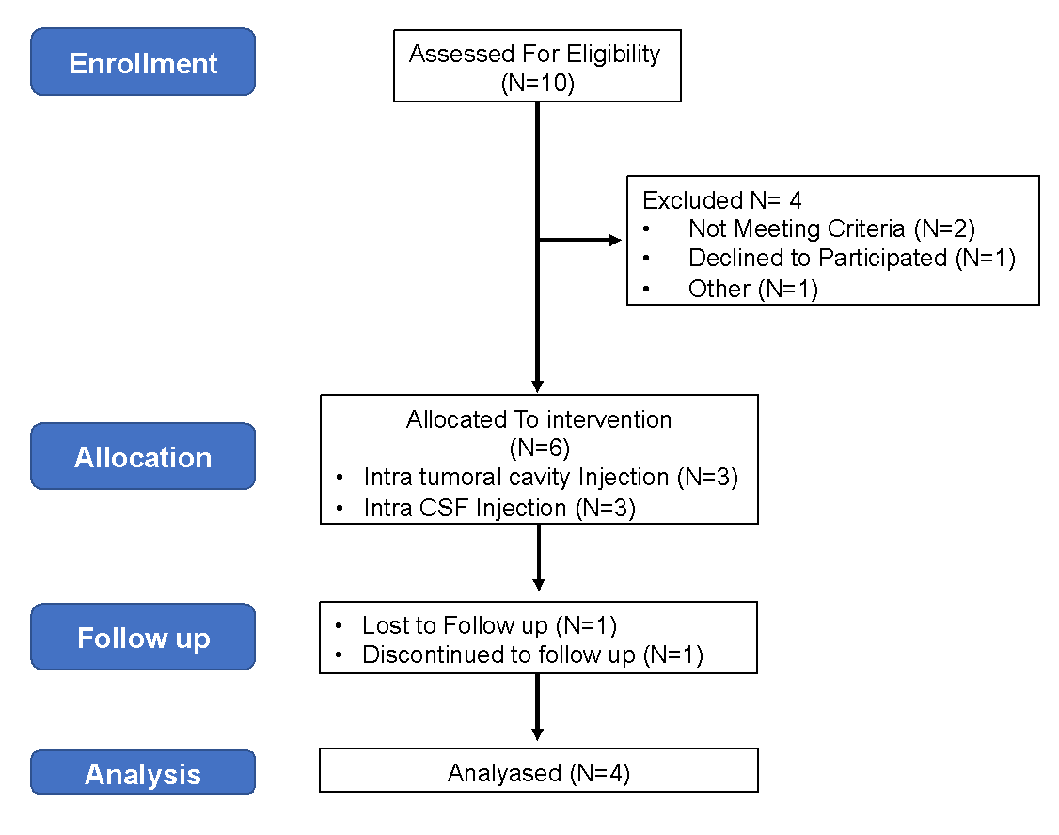
Figure 2: CONSORT of the present study

Table 4: Patient demographics
Patient # | Age | Sex | Diagnosis
1 | 7 | Male | Recurrent Glioblastoma
2 | 61 | Female | Metastatic Brain Tumor
3 | 58 | Male | Recurrent Glioblastoma
4 | 55 | Male | Recurrent Glioblastoma
5 | 3 | Female | Medulloblastoma
6 | 7 | Female | Medulloblastoma

Table 5: Adverse events profiles of haploidentical NK cells treated patients
 | CTACE Grade
 | 1 | 2 | 3 | 4
Hematological
Anemia | 0 | 0 | 0 | 0
Leukocytopenia | 0 | 0 | 0 | 0
Neutropenia | 0 | 0 | 0 | 0
Erythropenia | 0 | 0 | 0 | 0
Non-Hematological
Fever | 0 | 0 | 0 | 0
Pain at injection site | 2 | 0 | 0 | 0
Headache | 0 | 0 | 0 | 0
Meningismus | 0 | 0 | 0 | 0
Nausea/ Vomiting | 0 | 0 | 0 | 0
Fatigue | 0 | 0 | 0 | 0
Seizure | 0 | 0 | 0 | 0
Constipation/ Diarrhea | 0 | 0 | 0 | 0
Anorexia | 0 | 0 | 0 | 0
Hypertension | 0 | 0 | 0 | 0
New neurological sign | 0 | 0 | 0 | 0
Loss of consciousness | 0 | 0 | 0 | 0
Delirium | 0 | 0 | 0 | 0

