Pricing for Cost Benefit Analysis in Nielsen et al Acute Heat Assays Methods paper
Ethanol – absolute, 2.5L
Ethanol | Sigma-Aldrich (sigmaaldrich.com)
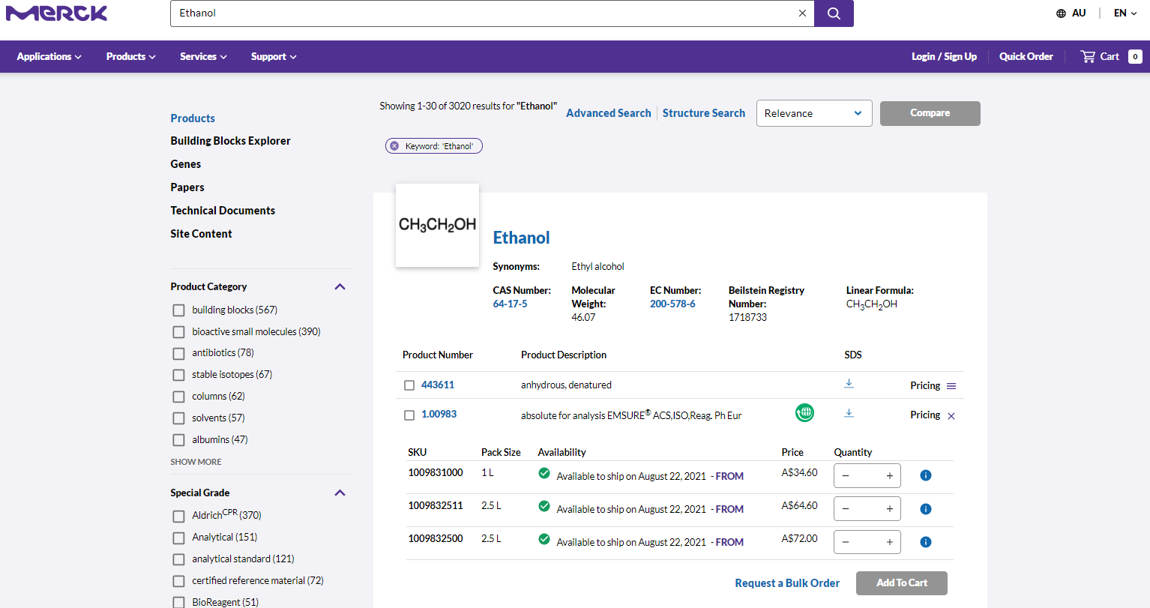

Pipette tips – red, green, and blue used
SpaceSaver Pipette Tip Refills | Made from recycled PETE (mt.com)
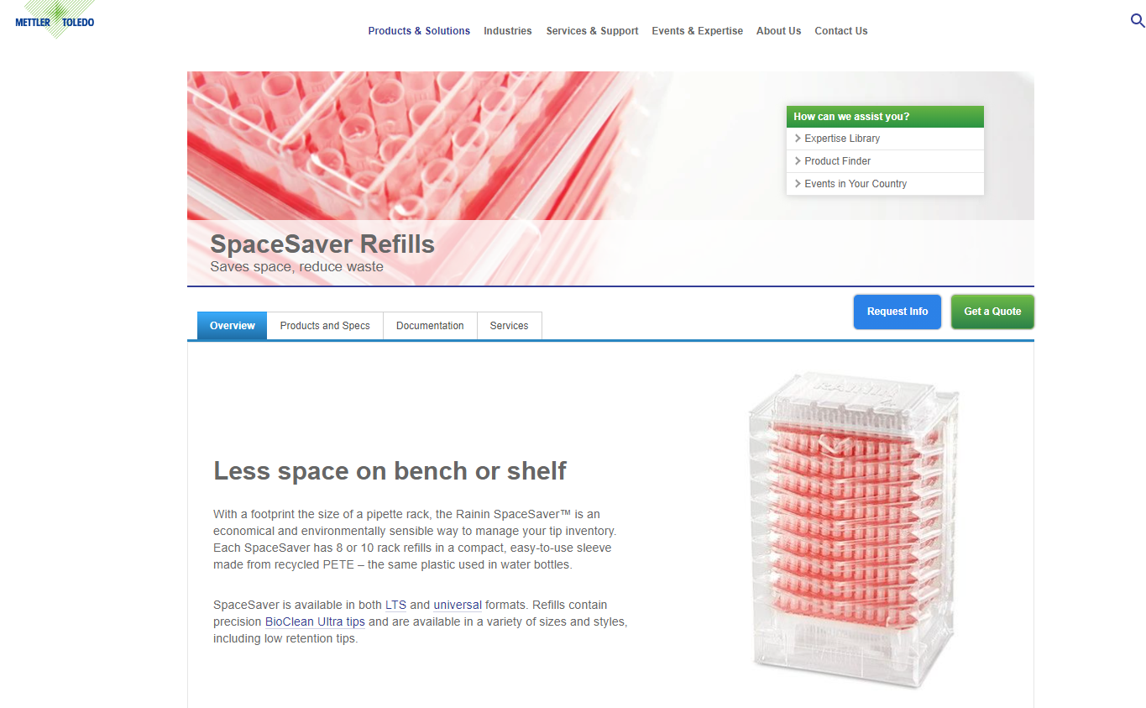
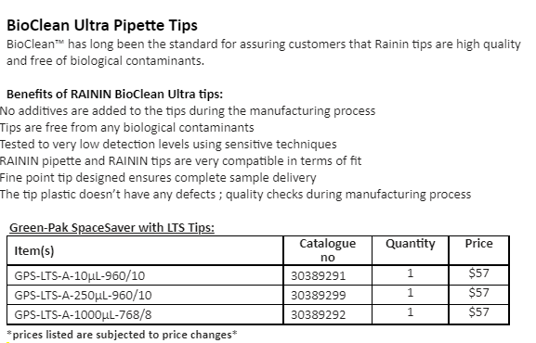
Spec plates – Chlorophyll and protein assays only
Immulon® Immunoassay Plates and Strip Assemblies | Krackeler Scientific, Inc.
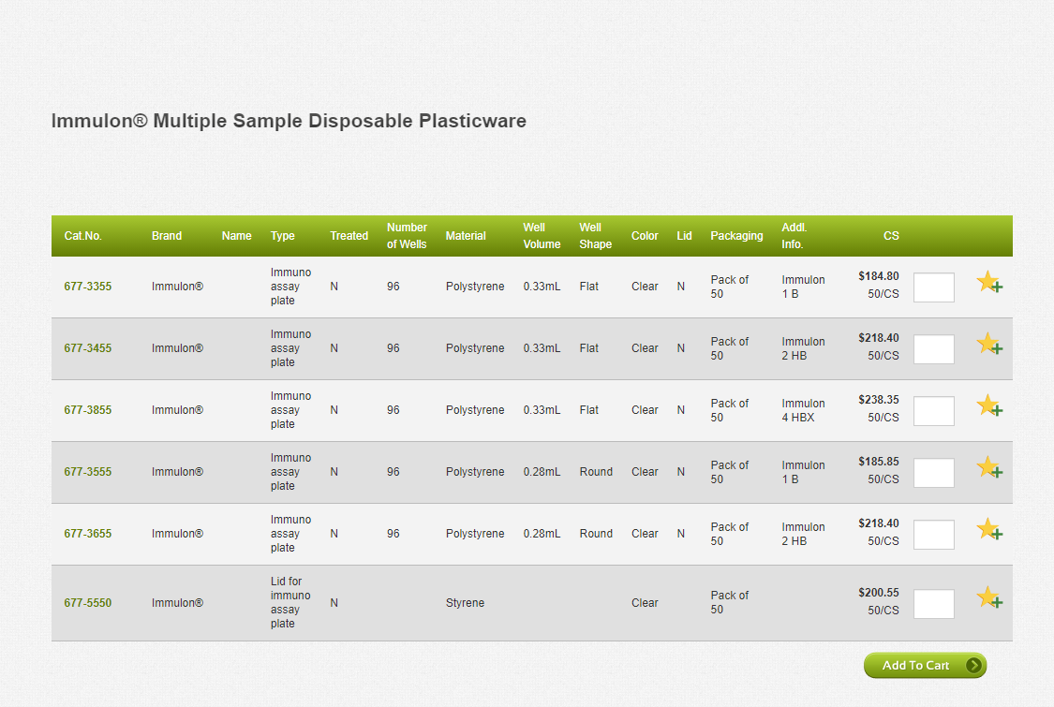

Deep well plates
SSI Deep Well Plate - 2.0 mL, 96-well, Square, V Bottom (5/pack) | LabGear Australia - Laboratory Equipment and Consumables for the Australian Scientific and Research Community
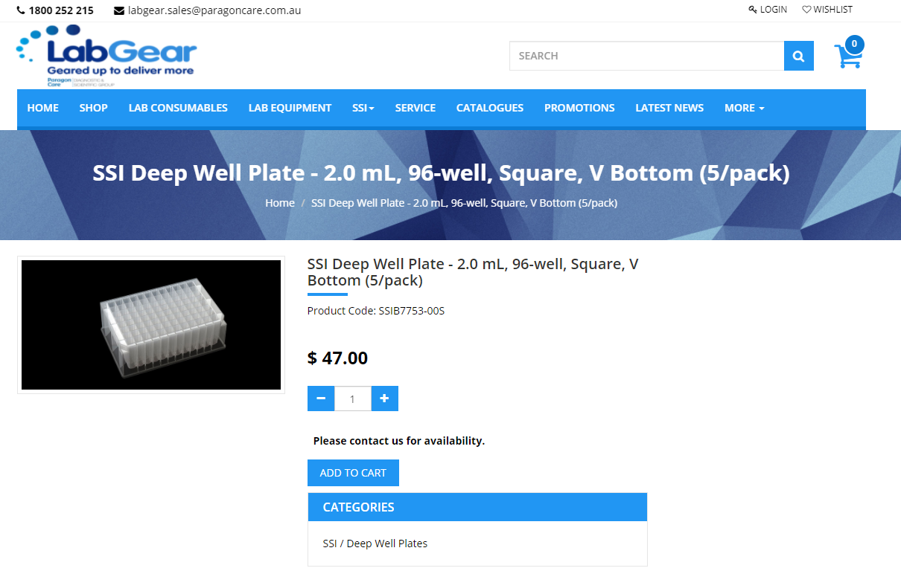
Air blow gun
MettleAir AG2-100 4" Compressed Air Blow Gun, 1/4" NPT, Inlet Commercial Grade, AG2-100 (Pack of 10): Amazon.com: Tools & Home Improvement
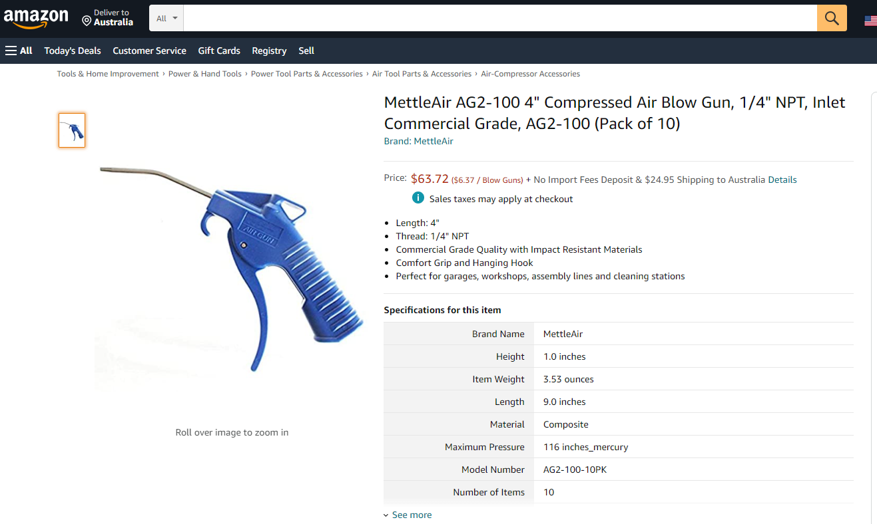

Aluminium foil
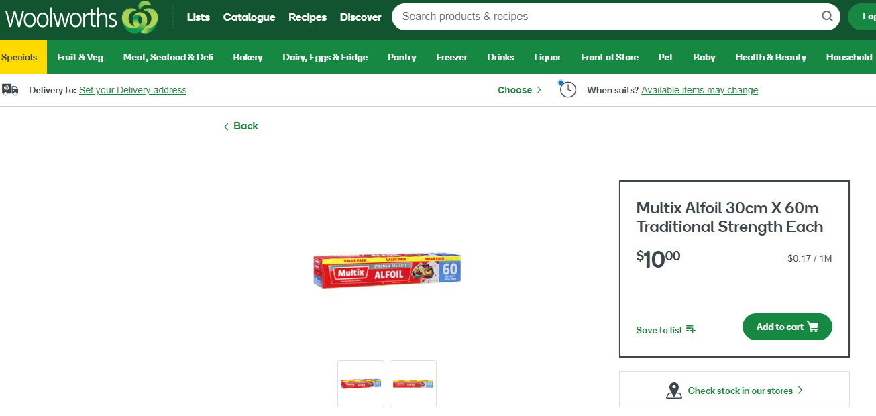

Refrigerated centrifuge with falcon-tube capacity
Centrifuge 5804/ 5804 R - Multipurpose Centrifuges, Centrifugation - Eppendorf South Pacific
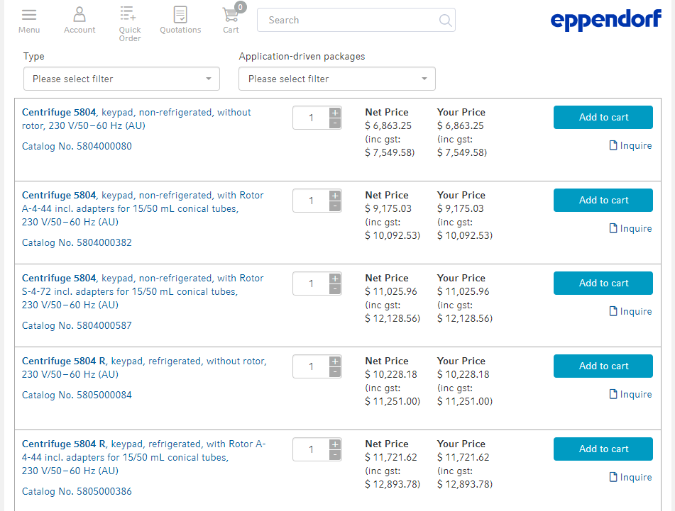

EDTA
EDTA | Sigma-Aldrich (sigmaaldrich.com)
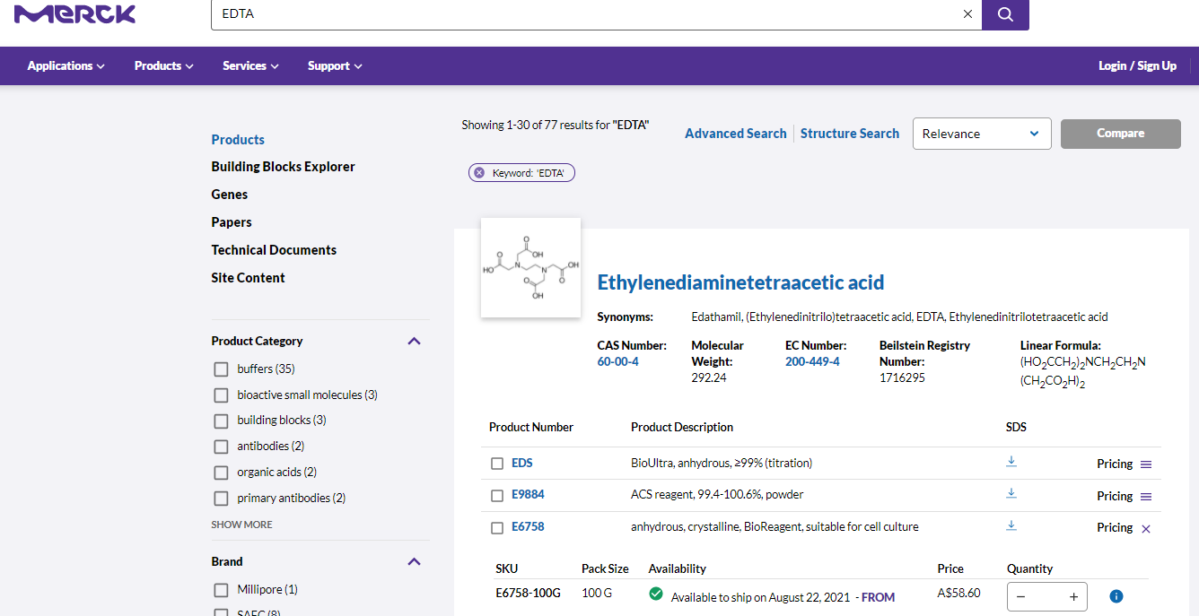
Styrofoam eskies
Polystyrene Six Pack Esky - Rope Handle for Carrying - Foam Sales
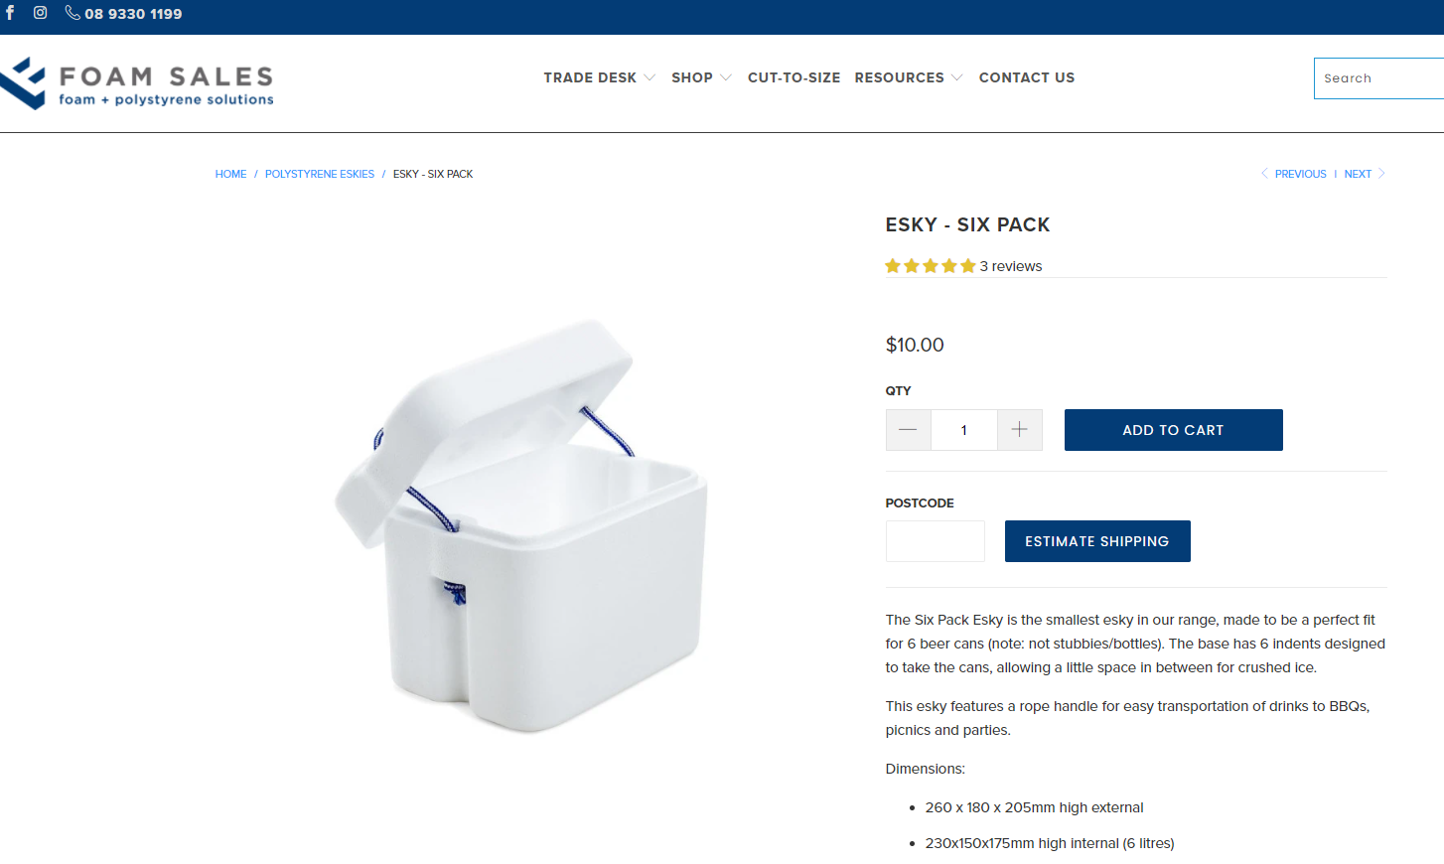
15ml Centrifuge tubes
Conical Centrifuge Tubes, Screw Cap, Graduated, Sterile, 15ml - Buy Online at LabDirect
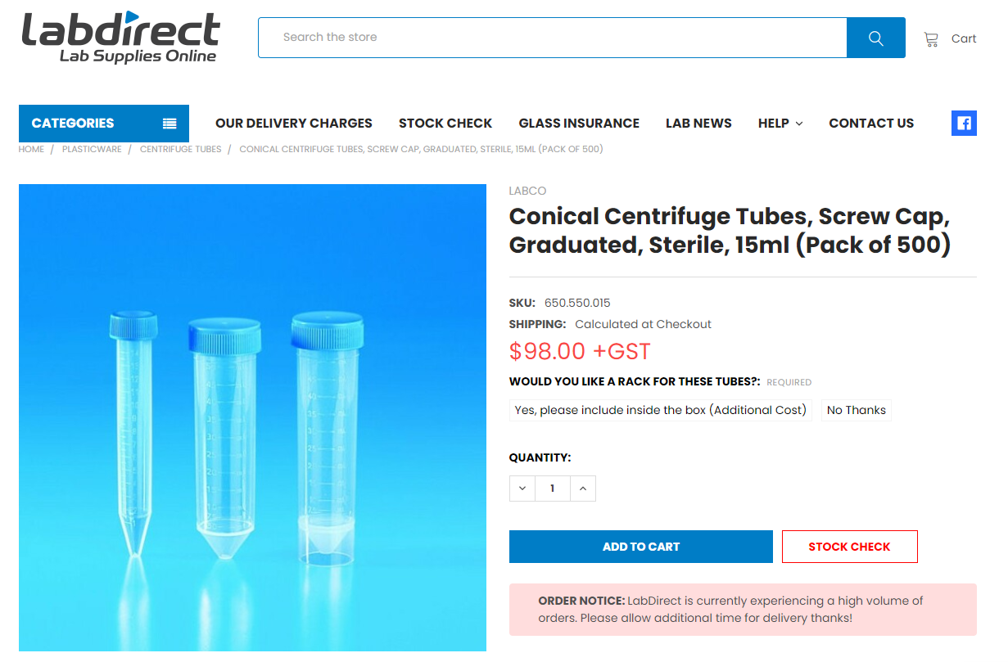

Formaldehyde solution
Formaldehyde solution for molecular biology, 36.5-38% in H2O | 50-00-0 (sigmaaldrich.com)
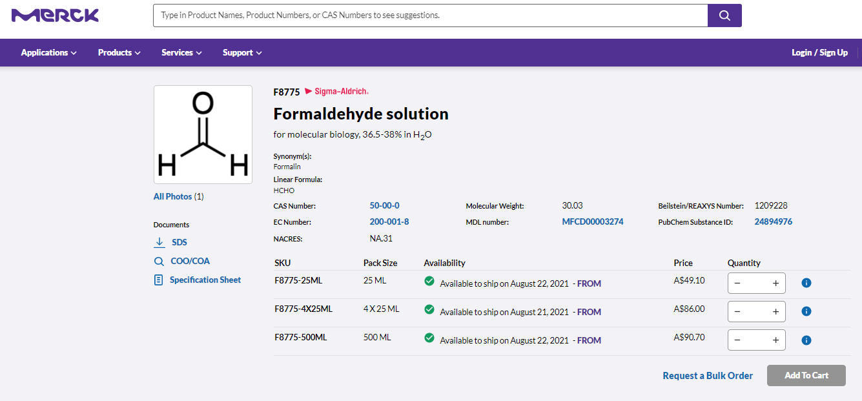

H2O2 solution
Hydrogen peroxide solution 30 % (w/w) in H2O, contains stabilizer | 7722-84-1 (sigmaaldrich.com)
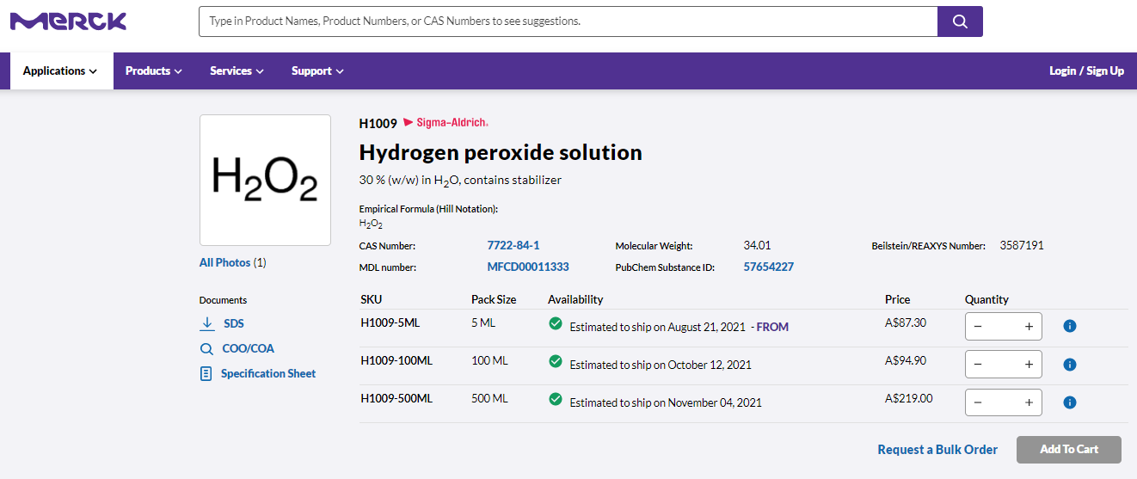

Homogeniser
PRO Scientific Bio-Gen PRO200 Homogenizer
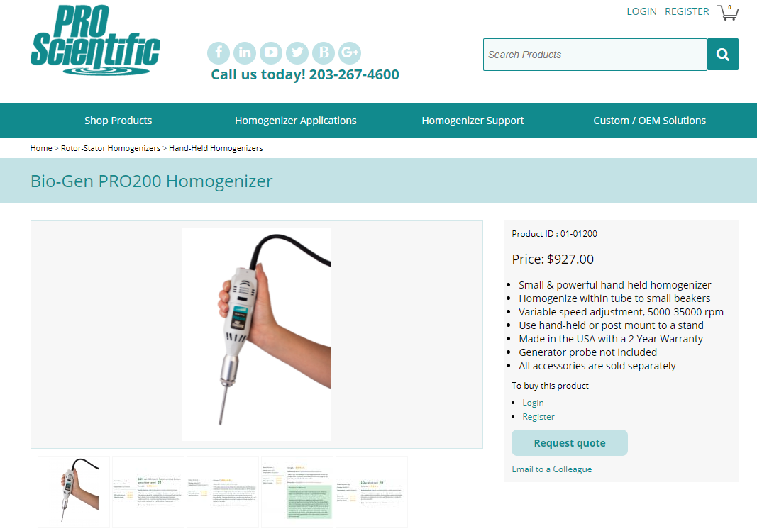

KimWipes
Kimtech® Science™ 34120A KimWipes™ Delicate Task Wipers - <br> White - 280 Sheets/Box - Case of 30 Boxes | KIMTECH SCIENCE* Wipers | Cleaning Cloths, Wipers & Sponges | Hygiene & Cleaning | Blackwoods
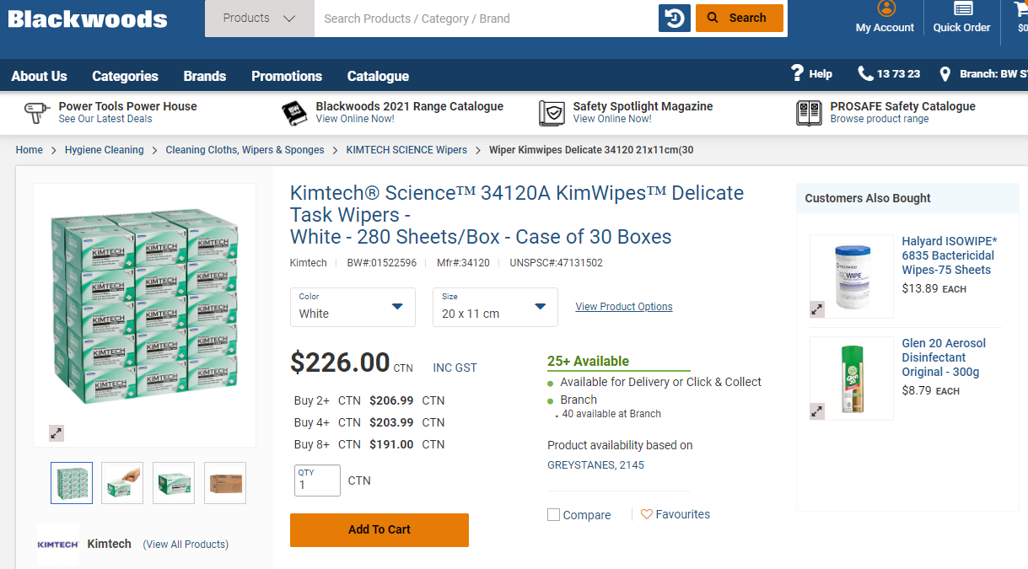
Zip-lock bags – 4x6”
Econo-Zip Reclosable Bags (thomassci.com)
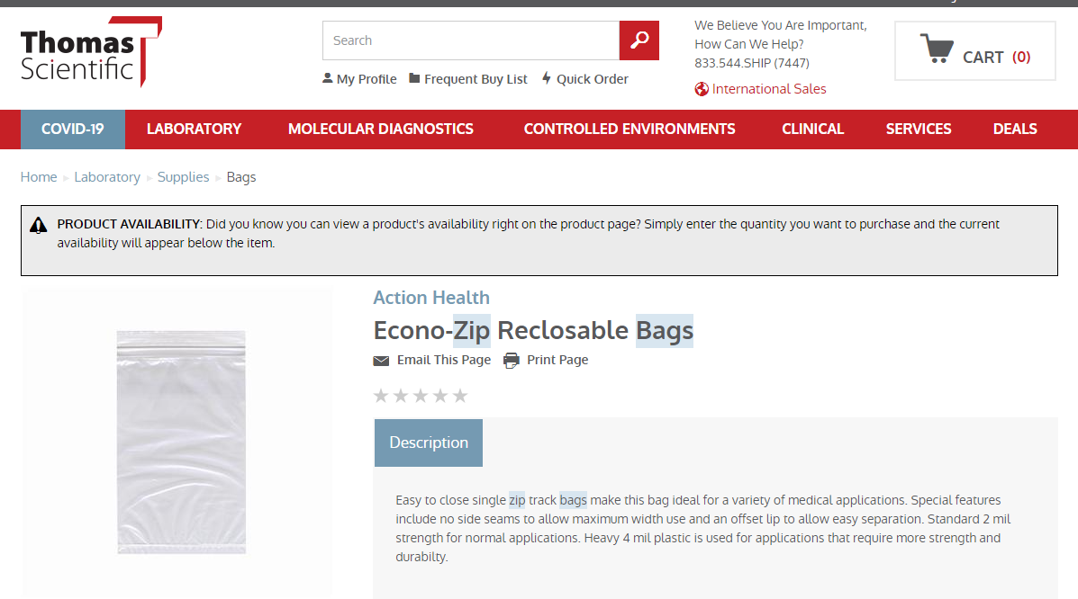
Microcentrifuge tubes, 1.5ml
1.5ml MICROCENTRIFUGE TUBE | Interpath
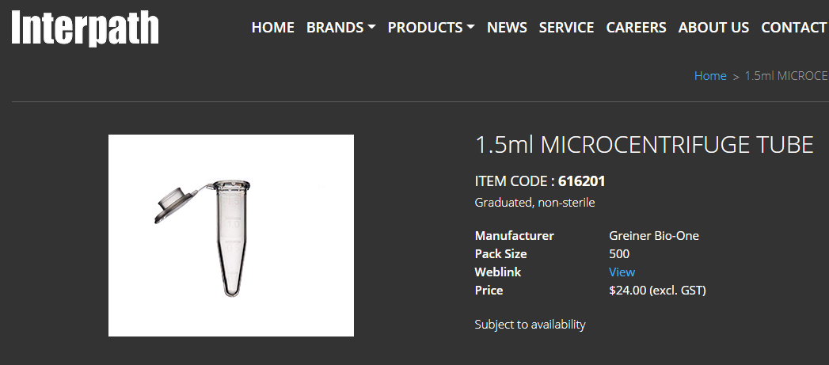

Multichannel pipettes
20uL
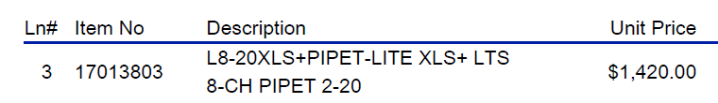
200uL
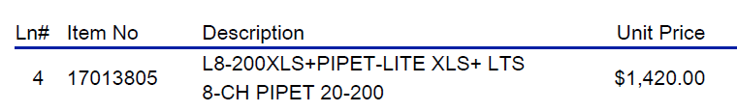

Sodium Hydroxide pellets
Sodium hydroxide - ‘Caustic soda’, Sodium hydroxide solution (sigmaaldrich.com)
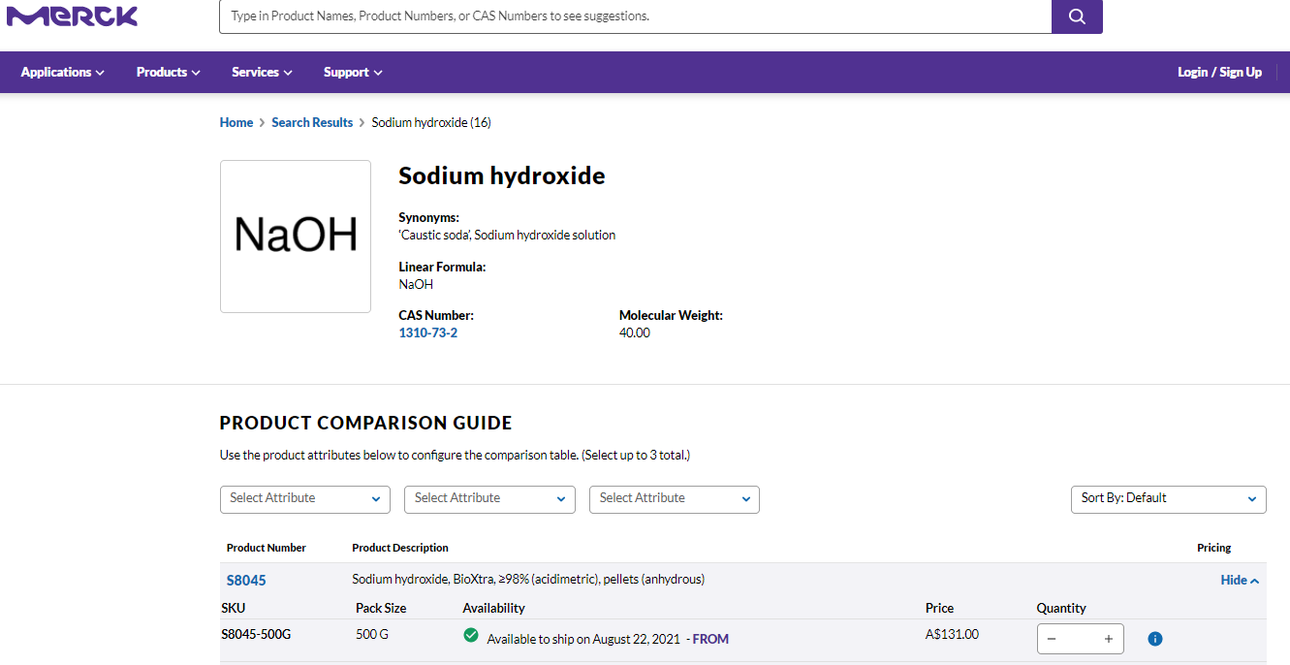

Oven
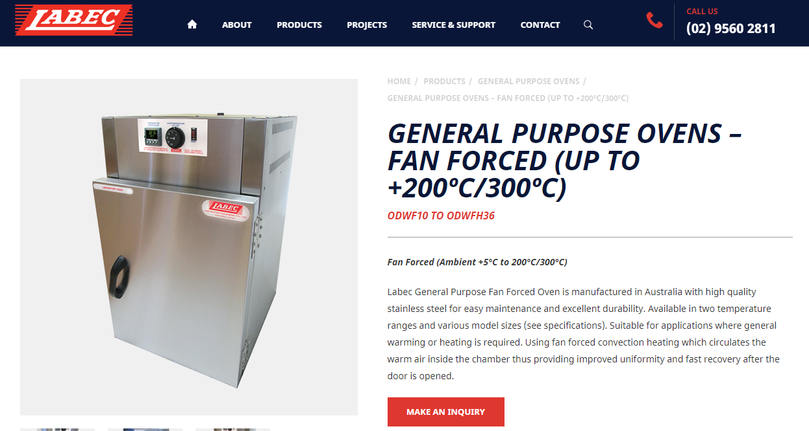
PBS tablets
Phosphate buffered saline - PBS, Phosphate buffered saline (sigmaaldrich.com)
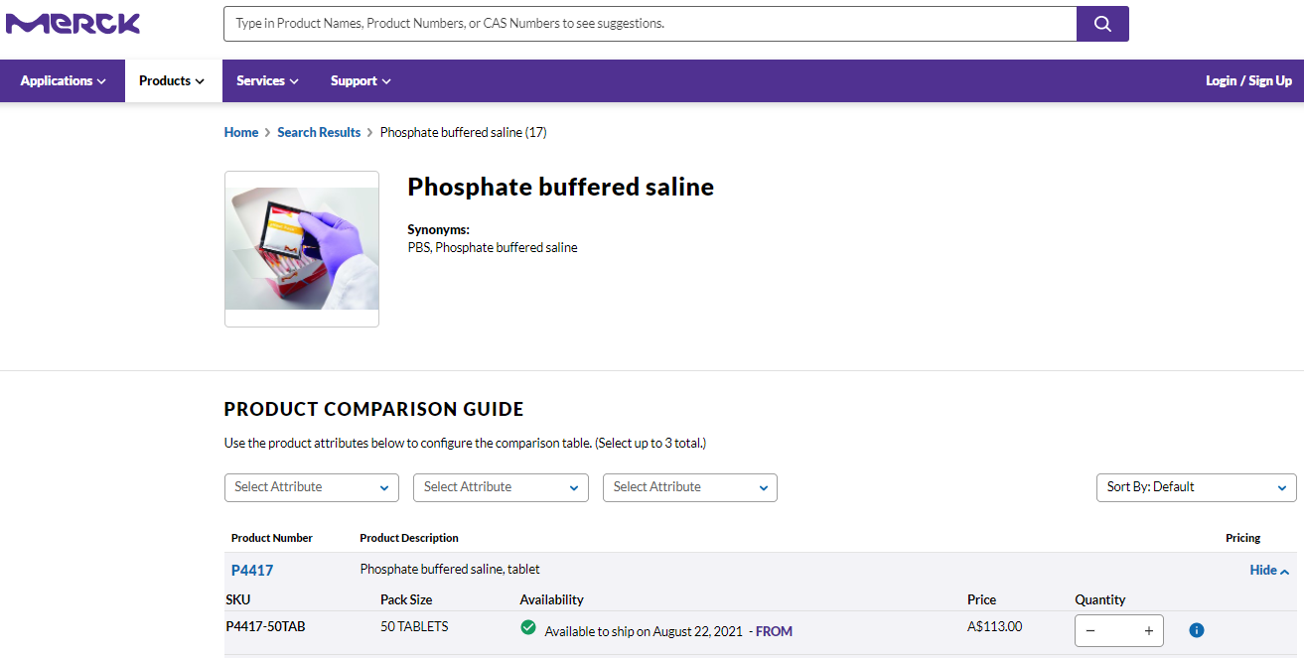

Single-channel pipettes
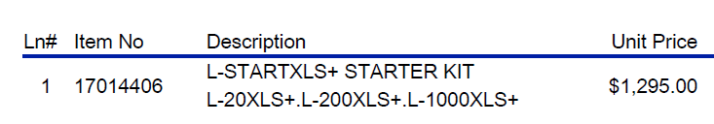

Protein kit – BD BioRad
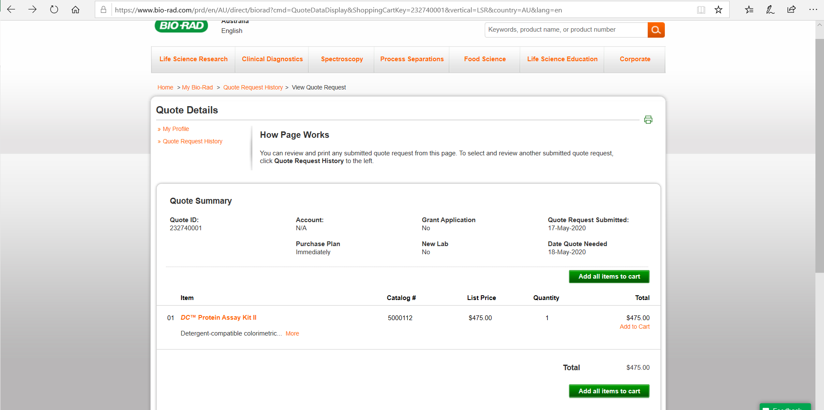
Small zip-lock bags
Small Resealable Bags 90 x 60mm | Seal Bags Small | QIS Packaging
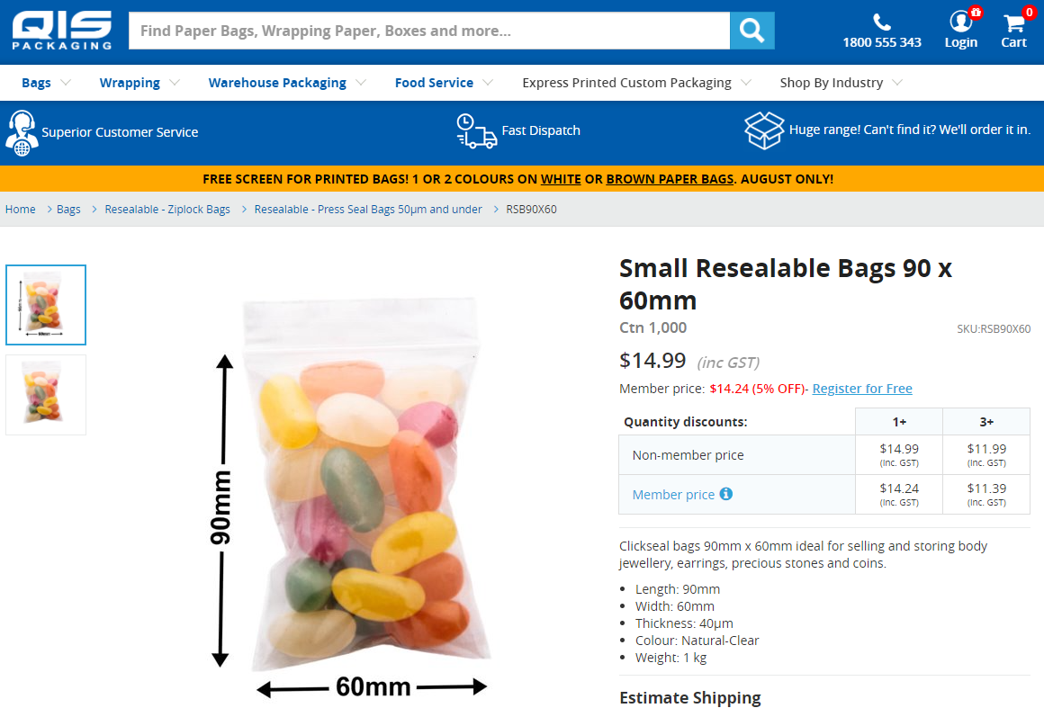

Digital timer
Wiltshire Digital Timer | BIG W
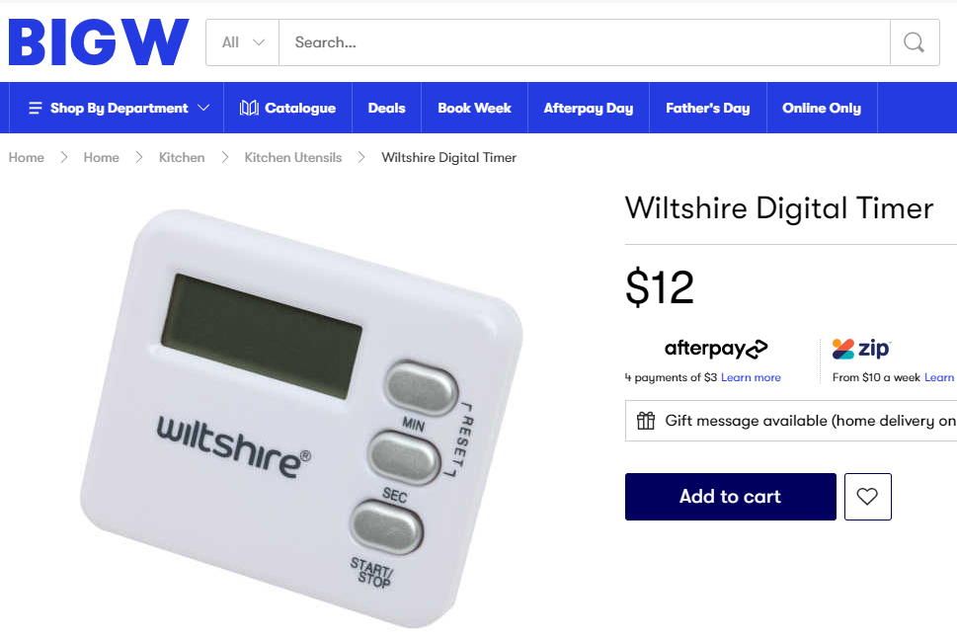
Vortex mixer
Personal Vortex Mixer - VM1 (instrumentchoice.com.au)
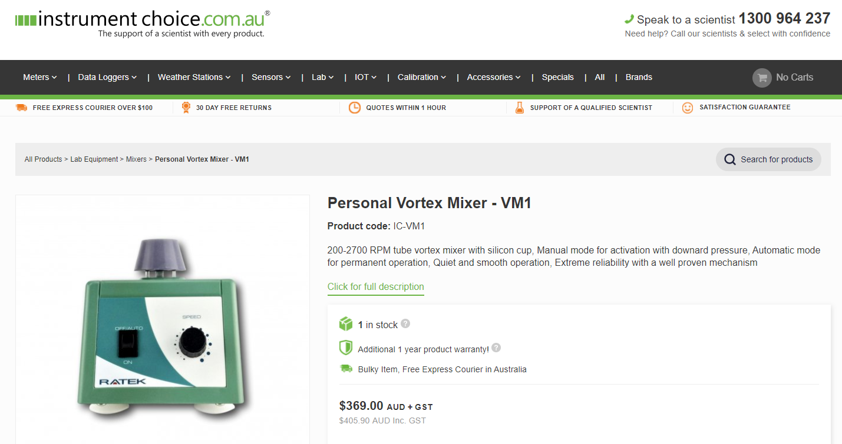

Multi-channel reservoirs
Reagent Reservoirs (thomassci.com)
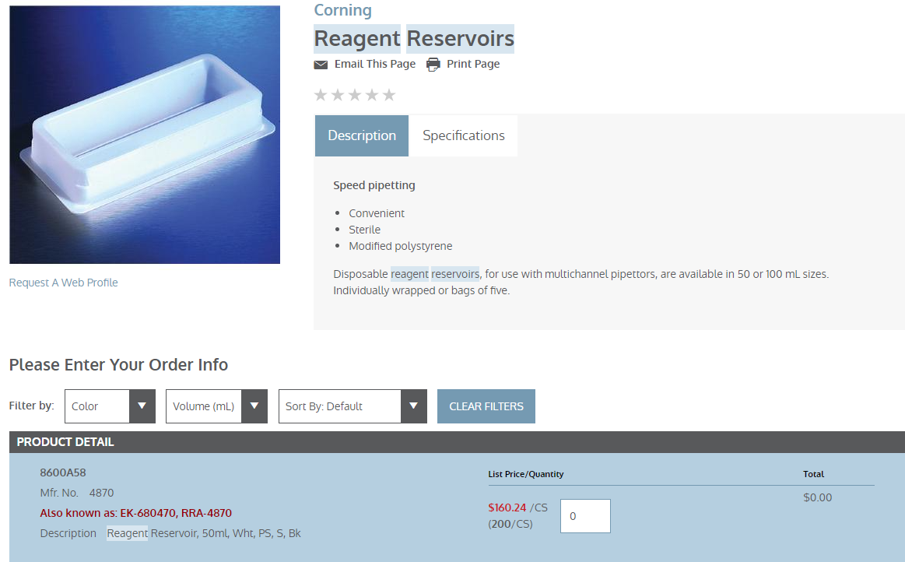

BD CS&T beads
CS&T Research Beads (bdbiosciences.com)
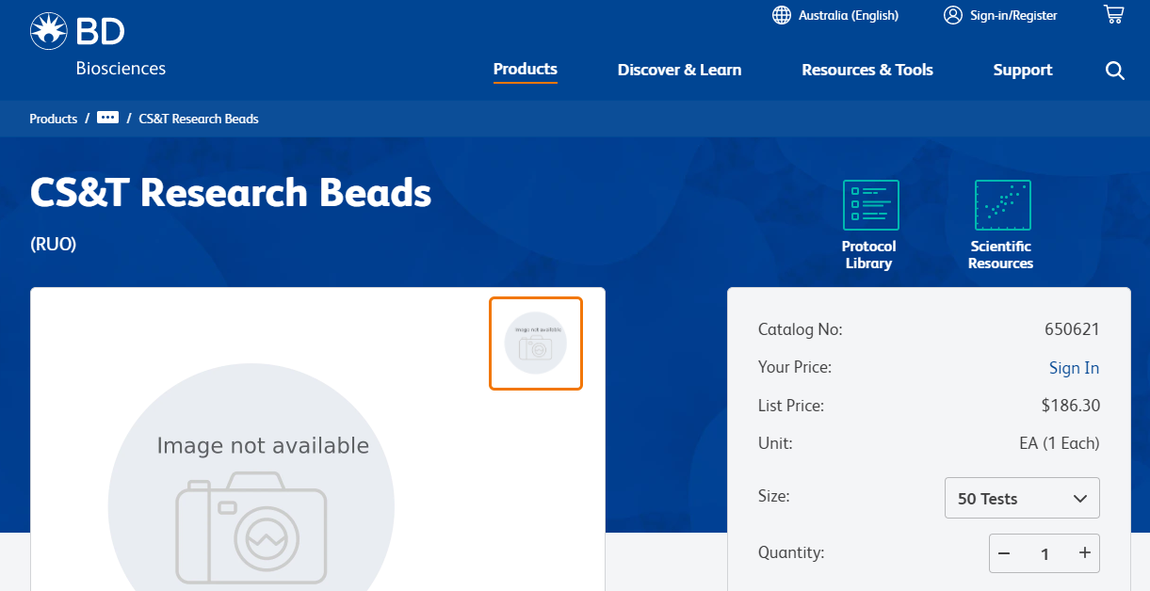

Colour chart
Coral Health Chart – CoralWatch
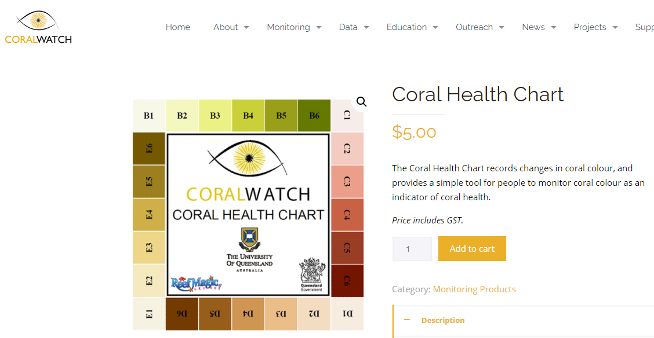

SD card
SanDisk Extreme SDXC Memory Card 128GB Black | Officeworks
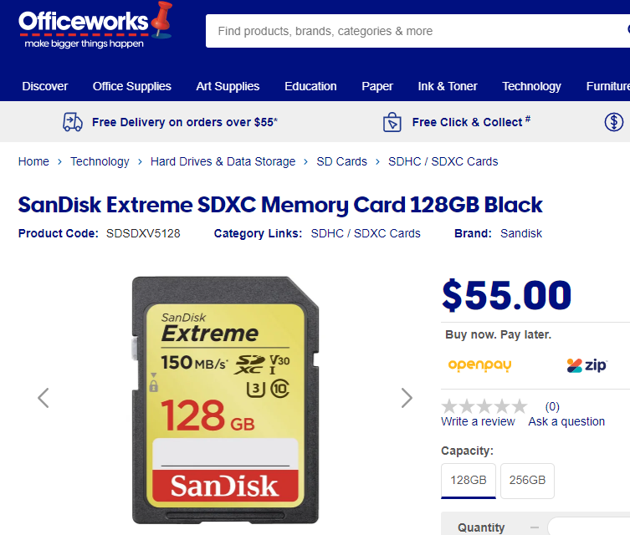

Camera
Discontinued - DSLR D300 - Nikon Australia Pty Ltd
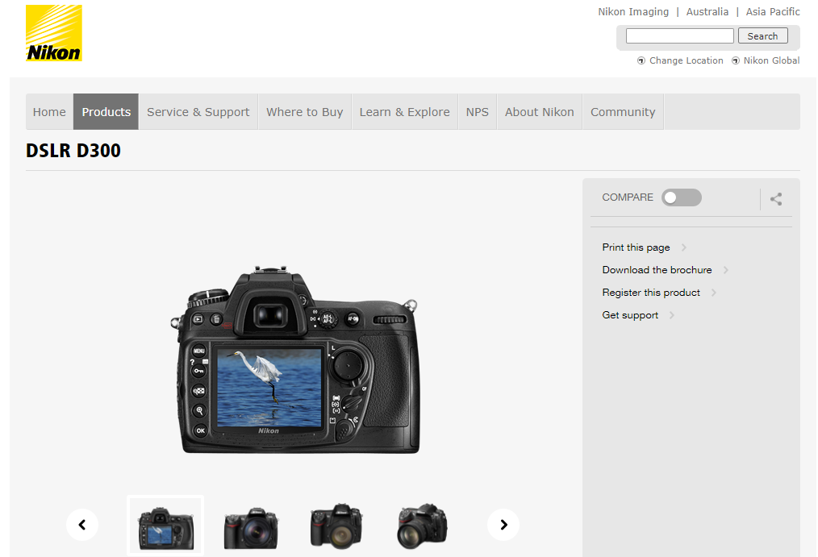

Scales
A&D FX-i Best Ammunition Reloading Scales - Shop Online (scaleshop.com.au)
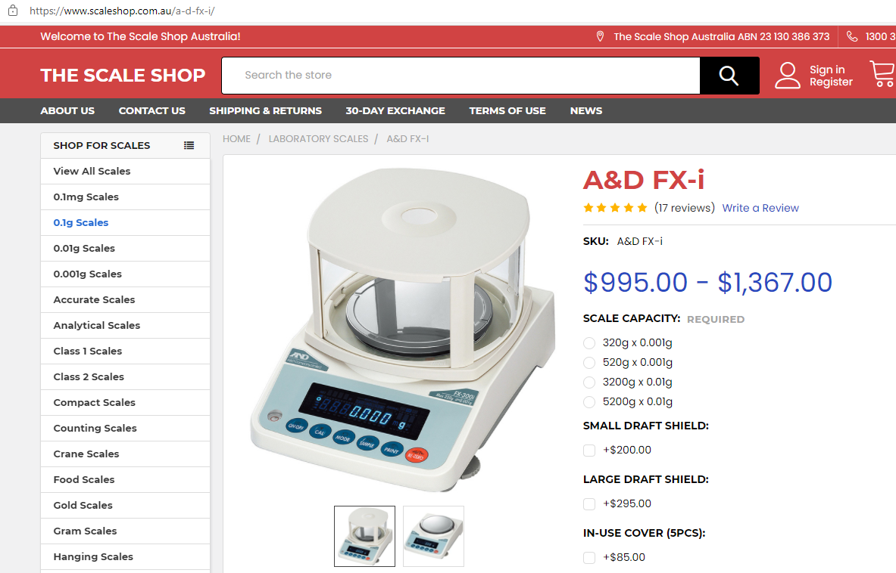
Forceps
Aaxis SM Forceps Stainless Steel Splinter 12.5cm — Medshop Australia
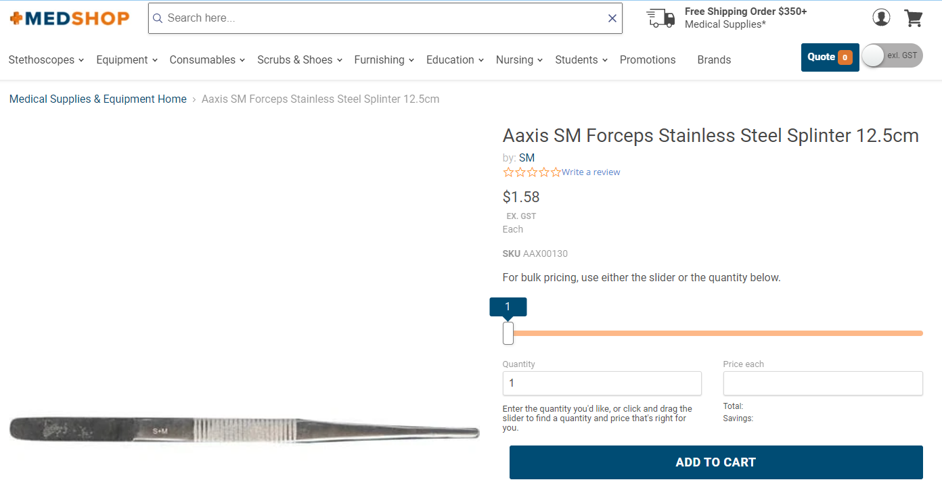

Paraffin wax
We R Memory Keepers 1.3 Kg Wick Paraffin Wax (spotlightstores.com)
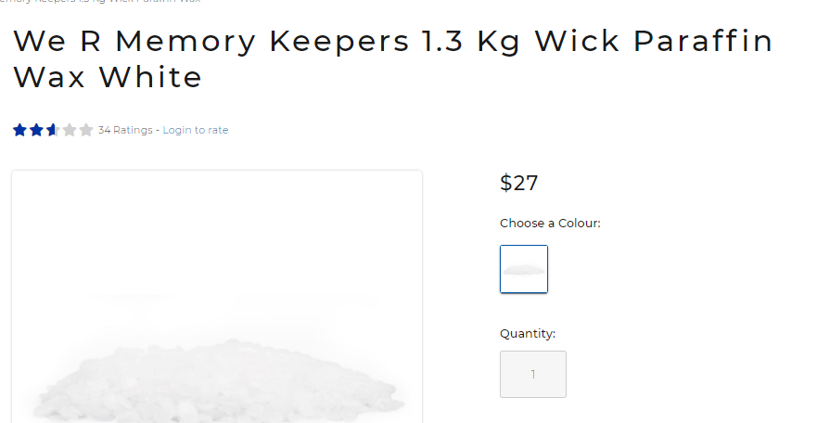

Waterbath
Digital Thermostatic Water Bath 4L (westlab.com.au)
