Experimental considerations of acute heat stress assays to quantify coral thermal tolerance
Supplementary Materials
Authors: JJV Nielsen*^{1,2,3}, G Matthews⁷, KR Frith^{2,8}, HB Harrison^{2,4}, MR. Marzonie^{2,3,4}, KL Slaughter^{3,5}, DJ Suggett⁶, LK Bay²
S1 – Experimental tank system
The tank-based heat stress assay system was specifically designed for mobility and flexibility of application following the CBASS (Coral Bleaching Automated Stress System) principle outlined by Voolstra et al. (2020). Our system consisted of two sets of three tanks, one set with temperature control capability (temperature manipulation system, Fig.S1) and the other without (ambient system, Fig.S1). The temperature manipulation system consisted of three independent acrylic tanks (55L), each supplied with heated flow-through seawater (55L h⁻¹). Tanks were placed in water jackets to aid in temperature control and stability. The jackets were supplied with recirculating, warm seawater, heated with a titanium heating element (Omega 2kW) held in a separate jacket (sump, Fig.S1) and pumped between jackets using a submersible pump (Reefe RP2400LV 24v). The sump also held a heat exchange coil (Wateco 56”) to heat seawater delivered to the tanks. Temperature was controlled with a programmable logic controller (Siemens S7 15-11-1 PN). For the ambient system, both the jackets and experimental tanks were supplied with flow-through seawater pumped from the ocean (55L h⁻¹). Every tank was fitted with a circulation pump (Turbelle® nanostream® 6055, Tunze, Penzburg, Germany). The entire system was set-up in the wet laboratory of the RV Solander and supplied with artificial lights (Hydra, AquaIllumination®, 400-700nm, C2 Development, Ames, Iowa, USA; 450 µmol photons m⁻² s⁻¹, no ramping, 7h:11h light:dark, 60% blue, 20% white, 10% green, and 10% red) suspended 40 cm above each tank. An initial light intensity of 550 µmol photons m⁻² s⁻¹ was chosen based on the light profile of the region for summer (AIMS light data Lizard Island Light From 26 Feb 2012 | AIMS metadata | aims.gov.au); however, this intensity led to visible bleaching in the ambient-treated corals and so was reduced for subsequent experimentation.
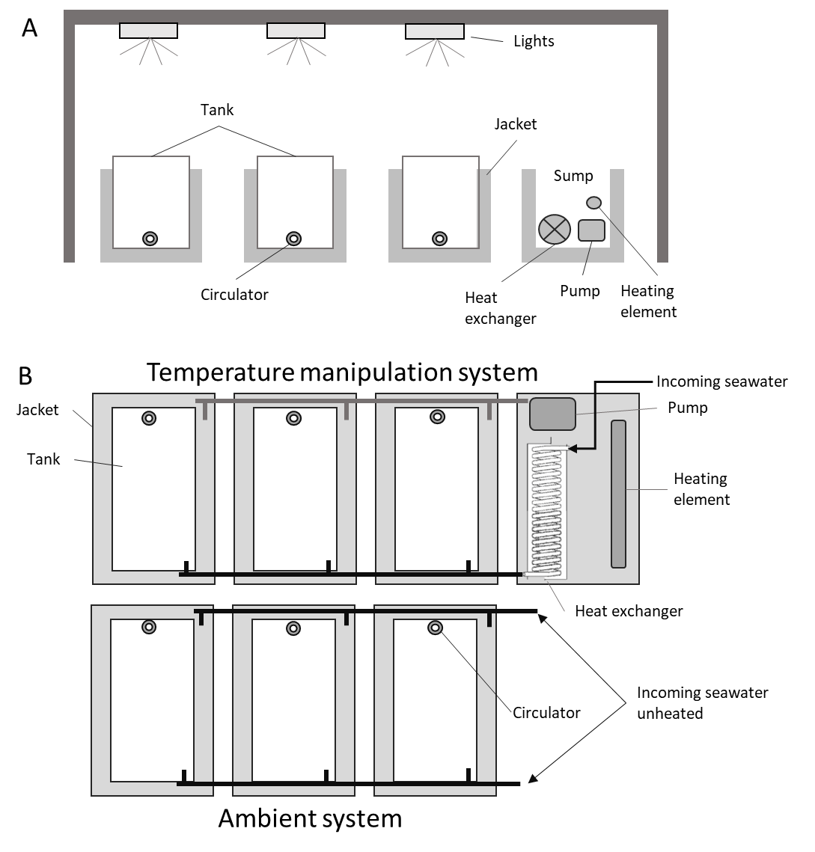
Fig S1 Schematic overview of the experimental tank set-up. (A) Side view of the temperature manipulation system, with three experimental tanks in water jackets and a fourth jacket acting as sump for heating water for both tanks and jackets. The sump contained the heating element, heat exchange coil, and a submersible pump to pump recirculating water to the jackets while the tanks were supplied with warm water from the heating coil. (B) Top-down view of the temperature manipulation and ambient systems. The ambient system was supplied unheated seawater to both jackets and tanks.

S2 - All experimental temperatures
Table S2 Treatment temperature (High and Mid) achieved during each acute heat stress experimental run compared to the ambient sea-water temperature.
Experiment | Reef | Treatment combo | Mean heated temperature | Heated SE | Mean ambient temperature | Ambient SE | Temperature difference
1 | 13-123  A. tenuis | High/Ambient | 34.89 | 0.059 | 29.94 | 0.026 | 4.952381
1 | 13-123  P. damicornis | High/Ambient | 35.02 | 0.068 | 30.03 | 0.049 | 4.990476
2 | Creech | High/Ambient | 34.63 | 0.097 | 29.59 | 0.029 | 5.038889
3 | 11-049 | High/Ambient | 34.99 | 0.12 | 29.96 | 0.020 | 5.035714
3 | 13-124 | High/Ambient | 34.98 | 0.061 | 30.55 | 0.013128 | 4.433333
3 | 13-124 | Mid/Ambient | 33.44 | 0.027 | 30.2 | 0.040237 | 3.24
3 | Corbett | High/Ambient | 35.23 | 0.037 | 30.8 | 0.016903 | 4.433333
3 | Corbett | Mid/Ambient | 32.99 | 0.060 | 30.39 | 0.015065 | 2.594444
3 | Davie | High/Ambient | 34.99 | 0.034 | 30.87 | 0.062994 | 4.12
3 | Davie | Mid/Ambient | 34.21 | 0.031 | 29.96 | 0.066898 | 4.255556
3 | Lagoon | High/Ambient | 35.09 | 0.089 | 29.53 | 0.023035 | 5.561905
3 | Lagoon | Mid/Ambient | 33.37 | 0.049 | 29.46 | 0.013436 | 3.911111
3 | Mantis | High/Ambient | 35.28 | 0.085 | 30.37 | 0.027021 | 4.913333
3 | Mantis | Mid/Ambient | 33.53 | 0.079 | 29.84 | 0.082896 | 3.688889

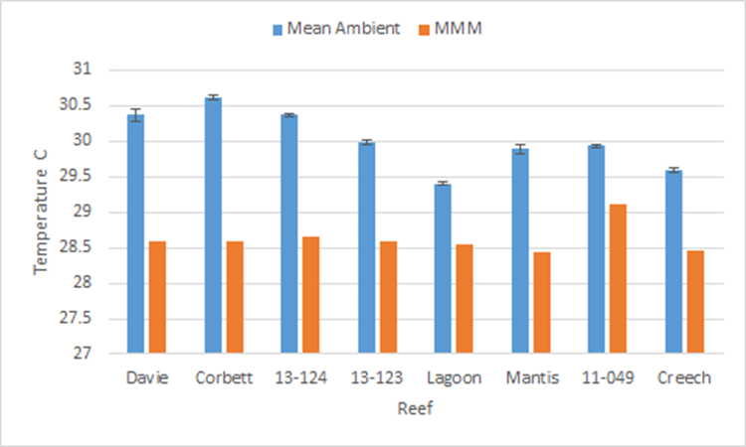
Fig S2. Difference between mean (±SE) ambient temperature at time of experiment and the reef-specific Max Monthly Mean (MMM) temperature obtained from NOAA.
S3 – Statistical outputs for size effects in A. tenuis and P. damicornis

Table S3.1. Statistical outputs for size and treatment effects in A. tenuis and P. damicornis.
Species | Trait | Transformation | Term | df | Z | p
A. tenuis | Colour change | Cube root | Treatment | 106 | -6.714 | 1.89E-11
A. tenuis | Colour change | Cube root | Size | 106 | 4.231 | 2.32E-05
A. tenuis | Colour change | Cube root | Treatment*Size | 106 | -3.255 | 0.00114
A. tenuis | Chlorophyll a | NA | Treatment | 104 | -6.236 | < 0.0001
A. tenuis | Chlorophyll a | NA | Size | 104 | 1.19 | 0.234
A. tenuis | Chlorophyll a | NA | Treatment*Size | 104 | -0.079 | 0.937
A. tenuis | Catalase activity | log | Treatment | 93 | 2.382 | 0.0172
A. tenuis | Catalase activity | log | Size | 93 | -1.309 | 0.1904
A. tenuis | Catalase activity | log | Treatment*Size | 93 | -1.281 | 0.2003
A. tenuis | Protein content | log | Treatment | 91 | -5.112 | < 0.0001
A. tenuis | Protein content | log | Size | 91 | -0.775 | 0.438
A. tenuis | Protein content | log | Treatment*Size | 91 | 0.882 | 0.378
A. tenuis | F_{v}/F_{m} | NA | Treatment | 212 | -10.13 | < 0.0001
A. tenuis | F_{v}/F_{m} | NA | Size | 212 | 0.82 | 0.413
A. tenuis | F_{v}/F_{m} | NA | Treatment*Size | 212 | 1.26 | 0.207
P. damicornis | Colour change | Cube root | Treatment | 106 | -9.273 | < 0.0001
P. damicornis | Colour change | Cube root | Size | 106 | -2.631 | 0.0085
P. damicornis | Colour change | Cube root | Treatment*Size | 106 | 2.499 | 0.0125
P. damicornis | Chlorophyll a | NA | Treatment | 96 | -2.776 | 0.0055
P. damicornis | Chlorophyll a | NA | Size | 96 | 2.653 | 0.00797
P. damicornis | Chlorophyll a | NA | Treatment*Size | 96 | -1.975 | 0.04827
P. damicornis | Catalase activity | log | Treatment | 86 | -4.546 | < 0.0001
P. damicornis | Catalase activity | log | Size | 86 | -1.851 | 0.064175
P. damicornis | Catalase activity | log | Treatment*Size | 86 | 2.82 | 0.004804
P. damicornis | Protein content | log | Treatment | 102 | -3.173 | 0.00151
P. damicornis | Protein content | log | Size | 102 | -2.761 | 0.00577
P. damicornis | Protein content | log | Treatment*Size | 102 | 0.136 | 0.89186
P. damicornis | F_{v}/F_{m} | NA | Treatment | 195 | -8.15 | < 0.0001
P. damicornis | F_{v}/F_{m} | NA | Size | 195 | -1.31 | 0.192
P. damicornis | F_{v}/F_{m} | NA | Treatment*Size | 195 | 0.27 | 0.785

Table S3.2 Post-hoc contrasts of physiological traits for both A. tenuis and P. damicornis.
Species | Trait | Contrast | df | T ratio | p
A. tenuis | Colour change | Large Heated - Large Ambient | 106 | 6.714 | < 0.0001
A. tenuis | Colour change | Small Ambient - Large Ambient | 106 | -4.231 | < 0.0001
A. tenuis | Colour change | Small Heated - Large Heated | 106 | 0.371 | 0.7114
A. tenuis | Colour change | Small Heated - Small Ambient | 106 | 11.316 | < 0.0001
P. damicornis | Chlorophyll a | Large Heated - Large Ambient | 96 | 2.776 | 0.0066
P. damicornis | Chlorophyll a | Small Ambient - Large Ambient | 96 | 5.586 | < 0.0001
P. damicornis | Chlorophyll a | Small Heated - Large Heated | 96 | -2.653 | 0.0093
P. damicornis | Chlorophyll a | Small Heated - Small Ambient | 96 | 0.177 | 0.8603
P. damicornis | Colour change | Large Heated - Large Ambient | 106 | 9.279 | < 0.0001
P. damicornis | Colour change | Small Ambient - Large Ambient | 106 | 5.745 | < 0.0001
P. damicornis | Colour change | Small Heated - Large Heated | 106 | 2.631 | 0.0098
P. damicornis | Colour change | Small Heated - Small Ambient | 106 | -0.902 | 0.3689
P. damicornis | Catalase activity | Large Heated - Large Ambient | 86 | 4.546 | < 0.0001
P. damicornis | Catalase activity | Small Ambient - Large Ambient | 86 | 0.225 | 0.8228
P. damicornis | Catalase activity | Small Heated - Large Heated | 86 | 1.851 | 0.0676
P. damicornis | Catalase activity | Small Heated - Small Ambient | 86 | -2.146 | 0.0347

S4 – Statistical outputs from time effect analysis
Table S4.1 Statistical outputs for sampling time effect in A. tenuis.
Trait | Term | estimate | d. error | z | p
Catalase | Intercept | -9.22 | 26.014 | -0.35 | 0.72
Catalase | T₁ | -56.85 | 33.85 | -1.68 | 0.093
Catalase | T₂ | 109.48 | 33.8 | 3.24 | 0.0012
Catalase | T₃ | 40.42 | 34.34 | 1.18 | 0.24
Catalase | T₄ | -34.53 | 34.56 | -1.00 | 0.32
Catalase | T₅ | -88.38 | 35.40 | -2.50 | 0.013
Catalase | T₆ | -74.58 | 32.88 | -2.27 | 0.023
Chlorophyll | Intercept | -24.18 | 9.90 | -2.44 | 0.015
Chlorophyll | T₁ | -17.29 | 14.57 | -1.19 | 0.24
Chlorophyll | T₂ | -27.73 | 13.55 | -2.05 | 0.041
Chlorophyll | T₃ | -41.19 | 13.20 | -3.12 | 0.0018
Chlorophyll | T₄ | -35.25 | 13.55 | -2.60 | 0.0093
Chlorophyll | T₅ | -59.65 | 14.00 | -4.26 | < 0.0001
Chlorophyll | T₆ | -54.06 | 13.20 | -4.10 | < 0.0001
Colour change | Intercept | -9.98 | 3.14 | -3.18 | 0.0015
Colour change | T₁ | -4.49 | 2.93 | -1.53 | 0.13
Colour change | T₂ | -8.96 | 2.93 | -3.05 | 0.0023
Colour change | T₃ | -15.33 | 2.93 | -5.23 | < 0.0001
Colour change | T₄ | -24.73 | 2.93 | -8.43 | < 0.0001
Colour change | T₅ | -30.70 | 2.93 | -10.46 | < 0.0001
Colour change | T₆ | -37.81 | 2.93 | -12.89 | < 0.0001
Protein | Intercept | -26.44 | 11.25 | -2.35 | 0.019
Protein | T₁ | -10.89 | 16.56 | -0.66 | 0.51
Protein | T₂ | -24.05 | 16.91 | -1.51 | 0.13
Protein | T₃ | -57.61 | 16.56 | -3.48 | 0.0005
Protein | T₄ | -58.08 | 15.91 | -3.65 | 0.0003
Protein | T₅ | -73.56 | 15.91 | -4.62 | < 0.0001
Protein | T₆ | -73.56 | 15.41 | -4.78 | < 0.0001
F_{v}/F_{m} | Intercept | -5.85 | 2.43 | -2.40 | 0.016
F_{v}/F_{m} | T₁ | -3.85 | 3.01 | -1.28 | 0.20
F_{v}/F_{m} | T₂ | -1.61 | 3.01 | -0.54 | 0.59
F_{v}/F_{m} | T₃ | 0.60 | 3.01 | 0.20 | 0.84
F_{v}/F_{m} | T₄ | 0.40 | 3.01 | 0.13 | 0.90
F_{v}/F_{m} | T₅ | -4.43 | 3.11 | -1.43 | 0.154
F_{v}/F_{m} | T₆ | -32.10 | 3.01 | -10.65 | < 0.0001

Table S4.2 Post-hoc contrasts of physiological traits over time, A. tenuis.
Traits | contrast | estimate | SE | df | t ratio | p value
Protein | T0 - T1 | 10.88921 | 16.6 | 39 | 0.658 | 0.9942
Protein | T0 - T2 | 24.04836 | 15.9 | 39 | 1.511 | 0.7364
Protein | T0 - T3 | 57.61369 | 16.6 | 39 | 3.479 | 0.0196
Protein | T0 - T4 | 58.07697 | 15.9 | 39 | 3.65 | 0.0124
Protein | T0 - T5 | 73.55848 | 15.9 | 39 | 4.623 | 0.0008
Protein | T0 - T6 | 73.55836 | 15.4 | 39 | 4.775 | 0.0005
Protein | T1 - T2 | 13.15916 | 16.6 | 39 | 0.795 | 0.9842
Protein | T1 - T3 | 46.72448 | 17.2 | 39 | 2.719 | 0.1204
Protein | T1 - T4 | 47.18777 | 16.6 | 39 | 2.849 | 0.0908
Protein | T1 - T5 | 62.66928 | 16.6 | 39 | 3.784 | 0.0086
Protein | T1 - T6 | 62.66915 | 16.1 | 39 | 3.898 | 0.0063
Protein | T2 - T3 | 33.56532 | 16.6 | 39 | 2.027 | 0.415
Protein | T2 - T4 | 34.02861 | 15.9 | 39 | 2.139 | 0.3513
Protein | T2 - T5 | 49.51012 | 15.9 | 39 | 3.112 | 0.0495
Protein | T2 - T6 | 49.50999 | 15.4 | 39 | 3.214 | 0.0386
Protein | T3 - T4 | 0.46329 | 16.6 | 39 | 0.028 | 1
Protein | T3 - T5 | 15.9448 | 16.6 | 39 | 0.963 | 0.959
Protein | T3 - T6 | 15.94467 | 16.1 | 39 | 0.992 | 0.9528
Protein | T4 - T5 | 15.48151 | 15.9 | 39 | 0.973 | 0.9569
Protein | T4 - T6 | 15.48138 | 15.4 | 39 | 1.005 | 0.9498
Protein | T5 - T6 | -0.00012 | 15.4 | 39 | 0 | 1
Chlorophyll | T0 - T1 | 17.29 | 14.6 | 45 | 1.187 | 0.8955
Chlorophyll | T0 - T2 | 27.73 | 13.6 | 45 | 2.046 | 0.4014
Chlorophyll | T0 - T3 | 41.19 | 13.2 | 45 | 3.121 | 0.0457
Chlorophyll | T0 - T4 | 35.24 | 13.6 | 45 | 2.601 | 0.15
Chlorophyll | T0 - T5 | 59.65 | 14 | 45 | 4.262 | 0.0018
Chlorophyll | T0 - T6 | 54.06 | 13.2 | 45 | 4.097 | 0.0031
Chlorophyll | T1 - T2 | 10.44 | 14.1 | 45 | 0.738 | 0.9893
Chlorophyll | T1 - T3 | 23.9 | 13.8 | 45 | 1.732 | 0.599
Chlorophyll | T1 - T4 | 17.96 | 14.1 | 45 | 1.27 | 0.8618
Chlorophyll | T1 - T5 | 42.36 | 14.6 | 45 | 2.908 | 0.0764
Chlorophyll | T1 - T6 | 36.77 | 13.8 | 45 | 2.665 | 0.1313
Chlorophyll | T2 - T3 | 13.46 | 12.7 | 45 | 1.058 | 0.9369
Chlorophyll | T2 - T4 | 7.52 | 13.1 | 45 | 0.574 | 0.9972
Chlorophyll | T2 - T5 | 31.92 | 13.6 | 45 | 2.356 | 0.2412
Chlorophyll | T2 - T6 | 26.33 | 12.7 | 45 | 2.07 | 0.3876
Chlorophyll | T3 - T4 | -5.94 | 12.7 | 45 | -0.467 | 0.9991
Chlorophyll | T3 - T5 | 18.46 | 13.2 | 45 | 1.399 | 0.7993
Chlorophyll | T3 - T6 | 12.87 | 12.3 | 45 | 1.043 | 0.941
Chlorophyll | T4 - T5 | 24.4 | 13.6 | 45 | 1.801 | 0.5544
Chlorophyll | T4 - T6 | 18.81 | 12.7 | 45 | 1.479 | 0.7556
Chlorophyll | T5 - T6 | -5.59 | 13.2 | 45 | -0.424 | 0.9995
Traits | contrast | estimate | SE | df | t ratio | p value
Colour change | T0 - T1 | 4.49 | 2.93 | 53 | 1.532 | 0.7249
Colour change | T0 - T2 | 8.96 | 2.93 | 53 | 3.054 | 0.0513
Colour change | T0 - T3 | 15.33 | 2.93 | 53 | 5.225 | 0.0001
Colour change | T0 - T4 | 24.73 | 2.93 | 53 | 8.429 | <.0001
Colour change | T0 - T5 | 30.7 | 2.93 | 53 | 10.462 | <.0001
Colour change | T0 - T6 | 37.81 | 2.93 | 53 | 12.887 | <.0001
Colour change | T1 - T2 | 4.47 | 2.83 | 53 | 1.577 | 0.6971
Colour change | T1 - T3 | 10.84 | 2.83 | 53 | 3.826 | 0.006
Colour change | T1 - T4 | 20.24 | 2.83 | 53 | 7.145 | <.0001
Colour change | T1 - T5 | 26.2 | 2.83 | 53 | 9.251 | <.0001
Colour change | T1 - T6 | 33.32 | 2.83 | 53 | 11.763 | <.0001
Colour change | T2 - T3 | 6.37 | 2.83 | 53 | 2.249 | 0.2878
Colour change | T2 - T4 | 15.77 | 2.83 | 53 | 5.568 | <.0001
Colour change | T2 - T5 | 21.74 | 2.83 | 53 | 7.674 | <.0001
Colour change | T2 - T6 | 28.85 | 2.83 | 53 | 10.186 | <.0001
Colour change | T3 - T4 | 9.4 | 2.83 | 53 | 3.318 | 0.0257
Colour change | T3 - T5 | 15.37 | 2.83 | 53 | 5.425 | <.0001
Colour change | T3 - T6 | 22.48 | 2.83 | 53 | 7.937 | <.0001
Colour change | T4 - T5 | 5.97 | 2.83 | 53 | 2.106 | 0.3641
Colour change | T4 - T6 | 13.08 | 2.83 | 53 | 4.619 | 0.0005
Colour change | T5 - T6 | 7.12 | 2.83 | 53 | 2.512 | 0.1758
Fv/Fm | T0 - T1 | 3.849 | 3.01 | 51 | 1.277 | 0.8591
Fv/Fm | T0 - T2 | 1.612 | 3.01 | 51 | 0.535 | 0.9982
Fv/Fm | T0 - T3 | -0.597 | 3.01 | 51 | -0.198 | 1
Fv/Fm | T0 - T4 | -0.396 | 3.01 | 51 | -0.131 | 1
Fv/Fm | T0 - T5 | 4.428 | 3.11 | 51 | 1.426 | 0.7855
Fv/Fm | T0 - T6 | 32.099 | 3.01 | 51 | 10.651 | <.0001
Fv/Fm | T1 - T2 | -2.237 | 2.8 | 51 | -0.798 | 0.9841
Fv/Fm | T1 - T3 | -4.446 | 2.8 | 51 | -1.586 | 0.6916
Fv/Fm | T1 - T4 | -4.245 | 2.8 | 51 | -1.514 | 0.735
Fv/Fm | T1 - T5 | 0.579 | 2.9 | 51 | 0.2 | 1
Fv/Fm | T1 - T6 | 28.25 | 2.8 | 51 | 10.078 | <.0001
Fv/Fm | T2 - T3 | -2.209 | 2.8 | 51 | -0.788 | 0.9851
Fv/Fm | T2 - T4 | -2.008 | 2.8 | 51 | -0.716 | 0.991
Fv/Fm | T2 - T5 | 2.816 | 2.9 | 51 | 0.972 | 0.9578
Fv/Fm | T2 - T6 | 30.488 | 2.8 | 51 | 10.876 | <.0001
Fv/Fm | T3 - T4 | 0.201 | 2.8 | 51 | 0.072 | 1
Fv/Fm | T3 - T5 | 5.025 | 2.9 | 51 | 1.734 | 0.5969
Fv/Fm | T3 - T6 | 32.696 | 2.8 | 51 | 11.664 | <.0001
Fv/Fm | T4 - T5 | 4.824 | 2.9 | 51 | 1.665 | 0.6417
Fv/Fm | T4 - T6 | 32.496 | 2.8 | 51 | 11.592 | <.0001
Fv/Fm | T5 - T6 | 27.672 | 2.9 | 51 | 9.551 | <.0001
Traits | contrast | estimate | SE | df | t ratio | p value
Catalase | T0 - T1 | 56.8 | 33.8 | 37 | 1.679 | 0.6334
Catalase | T0 - T2 | -109.5 | 33.8 | 37 | -3.239 | 0.0371
Catalase | T0 - T3 | -40.4 | 34.3 | 37 | -1.177 | 0.8983
Catalase | T0 - T4 | 34.5 | 34.6 | 37 | 0.999 | 0.951
Catalase | T0 - T5 | 88.4 | 35.4 | 37 | 2.497 | 0.1899
Catalase | T0 - T6 | 74.6 | 32.9 | 37 | 2.268 | 0.2861
Catalase | T1 - T2 | -166.3 | 33.8 | 37 | -4.921 | 0.0003
Catalase | T1 - T3 | -97.3 | 34.3 | 37 | -2.832 | 0.0956
Catalase | T1 - T4 | -22.3 | 34.6 | 37 | -0.646 | 0.9947
Catalase | T1 - T5 | 31.5 | 35.4 | 37 | 0.891 | 0.9717
Catalase | T1 - T6 | 17.7 | 32.9 | 37 | 0.539 | 0.998
Catalase | T2 - T3 | 69.1 | 33.1 | 37 | 2.089 | 0.38
Catalase | T2 - T4 | 144 | 31.9 | 37 | 4.51 | 0.0011
Catalase | T2 - T5 | 197.9 | 33 | 37 | 6.002 | <.0001
Catalase | T2 - T6 | 184.1 | 30.6 | 37 | 6.006 | <.0001
Catalase | T3 - T4 | 74.9 | 33.7 | 37 | 2.223 | 0.3083
Catalase | T3 - T5 | 128.8 | 34.6 | 37 | 3.726 | 0.0105
Catalase | T3 - T6 | 115 | 32.3 | 37 | 3.562 | 0.0163
Catalase | T4 - T5 | 53.9 | 33.1 | 37 | 1.629 | 0.6649
Catalase | T4 - T6 | 40.1 | 30.5 | 37 | 1.312 | 0.842
Catalase | T5 - T6 | -13.8 | 31.9 | 37 | -0.433 | 0.9994

S5 – PCA support graphs

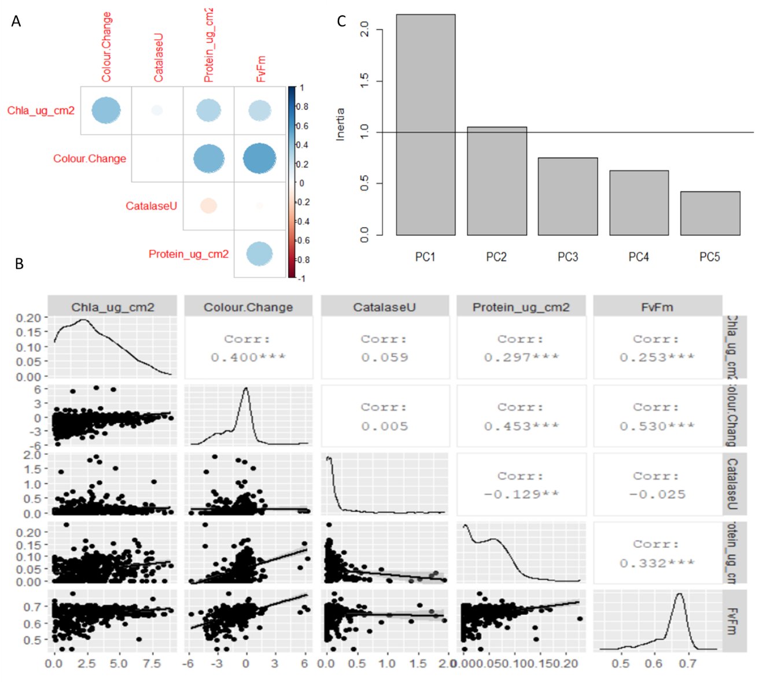
Fig S5. Support graphs for Principal Component Analysis of alternative physiological measurements. (A and B); some of the physiological measurements were correlated to each other. C; Screeplot showing the Eigen values of the five principle components generated. Principle components were plotted only for those where inertia > 1 (PC1 and PC2, specifically).

S6 – Cost benefit analysis details

The cost of equipment use per 100 samples was based on an approximation of how many samples were likely to be processed over a conservative lifespan of the respective item. For example, we assumed that a refrigerated centrifuge would have a lifespan of at least 10,000 samples whereas an icebox would only last for 1,000 samples (see supp mat). However, within this calculation we did not consider differences in centrifuge times across different physiological measurements, where the centrifuge is used once for chlorophyll extractions as opposed to three times successively for tissue blasting.

Table S6.1 Capital cost and lifespan of equipment required.
Equipment | Assays required for | Cost | Lifespan (# samples)
Diving-PAM | Photosynthesis efficiency | $49,074 | 100,000
Camera + memory card | Tissue colour change | $1,800 | 100,000
Memory card (SD) | Tissue colour change | $55 | 100,000
Coral Health Colour Chart | Tissue colour change | $5 | 1,000
Airgun | Tissue blasting | $63.72 | 10,000
Centrifuge, refrigerated | Tissue blasting, chlorophyll, protein | $11,720 | 10,000
Esky | Tissue blasting, chlorophyll, protein, catalase | $10 | 1,000
Homogeniser | Tissue blasting | $927 | 10,000
Pipette, single channel | Tissue blasting, chlorophyll, protein, catalase, symbiont density | $432 | 10,000
Vortex | Tissue blasting, chlorophyll, catalase, symbiont density | $369 | 10,000
Oven | Protein | $2,220 | 100,000
Pipette, multi-channel | Protein, catalase | $1,420 | 10,000
Sonicator | Chlorophyll, protein | $1,500 | 10,000
Spectrophotometer | Chlorophyll, protein, catalase | $25,000 | 100,000
Stopwatch | Chlorophyll, protein, catalase, surface area | $12 | 1,000
Scale | Surface area, chemical preparations | $995 | 10,000
Forceps | Tissue blasting, surface area | $1.58 | 1,000
Waterbath | Surface area | $1,115 | 10,000
Ultralow freezer | Sample storage | $50,000 | 100,000

Table S6.2 Overview of other costs, special consideration, and benefits for each assay examined here.
Assay | Other costs/special considerations | Benefit
Photosynthetic efficiency | Expensive initial outlay for instrument | In-field data gathering
Photosynthetic efficiency | Expensive initial outlay for instrument | Range of photo-physiological data available
Tissue colour change |  | In-field data gathering
Tissue colour change |  | Rapid processing - especially with more automation coming online
Tissue colour change |  | Accessible technology
Tissue blasting | Samples require special storage to be viable | Leg-work for a wide range of physiological measurements
Tissue blasting | Requires multiple pieces of laboratory equipment | Leg-work for a wide range of physiological measurements
Chlorophyll | Ethanol (hazardous chemical) or other solvent | Specific measurement of symbiont bleaching response
Chlorophyll | Specialist training - spectrophotometer | Specific measurement of symbiont bleaching response
Protein | Specialist training - spectrophotometer | Specific measurement of either symbiont and/or host physiological response to heat stress
Protein | Requires extraction kits
Catalase | Long downstream data processing | Specific measurement of either symbiont and/or host physiological response to heat stress
Catalase | Expensive microwell plates required
Catalase | Specialist training - spectrophotometer
Surface area | Required for most assays listed | Cheaper than 3D photogrammetry methods
Surface area | Prone to operator error | Cheaper than 3D photogrammetry methods
Surface area | Less accurate than 3D photogrammetry methods | Cheaper than 3D photogrammetry methods

