Supplementary material

Transparent liver tumor imaging for transarterial chemoembolization (TACE): cancer treatment mechanism in TACE

Sera Hong^{1†}, Won Seok Choi^{2†}, Baskaran Purushothaman¹, Jaemoon Koh³, Hyo-Cheol Kim⁴, Jin Wook Chung⁴, Joon Myong Song^{1∗}, Jin Woo Choi^{4∗}

¹ Department of Pharmacy, College of Pharmacy, Seoul National University, Seoul, Korea.
² Department of Radiology, Seoul National University Bundang Hospital, Seongnam, Korea.
³ Department of Pathology, Seoul National University Hospital, Seoul National University College of Medicine, Seoul, Korea.
⁴ Department of Radiology, Seoul National University Hospital, Seoul National University College of Medicine, Seoul, Korea.

Supplementary Figures
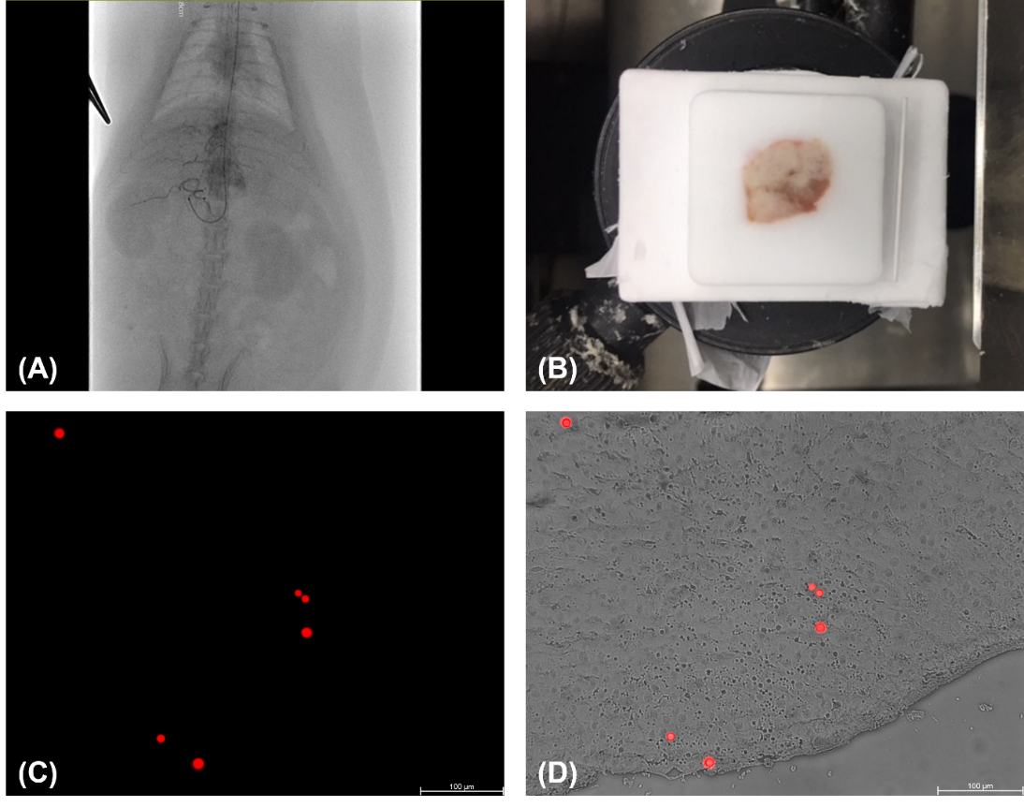
Figure S1. Transarterial embolization using fluorescent microspheres to determine the ideal particle size for rats. (A) Transarterial embolization was conducted in a rat model of hepatocellular carcinoma using fluorescent microspheres with a size range of 10-14 µm. (B) After the procedure, a tumor was harvested and frozen-sectioned. (C) Fluorescent microspheres were observed in the specimen. (D) The fluorescent image was merged with tumor tissue background, which showed intratumoral accumulation of 10-14 µm-sized fluorescent microspheres.
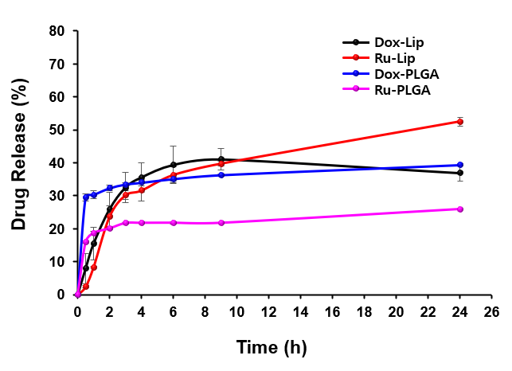
Figure S2. The in vitro drug release profiles of DOX-Lip, Ru-Lip, DOX-PLGA, and Ru-PLGA. Data are presented as the means ± standard deviation (SD; n = 3). Due to the loss of DOX stability in aqueous solution at 37℃ (2), the UV absorption of DOX decreased gradually after 6 h in Dox-Lip.

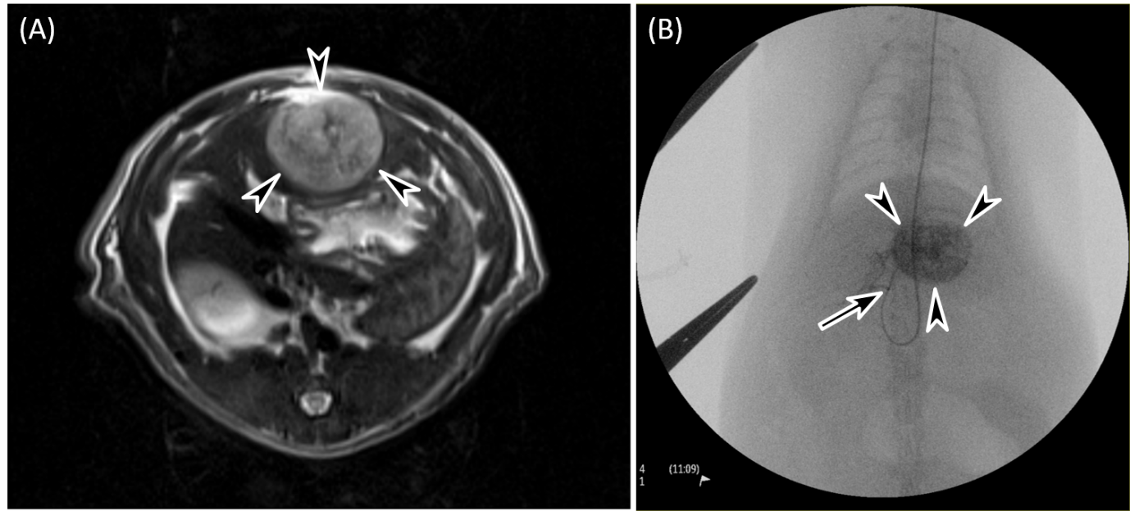
Figure S3. Representative images of rat TACE. (A) An axial T2-weighted MR image showing a 1.5 cm-sized tumor (arrowheads) in the rat liver. (B) A fluoroscopic image presenting a microcatheter (tip, arrow) introduced in the proper hepatic artery and contrast media stagnation in the tumor (arrowheads) during DEE-TACE using Ru-PLGA, suggesting occlusion of the intratumoral fine arteries by chemoembolic agents (size range, 3 to 50 μm).

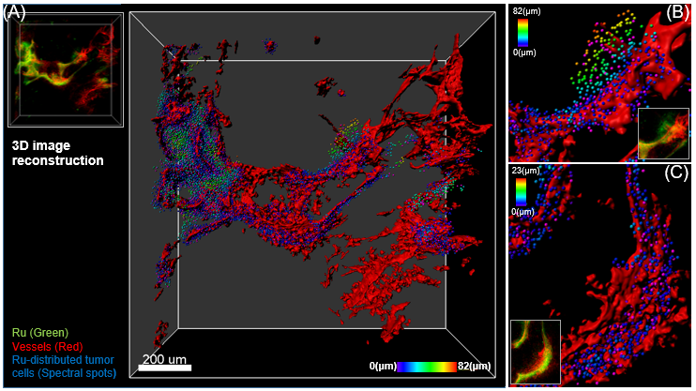
Figure S4. Representative images of 3D reconstruction of raw image. 3D images (cTACE-6hr) were reconstructed, and the spatial distribution of Ru in the tumor microenvironment was quantitatively analyzed using IMARIS software. (A) The reconstructed 3D-vessel structure is represented with spots (Ru-distributed tumor cells), while its corresponding raw image is shown. Spots were displayed in spectral color based on their distance to the nearest blood vessel. (B and C) Enlarged 3D-reconstructed images and their corresponding raw images.

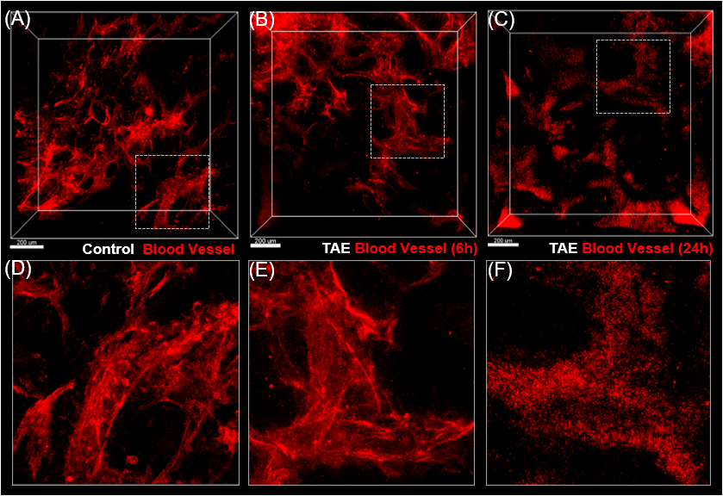
Figure S5. Rapid destruction of intratumoral vascular structures following transarterial embolization (TAE). (A) Vascular structures from a sham procedure control. (B and C) In tumors obtained after TAE, interval destruction of vascular structures was identified from (B) 6 to (C) 24 h after treatment: (D), (E), and (F) are magnified images of the dashed-box area in images (A), (B), and (C), respectively. Note, the blood vessel cells (red) are unaligned and conglomerated 24 after TAE.

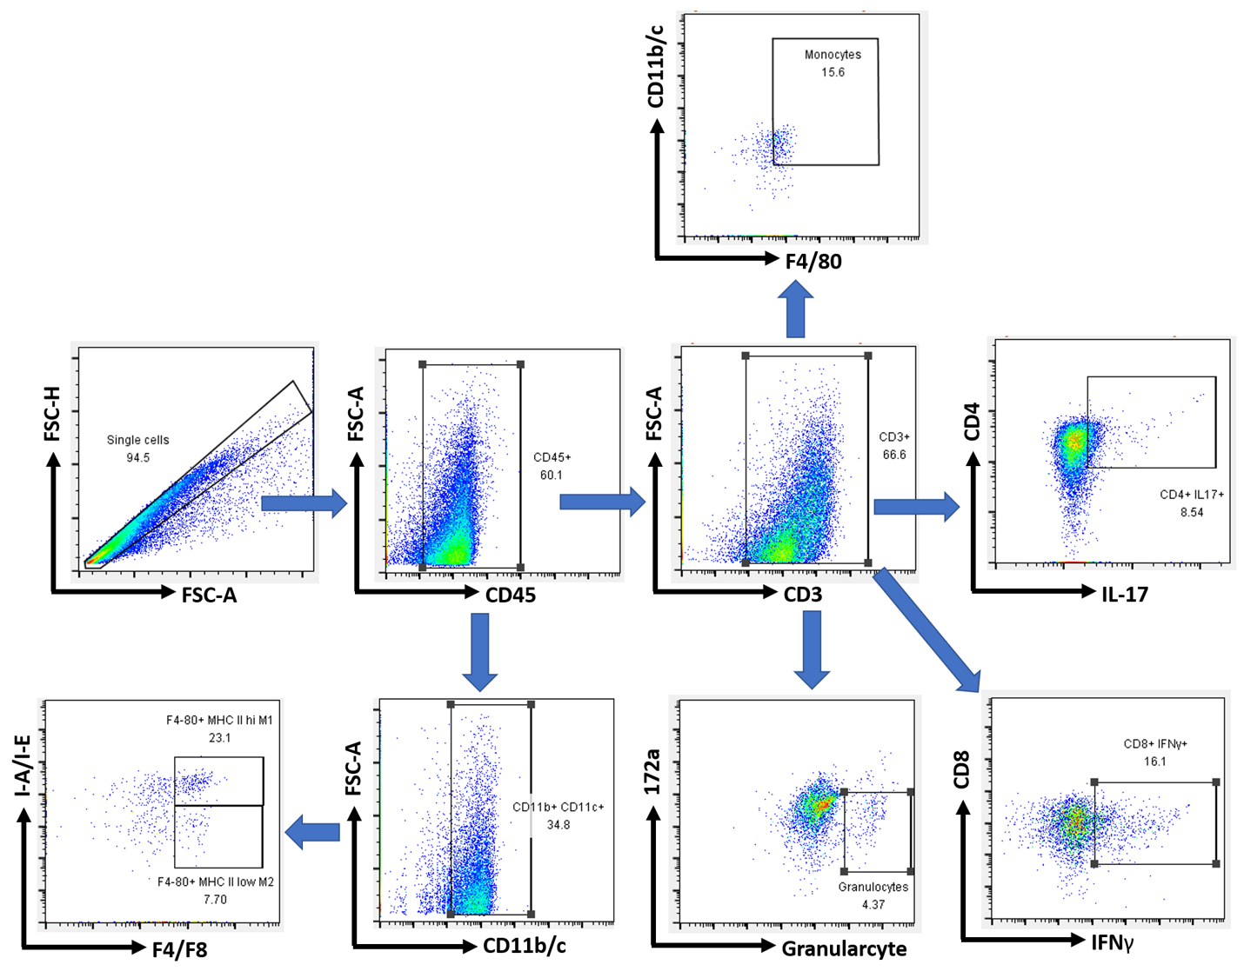
Figure S6. Flow cytometric analyses of the early immunogenic response following transarterial treatments.

Supplementary Tables
Table S1. List of antibodies for immunophenotyping.
Item | Marker | Antibody | Manufacturer | Catalog Number
CD32 | FC | Purified Mouse Anti-Rat CD32 Clone D34-485/0.5mg | BD Bioscience | 550271
CD3 | 1F4 | APC anti-rat CD3 Antibody | Biolegend | 155606
CD4 | OX-35 | FITC anti-rat CD4 (domain 2) Antibody | Biolegend | 203305
CD8 | OX-8 | PerCP anti-rat CD8a Antibody | Biolegend | 201712
CD45 | OX-1 | PE/Cyanine7 anti-rat CD45 Antibody | Biolegend | 202214
Granulocyte | HIS48 | FITC Mouse Anti-Rat Granulocytes | BD Bioscience | 554907
F4/80 | BM8.1 | F4/80 Rat mAb (redFluor(TM) 710 Conjugate) | cell signaling | 94009
CD172a | OX-41 | PE anti-rat CD172a (SIRPα) Antibody | Biolegend | 204706
MHC Class II | M5/114.15.2 | MHC Class II (I-A/I-E) Rat mAb (APC Conjugate) | cell signaling | 64776S
IL-17 | 17B7 | Anti-Mouse/Rat IL-17A PE | biogems | 73812-60
IFN-γ | DB-1 | PE anti-rat IFN-γ Antibody | Biolegend | 507806

Table S2. Drug loading efficiency and capacity of PLGA microspheres.
Formulation | DOX-PLGA MSs | Ru-PLGA MSs
Encapsulation efficiency (%) | 45.59$±$4.35 | 31.00$±$5.28
Loading capacity (%) | 3.72$±$0.35 | 3.89$±$0.66
Data represent as means ± SD (n = 3).

Table S3. Percentage of cells showing Ru uptake (6hr after cTACE) in relation to their distance from blood vessels.
Distance from vessels (µm) | Number of cells | % Number of Ru cells
0~10 | 6210 | 59.66
10~20 | 1952 | 18.75
20~30 | 1074 | 10.32
30~40 | 673 | 6.47
40~50 | 333 | 3.20
50~60 | 122 | 1.17
60~70 | 35 | 0.34
70~80 | 9 | 0.09
80~90 | 1 | 0.01

Table S4. Percentage of cells showing Ru uptake (24hr after cTACE) in relation to their distance from blood vessels.
Distance from vessels (µm) | Number of cells | % Number of Ru cells
0~10 | 4446 | 47.80
10~20 | 2029 | 21.81
20~30 | 1295 | 13.92
30~40 | 704 | 7.57
40~50 | 391 | 4.20
50~60 | 182 | 1.96
60~70 | 125 | 1.34
70~80 | 86 | 0.92
80~90 | 35 | 0.38
90~100 | 7 | 0.08
100~110 | 1 | 0.01
110~120 | 1 | 0.01

Table S5. Percentage of cells showing Ru uptake (6hr after DEE-TACE) in relation to their distance from blood vessels.
Distance from vessels (µm) | Number of cells | % Number of Ru cells
0~10 | 1370 | 57.66
10~20 | 635 | 26.73
20~30 | 185 | 7.79
30~40 | 76 | 3.20
40~50 | 45 | 1.89
50~60 | 24 | 1.01
60~70 | 14 | 0.59
70~80 | 11 | 0.46
80~90 | 9 | 0.38
90~100 | 6 | 0.25
100~110 | 1 | 0.04

Table S6. Percentage of cells showing Ru uptake (24hr after DEE-TACE) in relation to their distance from blood vessels.
Distance from vessels (µm) | Number of cells | % Number of Ru cells
0~10 | 3137 | 16.18
10~20 | 2723 | 14.04
20~30 | 2771 | 14.29
30~40 | 2591 | 13.36
40~50 | 2279 | 11.75
50~60 | 1789 | 9.22
60~70 | 1352 | 6.97
70~80 | 1009 | 5.20
80~90 | 637 | 3.28
90~100 | 337 | 1.74
100~110 | 194 | 1.00
110~120 | 134 | 0.69
120~130 | 103 | 0.53
130~140 | 94 | 0.48
140~150 | 67 | 0.35
150~160 | 56 | 0.29
160~170 | 50 | 0.26
170~180 | 29 | 0.15
180~190 | 22 | 0.11
190~200 | 13 | 0.07
200~210 | 7 | 0.04

† These authors contributed equally. ∗ Corresponding author: E-mail address: jmsong@snu.ac.kr (J. M. Song), jwchoi@snuh.org (J. W. Choi)

