Supplementary File

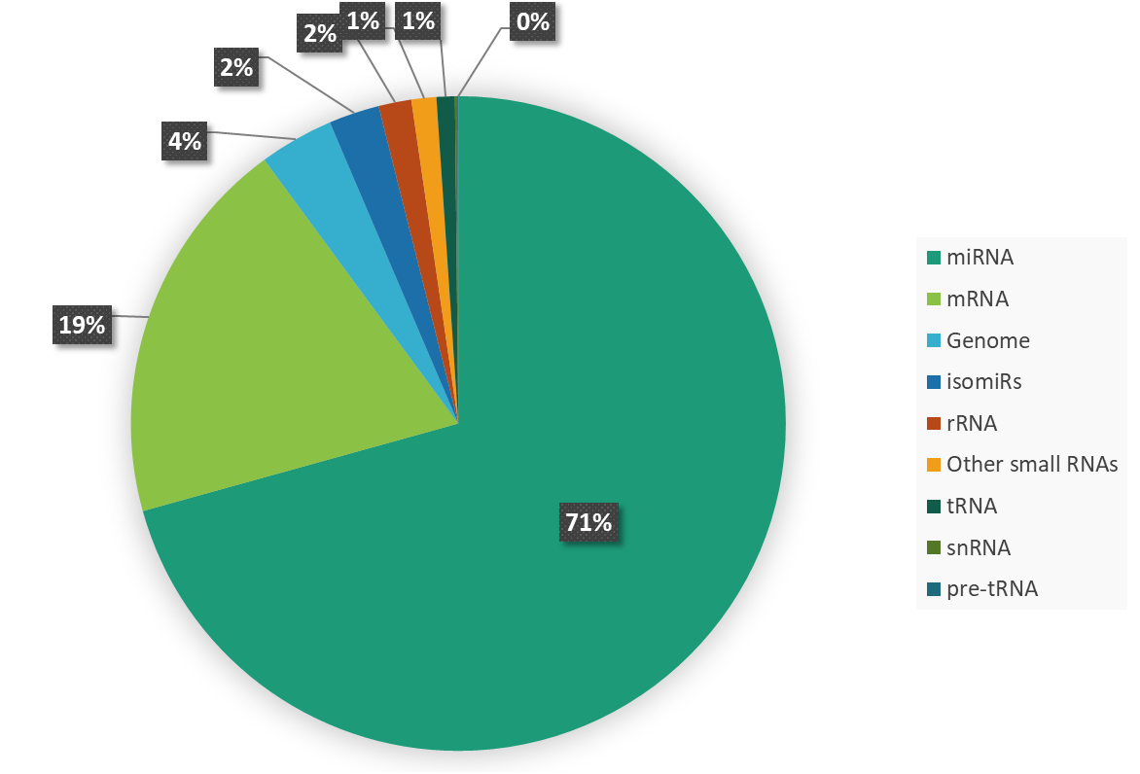
Supplementary Figure 1. RNA molecule distribution based on the small RNA sequencing data.

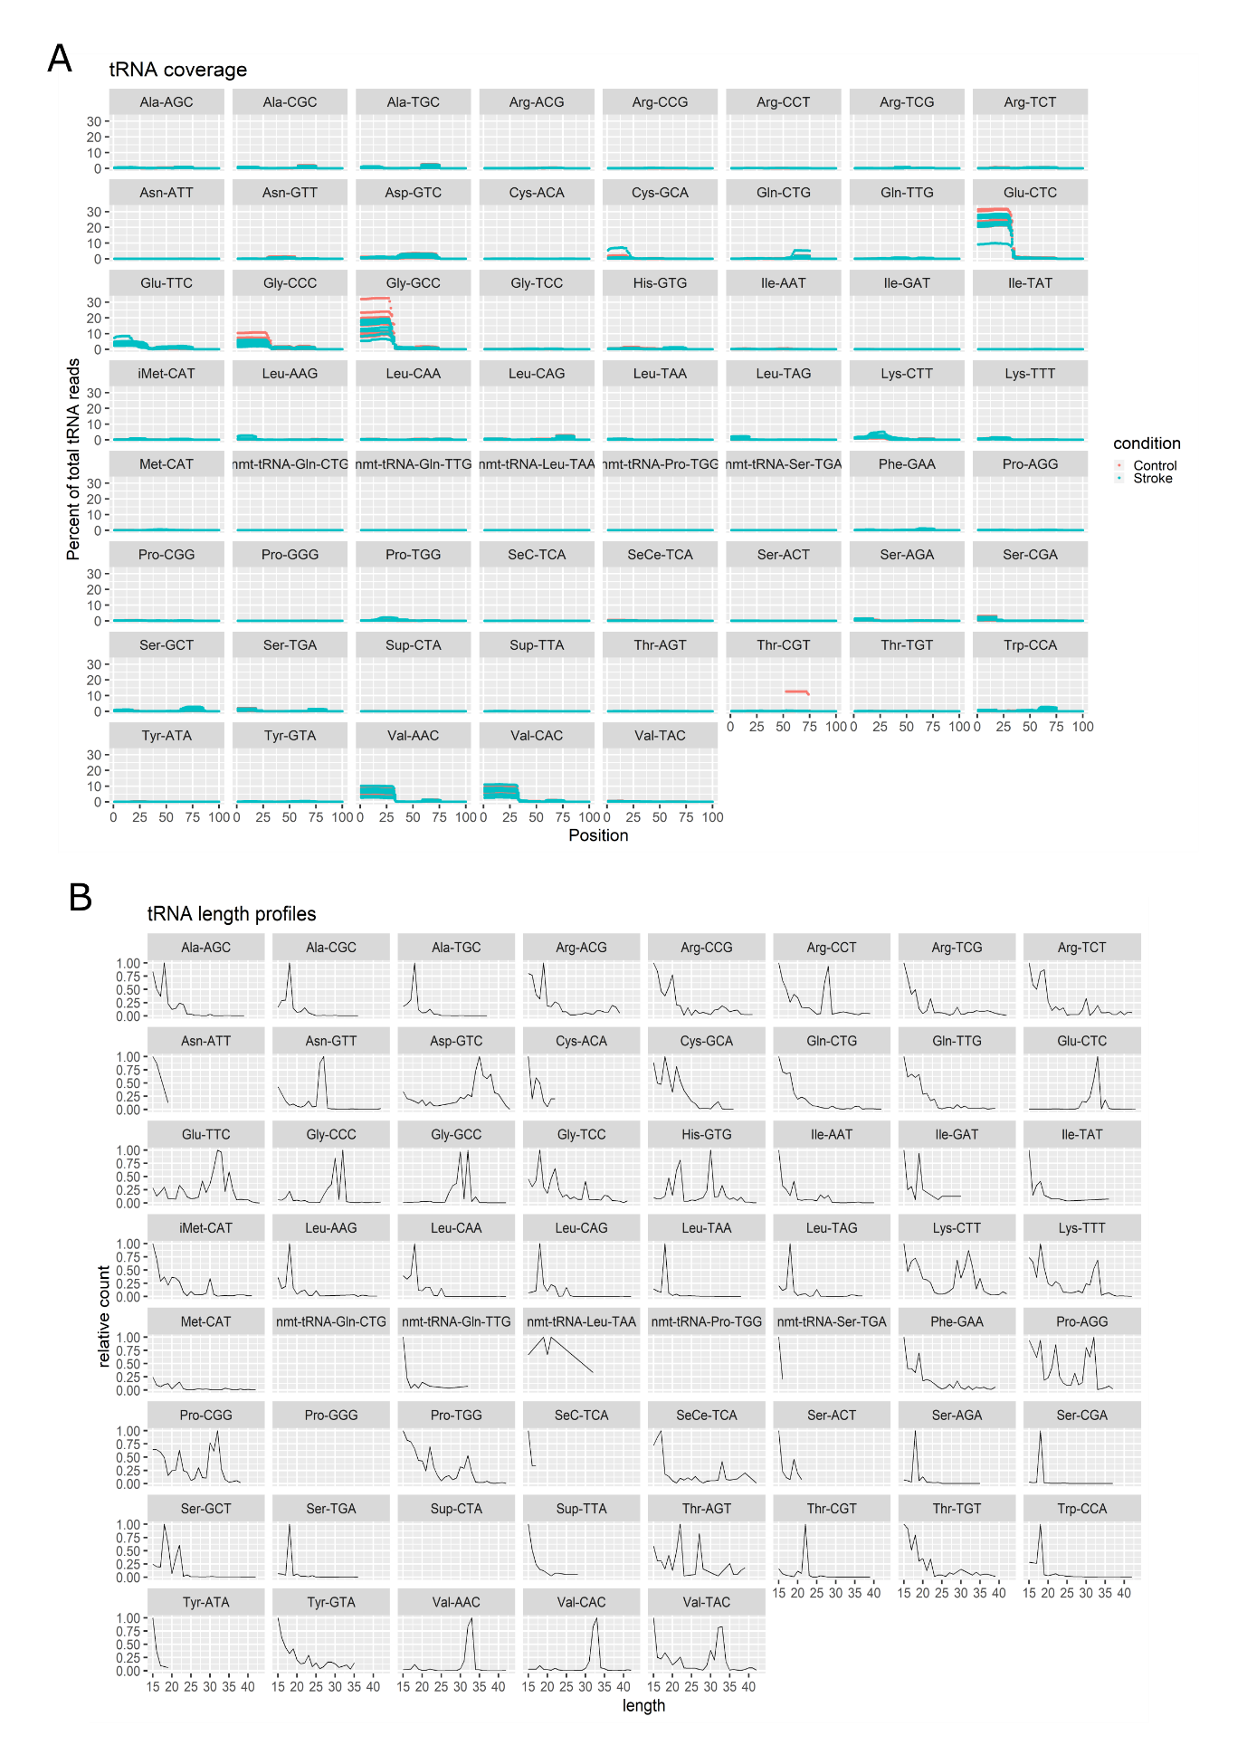
Supplementary Figure 2. tRNA fragment (tRF) read coverage by position and length profile. (A) Comparison between patients with ischemic stroke and controls regarding the distribution of tRFs over the tRNA molecules. (B) tRF sequencing qualities, according to the molecule lengths.

Supplementary Table 1. Molecular pathways affected by tRNA fragment (tRF) target gene expression.
Pathway name | Entities ratio | Entities p value | Target genes
Phe-GAA
RUNX1 regulates the transcription of genes involved in WNT signaling | 3/9 | 0.000192 | CBFB, RSPO3
Transcriptional Regulation by E2F6 | 4/46 | 0.00246 | BRCA1, RAD51
Erythropoietin activates STAT5 | 2/9 | 0.00543 | STAT5A
STAT5 activation | 2/9 | 0.00543 | STAT5A
Synthesis of DNA | 6/133 | 0.00578 | ANAPC15, POLE4, CDC16, PSME4, POLA1, SEM1
DNA replication | 6/142 | 0.00784 | ANAPC16, POLE5, CDC17, PSME5, POLA2, SEM2
Interleukin-9 signaling | 2/11 | 0.00799 | STAT5A
Interleukin-21 signaling | 2/12 | 0.00943 | STAT5A
APC/C:Cdc20 mediated degradation of Securin | 4/68 | 0.00959 | ANAPC15, PSME4, CDC16, SEM1
Signaling by Leptin | 2/13 | 0.011 | STAT5A
Regulation of RAS by GAPs | 4/71 | 0.011 | KEAP1, RASA3, PSME4, SEM1
EGR2 and SOX10-mediated initiation of Schwann cell myelination | 3/39 | 0.012 | PRX
Cdc20:Phospho-APC/C mediated degradation of Cyclin A | 4/73 | 0.0122 | ANAPC15, CDC16, PSME4, SEM1
LGI-ADAM interactions | 2/14 | 0.0126 | LGI1
Interleukin-2 signaling | 2/14 | 0.0126 | STAT5A
APC:Cdc20 mediated degradation of cell cycle proteins prior to the satisfaction of the cell cycle checkpoint | 4/74 | 0.0127 | ANAPC15, PSME4, CDC16, SEM1
APC/C:Cdh1 mediated degradation of Cdc20 and other APC/C:Cdh1 targeted proteins in late mitosis/early G1 | 4/74 | 0.0127 | ANAPC15, PSME4, CDC16, SEM1
CDK-mediated phosphorylation and removal of Cdc6 | 4/75 | 0.0133 | ANAPC15, PSME4, CDC16, SEM1
APC/C:Cdc20 mediated degradation of mitotic proteins | 4/76 | 0.014 | ANAPC15, PSME4, CDC16, SEM1
Activation of APC/C and APC/C:Cdc20 mediated degradation of mitotic proteins | 4/77 | 0.0145 | ANAPC15, PSME4, CDC16, SEM1
DNA replication initiation | 2/16 | 0.0162 | POLA1, POLE4
Interleukin-15 signaling | 2/16 | 0.0162 | STAT5A
Regulation of APC/C activators between G1/S and early anaphase | 4/83 | 0.0186 | ANAPC17, PSME6, CDC18, SEM1
Prolactin receptor signaling | 2/18 | 0.0202 | STAT5A
DNA replication pre-initiation | 4/88 | 0.022 | POLA1, PSME4, POLE4, SEM1
Leu-TAG
Orc1 removal from chromatin | 9/73 | 0.00368 | CCNA2, PSMA4, RBX1, MCM2, PSMD12, RPN1, ORC6, PSMF1
Interleukin-6 signaling | 4/17 | 0.00566 | CBL, IL6ST
DNA replication pre-initiation | 9/88 | 0.01166 | MCM2, PSMD12, RPN1, ORC6, PSMF1, PSMA4, RPA2
Switching of origins to a post-replicative state | 9/93 | 0.0161 | CCNA2, PSMA4, RBX1, MCM2, PSMD12, RPN1, ORC6, PSMF1
Activation of the pre-replicative complex | 5/36 | 0.0174 | MCM2, ORC6, RPA2
FasL/CD95L signaling | 2/5 | 0.0184 | CASP8
G1/S transition | 12/150 | 0.0232 | CCNA2, ORC6, PSMF1, RPN1, MAX, PSMA4, PTK6, MCM2, PSMD12, RPA2
RORA activates gene expression | 4/26 | 0.0233 | EP300, PPARA, SREBF1, SREBF1
Assembly of the pre-replicative complex | 7/68 | 0.0238 | MCM2, PSMD12, ORC6, PSMF1, PSMA4, RPN1
Alternative complement activation | 2/6 | 0.0258 | CFB, CFD
MTF1 activates gene expression | 2/6 | 0.0258 | CSRP1
Hyaluronan biosynthesis and export | 2/6 | 0.02578 | HAS1
FBXL7 down-regulates AURKA during mitotic entry and in early mitosis | 6/55 | 0.0275 | FBXL7, PSMF1, PSMA4, RBX1, PSMD12, RPN1
Mitotic G1 phase and G1/S transition | 13/173 | 0.0290 | CCNA2, ORC6, PSMF1, RPN1, MAX, PSMA4, PTK6, MCM2, PSMD12, RPA2
SUMOylation of DNA methylation proteins | 3/16 | 0.0290 | CBX8, DNMT3A, UBE2I
Degradation of DVL | 6/57 | 0.0319 | KLHL12, PSMF1, PSMA4, RBX1, PSMD12, RPN1
PI5P regulates TP53 acetylation | 3/17 | 0.0338 | EP300, PIN1, PIP4K2C,
NR1H2 & NR1H3 regulate gene expression linked to lipogenesis | 3/17 | 0.0338 | CCDC57, SREBF1
Maturation of nucleoprotein | 3/17 | 0.0338 | PARP16, UBE2I
IRS activation | 2/7 | 0.0341 | IRS1, IRS2
DNA replication | 11/142 | 0.0352 | CCNA2, PSMA4, RBX1, MCM2, PSMD12, RPA2, ORC6, PSMF1, RPN1,
Interleukin-6 family signaling | 4/30 | 0.0364 | CBL, IL6ST
Intra-Golgi and retrograde Golgi-to-ER traffic | 15/218 | 0.0387 | ACP2, CAP1, DYNC1LI2, KIFC1, SURF4, ARFGAP2, CYTH1, KIF13B, M6PR, TMED3, ARL3, DCTN3, KIF1C, PLA2G6
TRAIL signaling | 2/8 | 0.0434 | CASP8
SCF(Skp2)-mediated degradation of p27/p21 | 6/62 | 0.0447 | CCNA2, PSMF1, PSMA4, PTK6, PSMD12, RPN1
Glu-CTC
TP53 regulates transcription of death receptors and ligands | 4/18 | 0.00173 | PPP1R13B, TNFRSF10B
RUNX1 regulates the transcription of genes involved in WNT signaling | 3/9 | 0.00215 | CBFB, RSPO3
Interleukin-2 signaling | 3/14 | 0.00731 | IL2RA, STAT5A
TP53 regulates transcription of cell death genes | 7/83 | 0.00926 | APAF1, CASP2, TNFRSF10B, PPP1R13B
TNFs bind their physiological receptors | 4/30 | 0.0103 | TNFRSF1B, TNFSF15, TNFSF8
RUNX1 and FOXP3 control the development of regulatory T lymphocytes (Tregs) | 3/17 | 0.0123 | CBFB, IL2RA
Activation of AKT2 | 2/7 | 0.0166 | THEM4, TRIB1
TP53 regulates transcription of caspase activators and caspases | 3/20 | 0.0189 | APAF1, CASP2
TRAIL signaling | 2/8 | 0.0213 | TNFRSF10B
SMAD2/SMAD3:SMAD4 heterotrimer regulates transcription | 4/39 | 0.0243 | CDKN2B, SMAD4, SP8
EGR2 and SOX10-mediated initiation of Schwann cell myelination | 4/39 | 0.0243 | LAMC1, PRX
STAT5 Activation | 2/9 | 0.0265 | STAT5A
Erythropoietin activates STAT5 | 2/9 | 0.0265 | STAT5A
TNFR2 non-canonical NF-kB pathway | 7/104 | 0.0277 | PSME4, TNFRSF1B, REL, TNFSF15, SEM1, TNFSF8
Oncogene induced senescence | 4/42 | 0.0307 | CDKN2B, MDM4, SP8
Eicosanoids | 3/25 | 0.0333 | CYP4F2
Interleukin-9 signaling | 2/11 | 0.0381 | STAT5A
Transcriptional Regulation by E2F6 | 4/46 | 0.0407 | APAF1, RAD51
Interleukin-21 signaling | 2/12 | 0.0446 | STAT5A
Fatty acids | 3/29 | 0.0481 | CYP4F2
Glu-TTC
TRAIL signaling | 4/8 | 0.00235 | CASP10, FADD, TNFRSF10B, TNFRSF10D
TP53 regulates transcription of death receptors and ligands | 5/18 | 0.00831 | PPP1R13B, TNFRSF10B, TNFRSF10D
TP53 regulates transcription of caspase activators and caspases | 5/20 | 0.0126 | APAF1, CASP10, CASP2
NF-kB activation through FADD/RIP-1 pathway mediated by caspase-8 and -10 | 4/14 | 0.0161 | CASP10, FADD, MAVS, TRIM25
Interleukin-2 signaling | 4/14 | 0.0161 | IL2RA, STAT5A, SYK
RHOH GTPase cycle | 7/38 | 0.0165 | ARHGDIA, CAV1, NSFL1C, PAK1, PAK5, TFRC
Activation of RAC1 | 4/15 | 0.0201 | PAK1, PAK3, PAK5
RUNX1 regulates the transcription of genes involved in WNT signaling | 3/9 | 0.0242 | CBFB, RSPO3
RUNX3 regulates WNT signaling | 3/10 | 0.0316 | CCND1, TCF7L2
CDC42 GTPase cycle | 18/163 | 0.0332 | ARHGAP22, ARHGAP32, ARHGAP40, ARHGAP44, ARHGDIA, ARHGEF9, CAV1, DNMBP, FGD4, GNA13, PAK1, PAK3, PAK5, PIK3R2, TFRC, WIPF2
Pre-NOTCH transcription and translation | 11/89 | 0.0441 | CCND1, H2AFJ, H2AFX, HIST2H2BE, MAML3, NOTCH2, SIRT6, TFDP2
FasL/ CD95L signaling | 2/5 | 0.0461 | CASP10, FADD
Lipophagy | 3/12 | 0.0496 | PRKAB1, PRKAB2, PRKAG2
Gly-CCC
RHOJ GTPase cycle | 5/59 | 0.00581 | ARHGEF7, PAK3, CDC42BPA, VAMP3, JUP
TP53 regulates transcription of caspase activators and caspases | 3/20 | 0.00689 | APAF1, CASP2
Recognition and association of DNA glycosylase with a site containing an affected purine | 4/39 | 0.00696 | H2AFX, HIST2H2BE, MID1
Estrogen-dependent gene expression | 8/154 | 0.0101 | GREB1, HIST2H2BE, H2AFX, TGFA
Cleavage of the damaged purine | 4/45 | 0.0113 | H2AFX, HIST2H2BE, MID1
Depurination | 4/46 | 0.0121 | H2AFX, HIST2H2BE, MID1
ERCC6 (CSB) and EHMT2 (G9a) positively regulate rRNA expression | 4/48 | 0.0140 | H2AFX, HIST2H2BE, TTF1
TNFs bind their physiological receptors | 3/30 | 0.0202 | EDAR, TNFRSF9, TNFSF15
Transcriptional regulation by small RNAs | 5/81 | 0.0203 | H2AFX, NUP50, HIST2H2BE, POM121
Lipophagy | 2/12 | 0.0224 | PLIN3, PRKAG2
ALK mutants bind TKIs | 2/12 | 0.0224 | HIP1, PPM1B
Butyrophilin (BTN) family interactions | 2/12 | 0.0224 | BTN2A1, BTNL8
Packaging Of Telomere Ends | 3/34 | 0.0279 | H2AFX, HIST2H2BE
RNA Polymerase I Promoter Opening | 3/34 | 0.0279 | H2AFX, HIST2H2BE
CASP8 activity is inhibited | 2/14 | 0.0297 | CFLAR
Late endosomal microautophagy | 3/35 | 0.0300 | PLIN3, VPS37B
SUMOylation of chromatin organization proteins | 4/62 | 0.0318 | NUP50, POM121, PIAS2, ZBED1
Base-excision repair, AP site formation | 4/62 | 0.0318 | H2AFX, MID1, HIST2H2BE
DNA methylation | 3/36 | 0.0322 | H2AFX, HIST2H2BE
RHOQ GTPase cycle | 4/63 | 0.0334 | ARHGEF7, JUP, CDC42BPA, VAMP3
EGFR downregulation | 3/37 | 0.0345 | ARHGEF7, PTPN3, TGFA
Formation of editosomes by ADAR proteins | 1/2 | 0.0374 | ADARB1
RHOV GTPase cycle | 3/39 | 0.0393 | ARHGEF7, DST, TPM3
EGR2 and SOX10-mediated initiation of Schwann cell myelination | 3/39 | 0.0393 | PRX
Formation of the beta-catenin:TCF transactivating complex | 4/67 | 0.0404 | H2AFX, HIST2H2BE, KMT2D
Gly-GCC
SUMOylation of chromatin organization proteins | 7/62 | 0.00408 | CBX5, POM121, ZBED1, NUP50, POM121C, PIAS2, UBE2I
SUMOylation of ubiquitinylation proteins | 5/43 | 0.0128 | NUP50, POM121C, PIAS2, UBE2I, POM121
Homology directed repair | 9/130 | 0.0249 | H2AFX, RAD1, HIST2H2BE, RNF4, POLH, UBE2I
TP53 regulates transcription of caspase activators and caspases | 3/20 | 0.0267 | APAF1, CASP2
SUMOylation of SUMOylation proteins | 4/39 | 0.0370 | NUP50, POM121C, POM121, UBE2I
Recognition and association of DNA glycosylase with a site containing an affected purine | 4/39 | 0.0370 | H2AFX, HIST2H2BE, MID1
Gene silencing by RNA | 8/120 | 0.0401 | ASZ1, NUP50, POM121C, H2AFX, PLD6, HIST2H2BE, POM121
RHOJ GTPase cycle | 5/59 | 0.0417 | ARHGEF7, PAK3, CDC42BPA, VAMP3, JUP
DNA double-strand break repair | 10/168 | 0.0448 | H2AFX, POLH, UBE2I, HIST2H2BE, RAD1, KDM4A, RNF4
Transcriptional regulation by small RNAs | 6/81 | 0.0466 | H2AFX, POM121, HIST2H2BE, POM121C, NUP50
HDR through homologous recombination (HRR) or single strand annealing (SSA) | 8/124 | 0.0469 | H2AFX, RAD1, HIST2H2BE, RNF4, POLH, UBE2I
Val-AAC / Val-CAC
TP53 regulates transcription of death receptors and ligands | 5/18 | 4.76e-5 | FAS, TNFRSF10B
Interleukin-10 signaling | 7/86 | 0.00264 | CCL4, IL1R2, LIF
Transcriptional regulation by E2F6 | 5/46 | 0.00321 | CBX5, L3MBTL2, RNF2
CDC42 GTPase cycle | 9/163 | 0.00869 | ABR, ARHGEF5, PLEKHG1, ARHGAP45, FGD3, STOM, VAV3, ARHGEF4, OPHN1
G2/M DNA replication checkpoint | 2/7 | 0.00994 | WEE1
NRAGE signals death through JNK | 5/63 | 0.0116 | ABR, FGD3, VAV3, ARHGEF4, ARHGEF5
TRAIL signaling | 2/8 | 0.0128 | TNFRSF10B
VEGF ligand-receptor interactions | 2/8 | 0.0128 | VEGFA
VEGF binds to VEGFR, leading to receptor dimerization | 2/8 | 0.0128 | VEGFA
Downstream signaling events of B Cell Receptor (BCR) | 6/91 | 0.0138 | BTRC, CARD11, NFATC3, PSMB11, PSME3
CLEC7A (Dectin-1) signaling | 7/120 | 0.0150 | BTRC, PSMB11, CARD11, PSME3, NFATC3, UBE2V1
Interleukin-4 and Interleukin-13 signaling | 10/211 | 0.0156 | BCL2L1, LIF, VEGFA, CCL4, HGF
RHOA GTPase cycle | 8/154 | 0.0180 | ABR, ARHGEF5, STOM, VAV3, CCDC115, ARHGAP45, ARHGEF4, OPHN1
UCH proteinases | 6/98 | 0.0190 | FOXK1, PSME3, SMAD7, INO80, PSMB11
Activation of NF-kappaB in B cells | 5/72 | 0.0195 | BTRC, PSMB11, PSME3, CARD11
Death receptor signaling | 8/158 | 0.0206 | FAS, ABR, VAV3, ARHGEF4, FGD3, ARHGEF5, TNFRSF10B
Defective F8 accelerates dissociation of the A2 domain | 1/1 | 0.0210 | F8
Defective F8 binding to the cell membrane | 1/1 | 0.0210 | F8
Defective F8 secretion | 1/1 | 0.0210 | F8
Gamma carboxylation, hypusine formation, and arylsulfatase activation | 5/74 | 0.0216 | ARSB, FN3KRP, F8, SUMF2
Regulation by c-FLIP | 2/11 | 0.0232 | FAS, TNFRSF10B
Dimerization of procaspase-8 | 2/11 | 0.0232 | FAS, TNFRSF10B
BH3-only proteins associate with and inactivate anti-apoptotic BCL-2 members | 2/11 | 0.0232 | BCL2L1
Regulation of ornithine decarboxylase (ODC) | 4/51 | 0.0241 | OAZ3, PSMB11, PSME3
Response of EIF2AK1 (HRI) to heme deficiency | 3/29 | 0.0244 | ATF5

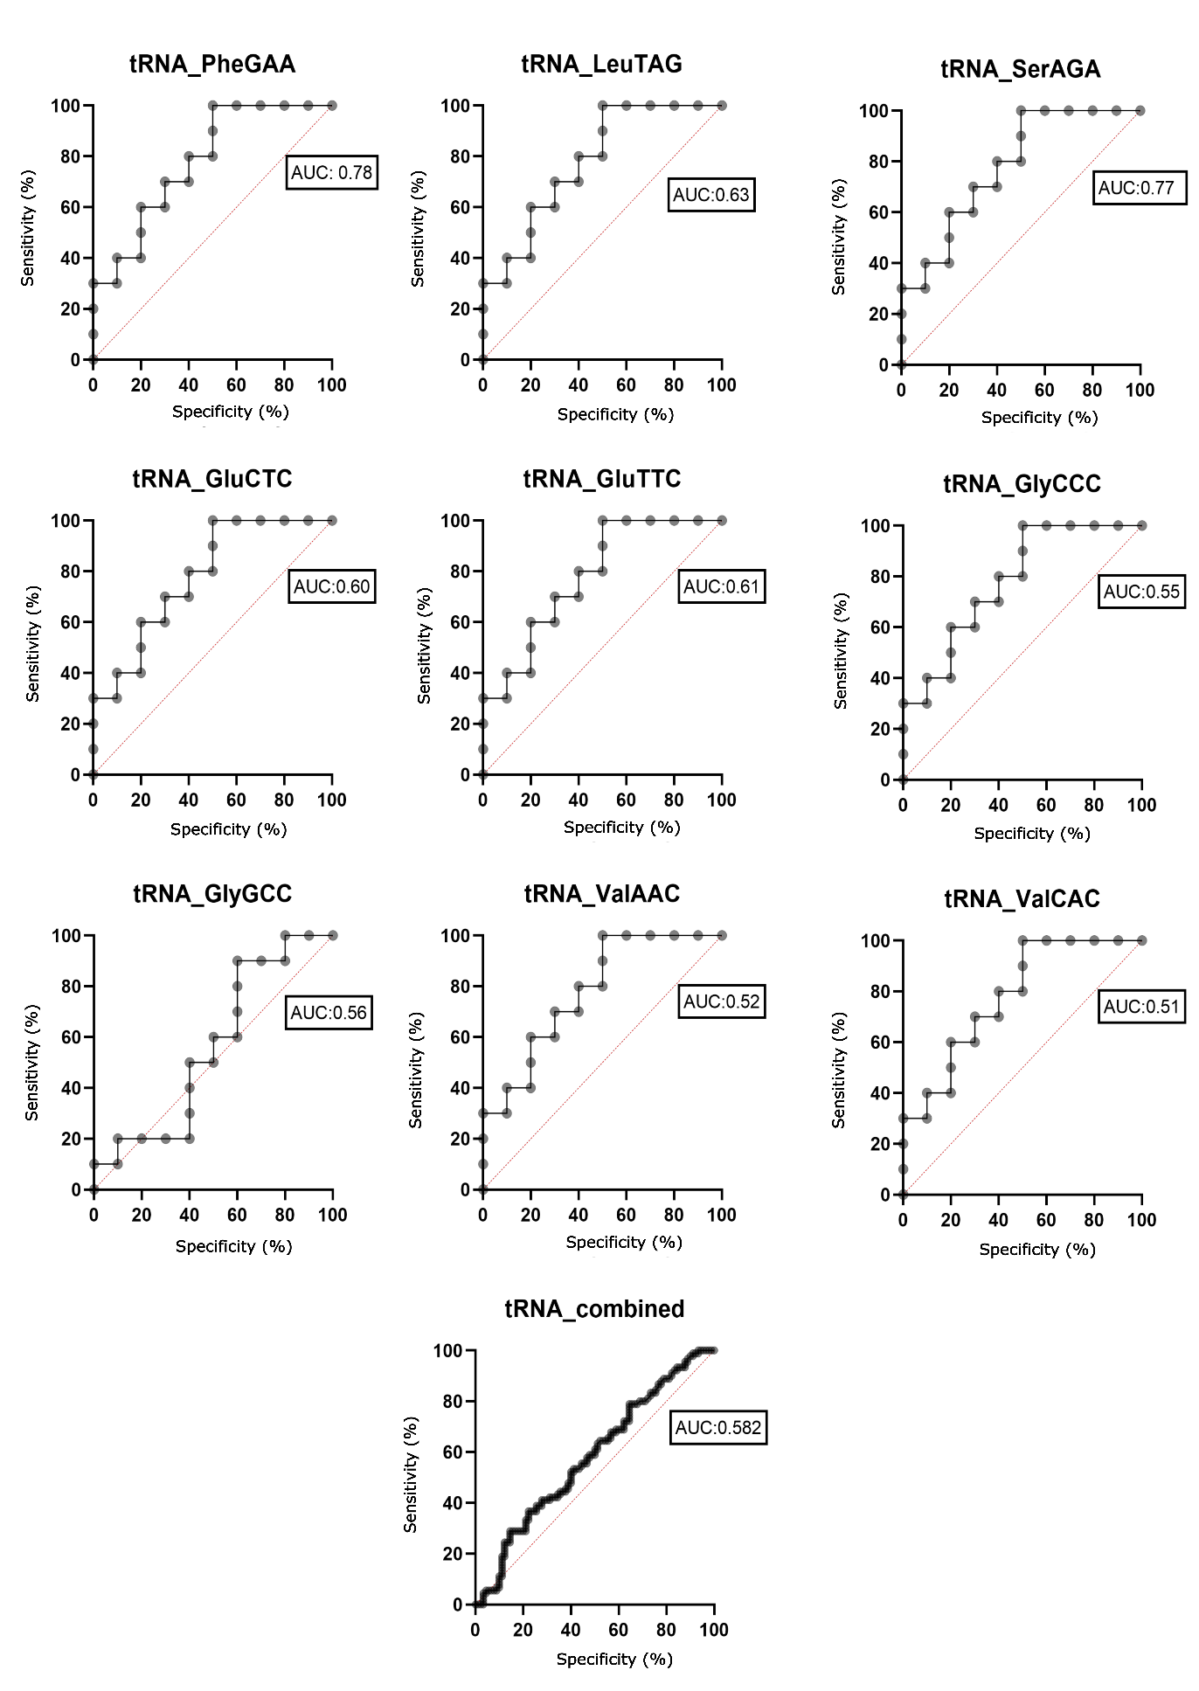 Supplementary figure 3. Received operating characteristic (ROC) curve analysis to differentiate patients with ischemic stroke from controls based on tRNA fragments (tRFs).

