Appendix A. Supplementary data
Contents

Table A.1 Sensitivity analyses by changing the df of the seasonal and long-term trends, relative humidity and mean temperature.
Table A.2 The results of sensitivity analyses after adding air pollutants (PM_{2.5}, NO₂) (df=3).
Table A.3 The results of anxiety outpatient visits associated with extreme meteorological factors used alternative cutoff points (95th or 5th percentile).

Fig. A.1. The time-series distribution of daily sunshine duration, wind speed, precipitation and anxiety outpatient visits in Suzhou, China, from 2017 to 2019.
Fig. A.2. The distributed lagged effects of extreme high sunshine duration and high precipitation on anxiety outpatient visits and subgroups.
Fig. A.3. The overall exposure-response relationship between extreme meteorological factors and anxiety outpatient visits over 14 lag days.

Table A.1 Sensitivity analyses by changing the df of the seasonal and long-term trends, relative humidity and mean temperature.
df | Low sunshine duration  (10th vs 50th) | High sunshine duration  (90th vs 50th) | Low wind speed  (10th vs 50th) | High wind speed  (90th vs 50th) | High precipitation  (90th vs 50th)
seasonal and long-term trends
6 | 1.375 (1.038-1.821)* | 0.893 (0.676-1.179) | 1.487 (1.005-2.199)* | 1.288 (0.932-1.780)* | 1.025 (0.973-1.079)
7# | 1.417 (1.056-1.901)* | 0.971 (0.719-1.310) | 1.529 (1.028-2.275)* | 1.396 (1.007-1.935)* | 1.027 (0.975-1.082)
8 | 1.434 (1.061-1.936)* | 0.964 (0.720-1.290) | 1.465 (0.984-2.182)* | 1.428 (1.007-2.025)* | 1.023 (0.968-1.081)
Mean temperature
3# | 1.417 (1.056-1.901)* | 0.893 (0.676-1.179) | 1.529 (1.028-2.275)* | 1.396 (1.007-1.935)* | 1.027 (0.975-1.082)
4 | 1.479 (1.101-1.986)* | 0.971 (0.719-1.310) | 1.567 (1.052-2.332)* | 1.407 (1.015-1.950)* | 1.021 (0.969-1.075)
5 | 1.488 (1.108-1.999)* | 0.964 (0.720-1.290) | 1.544 (1.035-2.302)* | 1.402 (1.010-1.944)* | 1.016 (0.964-1.071)
Relative humidity
3# | 1.417 (1.056-1.901)* | 0.971 (0.719-1.310) | 1.529 (1.028-2.275)* | 1.396 (1.007-1.935)* | 1.027 (0.975-1.082)
4 | 1.404 (1.046-1.885)* | 0.958 (0.709-1.295) | 1.514 (1.017-2.255)* | 1.381 (0.995-1.917)* | 1.029 (0.977-1.085)
5 | 1.402 (1.044-1.882)* | 0.957 (0.708-1.293) | 1.511 (1.014-2.251)* | 1.379 (0.993-1.914)* | 1.029 (0.977-1.085)
＃The model used in the article.
*P<0.05.

Table A.2 The results of sensitivity analyses after adding air pollutants (PM_{2.5}, NO₂) (df=3).
Factors | Model used in the article＃ | Add PM_{2.5} | Add NO₂
Low sunshine duration  (10th vs 50th) | 1.417 (1.056-1.901)* | 1.431 (1.064-1.924)* | 1.432 (1.064-1.928)*
High sunshine duration  (90th vs 50th) | 0.971 (0.719-1.310) | 0.975 (0.722-1.316) | 0.965 (0.714-1.304)
Low wind speed  (10th vs 50th) | 1.529 (1.028-2.275)* | 1.551 (1.036-2.322)* | 1.575 (1.051-2.361)*
High wind speed  (90th vs 50th) | 1.396 (1.007-1.935)* | 1.394 (1.003-1.939)* | 1.380 (0.993-1.916)*
High precipitation  (90th vs 50th) | 1.027 (0.975-1.082) | 1.031 (0.978-1.087) | 1.028 (0.975-1.083)
＃The model covariates include seasonal and long-term trends, temperature, humidity and day of week.
*P<0.05.

Table A.3 The results of anxiety outpatient visits associated with extreme meteorological factors used alternative cutoff points (95th or 5th percentile).
Lag days | Low sunshine duration  (5th vs 50th) | High sunshine duration  (95th vs 50th) | Low wind speed  (5th vs 50th) | High wind speed  (95th vs 50th) | High precipitation  (95th vs 50th)
Single-day lag
0 | 1.039 (0.988-1.093) | 0.992 (0.922-1.068) | 1.047 (0.985-1.113) | 0.991 (0.941-1.043) | 0.996 (0.970-1.023)
1 | 1.029 (0.989-1.071) | 0.991 (0.934-1.051) | 1.043 (0.993-1.096) | 0.997 (0.957-1.039) | 0.998 (0.977-1.019)
2 | 1.020 (0.988-1.052) | 0.989 (0.944-1.037) | 1.040 (0.999-1.082) | 1.003 (0.970-1.036) | 1.000 (0.984-1.016)
3 | 1.011 (0.986-1.038) | 0.988 (0.950-1.028) | 1.036 (1.001-1.073)* | 1.008 (0.980-1.037) | 1.001 (0.989-1.014)
4 | 1.005 (0.981-1.029) | 0.988 (0.951-1.026) | 1.033 (0.998-1.069) | 1.014 (0.986-1.042) | 1.003 (0.991-1.014)
5 | 1.000 (0.975-1.026) | 0.988 (0.949-1.028) | 1.030 (0.993-1.068) | 1.019 (0.989-1.048) | 1.004 (0.992-1.016)
6 | 0.998 (0.971-1.026) | 0.988 (0.947-1.031) | 1.027 (0.989-1.067) | 1.023 (0.992-1.055) | 1.005 (0.992-1.018)
7 | 0.999 (0.971-1.028) | 0.990 (0.948-1.034) | 1.025 (0.985-1.066) | 1.027 (0.995-1.060) | 1.006 (0.993-1.020)
8 | 1.003 (0.976-1.031) | 0.993 (0.951-1.035) | 1.023 (0.985-1.063) | 1.030 (0.999-1.063) | 1.007 (0.994-1.020)
9 | 1.011 (0.985-1.037) | 0.996 (0.957-1.036) | 1.022 (0.986-1.059) | 1.033 (1.004-1.063)* | 1.008 (0.996-1.020)
10 | 1.021 (0.997-1.045) | 1.000 (0.964-1.038) | 1.020 (0.987-1.055) | 1.035 (1.008-1.064)* | 1.008 (0.997-1.019)
11 | 1.033 (1.008-1.058)* | 1.005 (0.967-1.044) | 1.019 (0.986-1.055) | 1.037 (1.008-1.066)* | 1.009 (0.997-1.020)
12 | 1.047 (1.017-1.077)* | 1.010 (0.965-1.057) | 1.019 (0.980-1.059) | 1.038 (1.005-1.073)* | 1.009 (0.995-1.023)
13 | 1.062 (1.023-1.102)* | 1.016 (0.959-1.076) | 1.018 (0.971-1.067) | 1.040 (0.998-1.083) | 1.009 (0.991-1.028)
14 | 1.078 (1.028-1.130)* | 1.022 (0.951-1.098) | 1.018 (0.960-1.079) | 1.041 (0.989-1.096) | 1.009 (0.986-1.033)
Multi-day lag
0-7 | 1.107 (0.910-1.347) | 0.918 (0.680-1.240) | 1.323 (1.014-1.726)* | 1.086 (0.876-1.346) | 1.013 (0.920-1.115)
0-10 | 1.145 (0.904-1.450) | 0.907 (0.629-1.309) | 1.415 (1.019-1.966)* | 1.196 (0.918-1.558) | 1.036 (0.927-1.158)
0-14 | 1.417 (1.056-1.901)* | 0.956 (0.604-1.513) | 1.529 (1.028-2.275)* | 1.396 (1.007-1.935)* | 1.073 (0.937-1.229)
*P<0.05.

Fig. A.1. The time-series distribution of daily sunshine duration, wind speed, precipitation and anxiety outpatient visits in Suzhou, China, from 2017 to 2019.

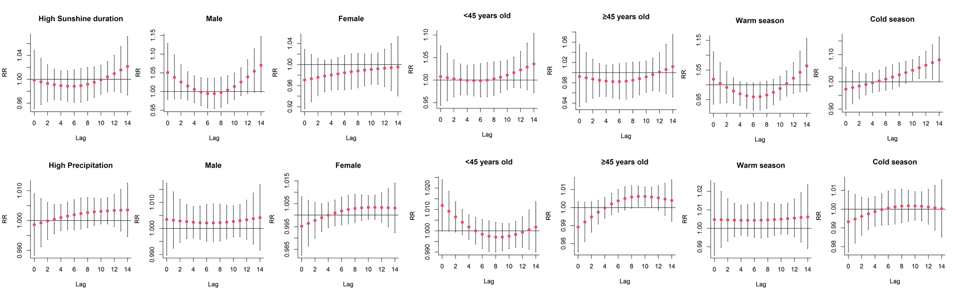
Fig. A.2. The distributed lagged effects of extreme high sunshine duration and high precipitation on anxiety outpatient visits and subgroups.

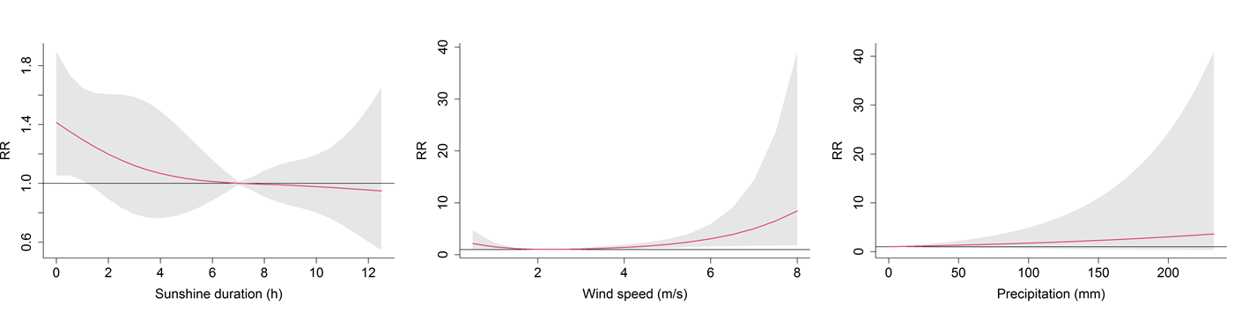
Fig. A.3. The overall exposure-response relationship between extreme meteorological factors and anxiety outpatient visits over 14 lag days.

