Appendix Table 1. Results of ANOVAs testing effects of parental herbivory (control vs. herbivory in the first generation) and parental root order (primary vs. secondary roots of the first generation) on growth, biomass allocation, physiological traits and methylated DNA levels of the offspring plants of Alternanthera philoxeroides. Total mass, leaf mass and stem mass were squared-root transformed. Values for which P < 0.05 are in bold.

Variables |  | Parental herbivory  (PH) |  |  | Parental root  order (PR) |  |  | PH × PR
 |  | F | P |  | F | P |  | F | P
Growth
Total mass |  | 1.13 | 0.303 |  | 0.35 | 0.565 |  | 5.53 | 0.032
Leaf mass |  | 1.74 | 0.206 |  | 0.37 | 0.553 |  | 5.65 | 0.030
Stem mass |  | 1.17 | 0.295 |  | 0.13 | 0.727 |  | 4.86 | 0.043
Root mass |  | 0.50 | 0.488 |  | 1.37 | 0.259 |  | 1.91 | 0.185
Number of nodes |  | <0.01 | 0.963 |  | <0.01 | 0.978 |  | 3.23 | 0.091
Number of leaves |  | 0.05 | 0.818 |  | 0.04 | 0.837 |  | 4.31 | 0.054
Solon length |  | 2.28 | 0.151 |  | 0.10 | 0.761 |  | 4.77 | 0.044
Biomass allocation
Root to shoot ratio |  | 5.99 | 0.026 |  | 0.01 | 0.905 |  | 1.25 | 0.280
Physiology
Total phenolic |  | 7.50 | 0.018 |  | 0.29 | 0.600 |  | 0.54 | 0.477
Water-soluble sugar |  | 2.75 | 0.123 |  | 0.01 | 0.939 |  | 0.01 | 0.936
Starch |  | 0.19 | 0.674 |  | 5.13 | 0.043 |  | 0.95 | 0.349
Total NSC |  | 0.95 | 0.348 |  | 2.68 | 0.127 |  | 0.52 | 0.486
Methylated DNA |  | 1.02 | 0.332 |  | 0.05 | 0.826 |  | 0.30 | 0.597

Appendix Table 2. Results of ANOVAs testing effects of grand-parental herbivory (control vs. herbivory in the first generation) and grand-parental root order (primary vs. secondary roots of the first generation) on methylated DNA level in leaves of the grand-offspring plants of Alternanthera philoxeroides without current herbivory.

variable |  | Grand-parental  herbivory (GH) |  |  | Grand-parental  root order (GR) |  |  | GH × GR
 |  | F_{1,12} | P |  | F_{1,12} | P |  | F_{1,12} | P
Methylated DNA |  | 1.54 | 0.233 |  | 0.05 | 0.831 |  | 0.06 | 0.813
Appendix Fig. 1. The simplified diagram depicting the branching order of the taproot system of Alternanthera philoxeroides. The primary root is the central, first-formed, main root, originating from the clonal fragments; the secondary roots branch off from the primary root.

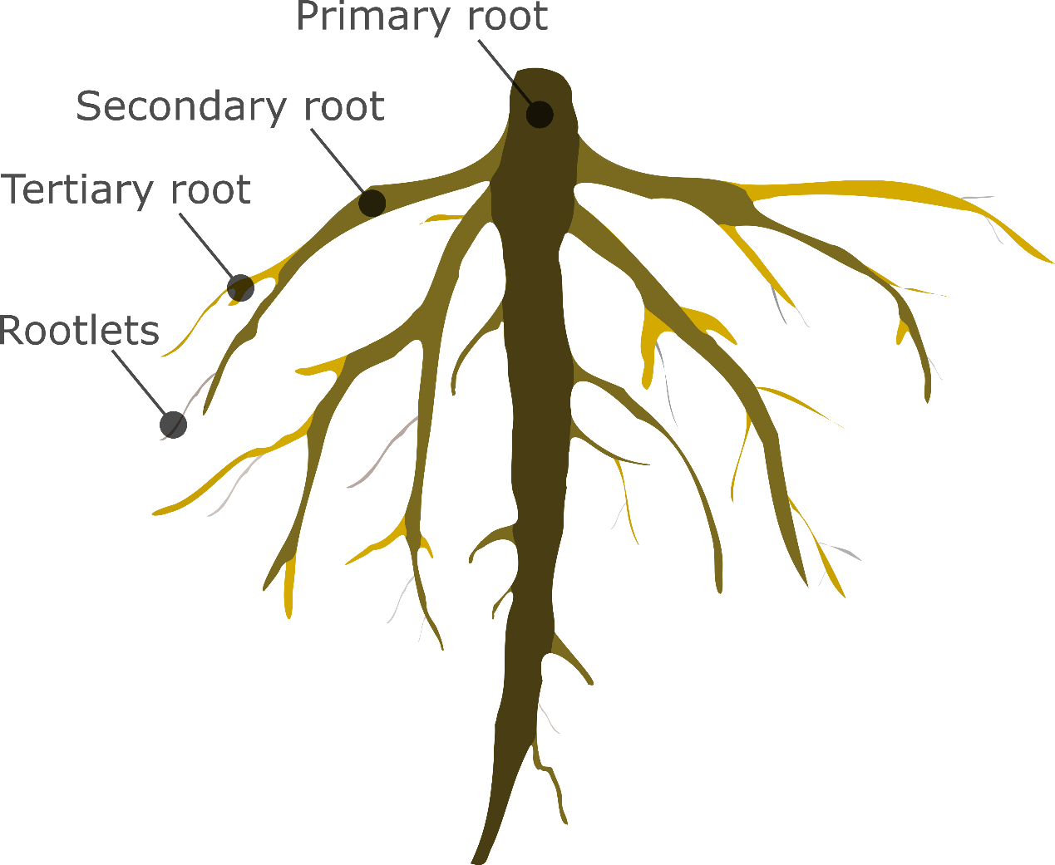
Appendix Fig. 2. Effects of herbivory in the first generation on (A) total mass, (B) leaf mass, (C) stem mass, (D) root mass, (E) number of nodes, (F) number of leaves, (G) stolon length, and (H) root to shoot ratio of the grand-parental plants (the first generation) of Alternanthera philoxeroides. The label "ns" means no significant difference between herbivory treatments; "*" means significant difference (P < 0.05).

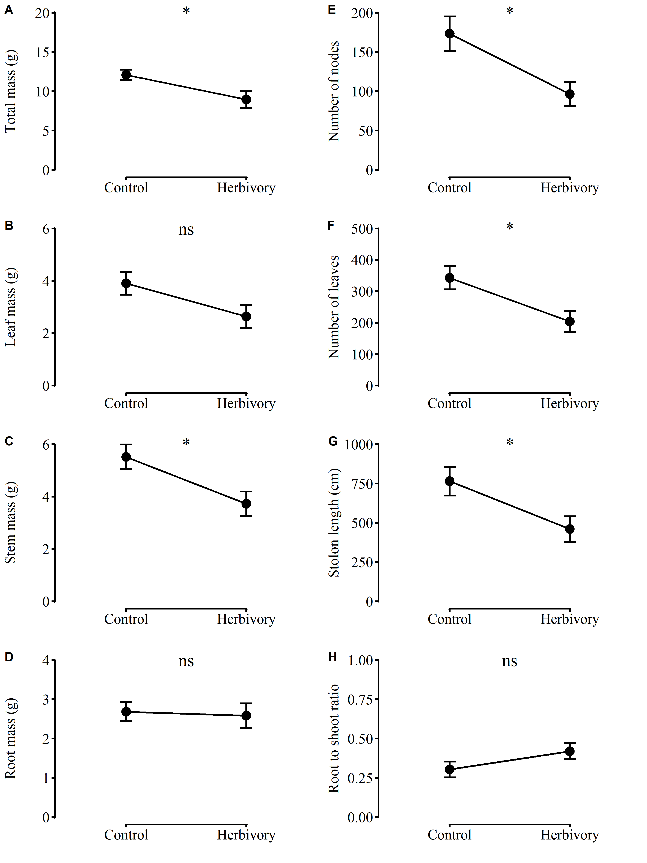
Appendix Fig. 3. Effects of herbivory in the first generation on the concentration of (A) total phenolic, (B) water-soluble sugar, (C) starch, and (D) total NSC of the grand-parental plants (the first generation) of Alternanthera philoxeroides. The label "ns" means no significant difference between herbivory treatments.

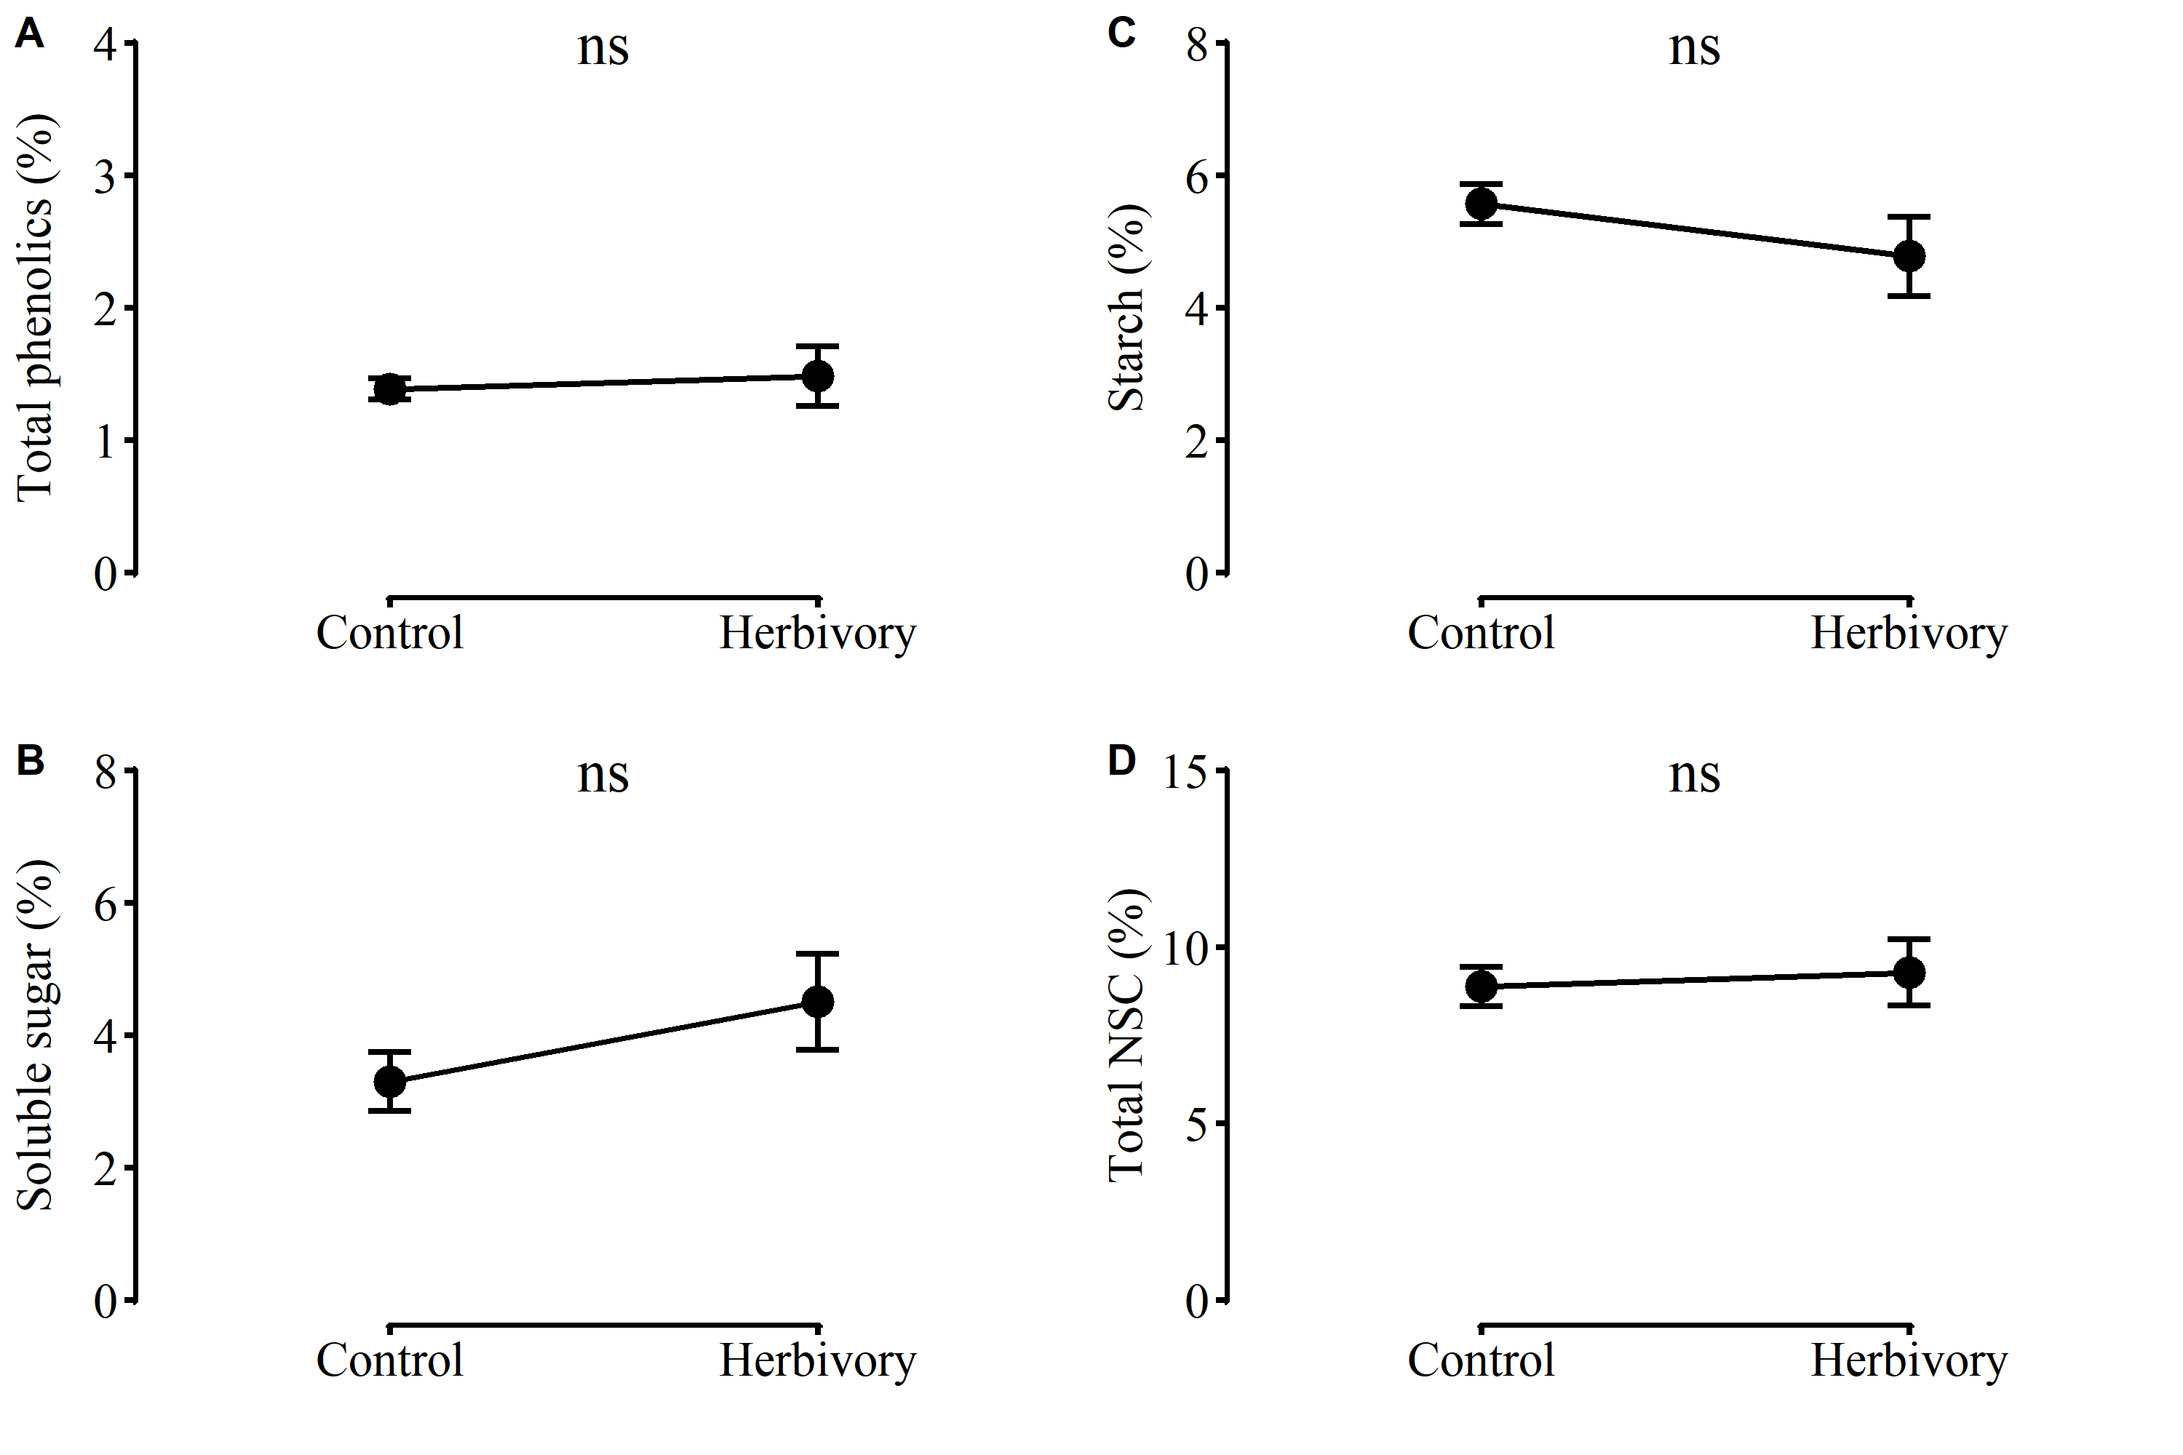
Appendix Fig. 4. Effects of parental herbivory (control vs. herbivory in the first generation) and parental root order (primary vs. secondary roots of the first generation) on (A) total mass, (B) leaf mass, (C) stem mass, (D) root mass, (E) number of nodes, (F) number of leaves, (G) stolon length, and (H) root to shoot ratio of the offspring plants (the second generation) of Alternanthera philoxeroides.

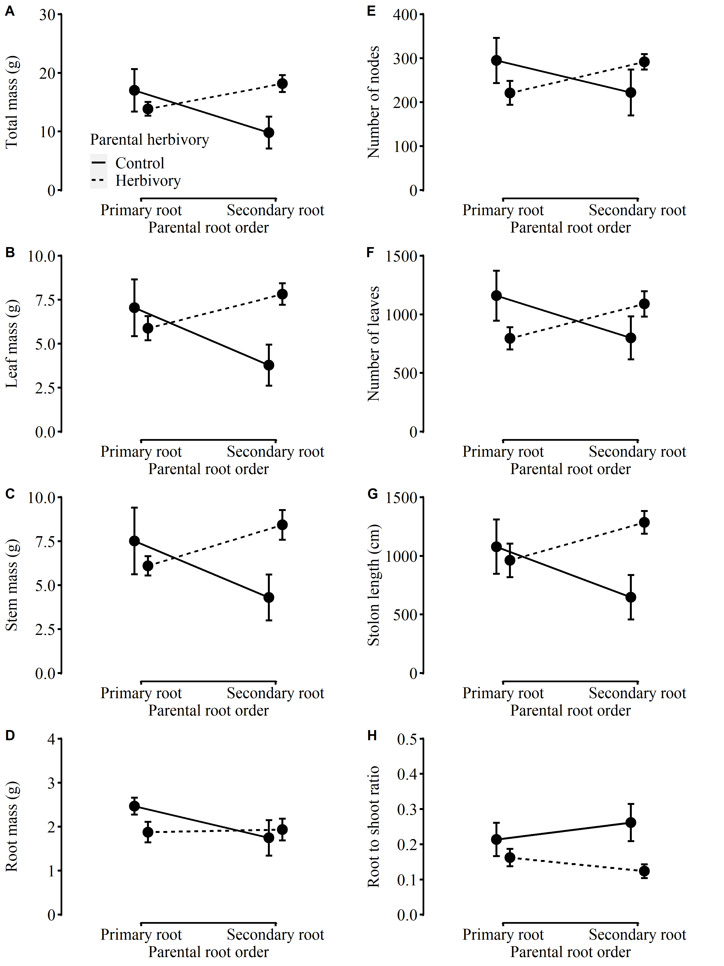

Appendix Fig. 5. Effects of parental herbivory (control vs. herbivory in the first generation) and parental root order (primary vs. secondary roots of the first generation) on the concentration of (A) total phenolic, (B) water-soluble sugar, (C) starch, and (D) total NSC of the offspring plants (the second generation) of Alternanthera philoxeroides.

