Supplementary Material
figures
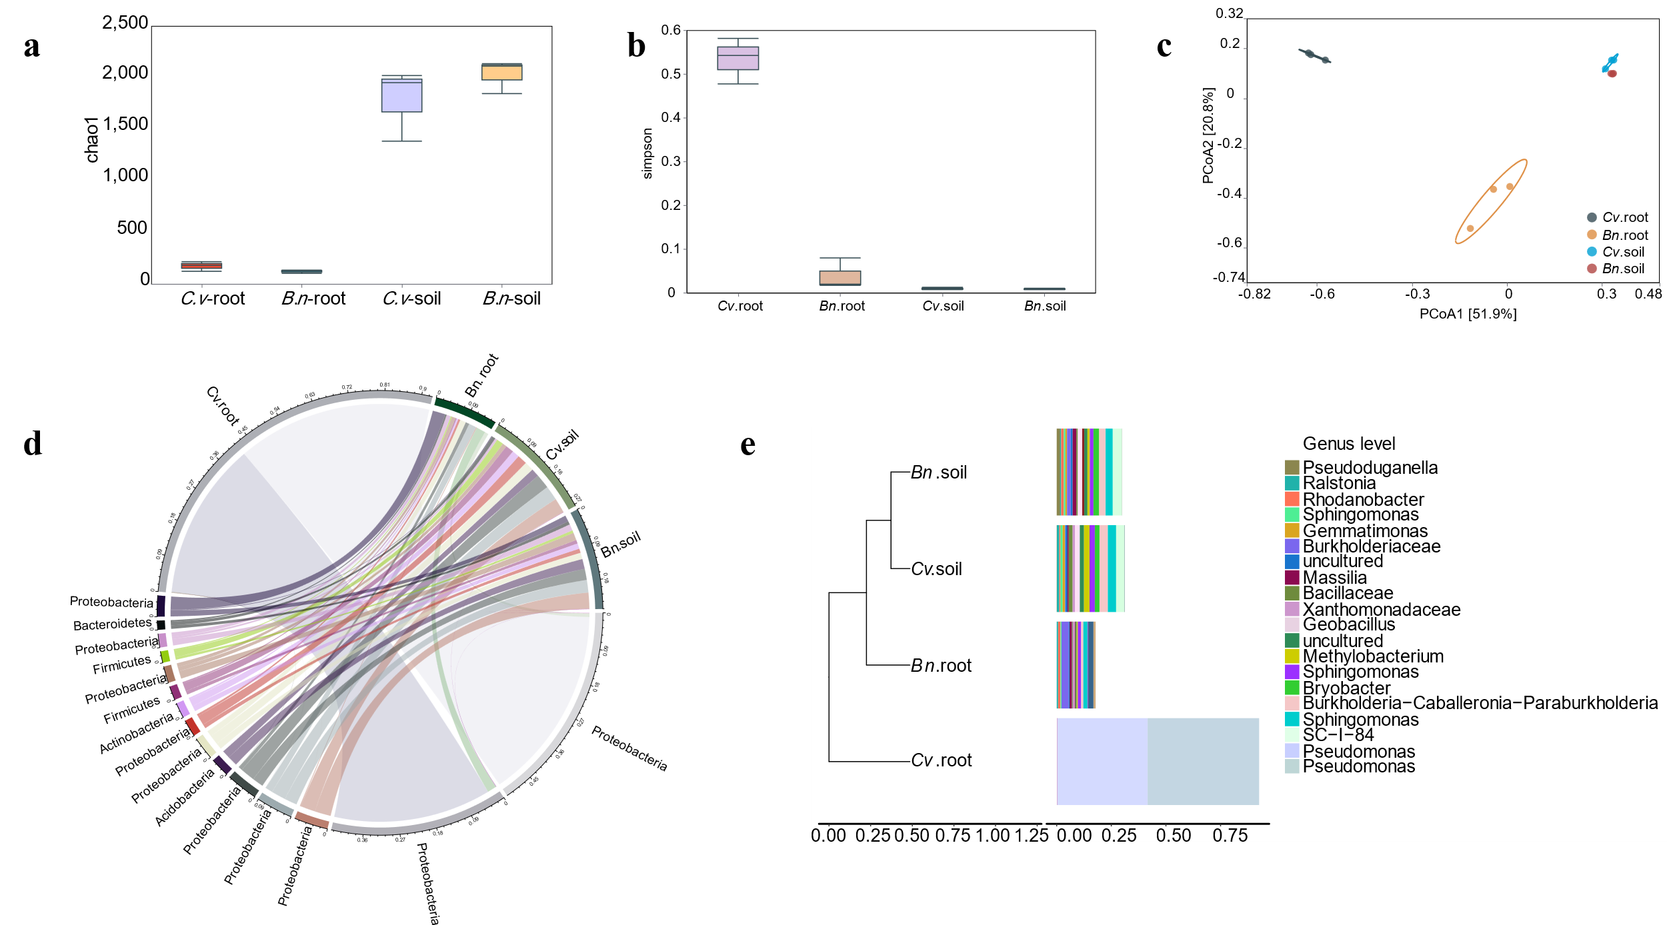
Fig. S1 Diversity analysis of rhizosphere soil microbiomes and root endophytic microbiomes. a, (Chao1) and b (Simpson), alpha diversity analysis of bacteria from rhizosphere soil and root in Brassica napus L.（Bn）and Cardamine violifolia (Cv). c, (PCoA), β-diversity analysis of bacteria from rhizosphere soil and root of Brassica napus L. and Cardamine violifolia based on Bray-Curtis distance. d, Phylogenetic analysis diagram of samples at phylum. e, Phylogenetic analysis diagram of samples at genus levels. The sequences with the top 20 overall relative abundance (the default value) were selected to construct the phylogenetic tree. The clustering tree structure (the default UPGMA(Average)) was shown on the left, and the relative abundance distribution map of each sample at the OUT level was shown on the right. The legend in the lower left corner of the figure is the distance scale. The shorter the branch distance is, the more similar the species composition of the two samples is.

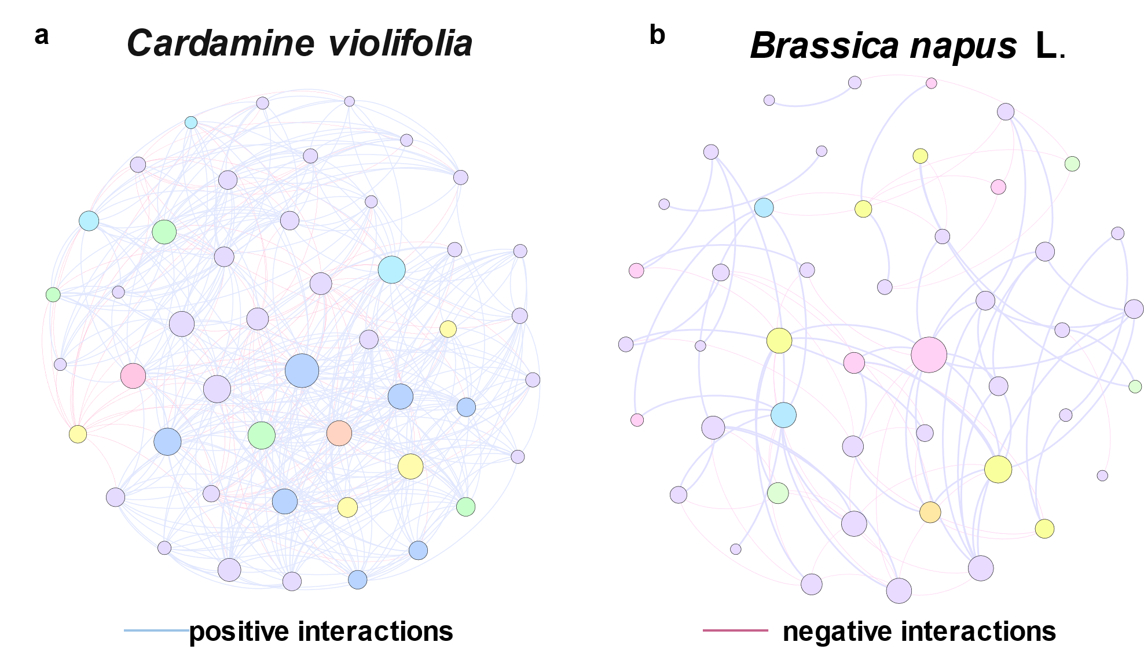
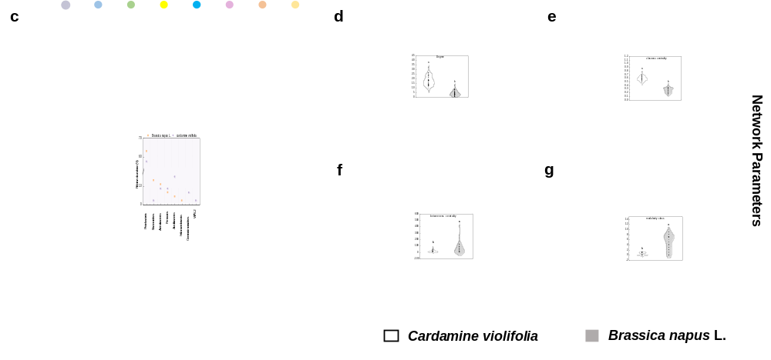
Fig. S2 Co-occurrence networks based on the rhizosphere microbiomes of Brassica napus L. and Cardamine violifolia. a, species correlation networks of rhizosphere in Cardamine violifolia. Green and blue numbers denote the number of positive and negative interactions between bacterial taxa, respectively. b, species correlation networks of rhizosphere in Brassica napus L. c, relative abundance of rhizosphere (soil and root) microbiome in Brassica napus L. and Cardamine violifolia. d-g, differences in network parameters (degree, closeness centrality, betweenness centrality, and modularity class) between networks based on the microbiomes of Brassica napus L. and Cardamine violifolia. Spearman clustering analysis was performed on the top 50 species in abundance. The relative abundance between species samples was calculated based on OTU table, and Spearman correlation coefficients were calculated using R software to obtain the relationships between species within samples or sample groups of soil and root. Then the species interaction network was constructed and displayed with the visualization software that showed the relationship between species. In the network diagram, the circle represents a species, the size represents its relative abundance, different colors represent different species classifications, the lines between the circles represent the correlation between the two species, and the thickness of the lines represents the size of the correlation coefficient.
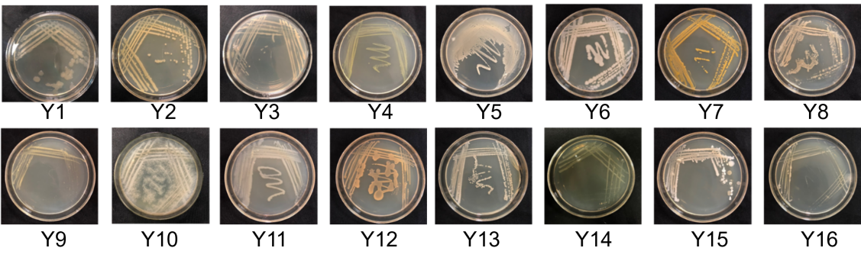
Fig.S3 Morphological characteristic of 16 bacterial strains of rhizosphere soil and root in Cardamine violifolia. The Y1-Y16 represent the number of different bacteria.

Fig. S4 Effect of key bacteria combinations on root development of Brassica napus L. in spilt-root experiment. a, the split root experimental device system. b, the picture of root of Brassica napus L. c, the average diameter d, surface area e, root volume of Brassica napus L. treated with key strains and compound bacteria. Asterisks denote significant differences (*P <0.05; **P <0.01; ***P<0.001) and ns denotes no statistical significance.

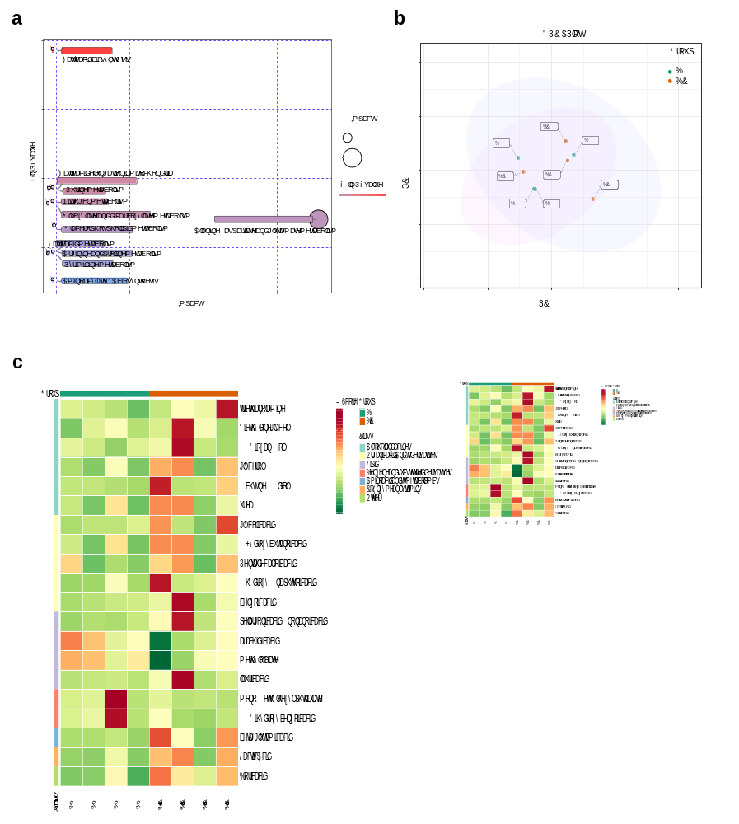
Fig. S5 Metabolism analysis of the split-root experiment treated with rhizophere microbiome and key microorganism of Cardamine violifolia. a, Pathway analysis for group CK vs T1, the results of metabolic pathway analysis were presented as bubble plots, each bubble in the bubble map represents a metabolic pathway, and the abscissa and bubble size represent the pathway. The size of the influence factor in topology analysis, the larger the size, the greater the influence factor; The vertical coordinate of bubble location and bubble color represent the p-value of enrichment analysis (take negative natural logarithm, -lp-value), the darker the color, the smaller the P value and the more significant the enrichment degree. Pathways highlighted by enrichment analysis and topological analysis are mapped. Note: Help customers understand the analysis results in depth. b, Score scatter plot of PCA model for group B6 vs BC, In the figure, abscissa PC[1] and ordinate PC[2] represent the scores of the first and second principal components, respectively. c, the heat map was drawn by R Complex Heatmap package, The abscissa is the name of the sample, and the ordinate is the differential metabolite. Different colors in the heat map represent the values obtained after normalization of the relative content of the differential metabolite, reflecting the level of the relative content (red represents high content, green represents low content). Hierarchical Clustering of differential metabolites is conducted, the tree graph on the left of the heat map represents the Clustering results of differential metabolites.
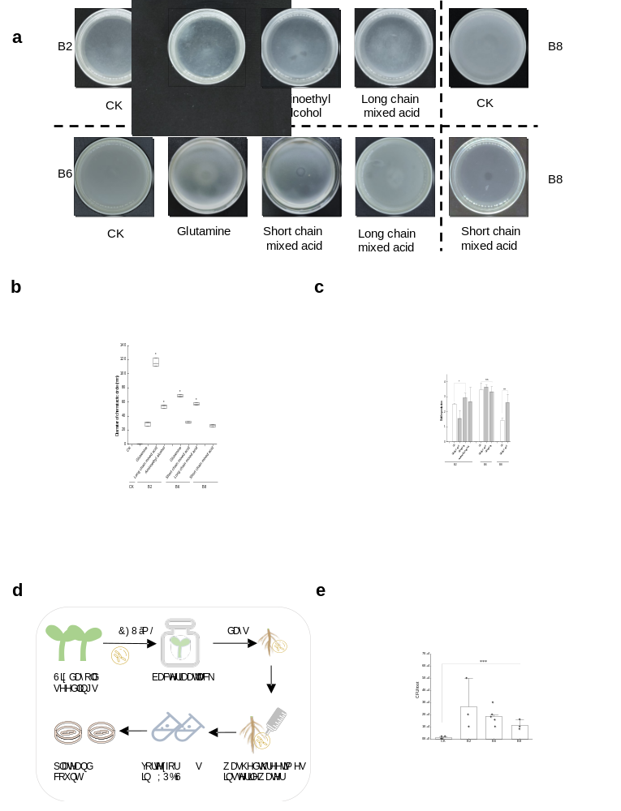
Fig.S6 The process of chemotaxis and colonization of key microorganisms in the root. a, Chemotactic effects of different bacteria and metabolites the number of bacteria colonized; b, Chemotactic diameters of different bacteria and metabolites; c, Measurement of biofilm production in key microorganism treated with 1 mM exudate. The bar graph shows representative data from independent experiments. Sets of data were compared by two-tailed Students t-test and 95% confidence intervals, where an asterisk represents a statistically significant difference at P < 0.05. d, A schematic diagram of colonization experiment that showing colonization of bacteria in the Brassica napus L. root system. e, Quantification of root-associated bacteria in the Brassica napus L. root system. Asterisks denote significant differences (***P<0.001).

