Table 1: Name of the restriction enzyme with its sites of digestion in case of CYP3A4*1B and CYP3A5*3 allele.
Allele | Restriction enzyme | Sites of digestion/Cutting site
CYP3A4*1B | MboII | 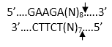
CYP3A5*3 | RsaI | 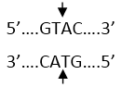
Cutting site

