Supplementary material for

Localized phosphorus promotes nutrient productivity of Brassica chinensis genotype with strong root morphological plasticity
Wei Gao¹, Deshan Zhang²*, Xiaoyan Tang³, Xiang Gao¹, Yunze Ruan¹, Yuqiang Zhang⁴, Jianbo Shen⁵

¹ School of Tropical Crops, Hainan University, Haikou 570228, China
² Institute of Ecological Environment Protection Research, Shanghai Academy of Agricultural Sciences, Shanghai 201403, China
³ College of Resources, Sichuan Agricultural University, Chengdu 611130, China
⁴ Nicholas School of the Environment, Duke University, Durham, NC, USA
⁵ Department of Plant Nutrition, China Agricultural University, Key Laboratory of Plant-Soil Interactions, Ministry of Education, Beijing 100193, China

*Corresponding author:
Deshan Zhang
Institute of Ecological Environment Protection Research
Shanghai Academy of Agricultural Sciences
No. 1000 Jin-Qi Road, Fengxian District, Shanghai 201403, China
E-mail: zds234@163.com
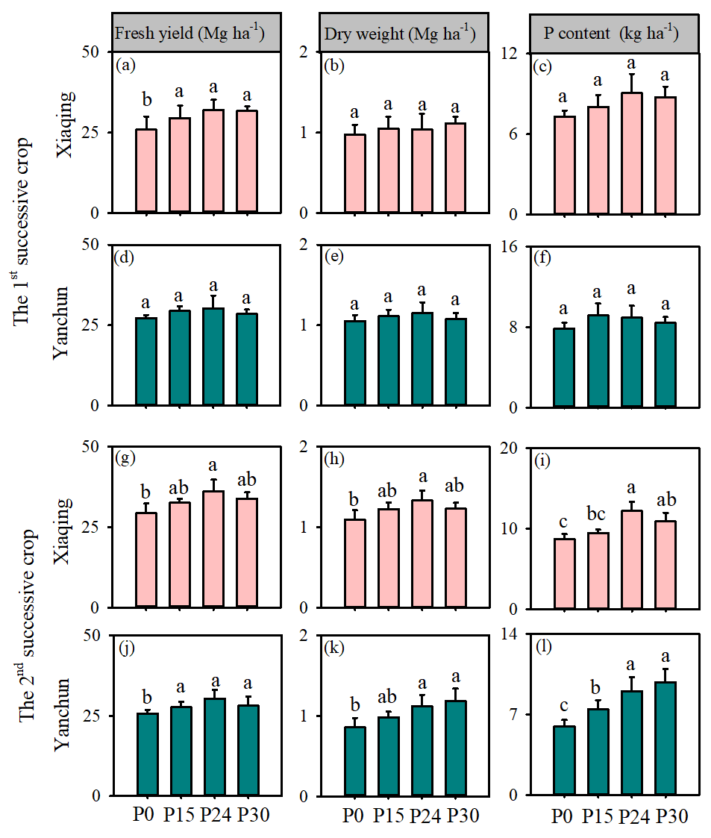
Fig. S1 Exp 1: fresh yield (a, d, g, j), dry weight (b, e, h, k), and shoot P content (c, f, i, l) in the 1st and 2nd successive crops of Xiaqing and Yanchan at four levels of mineral P supply. Error bars, + SE (n =4). P0: no mineral P application; P15: mineral P application with 15-kilogramm per hectare; P24: mineral P application with 24-kilogramm per hectare; P30: mineral P application with 30-kilogramm per hectare. Different lowercase letters denote significant differences among four levels of mineral P supply (p ≤0.05).
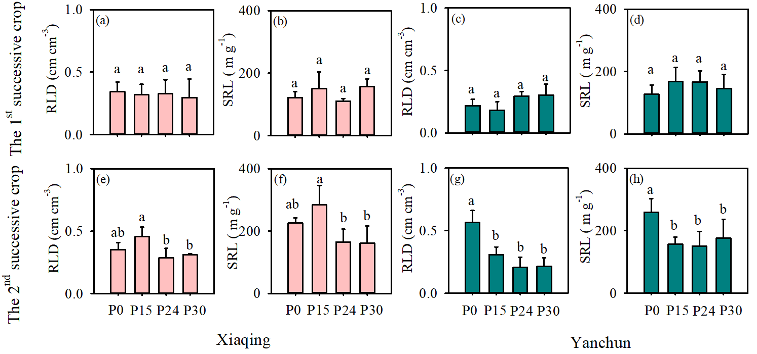
Fig. S2 Exp 1: root length density (RLD) and specific root length (SRL) in response to four levels of P supply in the 1st and 2nd successive crops of Xiaqing and Yanchan. Error bars, + SE (n =4). P0: no mineral P application; P15: mineral P application with 15-kilogramm per hectare; P24: mineral P application with 24-kilogramm per hectare; P30: mineral P application with 30-kilogramm per hectare. Different lowercase letters denote significant differences among four levels of mineral P supply (p ≤0.05).

Table S1 Exp 1: additional root morphological and physiological traits at four levels of P supply of B. chinensis L. Xiaqing and Yanchan.
Genotype | Treatment | RD (cm) | RTD (g cm⁻³) | C (mmol g⁻¹ soil) | M (mmol g⁻¹ soil) | RSR (g g⁻¹)
Xiaqing | P0 | 0.137±0.006ab | 0.153±0.046a | 2.846±1.505a | 46.926±1.636a | 3.701±0.843a
Xiaqing | P15 | 0.123±0.016b | 0.150±0.076a | 2.956±1.275a | 29.758±4.374b | 3.135±0.353a
Xiaqing | P24 | 0.161±0.027a | 0.183±0.043a | 2.181±1.906a | 42.286±7.549a | 2.648±0.860a
Xiaqing | P30 | 0.146±0.026ab | 0.210±0.061a | 2.380±0.608a | 21.720±1.94b | 4.071±0.941a
Yanchun | P0 | 0.161±0.045A | 0.189±0.091A | 0.213±0.143C | 8.824±1.251B | 4.655±1.355A
Yanchun | P15 | 0.149±0.014A | 0.258±0.016A | 0.135±0.058C | 19.531±7.425A | 3.916±0.501A
Yanchun | P24 | 0.192±0.031A | 0.249±0.084A | 0.547±0.101B | 16.544±1.689AB | 4.976±1.17A
Yanchun | P30 | 0.166±0.058A | 0.287±0.181A | 0.872±0.112A | 8.598±1.169B | 4.783±0.694A
Note: Different lowercase and uppercase letters denote significant differences at p ≤0.05 among P supply treatments in Xiaqing and Yanchun, respectively. RD, average root diameter; RTD, root tissue density; C, citrate; M, malate; RSR, root respiration rate. Values show the calculated mean ± SD, n =4.

Table S2 Exp2: spatial distribution of root length density in response to P supply rate and P supply pattern of Xiaqing and Yanchan.
Position (cm) | Depth (cm) | Root length density (cm cm⁻³)
Position (cm) | Depth (cm) | Xiaqing |  |  |  | Yanchun
Position (cm) | Depth (cm) | Hom-P15 | Het-P15 | Hom-P24 | Het-P24 | Hom-P15 | Het-P15 | Hom-P24 | Het-P24
-10 | 0-10 | 0.447±0.036c | 0.877±0.049a | 0.184±0.032d | 0.697±0.055b | 0.282±0.060C | 0.604±0.013A | 0.214±0.030C | 0.367±0.035B
-10 | 10-20 | 0.060±0.01b | 0.128±0.012a | 0.044±0.012b | 0.094±0.010a | 0.049±0.010A | 0.036±0.011A | 0.041±0.013A | 0.035±0.016A
-10 | 20-30 | 0.021±0.005a | 0.032±0.005a | 0.021±0.009a | 0.026±0.007a | 0.026±0.004A | 0.016±0.004B | 0.023±0.005A | 0.011±0.005B
0 | 0-10 | 1.198±0.067a | 1.088±0.088a | 1.095±0.098a | 0.995±0.081a | 1.196±0.060A | 1.096±0.046A | 1.139±0.062A | 0.953±0.053A
0 | 10-20 | 0.512±0.032a | 0.492±0.031a | 0.494±0.023a | 0.483±0.012a | 0.513±0.032A | 0.383±0.021B | 0.484±0.012A | 0.390±0.068B
0 | 20-30 | 0.114±0.010a | 0.093±0.014a | 0.134±0.016a | 0.107±0.015a | 0.114±0.011A | 0.091±0.005A | 0.134±0.008A | 0.120±0.006A
10 | 0-10 | 0.426±0.029a | 0.234±0.022b | 0.174±0.028c | 0.139±0.025c | 0.284±0.020A | 0.161±0.035B | 0.204±0.036AB | 0.114±0.010B
10 | 10-20 | 0.056±0.012a | 0.046±0.014a | 0.054±0.013a | 0.056±0.014a | 0.049±0.010A | 0.033±0.005A | 0.042±0.007A | 0.037±0.006A
10 | 20-30 | 0.019±0.005a | 0.018±0.005a | 0.023±0.005a | 0.025±0.003a | 0.021±0.003A | 0.016±0.005A | 0.021±0.002A | 0.014±0.006A
Note: Position indicates the sampling site in rows, and ‘-10’, ‘0’, and ‘10’ represent the positions of ‘1’, ‘2’, and ‘3’’ illustrated in Fig. 1 in the main body of paper. One-way ANOVA analysis was performed to study the effect of P supply rate and pattern on root growth. Different lowercase letters and uppercase letters denote significant differences of root length density at each individual soil depth at p ≤0.05 in B. chinensis L. Xiaqing and Yanchan, respectively. Values show the calculated mean ± SD, n =4.

