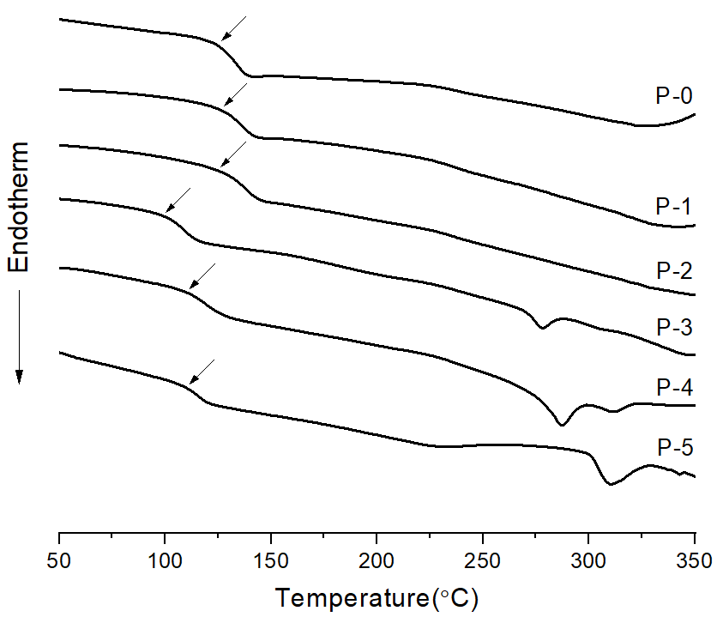

Supplement - Figure S1. DSC thermograms of Co-TLCPs according to various HQ contents.

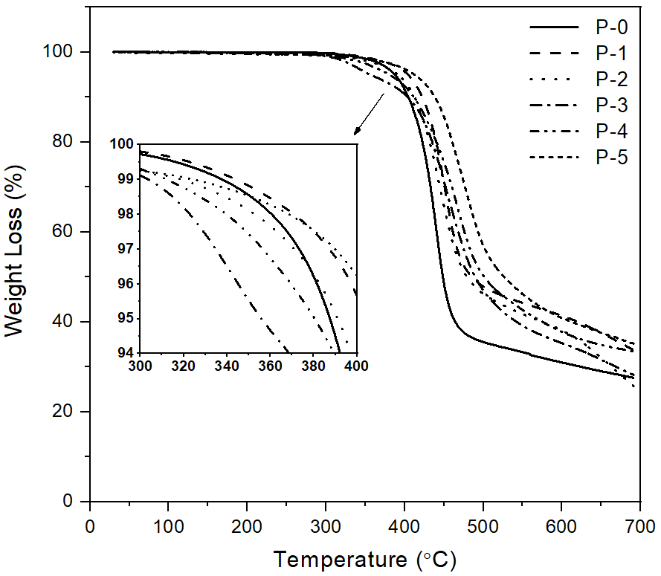

Supplement - Figure S2. TGA thermograms of Co-TLCPs according to various HQ contents.

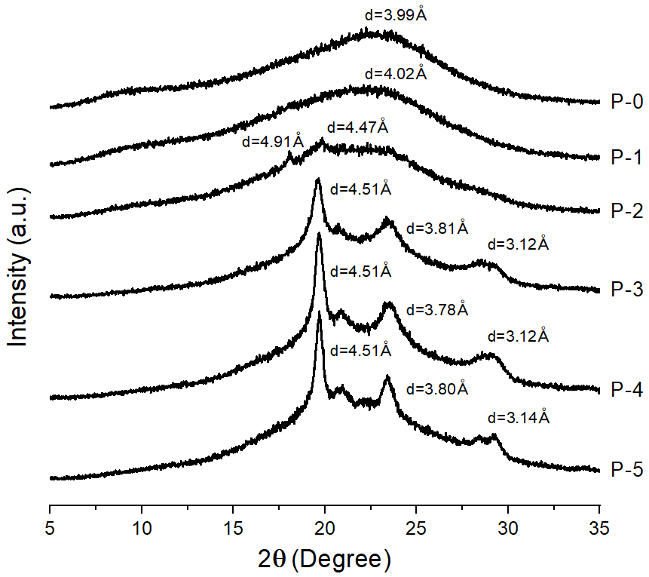

Supplement - Figure S3. XRD patterns of Co-TLCPs according to various HQ contents.

