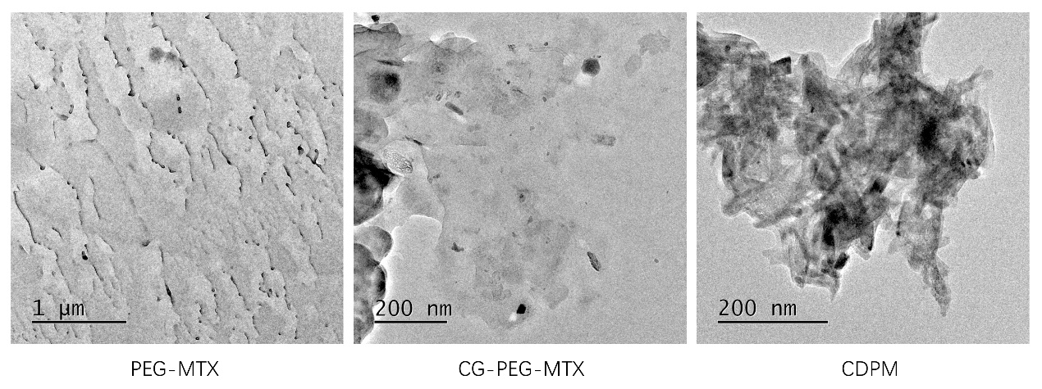
Figure S1. TEM images of the PEG-MTX, CG-PEG-MTX and CDPM.

Figure S2. BSA adsorption of PEG-MTX, CG-PEG-MTX, CDPM and the Micelles. *p < 0.05, **p < 0.01 and ***p < 0.001.

Figure S3. ROS levels were investigated by flow cytometry.

