Table S1 GC-MS compositions of the liquid hydrocarbon obtained by catalytic pyrolysis of waste polyethylene using mono- and bimetals/bentonite as catalysts.
Compounds name | Cu/bentonite |  | Co/bentonite |  | Ru/bentonite |  | Cu/Ni/bentonite
Compounds name | Ret. time (min) | Area (%) | Ret. time (min) | Area (%) | Ret. time (min) | Area (%) | Ret. time (min) | Area (%)
Cyclohexane, 1,2,3-trimethyl- | - | - | - | - | - | - | 5.0 | 3.87
3-Undecene, 8-methyl- | - | - | - | - | - | - | 5.79 | 3.11
Cyclopropane, 1,2-dimethyl-3-pentyl | - | - | - | - | - | - | 6.10 | 4.59
2-Octene, 3,7-dimethyl-, (Z)- | 6.23 | 2.42 | - | - | - | - | 6.24 | 6.18
Heptane, 3,3,5-trimethyl- | 7.63 | 2.14 | - | - | 7.64 | 1.53 | 7.64 | 1.48
2-Octene, 2,3,7-trimethyl- | 9.14 | 2.74 | 9.14 | 2.63 | 9.13 | 3.2 | 9.13 | 1.82
3-Decene, 2,2-dimethyl-,(E)- | 9.13 | 2.77 | - | - | 9.13 | 3.54 | - | -
Cyclopentane, 1,2-dibutyl- | - | - | - | - | - | - | 10.20 | 2.6
2-Decene, 2,4-dimethyl- | 15.30 | 5.05 | 15.31 | 7.42 | 15.30 | 7.63 | 15.30 | 2.26
Cyclopentane, 1,1,3,4-tetramethyl-, cis- | 15.49 | 1.89 | 15.51 | 1.48 | 15.50 | 2.03 | - | -
1-Tetradecene | 18.70 | 2.36 | - | - | - | - | 18.71 | 3.04
Cyclohexane, 1,5-diethyl-2,3-dimethyl- | 21.09 | 3.32 | 21.11 | 2.96 | 21.00 | 2.66 | - | -
2-Cyclohexylnonadecane | 24.53 | 1.86 | 24.53 | 3.22 | 24.53 | 2.63 | - | -
Cyclohexane, 1,2,3,4,5,6-hexaethyl- | 24.91 | 3.6 | 24.93 | 5.69 | 24.93 | 5.19 | - | -
2-Cyclohexylnonadecane | 26.59 | 1.72 | 26.59 | 1.83 | 26.59 | 1.44 | - | -

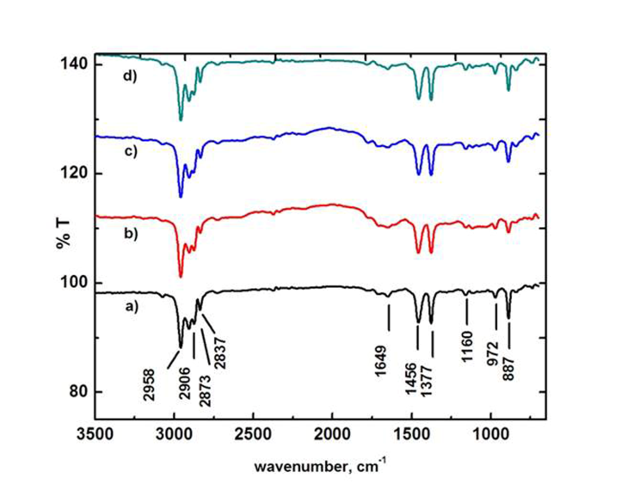
Fig. S1 FTIR spectra of the liquid product obtained by using raw bentonite (a), 3 M H₂SO₄ treated bentonite (b), 5 M H₂SO₄ treated bentonite (c), and 7 M H₂SO₄ treated bentonite (d).

