Supplemental Information
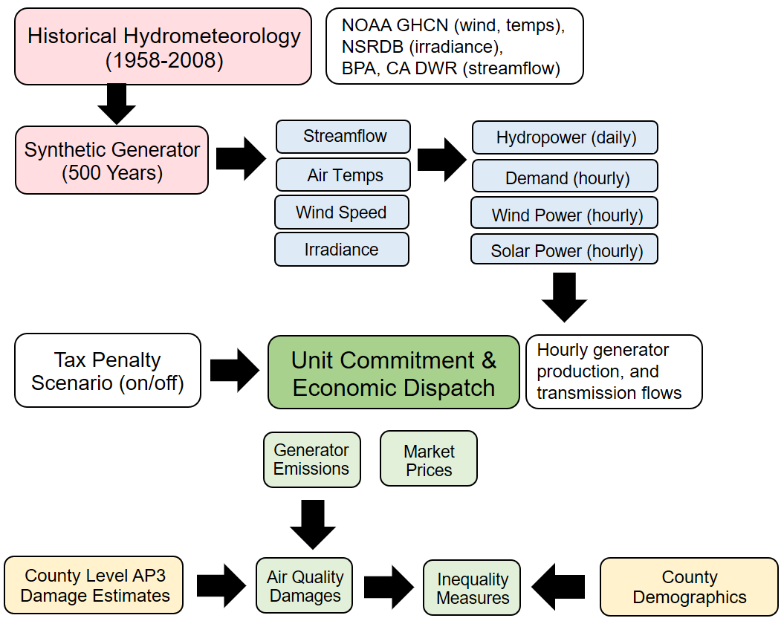
Figure S1. CAPOW’s workflow. The stochastic engine takes the historical hydrometeorological data (streamflow, air temperature, wind speed, and solar irradiation) from different sources and transforms them into 500 years of synthetic hydrometeorological data and then to the power system related inputs (available hydropower, solar power, wind power, and electricity demand). Then it runs the UC/ED model under various tax scenarios. The model output is the hourly power generation of each power plant in CAISO, the wholesale market price, which later on translates into the individual power plants' air pollution emissions and air pollution. Then using the county demographics, air pollution damages gets translated to inequality measures.

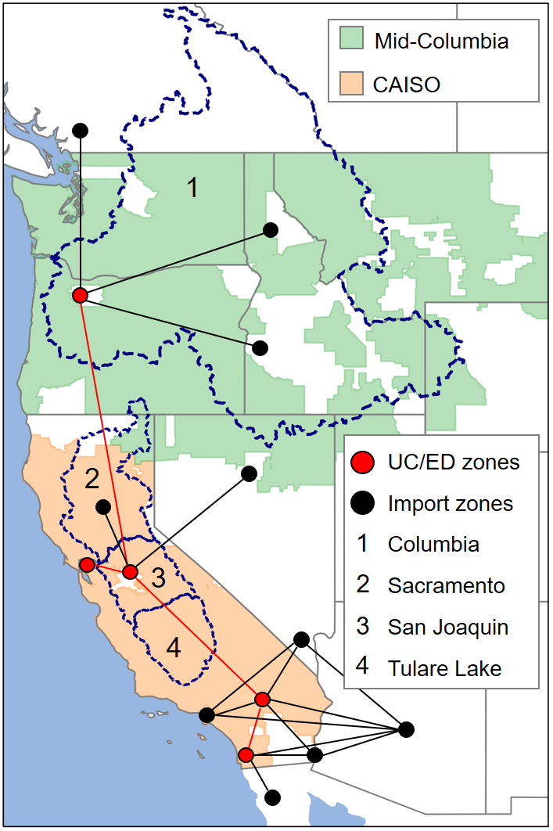
Figure S2. Topology of CAPOW’s model. The geographical scope of CAPOW is consists of two major wholesale electricity markets (Mid-Columbia (Mid-C) market (green area) in the Pacific Northwest and the California Independent System Operator (CAISO) in California (orange area)) and 4 major river basins (1-Columbia river, 2-Sacramento river, 3-San Joaquin river, and 4-Tulare Lake).

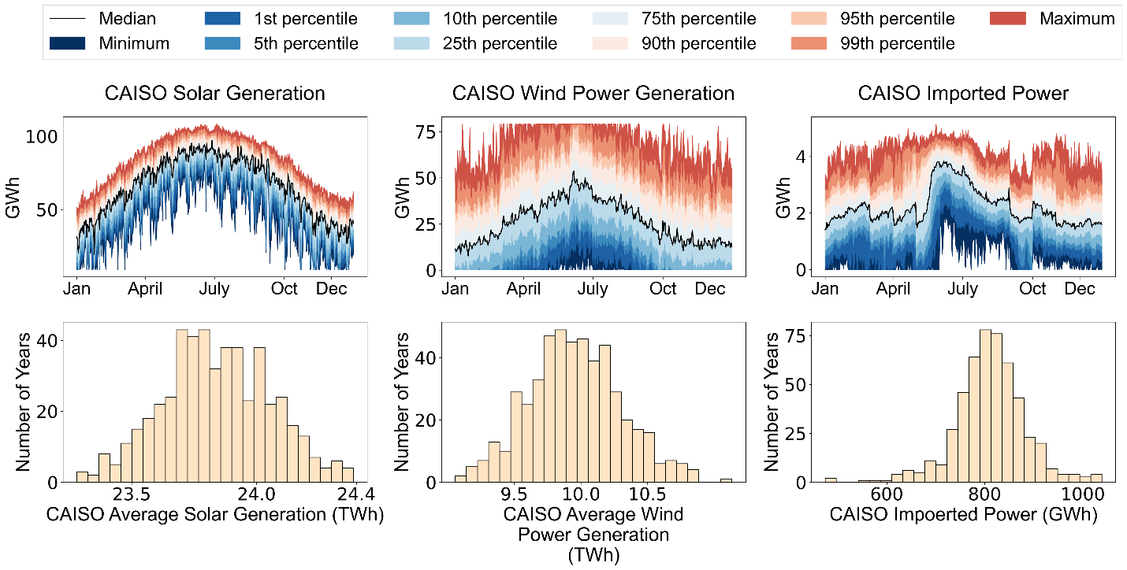
Figure S3. Simulated annual and seasonal uncertainty in solar and wind power generation and imported power from PNW.

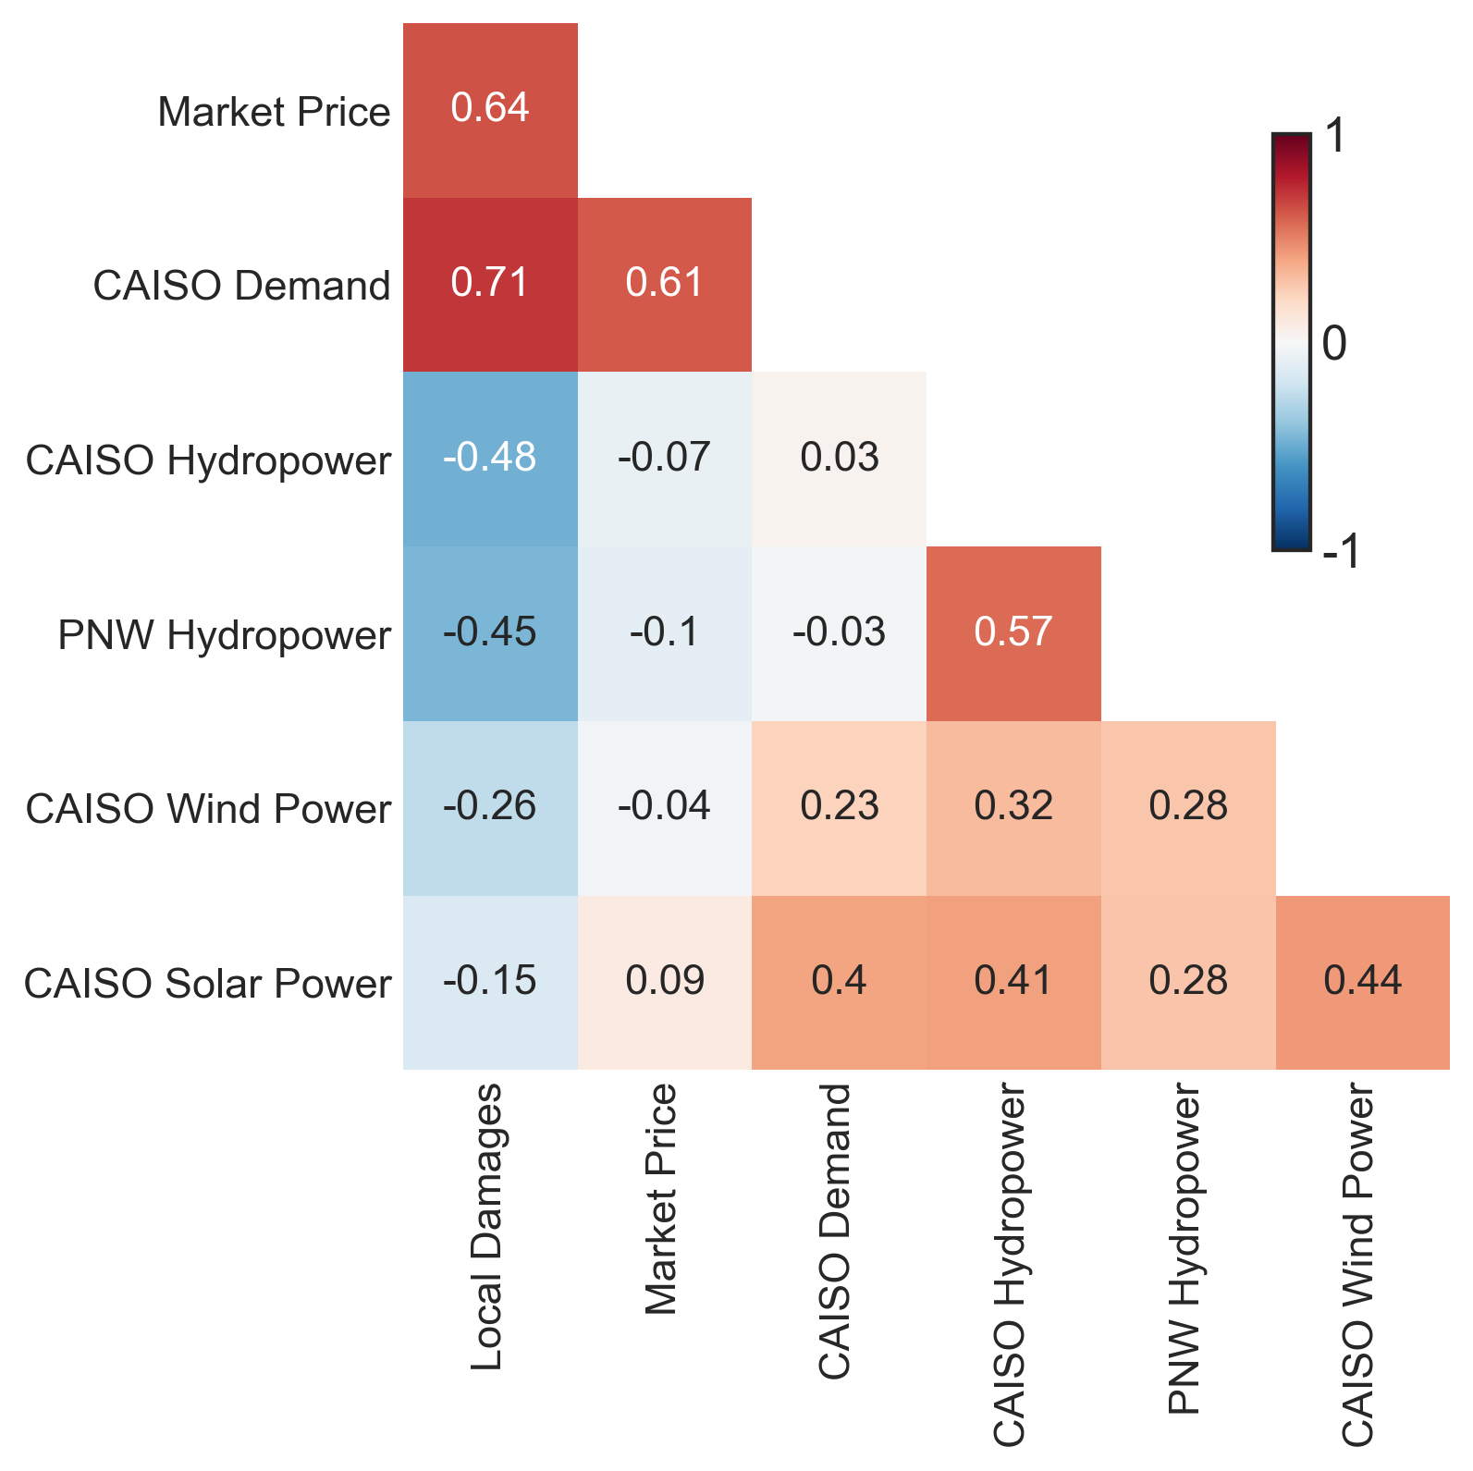
Figure S4. Daily correlations between various system performance metrics and state variables under the No Tax scenario. On a daily basis, there is a more positive correlation between air pollution damages and electricity demand and also a less negative correlation between air pollution damages and CAISO hydropower availability.

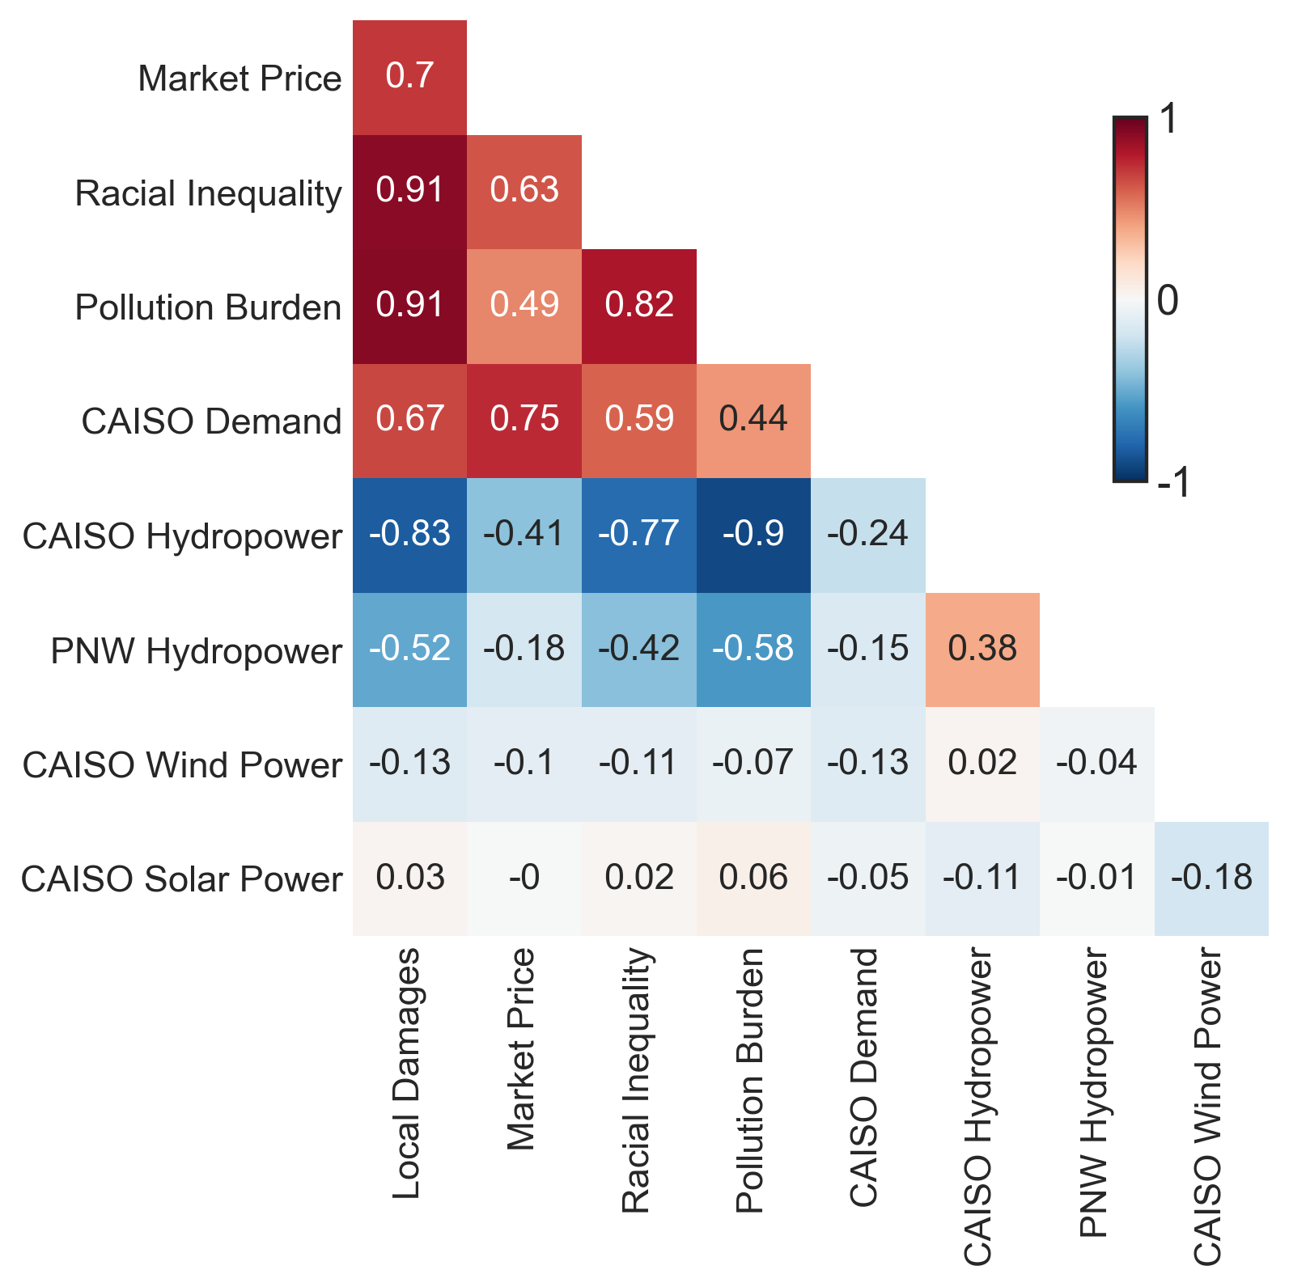
Figure S5. Annual correlations between various system performance metrics and state variables under the local emissions tax scenario.
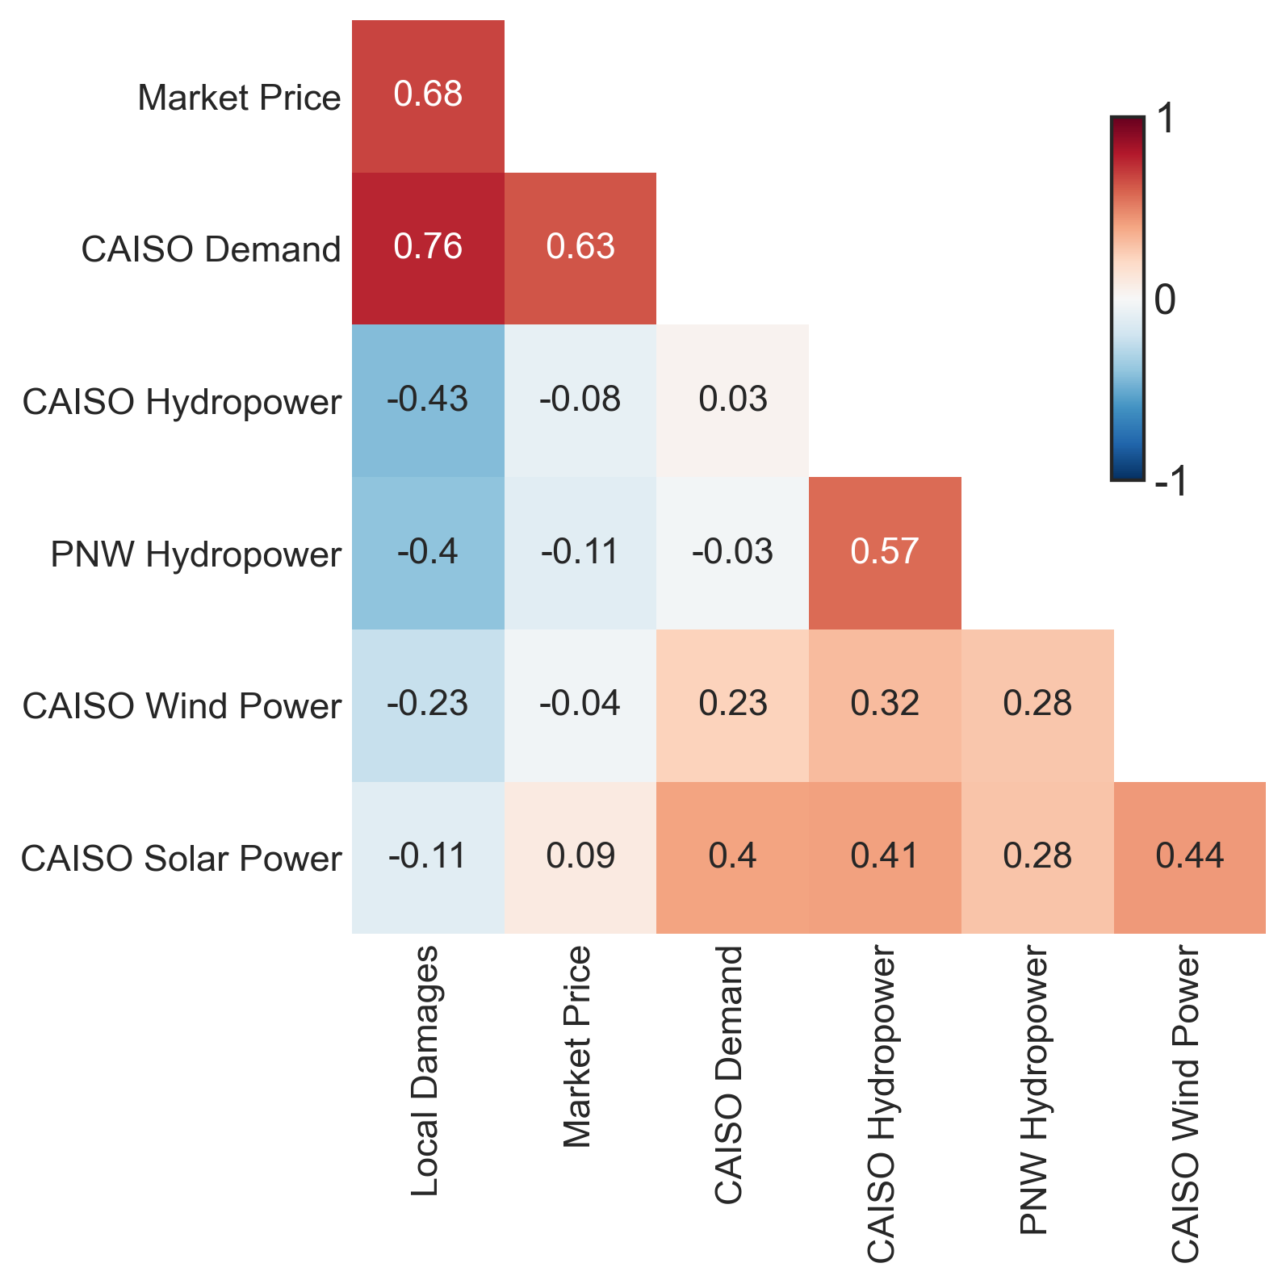
Figure S6. Daily correlations between various system performance metrics and state variables under the local emissions tax scenario. There are minimal differences in the daily correlation matrices of the no tax and local tax scenario.

The influence of penalties on power plant emissions
A key unanswered question that this study seeks to answer is whether heat waves and drought undermine the effectiveness of air pollution penalties that are put in place to reduce health damages. Our model simulations include the exploration of 4 different emissions control policies: 1) a base case (no penalties on either local air pollutants or CO₂ emissions; 2) a local air pollution tax (penalties on generator specific damages from emissions of SO₂, NO_{X}, and PM_{2.5}); 3) a CO₂ tax (penalties on generator specific damages from emissions of CO₂); and 4) a combined tax scenario in which a tax on local air pollutants and CO₂ emissions are enacted simultaneously. In the main paper, we only directly discuss results for the base case and local tax scenario. Our rationale for limiting results and discussion to these scenarios is that inclusion of penalties on CO₂ emissions, at least in the “short term” (without considering changes in the actual capacity mix), primarily serves to increase market prices without having a meaningful effect on air pollution damages from SO₂, NO_{X} and PM_{2.5} (Figure S7).

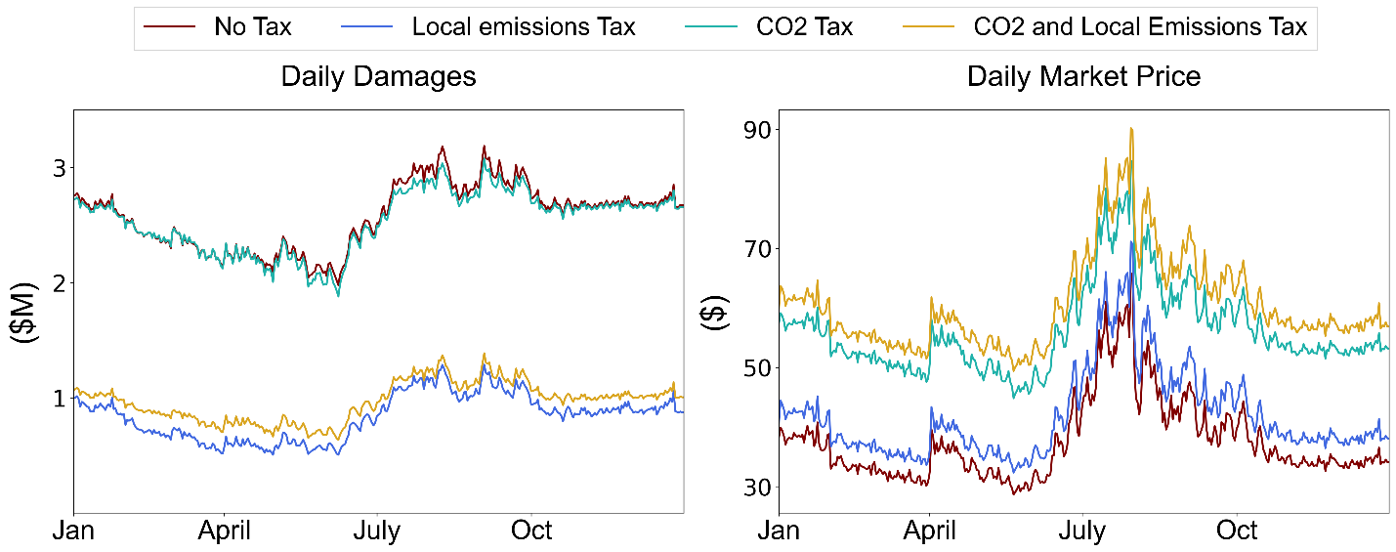
Figure S7. Daily average air pollution damages and market prices under various penalty scenarios calculated for the 500-year stochastic ensemble. Although the local tax scenario reduces the average air pollution damage over the 500 year ensemble by 67%, it only increases the average market price by 11%.

As expected, implementing penalties on power plant emissions of SO₂, NO_{X,} and PM_{2.5} under the local tax scenario leads to a significant (69% on average) reduction in annual damages across the 500-year ensemble relative to the base case (Figure S8). Power plants whose emissions inflict higher health damages are penalized more heavily are utilized less often by the modeled CAISO operator according to its cost-minimizing objective.
Also, note that in Figure S8 the presence of the local tax does not prevent damages of emissions from increasing to extremely high levels on certain days. This hints at an answer to the central question of whether droughts and heat waves undermine the effectiveness of emissions penalties.

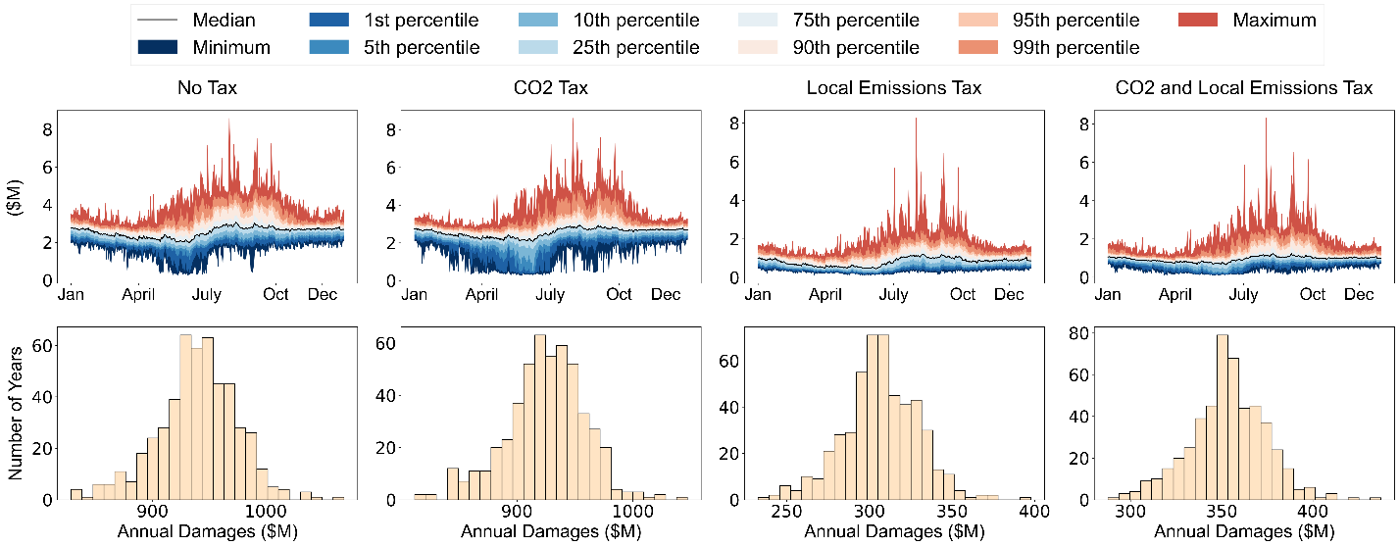

Figure S8. Simulated annual and seasonal uncertainty in total damages from local pollutants (SO₂, NO_{X}, and PM_{2.5}) under various tax scenarios. It should be noted that the peak on all of the four panels of the first row is the highest air pollution damage day observed in Figure 2, Figure 4, Figure 5, and Figure 6. None of the tax scenarios effectively reduce the air pollution damages on this specific day. Otherwise, the local tax is an effective policy at reducing air pollution damages.

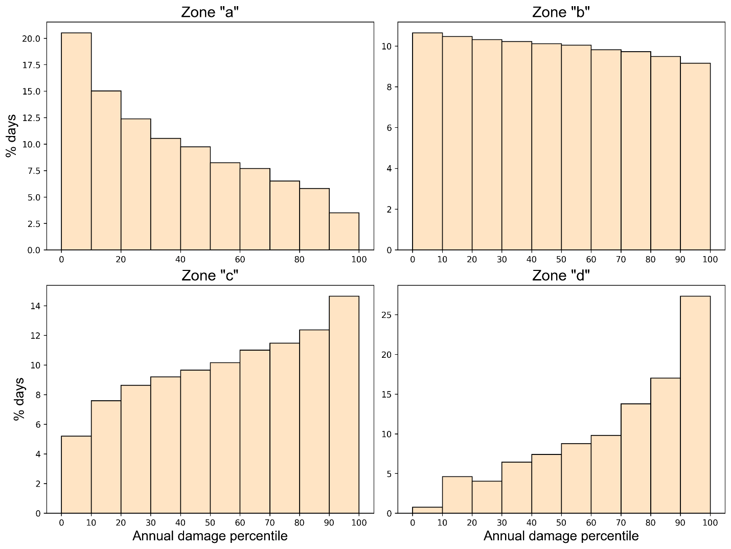Figure S9. This figure shows the distribution of days in each zone of Figure 5 based on the days corresponding year’s annual damages. It shows “bad days” (Zone “d”) can happen in any year, but it is more probable to see a “bad day” in a “bad year”.

A paradoxical effect of the local air tax on pollution inequality
An unanticipated finding from our experiment is that while taxing emissions of SO₂, NO_{X} and PM_{2.5} dramatically reduces overall air pollution damages (and reduces damages most for non-white communities on a per capita basis), it simultaneously strengthens the relationship between drought and inequality in human health damages from local air pollutants inequality (R = -0.57 without a tax, R = -0.77 with local emissions tax). At an annual time step, the availability of hydropower in the CAISO system becomes more predictive of racial inequality and inequality in pollution burden (positively correlated with both). Damages under an local tax scenario are much lower overall, but could potentially be more concentrated in majority non-white counties and counties with higher pre-existing pollution burdens.
To understand why, we must investigate what happens at the individual generator level. Figure S10 shows modeling results for each power plant (circle) over the full 500-year ensemble. The size of each circle corresponds to installed capacity, while color signifies the $/MWh damages caused by each power plant’s emissions of local air pollutants. The placement of each generator along the x-axis corresponds to its rank order marginal cost, with low cost generators on the left, and high cost generators on the right. The top row shows modeled results without a local air pollution tax in place; the bottom row shows results with the tax in place. Note that the rank order marginal cost of generators in the bottom row (with the tax in place) considers the effects of the tax (i.e. each power plant’s color) on marginal cost.
Figure S10a shows each generator’s capacity factor without a tax in place; in general, the cheapest generators (box I) have the highest capacity factors (these provide baseload power). Many of these power plants are relatively small generators with high emission damages ($/MWh). In Figure S10b, note that the same generators (box II) show a weaker negative correlation with CA hydropower generation; this is because these plants act as baseload generators in our model, even in wet years. Box III in Figure S10c shows the portion of damages from these same generators that affect majority (>50%) non-white counties.
The bottom shows results with the local air pollution tax in place. The lowest marginal cost generators likewise generally show the highest capacity factors, but now these generators are those with low air pollution penalties (dark blue in color). These are typically much larger capacity generators, and due to their size they exhibit stronger negative correlations between capacity factor and CA hydropower availability (i.e. they are used less during wet years). Although these are relatively low damage generators, they often result in high damages to the majority non-white counties. The result is that while per capita damages in majority non-white communities decreases more than in majority white communities, inequality becomes more strongly correlated with drought with the local air tax in place.
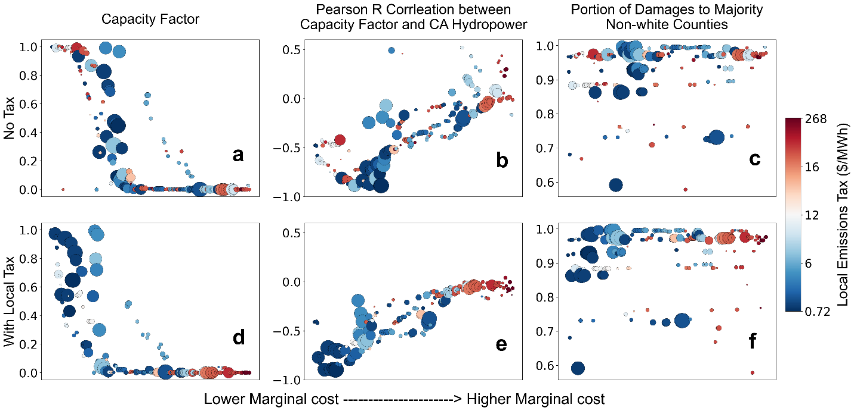
Figure S10. This figure shows the average properties of generators over the 500 year ensemble. The x-axis on all panels shows generators sorted by their marginal cost ($/MWh), without emission penalties (top row) and with the local tax (bottom row). The first column (panels a and d) show capacity factor, the middle column (panels b and e) show the correlation between hydropower and power generation for all generators, and the column on the right (panels c and f) are the portion of damages that go to majority non-white counties)

