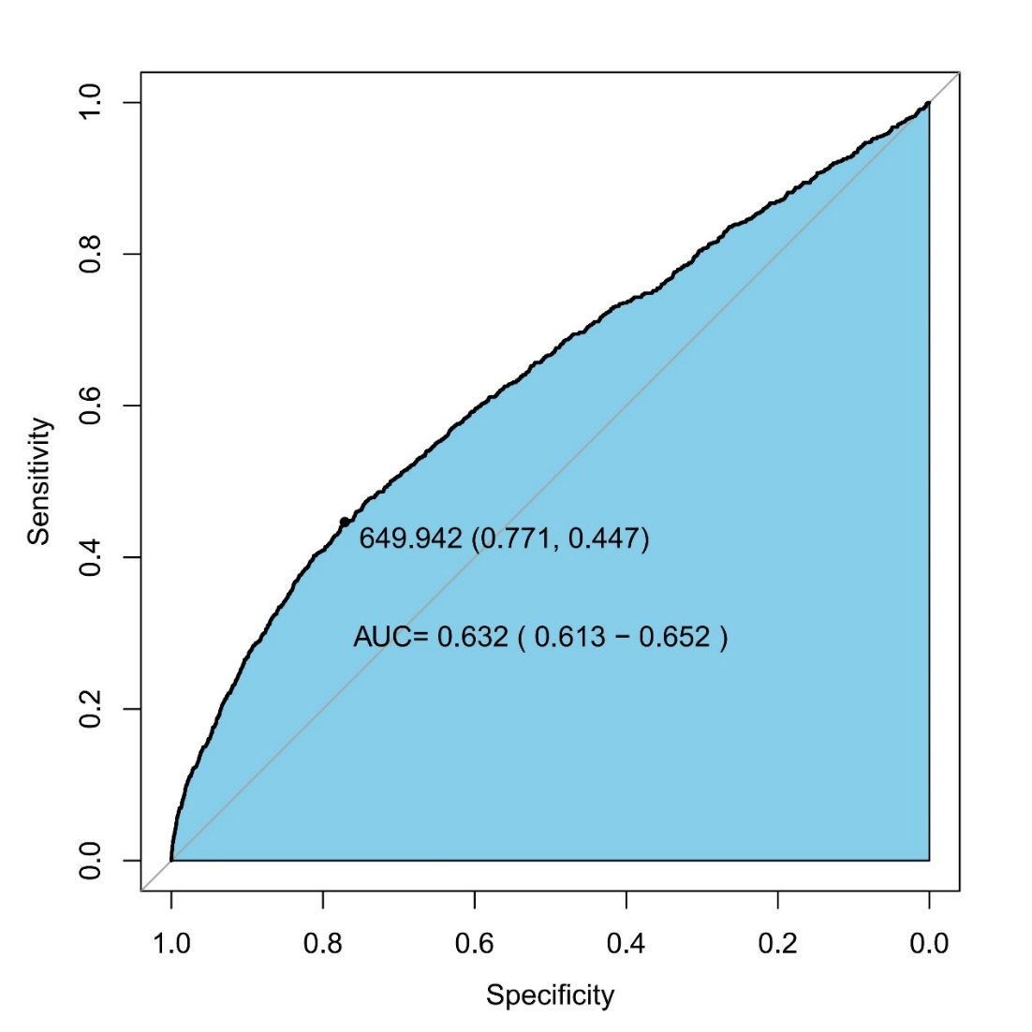
Figure A1 The ROC curve of SII for POD. ROC, receiver operating characteristics curve; SII, systemic-immune-inflammation index; POD, postoperative delirium; AUC, area under curve.
Table A1 Association between SII as continuous variable and POD. SII, systemic-immune-inflammation index; OR, odds ratio; CI, confidence interval; BMI, body mass index; COPD, chronic obstructive pulmonary disease; CKD, chronic kidney disease; ASA, American Society of Anesthesiologists physical status classification system; E.N.T, otolaryngology head and neck surgery; SBP, systolic blood pressure; MAP, mean arterial pressure; WBC, white blood cell; ESR, erythrocyte sedimentation rate; Glu, glucose; Cre, creatinine; AST, aspartate aminotransferase; ALT, alanine aminotransferase; NSAIDs, non-steroidal anti-inflammatory drugs
Variables | Univariate analysis |  | Multivariate analysis
Variables | OR (95%CI) | P | OR (95%CI) | P
SII | 1.0004(1.0003-1.0004) | <0.001 | 1.00007(1.00001-1.000130) | 0.009
Age | 1.089(1.078-1.1) | <0.001 | 1.062(1.048-1.075) | 1.062
Male (vs female) | 1.264(1.108-1.443) | <0.001 | 1.082 (0.908-1.290) | 1.082
BMI | 0.942(0.924-0.96) | <0.001 | 0.988 (0.968-1.008) | 0.240
Smoke (yes vs no) | 1.238(1.067-1.432) | 0.004 | 1.115 (0.931-1.332) | 0.234
Alcohol (yes vs no) | 1.161(0.995-1.35) | 0.055
Hypertension (yes vs no) | 1.181(1.036-1.346) | 0.013 | 1.077(0.926-1.252) | 0.335
Diabetes (yes vs no) | 1.226(1.057-1.418) | 0.007 | 1.023(0.861-1.213) | 0.792
Cardiovascular diseases (yes vs no) | 1.34(1.093-1.627) | 0.004 | 0.966 (0.770-1.201) | 0.761
COPD (yes vs no) | 2.531(1.996-3.17) | <0.001 | 1.894 (1.453-2.440) | <0.001
Cerebrovascular disease (yes vs no) | 1.629(1.348-1.954) | <0.001 | 1.385 (1.125-1.694) | 0.002
CKD (yes vs no) | 3.072(2.085-4.371) | <0.001 | 1.253 (0.749-2.013) | 0.370
Depression and anxiety (yes vs no) | 2.976(1.638-4.983) | <0.001 | 1.556 (0.7183-3.046) | 0.228
Non-independent functional status (yes vs no) | 1.97(1.726-2.247) | <0.001 | 1.146(0.980-1.339) | 0.086
ASA (vs I)
II | 1.151(0.586-2.703) | 0.715 | 0.767 (0.386-1.813) | 0.494
III | 3.25(1.649-7.655) | 0.002 | 1.163 (0.580-2.768) | 0.701
IV | 15.179(7.192-37.315) | <0.001 | 2.685 (1.209-6.831) | 0.023
Days in hospital before surgery | 1.003(1-1.008) | 0.043 | 1.000(0.989-1.005) | 0.934
Emergency surgery, (yes vs no) | 4.341(3.437-5.423) | <0.001 | 2.518(1.838-3.409) | <0.001
Hemoglobin | 0.976(0.973-0.98) | <0.001 | 0.995 (0.990-0.999) | 0.038
WBC count | 1.13(1.106-1.154) | <0.001 | 1.043 (1.024-1.063) | <0.001
Monocytes | 0.302(0.01-2.334) | 0.48
Glu | 1.141(1.111-1.17) | <0.001 | 1.059 (1.022-1.095) | 0.001
Albumin | 0.881(0.867-0.894) | <0.001 | 0.965 (0.946-0.984) | <0.001
Cre | 1.004(1.002-1.005) | <0.001 | 1.001 (0.999-1.003) | 0.382
Total bilirubin | 1.003(1.002-1.005) | <0.001 | 1.000 (0.998-1.002) | 0.975
AST | 1.001(0.999-1.002) | 0.344 |  | 0.707
ALT | 1.003(1.001-1.004) | <0.001 | 1.000 (0.997-1.002) | 0.108
PT | 1.2(1.15-1.253) | <0.001 | 1.044 (0.987-1.095) | 0.001
Preoperative medication
Anticholinergic drug (yes vs no) | 0.914(0.802-1.043) | 0.18
NSAIDs (yes vs no) | 0.725(0.532-0.964) | 0.034
Benzodiazepines (yes vs no) | 1.154(0.99-1.34) | 0.064 | 0.882 (0.625-1.219)
Antipsychotic drugs (yes vs no) | 72.022(48.077-110.042) | <0.001 | 46.940 (29.738-75.417) | <0.001
Type of surgery (vs Hepatopancreatobiliary and gastrointestinal surgery)
Orthopedic surgery | 0.804(0.687-0.939) | 0.006 | 1.002 (0.802-1.251) | 0.985
Urinary surgery | 0.595(0.452-0.772) | <0.001 | 1.039 (0.770-1.384) | 0.797
Thoracic surgery | 0.546(0.397-0.733) | <0.001 | 1.034 (0.730-1.434) | 0.847
E.N.T | 0.349(0.218-0.529) | <0.001 | 0.669 (0.401-1.057) | 0.101
Gynecology | 0.596(0.382-0.884) | 0.015 | 1.221 (0.752-1.897) | 0.395
Vascular surgery | 1.029(0.749-1.382) | 0.855 | 1.367 (0.945-1.942) | 0.089
Others | 0.481(0.349-0.648) | <0.001 | 1.094 (0.766-1.532) | 0.609
Anesthesia method (vs Basal anesthesia)
Epidural anesthesia | 0.458(0.152-1.281) | 0.141
Nerve blocks | 1.776(0.853-4.051) | 0.143
General anesthesia | 1.331(0.728-2.797) | 0.399
General anesthesia combined with other anesthesia | 1.314(0.699-2.812) | 0.436
Duration of surgery | 1.004(1.004-1.005) | <0.001 | 1.001 (0.999-1.003) | 0.089
Duration of anesthesia | 1.004(1.004-1.005) | <0.001 | 1.002 (1.000-1.003) | 0.012
Blood loss | 1.001(1-1.001) | <0.001 | 1.000 (0.999-1.000) | 0.418
Urine | 1.001(1-1.001) | <0.001 | 1.000 (0.999-1.000) | 0.615
Crystalloid | 1(1-1.001) | <0.001 | 1.000(0.999-1.000) | 0.568
Colloid | 1.001(1.001-1.001) | <0.001 | 1.000 (1.000-1.001) | <0.001
Blood transfusion | 2.558(2.208-2.957) | <0.001 | 1.318(1.085-1.596) | 0.005
Duration of SBP>140 mmHg | 1.007(1.006-1.009) | <0.001 | 1.001 (0.999-1.003) | 0.158
Duration of MAP<60 mmHg | 1.016(1.013-1.019) | <0.001 | 1.005 (1.002-1.009) | 0.003
Intraoperative medication
Glucocorticoid | 1.064(0.929-1.22) | 0.376
Dexmedetomidine | 1.094(0.881-1.344) | 0.403
Table A2 Univariate and multivariate logistic regression analyses for POD in Model 3. SII, systemic-immune-inflammation index; OR, odds ratio; CI, confidence interval; BMI, body mass index; COPD, chronic obstructive pulmonary disease; CKD, chronic kidney disease; ASA, American Society of Anesthesiologists physical status classification system; E.N.T, otolaryngology head, and neck surgery; SBP, systolic blood pressure; MAP, mean arterial pressure; WBC, white blood cell; ESR, erythrocyte sedimentation rate; Glu, glucose; Cre, creatinine; AST, aspartate aminotransferase; ALT, alanine aminotransferase; NSAIDs, non-steroidal anti-inflammatory drugs
Variables | Univariate analysis |  | Multivariate analysis
Variables | OR (95%CI) | P | OR (95%CI) | P
SII (≤650 vs >650) | 2.709(2.373-3.092) | <0.001 | 1.302(1.106-1.531) | 0.001
Age | 1.089(1.078-1.1) | <0.001 | 1.061(1.047-1.074) | <0.001
Male (vs female) | 1.264(1.108-1.443) | <0.001 | 1.067(0.895-1.273) | 0.466
BMI | 0.942(0.924-0.96) | <0.001 | 0.988(0.968-1.008) | 0.248
Smoke (yes vs no) | 1.238(1.067-1.432) | 0.004 | 1.114(0.931-1.331) | 0.235
Alcohol (yes vs no) | 1.161(0.995-1.35) | 0.055
Hypertension (yes vs no) | 1.181(1.036-1.346) | 0.013 | 1.076(0.925-1.251) | 0.342
Diabetes (yes vs no) | 1.226(1.057-1.418) | 0.007 | 1.028(0.865-1.219) | 0.752
Cardiovascular diseases (yes vs no) | 1.34(1.093-1.627) | 0.004 | 0.967(0.771-1.202) | 0.766
COPD (yes vs no) | 2.531(1.996-3.17) | <0.001 | 1.872(1.436-2.411) | <0.001
Cerebrovascular disease (yes vs no) | 1.629(1.348-1.954) | <0.001 | 1.380(1.121-1.687) | 0.002
CKD (yes vs no) | 3.072(2.085-4.371) | <0.001 | 1.253(0.748-2.012) | 0.371
Depression and anxiety (yes vs no) | 2.976(1.638-4.983) | <0.001 | 1.574(0.729-3.068) | 0.214
Non-independent functional status (yes vs no) | 1.97(1.726-2.247) | <0.001 | 1.128(0.965-1.319) | 0.129
ASA (vs I)
II | 1.151(0.586-2.703) | 0.715
III | 3.25(1.649-7.655) | 0.002
IV | 15.179(7.192-37.315) | <0.001
Days in hospital before surgery | 1.003(1-1.008) | 0.043 | 1.000(0.989-1.005) | 0.905
Emergency surgery, (yes vs no) | 4.341(3.437-5.423) | <0.001 | 2.590(1.905-3.484) | <0.001
Hemoglobin | 0.976(0.973-0.98) | <0.001 | 0.996(0.991-1.001) | 0.085
WBC count | 1.13(1.106-1.154) | <0.001 | 1.043(1.025-1.063) | <0.001
Monocytes | 0.302(0.01-2.334) | 0.48
Glu | 1.141(1.111-1.17) | <0.001 | 1.056(1.019-1.092) | 0.002
Albumin | 0.881(0.867-0.894) | <0.001 | 0.966(0.947-0.985) | <0.001
Cre | 1.004(1.002-1.005) | <0.001 | 1.001(0.999-1.003) | 0.403
Total bilirubin | 1.003(1.002-1.005) | <0.001 | 0.999(0.998-1.002) | 0.849
AST | 1.001(0.999-1.002) | 0.344
ALT | 1.003(1.001-1.004) | <0.001 | 0.999(0.997-1.002) | 0.737
PT | 1.2(1.15-1.253) | <0.001 | 1.046(0.99-1.097) | 0.086
Preoperative medication
Anticholinergic drug (yes vs no) | 0.914(0.802-1.043) | 0.18
NSAIDs (yes vs no) | 0.725(0.532-0.964) | 0.034 | 0.886(0.627-1.223) | 0.474
Benzodiazepines (yes vs no) | 1.154(0.99-1.34) | 0.064
Antipsychotic drugs (yes vs no) | 72.022(48.077-110.042) | <0.001 | 47.479(30.071-76.309) | <0.001
Type of surgery (vs Hepatopancreatobiliary and gastrointestinal surgery)
Orthopedic surgery | 0.804(0.687-0.939) | 0.006 | 0.989(0.791-1.235) | 0.922
Urinary surgery | 0.595(0.452-0.772) | <0.001 | 1.037(0.768-1.382) | 0.807
Thoracic surgery | 0.546(0.397-0.733) | <0.001 | 1.019(0.72-1.415) | 0.911
E.N.T | 0.349(0.218-0.529) | <0.001 | 0.665(0.399-1.05) | 0.096
Gynecology | 0.596(0.382-0.884) | 0.015 | 1.221(0.752-1.897) | 0.396
Vascular surgery | 1.029(0.749-1.382) | 0.855 | 1.358(0.938-1.93) | 0.096
Others | 0.481(0.349-0.648) | <0.001 | 1.092(0.764-1.528) | 0.618
Anesthesia method (vs Basal anesthesia)
Epidural anesthesia | 0.458(0.152-1.281) | 0.141
Nerve blocks | 1.776(0.853-4.051) | 0.143
General anesthesia | 1.331(0.728-2.797) | 0.399
General anesthesia combined with other anesthesia | 1.314(0.699-2.812) | 0.436
Duration of surgery | 1.004(1.004-1.005) | <0.001 | 1.001(1-1.003) | 0.100
Duration of anesthesia | 1.004(1.004-1.005) | <0.001 | 1.002(1-1.003) | 0.011
Blood loss | 1.001(1-1.001) | <0.001 | 0.999(1-1) | 0.377
Urine | 1.001(1-1.001) | <0.001 | 1.000(1-1) | 0.588
Crystalloid | 1(1-1.001) | <0.001 | 1.000(1-1) | 0.582
Colloid | 1.001(1.001-1.001) | <0.001 | 1.000(1-1.001) | <0.001
Blood transfusion | 2.558(2.208-2.957) | <0.001 | 1.318(1.086-1.596) | 0.005
Duration of SBP>140 mmHg | 1.007(1.006-1.009) | <0.001 | 1.001(0.999-1.003) | 0.171
Duration of MAP<60 mmHg | 1.016(1.013-1.019) | <0.001 | 1.005(1.002-1.009) | 0.003
Intraoperative medication
Glucocorticoid | 1.064(0.929-1.22) | 0.376
Dexmedetomidine | 1.094(0.881-1.344) | 0.403

Table A3 Univariate logistic regression analyses for POD in the Model PSM. SII, systemic-immune-inflammation index; OR, odds ratio; CI, confidence interval; BMI, body mass index; COPD, chronic obstructive pulmonary disease; CKD, chronic kidney disease; ASA, American Society of Anesthesiologists physical status classification system; E.N.T, otolaryngology head and neck surgery; SBP, systolic blood pressure; MAP, mean arterial pressure; WBC, white blood cell; ESR, erythrocyte sedimentation rate; Glu, glucose; Cre, creatinine; AST, aspartate aminotransferase; ALT, alanine aminotransferase; NSAIDs, non-steroidal anti-inflammatory drugs.
Variables | Univariate analysis
Variables | OR (95%CI) | P
SII (≤650 vs >650) | 1.301(1.062-1.598) | 0.011
Age | 1.089(1.073-1.106) | <0.001
Male (vs female) | 1.147(0.935-1.409) | 0.19
BMI | 0.962(0.935-0.99) | 0.009
Smoke (yes vs no) | 1.081(0.855-1.355) | 0.509
Alcohol (yes vs no) | 1.047(0.821-1.322) | 0.706
Hypertension (yes vs no) | 1.138(0.929-1.394) | 0.212
Diabetes (yes vs no) | 1.273(1.015-1.585) | 0.034
Cardiovascular diseases (yes vs no) | 1.305(0.946-1.76) | 0.092
COPD (yes vs no) | 1.82(1.23-2.604) | 0.002
Cerebrovascular disease (yes vs no) | 1.739(1.309-2.275) | <0.001
CKD (yes vs no) | 1.649(0.774-3.079) | 0.151
Depression and anxiety (yes vs no) | 2.841(1.177-5.831) | 0.009
Non-independent functional status (yes vs no) | 1.57(1.281-1.924) | <0.001
ASA (vs I)
II | 0.926(0.345-3.79) | 0.897
III | 2.141(0.792-8.785) | 0.199
IV | 8.579(2.856-37.087) | <0.001
Days in hospital before surgery | 1.012(1.003-1.024) | 0.018
Emergency surgery, (yes vs no) | 2.828(1.912-4.052) | <0.001
Hemoglobin | 0.983(0.978-0.988) | <0.001
WBC count | 1.041(1.017-1.067) | <0.001
Monocytes | 1.308(0.16-2.873) | 0.589
Glu | 1.046(0.994-1.096) | 0.072
Albumin | 0.903(0.882-0.924) | <0.001
Cre | 1.003(1-1.005) | 0.018
Total bilirubin | 1.002(0.999-1.004) | 0.109
AST | 1(0.997-1.002) | 0.738
ALT | 1.002(0.999-1.004) | 0.207
PT | 1.222(1.142-1.306) | <0.001
Preoperative medication
Anticholinergic drug (yes vs no) | 0.916(0.748-1.123) | 0.398
NSAIDs (yes vs no) | 0.809(0.508-1.223) | 0.343
Benzodiazepines (yes vs no) | 1.144(0.898-1.445) | 0.267
Antipsychotic drugs (yes vs no) | 71.168(38.15-140.968) | <0.001
Type of surgery (vs Hepatopancreatobiliary and gastrointestinal surgery)
Orthopedic surgery | 0.835(0.657-1.057) | 0.137
Urinary surgery | 0.652(0.396-1.015) | 0.073
Thoracic surgery | 0.472(0.261-0.788) | 0.007
E.N.T | 0.613(0.338-1.026) | 0.082
Gynecology | 0.742(0.364-1.346) | 0.367
Vascular surgery | 1.28(0.741-2.072) | 0.344
Others | 0.388(0.197-0.682) | 0.002
Anesthesia method (vs Basal anesthesia)
Epidural anesthesia | 0.619(0.12-2.855) | 0.534
Nerve blocks | 2.03(0.71-7.278) | 0.221
General anesthesia | 1.28(0.535-4.188) | 0.629
General anesthesia combined with other anesthesia | 1.227(0.488-4.123) | 0.699
Duration of surgery | 1.004(1.003-1.004) | <0.001
Duration of anesthesia | 1.003(1.002-1.004) | <0.001
Blood loss | 1(1-1.001) | <0.001
Urine | 1.001(1-1.001) | <0.001
Crystalloid | 1(1-1) | <0.001
Colloid | 1.001(1.001-1.001) | <0.001
Blood transfusion | 2.311(1.851-2.871) | <0.001
Duration of SBP>140 mmHg | 1.006(1.004-1.009) | <0.001
Duration of MAP<60 mmHg | 1.013(1.009-1.017) | <0.001
Intraoperative medication
Glucocorticoid | 1.143(0.924-1.42) | 0.223
Dexmedetomidine | 1.104(0.782-1.517) | 0.559

