Motives | OOH-PC | EMS | Adjusted risk ratio* (95% CI) | Forest plot
Own assessments and expectations |  |  |  | 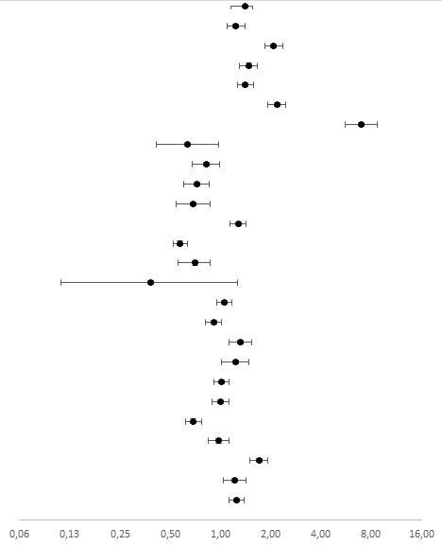
Perceived need for prompt action | 81.4 | 87.7 | 1.35 (1.16-1.56)
Unpleasant symptoms | 82.5 | 84.3 | 1.24 (1.09-1.41)
Perceived condition to be life-threatening | 9.2 | 56.0 | 2.08 (1.85-2.35)
Worried | 59.8 | 77.5 | 1.47 (1.29-1.66)
Expected need for examination | 37.7 | 55.9 | 1.41 (1.27-1.57)
Expected need for specialist care/hospital admission | 18.4 | 65.1 | 2.18 (1.92-2.47)
Expected need for ambulance | 3.5 | 82.4 | 6.95 (5.56-8.69)
Renewal of prescription | 4.9 | 1.9 | 0.63 (0.41-0.97)
Perceived barriers and benefits
Own GP not accessible during daytime | 12.8 | 10.8 | 0.82 (0.68-0.99)
Own GP no time available soon enough | 16.7 | 9.4 | 0.72 (0.60-0.86)
No possibility to contact own GP during daytime | 9.0 | 5.0 | 0.69 (0.54-0.87)
Easiest option | 15.8 | 42.2 | 1.28 (1.14-1.42)
Need arose outside office hours | 89.8 | 56.7 | 0.57 (0.52-0.63)
Need for quick help because of work | 17.8 | 8.0 | 0.70 (0.56-0.87)
Need for quick help because of daycare attendance | 10.3 | 2.3 | 0.38 (0.11-1.26)
Previous experience and knowledge
Previous experience with similar symptoms | 34.3 | 43.9 | 1.05 (0.95-1.17)
Previous positive experience with this healthcare service | 36.5 | 38.8 | 0.91 (0.81-1.01)
Perceived most suitable healthcare service | 75.9 | 87.5 | 1.31 (1.12-1.53)
Needed second opinion | 4.6 | 9.9 | 1.23 (1.02-1.48)
Needs and wishes
Did not know where else to call | 45.5 | 45.4 | 1.01 (0.91-1.13)
Wanted to talk to a physician | 32.2 | 34.1 | 1.00 (0.89-1.12)
Wanted to talk to a nurse | 75.2 | 51.7 | 0.69 (0.62-0.77)
Could not take responsibility | 23.3 | 23.0 | 0.98 (0.85-1.12)
Nobody to talk to | 34.8 | 70.8 | 1.70 (1.5-1.92)
Recommended (from non-medical person) to call | 5.8 | 18.7 | 1.22 (1.04-1.43)
Did not know where else to call | 20.2 | 33.7 | 1.25 (1.12-1.39)
Table 2. Motives for contacting OOH healthcare, stratified per setting, with the five most important motives marked in bold (% according to importance) and adjusted risk ratio for motives associated with OOH-PC contact versus EMS (RR, 95% CI)

