Table 1
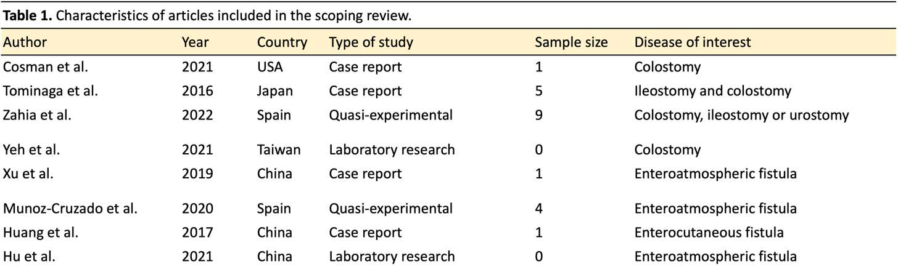
Table 1. Characteristics of articles included in the scoping review.
Legend: Articles and their details included within the review with basic details.
Table 2
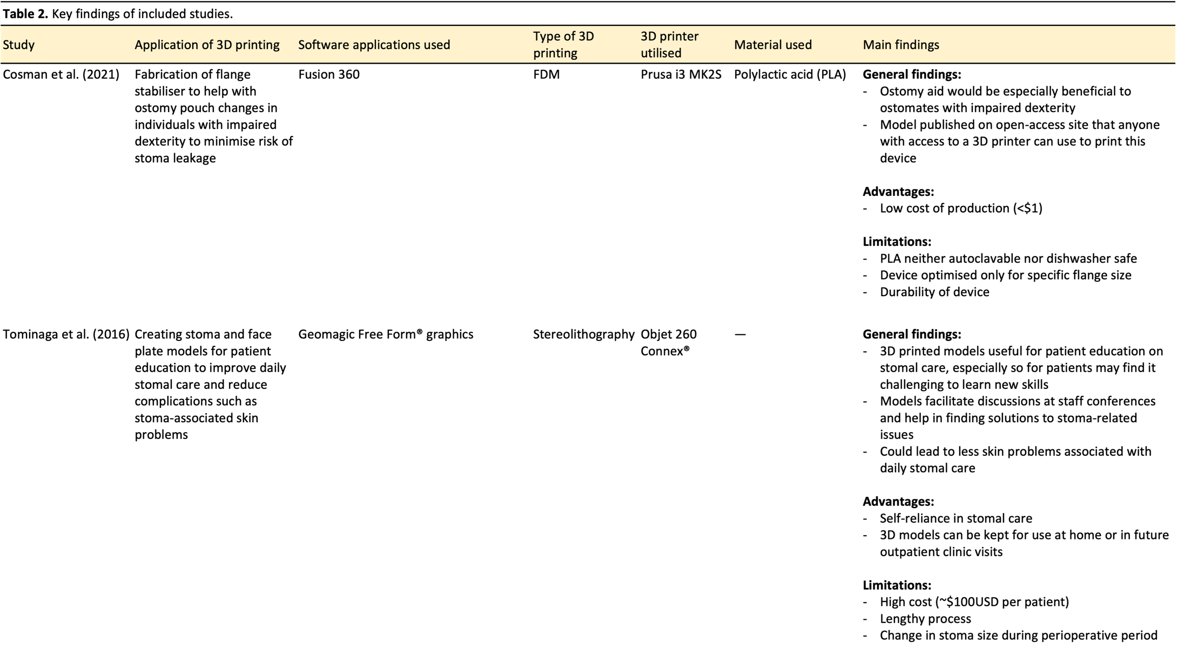

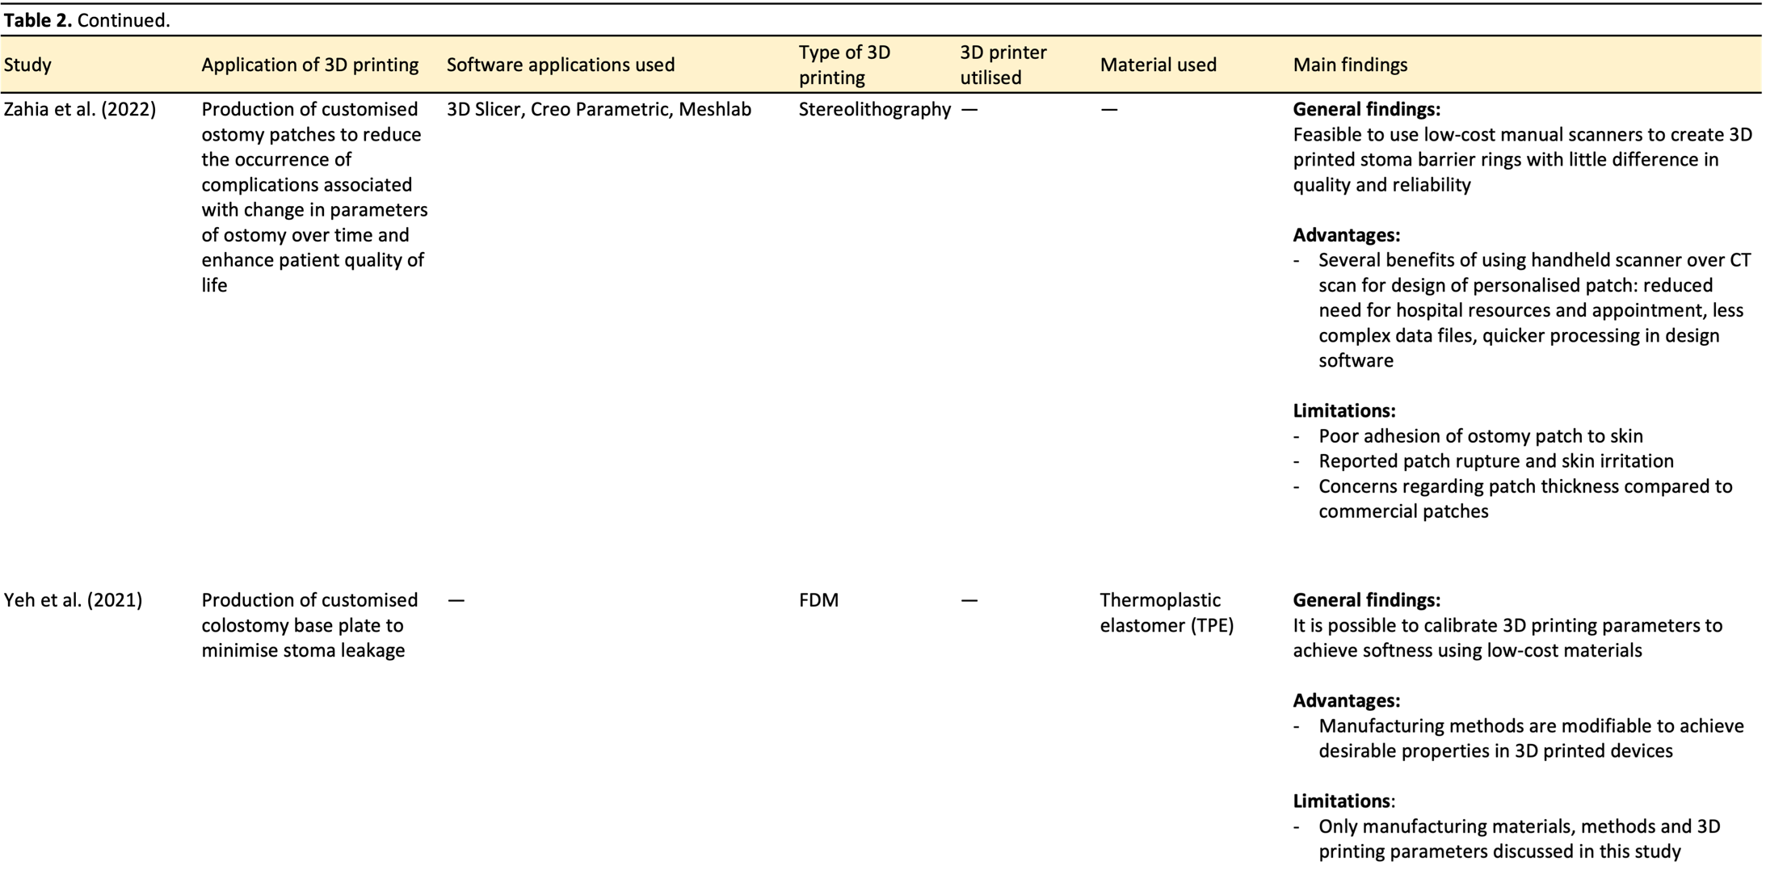

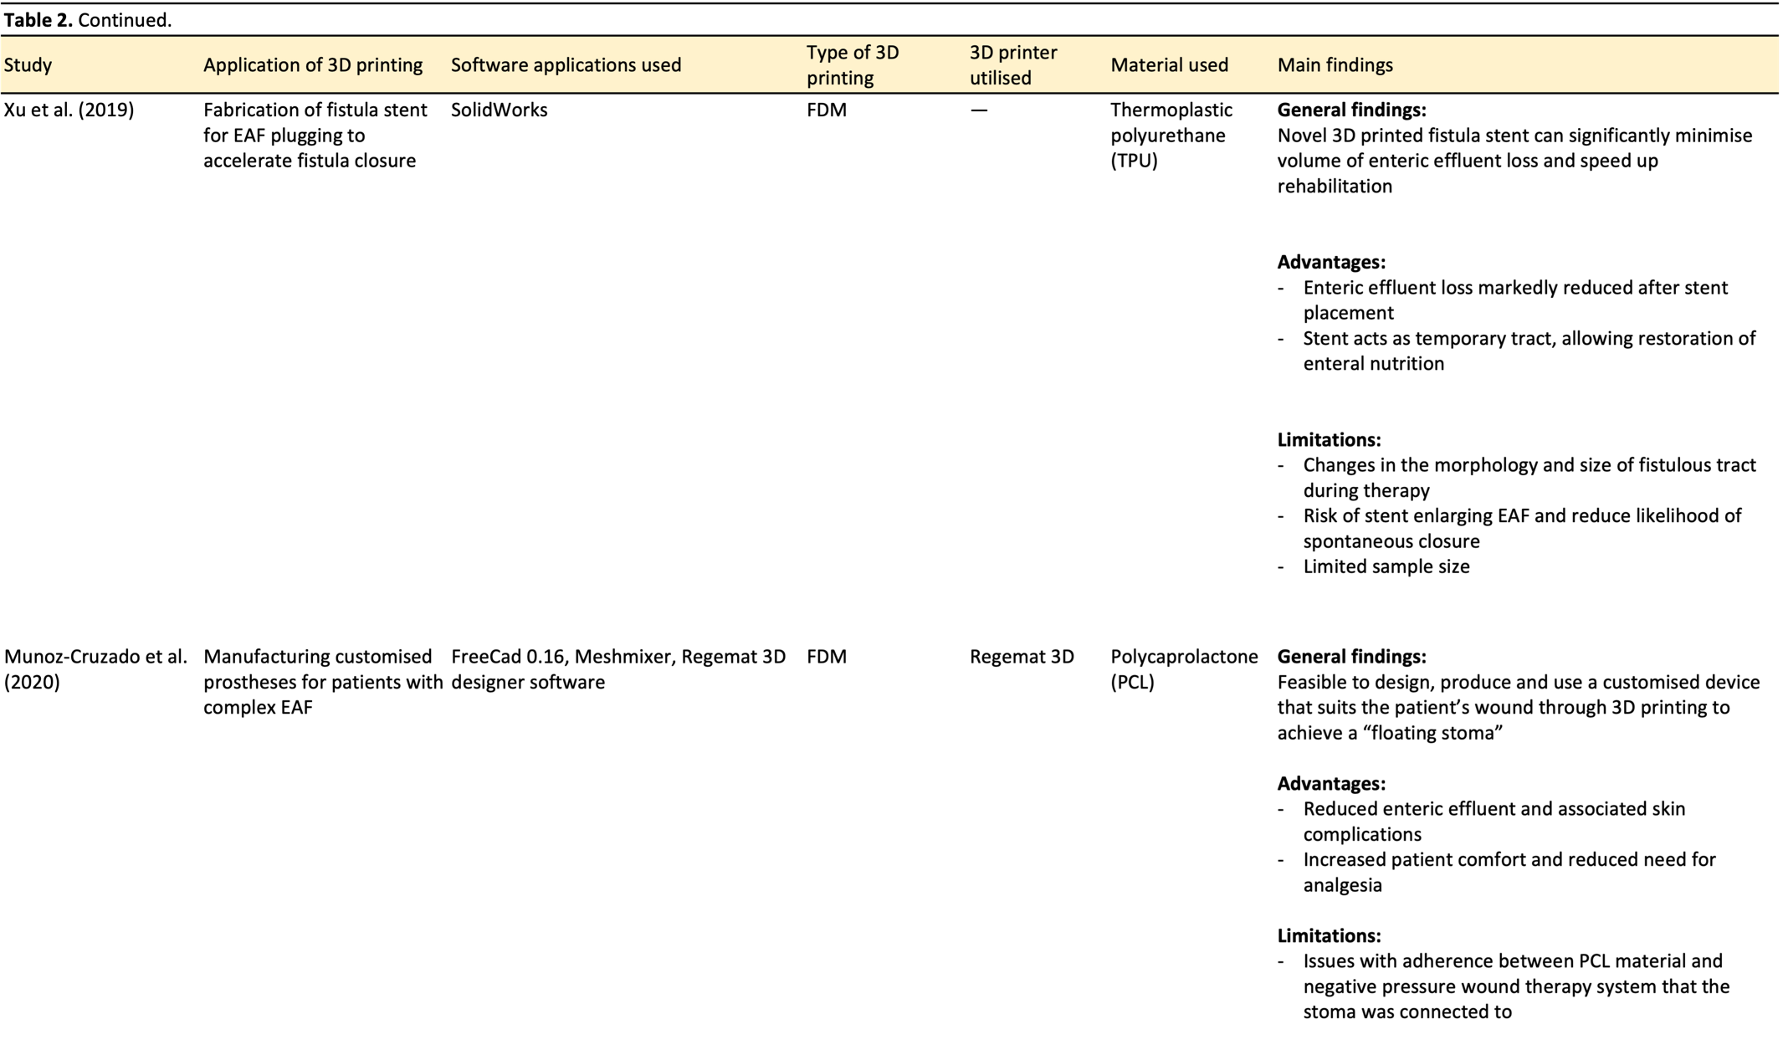

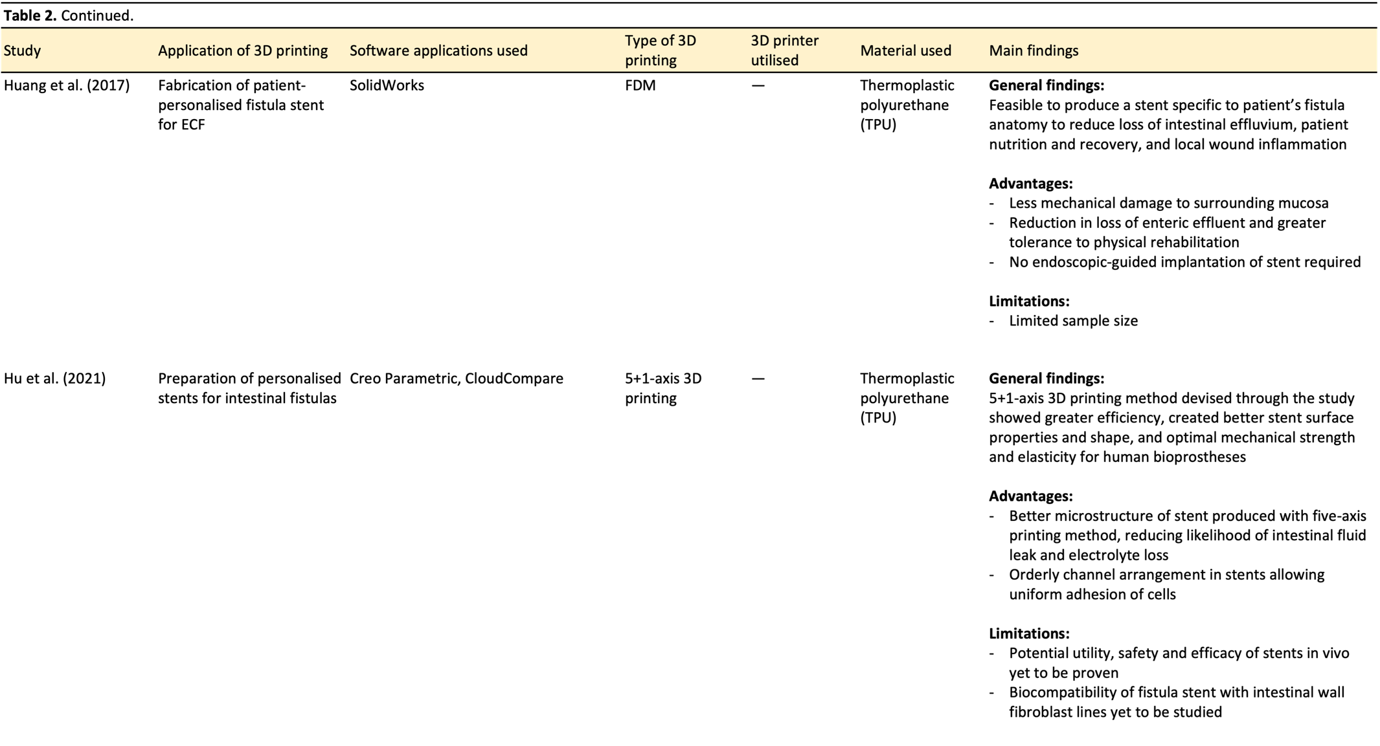
Table 2: Key findings of included studies.
Legend: describing studies and the main findings from each paper. FDM: fused deposition modelling; EAF: entero-atmospheric fistula; ECF: enterocutaneous fistula; CT: computerised tomography

