Additional File 1: Supporting Figures

Figure S1. Validation of a new method for differential detection of glycogen, maltodextrin and glucose in vaginal samples. (A) Fluorometric glycogen quantification assay (BioVision) detects glucose derived from 3.2 µg/mL solutions of maltose, maltotriose, maltodextrin and glycogen in the presence of the hydrolysis enzyme mix that catalyzes the production of glucose from alpha-glucan (glucose) polymers (solid bars). Control samples without hydrolysis enzyme mix (hatched bars) indicate the background glucose levels, which are subtracted from hydrolyzed samples to determine the concentration of glucose polymers. Results are presented as mean ± standard deviation of 3 technical replicates. (B) Schematic illustration of the differential glycogen and maltodextrin quantification assay. Glycogen (>100 kDa) is separated from maltodextrin and glucose (<100 kDa) by size filtration using a 100 kDa molecular weight cutoff centrifugal filter unit. The concentrate fraction is subjected to enzyme hydrolysis to fluorometrically detect glucose derived from glycogen and the filtrate fraction is identically hydrolyzed to derive glucose from maltodextrin (along with maltose and maltotriose). Control samples of the concentrate and filtrate without hydrolysis enzyme mix account for the background glucose levels in each fraction. (C) Quantification of glucose (GLU) or glucose derived from solutions of maltodextrin (MD), glycogen (GLYC), a mixture of glycogen and maltodextrins (GLYC/MD), or a mixture of glycogen, maltodextrins and glucose (GLYC/MD/GLU), using solutions containing 3.2 µg/mL of each carbohydrate. Glucose enzymatically released in the high molecular weight concentrates is shown in the top graph (blue, glycogen), while that released in the low molecular weight filtrates is shown in the middle graph (purple, maltodextrin); glucose detected in the absence of the hydrolysis enzyme mix is shown in the bottom graph (teal, glucose). Results are presented as mean ± standard deviation of 3 technical replicates. Schematic illustration created with Biorender.com.

Figure S2. Correlates of total protein in vaginal swab supernatants. (A) Total protein concentration (µg/mL) measured in vaginal swab supernatants and presented as mean ± range from one independent experiment run in technical duplicate. (B) Bacterial abundance in vaginal swab cell pellets, as determined by broad-range 16S rRNA gene qPCR run in technical duplicate and presented as mean 16S rRNA gene copies per swab ± coefficient of variance. (C–D) Scatterplots of total protein concentration (µg/mL) as a function of (C) bacterial abundance (mean 16S rRNA gene copies/swab) and (D) days since last menstrual period (excluding one sample with >35 days). Regression lines were fitted using a generazlied linear model and error bars indicate 95% confidence intervals. Relationships were assessed with Spearman’s correlation, yielding the rho coefficients and p-values above each plot. (E) Distribution and mean of total protein concentration (µg/mL) for each swab supernatant sample by the week of the menstrual cycle in which the sample was collected (days since last menstrual period: 1–7 days, 8–15 days, 16–21 days, 22–28 days, or 29–50 days). Significance levels: ns=not statistically significant, *p≤0.05, **p≤0.01, ***p≤0.001, ****p≤0.0001.

Figure S3. Elevated D-lactic acid levels in vaginal samples dominated by L. crispatus. (A) D-lactic acid, L-lactic acid and additive total lactic acid levels were quantified in vaginal swab supernatants (N=17) and normalized to total protein concentration. Results are presented as mean ± range of lactic acid from one independent experiment run in technical duplicate. (B–D) Distribution of lactic acid levels in L. crispatus-dominated (N=11) and non-L. crispatus-dominated (N=6) vaginal samples for (B) D-lactic acid (C) L-lactic acid and (D) total lactic acid presented as mean ± standard error of the mean. Statistical significance was assessed with a Mann-Whitney U-test: D-lactic acid *p=0.0202, L-lactic acid ns p>0.999. total lactic acid ns p=0.301. Significance levels: ns=not statistically significant, *p≤0.05, **p≤0.01, ***p≤0.001, ****p≤0.0001.

Figure S4. Enzyme activities detected in a fluorescent starch degradation assay. Fluorophore-conjugated starch was incubated with commercially available enzymes, α-glucosidase, pullulanase and α-amylase, alone and in combination. Degradation of the fluorescent starch substrate was quantified by measuring the increase in fluorescence (excitation/emission 485/527 nm) over a two-hour time course with reads every three minutes. The enzyme activity is expressed as the maximum relative fluorescence units (RFU)/seconds and presented as mean ± range from one independent experiment performed in technical duplicate.

Figure S5. Human α-amylase correlates with amylopullulanase and α-glucosidase activities in vaginal swab supernatants, but not pullulanase activity. (A–D) Scatterplots of (A) amylopullulanase activity (max RFU/sec/ng protein) (B) α-amylase enzyme activity (mU/ng protein) (C) α-glucosidase enzyme activity (mU/ng protein) and (D) pullulanase enzyme activity (U/ng protein) as a function of human α-amylase enzyme concentration. All relationships were assessed with Spearman’s correlation, with the rho coefficient and p-value indicated above each scatterplot. Significance levels: ns=not statistically significant, *p≤0.05, **p≤0.01, ***p≤0.001, ****p≤0.0001.

Figure S6. α-glucosidase activity correlates with maltodextrin levels in vaginal swab supernatants. (A) α-glucosidase enzyme activity was measured in vaginal swab supernatants (N=17) and in select vaginal swab cell pellets (all except samples 2, 7, 13 and 17; N=13). Results were normalized to total protein concentration and presented as mean mU/ng protein ± range from one independent experiment run in technical duplicate. (B) Distribution of α-glucosidase activity in L. crispatus-dominated (Lc Dominated; N=11) and non-L. crispatus dominated (non-Lc Dominated; N=6) vaginal supernatant samples presented as median ± interquartile range. Statistical significance between Lc Dominated and non-Lc Dominated samples was assessed with a Mann Whitney U-test (ns p=0.884). (C–D) Scatterplots of (C) glycogen and (D) maltodextrin levels as a function of α-glucosidase enzyme activity. Regression lines were fitted using a generalized linear model and error bars indicate 95% confidence intervals. Relationships were assessed with Spearman’s correlation, with the rho coefficient and p-value indicated above each scatterplot. Significance levels: ns=not statistically significant, *p≤0.05, **p≤0.01, ***p≤0.001, ****p≤0.0001.

Figure S7. Pullulanase activity does not correlate with glycogen or maltodextrin levels in vaginal swab supernatants. Scatterplots of (A) glycogen or (B) maltodextrin measurements as a function of pullulanase activity. Regression lines were fitted using a generalized linear model with error bars indicating 95% confidence intervals. Relationships were assessed with Spearman’s correlation, with the rho coefficient and p-value indicated above each scatterplot. Significance levels: ns=not statistically significant, *p≤0.05, **p≤0.01, ***p≤0.001, ****p≤0.0001.

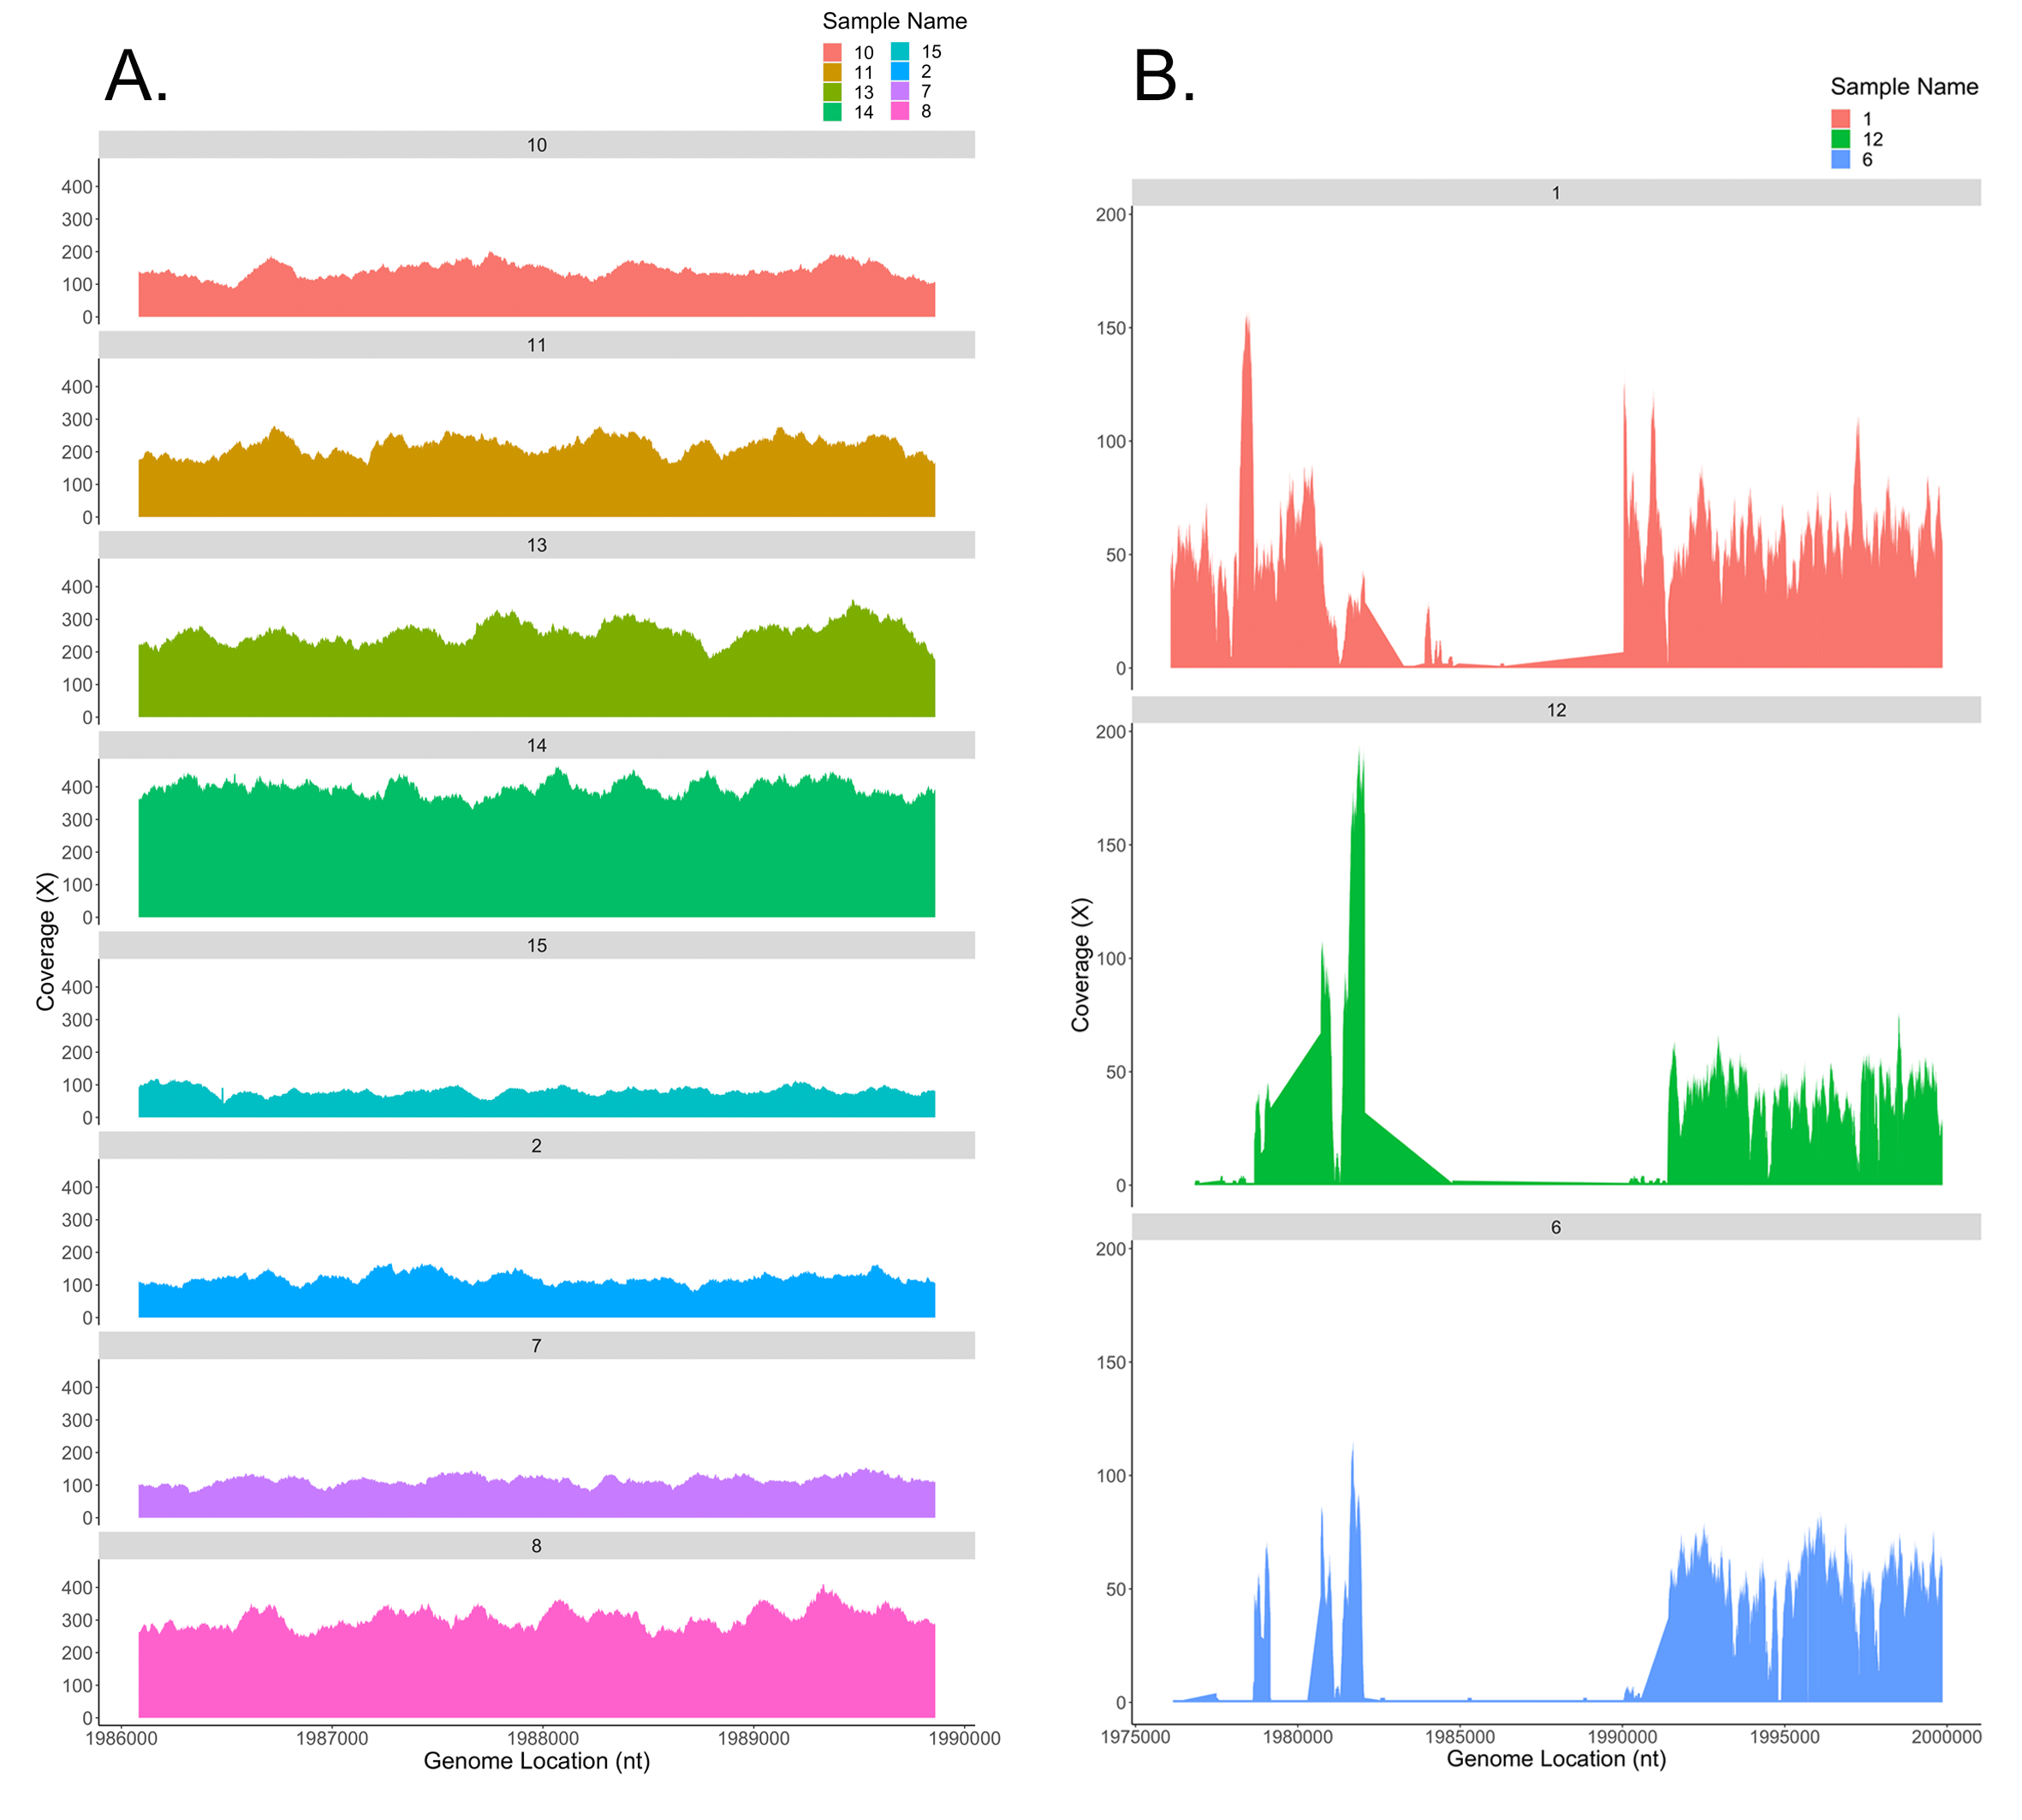
Figure S8. Coverage of the L. crispatus pulA gene and flanking regions in vaginal metagenomes dominated by L. crispatus. To further assess evidence of pulA gene presence/absence in vaginal metagenomes, we undertook read coverage analysis. Using unassembled reads, this approach served to confirm that our failure to detect pulA genes in some samples by BLASTn was due to low abundance/coverage, as opposed to assembly errors. (A) Depth of read coverage across the pulA gene (positions 1986082 to 1989861) when reads from each L. crispatus-dominated sample that produced a pulA BLASTn hit were mapped to the closed L. crispatus reference genome FFDAARGOS_743. Each sample that produced a pulA BLASTn hit displayed >100X coverage. (B) Read coverage of samples 1, 6 and 12, which all failed to produce a pulA BLASTn hit despite being dominated by L. crispatus, across a larger region consisting of 10,000 bases upstream and downstream of the pulA gene. High coverage regions, representative of what was seen across the broader L. crispatus reference genome (Tables S19–S20, Additional File 3), flanked a large low coverage area in the center of each graph that encompassed the pulA gene locus. This suggests a large genomic fragment that includes the pulA gene is missing in each of these genomes.

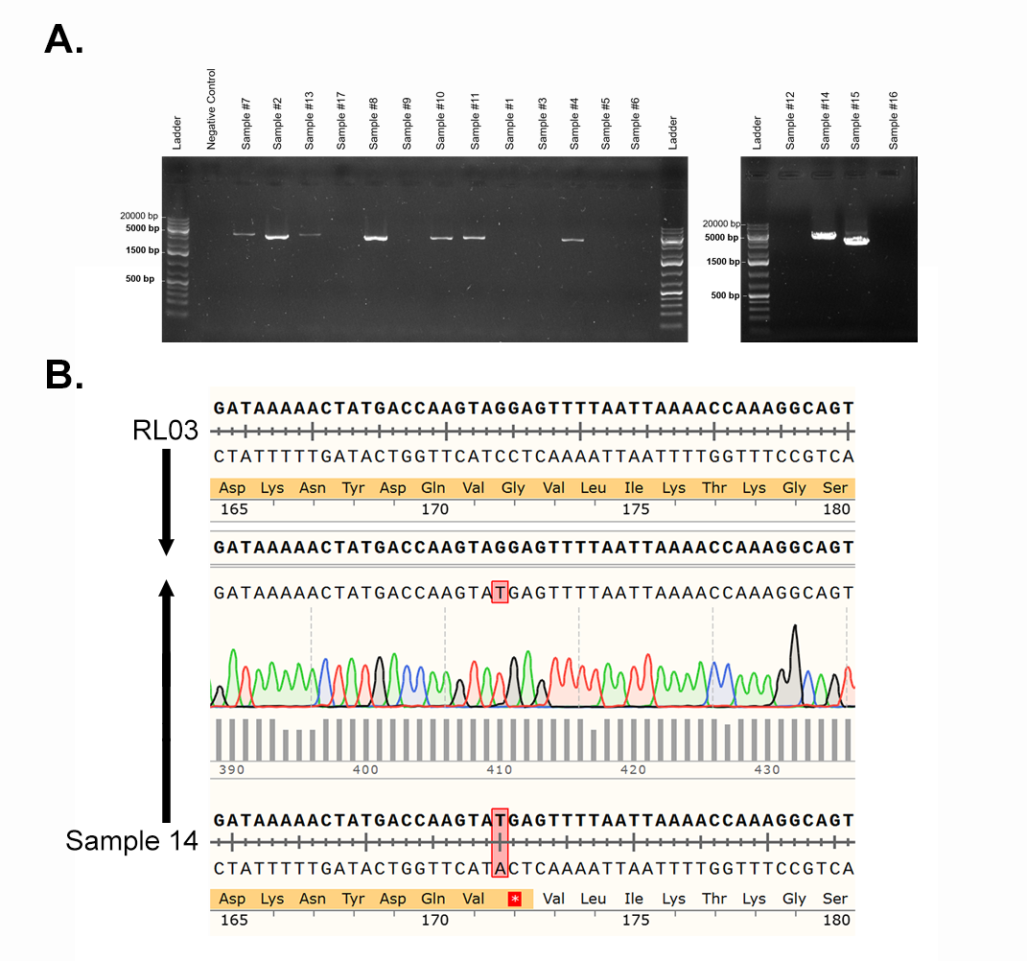
Figure S9. L. crispatus pulA gene amplification from vaginal swab samples. (A) Agarose gel (0.7%) electrophoresis of PCR products amplified using primers targeting nucleotides 74 to 3651 of the L. crispatus RL03 pulA gene (NCBI Accession: NZ_NKLQ01000285) with an expected product of 3578 bp. A ‘no DNA template’ negative control was included, as shown in lane #2 on the gel to the left. (B) Sanger sequencing traces generated by sequencing the pulA PCR product from Sample #14 from the 5’ end (primer binding at ~74 bp) and aligning to the RL03 reference. The G514T single nucleotide polymorphism observed in this sample’s metagenomic assembly was evident, resulting in a premature stop codon at amino acid 172. Significance levels: ns=not statistically significant, *p≤0.05, **p≤0.01, ***p≤0.001, ****p≤0.0001.

Figure S10. Glycogen and maltodextrin levels do not depend on whether L. crispatus encodes a functional pullulanase. Distribution of (A) glycogen (µg/ng protein) and (B) maltodextrin (µg/ng protein) levels in L. crispatus-dominated samples with a full-length pulA gene predicted to encode an active protein (N=7) and those missing or encoding a mutated pulA gene predicted to be inactivated (N=4). Data presented as median ± interquartile range and statistical significance between Lc Dominated samples with active vs. absent/inactive pulA was assessed with a Mann-Whitney U-test (glycogen ns p=0.788, maltodextrin ns p=0.788).

Figure S11. Amylase and α-glucosidase activities do not correlate with vaginal lactic acid. Scatterplots of D-lactic acid, L-lactic acid and total lactic acid measurements as a function of (A–C) amylopullulanase activity (Max RFU/sec/ng protein), (D–F) α-amylase activity (mU/ng protein), (G–I) human α-amylase concentration (mU/ng protein) or (J–L) α-glucosidase activity (mU/ng protein). Regression lines were fitted using a generalized linear model with error bars indicating 95% confidence intervals. Relationships were assessed with Spearman’s correlation, with the rho coefficient and p-value indicated above each scatterplot. Significance levels: ns=not statistically significant, *p≤0.05, **p≤0.01, ***p≤0.001, ****p≤0.0001.
Figure S12. Correlations of enzyme activity in vaginal swab supernatants. (A–C) Scatterplots of (A) pullulanase activity (U/ng protein), (B) α-amylase activity (mU/ng protein) or (C) α-glucosidase activity (mU/ng protein) as a function of amylopullulanase activity (Max RFU/sec/ng protein). (D,E) Scatterplots of (D) α-amylase activity (mU/ng protein) or (E) α-glucosidase activity (mU/ng protein) as a function of pullulanase activity (U/ng protein) or (F) α-glucosidase activity (mU/ng protein) as a function of α-amylase activity (mU/ng protein). Regression lines were fitted using a generalized linear model with error bars indicating 95% confidence intervals. Relationships were assessed with Spearman’s correlation, with the rho coefficient and p-value indicated above each scatterplot. Significance levels: ns=not statistically significant, *p≤0.05, **p≤0.01, ***p≤0.001, ****p≤0.0001.

