Supplementary Figures
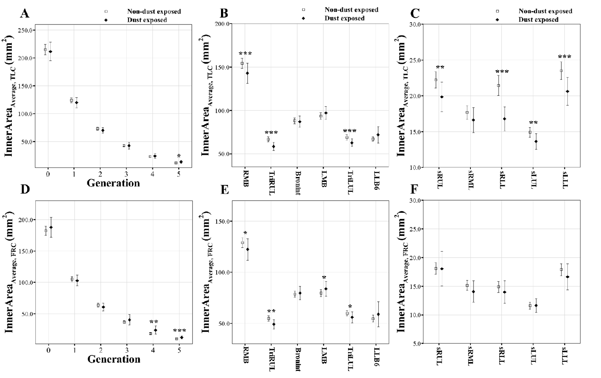
Supplementary Fig 1. Comparison of average inner area at TLC (A, B, and C) and FRC scans (D, E, and F) between non-dust-exposed subjects and dust-exposed subjects. Values are presented as mean (CI); *P<0.05; **P<0.01; ***P<0.001. Generation zero is started from trachea. BronInt, bronchus intermedius; FRC, functional residual capacity; LMB, left main bronchus; RMB, right main bronchus; sLLL, subgrouped left lower lobe; sLUL, subgrouped left upper lobe; sRLL, subgrouped right lower lobe; sRML, subgrouped right middle lobe; sRUL, subgrouped right upper lobe; TLC, total lung capacity; TriLUL, trifurcation of left upper lobe; TriRUL, trifurcation of right upper lobe.

Supplementary Tables
Supplementary Table 1. Comparison of demographic and QCT imaging functional variables between included and excluded dust-exposed subjects
Variables | Region | Included DE subjects  (n = 41) |  | Excluded DE subjects  (n = 22) |  | P value
Female, N (%) | - | 21 | (51.2%) | 0 | (0%) | <0.001
Age | - | 70.05 | (7.990) | 70.36 | (6.800) | 0.925
Height | - | 157.90 | (11.28) | 163.41 | (6.990) | 0.090
BMI | - | 24.13 | (2.780) | 23.31 | (2.660) | 0.462
Smoking status  (Non, Former, Current) | - | 26 / 5 / 10 |  | 2 / 4 / 16 |  | <0.001
Pack-years | - | 10.402 | (22.748) | 19.205 | (18.040) | <0.001
TLC, liter | Total | 3.477 | (0.979) | 4.471 | (0.770) | <0.001
FRC, liter | Total | 1.977 | (0.748) | 2.611 | (0.640) | <0.001
Emph% | Total | 0.010 | (0.013) | 0.020 | (0.010) | <0.001
fSAD% | Total | 0.080 | (0.107) | 0.117 | (0.080) | <0.01
Jacobian | Total | 1.617 | (0.351) | 1.587 | (0.370) | 0.574
Values are presented as mean (Standard deviation); DE, dust exposed; Emph%, percent emphysema; FRC, functional residual volume; fSAD%, percent functional small airway disease; IC, inspiratory capacity; TLC, total lung capacity; QCT, quantitative computed tomography;

Supplementary Table 2. Comparison of QCT imaging structural variables between included and excluded dust-exposed subjects
Variables | Region | Included DE subjects  (n = 41) |  | Excluded DE subjects  (n = 22) |  | P value
θ | RMB | 83.475 | (7.226) | 83.943 | (7.63) | 0.795
 | LMB | 79.955 | (9.554) | 77.001 | (7.53) | 0.267
 | TriLUL | 88.375 | (9.230) | 90.117 | (12.12) | 0.564
ε^{θ} | RMB | 0.082 | (0.065) | 0.048 | (0.07) | 0.052
 | TriLUL | 0.027 | (0.098) | 0.059 | (0.12) | 0.509
D_{h}* (TLC) | RMB | 0.720 | (0.077) | 0.719 | (0.08) | 0.965
 | sRUL | 0.265 | (0.045) | 0.269 | (0.04) | 0.818
 | sRLL | 0.243 | (0.039) | 0.250 | (0.04) | 0.584
 | sLLL | 0.269 | (0.042) | 0.258 | (0.04) | 0.320
D_{h}* (FRC) | RMB | 0.645 | (0.073) | 0.640 | (0.06) | 0.920
WT* (TLC) | sRUL | 0.584 | (0.047) | 0.593 | (0.04) | 0.341
 | sRML | 0.562 | (0.044) | 0.580 | (0.04) | 0.102
 | sRLL | 0.563 | (0.044) | 0.587 | (0.03) | 0.025
 | sLUL | 0.545 | (0.037) | 0.543 | (0.04) | 0.818
 | sLLL | 0.595 | (0.035) | 0.592 | (0.03) | 0.920
WT* (FRC) | sRUL | 0.578 | (0.051) | 0.588 | (0.05) | 0.453
 | sRML | 0.563 | (0.045) | 0.569 | (0.04) | 0.526
 | sRLL | 0.565 | (0.045) | 0.571 | (0.03) | 0.624
 | sLUL | 0.533 | (0.042) | 0.540 | (0.03) | 0.564
 | sLLL | 0.582 | (0.048) | 0.577 | (0.03) | 0.564
ε^{WT} | RMB | 18.488 | (24.273) | 10.654 | (21.812) | 0.205
 | sRML | 0.015 | (6.861) | 2.117 | (5.878) | 0.245
 | sRLL | -0.091 | (6.396) | 2.770 | (5.037) | 0.084
 | sLUL | 2.548 | (6.457) | 0.644 | (5.988) | 0.445
Values are presented as mean (SD); DE, dust exposed; θ, alteration of airway structure; FRC, functional residual volume; TLC, total lung capacity; QCT, quantitative computed tomography; LMB, left main bronchus; RMB, right main bronchus; sLLL, subgrouped left lower lobe; sLUL, subgrouped left upper lobe; sRLL, subgrouped right lower lobe; sRML, subgrouped right middle lobe; sRUL, subgrouped right upper lobe; TriLUL, trifurcation of left upper lobe. *, value nomarlized by sex, age, and height.

