Supplementary Information

Fluid shear stress facilitates prostate cancer metastasis through Piezo1-Src-YAP/TAZ axis
Ok-Hyeon Kim^{1,2}, Young Wook Choi³, Soon Auck Hong⁴, Mineui Hong⁴, In Ho Chang^{3,#}, Hyun Jung Lee^{1,2,#}
¹Department of Anatomy and Cell Biology, College of Medicine, Chung-Ang University, Seoul, 06974, South Korea
²Department of Global Innovative Drugs, Graduate School of Chung-Ang University, Seoul, 06974, South Korea
³Department of Urology, Chung-Ang University Hospital, Chung-Ang University College of Medicine, Seoul, 06974, South Korea
⁴Department of Pathology, College of Medicine, Chung-Ang University, Seoul, 06974, South Korea

Table1. qRT-PCR Primer sequences

Gene | Forward | Reverse
Piezo1 | 5′-ATGTTGCTCTACACCCTGACC-3′ | 5′-CCAGCACACACATAGATCCAGT-3′
AMOTL2 | 5′-ATTGAGAAGCTGGAAAGCGA-3′ | 5′-GGTTGAAGTCTTGCAGCCTC-3′
ANKRD1 | 5′-AGTAGAGGAACTGGTCACTGG-3′ | 5′-TGGGCTAGAAGTGTCTTCAGAT-3′
CTGF | 5′-CAAGGGCCTCTTCTGTGACT-3′ | 5′-ACGTGCACTGGTACTTGCAG-3′
KRT80 | 5′-GCTGCTCTTGCCATAATCAA-3′ | 5′-AATGCTCCTGCCCAATCTC-3′
PLOD2 | 5′-GCGTTCTCTTCGTCCTCATC-3′ | 5′-CATGAAGCTCCAGCCTTTTC-3′
GAPDH | 5′-CAGCCTCAAGATCATCAGCA-3′ | 5′-TGTGGTCATGAGTCCTTCCA-3′

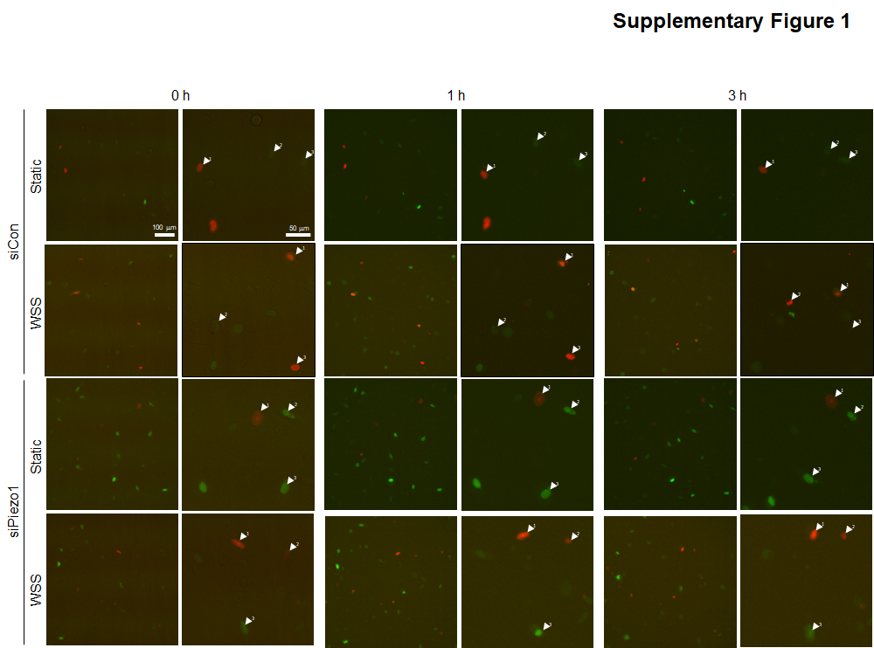

Supplementary Figure 1.
FUCCI images following WSS stimulation with or without Piezo1 siRNA captured at 0, 1, and 3 h, while monitoring the cell cycle of living cells in real time. Representative images are indicated by white arrows and numbers in the enlarged still images. Cell cycle profiles are color-coded: G1, red; early S, yellow; and late S/G2/M, green. Scale bars represent 100 μm and 50 μm.

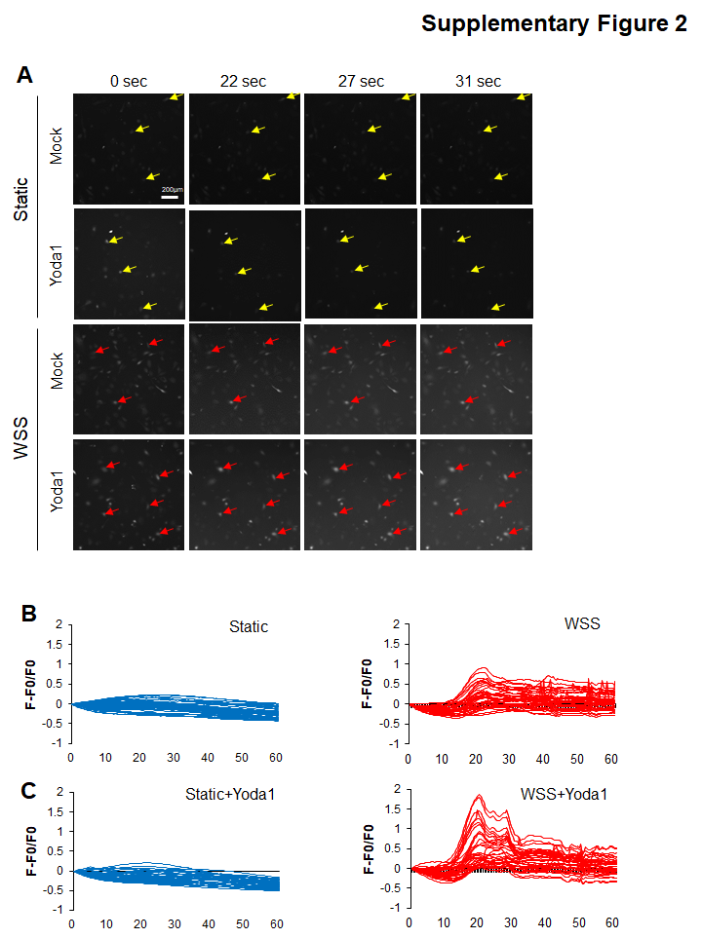
Supplementary Figure 2.
(A) Intracellular Ca²⁺ concentration monitored using Fluo-4AM with WSS. Vehicle or Yoda1 was administered 1 h prior to WSS application (n=3 independent experiments, >3 replicates per experiment). WSS was initiated 20 s after starting image acquisition. Yellow and red arrows indicate flashed cells. Scale bar represents 200 μm. (B) Quantification of Fluo-4AM intensity by NIS Elements imaging software captures multiple spikes in calcium flux following the application of WSS.

