Synthesis, Characterization, and Reaction of Divinyl-substituted Laddersiloxanes

Yujia Liu,^{a,b} Aimi Endo,^{b} Peiyao Zhang,^{c} Akira Takizawa,^{b} Nobuhiro Takeda, ^{b} Armelle Ouali,*^{a,c} Masafumi Unno*^{a,b}
a. Gunma University Initiative for Advanced Research (GIAR)-International Open Laboratory with Institute Charles Gerhardt Montpellier (UMR5253 CNRS-UM-ENSCM), France. Gunma University, Kiryu 376-8515, Japan
- Department of Chemistry and Chemical Biology, Graduate School of Science and Technology. Gunma University, Kiryu 376-8515, Japan
- Institut Charles Gerhardt Montpellier, UMR 5253 CNRS-UM-ENSCM. ENSCM, 8 rue de l’Ecole Normale, 34296 Montpellier Cedex 05, France

Supporting information

Table of contents | Pages
General considerations | S2
Experimental procedures and characterization data for synthetic compounds 3a, 3b, 4a, 4b, 5 and 5’ | S3
¹H, ¹³C and ²⁹Si-NMR spectra for synthetic compounds 3a, 3b, 4a, 4b, 5 and 5’ | S8
X-ray diffraction and crystallography for compound 5’ | S17

General considerations
All reactions were performed under an argon atmosphere using the standard Schlenk except particular precision. THF and toluene were dried using mBRAUN purification system. Triethylamine was distilled from potassium hydroxide, stored on potassium hydroxide under an argon atmosphere with protection from light. Trimethoxyphenylsilane was purchased from Kanto Chemical Co., Inc.; isobutyl(trimethoxy)silane and Karstedt’s catalyst (in xylene, 2% Pt) were purchased from Sigma-Aldrich; dichlorophenylvinylsilane was purchased from Gelest, Inc.; dichloromethylvinylsilane was purchased from TCI Co., Ltd. and dimethylphenylsilane was purchased from Fujifilm Wako Pure Chemical Co. Chemical Reagents. All of these reagents were used as received, without further purification.

The Fourier transformation nuclear magnetic resonance (NMR) spectra were obtained using a JEOL JNM-ECS 300 (¹H at 300.53 MHz, ¹³C at 75.57 MHz, ²⁹Si at 59.71 MHz), JEOL JNM-ECA 400 (¹H at 399.78 MHz) and JEOL JNM-ECA 600 (¹H at 600.17 MHz, ¹³C at 150.91 MHz, ²⁹Si at 119.24 MHz) NMR instruments. For ¹H NMR, chemical shifts are reported as δ units (ppm) relative to SiMe₄ (TMS) and the residual solvents peaks were used as standards. For ¹³C NMR and ²⁹Si NMR, chemical shifts are reported as δ units (ppm) relative to SiMe₄ (TMS), the residual solvents peaks were used as standards and spectra were obtained with complete proton decoupling. MALDI-TOF mass analysis were carried out with a Shimadzu AXIMA Performance instrument using 2,5-dihydroxybenzoic acid (dithranol) as the matrix and AgNO₃ as the ion source. All reagents used were of analytical grade. Element analyses were performed by the Center for Material Research by Instrumental Analysis (CIA), Gunma University, Japan. TGA was carried out with a Rigaku thermogravimetric analyzer (Thermoplus TG-8120). The investigations were carried out under a nitrogen flow (250 mL min⁻¹) with a heating rate 10 ˚C min⁻¹. All samples were measured with temperatures ranging from 50 to 1000 ˚C, where they remained for 5 min. The weight loss and heating rate were continuously recorded along the experiment.

Experimental procedures and characterization data for synthetic compounds 3a, 3b, 4a, 4b, 5 and 5’

(1R,3S,7R,9S)-5,11-dimethyl-5,11-divinyl-2,4,6,8,10,12,13,14-octaoxa-1,3,5,7,9,11-hexasilatricyclo[7.3.1.1^{3,7}]tetradecane (3a):

An argon-purged, three-necked, round bottom flask equipped with a stir bar and an addition-funnel was charged with all-cis-tetraphenyl-cyclotetrasiloxanetetraol (1a)¹ (5.53 g, 10.0 mmol), triethylamine (6.0 mL, 42 mmol) and anhydrous THF (200 mL). Dichlorovinylmethylsilane 2a (2.8 mL, 21 mmol) and anhydrous THF (300 mL) were introduced into an addition-funnel under argon atmosphere. Then the solution of diallyldichlorosilane was added dropwise into the flask at 0 °C (addition time: 3.5 h). After the addition, the reaction mixture was allowed to stir at 25 °C for additional 1 hour. And then the saturated NH₄Cl solution was added into the reaction medium to neutralize triethylamine and CHCl₃ was added to extract the product. The organic layer was then washed with brine 3 times, dried over with anhydrous Na₂SO₄ and concentrated on the rotavapor to afford a slight yellowish solid which was washed with cold hexane to give the desired product 5.032 g (73% yield).
¹H NMR (300.53 MHz, CDCl₃): δ = 0.43-0.55(m, 6H), 5.90-6.25 (m, 6H), 7.37-7.45 (m, 12H), 7.69-7.73 (m, 8H).
¹³C{¹H} NMR (150.91 MHz, CDCl₃): δ = -0.78, -0.52, -0.51, -0.50, -0.44, 128.03, 128.08, 128.10, 130.18, 130.24, 130.34, 130.37, 131.06, 131.09, 134.25, 134.35, 134.49, 135.41, 135.58, 136.17, 136.47 ppm.
²⁹Si{¹H} NMR (59.71 MHz, CDCl₃): δ = -18.54, -18.65, -19.09, -19.23, -67.77, -67.85 ppm.
MALDI-TOF MS (m/z): 711.40 ([M+Na]⁺, calcd 711.06).
Elemental analysis: Calcd for C₃₀H₃₂O₈Si₆・2H₂O: C, 49.69; H, 5.00. Found: C, 49.72; H, 4.63.

(1R,3S,7R,9S)-1,3,7,9-tetraisobutyl-5,11-dimethyl-5,11-divinyl-2,4,6,8,10,12,13,14-octaoxa-1,3,5,7,9,11-hexasilatricyclo[7.3.1.13,7]tetradecane (3b):

An argon-purged, three-necked, round bottom flask equipped with a stir bar and an addition-funnel was charged with all-cis-tetraisobutyl-cyclotetrasiloxanetetraol (1b)² (2.36 g, 5.0 mmol), triethylamine (3.0 mL, 21 mmol) and anhydrous THF (100 mL). Dichloromethylvinylsilane 2a (1.4 mL, 10.5 mmol) and anhydrous THF (150 mL) were introduced into an addition-funnel under argon atmosphere. Then the solution of diallyldichlorosilane was added dropwise into the flask at 0 °C (addition time: 2.0 h). After the addition, the reaction mixture was allowed to stir at 25 °C for additional 1 hour. And then the saturated NH₄Cl solution was added into the reaction medium to neutralize triethylamine and CHCl₃ was added to extract the product. The organic layer was then washed with brine 3 times, dried over with anhydrous Na₂SO₄ and concentrated on the rotavapor. The crude product was washed passed through a column chromatography to give a yellow oil 2.839 g (93% yield).
¹H NMR (600.17 MHz, CDCl₃): δ = 0.20-0.32 (m, 6H), 0.56-0.69 (m, 8H), 0.94-0.99 (m, 24H), 1.84-1.92 (m, 4H), 5.88-6.08 (m, 6H).
¹³C{¹H} NMR (150.91 MHz, CDCl₃): δ = -1.05, -0.77, -0.51, -0.40, 23.07, 23.10, 23.14, 23.86, 23.91, 24.19, 25.90, 25.93, 26.04, 26.16, 134.29, 134.46, 134.95, 135.27, 135.34, 135.66, 135.69, 135.87 ppm.
²⁹Si{¹H} NMR (119.24 MHz, CDCl₃): δ = -20.51, -20.56, -20.89, -21.03, -55.51, -55.62, -55.66 ppm.
Elemental analysis: Calcd for C₂₂H₄₈O₈Si₆・0.6H₂O: C, 42.62; H, 8.00. Found: C, 42.63; H, 8.08.

(1R,3S,7R,9S)-1,3,5,7,9,11-hexaphenyl-5,11-divinyl-2,4,6,8,10,12,13,14-octaoxa-1,3,5,7,9,11-hexasilatricyclo[7.3.1.1^{3,7}]tetradecane (4a):

An argon-purged, three-necked, round bottom flask equipped with a stir bar and an addition-funnel was charged with all-cis-tetraphenyl-cyclotetrasiloxanetetraol (1a) (2.76 g, 5.0 mmol), triethylamine (2.93 mL, 21 mmol) and anhydrous THF (100 mL). Dichlorovinylphenylsilane 2b (1.8 mL, 10.5 mmol) and anhydrous THF (150 mL) were introduced into an addition-funnel under argon atmosphere. Then the solution of dichlorovinylphenylsilane was added dropwise into the flask at 0 °C (addition time: 2.0 h). After the addition, the reaction mixture was allowed to stir at 25 °C for additional 1 hour. And then the saturated NH₄Cl solution was added into the reaction medium to neutralize triethylamine and CHCl₃ was added to extract the product. The organic layer was then washed with brine 3 times, dried over with anhydrous Na₂SO₄ and concentrated on the rotavapor to afford a slight yellowish solid which was washed with cold hexane to give the desired product 3.05 g (75 % yield).
¹H NMR (300.53 MHz, CDCl₃): δ = 5.33-6.25 (m, 6H), 7.73-7.00 (m, 30H).
¹³C{¹H} NMR (150.91 MHz, CDCl₃): δ = 127.92, 127.94, 127.95, 128.04, 128.11, 128.18, 130.13, 130.72, 131.06, 131.13, 131.18, 133.38, 134.07, 134.21, 134.39, 134.44, 134.54 ppm.
²⁹Si{¹H} NMR (59.71 MHz, CDCl₃): δ = -33.09, -33.15, -33.23, -33.71, -67.01, -67.47, -67.53, -67.74 ppm.
MALDI-TOF MS (m/z): 835.61 ([M+Na]⁺, calcd 835.09).
Elemental analysis: Calcd for C₄₀H₃₆O₈Si₆・5/2H₂O: C, 55.98; H, 4.82. Found: C, 55.98; H, 4.44.

(1R,3S,7R,9S)-5,11-dimethyl-5,11-divinyl-2,4,6,8,10,12,13,14-octaoxa-1,3,5,7,9,11-hexasilatricyclo[7.3.1.1^{3,7}]tetradecane (4b):

An argon-purged, three-necked, round bottom flask equipped with a stir bar and an addition-funnel was charged with all-cis-tetraisobutyl-cyclotetrasiloxanetetraol (1b) (2.36 g, 5.0 mmol), triethylamine (3.0 mL, 21 mmol) and anhydrous THF (100 mL). Dichlorovinylphenylsilane 2b (1.8 mL, 10.5 mmol) and anhydrous THF (150 mL) were introduced into an addition-funnel under argon atmosphere. Then the solution of diallyldichlorosilane was added dropwise into the flask at 0 °C (addition time: 2.0 h). After the addition, the reaction mixture was allowed to stir at 25 °C for additional 1 hour. And then the saturated NH₄Cl solution was added into the reaction medium to neutralize triethylamine and CHCl₃ was added to extract the product. The organic layer was then washed with brine 3 times, dried over with anhydrous Na₂SO₄ and concentrated on the rotavapor. The crude product was washed passed through a column chromatography to give a yellow oil 3.103 g (85% yield).
¹H NMR (600.17 MHz, CDCl₃): δ = 0.64-0.79 (m, 8H), 0.86-1.05 (m, 24H), 1.82-1.99 (m, 4H), 5.15-5.39 (m, 1H), 5.89-6.25 (m, 5H), 6.93-6.96 (m, 1H), 7.17-7.43 (m, 6H), 7.54-7.74 (m, 3H).
¹³C{¹H} NMR (150.91 MHz, CDCl₃): δ = 23.05, 23.11, 23.28, 23.33, 23.85, 23.91, 23.94, 25.84, 25.86, 25.89, 25.93, 25.97, 26.01, 26.04, 127.73, 127.81, 127.95, 128.02, 130.34, 130.40, 130.52, 132.64, 134.02, 134.07, 134.29, 134.49, 134.73, 135.73, 135.90, 136.82 ppm.
²⁹Si{¹H} NMR (119.24 MHz, CDCl₃): δ = -35.15, -35.29, -35.89, -55.24, -55.74, -55.79, -56.01 ppm.
MALDI-TOF MS (m/z): 756.19 ([M+Na]⁺, calcd 756.26).
Elemental analysis: Calcd for C₃₂H₅₂O₈Si₆・1.2H₂O: C, 50.92; H, 7.26. Found: C, 50.92; H, 7.21.

(1R,3S,5r,7R,9S,11r)-5,11-bis(2-(dimethyl(phenyl)silyl)ethyl)-1,3,5,7,9,11-hexaphenyl-2,4,6,8,10,12,13,14-octaoxa-1,3,5,7,9,11-hexasilatricyclo[7.3.1.13,7]tetradecane (5’):

An argon-purged, schlenk flask equipped with a stir bar was charged with 4a (0.24 g, 0.30 mmol), dimethylphenylsilane (0.14 mL, 0.90 mmol) and anhydrous toluene (1.8 mL). Karstedt catalyst (2% Pt, commercial bottle, diulated 100 times in anhydrous toluene under argon, 171 μL, 0.15 μmol Pt) was added into the mixture under argon atomosphere at 25 ℃. After the addition, the mixture was heated to 65 ℃ and allowed to stir at 65 ˚C for 16 h. After the reaction, the reaction mixture was cooled down to room temperature and passed through a silica plug which washed with toluene and dichloromethane. The solvents were removed on the rotavapor to give the crude product (5) of 3 isomers mixture (354 mg). The crude product 5 was washed with cold hexane and after filtration, a yellow sticky solid (A, not soluble in cold hexane) and a clear filtrate (B) were obtained. The filtrate B was decanted at room temperture and a white solid was precipitated. After filtration, 1 pure isomer 5’ was obtained as a white solid (61 mg, 19% yield). The single crystal for X-ray analysis was obtained from chloroform and hexane.
¹H NMR (399.78 MHz, CDCl₃): δ = 0.07 (s, 12H), 0.57-0.61 (m, 4H), 0.76-0.80 (m, 4H), 6.97 (t, J = 7.56 Hz, 4H), 7.19-7.33 (m, 20H), 7.42-7.49 (m, 8H), 7.66 (d, J = 6.64 Hz, 8H) ppm.
¹³C NMR (150.19 MHz, CDCl₃): δ = -3.68, 6.72, 8.43, 127.81, 127.93, 128.07, 128.93, 130.46, 130.49, 131.08, 132.86, 133.67, 133.70, 134.38, 138.91 ppm.
²⁹Si NMR (119.24 MHz, CDCl₃): δ = -0.58, -18.89, -66.63 ppm.
MALDI-TOF MS (m/z): 1108.84 ([M+Na]⁺, calcd 1108.76).
Elemental analysis: Calcd for C₅₆H₆₀O₈Si₈: C, 61.95; H, 5.57. Found: C, 61.67; H, 5.60.

¹H, ¹³C and ²⁹Si-NMR Spectra for synthetic compounds 3a, 3b, 4a, 4b, 5 and 5’
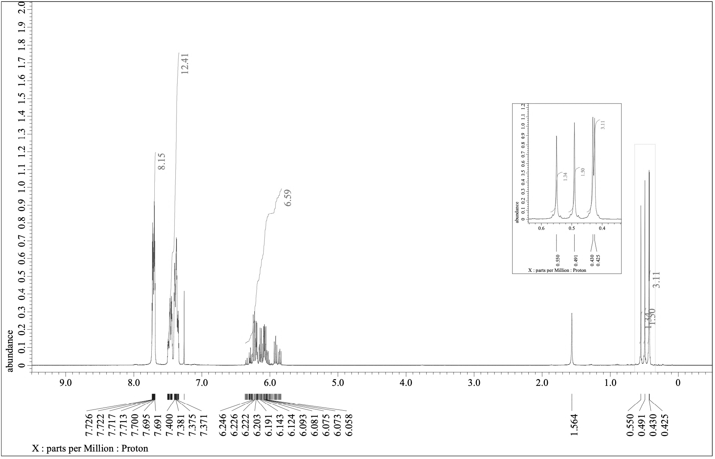
3a
¹H NMR (300.53 MHz, CDCl₃)

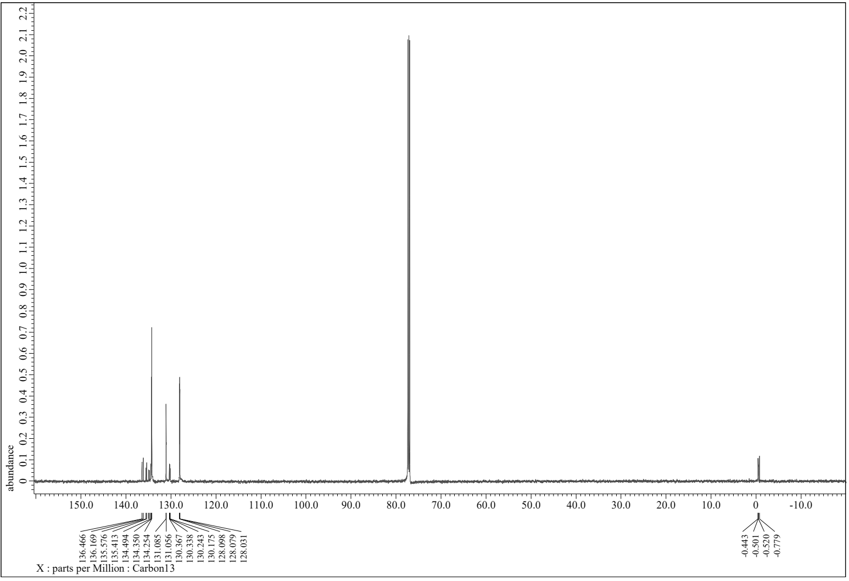
3a
¹³C NMR (150.91 MHz, CDCl₃)

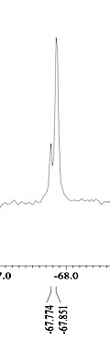
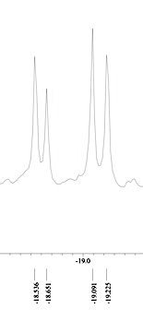
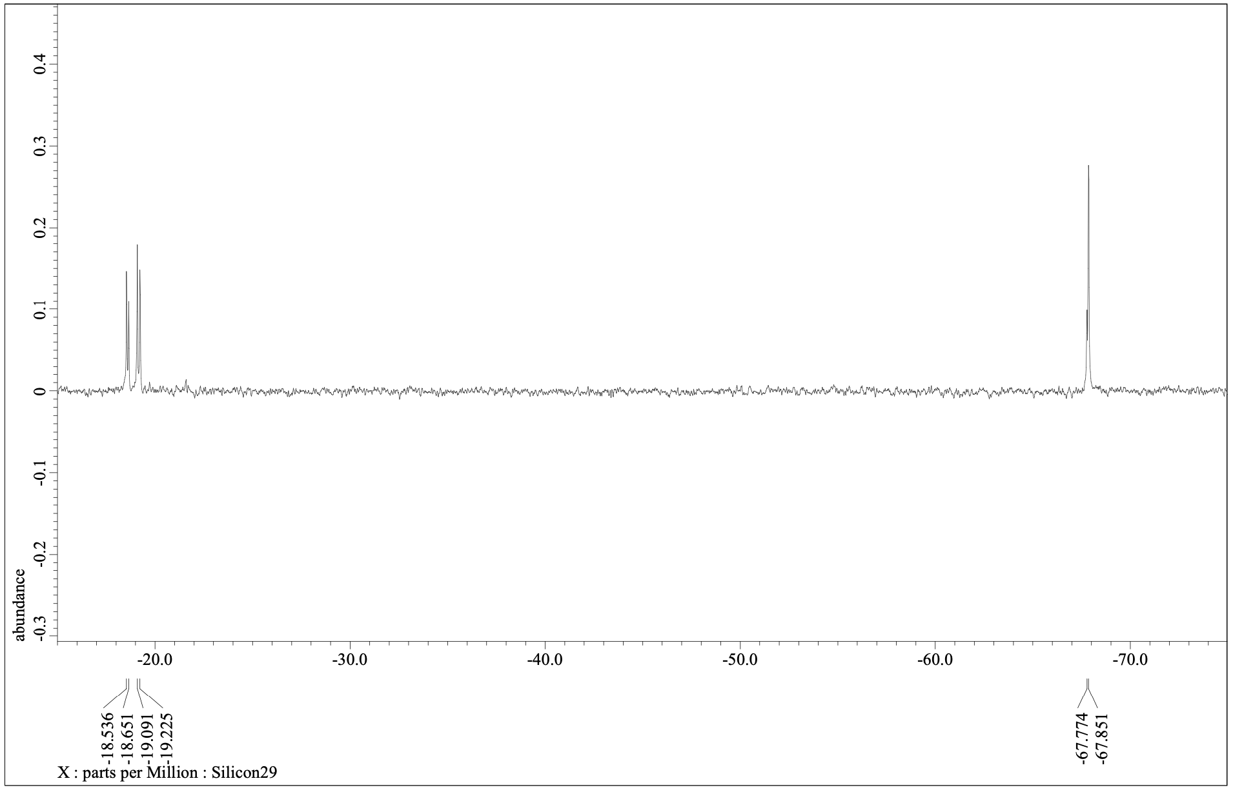
3a
-Si-
-Si-
²⁹Si NMR (59.71 MHz, CDCl₃)

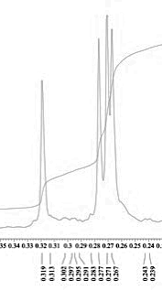
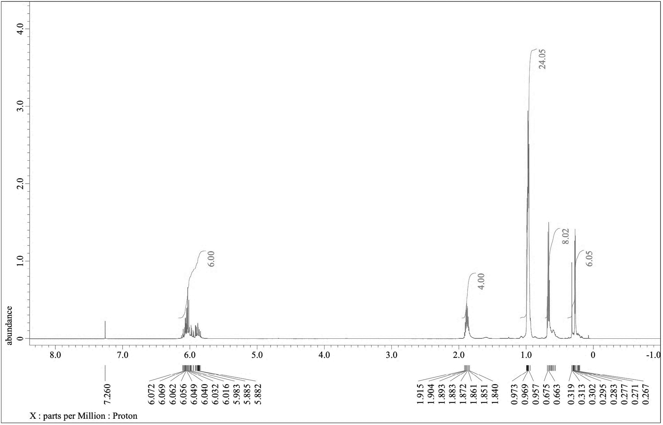
3b
¹H NMR (600.17 MHz, CDCl₃)

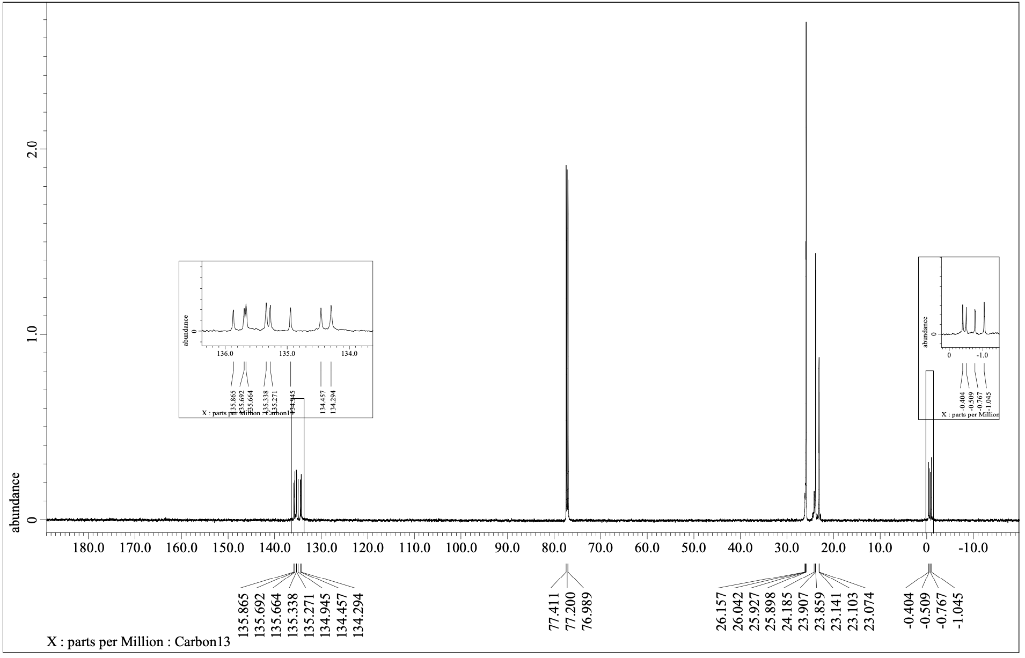
3b
¹³C NMR (150.91 MHz, CDCl₃)

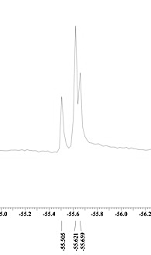
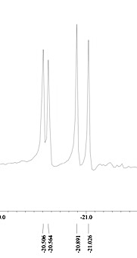
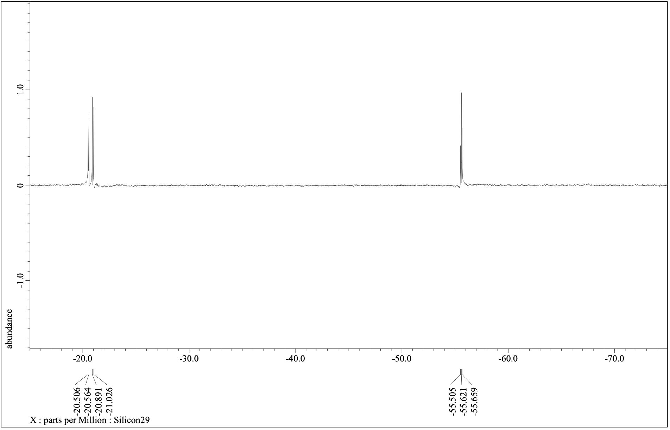
3b
-Si-
-Si-
²⁹Si NMR (119.24 MHz, CDCl₃)
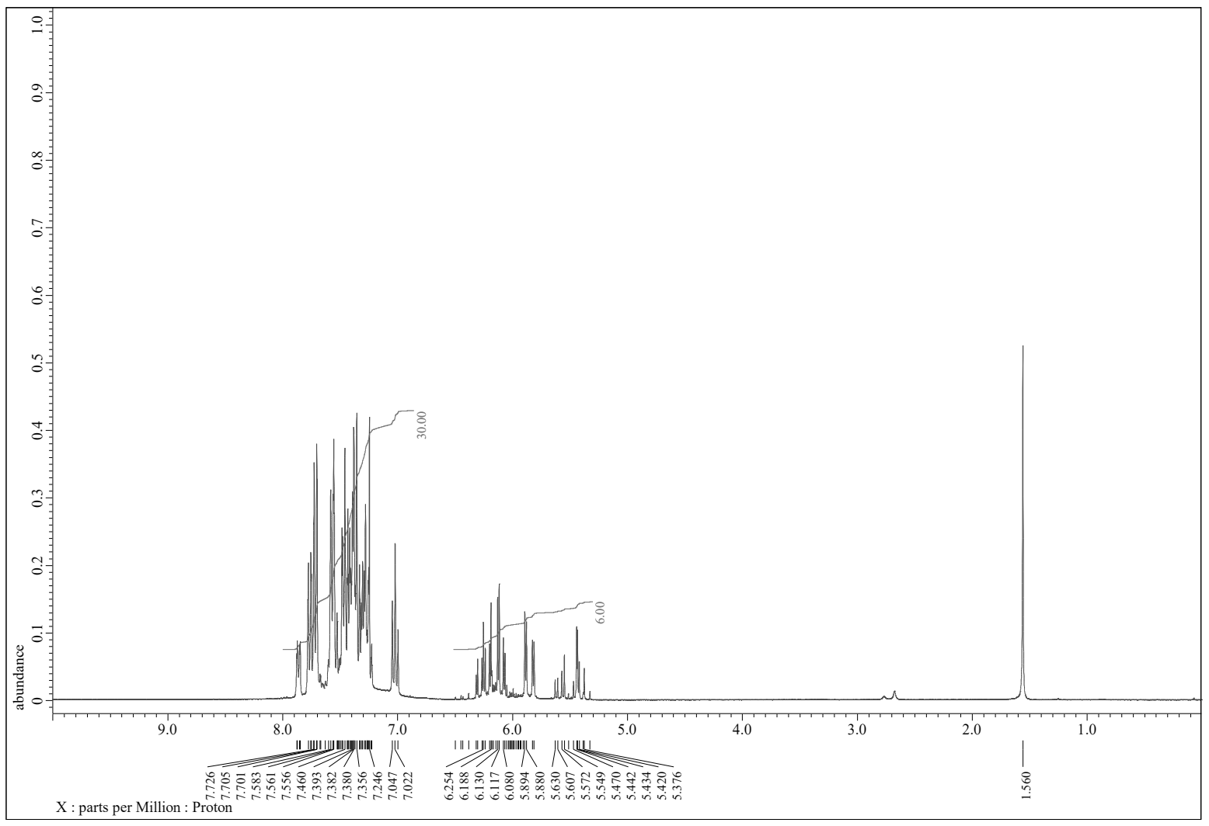
4a
¹H NMR (300.53 MHz, CDCl₃)

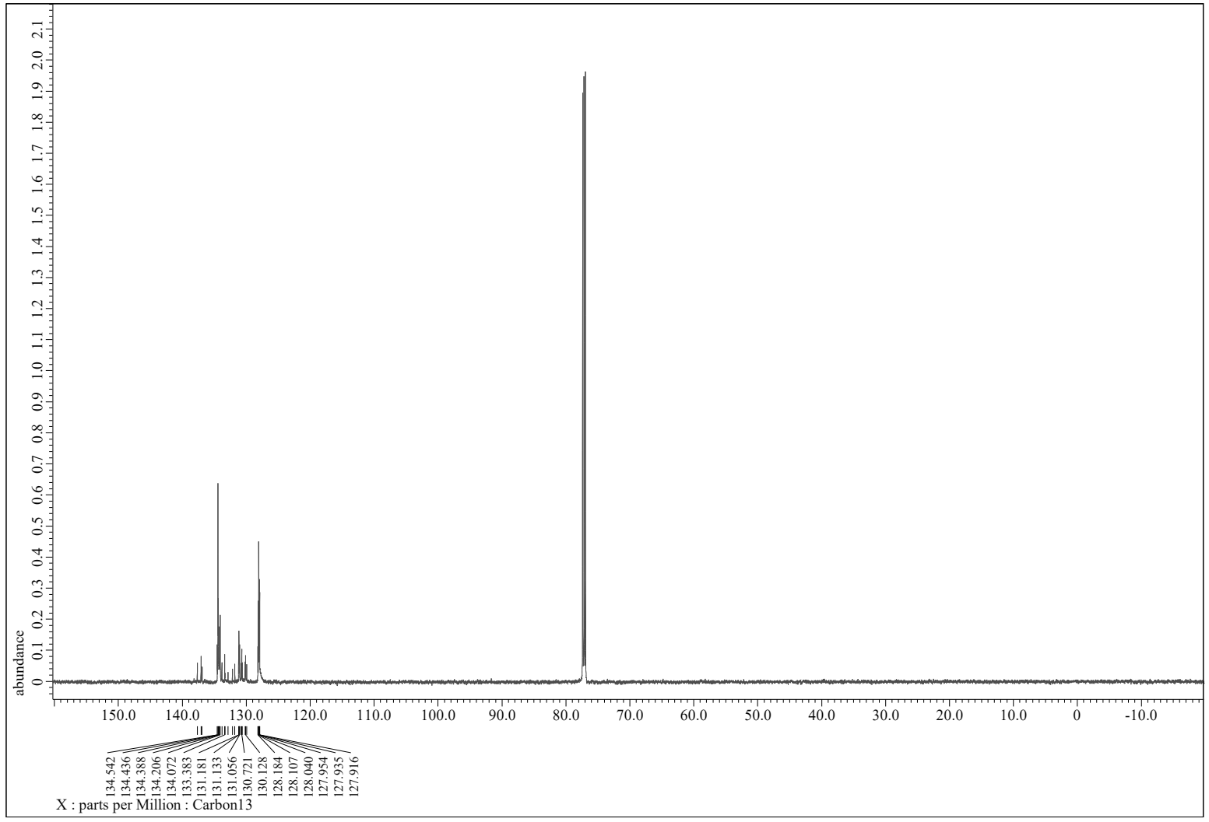
4a
¹³C NMR (150.91 MHz, CDCl₃)

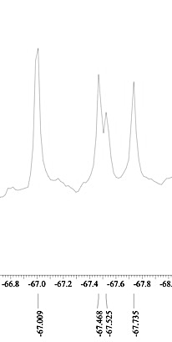
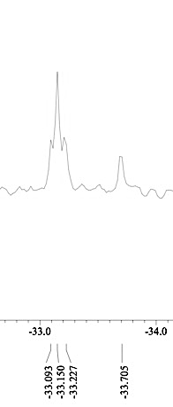
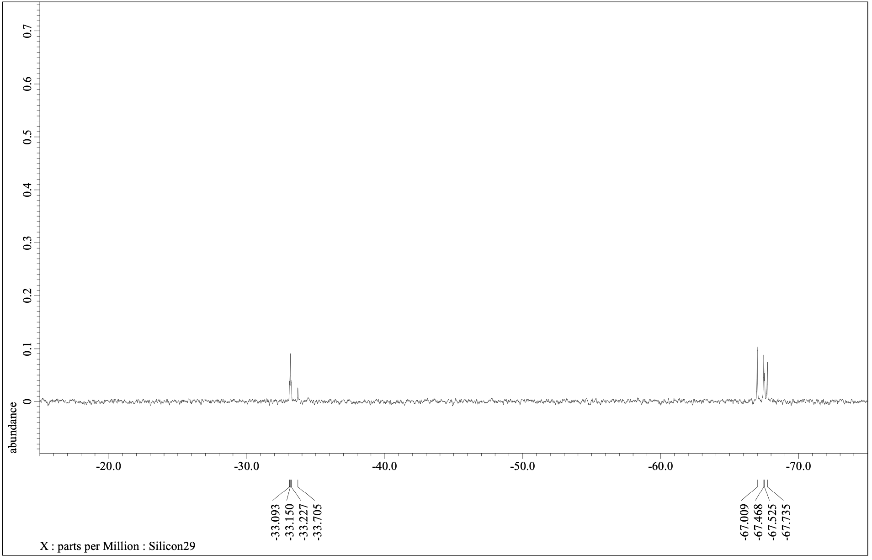
4a
-Si-
-Si-
²⁹Si NMR (59.71 MHz, CDCl₃)

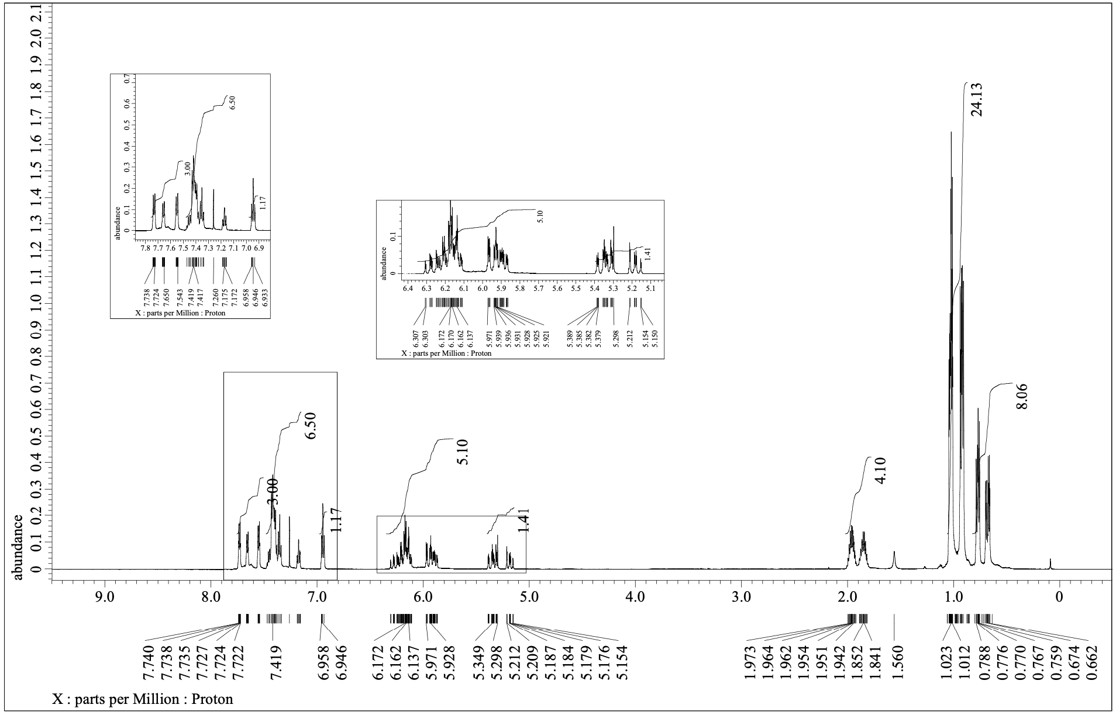
4b
¹H NMR (600.17 MHz, CDCl₃)
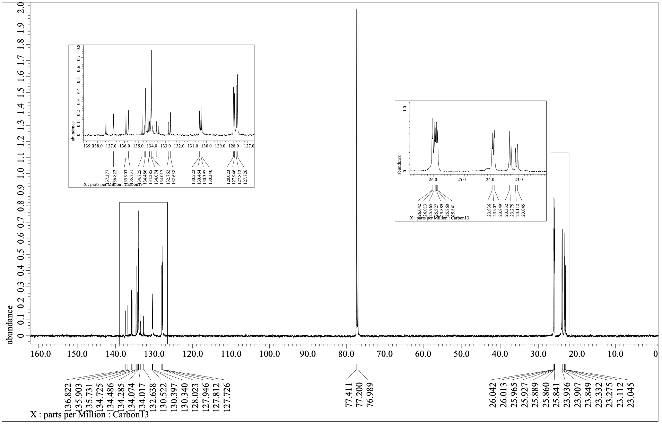
4b
¹³C NMR (150.91 MHz, CDCl₃)

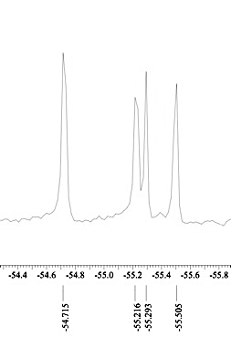
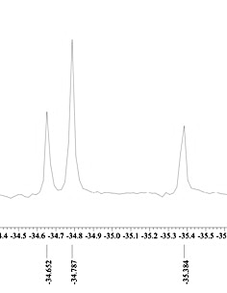
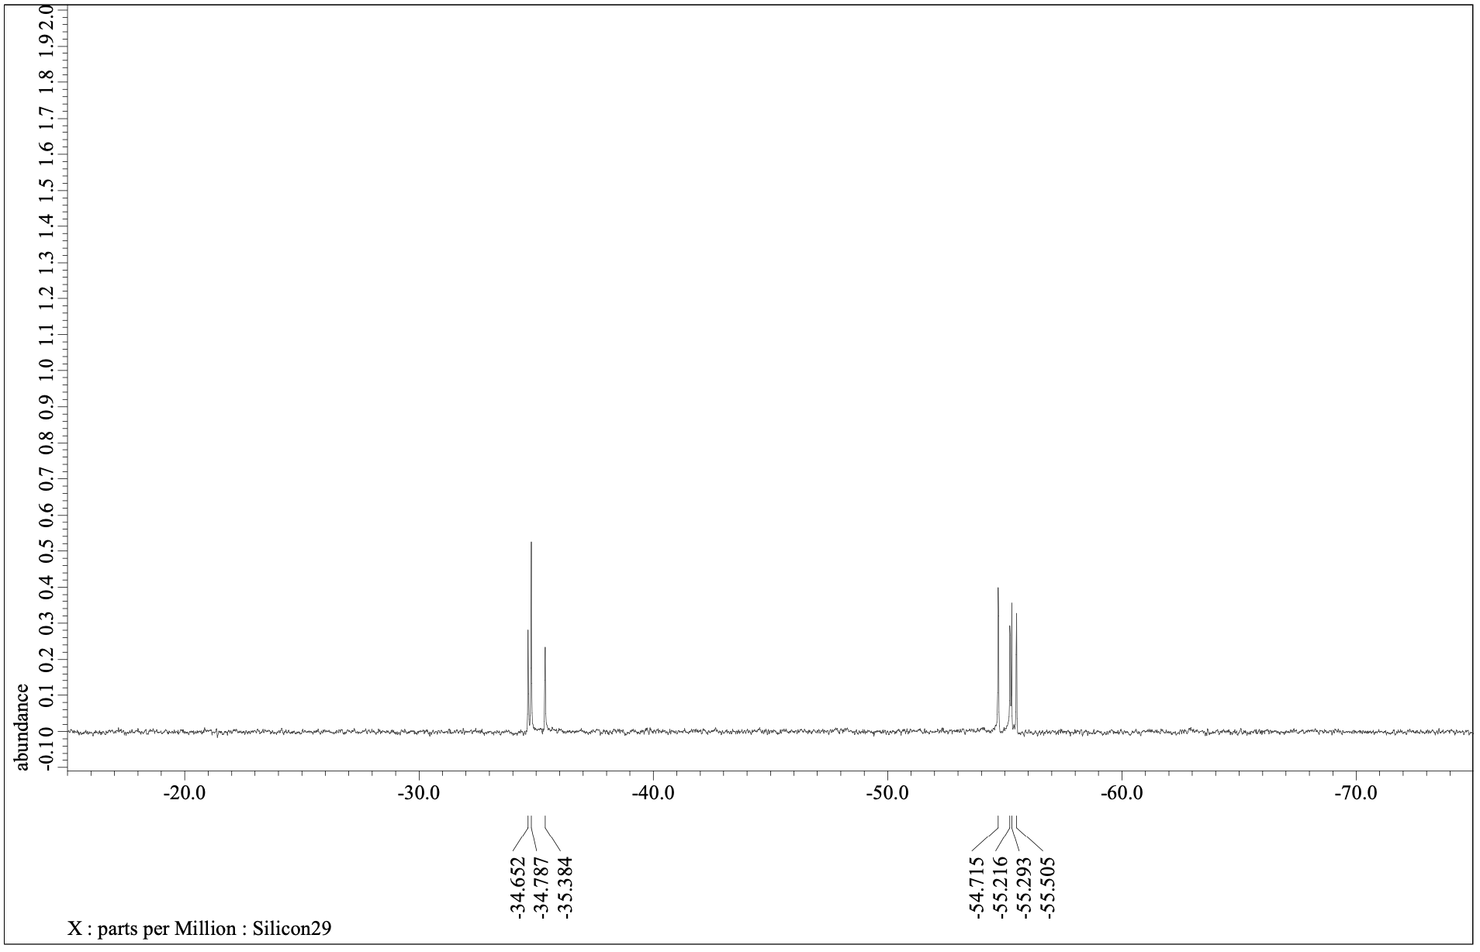
4b
-Si-
-Si-
²⁹Si NMR (119.24 MHz, CDCl₃)

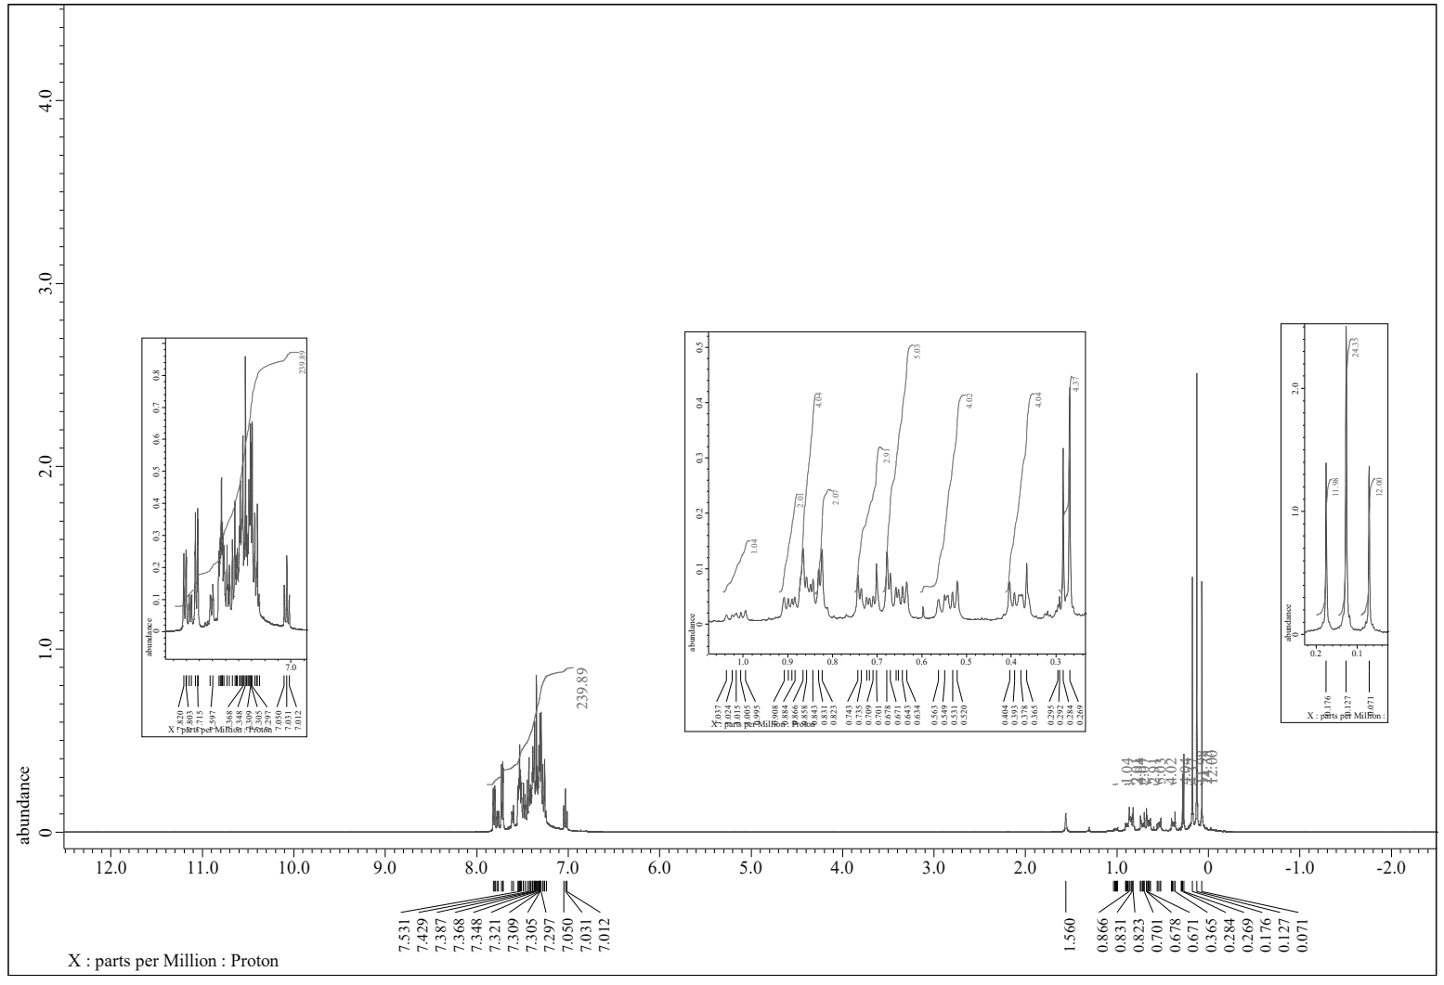
5
¹H NMR (399.78 MHz, CDCl₃)

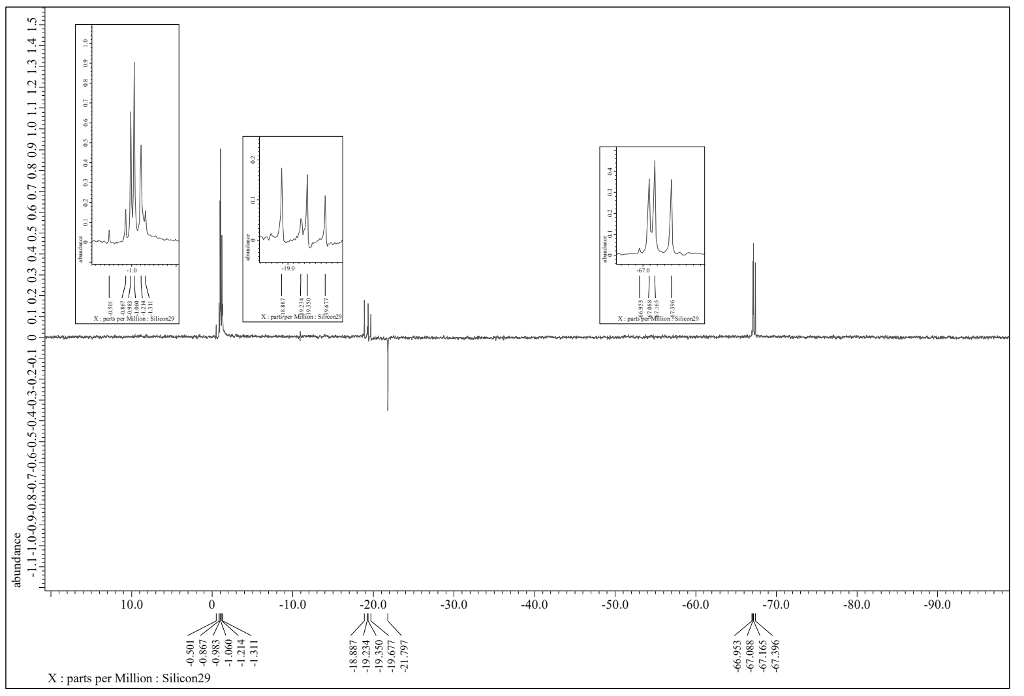
5
-Si-
-Si-
-Si-
²⁹Si NMR (119.24 MHz, CDCl₃)

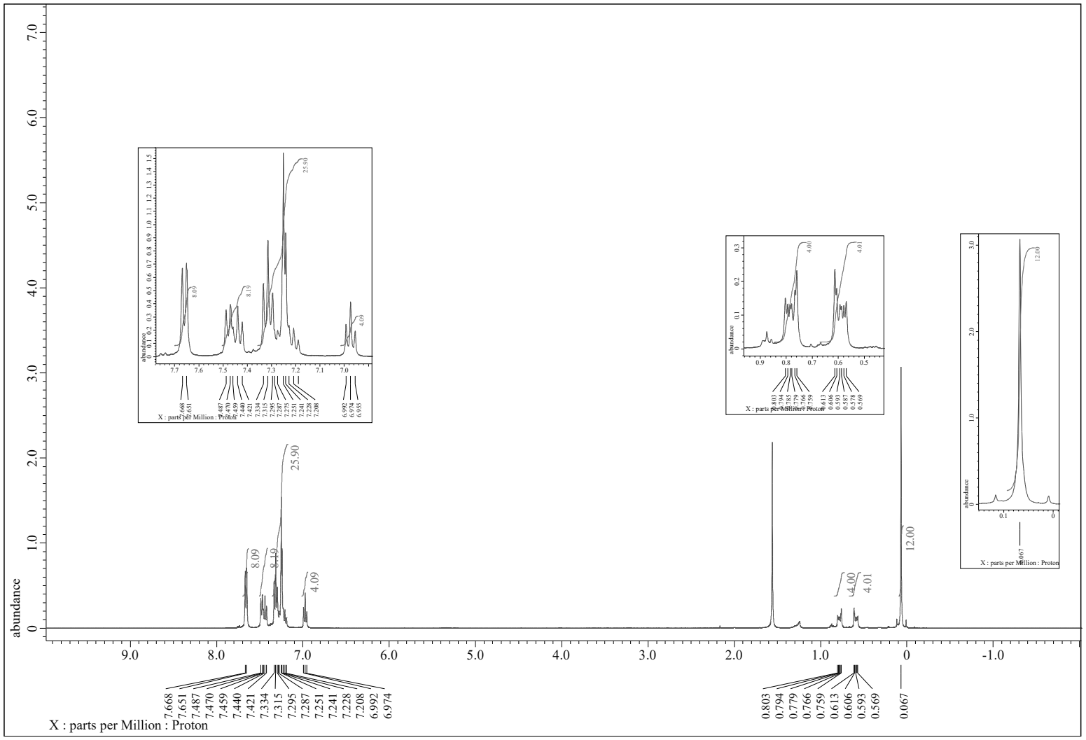
5’
¹H NMR (600.17 MHz, CDCl₃)

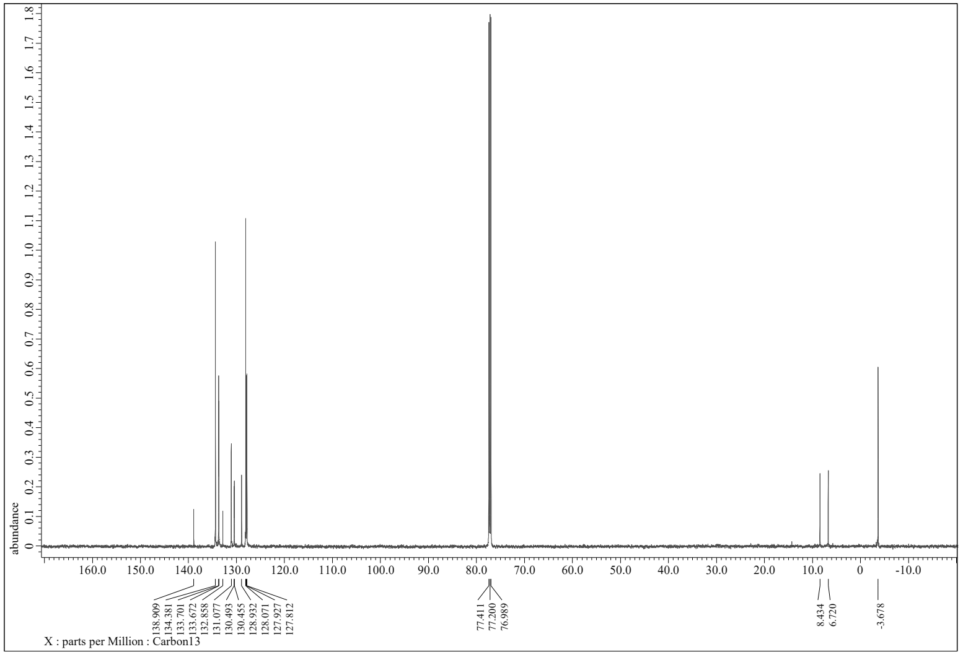
5’
¹³C NMR (150.91 MHz, CDCl₃)

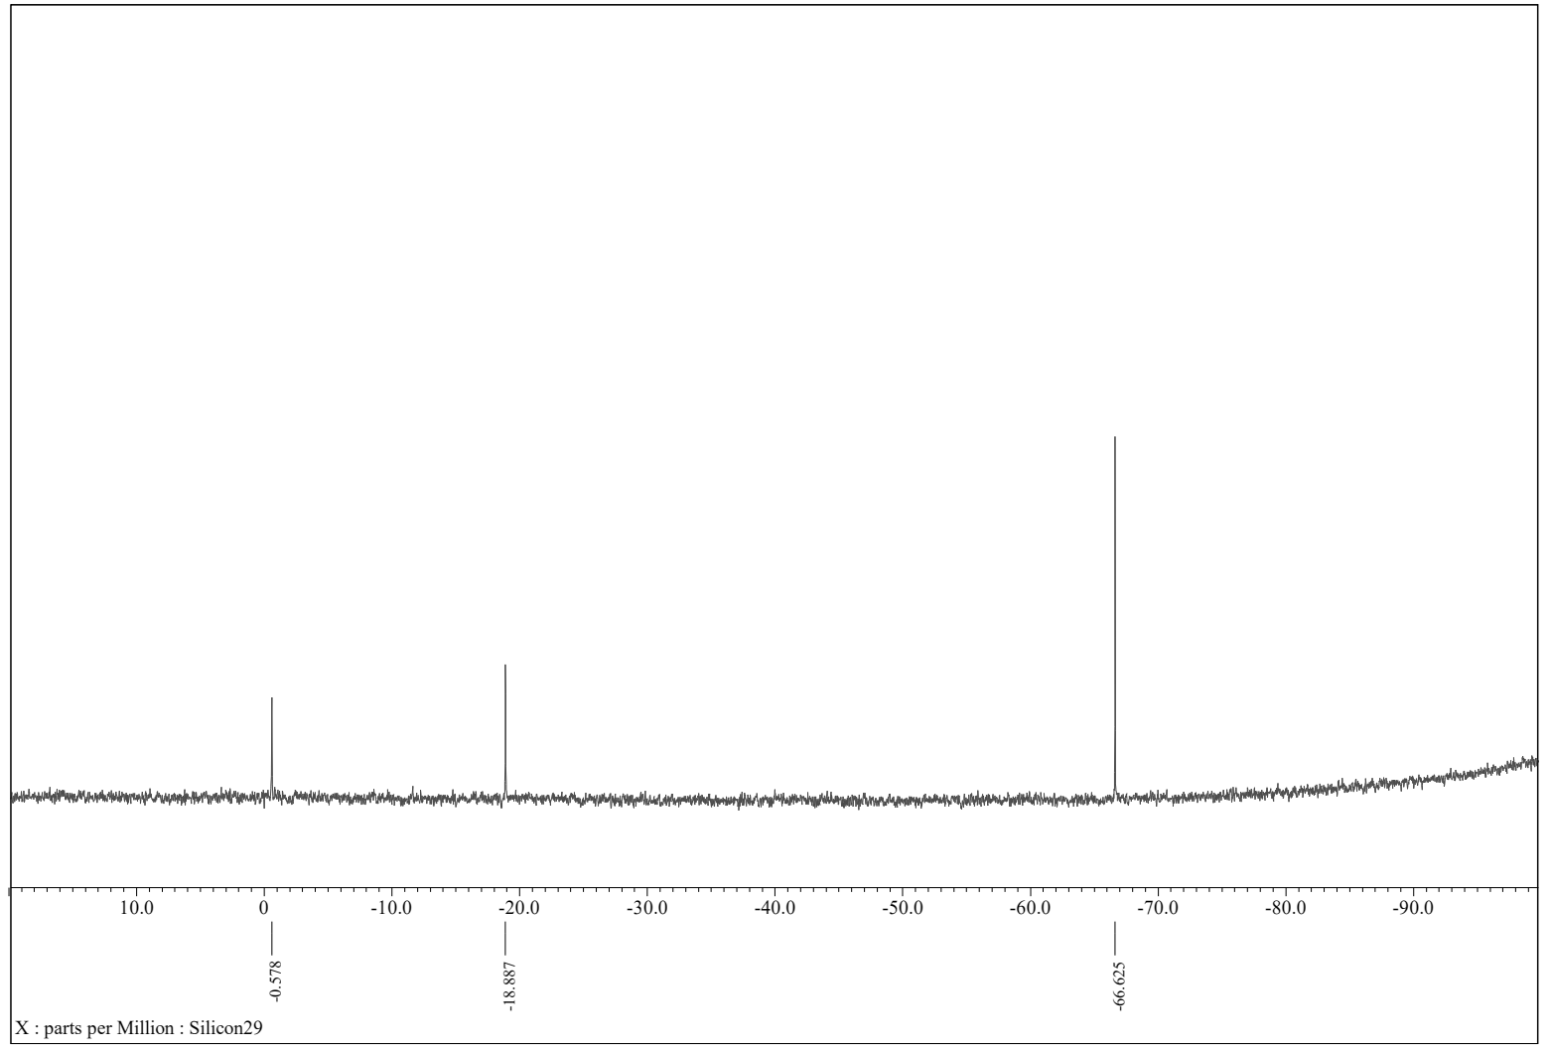
5’
-Si-
-Si-
²⁹Si NMR (119.24 MHz, CDCl₃)
-Si-

X-ray diffraction and crystallography for compound 5’
Colorless crystals were obtained by vapor diffusion method from a solution of compound 5 in chloroform placed in a larger vial containing hexane at 20 ºC. The crystal was immersed in a drop of oil and mounted on a MicroMount. The intensity data were collected on a Rigaku VariMax with an XtaLab P200 diffractometer with multi-layer mirror monochromated Mo K_{α} radiation (λ = 0.71075 Å). The structures were solved using SHELXT, and refined by full-matrix least-squares procedures on F² for all reflections (SHELXL-2014/7). All the non-hydrogen atoms were refined anisotropically. All hydrogens were placed using AFIX instructions. All calculations were carried out using Yadokari-XG2009. Crystallographic data have been deposited with Cambridge Crystallographic Data Centre: Deposition number CCDC-2049208. Copies of the data can be obtained free of charge via http://www.ccde.cam.ac.uk/conts/retrieving.html (or from the Cambridge Crystallographic Data Centre, 12, Union Road, Cambridge, CB2 1EZ, U.K.; Fax: +44 1223 336033; e-mail: deposit@ccdc.cam.ac.uk).
Crystal data, data collection and structure refinement details are summarized in Table S1. The H atoms were positioned geometrically (C—H = 0.95–1.00 A ˚ ) and refined as riding atoms with Uiso (H) =1.5Ueq (C) for methyl or 1.2Ueq (C) for aromatic and methine H atoms. The methyl groups were allowed to rotate freely around the C—C bond. The triflate anion exhibits disorder and was modelled with occupancies of 0.629 (17) and 0.371 (17). The geometric parameters of the minor component were restrained to be similar to those of the major component by using SAME restraint. In addition, one of the methyl groups in the complex cation exhibits disorder and was modelled with occupancies of 0.786 (14) and 0.214 (14). The C25—C27A and C25—C27B bond lengths were restrained to be equal to each other by using SADI restraint.
Table S1. Crystal Data and Refinement Details for compound 5’
Compounds | 5’
empirical formula | C₅₆H₆₀O₈Si₈
formula weight | 1085.76
temperature (K) | 130
crystal system | Orthohombic
space group | P2₁2₁2₁
a (Å) | 10.7393(17)
b (Å) | 18.409(3)
c (Å) | 29.205(5)
α (deg) | 90
β (deg) | 90
γ (deg) | 90
V (Å³) | 5773.8(16)
Z | 4
D_{calc} (Mg m^{–3}) | 1.249
absorp coeff (mm^{–1}) | 0.237
crystal size (mm) | 0.25×0.16×0.02
θ range (°) | 2.601-27.489
no. of reflns measd | 104155
no. of indep reflns | 13215
R_{int} | 0.1825
completeness | 99.8%
data/restraints/parameters | 13215/0/649
goodness–of–fit on F² | 1.032
final R indices [I>2σ(I)] ª | R₁ = 0. 0834  wR₂ = 0.1965
R indices (all data)ª | R₁ = 0. 1222  wR₂ = 0.2217
largest diff. peak  and hole (e Å^{–3}) | 0.910  and -0.491
ª R₁ = Σ||F_{o}| – |F_{c}||/Σ|F_{o}|, wR₂ = [(ΣwF_{o}² – F_{c}²)²/Σw(F_{o}²)²]^{1/2}.

Ito, R.; Kakihana, Y.; Kawakami, Y. Cyclic Tetrasiloxanetetraols: Formation, Isolation, and Characterization. Chem. Lett. 2009, 38, 364-365.
(a) H. Endo, N. Takeda, M. Takanashi, T. Imai, M. Unno, Refractive Indices of Silsesquioxanes with Various Structures, Silicon, 2015, 7, 127-132; (b) H. Endo, N. Takeda, M. Unno, Stereoisomerization of Cyclic Silanols, Chem. Asian J. 2017, 12, 1224-1233.
Sheldrick, G. M., Acta Crystallogr. A, 2015, 71, 3-8.
Sheldrick, G. M., Acta Crystallogr. C, 2015, 71, 3−8.
(a) Yadokari-XG, K. Wakita, 2001; (b) C. Kabuto, S. Akita, T. Nemoto, E. Kwon, J. Cryst. Soc. Jpn. 2009, 51, 218-224.

