Blareau et al. submitted

Supplementary Information

Fig. S1 Arial photography of the study site with apiary and plant locations

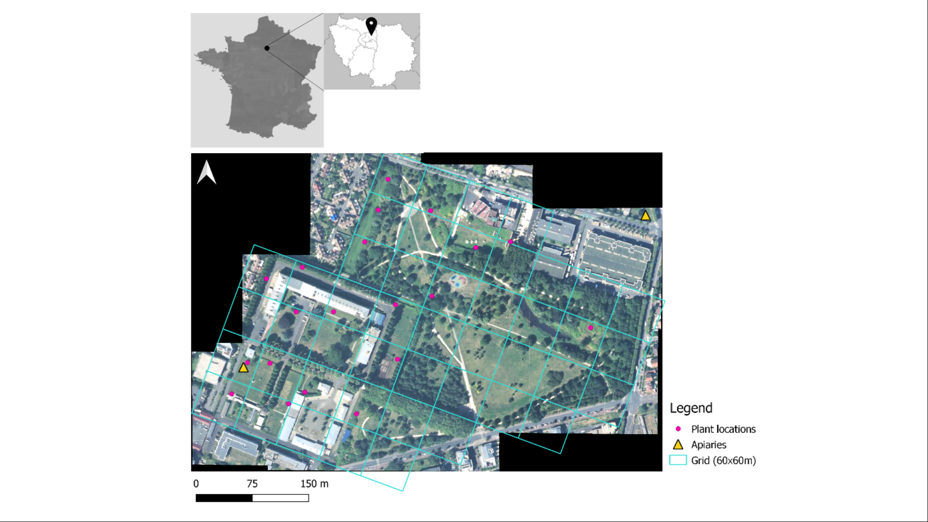

Fig. S2 (a) Strawberry plants after potting, (b) example of two strawberry plants at their designated location with pollinator exclusion bags around the open flowers, (c) a strawberry flower excluded from insect visits by means of a pollinator exclusion bag, (d) a Diptera visiting a strawberry flower
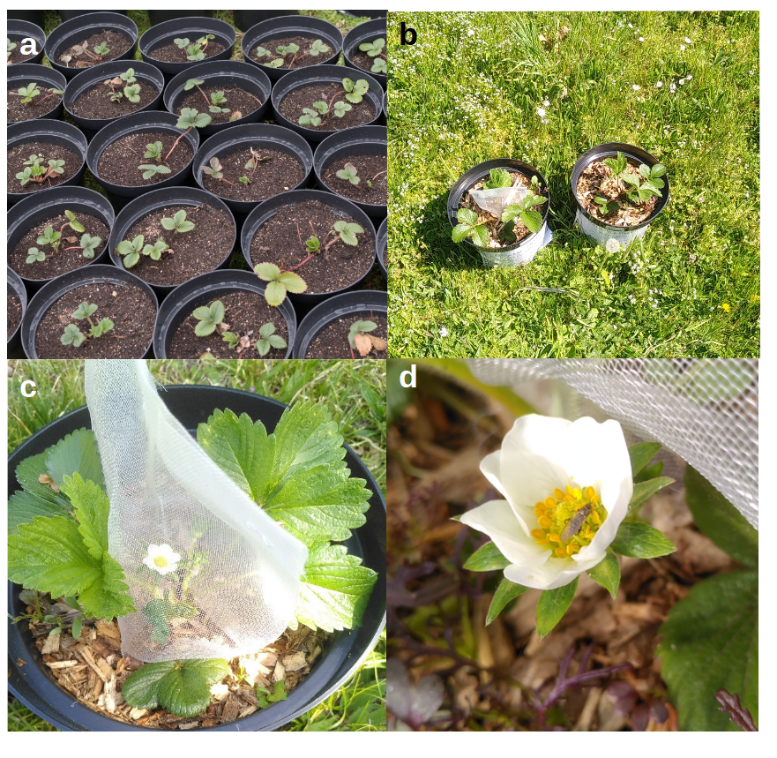

Fig. S3 Example of a strawberry showing a malformation

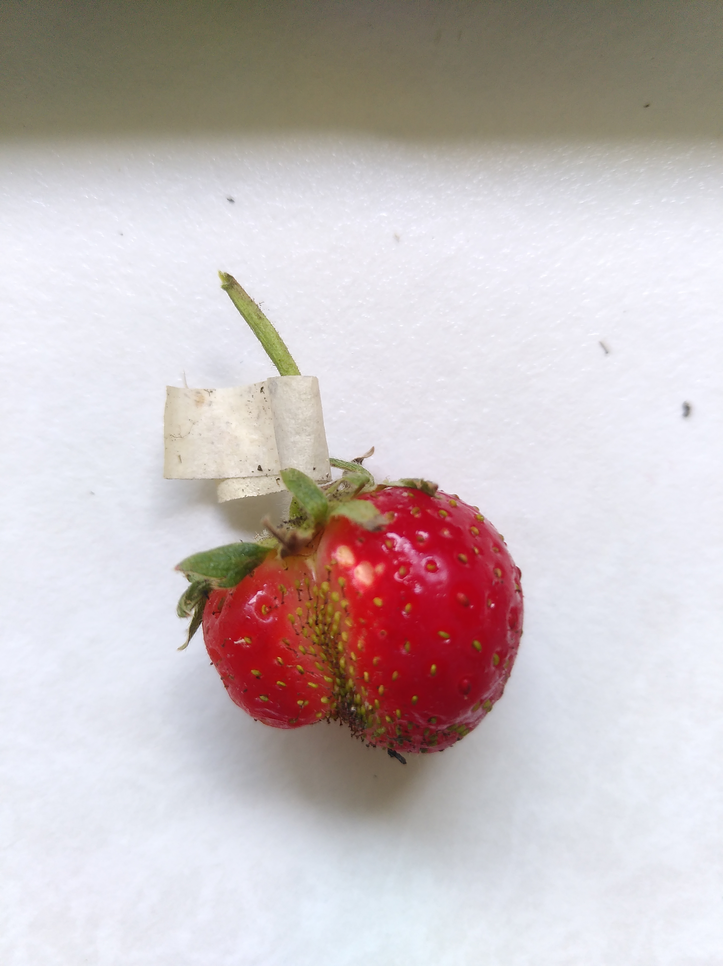
Table S1 Tukey test values comparing fruit set for different pollination treatments

 | Estimate | Standard error | P value
Hand vs self/wind pollination | 15.439 | 1817.760 | 1.000
Open vs self/wind pollination | -2.410 | 1.088 | 0.092
Open+hand vs self/wind pollination | -1.562 | 1.247 | 0.538
Open vs hand pollination | -17.848 | 1817.760 | 1.000
Open+hand vs hand pollination | -17.001 | 1817.760 | 1.000
Open+hand vs open pollination | 0.847 | 0.841 | 0.701

Table S2 Tukey test values comparing the occurrence of malformations for different pollination treatments from the GLM testing the effects of fruit width and pollination treatment on malformation

 | Estimate | Standard error | P value
Hand vs self/wind pollination | 0.361 | 0.708 | 0.955
Open vs self/wind pollination | 0.103 | 0.734 | 0.999
Open+hand vs self/wind pollination | -0.864 | 1.171 | 0.878
Open vs hand pollination | -0.258 | 0.749 | 0.985
Open+hand vs hand pollination | -1.226 | 1.175 | 0.716
Open+hand vs open pollination | -0.968 | 1.195 | 0.845

Table S3 Tukey test values comparing fruit size for different pollination treatments from the linear model testing the effects of seed number and pollination treatment on fruit size

 | Estimate | Standard error | P value
Hand vs self/wind pollination | -0.061 | 0.100 | 0.928
Open vs self/wind pollination | -0.004 | 0.100 | 1.000
Open+hand vs self/wind pollination | -0.049 | 0.117 | 0.974
Open vs hand pollination | 0.058 | 0.107 | 0.948
Open+hand vs hand pollination | 0.012 | 0.124 | 1.000
Open+hand vs open pollination | -0.46 | 0.123 | 0.982

