Supplementary information
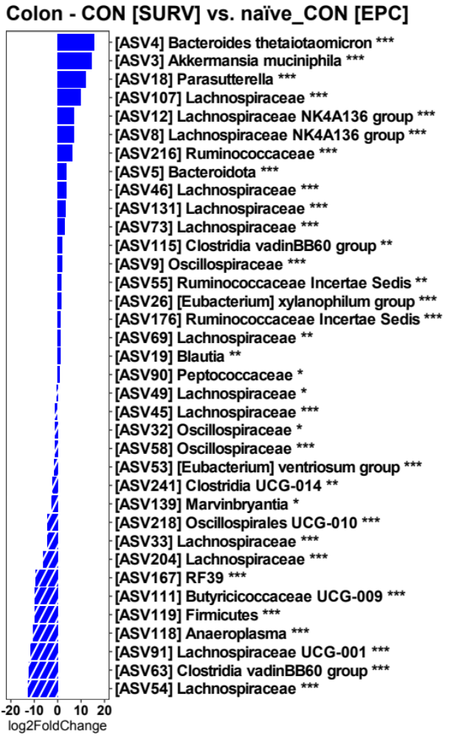
Figure S1: DESeq2 differential expression analysis of the microbial community between naïve C3H/HeOuJ mice from the SURV and EPC experiments. The SURV experiment is distinguishable by the complete absence of major taxa such as Bacteroides thetaiotaomicron, Akkermansia muciniphila and Parasutterella (n = 13-14; bolded taxa represent a trend (P < 0.10); * P < 0.05, ** P < 0.01, *** P < 0.001).

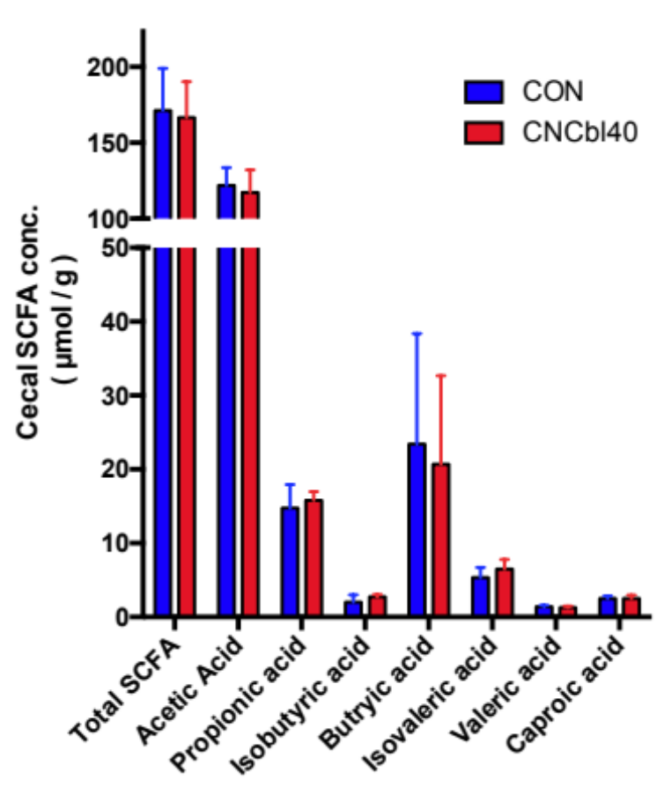
Figure S2: Cecal SCFA profiles of naïve C3H/HeOuJ mice from the SURV experiment. Cyanocobalamin supplementation did not alter SCFA production in the cecum (n=6).

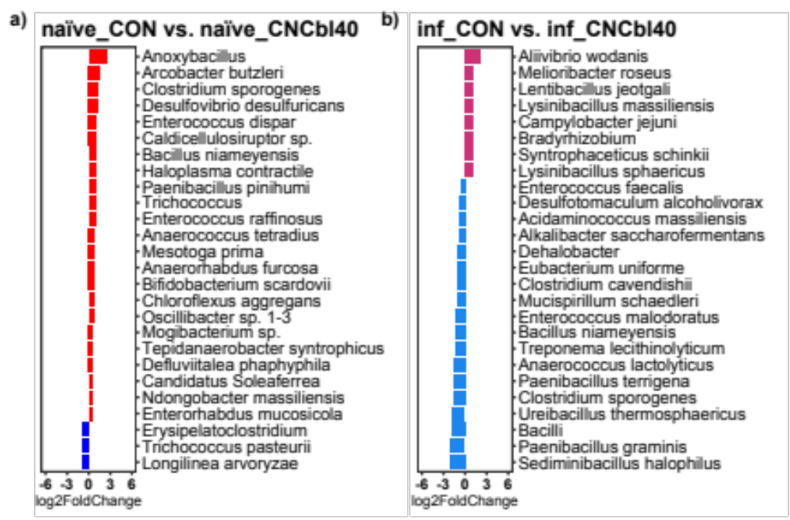
Figure S3: DESeq2 differential expression analyses of the active microbial community as determine by cecal metatranscriptomics of C3H/HeOuJ mice. Cyanocobalamin supplementation increased the abundance of numerous active members before infection (a); however, mice at D5PI receiving regular drinking water (b) displayed greater numbers of different active members. All plotted taxa have a non-adjusted P value less than 0.05 (n = 8).

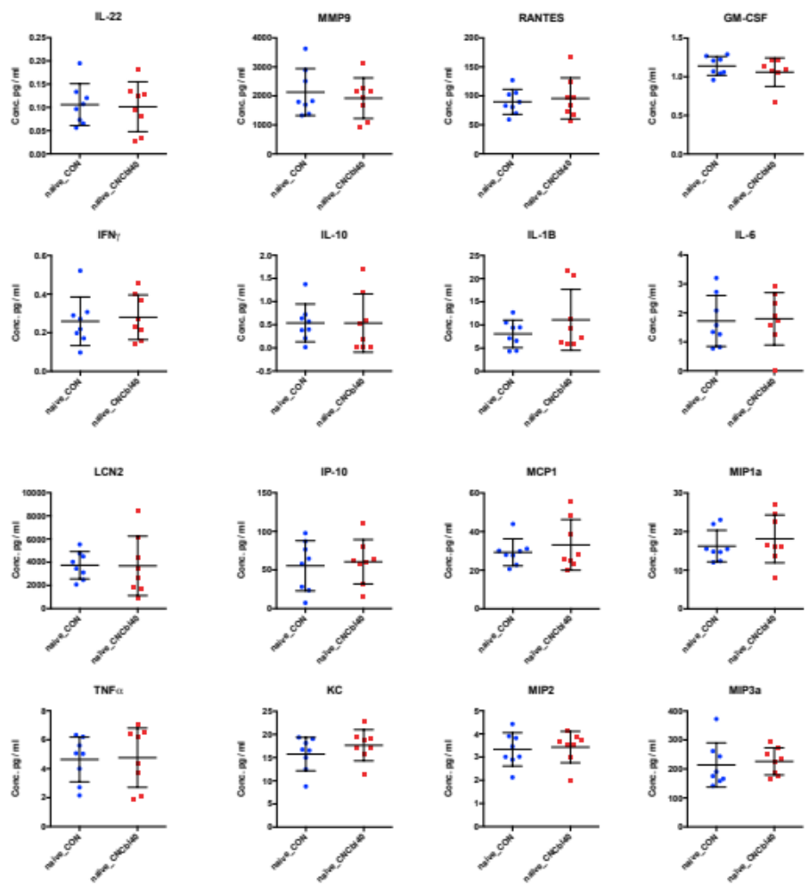
Figure S4: Inflammation biomarkers in naïve C3H/HeOuJ mice from the EPC experiment (n = 8).
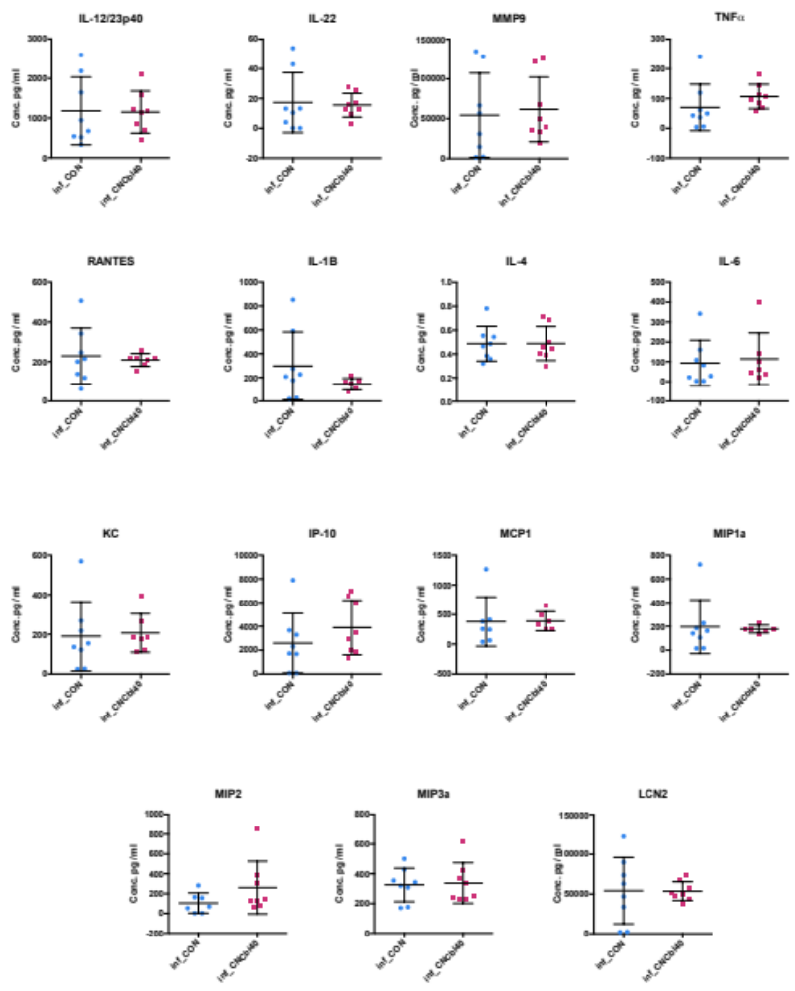
Figure S5: Inflammation biomarkers in C. rodentium-challenged C3H/HeOuJ from the EPC experiment (n = 8).

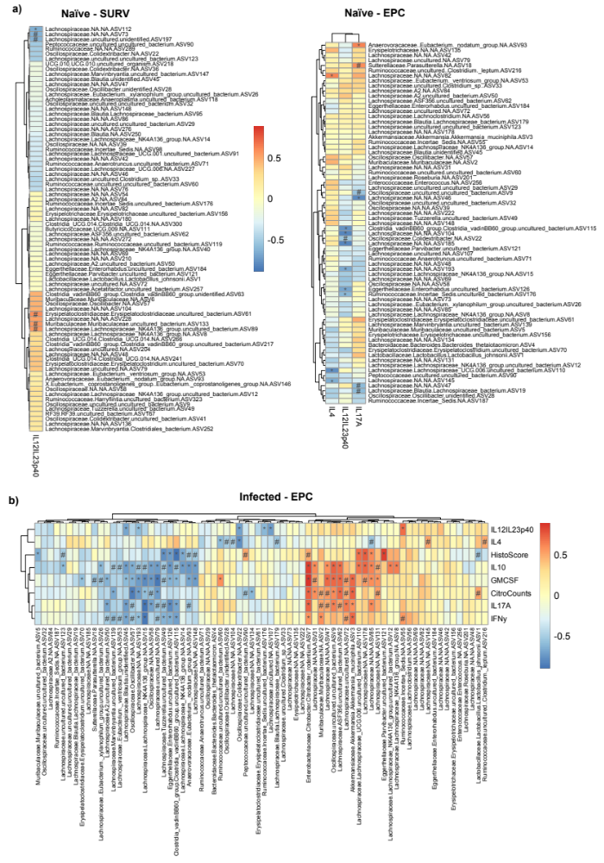
Figure S6: Spearman’s correlation of the significantly altered immune profiles of colon tissues and microbiota in C3H/HeOuJ mice. (a) Naïve mice from the SURV (n=10) and EPC experiment (n=11) (b) Infected mice from the EPC experiment (n=12). A trend (P < 0.10) is denoted with # and significance (P < 0.05) with *.

Table S1: Real-time qRT-PCR primer list.
Target Genes | Oligonucleotide sequences  (5' - 3') |  | Product  length | Ref.
ActB * | F: | TGACAGGATGCAGAAGGAGA | 131 | [26]
 | R: | GCTGGAAGGTGGACAGTGAG | 131 | [26]
IL12A | F: | CCACCCTTGCCCTCCTAAAC | 132 | [26]
 | R: | GTTTTTCTCTGGCCGTCTTCA | 132 | [26]
IL12B | F: | GGGACATCATCAAACCAGACCC | 239 | [26]
 | R: | GCCTTTGCATTGGACTTCGG | 239 | [26]
Rpoa # | F: | ACGTCAGCCGGAAGTGAAAGAAGA | 86 | [24]
 | R: | AGCGGACAGTCAATTCCAGATCGT | 86 | [24]
Ler | F: | ACAGTTTGAATCTCCTGCTCACGC | 98 | [24]
 | R: | AATTCGCCCACAACAAGCCCATAC | 98 | [24]
Tir | F: | ATCAGATATCTCGCAAGCTCG | 134 | [27]
 | R: | CAACTCCATCTCCCATTCCTG | 134 | [27]
EspA | F: | ACGAGGTAACAACCATGCGAGTGT | 87 | [27]
 | R: | CTGCCTGGCATTGCTTTCCAGAAT | 87 | [27]
Note: The annealing temperature used for all genes was 60°C. Housekeeping genes used for mice (*) and bacterial (#) gene expression calculations.

Table S2. Summary of beta-diversity analyses of microbial communities.
 |  | Weighted UniFrac |  | Unweighted UniFrac
Region | Comparisons | Dispersion | Orientation | Dispersion | Orientation
Ileum | naïve_CON vs naïve_CNCbl40 | 0.98 | 1 | 1 | 1
Ileum | inf_CON vs inf_CNCbl40 | 1 | 1 | 1 | 1
Ileum | naïve_CON vs inf_CON | 1 | 1 | 1 | 1
Ileum | naïve_CNCbl40 vs inf_CNCbl40 | 1 | 0.49 | 0.88 | 1
Ileum | naïve_CON vs inf_CNCbl40 | 1 | 1 | 0.97 | 0.4
Ileum | naïve_CNCbl40 vs inf_CON | 1 | 1 | 0.89 | 0.53
Cecum | naïve_CON vs naïve_CNCbl40 | 1 | 1 | 0.13 | 0.02
Cecum | inf_CON vs inf_CNCbl40 | 0.84 | 1 | 1 | 0.25
Cecum | naïve_CON vs inf_CON | 1 | 0.15 | 0.48 | 0.01
Cecum | naïve_CNCbl40 vs inf_CNCbl40 | 0.9 | 0.01 | 0.83 | 0.1
Cecum | naïve_CON vs inf_CNCbl40 | 0.79 | 0.01 | 0.54 | 0.01
Cecum | naïve_CNCbl40 vs inf_CON | 1 | 0.35 | 0.84 | 0.01
Colon | naïve_CON vs naïve_CNCbl40 | 0.92 | 1 | 0.25 | 0.01
Colon | inf_CON vs inf_CNCbl40 | 1 | 0.17 | 0.96 | 1
Colon | naïve_CON vs inf_CON | 0.95 | 1 | 0.33 | 0.81
Colon | naïve_CNCbl40 vs inf_CNCbl40 | 0.74 | 0.01 | 0.91 | 0.04
Colon | naïve_CON vs inf_CNCbl40 | 0.96 | 0.01 | 0.1 | 0.01
Colon | naïve_CNCbl40 vs inf_CON | 0.73 | 0.34 | 1 | 0.05
Colon  [SURV vs EPC] | CON vs CNCbl40 | 0.21 | 0.7 | 0.01 | 0.01
Colon  [SURV vs EPC] | naïve_CON vs naïve_CNCbl40 | 0.88 | 1 | 0.02 | 0.01
Colon  [SURV vs EPC] | naïve_CON vs CON | 0.31 | 0.01 | 0.76 | 0.01
Colon  [SURV vs EPC] | naïve_CNCbl40 vs CNCbl40 | 0.73 | 0.01 | 0.44 | 0.01
Cecum  [RNA-seq] | naïve_CON vs naïve_CNCbl40 | 0.38 | 1 | 0.29 | 0.6
Cecum  [RNA-seq] | inf_CON vs inf_CNCbl40 | 0.71 | 0.85 | 0.53 | 0.32
Cecum  [RNA-seq] | naïve_CON vs inf_CON | 0.06 | 0.77 | 0.16 | 0.01
Cecum  [RNA-seq] | naïve_CNCbl40 vs inf_CNCbl40 | 1 | 0.85 | 0.73 | 0.042
Cecum  [RNA-seq] | naïve_CON vs inf_CNCbl40 | 0.4 | 0.08 | 0.87 | 0.01
Cecum  [RNA-seq] | naïve_CNCbl40 vs inf_CON | 0.74 | 1 | 1 | 0.08
Note: Dispersion p-values were calculated with betadisper() using a permuted model that indicates a difference in dispersion between groups. Orientation p-values were calculated with pairwise.adonis() and adjusted using bonferroni (perm=999) method, and indicates significantly different clustering between groups.

