Statistical Analysis Plan for the Motor Neuron Disease Systematic Multi-Arm Adaptive Randomised Trial (MND-SMART)
Supplementary File 1
Simulation work for co-primary ALS-FRS-R analysis model development

- AIM
To explore different models for the ALS-FRS-R analysis.

- DATA GENERATING PROCEDURE
We considered 3 cases regarding the treatment effect:
- Case (a): treatment affects neither ALS-FRS-R nor survival;
- Case (b): treatment affects ALS-FRS-R but not survival;
- Case (c): treatment affects both ALS-FRS-R and survival via a shared random effect.

Case (a) Case (b) Case (c)
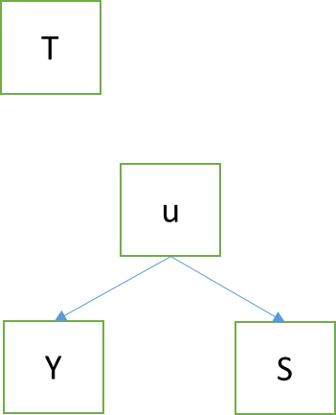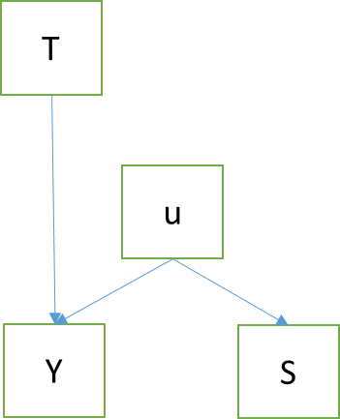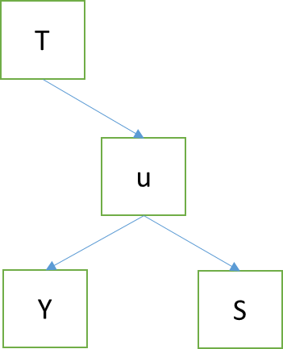
T, treatment; Y, outcome; S, survival; u, random slope

For each of the n_{sample} = 200 participants:
- Generate a randomised treatment trt with probability 0.5;
- Generate random coefficients for participant ALS-FRS-R trajectory b_intercept ~ N(30, 1²) and b_visit;
- Cases (a) and (b): b_visit ~ N(-0.9, 0.8²)
- Case ©: b_visit ~ N(0.7trt - 0.9, 0.8²)
- Generate individual deviation from the mean slope b_visit_randerr = b_visit - (-0.9)
- Generate survival time and event indicator with administrative censoring at 5 years (mortality at 5 years ~50%)
- Cases (a) and (b): exponential baseline hazard with λ = 0.13; covariate b_visit_randerr with log hazard ratio = -0.3;
- Case (c): exponential baseline hazard with λ = 0.2; covariate b_visit_randerr with log hazard ratio = -1.5;
- Expand the data so each participant has 5 rows of data for 1 baseline and 4 follow-up visits;
- Generate individual-level random errors e ~ N(0, (√3)²);
- Generate individual ALS trajectories; ALS scores decline over time
- Cases (a) and (c): als = b_intercept + b_visit*visit + e;
- Case (b): als = b_intercept + b_visit*visit + 0.5*trt*visit + e;
- Generate variables start and stop for each observation window (the number of rows per participant now vary, depending on when they die);
- Update event (death) indicator for visits during which the participants are still alive
- Generate baseline ALS-FRS-R score als_bs for each participant.
- Repeat steps 1–10 to create n_{rep} = 1,000 simulation repetitions.

- ESTIMAND
Treatment effect on ALS-FRS-R score at the last visit.

- METHODS OF ANALYSIS
Stata code
Unconditional estimand
Mixed model 1: time-specific treatment effect
mixed als i.visit 1.trt#i.visit i.visit#c.als_bl if visit > 0 || id: visit, stddev cov(uns) iter(20) reml dfmethod(kroger)
Mixed model 2: treatment effect is linear with time
mixed als i.trt i.visit 1.trt#c.visit c.als_bl i.visit#c.als_bl if visit > 0 || id: visit, stddev cov(uns) iter(20) reml dfmethod(kroger)
Mixed model 3: treatment effect is proportional to time
mixed als i.visit 1.trt#c.visit c.als_bl i.visit#c.als_bl if visit > 0 || id: visit, stddev cov(uns) iter(20) reml dfmethod(kroger)

Partly conditional estimand
GEE model 1: time-specific treatment effect
reg als i.visit 1.trt#i.visit i.visit#c.als_bl if visit > 0, vce(cluster id)
GEE model 2: treatment effect is linear with time
reg als i.trt i.visit 1.trt#c.visit c.als_bl i.visit#c.als_bl if visit > 0, vce(cluster id)
GEE model 3: treatment effect is proportional to time
reg als i.visit 1.trt#c.visit c.als_bl i.visit#c.als_bl if visit > 0, vce(cluster id)

- PERFORMANCE MEASURES
- Bias in point estimate;
- Efficiency (average model standard errors versus empirical standard errors);
- Coverage of 95% confidence intervals;
- Power of 5% test.

- RESULTS (graphs)
Case (a): treatment affects neither ALS-FRS-R nor survival
Unconditional estimand = partly conditional estimand = 0

Case (b): treatment affects ALS-FRS-R but not survival
Unconditional estimand = partly conditional estimand = 2

Case (c): treatment affects both ALS-FRS-R and survival via a shared random effect
Unconditional estimand = 2.016

Partly conditional estimand = 1.861

