Supplement Appendix for
Effect of an Artificial Intelligence-assisted Antibiotic Susceptibility Test on Reducing the Mortality Rate of and Antibiotics Use in Patients with Bacteremia: A Prospective Observational Cohort Study

Hsin-Yao Wang, MD¹, Chia-Ru Chung, PhD², Yi-Ju Tseng, PhD^{1,3}, Yhu-Chering Huang, MD⁴, Jia-Ruei Yu, MD¹, Chao-Jung Chen, PhD^{5,6}, Ting-Wei Lin, MD¹, Wan-Ting Huang, MD⁷, Tzong-Yi Lee, PhD^{8,9}, Jorng-Tzong Horng, PhD^{1,2,10}, Jang-Jih Lu, MD, PhD^{1,11,12}

- Department of Laboratory Medicine, Chang Gung Memorial Hospital at Linkou, Taoyuan City, Taiwan
- Department of Computer Science and Information Engineering, National Central University, Taoyuan City, Taiwan
- Department of Computer Science, National Yang Ming Chiao Tung University, Hsinchu City, Taiwan
- Division of Pediatric Infectious Diseases, Department of Pediatrics, Chang Gung Memorial Hospital, Taoyuan City, Taiwan
- Graduate Institute of Integrated Medicine, China Medical university, Taichung, Taiwan
- Proteomics Core Laboratory, China Medical University Hospital, Taichung, Taiwan
- Department of Laboratory Medicine, Kaohsiung Chang Gung Memorial Hospital and Chang Gung University College of Medicine, Kaohsiung, Taiwan
- School of Life and Health Sciences, The Chinese University of Hong Kong, Shenzhen, China
- Warshel Institute for Computational Biology, The Chinese University of Hong Kong, Shenzhen, China
- Department of Bioinformatics and Medical Engineering, Asia University, Taichung City, Taiwan
- School of Medicine, Chang Gung University, Taoyuan City, Taiwan
- Department of Medical Biotechnology and Laboratory Science, Chang Gung University, Taoyuan City, Taiwan
Materials and methods
Specimen processing, bacterial species identification, and antibiotics susceptibility tests
We received clinical specimens from all the wards continuously. The specimen types included blood, respiratory tract specimen (ie, sputum, bronchial wash, and bronchoalveolar lavage), sterile cavity fluid (ie, ascites, pleural effusion, pericardial effusion, cerebrospinal fluid, and synovial fluid), urine, and wound. Blood samples were collected from the patients in whom bacteremia was suspected, and cultured in trypticase soy broth (Becton Dickinson, MD, USA). Subculture culture was done for the positive blood culture bottles onto blood plate (BP) agar (Becton Dickinson, MD, USA). Beside subculture, a rapid spin-down procedure was taken to harvest bacterial pellet from positive blood culture bottles for MALDI-TOF analysis and AST prediction. Five ml blood was moved out from a blood culture bottle to a serum separator tube (Becton Dickinson, MD, USA), followed by centrifugation with 3500 rpm for 10 mins. Supernatant was removed and 1 ml 0.9% saline was used to resuspend the pellet. The solution was then centrifuged with 10000 rpm for 5 min. The pellet was kept and mixed well with 1 ml RBC lysis buffer for 3 min, followed by centrifugation 10000 rpm for 5 min. The precipitate was dried under room air for 3 min and used for further MALDI-TOF analysis, and AST predictions (by XBugHunter). The whole procedures cost less than 1 hour after an alert of positive blood culture.
For sputum specimens, BP agar (Becton Dickinson), eosin methylene blue (EMB) agar (Becton Dickinson), CNA agar (Becton Dickinson), and chocolate agar (Becton Dickinson) were used for cultivation. For test of sterile cavity fluid, thioglycollate broth (Becton Dickinson) was used addition to BP, EMB, CNA, and chocolate agars. Urine specimens were quantitatively inoculated on BP and EMB agars. Saline (0.9%) was used for rinsing swabs that were used for collection of wound specimens, and then inoculated on BP, EMB, CNA, and chocolate agars. Pus specimens were inoculated in thioglycollate broth and on agars. We conducted the cultures in a CO₂ incubator at 37℃ for 18–24 hours. Single colonies that recovered from the agars were used for species identification and antibiotics susceptibility tests. Bacterial species were identified by using matrix-assisted laser desorption ionization time-of-flight (MALDI-TOF) spectra (Bruker Daltonik GmbH, Bremen, Germany). A log score (generated through Biotyper 3.1) higher than two was used to confirm the bacterial species. Antibiotics susceptibilities were tested by using both microdilution (for blood and sterile cavity fluids specimens) and paper disc methods (other specimens). M50 instrument (Becton Dickinson) was used for testing minimal inhibitory concertation of antibiotics via microdilution method. The susceptibility of antibiotics was interpreted according to CLSI M100 of the corresponding years.

Development and validation of AST prediction models on XBugHunter
After the preprocessing of the MS and AST, we adopted several machine learning-based methods, decision tree (DT), logistic regression (LR), random forest (RF), support vector machine (SVM), and artificial neural network (NN), to construct the prediction models. More specifically, the 10-fold cross validation was used to determine the possible parameters. Note that these methods were implemented by scikit-learn package provided in python(1). We calculated four common metrics, sensitivity (SEN), specificity (SPE), accuracy (ACC), and area under the receiver operating characteristic curve (AUROC), to evaluate the prediction models. Except AUROC, their definitions are given below:
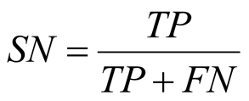
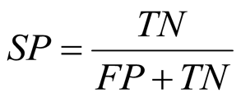
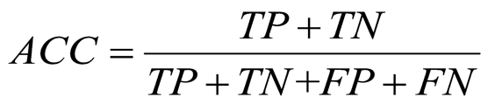,
where TP means true positive and refers to the number of non-susceptible MS that were correctly predicted by the classifier, TN means true negatives and refers to the number of susceptible MS that were correctly predicted by the classifier, FP means false positives and refers to the number of non-susceptible MS that were incorrectly predicted by the classifier, and FN means false negative and refers to the number of susceptible MS that were incorrectly predicted by the classifier. In this study, the model with the highest AUROC was regarded as the best model and was further provided to evaluate the clinical efficacy.

Feature importance for the predictive models
In this study, we adopted the random forest to investigate the feature importance. Specifically, the importance of a feature is determined by Gini importance which is provided by python in scikit-learn package(1). Note that the number of trees in the random forest was 1000 and the nodes were expanded until all leaves were pure or contained less than 1.

Identification of protein markers
We evaluated the informatics peaks with the highest importance for predictive models. Based on the feature importance list (Table S1), we applied LIFT technology (Bruker Daltonics) to identify the informative peaks whose m/z value was lower than m/z 4000, and the spectral intensity was relatively high enough for the subsequent TOF/TOF process. In the list of peak candidates for S. aureus, an m/z value of 3006 matched the selection criteria. The details of the LIFT are described in a previous study(2).
Results
Informative peaks for predicting AST
The informative peaks were defined as the peaks with significantly different frequency of occurrence between the binary classes (e.g., MRSA and MSSA). For the ESKAPE, the top 15 most informative peaks are provided in detail in Table S1. The top informative peaks would participate in the resistance or toxicity of pathogens and are worthy of further identification. Based on the top informative peaks, we attempted to identify the informative peaks of S. aureus. Peaks of m/z 6593, 3297, 2414, 6552, 2430, 3038, 7595, 2877, 2908, 4642, 5526, 2454, 2763, and 3075 were found more frequently in MRSA, whereas, m/z 7421, 3763, 4497, 3277, 3006, and 3892 occurred more frequently in MSSA. The m/z 3006 was sequenced as FXXVIISTIGDLIVKWIIDTVNKPTVPK, and identified as delta-lysin family phenol-soluble modulin (PSM) (Figure S6).
Table S1. Top 15 RF importance of MS peaks.
Rank | MZ | R proportion | S proportion | Difference | RF importance
(a) S. aureus
1 | 6593.357 | 0.6937 | 0.4687 | 0.2250 | 0.0259
2 | 3296.813 | 0.4381 | 0.1939 | 0.2442 | 0.0212
3 | 2413.887 | 0.2424 | 0.1072 | 0.1352 | 0.0197
4 | 6552.397 | 0.8136 | 0.6643 | 0.1493 | 0.0152
5 | 2430.353 | 0.6162 | 0.5066 | 0.1096 | 0.0145
6 | 3037.908 | 0.5404 | 0.5158 | 0.0246 | 0.0141
7 | 7420.699 | 0.1256 | 0.264 | 0.1384 | 0.0114
8 | 3763.634 | 0.2631 | 0.3484 | 0.0853 | 0.0107
9 | 4497.474 | 0.3266 | 0.4461 | 0.1195 | 0.0105
10 | 3277.255 | 0.5699 | 0.6132 | 0.0433 | 0.0102
11 | 7595.253 | 0.1746 | 0.0326 | 0.1420 | 0.0099
12 | 2877.45 | 0.4007 | 0.2498 | 0.1509 | 0.0094
13 | 3006.311 | 0.8063 | 0.8346 | 0.0283 | 0.0092
14 | 2907.865 | 0.2384 | 0.1588 | 0.0796 | 0.0085
15 | 4641.999 | 0.2106 | 0.0972 | 0.1134 | 0.0085
(b) A. baumannii
1 | 6160.411 | 0.0316 | 0.4006 | 0.3690 | 0.0721
2 | 9074.113 | 0.0108 | 0.1803 | 0.1695 | 0.0285
3 | 6151.368 | 0.4305 | 0.1496 | 0.2809 | 0.0255
4 | 2919.033 | 0.4879 | 0.2947 | 0.1932 | 0.0173
5 | 4107.303 | 0.0194 | 0.1694 | 0.1500 | 0.0165
6 | 7853.416 | 0.2730 | 0.0416 | 0.2314 | 0.0157
7 | 12287.38 | 0.1683 | 0.0021 | 0.1662 | 0.0109
8 | 6143.598 | 0.1999 | 0.0559 | 0.1440 | 0.0102
9 | 12300.19 | 0.1387 | 0.0105 | 0.1282 | 0.0086
10 | 6329.521 | 0.7450 | 0.6246 | 0.1204 | 0.0072
11 | 9086.013 | 0.1968 | 0.0345 | 0.1623 | 0.0072
12 | 4244.316 | 0.7323 | 0.7230 | 0.0093 | 0.0071
13 | 3674.093 | 0.0258 | 0.1257 | 0.0999 | 0.0068
14 | 3965.205 | 0.5625 | 0.6221 | 0.0596 | 0.0068
15 | 5373.209 | 0.0050 | 0.0664 | 0.0614 | 0.0068
(c) E. faecium
1 | 6661.806 | 0.4053 | 0.1391 | 0.2662 | 0.019
2 | 6603.880 | 0.8736 | 0.6459 | 0.2277 | 0.0185
3 | 3300.989 | 0.9222 | 0.7285 | 0.1937 | 0.0177
4 | 6689.544 | 0.4197 | 0.1832 | 0.2365 | 0.0143
5 | 3870.819 | 0.1962 | 0.4079 | 0.2117 | 0.0112
6 | 6343.554 | 0.9722 | 0.8193 | 0.1529 | 0.0108
7 | 3171.921 | 0.9767 | 0.8315 | 0.1452 | 0.0092
8 | 2719.417 | 0.1806 | 0.2774 | 0.0968 | 0.0088
9 | 3645.827 | 0.9540 | 0.7908 | 0.1632 | 0.0086
10 | 6512.420 | 0.7159 | 0.8581 | 0.1422 | 0.0078
11 | 3255.724 | 0.6944 | 0.8349 | 0.1405 | 0.0073
12 | 3883.734 | 0.9561 | 0.8412 | 0.1149 | 0.0064
13 | 5094.334 | 0.4584 | 0.3053 | 0.1531 | 0.0063
14 | 3688.113 | 0.7852 | 0.7897 | 0.0045 | 0.0063
15 | 3164.015 | 0.0422 | 0.1787 | 0.1365 | 0.0062
(d) K. pneumoniae
1 | 4520.218 | 0.1565 | 0.0230 | 0.1335 | 0.0244
2 | 5410.193 | 0.6781 | 0.4975 | 0.1806 | 0.0143
3 | 5938.689 | 0.6847 | 0.5742 | 0.1105 | 0.0108
4 | 11878.28 | 0.4481 | 0.3005 | 0.1476 | 0.0107
5 | 4708.548 | 0.1089 | 0.0403 | 0.0686 | 0.0104
6 | 5070.876 | 0.2652 | 0.1651 | 0.1001 | 0.0087
7 | 6153.029 | 0.4789 | 0.3508 | 0.1281 | 0.0068
8 | 5280.115 | 0.8502 | 0.7916 | 0.0586 | 0.0067
9 | 2617.024 | 0.5880 | 0.6734 | 0.0854 | 0.0062
10 | 4155.528 | 0.7309 | 0.6490 | 0.0819 | 0.0062
11 | 7706.079 | 0.8559 | 0.8361 | 0.0198 | 0.0062
12 | 8309.833 | 0.6562 | 0.5782 | 0.0780 | 0.0061
13 | 4570.745 | 0.8879 | 0.9311 | 0.0432 | 0.0059
14 | 2035.513 | 0.6476 | 0.6825 | 0.0349 | 0.0056
15 | 5322.208 | 0.2063 | 0.3022 | 0.0959 | 0.0052
(e) E. aerogenes
1 | 4395.726 | 0.3551 | 0.2494 | 0.1057 | 0.0162
2 | 3784.287 | 0.5513 | 0.6797 | 0.1284 | 0.0112
3 | 7359.469 | 0.6672 | 0.7539 | 0.0867 | 0.0098
4 | 7568.535 | 0.6152 | 0.6381 | 0.0229 | 0.0093
5 | 7648.238 | 0.9302 | 0.9454 | 0.0152 | 0.0083
6 | 3679.699 | 0.6226 | 0.7196 | 0.0970 | 0.0080
7 | 2697.051 | 0.9539 | 0.9511 | 0.0028 | 0.0066
8 | 2221.819 | 0.5661 | 0.5020 | 0.0641 | 0.0064
9 | 9139.830 | 0.9346 | 0.9650 | 0.0304 | 0.0063
10 | 3580.358 | 0.9525 | 0.9641 | 0.0116 | 0.0061
11 | 3824.498 | 0.8975 | 0.9030 | 0.0055 | 0.0061
12 | 2856.061 | 0.8737 | 0.8794 | 0.0057 | 0.0059
13 | 7159.944 | 0.9480 | 0.9731 | 0.0251 | 0.0058
14 | 4570.251 | 0.9287 | 0.9593 | 0.0306 | 0.0057
15 | 3143.980 | 0.8083 | 0.8191 | 0.0108 | 0.0057
(f) E. cloacae
1 | 5092.599 | 0.2418 | 0.0956 | 0.1462 | 0.0190
2 | 5643.628 | 0.6305 | 0.5392 | 0.0913 | 0.0102
3 | 2820.995 | 0.4559 | 0.3323 | 0.1236 | 0.0083
4 | 4490.338 | 0.1895 | 0.1361 | 0.0534 | 0.0077
5 | 5627.055 | 0.3300 | 0.2460 | 0.0840 | 0.0062
6 | 2852.508 | 0.9109 | 0.8933 | 0.0176 | 0.0058
7 | 4164.163 | 0.8373 | 0.7590 | 0.0783 | 0.0057
8 | 5105.856 | 0.2500 | 0.2857 | 0.0357 | 0.0057
9 | 5663.909 | 0.7923 | 0.7766 | 0.0157 | 0.0057
10 | 2544.661 | 0.2345 | 0.1500 | 0.0845 | 0.0056
11 | 3579.762 | 0.8773 | 0.8009 | 0.0764 | 0.0056
12 | 3845.112 | 0.6073 | 0.4619 | 0.1454 | 0.0052
13 | 8413.320 | 0.3550 | 0.2302 | 0.1248 | 0.0052
14 | 6329.332 | 0.9023 | 0.8987 | 0.0036 | 0.0052
15 | 3621.633 | 0.9509 | 0.9255 | 0.0254 | 0.0050

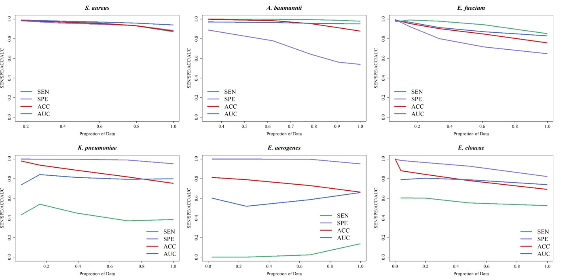
Figure S1. Adopting gray zone method to enhance predictive performance. Performance of the random forest under different gray zones (proportions of data). Note that the gray zone was determined around 0.5. In other words, the performance was evaluated for the predicted probabilities which were less than 0.5 − θ or larger than 0.5 + θ. For example, the predicted probabilities which were less than 0.3 were predicted as susceptible while those larger than 0.7 as resistant ones if θ = 0.2. SEN: sensitivity; SPE: specificity; ACC: accuracy; AUC: area under receiver operating characteristic curve.
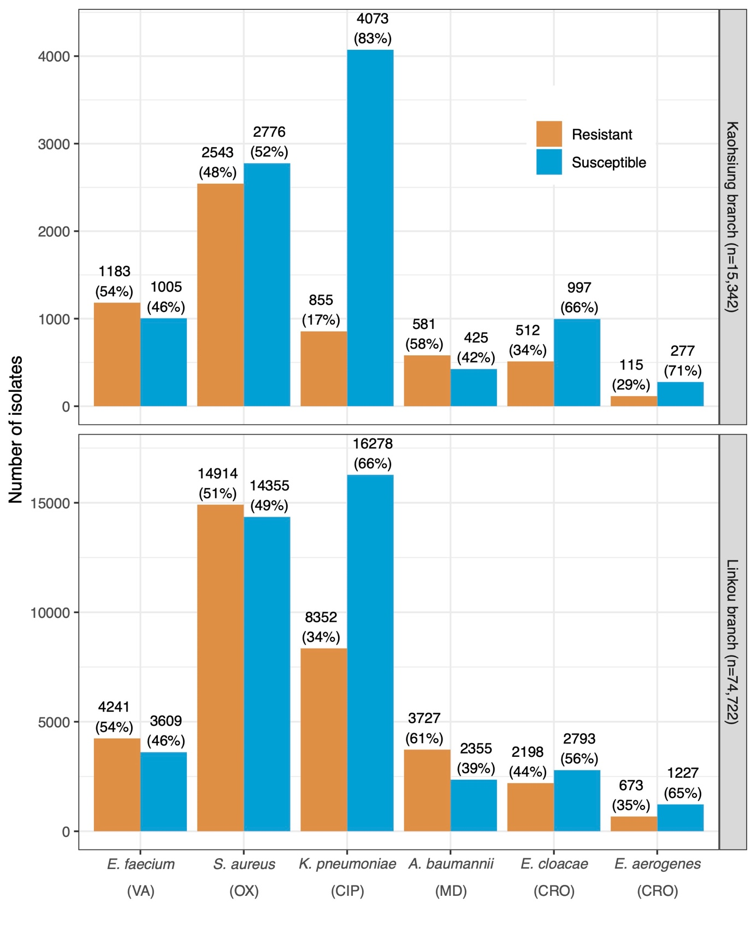
Figure S2(A). Distribution of susceptible and resistant ESKAPE isolates in Linkou Chang Gung Memorial Hospital (CGMH) and Kaohsiung CGMH (VA: vancomycin; OX: oxacillin; CIP: ciprofloxacin; MD: multiple drugs; CRO: ceftriaxone).
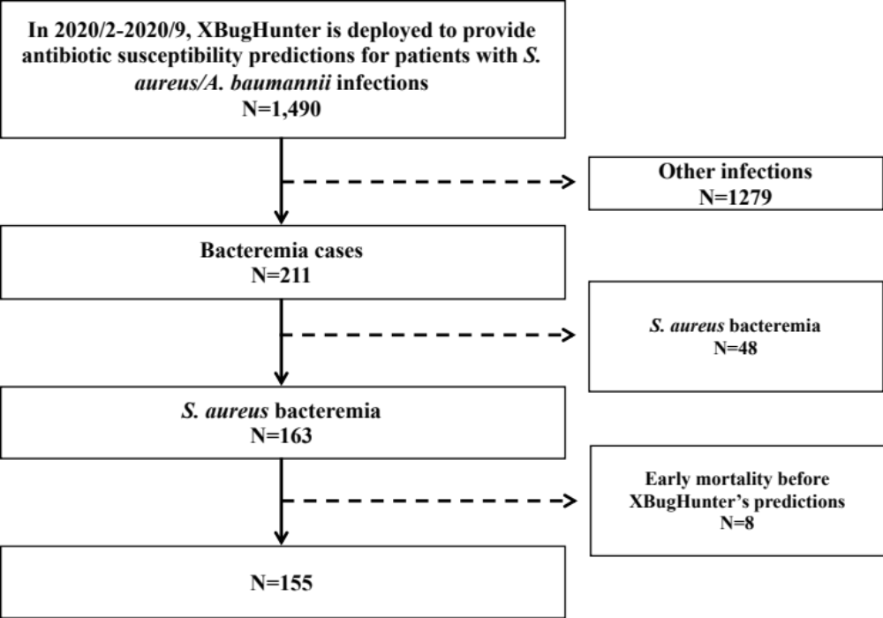
Figure S2(B). S. aureus bacteremia cases eligibility of the prospective observational cohort.
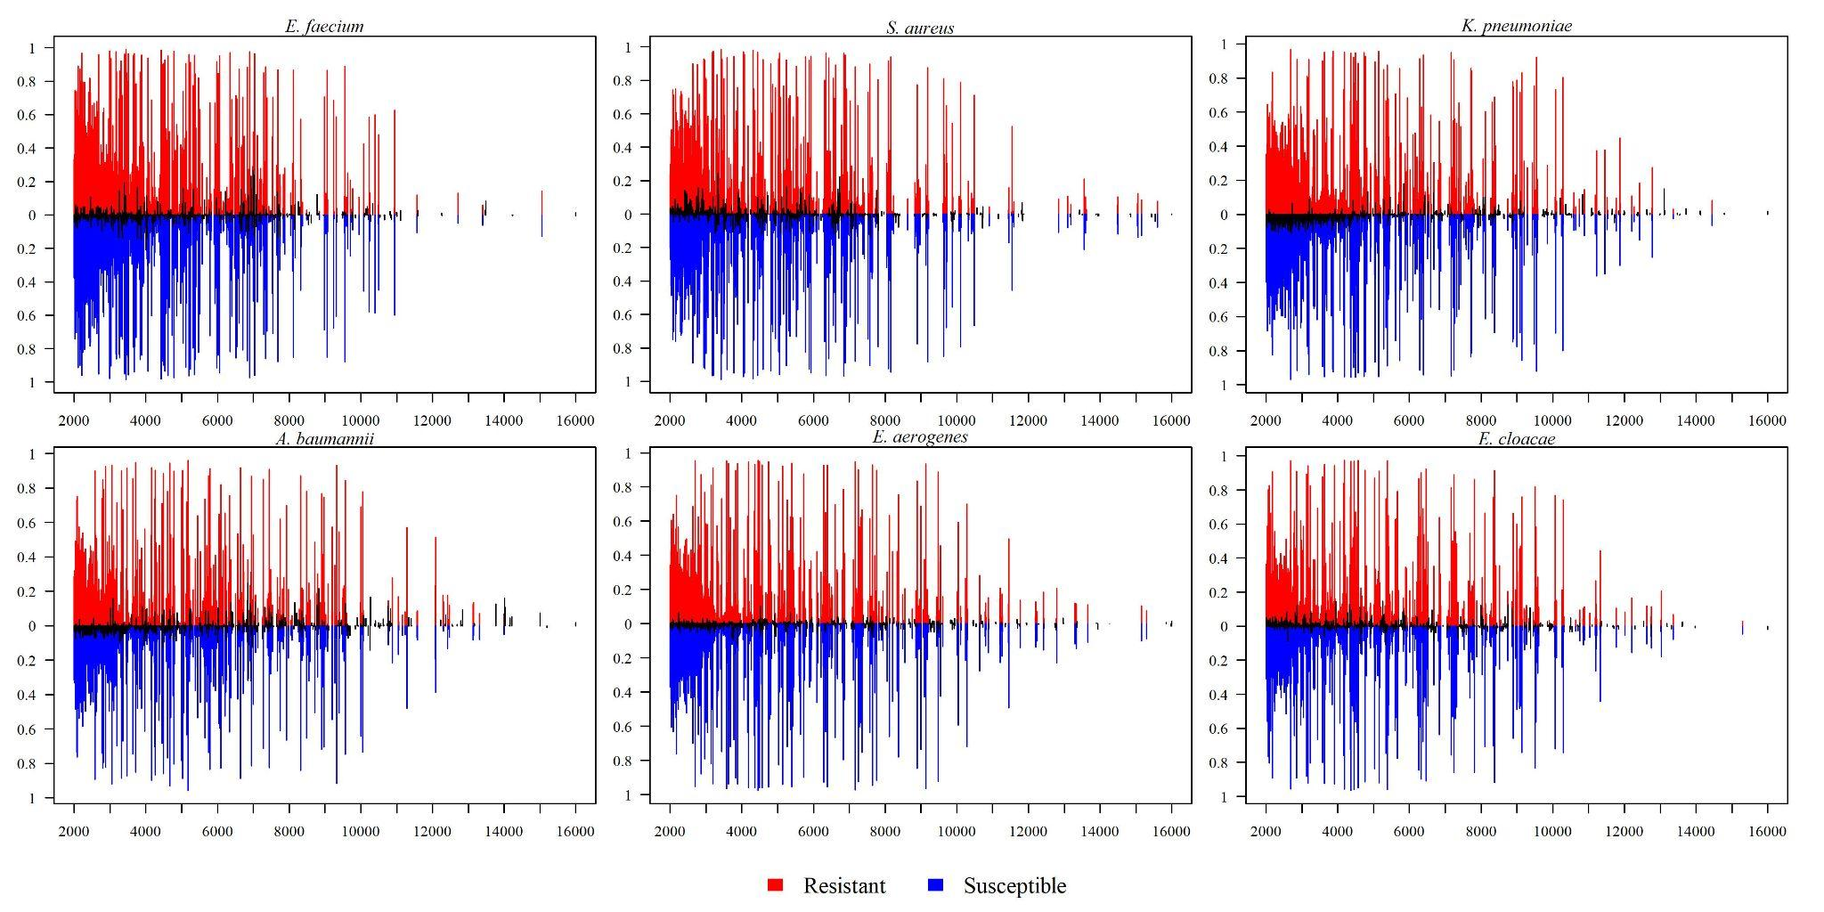
Figure S3(A). MALDI-TOF MS spectra between resistant and susceptible isolates.
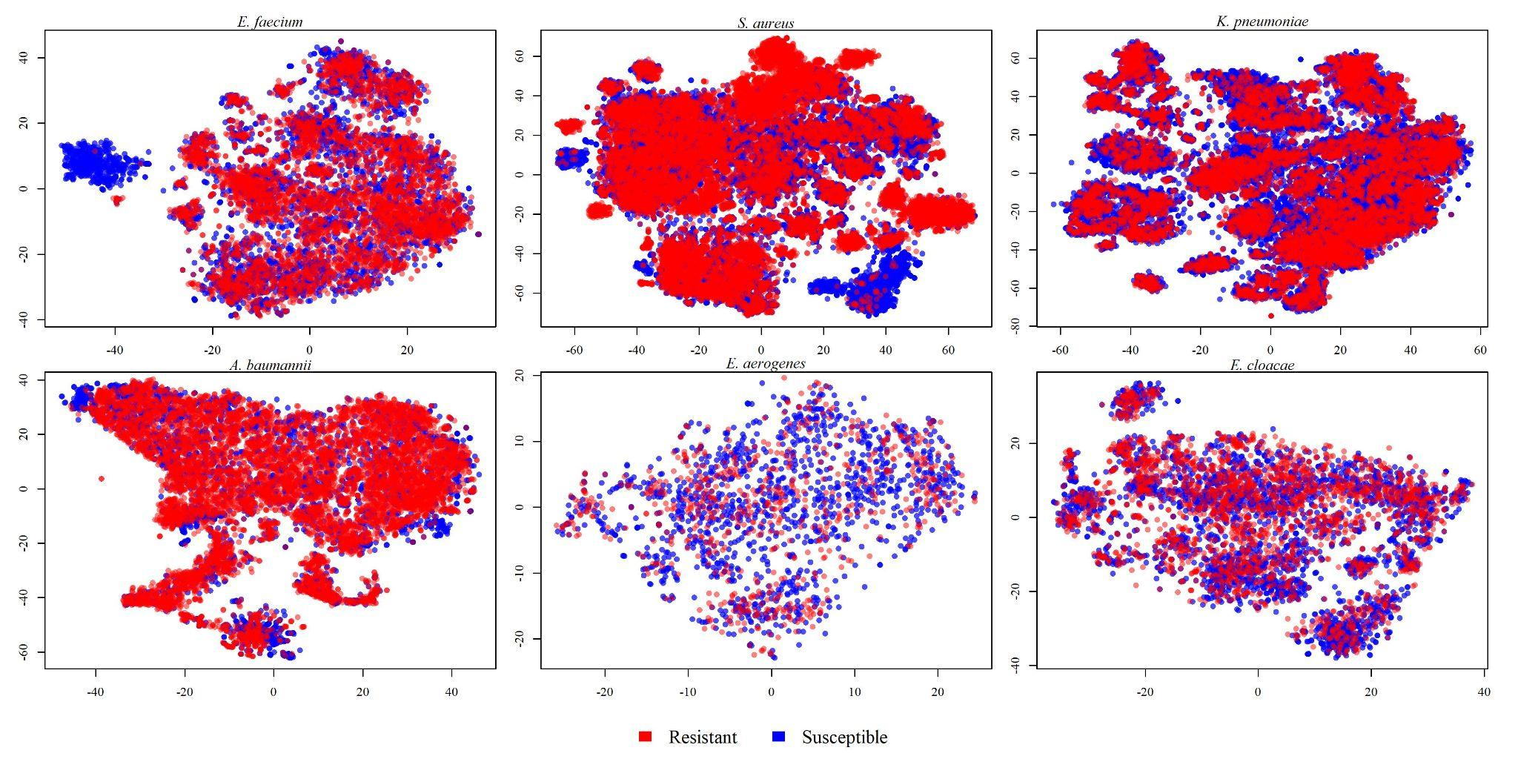
Figure S3(B). MALDI-TOF MS spectra-based clustering of resistant and susceptible ESKAPE isolates by using t-distributed stochastic neighbor embedding plots
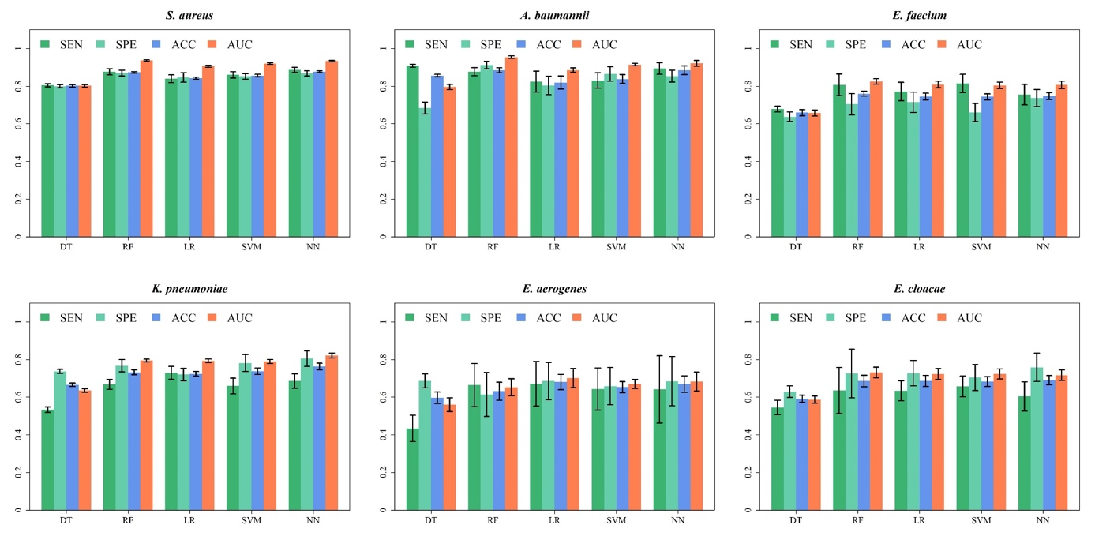
Figure S4(A). Internal validation by using different ML algorithms. SEN: sensitivity; SPE: specificity; ACC: accuracy; AUC: area under receiver operating characteristic curve. DT: decision tree; RF: random forest; LR: logistic regression; SVM: support vector machine; NN: artificial neural networks.
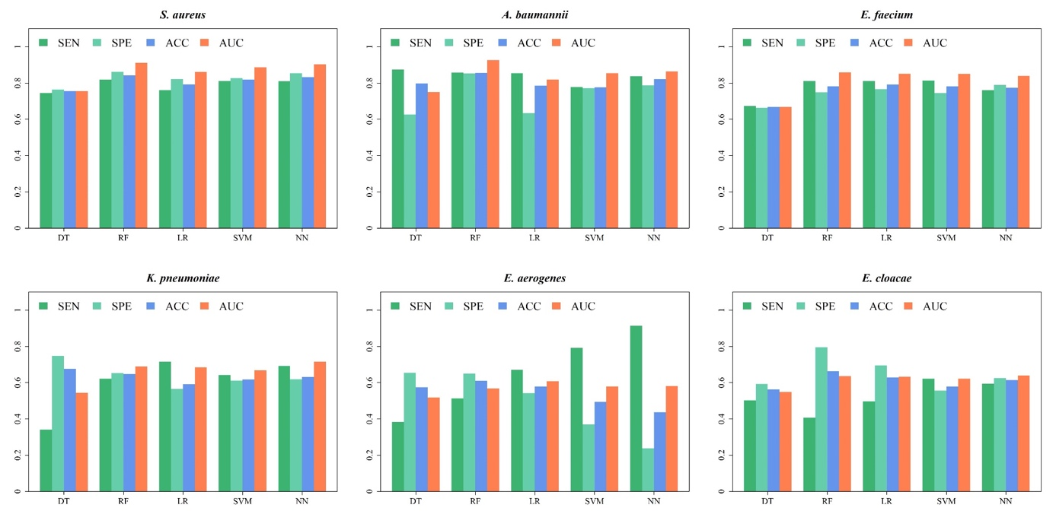
Figure S4(B). Independent testing by using different ML algorithms. SEN: sensitivity; SPE: specificity; ACC: accuracy; AUC: area under receiver operating characteristic curve. DT: decision tree; RF: random forest; LR: logistic regression; SVM: support vector machine; NN: artificial neural networks.
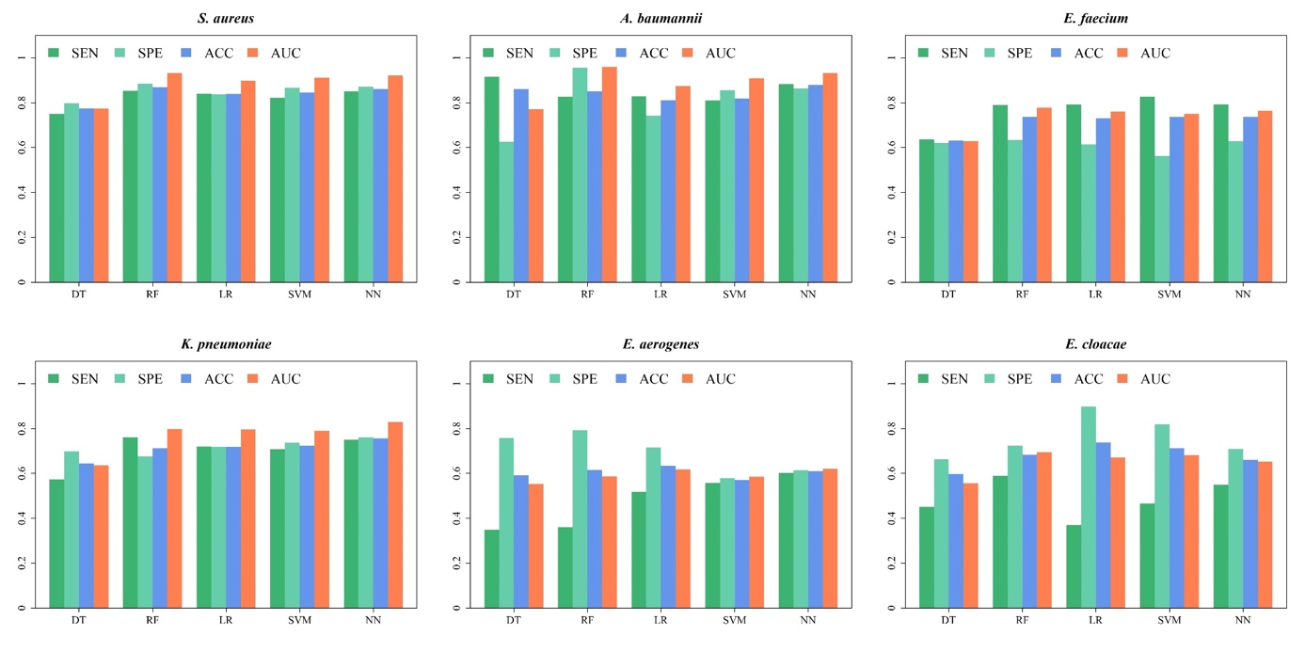
Figure S4(C). Time-wise independent testing by using different ML algorithms. SEN: sensitivity; SPE: specificity; ACC: accuracy; AUC: area under receiver operating characteristic curve. DT: decision tree; RF: random forest; LR: logistic regression; SVM: support vector machine; NN: artificial neural networks.
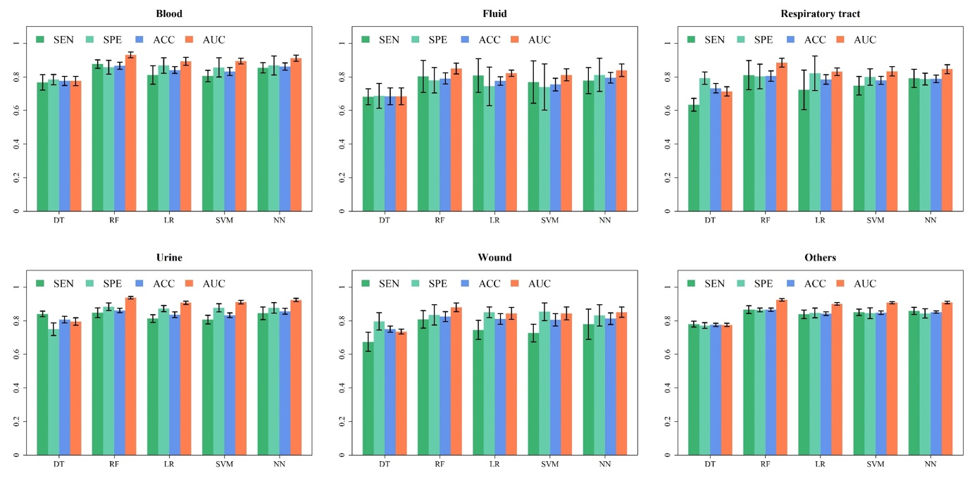
Figure S5(A). Internal validation of different S. aureus ML models in a various of specimen types. SEN: sensitivity; SPE: specificity; ACC: accuracy; AUC: area under receiver operating characteristic curve. DT: decision tree; RF: random forest; LR: logistic regression; SVM: support vector machine; NN: artificial neural networks.
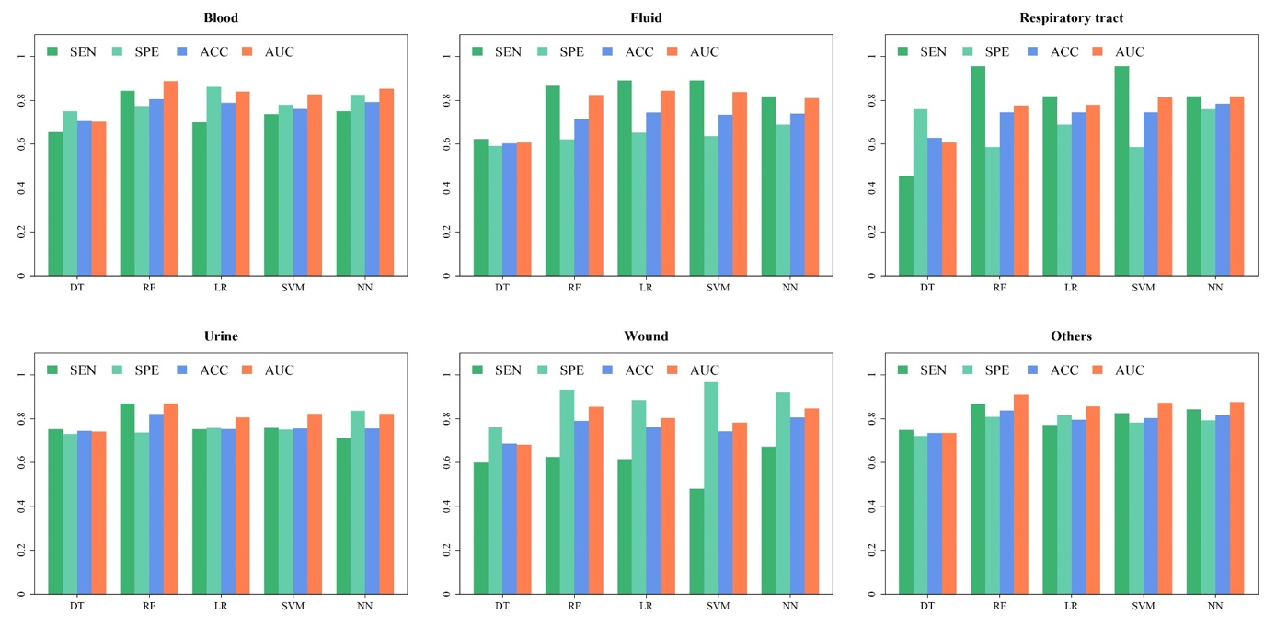
Figure S5(B). Independent testing of different S. aureus ML models in a various of specimen types. SEN: sensitivity; SPE: specificity; ACC: accuracy; AUC: area under receiver operating characteristic curve. DT: decision tree; RF: random forest; LR: logistic regression; SVM: support vector machine; NN: artificial neural networks.
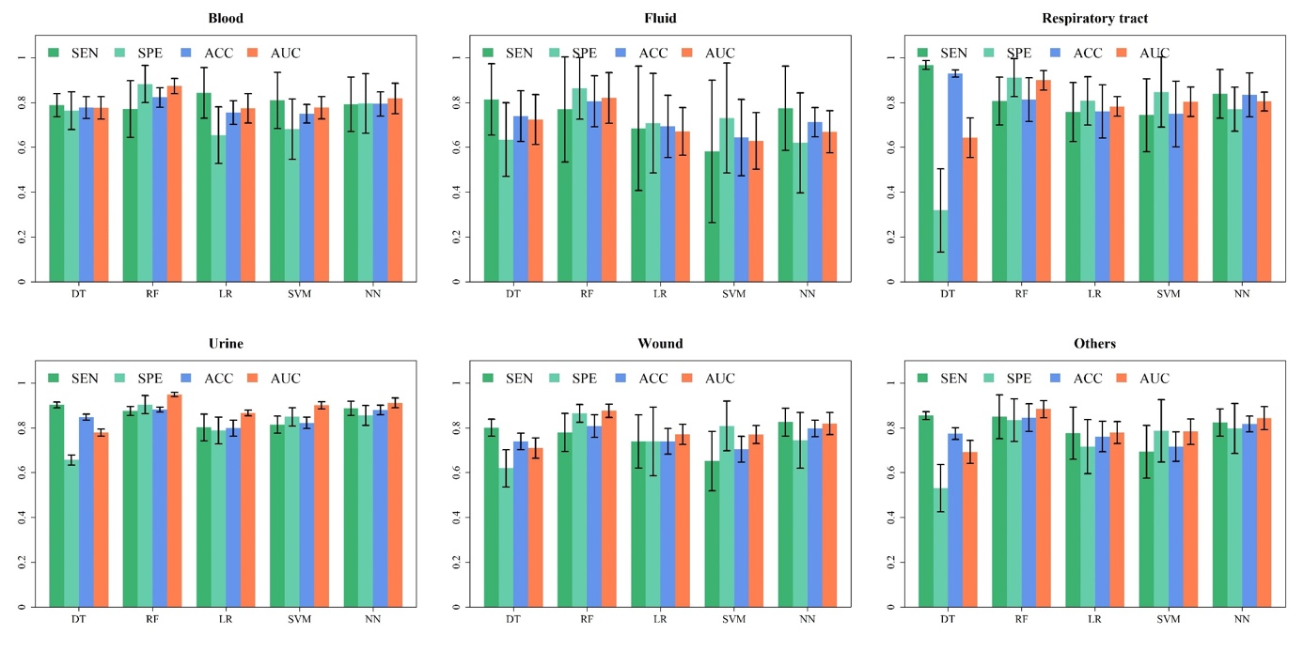
Figure S5(C). Internal validation of different A. baumannii ML models in a various of specimen types. SEN: sensitivity; SPE: specificity; ACC: accuracy; AUC: area under receiver operating characteristic curve. DT: decision tree; RF: random forest; LR: logistic regression; SVM: support vector machine; NN: artificial neural networks.
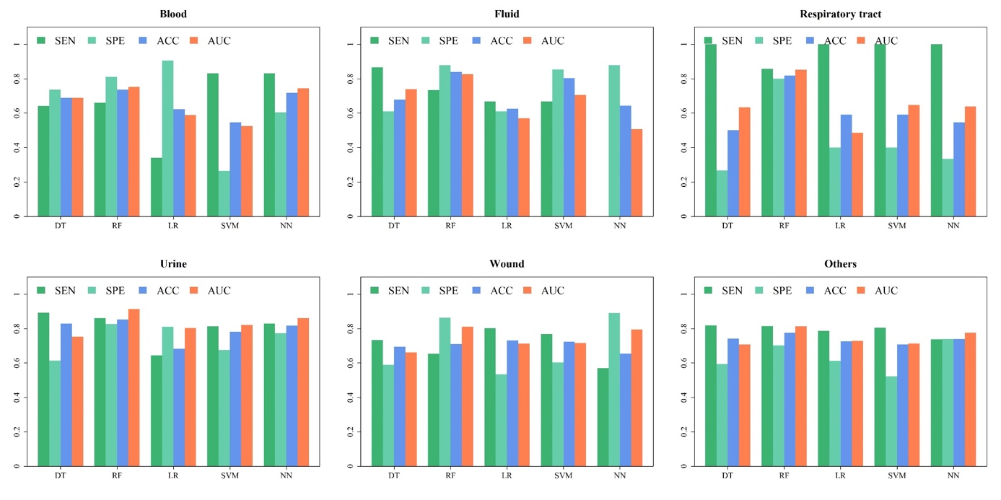
Figure S5(D). Independent testing of different A. baumannii ML models in a various of specimen types. SEN: sensitivity; SPE: specificity; ACC: accuracy; AUC: area under receiver operating characteristic curve. DT: decision tree; RF: random forest; LR: logistic regression; SVM: support vector machine; NN: artificial neural networks.
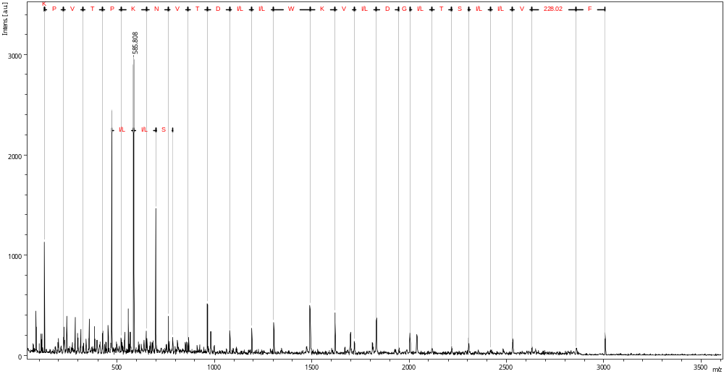
Figure S6. Peptide sequence of m/z 3006.
Table S2. Cross-national validations for S. aureus (OX). Based on our workflow of data preprocessing and model construction, we created 5 models by using local cites: data of Linkou (LK) and Kaohsiung (KH) are obtained from the present study; data from DRIAMS-A, DRIAMS-B, and DRIAMS-C are obtained from a previously published study (3). AUROC is used as the metric of diagnostic performance. In the validations, the models attain higher performance on the data of cites from which they are trained. For models trained by using data from LK and KH, the performance is high on the data of LK and KH, but not for DRIAMS-A, DRIAMS-B, and DRIAMS-C. For model trained by DRIAMS-A, the performance is good only on the data of DRIAMS-A. For models trained by DRIAMS-B or DRIAMS-C, the performance on either dataset is unacceptable.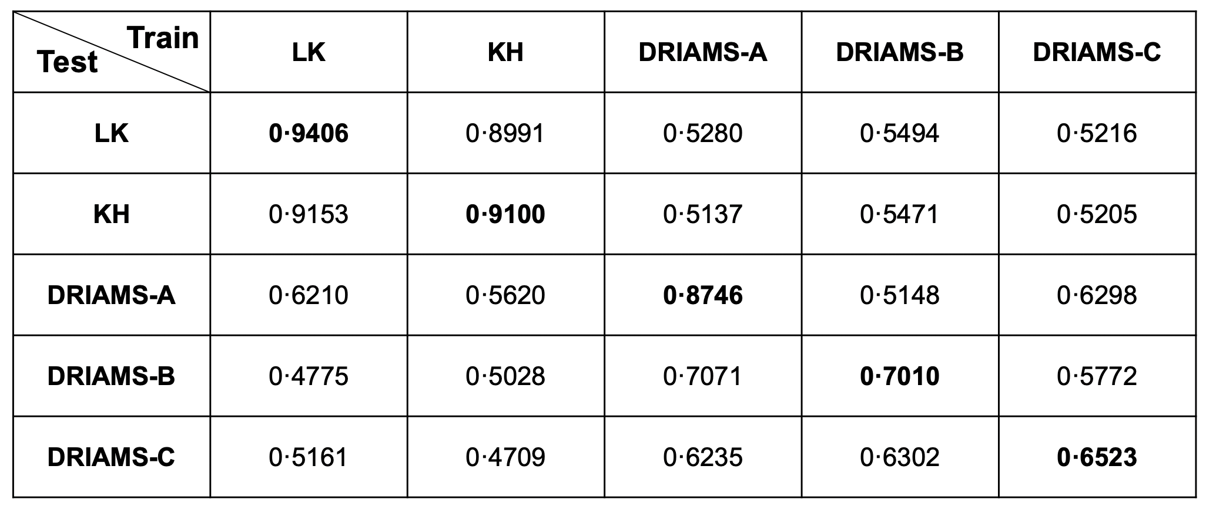
Reference
1. Pedregosa F, Varoquaux G, Gramfort A, Michel V, Thirion B, Grisel O, et al. Scikit-learn: Machine Learning in Python. J Mach Learn Res. 2011;12(null):2825–30.
2. Gagnaire J, Dauwalder O, Boisset S, Khau D, Freydiere AM, Ader F, et al. Detection of Staphylococcus aureus delta-toxin production by whole-cell MALDI-TOF mass spectrometry. PLoS One. 2012;7(7):e40660.
3. Weis C, Cuenod A, Rieck B, Dubuis O, Graf S, Lang C, et al. Direct antimicrobial resistance prediction from clinical MALDI-TOF mass spectra using machine learning. Nat Med. 2022;28(1):164-74.

