SUPPLEMENTARY MATERIAL
Altered methylation pattern in EXOC4 is associated with stroke outcome: An Epigenome-Wide Association study

Natalia Cullell, MSc^{1,2,3}, Carolina Soriano-Tárraga, PhD⁴, Cristina Gallego-Fábrega, PhD¹, Jara Cárcel-Márquez, MSc¹,Elena Muiño, MD¹, Laia Llucià-Carol MSc ¹, Miquel Lledós MSc ¹,Manel Esteller, PhD^{7,8,9}, Manuel Castro, PhD⁷, Joan Montaner, MD, PhD^{5,10}, Anna Rosell, PhD⁵, Roberto Elosúa, MD¹¹, Alba Fernández-Sanlés, PhD¹¹, Joan Martí-Fábregas, MD, PhD¹², Jerzy Krupinski, MD, PhD^{2,6} , Jaume Roquer, MD⁴, Jordi Jiménez-Conde, MD, PhD^{4*}, Israel Fernández-Cadenas, PhD^{1*}

1- Stroke Pharmacogenomics and Genetics, Institut de Recerca de Sant Pau, Hospital Sant Pau, Barcelona, Spain.
2- Neurology. Hospital Universitari MútuaTerrassa/ Fundacio Docència i Recerca MutuaTerrassa, Terrassa, Spain
3- Facultat de Medicina. Universitat de Barcelona, Barcelona, Spain
4- Neurology, Hospital del Mar; Neurovascular Research Group, IMIM; Universitat Autònoma de Barcelona / DCEXS‐Universitat Pompeu Fabra, Barcelona, Spain
5-Department of Psychiatry, Washington University School of Medicine, Saint Louis, Missouri, US
6-NeuroGenomics and Informatics, Washington University School of Medicine, Saint Louis, Missouri, US
7-Cancer Epigenetics & Biology Program (PEBC), L’Hospitalet, Barcelona, Spain
8-Department of Physiological Sciences II, School of Medicine, Universitat de Barcelona, Barcelona, Spain
9-Institució Catalana de Recerca i Estudis Avançats (ICREA), Barcelona, Spain
10- Neurovascular Research Laboratory, Vall d'Hebron Institut de Recerca (VHIR), Barcelona, Spain
11-Instituto de Biomedicina de Sevilla, IBiS/Hospital Universitario Virgen del Rocío / CSIC. Universidad de Sevilla & Department of Neurology, Hospital Universitario Virgen Macarena Sevilla, Spain
12- Neurology, Hospital de la Santa Creu i Sant, Barcelona, Spain
13- Centre for Bioscience, School of HealthCare Science, Manchester Metropolitan University, Manchester, UK

1- Supplemental e-FIGURES
Figure I: Batch effect evaluation MDS plot
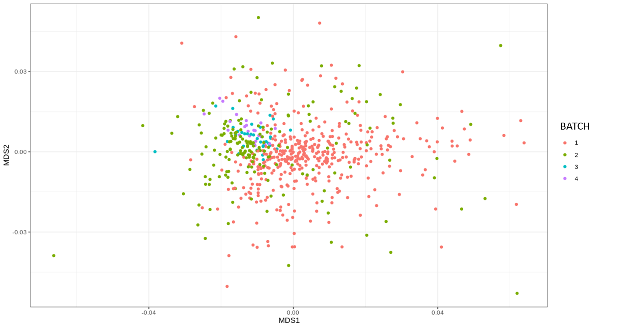

MDS plot stratifying samples with colours for batch effect differentiation. Each colour identifies a different batch included in the Discovery cohort.

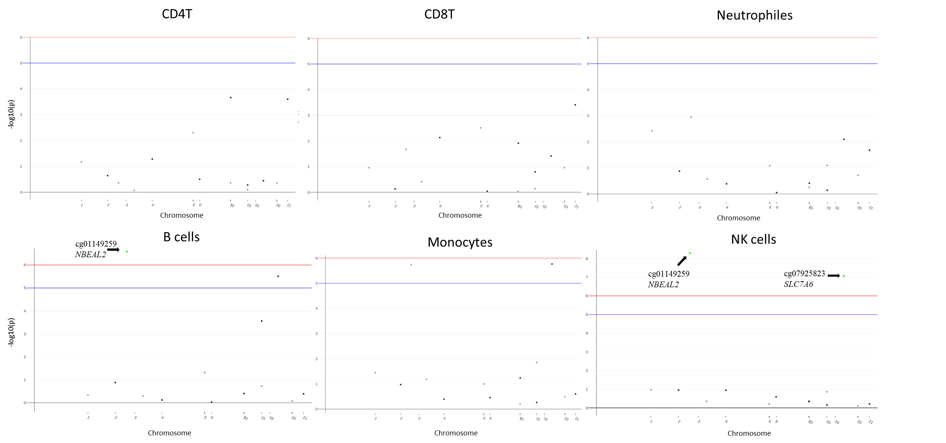
Figure II: Manhattan plots for DMCT

Manhattan plot for the nominal CpG-sites in the meta-analysis stratified by cell-types: CD4+ T-cells, CD8+ T-cells, Neutrophiles, B-cells, Monocytes and natural killer (NK) cells. Green dots represent CpG-sites epigenome-wide associated with ΔNIHSS in the specific cell-type. Red and blue lines represent the epigenome-wide and nominal significance threshold, respectively.

2- Supplemental e-TABLES

Table I: Analysis of variables associated with ∆NIHSS in bivariate and regression analysis.

 | ∆NIHSS
 | Bivariate analysis | Backward Stepwise Regression
B_NIHSS | <2.2x10^{-16*} | <2.2x10^{-16*}
mRS 3 | 8.35x10⁻⁰⁷* | <2.2x10^{-16*}
Age | 0.77 | -
Sex | 0.90 | -
B_glucose | 0.45 | -
DM | 0.09 | -
DL | 0.07 | -
tPA | 3.2x10^{-09*} | 2.5x10⁻⁰²*
AF | 2.7x10^{-04*} | 1.75x10⁻⁰²*
HTN | 0.46 | -
SMK | 0.13 | -

∆NIHSS: difference between baseline NIHSS and NIHSS at discharge; B_NIHSS: NIHSS at baseline; B_glucose: glucose levels measured at baseline; DM: diabetes mellitus; DL: dyslipidemia; tPA: treatment with rtPA; AF: atrial fibrillation; HTN: hypertension; SMK; smoking habit.
Table II: Analysis of variables associated with mRS at 3 months in bivariate and regression analysis.

 | mRS 3
 | Bivariate analysis | Backward Stepwise Regression
∆NIHSS | 8.35x10⁻⁰⁷* | < 2x10⁻¹⁶*
B_NIHSS | <2.2x10⁻¹⁶* | < 2x10⁻¹⁶
Age | <2.2x10⁻¹⁶* | 4.27x10⁻¹⁰ *
Sex | 9.11x10⁻⁰⁹* | 1.3x10⁻⁰²*
B_glucose | 1.2x10⁻⁰³* | -
DM | 0.198 | -
DL | 4.7x10⁻⁰³* | -
tPA | 0.6149 | -
AF | 7.67x10⁻¹¹* | -
HTN | 0.08 | -
SMK | 4.098x10⁻⁰⁴* | 4.4x10⁻⁰²*

∆NIHSS: difference between baseline NIHSS and NIHSS at discharge; B_NIHSS: NIHSS at baseline; B_glucose: glucose levels measured at baseline; DM: diabetes mellitus; DL: dyslipidemia; tPA: treatment with rtPA; AF: atrial fibrillation; HTN: hypertension; SMK; smoking habit.

Table III: Feature enrichment analysis

 | EWAS analysis | Hypermethylation ∆NIHSS > 0 |  |  |  |  |  |  |  | Hypomethylation ∆NIHSS > 0 |  |  |  |  |  |  |  | Enrichement analysis | P_value
 |  | 1stExon | 3'UTR | 5'UTR | Body | IGR | TSS1500 | TSS200 | 1stExon |  | 3'UTR | 5'UTR | Body | IGR | TSS1500 | TSS200
DISCOVERY | SIGN. (N = 5) | 0.0% | 0.0% | 0.0% | 60.0% | 20.0% | 0.0% | 0.0% | 0.0% |  | 0.0% | 0.0% | 0.0% | 0.0% | 0.0% | 20.0% | VS ALL |  | 0.48
DISCOVERY | NOMINAL (N = 44) | 0.0% | 0.0% | 0.0% | 18.2% | 2.3% | 0.0% | 0.0% | 2.3% |  | 2.3% | 15.9% | 15.9% | 11.4% | 11.4% | 20.5% | VS ALL |  | 9.23x10⁻⁰³
DISCOVERY | SIGN.  (NOMINAL DISCOVERY)  (N = 2) | 0.0% | 0.0% | 0.0% | 100% | 0.0% | 0.0% | 0.0% | 0.0% |  | 0.0% | 0.0% | 0.0% | 0.0% | 0.0% | 0.0% | VS ALL  (NOMINAL DISCOVERY) |  | 0.31
DISCOVERY | NOMINAL  (NOMINAL DISCOVERY)  (N = 20) | 0.0% | 0.0% | 0.0% | 25.0% | 0.0% | 0.0% | 0.0% | 5.0% |  | 5.0% | 20.0% | 10.0% | 10.0% | 15.0% | 10.0% | VS ALL  (NOMINAL DISCOVERY) |  | 0.45
 | ALL (N = 423,156) | 1.7% | 1.5% | 3.2% | 13.8% | 10.1% | 5.2% | 3.5% | 3.3% |  | 1.9% | 5.6% | 19.2% | 14.0% | 9.2% | 7.8%

Feature enrichment analysis considering the classification of hypermethylated and hypomethylated CpG-sites associated with ∆NIHSS improvement (∆NIHSS > 0). Different feature comparisons were done depending on the CpG-sites considered.
In one hand, the features for the significant (N = 5) and significant+nominal (n = 44) CpG-sites from the Discovery analysis were compared with the features from all the CpG-sites included in the array (after QCs; N = 423,156). In the other hand, significant (N = 3) and significant+nominal (N = 43) CpG-sites from the meta-analysis were compared with the features from all the CpG-sites included in the array (after QCs). A sub-analysis comparing significant (N = 2) and significant+nominal (N = 20) CpG-sites considering only the CpG-sites with a p-value < 10x10⁻⁰⁶ in the Discovery (N = 44) was also done.
EWAS analysis column: analysis considered for CpG-site selection; Hypermethylation and Hypomethylation columns: percentage of CpG-sites belonging to each feature depending on their methylation status regarding ∆NIHSS. Enrichment analysis column: CpG-site background used for comparison (all CpG-sites or all nominal CpG-sites from the Discovery). P_value: p-value for the enrichment analysis.
∆NIHSS: difference between baseline NIHSS and NIHSS at discharge; 3’UTR: 3’ untranslated region (UTR); 5’UTR: 5’ untranslated region (UTR); TSS200: transcription start site (TSS) between 0 and 200 nucleotides from the TSS; TSS1500: transcription start site (TSS) between 200 and 1500 nucleotides from the TSS; IGR: intergenic region

Table IV: Differentially methylated region (DMR) results
Chr | Start | End | Value | Width | P-value
7 | 27183133 | 27184521 | 0,015 | 1388 | 1,87E-04
20 | 36148699 | 36149455 | -0,012 | 756 | 7,46E-04
1 | 248100276 | 248100614 | 0,027 | 338 | 1,62E-03
6 | 30039132 | 30039801 | 0,015 | 669 | 2,06E-03
12 | 75784541 | 75785232 | 0,022 | 691 | 2,21E-03
22 | 22221599 | 22221878 | 0,028 | 279 | 2,29E-03
6 | 28956226 | 28956731 | 0,013 | 505 | 3,14E-03
17 | 77924582 | 77924733 | 0,025 | 151 | 3,66E-03
6 | 32847548 | 32847845 | 0,015 | 297 | 4,01E-03
6 | 33280052 | 33280518 | 0,012 | 466 | 4,79E-03
5 | 149546331 | 149546471 | 0,021 | 140 | 6,10E-03
6 | 32118295 | 32118457 | 0,015 | 162 | 6,21E-03
7 | 1080473 | 1081250 | -0,021 | 777 | 6,55E-03
7 | 56515510 | 56516255 | -0,023 | 745 | 8,83E-03
17 | 7832680 | 7833237 | 0,017 | 557 | 9,70E-03
15 | 31515750 | 31516481 | 0,018 | 731 | 9,85E-03
1 | 161008462 | 161008826 | -0,016 | 364 | 1,11E-02
19 | 13875014 | 13875329 | 0,017 | 315 | 1,27E-02
22 | 45809596 | 45810043 | 0,017 | 447 | 1,33E-02
18 | 61616369 | 61616718 | 0,016 | 349 | 1,42E-02
17 | 33759512 | 33760249 | 0,017 | 737 | 1,43E-02
7 | 27142535 | 27143287 | 0,015 | 752 | 1,54E-02
12 | 14926572 | 14927099 | 0,012 | 527 | 1,71E-02
18 | 14132207 | 14132366 | 0,017 | 159 | 1,93E-02
5 | 1594579 | 1594863 | 0,020 | 284 | 2,16E-02
20 | 50418952 | 50418959 | 0,014 | 7 | 2,16E-02
22 | 42394590 | 42394853 | 0,019 | 263 | 2,17E-02
6 | 29911334 | 29911558 | 0,017 | 224 | 2,20E-02
1 | 205818956 | 205819463 | 0,017 | 507 | 2,39E-02
15 | 81426347 | 81426820 | 0,016 | 473 | 2,62E-02
12 | 108078821 | 108079012 | 0,011 | 191 | 3,03E-02
1 | 230415225 | 230415668 | 0,017 | 443 | 3,15E-02
1 | 210000883 | 210001082 | 0,015 | 199 | 3,16E-02
11 | 70507825 | 70508410 | 0,018 | 585 | 3,30E-02
11 | 67383377 | 67383862 | 0,012 | 485 | 3,34E-02
7 | 27225811 | 27226329 | 0,014 | 518 | 3,34E-02
6 | 31734147 | 31734580 | 0,014 | 433 | 3,38E-02
5 | 78985484 | 78985592 | 0,012 | 108 | 3,51E-02
1 | 76189707 | 76189770 | 0,014 | 63 | 3,55E-02
20 | 61340827 | 61340885 | 0,018 | 58 | 3,69E-02
15 | 22833149 | 22833335 | -0,017 | 186 | 4,04E-02
12 | 29302016 | 29302035 | 0,013 | 19 | 4,10E-02
10 | 124638756 | 124639110 | 0,017 | 354 | 4,25E-02
3 | 45077369 | 45077920 | 0,014 | 551 | 4,46E-02
15 | 63340581 | 63340702 | 0,014 | 121 | 4,53E-02
17 | 17109936 | 17110353 | 0,016 | 417 | 4,60E-02
2 | 157184816 | 157184978 | 0,018 | 162 | 4,62E-02
20 | 36322069 | 36322169 | 0,013 | 100 | 4,92E-02
16 | 30441151 | 30441498 | 0,016 | 347 | 4,92E-02
15 | 41952827 | 41953061 | 0,017 | 234 | 4,92E-02

Significant DMR results (p-value < 0.05) in the Discovery cohort. Chr: chromosome where the DMR belongs to; Start-End: start position and final position of the DMR; Value: Average methylation variation in the DMR; Width: number of CpG-sites included in the DMR; P-value: p-value for the association of the DMR with ∆NIHSS.

Table V: Differentially methylated block (DMB) results
Chr | Start | End | Value | P-value
2 | 212609384 | 212618994 | 0,00351132 | 1,47E-05
2 | 213248884 | 213292541 | 0,00268735 | 4,30E-05
20 | 61158255 | 61167926 | -0,00114466 | 2,95E-04
4 | 92879355 | 92879355 | 0,00164698 | 5,85E-04
5 | 97645526 | 97728044 | -0,00103882 | 6,00E-04
22 | 22843648 | 22843648 | -0,00160559 | 6,60E-04
6 | 62596341 | 62737607 | -0,00120416 | 7,11E-04
13 | 67479146 | 67721697 | 0,0009132 | 8,03E-04
8 | 91227102 | 91411453 | 0,00117496 | 8,29E-04
9 | 71795999 | 71819910 | 0,00099709 | 2,03E-03
1 | 99774415 | 99774415 | -0,00120781 | 2,20E-03
22 | 21089054 | 21090192,5 | 0,00100978 | 3,18E-03
22 | 22874756,4 | 22918718 | 0,00089951 | 3,50E-03
3 | 21426059 | 21447688 | -0,00083278 | 3,61E-03
6 | 98744658 | 99007865 | 0,00077624 | 3,86E-03
11 | 89232216 | 89322779 | 0,00087646 | 3,97E-03
3 | 177778301 | 181556886 | -0,00031368 | 4,05E-03
18 | 22033229 | 22039676,5 | -0,00095528 | 4,09E-03
9 | 72158091 | 72347081 | 0,00094816 | 4,24E-03
20 | 48178928 | 48252667 | 0,00093139 | 4,62E-03
12 | 10208551 | 11662075 | -0,00029217 | 4,81E-03
5 | 97315689 | 97445281 | 0,00091453 | 5,02E-03
4 | 96051461 | 96102203 | 0,00078167 | 5,07E-03
5 | 91988522 | 92582155 | -0,00056859 | 5,52E-03
8 | 136439150 | 136803393 | -0,00061732 | 6,10E-03
4 | 187037287 | 187637871 | -0,00033556 | 6,29E-03
4 | 169418137 | 170328730 | -0,00034564 | 6,65E-03
7 | 19408343 | 21788417,5 | -0,0003552 | 6,70E-03
3 | 81533970 | 81816600 | -0,00073733 | 6,82E-03
16 | 34214005,7 | 34265361 | 0,00078642 | 6,86E-03
14 | 34385840 | 34488059 | 0,00064496 | 6,86E-03
3 | 171283606 | 172325619 | -0,0003173 | 7,05E-03
4 | 125660016 | 125857940 | 0,00071598 | 7,87E-03
4 | 119910700 | 120726319 | -0,00040147 | 7,87E-03
15 | 25414750,6 | 25726500 | -0,00029 | 8,05E-03
6 | 85298261 | 85445250 | 0,00062238 | 8,27E-03
7 | 81475720 | 81475720 | 0,00088104 | 8,30E-03
12 | 15501337 | 16512966 | -0,00038982 | 8,35E-03
11 | 27453034 | 28985617 | -0,00035097 | 8,38E-03
9 | 71669714 | 71691305 | -0,00081309 | 8,53E-03
4 | 163661836 | 163907607 | 0,00069887 | 8,85E-03
6 | 154406753 | 155432132 | -0,00033527 | 9,34E-03
6 | 143474125 | 144294847 | -0,00033565 | 9,60E-03
2 | 77747049 | 77856944 | -0,00068491 | 9,75E-03
8 | 87404176 | 87632363 | -0,00062299 | 9,77E-03
4 | 7750448 | 8145692 | -0,00026979 | 9,82E-03
4 | 36162678 | 36257279 | 0,00068168 | 9,97E-03

Top block results (p-value < 10⁻⁰⁴) in the Discovery cohort. Chr: chromosome where the DMR belongs to; Start-End: start position and final position of the block; Value: Average methylation variation in the block; P-value: p-value for the association of the block with ∆NIHSS.

Table VI: EWAS summary statistics in the meta-analyses for dichotomic ∆NIHSS.
CpG | CHR | BP | Gene | Feature | COEFF  (UCI,LCI) | P
cg00039070 | 7 | 133167057 | EXOC4 | Body | -3.67(-3.66,-3.67) | 4.56E-04
cg00347584 | 11 | 47283025 | NR1H3 | Body | 3.66(3.67,3.65) | 2.29E-04
cg00939347 | 10 | 652260 | DIP2C | Body | -3.07(-3.07,-3.07) | 2.16E-03
cg01149259 | 3 | 47021396 | NBEAL2 | 1stExon | 2.60(2.60,2.60) | 4.44E-03
cg02996131 | 6 | 152958598 | SYNE1 | TSS1500 | 4.18(4.19,4.17) | 3.04E-05
cg03732020 | 11 | 47282968 | NR1H3 | Body | 4.26(4.27,4.25) | 2.27E-05
cg04886221 | 1 | 27669729 | SYTL1 | 5'UTR | 2.33(2.33,2.33) | 1.37E-02
cg05979619 | 2 | 112704577 | MERTK | Body | -2.61(-2.61,-2.61) | 1.07E-02
cg06933752 | 11 | 64889788 | FAU | TSS200 | 2.83(2.83,2.83) | 3.00E-03
cg07475390 | 1 | 14440604 |  | IGR | 2.38(2.39,2.38) | 1.89E-02
cg07925823 | 16 | 68298504 | SLC7A6 | 5'UTR | 2.75(2.75,2.75) | 2.65E-03
cg07987148 | 20 | 45318890 | TP53RK | TSS1500 | 3.26(3.27,3.25) | 1.02E-03
cg08119231 | 1 | 220921216 | MOSC2 | TSS1500 | 3.19(3.20,3.19) | 1.29E-03
cg08526825 | 16 | 2802229 | SRRM2 | TSS200 | 2.50(2.50,2.50) | 1.80E-02
cg09548897 | 16 | 341277 | AXIN1 | Body | -3.00(-3.00,-3.00) | 5.27E-03
cg09741713 | 12 | 62471915 | FAM19A2 | 5'UTR | 2.90(2.91,2.90) | 3.82E-03
cg10156941 | 17 | 1466296 | PITPNA | TSS200 | 5.00(5.00,5.00) | 4.93E-04
cg10363284 | 4 | 8007138 | ABLIM2 | Body | -4.09(-4.08,-4.09) | 4.60E-05
cg10977834 | 4 | 77996840 | CCNI | 5'UTR | 4.33(4.33,4.33) | 8.58E-06
cg12103149 | 6 | 30181173 | TRIM26 | TSS200 | 3.00(3.00,3.00) | 1.21E-04
cg12349416 | 11 | 4206098 |  | IGR | 3.53(3.53,3.52) | 4.36E-04
cg13114315 | 21 | 37546467 | DOPEY2 | Body | 1.98(2.00,1.97) | 4.55E-02
cg14414100 | 9 | 19547530 | SLC24A2 | Body | 2.28(2.29,2.27) | 2.22E-02
cg14482313 | 12 | 52626889 | KRT7 | TSS200 | 4.25(4.26,4.24) | 2.79E-05
cg14659930 | 3 | 114128301 | ZBTB20 | 5'UTR | 3.32(3.34,3.30) | 8.71E-04
cg15765398 | 21 | 46409994 |  | IGR | -3.58(-3.57,-3.59) | 3.36E-04
cg18707780 | 15 | 100273790 | LYSMD4 | TSS200 | 3.50(3.50,3.50) | 6.31E-05
cg18795809 | 4 | 10458531 | ZNF518B | 5'UTR | 2.71(2.72,2.71) | 7.17E-03
cg18831371 | 5 | 176037325 | GPRIN1 | TSS200 | 3.00(3.00,3.00) | 3.37E-03
cg19935850 | 4 | 41753439 |  | IGR | 3.51(3.52,3.50) | 4.88E-04
cg20383948 | 21 | 46898137 | COL18A1 | Body | 2.75(2.75,2.75) | 7.97E-03
cg20648899 | 6 | 94126141 | EPHA7 | Body | 2.95(2.96,2.93) | 3.28E-03
cg21404878 | 15 | 72578605 | BRUNOL6 | 3'UTR | 2.08(2.08,2.07) | 3.66E-02
cg21574204 | 6 | 28048958 | ZNF165 | 5'UTR | 4.00(4.00,4.00) | 3.32E-05
cg22363670 | 7 | 86273169 | GRM3 | TSS200 | 1.73(1.73,1.73) | 6.79E-02
cg24978805 | 7 | 3727189 | SDK1 | Body | -2.44(-2.43,-2.44) | 1.37E-02
cg25354926 | 4 | 812611 | CPLX1 | Body | -1.75(-1.75,-1.75) | 8.79E-02
cg26050512 | 20 | 57556066 | TH1L | TSS1500 | 3.33(3.33,3.33) | 7.55E-05

Summary statistics for EWAS results in the meta-analysis considering ∆NIHSS as a dichotomic variable (only for the 38 CpG sites with nominal association in the Discovery EWAS analysis of continuous ∆NIHSS and available in the Discovery and Replication cohorts).

CpG: CpG site ID; CHR: chromosome where the CpG site is located; BP: specific chromosomal position for the CpG site; Gene: Gene annotation (from the Illumina Manifest File); Feature: Genomic location of the CpG site. It could reside in the 5’ untranslated region (UTR), between 0 and 200 nucleotides from the transcription start site (TSS), TSS200, or between 200 and 1500 nucleotides from the TSS, TSS1500. It could be also located in the body of the gene, in the 3’UTR or in an intergenic region (IGR); COEFF (UCI,LCI): Effect size for the association of the CpG-site with the dichotomic ∆NIHSS, with information for the upper (UCI) and lower (LCI) 95% confidence intervals; P: p-value for the association of the CpG-site with the dichotomic ∆NIHSS.

Table VII: Demographic and clinical data for the subjects included in the analysis with SOMAscan

 | Stroke patients | Controls
Subjects(n) | 26 | 20
Sex  Male,n(%)  Female,n(%) | 10 (38.5%)  16 (61.5%) | 11 (55%)  9 (45%)
Age in years, median (IQR) | 77 (13) | 64 (5)
Presence of HTN, n(%) | 12 (46.15%) | 20 (100%)
Smoking,n(%) | 3 (11.5%) | 3 (15%)
Treatment with rtPA, n (%) | 26 (100%) | N/A
TOAST  CES, n(%)  LAS, n(%)  SVS, n(%)  Und, n(%)  NA, n(%) | 16 (35.9%)  5 (27.8%)  0 (0%)  3 (3.9%)  2 (7.7%) | N/A  N/A  N/A  N/A  N/A

Demographic and clinical features for subjects included in the proteomic analysis with SOMAscan.
IQR: interquartile range; HTN: Hypertension; CES: cardioembolic stroke; LAS: large artery stroke; SVS: small vessel stroke; und: undetermined stroke.

