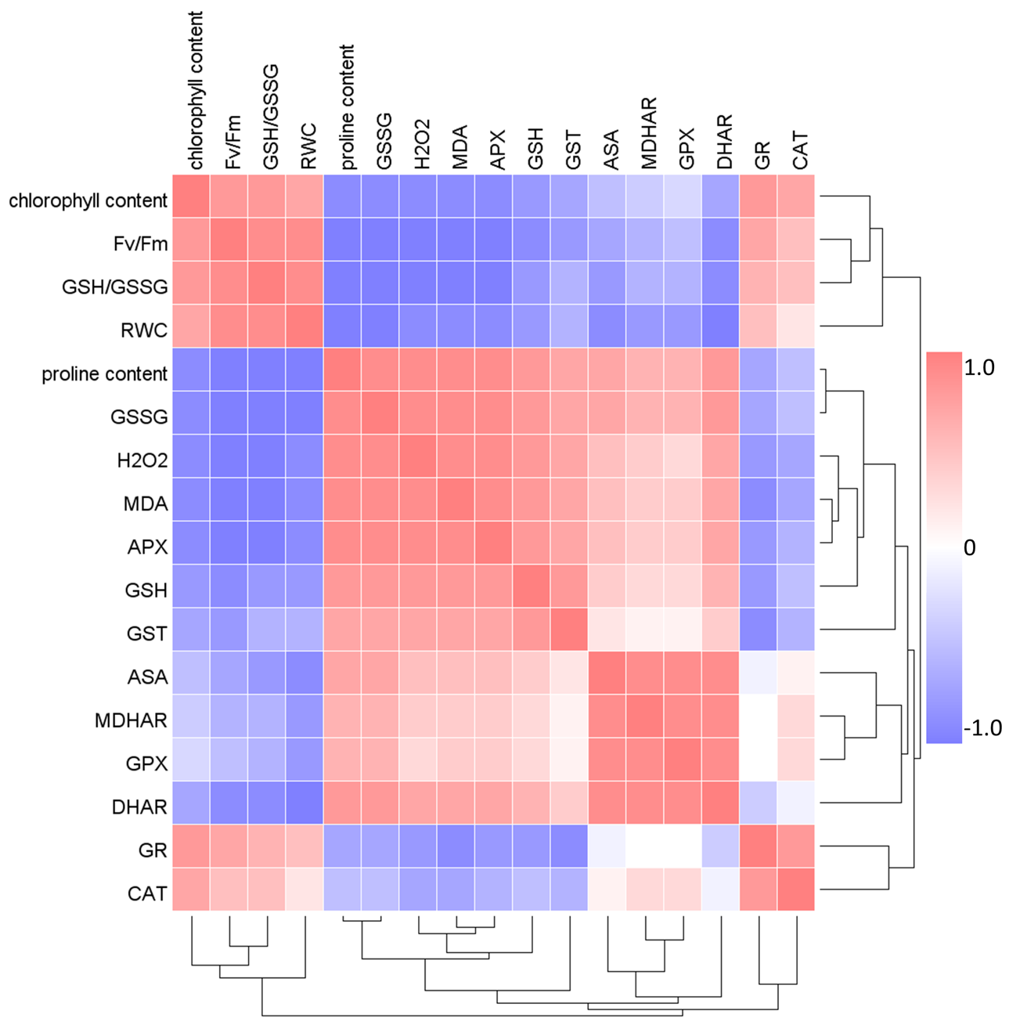

Supplemental Figure 1. Heatmap with cluster analysis depicting Pearson’s correlation analysis between physiological and biochemical parameters evaluated in ‘Asgari’ seedless grape (Vitis vinifera L.) under PEG-induced drought stress.

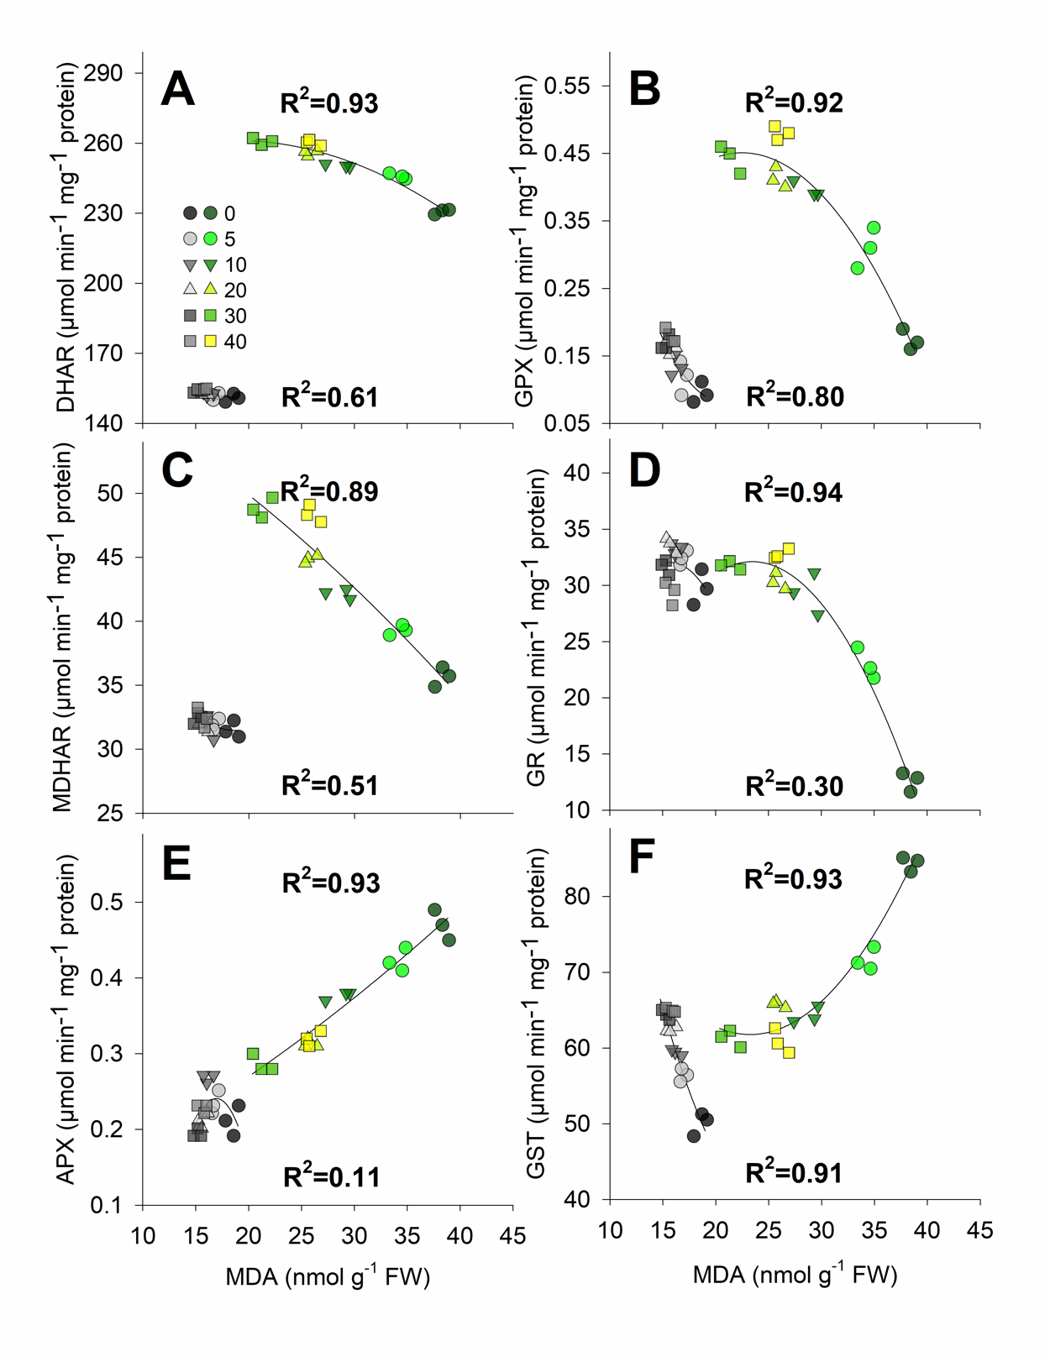

Supplemental Figure 2. The effect of Fe NPs concentration on the relationship between MDA and A) DHAR, C) MDHAR, E) APX, and GSH and B) GST, D) GPX, and F) GR in control (grey shapes) and PEG-induced drought-stressed (colored shapes) ‘Asgari’ seedless grape (Vitis vinifera L.) plants. R² values for C and E depict first-order correlations, while A, B, D, and F depict second-order correlations.

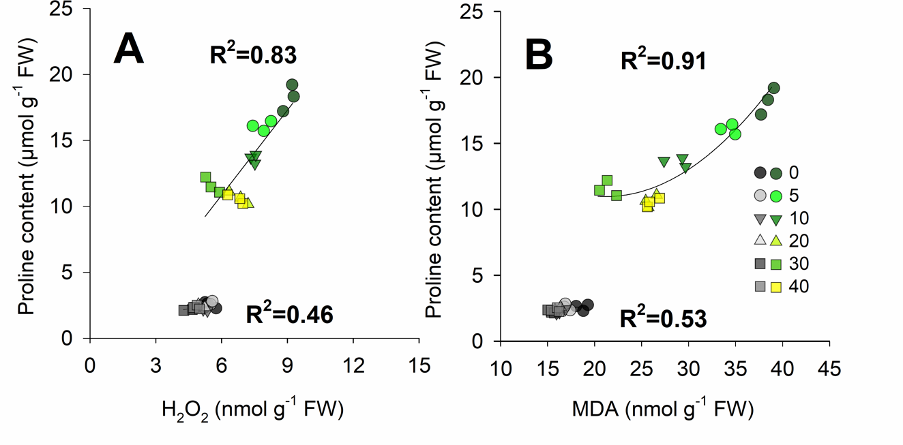
Supplemental Figure 3. The effect of Fe NPs concentration on the relationship between A) H₂O₂ and B) MDA with Proline content in control (grey shapes) and PEG-induced drought-stressed (colored shapes) ‘Asgari’ seedless grape (Vitis vinifera L.) plants. R² values for A depict first-order correlations, while B depicts second-order correlations.

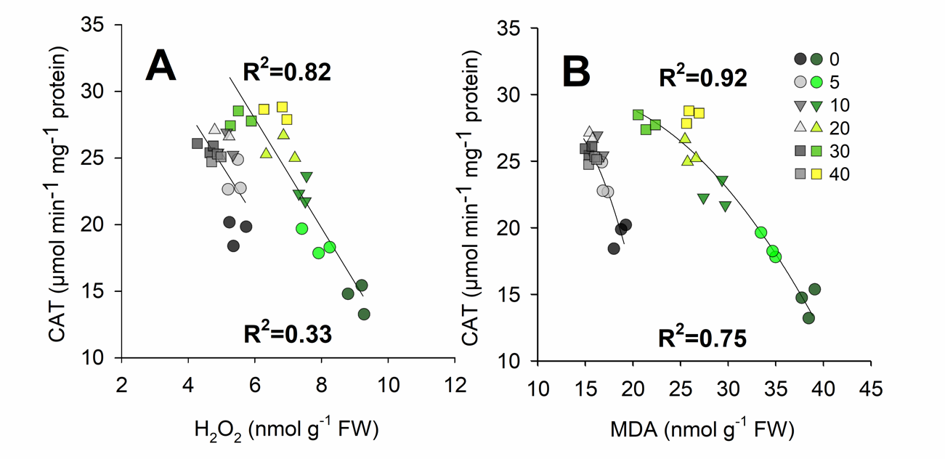

Supplemental Figure 4. The effect of Fe NPs concentration on the relationship between A) H₂O₂ and B) MDA with CAT in control (grey shapes) and PEG-induced drought-stressed (colored shapes) ‘Asgari’ seedless grape (Vitis vinifera L.) plants. R² values for A depict first-order correlations, while B depicts second-order correlations.

