Functional inhibition of the StERF3 gene by dual targeting through CRISPR/Cas9 enhances resistance to the late blight disease in Solanum Tuberosum L.
Hafiza Arooj Razzaq¹, Siddra Ijaz¹, Imran Ul Haq², and Iqrar Ahmad Khan³
¹Centre of Agricultural Biochemistry and Biotechnology (CABB), University of Agriculture, University Road, Faisalabad 38000, Pakistan
²Department of Plant Pathology, University of Agriculture, University Road, Faisalabad 38000, Pakistan
³Institute of Horticulture Sciences, University of Agriculture, University Road, Faisalabad 38000, Pakistan

*Corresponding Author: siddraijazkhan@yahoo.com

Journal name: Molecular Biology Reports

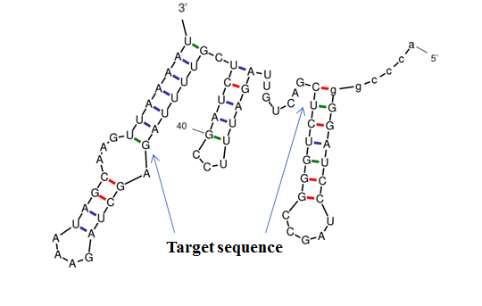
Figure S1 Secondary structures of sgRNA: target sequence-I showing no base pairing of sgRNA with target 1

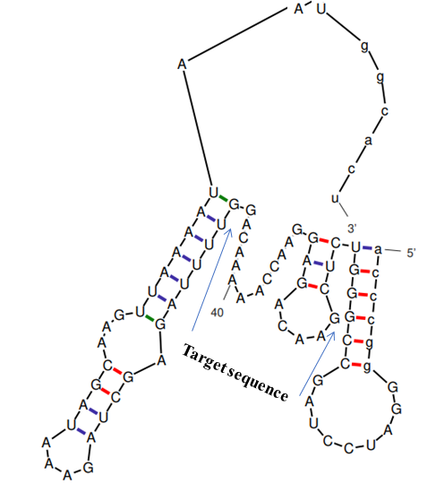
Figure S2 Secondary structures of sgRNA: target sequence-II showing pairing of 3 bases of sgRNA with target 2

Table S1 List of primer sequences used in CRISPR/Cas9 genome editing study of potato cv. Lady Rosetta.
sterf3-F | 5´ CGGAGATAAGAGATCCCGGTAA 3´
sterf3-R | 5´ GTTTCACGTCAACACGCATAAA 3´
gRT1(+) | 5´ GACTGTTAGATTTCCGATCTCGTTTTAGAGCTAGAAAT 3´
gRT2(+) | 5´ GAACAGAGGAACCAAAAACAGGTTTTAGAGCTAGAAAT 3´
gR-R | 5´ CGGAGGAAAATTCCATCCAC 3´
U-F | 5´ CTCCGTTTTACCTGTGGAATCG 3´
UT1 (-) | 5´ GAGATCGGAAATCTAACAGTCGGCAGCCAAGCCAGCA 3´
UT2 (-) | 5´ CTGTTTTTGGTTCCTCTGTTCGGCAGCCAAGCCAGCA 3´
Pps-RB | 5´ TTCAGAGGTCTCTACCGACTAGTGTGGAATCGGCAGCAAAGG 3´
Pgs-ef3.1 | 5´ AGCGTGGGTCTCGCAGATAGTCCATCCACTCCAAGCTC 3´
Pps- ef3.1 | 5´ TTCAGAGGTCTCTTCTGCAATGGAATCGGCAGCAAAGG 3´
Pgs- ef3.2 | 5´ AGCGTGGGTCTCGACCTCAATCCATCCACTCCAAGCTC 3´
Pps- ef3.2 | 5´ TTCAGAGGTCTCTAGGTTTCTGGAATCGGCAGCAAAGG 3´
Pgs-LB | 5´ AGCGTGGGTCTCGCTCGACGCGTATCCATCCACTCCAAGCTC 3´

