Fig S1- FTIR spectra of raw cotton
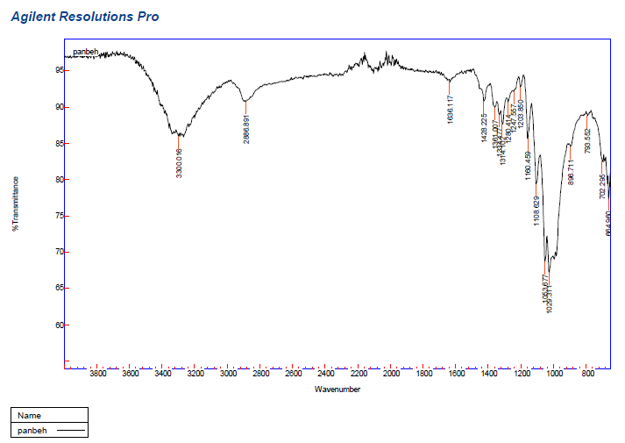

Fig S2- SEM images of raw cotton, A) 200x and B) 100x magnitude
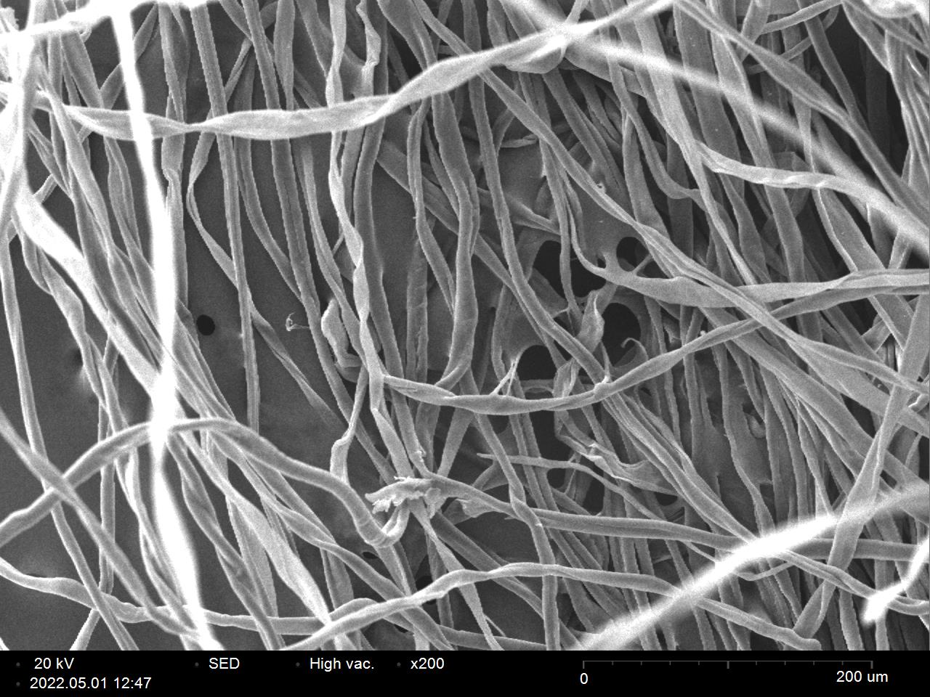
A
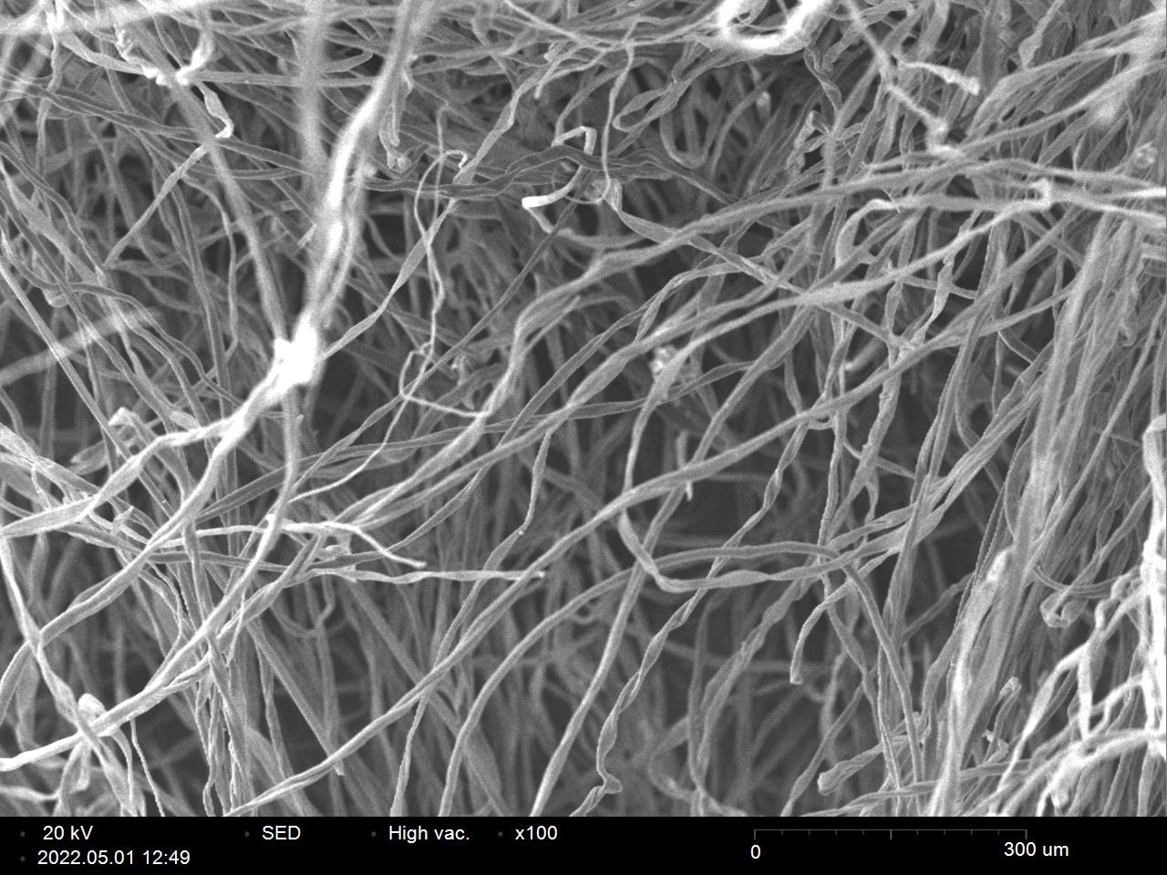
B

Fig S3- XRD pattern of raw cotton

