Supplementary materials

Article
Description of Winogradskyella luteola sp.nov., Erythrobacter ani sp.nov., and Erythrobacter crassostrea sp.nov., three novel bacteria of two different genus Winogradskyella and Erythrobacter, from the hemolymph of Pacific Oyster Crassostrea gigas. Prediction of bioremediation
Hani Pira ª, Mathias Müsken ^{b}, Peter J. Schupp ^{c} and Joachim Wink ª*
ª Microbial Strain Collection (MISG), Helmholtz Centre for Infection Research (HZI), 38124 Braunschweig, Germany; hani.pira@helmholtz-hzi.de (H.P); Joachim.Wink@helmholtz-hzi.de (J.W).
^{b} Central Facility for Microscopy, Helmholtz Centre for Infection Research (HZI), 38124 Braunschweig, Germany; Mathias.Muesken@helmholtz-hzi.de(M.M).
^{c} University Oldenburg, Institute for Chemistry and Biology of the Marine Environment, Oldenburg, Germany; peter.schupp@uni-oldenburg.de (PJ.S).
* Correspondence: Joachim.Wink@helmholtz-hzi.de (J.W).

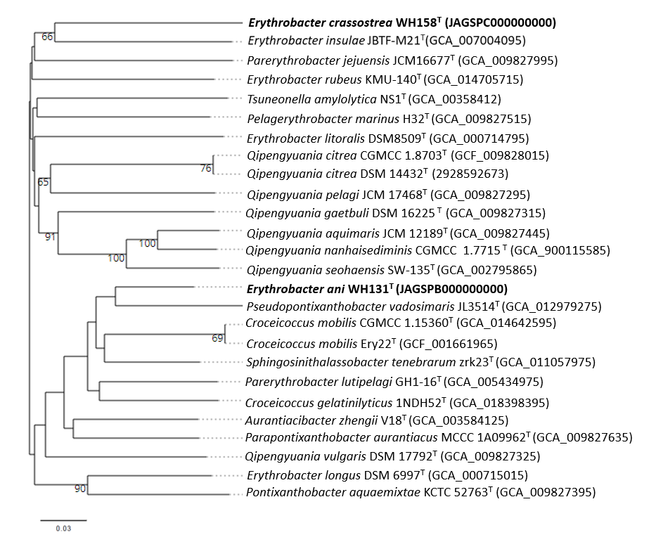

Fig. S1. Phylogenomic tree inferred from GBDP distances based on genomic data between strain WH131^{T},WH158^{T} and the closely related type strains based on Type (Strain) Genome Server (TYGS) (https://tygs.dsmz.de/). The number at the nodes are GBDP pseudo-bootstrap support values > 60 % from 100 replications, with average branch support of 40.3%.

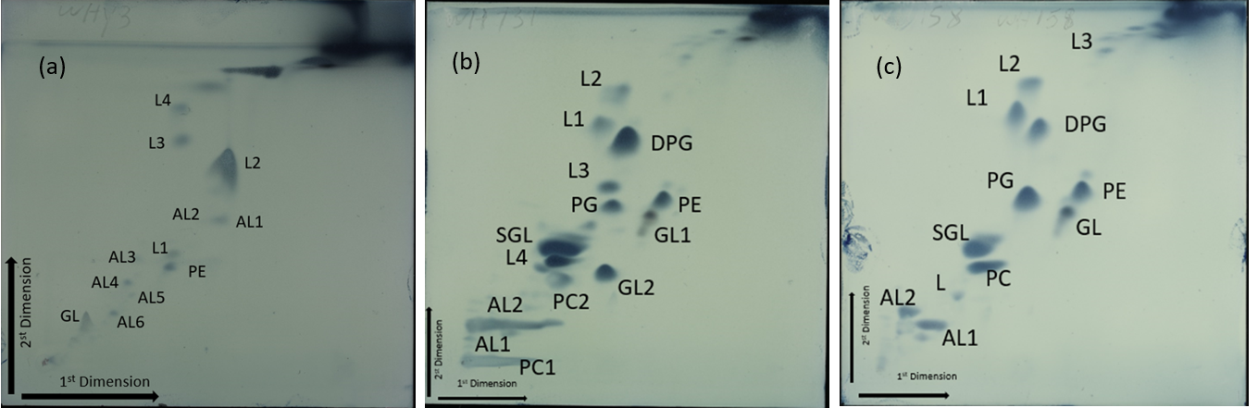
Fig. S2.The profile of cellular polarlipid of strains (a) WHY3^{T}, (b) WH131^{T}, (c) WH158^{T}. Diphosphatidylglycerol (DPG), phosphatidylcholine (PC), phosphatidylinositol (PI), phosphatidylglycerol (PG), phosphatidylethanolamine (PE), sphingoglycolipid (SGL), unidentified phospholipids (PL), unidentified glycolipid (GL), unidentified aminolipid (AL) and unidentified polar lipid (L).

Table S1
Antibiotic susceptibility of strains WHA3^{T}, WH131^{T,} and WH158^{T} for the most closely related type strains. Strains: 1, Winogradskyella luteola WHY3^{T}; 2, Winogradskyella flava KCTC 52348^{T} 3, Winogradskyella ouciana ZXX205^{T}; 4, Winogradskyella echinorum KCTC 22026^{T}; 5, Erythrobacter ani WH131^{T}; 6, Erythrobacter crassostrea WH158^{T}; 7, Erythrobacter insulae JBTF-M21^{T}; 8, Erythrobacter rubeus KMU-140^{T}; 9, Erythrobacter longus DSM 6997^{T}; 10, Erythrobacter litoralis DSM8509^{T}.
Genus name  Species name | Winogradskyella |  |  |  | Erythrobacter
Genus name  Species name | 1 | 2 | 3 | 4 | 5 | 6 | 7 | 8 | 9 | 10
Susceptibility to:
Polymyxin | - | ND | ND | -⸸ | - | - | -‡ | ND | - | -
Gentamycin | - | -* | ND | -⸸ | + | + | -‡ | ND | + | -
Oxytetracycline | - | ND | ND | ND | - | - | ND | ND | - | -
Ampicillin | - | +* | ND | -⸸ | - | - | -‡ | ND | - | -
Chloramphenicol | + | +* | ND | +⸸ | + | + | +‡ | ND | + | +
Spectinomycin | - | ND | ND | -⸸ | + | + | ND | ND | + | +
Kanamycin | - | -* | ND | -⸸ | + | + | -‡ | ND | + | +
Cephalosporin | - | ND | ND | ND | - | - | ND | ND | - | -
Fusidic acid | + | ND | +† | ND | + | + | ND | -** | + | +
Bacitracin | - | ND | ND | ND | - | - | ND | ND | - | -
Thiostrepton | + | ND | ND | ND | + | + | ND | ND | + | +
Trimethoprim | - | ND | ND | ND | - | - | ND | ND | - | -
Erythromycin | + | +* | ND | +⸸ | + | + | ND | ND | + | +
Tetracycline | - | ND | ND | -⸸ | + | + | +‡ | ND | + | +
Vancomycin | + | +* | -† | ND | - | - | ND | -** | - | -
Amikacin | ND | -* | ND | ND | ND | ND | ND | ND | ND | ND
Nalidixic acid | + | -* | +† | ND | - | + | ND | -** | - | +
Penicillin | ND | -* | ND | ND | ND | ND | -‡ | ND | + | -
Streptomycin | - | -* | ND | ND | ND | ND | -‡ | ND | - | -
Lincomycin | + | ND | - | +⸸ | - | - | -‡ | -** | - | -
Troleandomycin | + | ND | +† | ND | - | - | ND | -** | - | -
Rifamycin SV | + | ND | +† | ND | - | - | ND | -** | - | -
Minocycline | + | ND | +† | ND | - | - | ND | -** | - | -
Aztreonam | + | ND | +† | ND | + | + | ND | -** | - | +
+, positive; -, negative; ND, no data

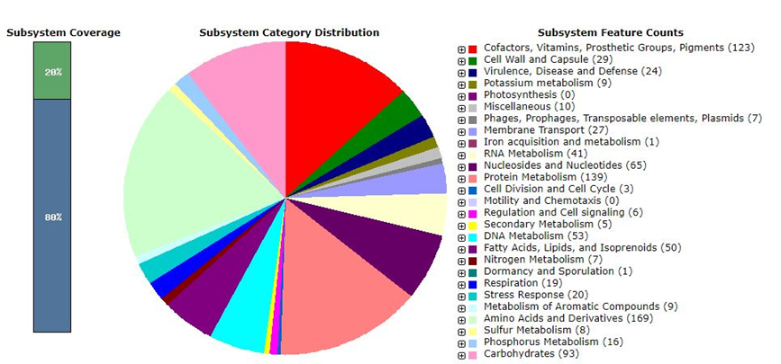
(a)
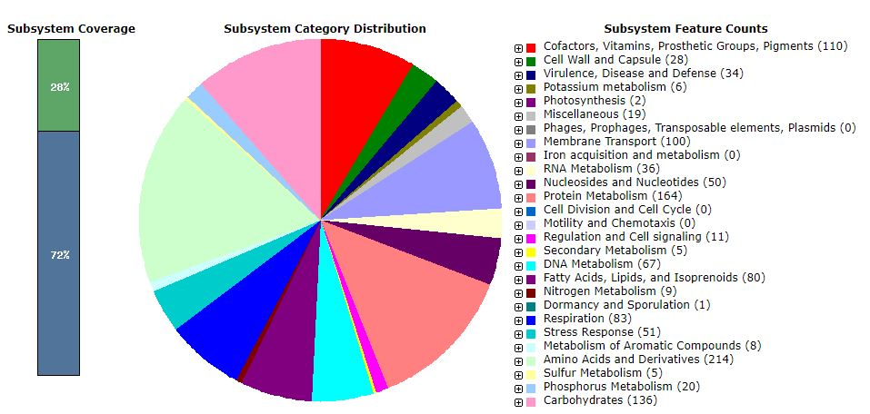
(b)

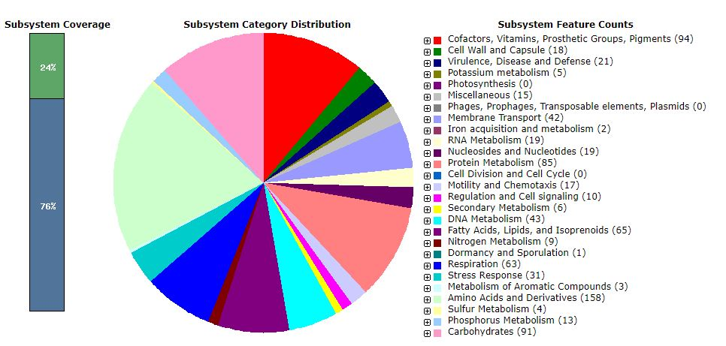
(c)

Fig. S3. RAST Subsystem category (https://rast.nmpdr.org) of the draft genome of strains (a), Winogradskyella luteola WHY3^{T}; (b), Erythrobacter ani WH131^{T}; (c), Erythrobacter crassostrea WH158^{T}.

Table S2
RAST analysis result (https://rast.nmpdr.org) of the draft genome of strains 1, Winogradskyella luteola WHY3^{T}; 2, Erythrobacter ani WH131^{T}; 3, Erythrobacter crassostrea WH158^{T}.
Subsystem Feature | 1 | 2 | 3
Cofactors, Vitamins, Prosthetic Groups, Pigments  Biotin  Cofactors, Vitamins, Prosthetic Groups, Pigments - no subcategory  Tetrapyrroles  Riboflavin, FMN, FAD  Pyridoxine  NAD and NADP  Folate and pterines  Coenzyme A  Quinone cofactors | 123  1  4  10  12  0  10  50  14  12 | 110  5  5  14  13  9  11  42  11  0 | 94  5  5  11  13  7  8  35  10  0
Cell Wall and Capsule  Gram-Negative cell wall components  Cell Wall and Capsule - no subcategory  Capsular and extracellular polysacchrides  Gram-Positive cell wall components  Cell wall of Mycobacteria | 29  1  8  20  0  0 | 28  1  12  15  0  0 | 18  1  8  9  0  0
Virulence, Disease, and Defense  Resistance to antibiotics and toxic compounds  Invasion and intracellular resistance | 24  12  12 | 34  22  12 | 21  13  8
Potassium metabolism  Potassium metabolism - no subcategory | 9  9 | 6  6 | 5  5
Photosynthesis  Light-harvesting complexes | 0  0 | 2  2 | 0  0
Miscellaneous  Plant-Prokaryote DOE project  Miscellaneous - no subcategory | 10  9  1 | 19  15  4 | 15  14  1
Phages, Prophages, Transposable elements, Plasmids  Phages, Prophages | 7  7 | 0  0 | 0  0
Membrane Transport  Protein secretion system, Type II  Protein translocation across cytoplasmic membrane  Cation transporters  Uni- Sym- and Antiporters  Membrane Transport - no subcategory  TRAP transporters  Protein and nucleoprotein secretion system, Type IV | 27  0  2  4  2  19  0  0 | 100  15  3  6  2  22  0  52 | 42  10  4  1  2  23  2  0
RNA Metabolism  RNA processing and modification  Transcription | 41  18  23 | 36  18  18 | 19  6  13
Nucleosides and Nucleotides  Pyrimidines  Purines  Nucleosides and Nucleotides - no subcategory  Detoxification | 65  18  37  6  4 | 50  12  27  7  4 | 19  0  12  4  3
Protein Metabolism  Protein folding  Selenoproteins  Protein biosynthesis  Protein processing and modification  Protein degradation | 139  5  0  102  14  18 | 164  9  1  129  7  18 | 85  8  1  56  6  14
Cell Division and Cell Cycle | 3 | 0 | 0
Motility and Chemotaxis  Flagellar motility in Prokaryota | 0  0 | 0  0 | 17  17
Regulation and Cell signaling  Regulation and Cell signaling - no subcategory  Programmed Cell Death and Toxin-antitoxin Systems | 6  6  0 | 11  11  0 | 10  10  10
Secondary Metabolism  Biosynthesis of phenylpropanoids  Plant Hormones  Secondary Metabolism - no subcategory  Plant Alkaloids | 5  0  4  0  1 | 5  1  4  0  0 | 6  0  4  2  0
DNA Metabolism  DNA repair  CRISPs  DNA Metabolism - no subcategory  DNA replication  DNA uptake, competence | 53  40  2  5  4  2 | 67  48  0  9  8  2 | 43  31  0  3  7  2
Fatty Acids, Lipids, and Isoprenoids  Isoprenoids  Phospholipids  Triacylglycerols  Fatty acids  Fatty Acids, Lipids, and Isoprenoids - no subcategory | 50  20  0  0  22  8 | 80  15  0  1  41  23 | 65  12  0  1  33  19
Nitrogen Metabolism  Nitrogen Metabolism - no subcategory  Denitrification | 7  6  1 | 9  9  0 | 9  9  0
Dormancy and Sporulation  Dormancy and Sporulation - no subcategory | 1  1 | 1  1 | 1  1
Respiration  ATP synthases  Biotin  Electron accepting reactions  Electron donating reactions  Respiration - no subcategory | 19  8  1  1  2  8 | 83  10  5  8  35  30 | 63  0  5  7  34  22
Stress Response  Osmotic stress  Oxidative stress  Detoxification  Stress Response - no subcategory  Periplasmic Stress | 20  4  9  4  2  5 | 51  3  35  6  8  3 | 31  3  16  5  7  3
Metabolism of Aromatic Compounds  Peripheral pathways for catabolism of aromatic compounds  Metabolism of central aromatic intermediates  Metabolism of Aromatic Compounds - no subcategory | 9  1  7  1 | 8  2  5  1 | 3  1  2  0
Amino Acids and Derivatives  Amino Acids and Derivatives - no subcategory  Glutamine, glutamate, aspartate, asparagine; ammonia assimilation  Histidine Metabolism  Arginine; urea cycle, polyamines  Lysine, threonine, methionine, and cysteine  Branched-chain amino acids  Aromatic amino acids and derivatives  Proline and 4-hydroxyproline  Alanine, serine, and glycine | 169  0  16  11  12  31  23  35  3  38 | 214  3  17  9  0  56  51  36  10  32 | 158  0  14  8  0  39  25  34  8  30
Sulfur Metabolism  Sulfur Metabolism - no subcategory | 8  8 | 5  5 | 4  4
Phosphorus Metabolism  Phosphorus Metabolism - no subcategory | 16  16 | 20  20 | 13  13
Carbohydrates  Carbohydrates - no subcategory  Central carbohydrate metabolism  Di- and oligosaccharides  One-carbon Metabolism  Organic acids  Fermentation  Sugar alcohols  Monosaccharides  CO2 fixation  Polysaccharides | 93  1  45  3  4  0  15  8  11  2  4 | 136  1  68  9  4  5  39  5  5  0  0 | 91  1  39  3  5  5  29  0  9  0  0
Iron acquisition and metabolism  Iron acquisition and metabolism - no subcategory | 1  1 | 0  0 | 2  2

