Supporting Information

Energy-resolving large area X-ray imaging enabled by stacked metal halide scintillators

Peng Ran¹, Lurong Yang¹, Tingming Jiang¹, Xuehui Xu¹, Juan Hui¹, Yirong Su¹, Cuifang Kuang¹, Xu Liu¹, Yang (Michael) Yang¹*
¹State Key Laboratory of Modern Optical Instrumentation, College of Optical Science and Engineering, International Research Center for Advanced Photonics, Zhejiang University, Hangzhou, Zhejiang, China
*Correspondence and requests for materials should be addressed to Yang (Michael) Yang (yangyang15@zju.edu.cn)

Experimental section
Chemicals.
Cesium iodide (CsI, 99.9%), copper iodide (CuI, 99.95%) and Methanol (99.8%) were purchased from Aladdin. Methylbenzene (AR) were purchased from Sinopharm Chemical Reagent Co. Ltd. (SCRC). N, N-Dimethylformamide (DMF, 99.9%), and dimethyl sulfoxide (DMSO, 99.9%) were purchased from J&K Scientific. All reagents and solvents were used without further purification.
Synthesis of Cs₃Cu₂I₅ powder.
The synthesis of Cs₃Cu₂I₅ powder was based on the anti-solvent method. In the synthesis process, 6 mmol CsI and 4 mmol CuI were dissolved in 6 ml DMSO and stirred for 1 h at 60 °C. 2mL methanol as anti-solvent was added into the centrifuge tube in advance, and then 500μL saturated precursor solution was quickly injected into the tube. A large amount of white precipitate immediately appeared. The centrifuge tube was placed in the centrifuge for 5 minutes at the speed of 5000 rpm min⁻¹, then removed the supernatant and cleaned precipitate with methylbenzene. Repeated the process more than three times and dried the precipitate at 100 °C in a vacuum oven, then the coarse powder was obtained. In order to prepare high-quality films, the coarse powder synthesized by the anti-solvent method must be further processed in an agate mortar. The final fine powders can be obtained either by grinding the single crystal or by the anti-solvent method. From our experiment, there is almost no difference in quality between these two methods
Fabrication of scintillator film
Fig.S2 shows the process of fabricating scintillator film. The scintillator powder was first added to the toluene-PMMA mixture solution and stirred on the heating table until evenly dispersed. Then the mixture solution was poured into a glass mold and placed in a fume hood until toluene was completely volatilized. Finally, the scintillator films can be removed from the mold.
Cs₃Cu₂I₅ is taken as an example to introduce the method of making a scintillator film. Cs₃Cu₂I₅ powder was added to the toluene solution of PMMA. The mass ratio of Cs₃Cu₂I₅ and PMMA was 1:1, and 800μL toluene was added to every 100 mg mixture powder. Due to Cs₃Cu₂I₅ being insoluble in toluene, the mixed solution must be stirred and heated long enough to ensure its uniform dispersion. The improper mass ratio was easy to causes aggregation of Cs₃Cu₂I₅ in the film and affects the imaging quality. The mixed solution was dipped into a glass mold smoothly and evenly, and then the mold was placed in the fume hood at room temperature. After a few hours, the toluene is completely volatilized and the scintillator film can be removed from the mold.
Material characterization.
X-ray diffraction patterns (XRD) of the samples were recorded on a PANalytical B.V. X-pert Powder X-ray diffractometer 6100 (with Cu Kα(λ = 1.5418 Å) radiation in a θ−θ mode) at room temperature at a rate of 5°/min between 5 and 70° in the 2θ mode. The photoluminescence excitation (PLE) and photoluminescence (PL) spectra were recorded by an Edinburgh Instruments spectroﬂuorometer (FLS920). Scanning electron microscopy (SEM) images were taken on a German Zeiss Utral 55 electron microscope equipped with an Oxford X-Max 20 silicon drift detector.
Measurement of radioluminescence (RL) spectrum and intensity
A fiber-coupled fluorescence spectrometer (Ocean Optics QE PRO), an X-rays tube, and a quartz mold containing the scintillator powder sample were constructed into an experimental system as shown in Fig.S9. The corresponding RL intensity can be calculated by integrating the RL spectrum collected by a spectrometer. The RL intensity of scintillator powders and films under different radiation doses was measured in the same setup.
X-rays imaging system
The X-rays imaging system was constructed as shown in Fig.S1. The X-ray source was a Mini-X2 X-rays tube produced by Amptek Inc (target material: tungsten, P_{max} = 10 W). In this system, X-rays firstly penetrated through the imaging object and are absorbed by the scintillator screen. Then the optical path was deflected by a reflector to remove the negative effect caused by direct X-rays radiation to the camera. Lastly, a camera was employed to capture X-rays images. In testing the imaging performance of monolayer scintillators (such as light output, spatial resolution, imaging), the camera used is CMOS with high sensitivity (Photometrics, Prime 95B).
In testing the imaging performance of the multilayer scintillator, the camera used is a color CMOS camera (ZWO ASI224MC). The color camera’s RGB channels can represent the images of red, green, and blue wavelength radioluminescence, respectively. Therefore, the radioluminescence information of multilayer scintillators can be obtained simultaneously by photographing one RGB image. Because this color camera cannot detect infrared light, a high sensitivity CMOS camera (Photometrics, Prime 95B) which can respond to infrared wavelength was used to collect the radioluminescence information of the top layer of the four-layer stacked scintillator.
MTF measurement
MTF always serves as the evaluation index of the spatial resolution performance of the imaging system and is defined as the transfer capability of the input signal modulation of spatial frequency. In this work, a usual slanted-edge method was taken advantage of in calculating the MTF curve. First, a piece of aluminum (thickness: ~1 mm) with a sharp edge was placed on the scintillator, and its edge profile was derived from the resulting X-rays image. Then the edge spread function (ESF) could be derived from the slanted-edge profile of this X-rays image. Finally, the MTF can be calculated by the following equation:
$$MTF(ν)=F(LSF(x))=\frac{d(ESF(x))}{dx}$$
where $ν$ is the spatial frequency, and $x$ is the position of the pixels.

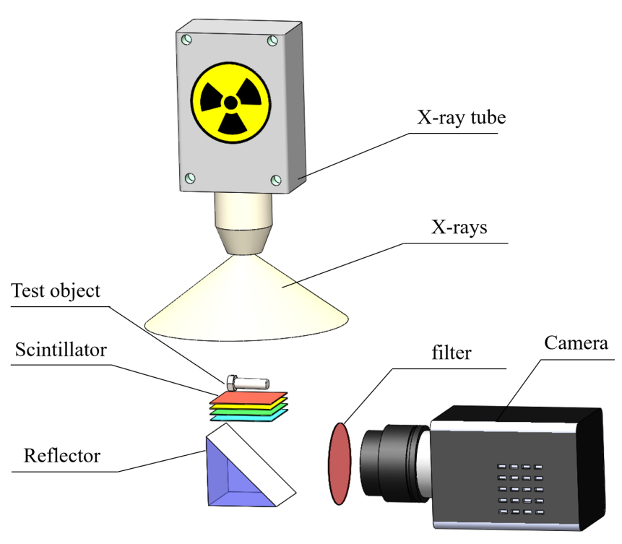不要花filer 直接写成color or multispectral camera 和图一一致
Fig.S1 Schematic diagram of the X-ray imaging system.

Fig.S2 The dip-casting process of fabricating thick scintillator films used in this study.

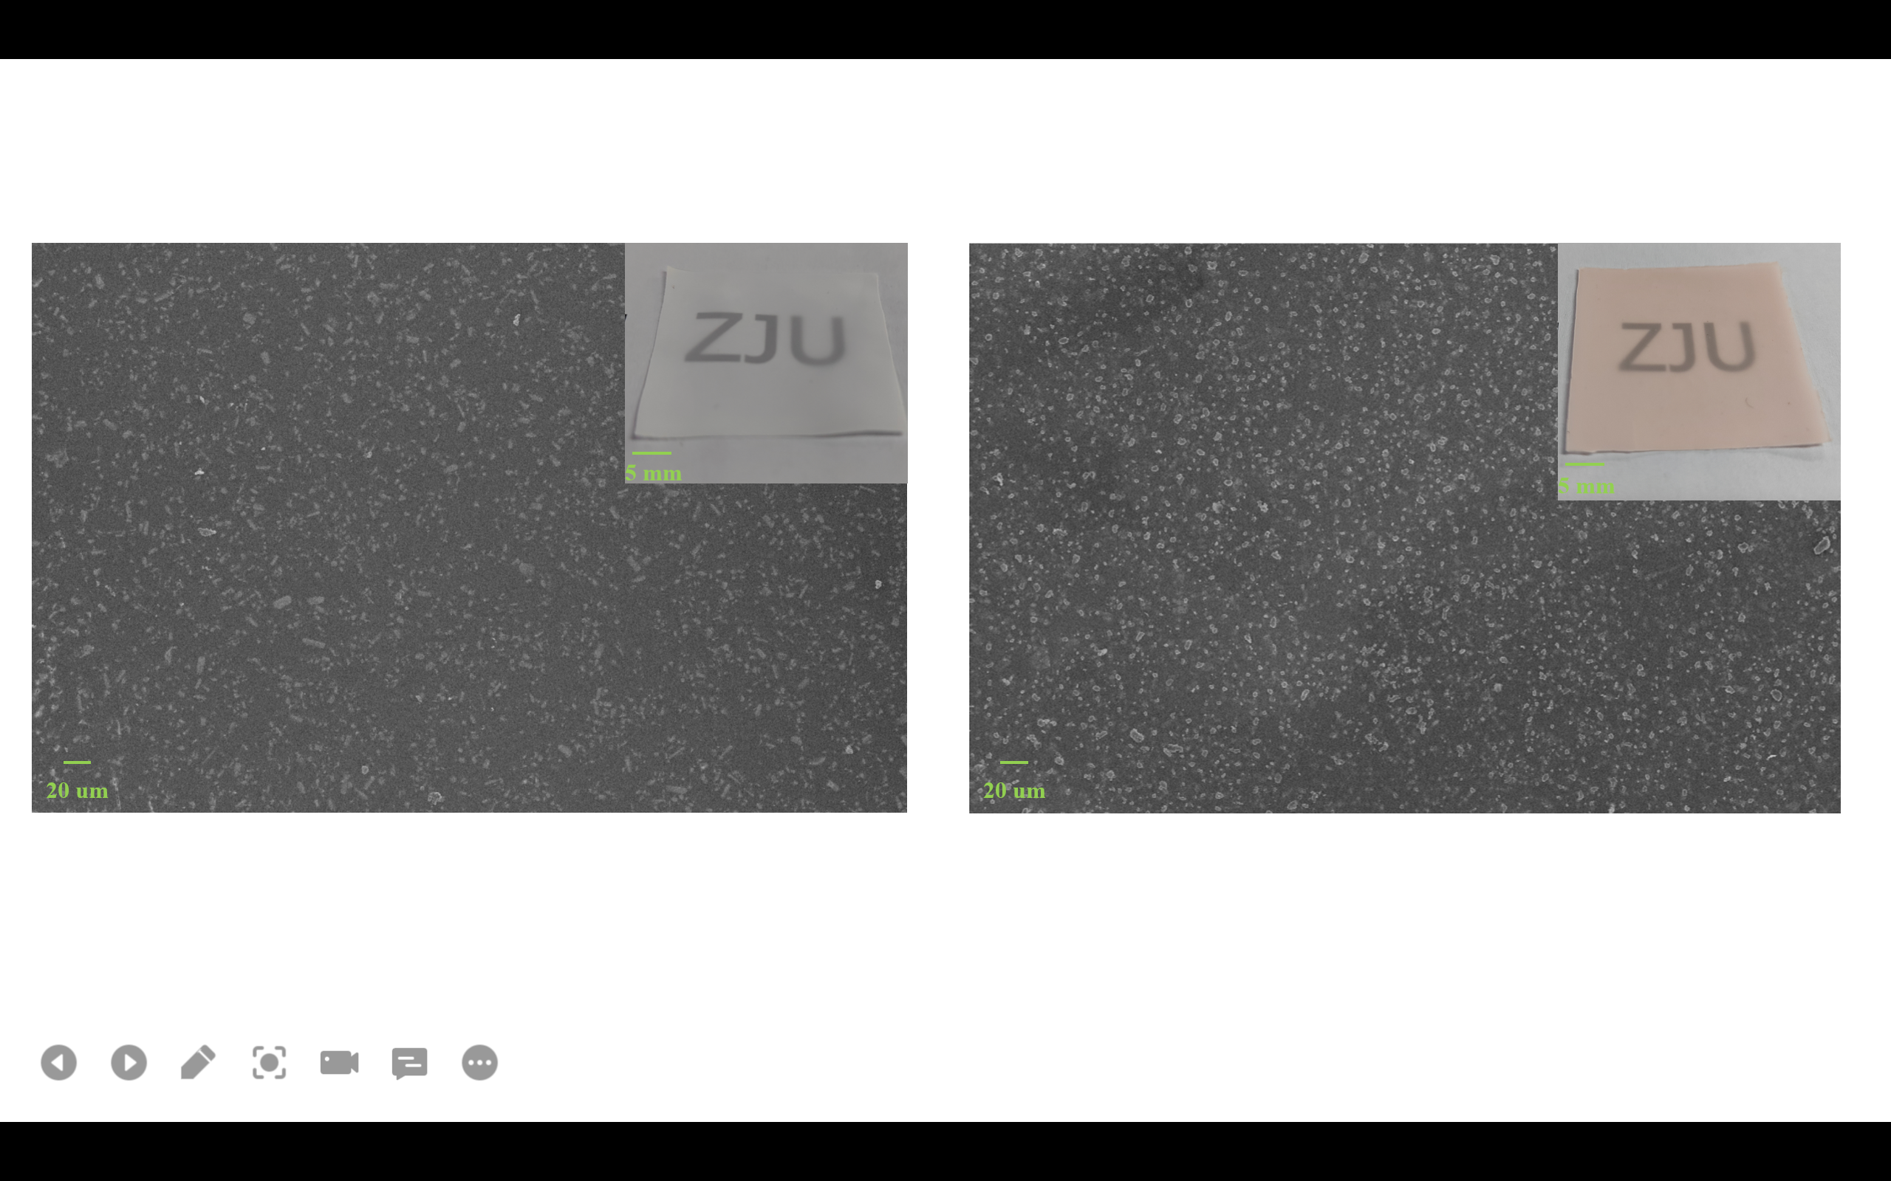

Fig.S3 The scanning electron microscopy (SEM) images of the surface of two scintillator films.

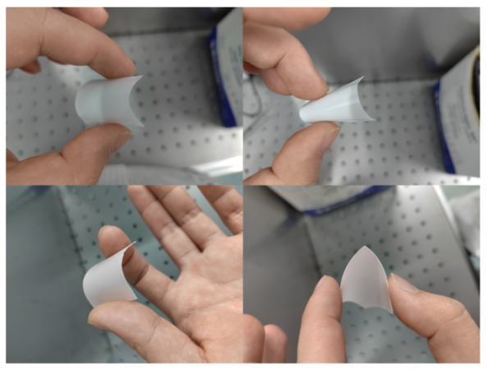
Fig.S4 The bendable features of the Cs₃Cu₂I₅ and C₄H₁₂NMnCl₃ scintillator films

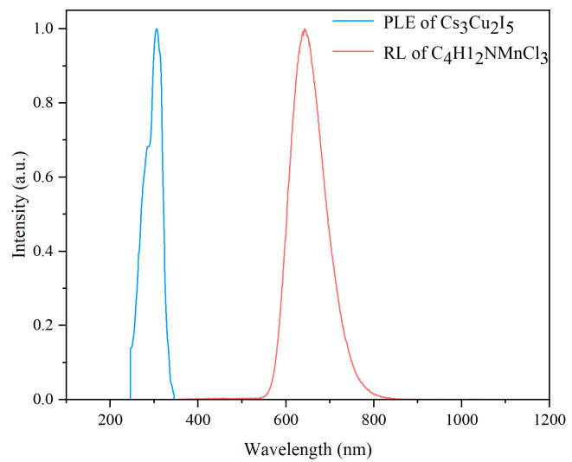
Fig.S5 The photoluminescence excitation spectrum (PLE) of Cs₃Cu₂I₅ and the radiation luminescence spectrum (RL) of C₄H₁₂NMnCl₃.
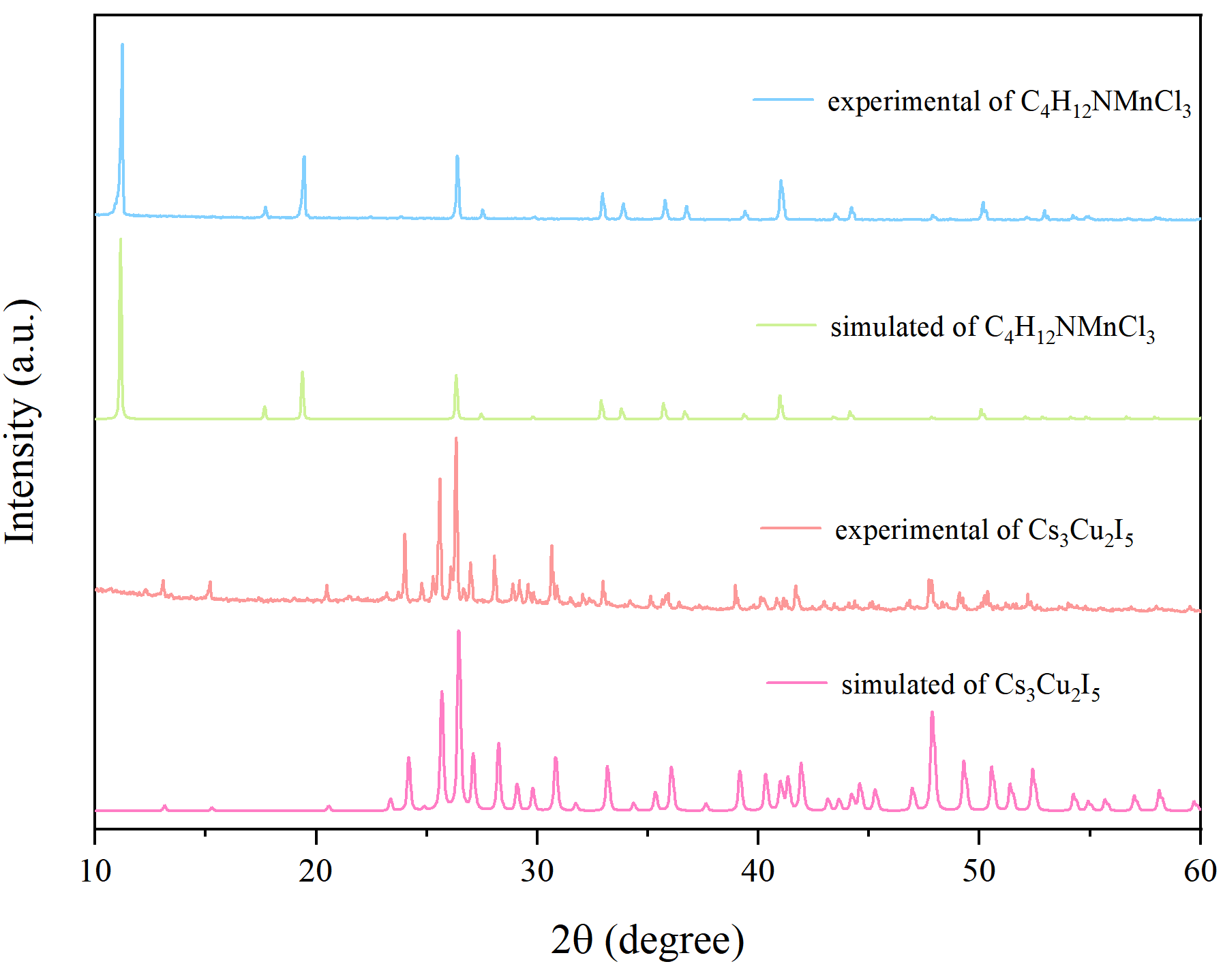
Fig.S6 The experimental and simulated X-ray diffraction (XRD) patterns of Cs₃Cu₂I₅ and C₄H₁₂NMnCl₃ powders.

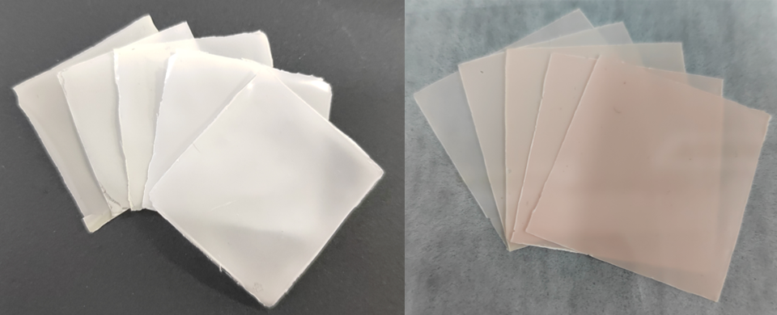
Fig.S7 Cs₃Cu₂I₅ and C₄H₁₂NMnCl₃ scintillator films of different equivalent thickness

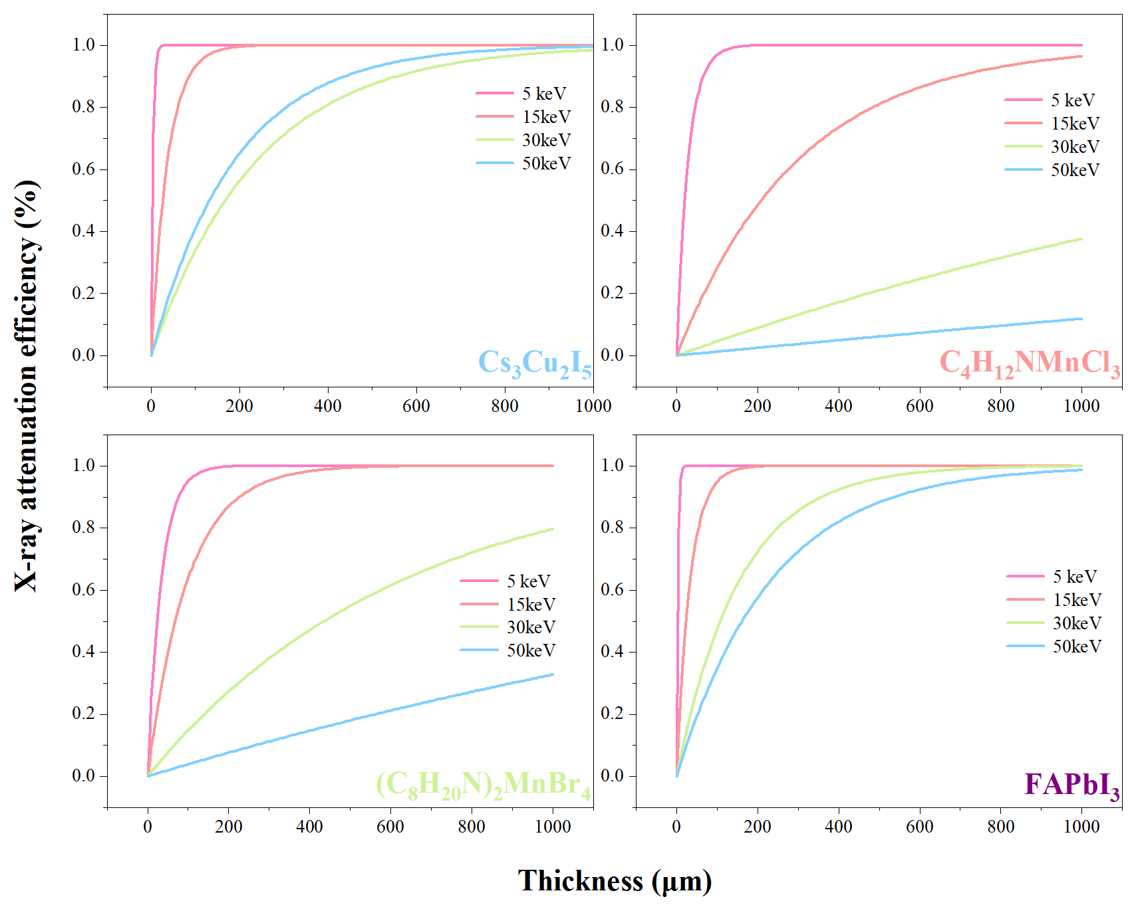
Fig.S8 The attenuation efficiency of four scintillator films at 5, 15, 30 and 50 keV energy segments.
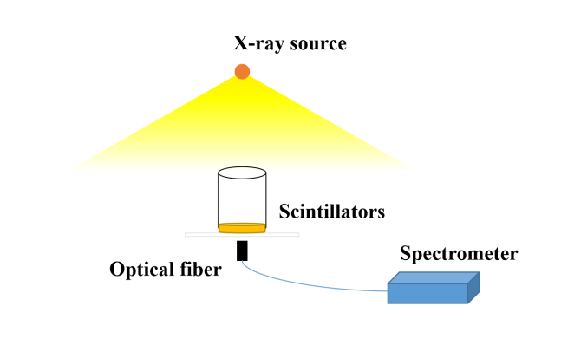
Fig.S9 Schematic diagram of the radioluminescence (RL) measurement system.

