Supporting Information
Preparation of Ni₂P decorated black phosphorus nanosheets supported on two-dimensional α-zirconium phosphate and its catalysis for hydrodesulfurization of dibenzothiophene
Jia Li ¹, Hongqin Ma^{*1, 2} , Jie Wang ¹, Luqi Yu ¹, Xinyue Luo ¹, Junyu Gao¹
1 School of Chemical Engineering and Technology, Tianjin University, 92 Weijin Road, Nankai District, Tianjin 300072, China
2 Tianjin Key Laboratory of Chemical Process Safety and Equipment Technology, Tianjin University, 92 Weijin Road, Nankai District, Tianjin 300072, China
Corresponding author:
* Prof. Hongqin Ma, Tel.: +86-22-2740-0952. E-mail: hqma@tju.edu.cn
Preparation of bulk BP
Bulk BP was prepared through a facile mineralization method using Sn and SnI₄ as reaction promoters. 20 mg of Sn,10 mg of SnI₄, and 500 mg of red phosphorus were transferred into a quartz glass tube with a diameter of 15 mm and a length of 150 mm [1]. The tube was evacuated under the vacuum condition(20Pa). The sealed silica tube was horizontally placed in a tube furnace (SK-1200), heated to 923 K within 8 h and dwelled at that temperature for 5 h, and then was cooled down to 723 K in a period of 10 h. Eventually, the tube was naturally cooled down to room temperature. The bulk BP was kept in a glovebox under dark and dry conditions for further analysis.

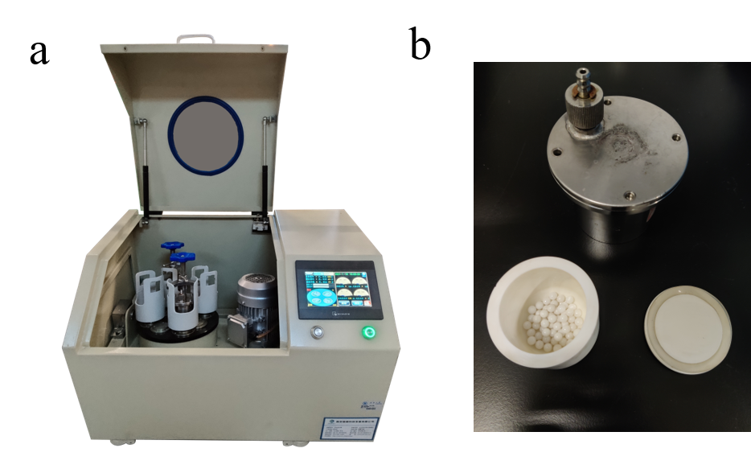

Figure S1 (a) The photograph of the PMQW-04 planetary ball-mill. (b) The photograph of a zirconia sealed pot with some zirconia balls.

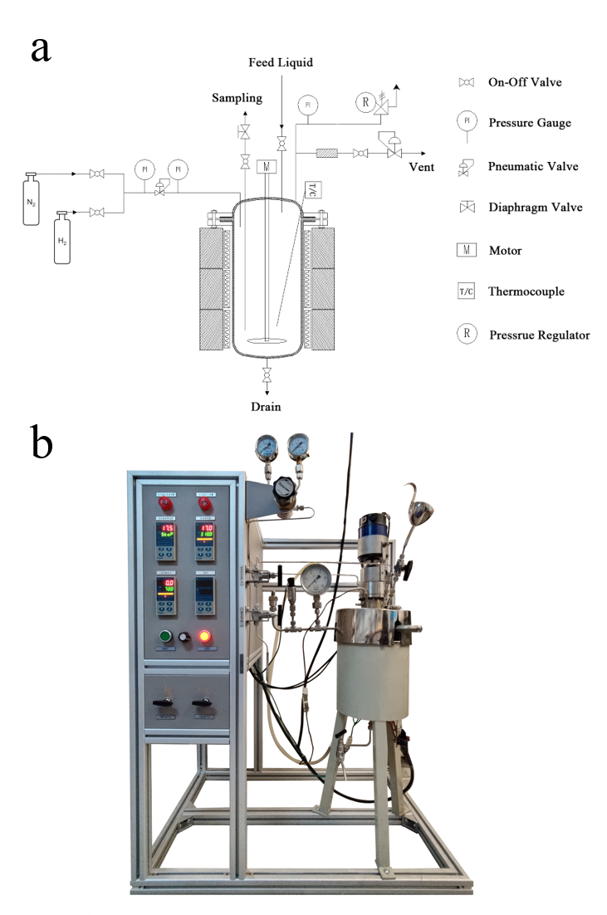
Figure S2 (a) Schematic of HDS unit. (b) Picture of the HDS activity evaluation device.
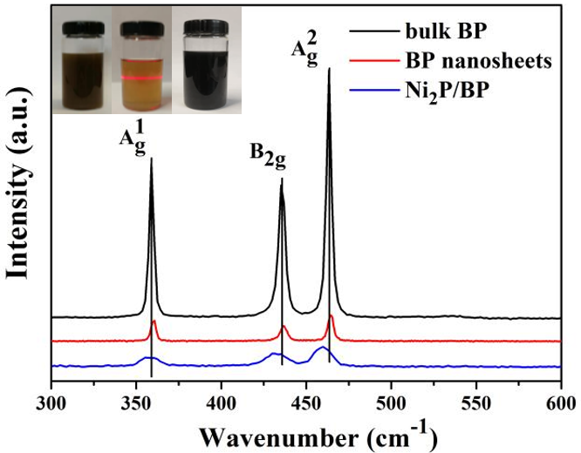
Figure S3 Raman spectra of bulk BP, BP nanosheets, and Ni₂P/BP nanosheets.

The dark brown inset on the left reveals a high BP concentration can be achieved after 4000 rpm centrifugation by freeze-assisted exfoliation method. The few-layer BP concentration was measured by ICP-MS and resulted BP nanosheets was about 0.65 mg mL⁻¹. Specifically, the DMSO solution containing BP nanosheets with remarkable dispersity can keep stability at ambient temperature for more than 3 weeks without any conspicuous degradation. Furthermore, the color of the resultant BP suspension changes from brown to yellow after being centrifuged at 11000 rpm for 25 min (the middle inset). The right inset displays the black dispersion containing Ni₂P/BP nanosheets. The color changes on account of the strong electronic interaction between BP nanosheets and Ni₂P nanoparticles [2], indicating the successful growth of Ni₂P nanoparticles on BP nanosheets.

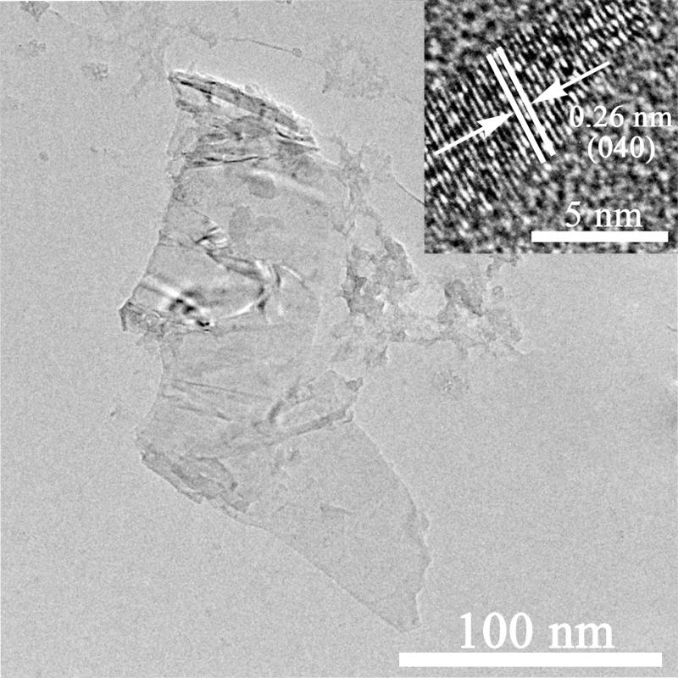
Figure S4 TEM image of BP nanosheets after exfoliation (the inset of HRTEM of BP nanosheets).

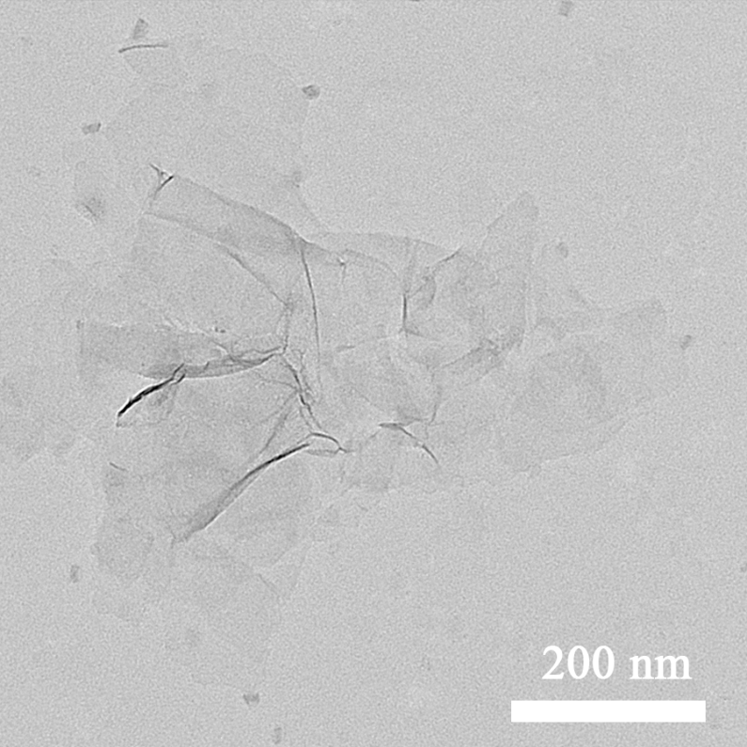
Figure S5 TEM image of exfoliated α-ZrP nanosheets

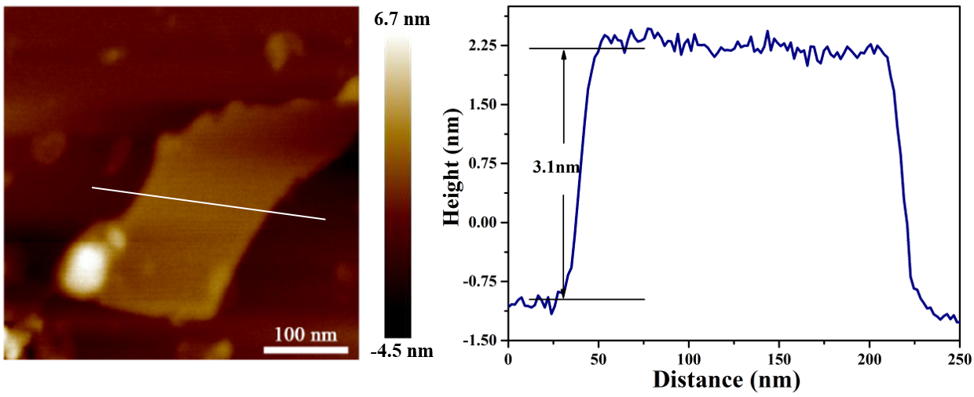
Figure S6 AFM image of α-ZrP nanosheets after exfoliation

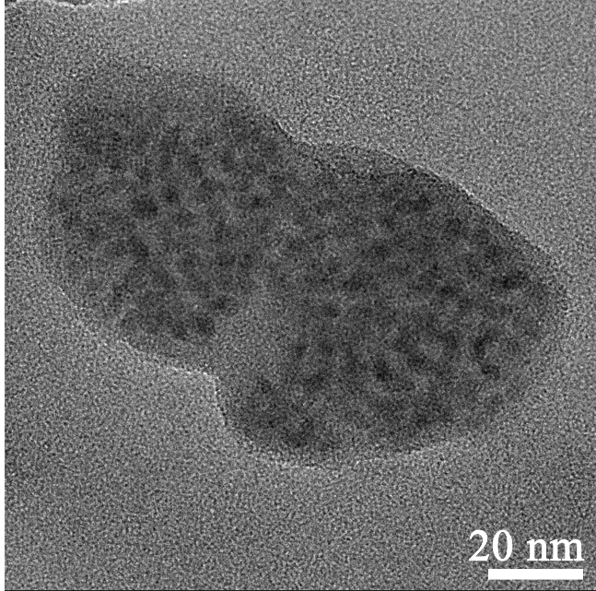
Figure S7 TEM image of Ni₂P/BP nanosheets

Table 1 Summary of XPS binding energy of Ni 2p, P 2p , and Zr 3d for the samples of BP, Ni₂P/BP, α-ZrP, and Ni₂P/BP@ZrP.
Materials | Binding energy (eV)
Materials | Ni 2p_{3/2} | Ni 2p_{1/2} | Oxidized Ni | Satellites | P 2p_{3/2} | P 2p_{1/2} | P_{x}O_{y} | Zr 3d_{5/2} | Zr 3d_{3/2}
BP | — | — | — | — | 129.9 | 130.8 | 133.8 | — | —
Ni₂P/BP | 852.9 | 870.1 | 856.7/874.7 | 861.9/880.6 | 129.2 | 130.1 | 133.2 | — | —
Ni₂P/BP@ZrP | 853.2 | 870.6 | 856.9/874.8 | 862.3/880.9 | — | — |  | 182.8 | 185.2
α-ZrP | — | — | — | — | — | — |  | 183.1 | 185.5

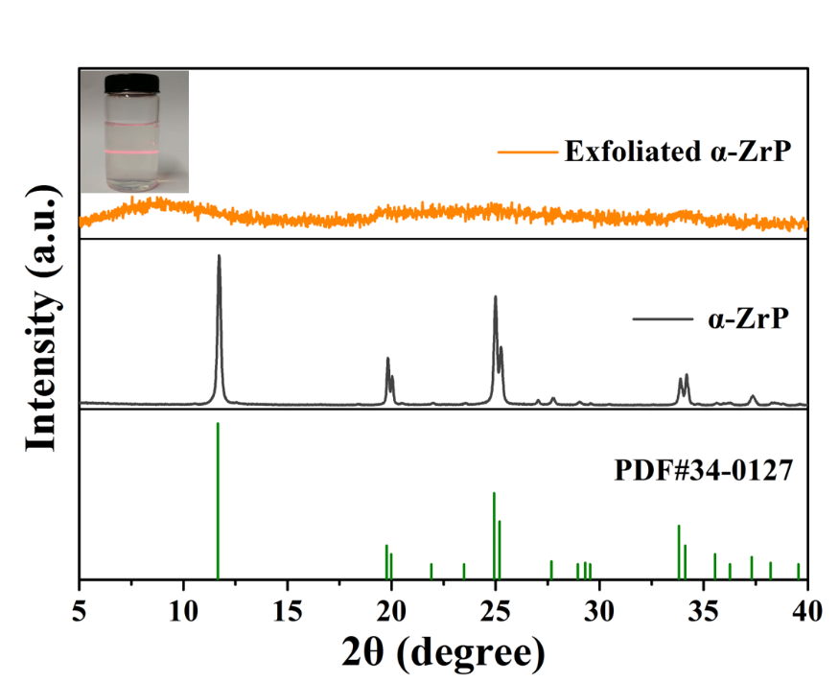
Figure S8 XRD patterns of α-ZrP and exfoliated α-ZrP.

The crystal phase of α-ZrP was confirmed by X-ray diffraction. The XRD patterns show the pristine α-ZrP and exfoliated α-ZrP. In the case of α-ZrP, the peaks at 2θ =11.7°, 19.8°, and 24.9° are indexed to (200), (111), and (113) planes of the α-ZrP (PDF # 34-0127), respectively. The diffraction peaks of α-ZrP are sharp and no impurity peaks are observed, indicating the well crystalline nature and high purity of the products. After being exfoliated by 1-propylamine, the characteristic diffraction peaks of pristine α-ZrP disappeared and only a broad peak existed, referring that the exfoliated α-ZrP has an amorphous structure.
Reference
1. Wang J, Ma H, Li J, Luo X, Yu L (2021) Preparation of Cu(І) Decorated 2D Black Phosphorus Nanosheets for Adsorption Desulfurization from Model Fuel. ChemNanoMat. doi:10.1002/cnma.202000609
2. Boppella R, Yang W, Tan J, Kwon H-C, Park J, Moon J (2019) Black phosphorus supported Ni2P co-catalyst on graphitic carbon nitride enabling simultaneous boosting charge separation and surface reaction. Appl Catal, B 242:422-430. doi:10.1016/j.apcatb.2018.10.018

