Manuscript submitted to Cellular Oncology
Integrated miRNA-mRNA analysis revealed distinct molecular signatures and regulatory networks in cancer stem-like cell models of hepatocellular carcinoma
Ain Zubaidah Ayob¹, Nur Akmarina Mohd Said², Thamil Selvee Ramasamy^{1*}
¹ Stem Cell Biology Laboratory, Department of Molecular Medicine, Faculty of Medicine, University of Malaya, 50603, Kuala Lumpur, Malaysia
² Department of Pharmaceutical Life Science, Faculty of Pharmacy, University of Malaya, 50603, Kuala Lumpur, Malaysia

*Corresponding author: selvee@ummc.edu.my

Supplementary information 1
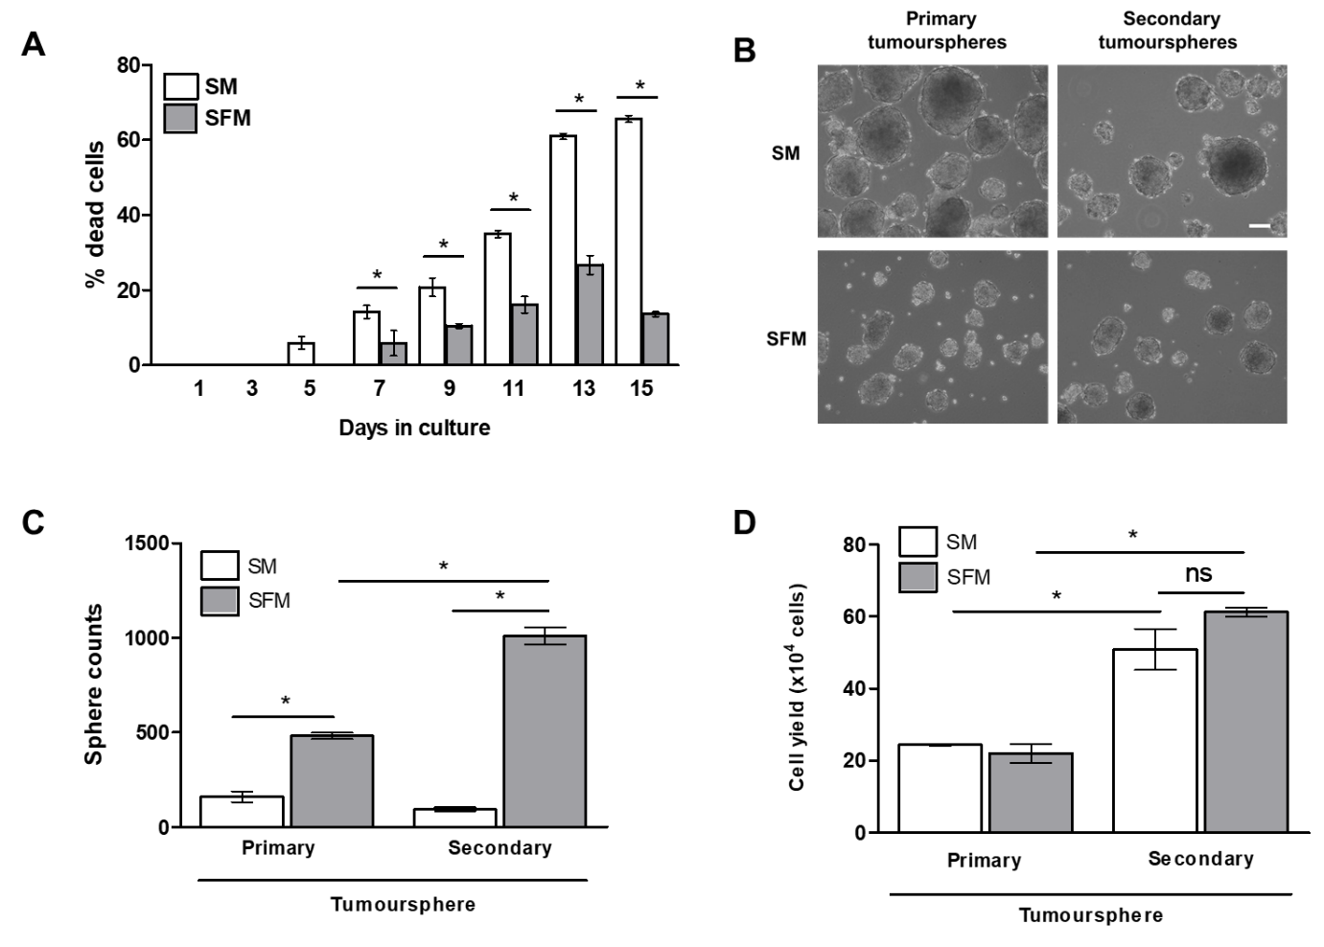
Fig. S1 HepG2 tumoursphere model. (A) Bar graph indicating the percentage of dead cells in HepG2 tumoursphere cultured at the indicated timepoints in SM (clear bar) and SFM (grey bar). (B) Phase contrast image indicate the morphology of primary and secondary tumourspheres cultured for 7 days in SM and SFM media (C) Bar graph indicated the sphere counts and (D) cell yield of primary and secondary tumoursphere cultured in SM (clear bar) and SFM (grey bar). Value represents mean ± S.E.M from three independent experiments (n=3). Significant difference was calculated using Student’s t-test, asterisk (*) indicates p<0.05. Scale bar, 50 μm.
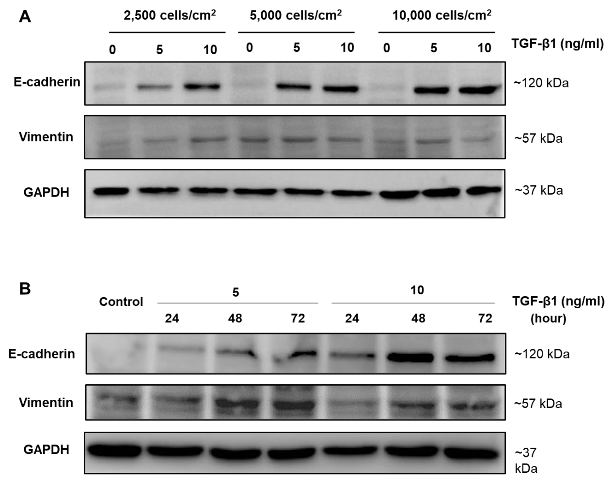
Fig. S2 Expression of E-cadherin and Vimentin at protein level in HepG2 cells treated with TGF-β1. Western blot image indicating E-cadherin and Vimentin protein expression in HepG2 cells treated with 5 and 10 ng/ml of TGF-β1 at different seeding densities of A) 2500, 5000, 10000 cells/cm² for 72 hours and B) 30,000 cells/cm² at the indicated time-points. GAPDH expression used as a loading control.

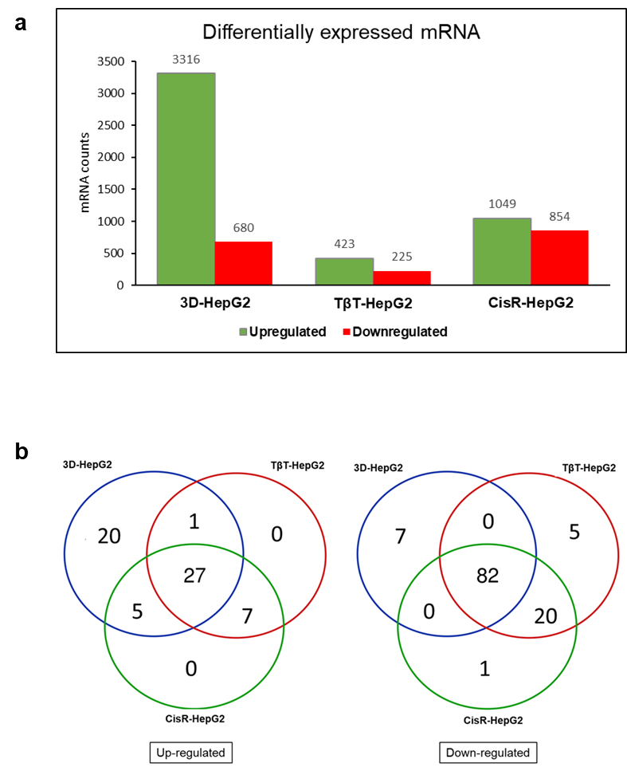
Fig. S3 Differentially expressed mRNAs in HepG2-derived CSC-like models (a) Bar graph comparing the number of upregulated and downregulated DE mRNAs between the three HepG2-derived CSC-like models. (b) Venn diagram showing the up-regulated (left panel) and down-regulated (right panel) DE mRNAs from the 142 commonly expressed DE mRNAs in the three models.
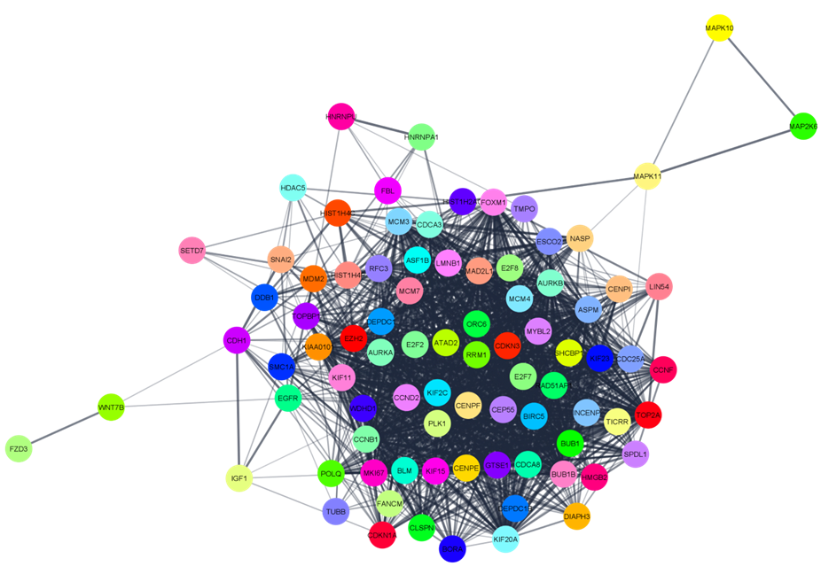
Fig.S4 Protein-protein interaction networks of the hub genes identified from HepG2-derived CSC-like models. A total of 86 hub genes were consolidated from the three HepG2 derived CSC-like model based on the criteria described in the method section.

Table S1 List of primers and their sequence used for this study
Gene name | Accession number | Gene sequence
E-CADHERIN | NM_004360.5 | F: CCACCAAAGTCACGCTGAAT  R: GGAGTTGGGAAATGTGAGC
SNAIL1 | NM_005985.4 | F: CCCAGTGCCTCGACCACTAT  R: GCTGGAAGGTAAACTCTGGATTAGA
TWIST | NM_000474.4 | F: GCATTCTCAAGAGGTCGTGC  R: ATGGTTTTGCAGGCCAGTTTG
VIMENTIN | NM_003380.5 | F: TCCAAGTTTGCTGACCTCTCTG  R: CAGTGGACTCCTGCTTTGCC
ABCG2 | NM_004827.3 | F: TGCCCAGGACTCAATGCAACAG  R: GACTGAAGGGCTACTAAC
ABCB1 | NM_001348945.2 | F: TGG TAG GAG TGT CCG TGG AT  R: TTG CAA ATG CTG GTT GCA GG
ABCC1 | NM_004996.4 | F: CCC GCT CTG GGA CTG GAA  R: AAA ACA AGG CAC CCA CAC GA
LIN28 | NM_024674.6 | F: CGGGCATCTGTAAGTGGTTC  R: CAGACCCTTGGCTGACTTCT
KLF4 | NM_004235.6 | F: GAAATTCGCCCGCTCCGATGA  R: CTGTGTGTTTGCGGTAGTGCC
PCNA | NM_182649.2 | F: CCTGTAGCGGCGTTGTTG  R: CGTTGATGAGGTCCTTGAGTG
ZEB1 | NM_001323654.1 | F: GATCCAGCCAAATGGAAATCA  R: GGCGGTGTAGAATCAGAGTCATTC
OCT4 | NM_002701.6 | F: GAGAACCGAGTGAGAGGCAACC  R: CATAGTCGCTGCTTGATCGCTTG
SOX2 | NM_003106.4 | F: TTGCTGCCTCTTTAAGACTAGGA  R: CTGGGGCTCAAACTTCTCTC

Table S2 List of DE mRNA whose expression were identified to be commonly upregulated and downregulated between the three in vitro models
Regulation | List of DE mRNA
Upregulated | IDS, IGFBP2, BMF, CGB, LINC00869, HIST1H2AC, SEC14L2, DGKA, PTHLH, LIPH, LYPD1, RNF157-AS1, PAK1, CCDC153, PKIB, ERICH5, PFKFB1, lnc-AP002478.1-1, ALOX5, NRP2, RAMP1, LARP6, LOC101927482, CDH1, FLJ32255, ADAMTS10, TMSB4X
Downregulated | ESPL1, E2F8, CCNB1 RFC3, GINS1, DSCC1, ANLN, FOXM1, CDK1, HIST1H3B, KIF11, ORC1, ASF1B, KIFC1, CENPU, MYBL2, AURKA, KIF14, AURKB, CHAF1A, FANCA, HIST1H2BB, KIF4A, KIF2C, HIST1H3G, CENPA, CDCA7, ZWINT, PLK4, CCNA2, HIST1H2AG, GTSE1, BUB1, HOXD1, HIST1H2AI, PRR11, TROAP, CDCA5, KIF23, TK1, HIST1H3H, ASPM, SPAG5, CDCA3, HIST2H3A, HIST1H2AM, MND1, HIST1H2AJ, HIST1H4D, HIST1H2AK, CEP55, AUNIP, DDIAS, FANCI, RAD54L, CDC45, HIST1H4F, MCM2, FAM72A, KIF15, BUB1B, DLGAP, HJURP, ESCO2, HIST1H2AH, MKI67, DTL, FAM83D, CDCA2, RAD51, LINC00176, HMMR, HIST1H3D, ERCC6L, KIF20A, ORC6, KIF22, HIST1H3F, CENPM, GINS2, CENPF, HIST1H2BF

Table S3 Hub genes identified based on analysis of nodes from protein-protein interactions (PPI) networks constructed from the target genes in the miRNA-mRNA regulatory networks of the three CSC-like models. Nodes based on degree of connectivity with cut-off score = 10 were assigned as the hub genes.
3D-HepG2 model | TβT-HepG2 model | CisR-HepG2 model
Gene name Score | Gene name Score | Gene name Score
  KIF23 | 20
  ASPM | 18
  TOP2A | 18
  AURKB | 17
  KIF11 | 15
  EGFR | 13
  CLSPN | 13
  CENPF | 12
  CEP55 | 12
  NASP | 11
  ESCO2 | 11
  ORC6 | 10
  IGF1 | 10
  GTSE1 | 10
  CCNB1 | 36
  AURKA | 35
  BUB1 | 35
  KIF20A | 35
  BUB1B | 34
  BIRC5 | 34
  CDCA8 | 34
  MAD2L1 | 33
  PLK1 | 33
  CENPF | 33
  CEP55 | 33
  KIF2C | 33
  TOP2A | 33
  KIF15 | 32
  MKI67 | 32
  CDKN3 | 31
  FOXM1 | 30
  KIAA0101 | 29
  DEPDC1 | 29
  ASF1B | 28
  MYBL2 | 27
  SHCBP1 | 27
  CDCA3 | 27
  GTSE1 | 25
  E2F8 | 25
  ATAD2 | 24
  DEPDC1B | 23
  CENPI | 21
  RFC3 | 21
  INCENP | 19
  POLQ | 18
  ORC6 | 17
  DIAPH3 | 16
  HMGB2 | 15
  HIST1H4F | 12
  E2F2 | 11
  EZH2 | 47
  CCNB1 | 45
  PLK1 | 43
  TOP2A | 42
  KIF20A | 41
  AURKA | 39
  MCM7 | 39
  CENPE | 38
  BUB1 | 38
  MKI67 | 38
  MCM3 | 36
  MCM4 | 35
  MAD2L1 | 34
  CDC25A | 33
  RAD51AP1 | 32
  HIST1H4F | 32
  MDM2 | 30
  ASF1B | 30
  CLSPN | 29
  E2F7 | 29
  MYBL2 | 28
  WDHD1 | 28
  BLM | 27
  LMNB1 | 26
  E2F8 | 26
  RRM1 | 25
  GTSE1 | 25
  ATAD2 | 23
  CDKN1A | 23
  TICRR | 22
  CCNF | 21
  DEPDC1 | 21
  TOPBP1 | 19
  POLQ | 19
  SHCBP1 | 19
  HIST1H4C | 18
  CDH1 | 16
  SMC1A | 16
  SPDL1 | 15
  HIST1H2AC | 15
  HMGB2 | 14
  HNRNPA1 | 14
  SNAI2 | 14
  FBL | 13
  CCND2 | 13
  BORA | 13
  FANCM | 12
  HNRNPU | 12
  TMPO | 11
  DDB1 | 11
  DIAPH3 | 11
  HDAC5 | 10
  SETD7 | 10
  TUBB | 10
  LIN54 | 10

Table S3 Significantly enriched terms for GO and KEGG functional enrichment based on the 86 hub genes
Category | Term | Count | % | P-Value
KEGG Pathway | hsa04110:Cell cycle | 15 | 17.44186 | 1.32E-14
KEGG Pathway | hsa04068:FoxO signaling pathway | 11 | 12.7907 | 7.94E-09
KEGG Pathway | hsa05200:Pathways in cancer | 11 | 12.7907 | 1.42E-04
KEGG Pathway | hsa04914:Progesterone-mediated oocyte maturation | 9 | 10.46512 | 5.78E-08
KEGG Pathway | hsa05205:Proteoglycans in cancer | 8 | 9.302326 | 2.43E-04
KEGG Pathway | hsa05203:Viral carcinogenesis | 8 | 9.302326 | 2.83E-04
KEGG Pathway | hsa05166:HTLV-I infection | 8 | 9.302326 | 0.001024
KEGG Pathway | hsa05218:Melanoma | 7 | 8.139535 | 5.05E-06
KEGG Pathway | hsa04114:Oocyte meiosis | 7 | 8.139535 | 6.61E-05
KEGG Pathway | hsa05214:Glioma | 6 | 6.976744 | 5.27E-05
KEGG Pathway | hsa04115:p53 signaling pathway | 6 | 6.976744 | 6.10E-05
KEGG Pathway | hsa05215:Prostate cancer | 6 | 6.976744 | 2.24E-04
KEGG Pathway | hsa05169:Epstein-Barr virus infection | 6 | 6.976744 | 0.001009
KEGG Pathway | hsa05161:Hepatitis B | 6 | 6.976744 | 0.002176
KEGG Pathway | hsa04390:Hippo signaling pathway | 6 | 6.976744 | 0.002598
KEGG Pathway | hsa04015:Rap1 signaling pathway | 6 | 6.976744 | 0.010429
KEGG Pathway | hsa05219:Bladder cancer | 5 | 5.813953 | 1.24E-04
KEGG Pathway | hsa04750:Inflammatory mediator regulation of TRP channels | 5 | 5.813953 | 0.003399
KEGG Pathway | hsa05160:Hepatitis C | 5 | 5.813953 | 0.009971
KEGG Pathway | hsa04550:Signaling pathways regulating pluripotency of stem cells | 5 | 5.813953 | 0.01188
KEGG Pathway | hsa04510:Focal adhesion | 5 | 5.813953 | 0.041722
KEGG Pathway | hsa03030:DNA replication | 4 | 4.651163 | 0.001505
KEGG Pathway | hsa04664:Fc epsilon RI signaling pathway | 4 | 4.651163 | 0.009163
KEGG Pathway | hsa04917:Prolactin signaling pathway | 4 | 4.651163 | 0.010312
KEGG Pathway | hsa04012:ErbB signaling pathway | 4 | 4.651163 | 0.017819
KEGG Pathway | hsa04912:GnRH signaling pathway | 4 | 4.651163 | 0.020067
KEGG Pathway | hsa04066:HIF-1 signaling pathway | 4 | 4.651163 | 0.023087
KEGG Pathway | hsa04620:Toll-like receptor signaling pathway | 4 | 4.651163 | 0.029833
KEGG Pathway | hsa04668:TNF signaling pathway | 4 | 4.651163 | 0.03056
KEGG Pathway | hsa05223:Non-small cell lung cancer | 3 | 3.488372 | 0.049525
GO Molecular Functions (MF) | GO:0005515~protein binding | 76 | 88.37209 | 1.11E-12
GO Molecular Functions (MF) | GO:0005524~ATP binding | 27 | 31.39535 | 1.01E-08
GO Molecular Functions (MF) | GO:0003677~DNA binding | 26 | 30.23256 | 4.10E-07
GO Molecular Functions (MF) | GO:0003682~chromatin binding | 13 | 15.11628 | 5.78E-07
GO Molecular Functions (MF) | GO:0019901~protein kinase binding | 11 | 12.7907 | 1.89E-05
GO Molecular Functions (MF) | GO:0004672~protein kinase activity | 9 | 10.46512 | 4.48E-04
GO Molecular Functions (MF) | GO:0016887~ATPase activity | 8 | 9.302326 | 3.80E-05
GO Molecular Functions (MF) | GO:0008017~microtubule binding | 7 | 8.139535 | 6.34E-04
GO Molecular Functions (MF) | GO:0004674~protein serine/threonine kinase activity | 7 | 8.139535 | 0.011738
GO Molecular Functions (MF) | GO:0046982~protein heterodimerization activity | 7 | 8.139535 | 0.029813
GO Molecular Functions (MF) | GO:0001047~core promoter binding | 6 | 6.976744 | 1.74E-05
GO Molecular Functions (MF) | GO:0003777~microtubule motor activity | 6 | 6.976744 | 5.14E-05
GO Molecular Functions (MF) | GO:0003697~single-stranded DNA binding | 6 | 6.976744 | 1.06E-04
GO Molecular Functions (MF) | GO:0016301~kinase activity | 5 | 5.813953 | 0.033423
GO Molecular Functions (MF) | GO:0042393~histone binding | 4 | 4.651163 | 0.023685
GO Molecular Functions (MF) | GO:0003678~DNA helicase activity | 3 | 3.488372 | 0.006436
GO Molecular Functions (MF) | GO:0004003~ATP-dependent DNA helicase activity | 3 | 3.488372 | 0.011268
GO Molecular Functions (MF) | GO:0003684~damaged DNA binding | 3 | 3.488372 | 0.040144
GO Molecular Functions (MF) | GO:0002039~p53 binding | 3 | 3.488372 | 0.044868
GO Molecular Functions (MF) | GO:0043515~kinetochore binding | 2 | 2.325581 | 0.019991
GO Molecular Functions (MF) | GO:0035174~histone serine kinase activity | 2 | 2.325581 | 0.024927
GO Molecular Functions (MF) | GO:0010997~anaphase-promoting complex binding | 2 | 2.325581 | 0.029838
GO Molecular Functions (MF) | GO:0043142~single-stranded DNA-dependent ATPase activity | 2 | 2.325581 | 0.04924
GO Cellular Component | GO:0005654~nucleoplasm | 58 | 67.44186 | 4.52E-27
GO Cellular Component | GO:0005634~nucleus | 56 | 65.11628 | 2.52E-11
GO Cellular Component | GO:0005737~cytoplasm | 40 | 46.51163 | 5.36E-04
GO Cellular Component | GO:0005829~cytosol | 34 | 39.53488 | 6.26E-06
GO Cellular Component | GO:0016020~membrane | 23 | 26.74419 | 3.66E-04
GO Cellular Component | GO:0030496~midbody | 13 | 15.11628 | 7.99E-13
GO Cellular Component | GO:0043234~protein complex | 12 | 13.95349 | 3.28E-06
GO Cellular Component | GO:0000776~kinetochore | 11 | 12.7907 | 4.05E-12
GO Cellular Component | GO:0005819~spindle | 11 | 12.7907 | 2.35E-10
GO Cellular Component | GO:0048471~perinuclear region of cytoplasm | 11 | 12.7907 | 6.16E-04
GO Cellular Component | GO:0005730~nucleolus | 11 | 12.7907 | 0.006463
GO Cellular Component | GO:0005874~microtubule | 10 | 11.62791 | 1.44E-05
GO Cellular Component | GO:0005813~centrosome | 9 | 10.46512 | 8.35E-04
GO Cellular Component | GO:0000775~chromosome, centromeric region | 8 | 9.302326 | 8.18E-09
GO Cellular Component | GO:0000777~condensed chromosome kinetochore | 8 | 9.302326 | 1.61E-07
GO Cellular Component | GO:0000785~chromatin | 7 | 8.139535 | 3.67E-06
GO Cellular Component | GO:0000922~spindle pole | 7 | 8.139535 | 1.19E-05
GO Cellular Component | GO:0000790~nuclear chromatin | 7 | 8.139535 | 2.85E-04
GO Cellular Component | GO:0005694~chromosome | 6 | 6.976744 | 1.31E-04
GO Cellular Component | GO:0000784~nuclear chromosome, telomeric region | 6 | 6.976744 | 3.55E-04
GO Cellular Component | GO:0051233~spindle midzone | 5 | 5.813953 | 1.62E-06
GO Cellular Component | GO:0005876~spindle microtubule | 5 | 5.813953 | 5.19E-05
GO Cellular Component | GO:0005871~kinesin complex | 5 | 5.813953 | 1.08E-04
GO Cellular Component | GO:0000228~nuclear chromosome | 5 | 5.813953 | 1.08E-04
GO Cellular Component | GO:0005814~centriole | 5 | 5.813953 | 0.001929
GO Cellular Component | GO:0032133~chromosome passenger complex | 4 | 4.651163 | 9.73E-07
GO Cellular Component | GO:0000940~condensed chromosome outer kinetochore | 4 | 4.651163 | 5.39E-06
GO Cellular Component | GO:0010369~chromocenter | 4 | 4.651163 | 2.09E-05
GO Cellular Component | GO:0045171~intercellular bridge | 4 | 4.651163 | 0.00113
GO Cellular Component | GO:0015630~microtubule cytoskeleton | 4 | 4.651163 | 0.026249
GO Cellular Component | GO:0005635~nuclear envelope | 4 | 4.651163 | 0.038291
GO Cellular Component | GO:0000942~condensed nuclear chromosome outer kinetochore | 3 | 3.488372 | 1.28E-04
GO Cellular Component | GO:0045120~pronucleus | 3 | 3.488372 | 4.45E-04
GO Cellular Component | GO:0042555~MCM complex | 3 | 3.488372 | 7.58E-04
GO Cellular Component | GO:0072687~meiotic spindle | 3 | 3.488372 | 7.58E-04
GO Cellular Component | GO:0000793~condensed chromosome | 3 | 3.488372 | 0.006016
GO Cellular Component | GO:0072686~mitotic spindle | 3 | 3.488372 | 0.01567
GO Cellular Component | GO:0005881~cytoplasmic microtubule | 3 | 3.488372 | 0.023646
GO Cellular Component | GO:0000779~condensed chromosome, centromeric region | 2 | 2.325581 | 0.032201
GO Cellular Component | GO:0000780~condensed nuclear chromosome, centromeric region | 2 | 2.325581 | 0.045686
GO Cellular Component | GO:0031616~spindle pole centrosome | 2 | 2.325581 | 0.045686
GO Biological process | GO:0051301~cell division | 19 | 22.09302 | 7.78E-14
GO Biological process | GO:0007067~mitotic nuclear division | 17 | 19.76744 | 6.77E-14
GO Biological process | GO:0007062~sister chromatid cohesion | 14 | 16.27907 | 2.99E-15
GO Biological process | GO:0006260~DNA replication | 14 | 16.27907 | 6.44E-13
GO Biological process | GO:0008283~cell proliferation | 14 | 16.27907 | 2.70E-08
GO Biological process | GO:0051726~regulation of cell cycle | 10 | 11.62791 | 1.01E-08
GO Biological process | GO:0042493~response to drug | 10 | 11.62791 | 1.89E-05
GO Biological process | GO:0043066~negative regulation of apoptotic process | 10 | 11.62791 | 4.05E-04
GO Biological process | GO:0000086~G2/M transition of mitotic cell cycle | 9 | 10.46512 | 3.77E-07
GO Biological process | GO:0007049~cell cycle | 9 | 10.46512 | 1.17E-05
GO Biological process | GO:0006281~DNA repair | 9 | 10.46512 | 2.09E-05
GO Biological process | GO:0000122~negative regulation of transcription from RNA polymerase II promoter | 9 | 10.46512 | 0.025725
GO Biological process | GO:0016925~protein sumoylation | 8 | 9.302326 | 1.78E-06
GO Biological process | GO:0042787~protein ubiquitination involved in ubiquitin-dependent protein catabolic process | 8 | 9.302326 | 1.06E-05
GO Biological process | GO:0006974~cellular response to DNA damage stimulus | 8 | 9.302326 | 7.57E-05
GO Biological process | GO:0045892~negative regulation of transcription, DNA-templated | 8 | 9.302326 | 0.011681
GO Biological process | GO:0000082~G1/S transition of mitotic cell cycle | 7 | 8.139535 | 1.12E-05
GO Biological process | GO:1901796~regulation of signal transduction by p53 class mediator | 7 | 8.139535 | 3.41E-05
GO Biological process | GO:0006468~protein phosphorylation | 7 | 8.139535 | 0.025329
GO Biological process | GO:0045893~positive regulation of transcription, DNA-templated | 7 | 8.139535 | 0.042061
GO Biological process | GO:0007080~mitotic metaphase plate congression | 6 | 6.976744 | 1.01E-06
GO Biological process | GO:0006977~DNA damage response, signal transduction by p53 class mediator resulting in cell cycle arrest | 6 | 6.976744 | 1.36E-05
GO Biological process | GO:0007059~chromosome segregation | 6 | 6.976744 | 2.13E-05
GO Biological process | GO:0031145~anaphase-promoting complex-dependent catabolic process | 6 | 6.976744 | 4.42E-05
GO Biological process | GO:0007018~microtubule-based movement | 6 | 6.976744 | 4.99E-05
GO Biological process | GO:0007094~mitotic spindle assembly checkpoint | 5 | 5.813953 | 2.53E-06
GO Biological process | GO:0006270~DNA replication initiation | 5 | 5.813953 | 1.80E-05
GO Biological process | GO:0006325~chromatin organization | 5 | 5.813953 | 5.91E-05
GO Biological process | GO:0000910~cytokinesis | 5 | 5.813953 | 9.15E-05
GO Biological process | GO:0006890~retrograde vesicle-mediated transport, Golgi to ER | 5 | 5.813953 | 7.24E-04
GO Biological process | GO:0019886~antigen processing and presentation of exogenous peptide antigen via MHC class II | 5 | 5.813953 | 0.001114
GO Biological process | GO:0006334~nucleosome assembly | 5 | 5.813953 | 0.002864
GO Biological process | GO:0051983~regulation of chromosome segregation | 4 | 4.651163 | 6.41E-06
GO Biological process | GO:0007051~spindle organization | 4 | 4.651163 | 6.23E-05
GO Biological process | GO:0006336~DNA replication-independent nucleosome assembly | 4 | 4.651163 | 2.79E-04
GO Biological process | GO:0000281~mitotic cytokinesis | 4 | 4.651163 | 3.88E-04
GO Biological process | GO:0007052~mitotic spindle organization | 4 | 4.651163 | 4.29E-04
GO Biological process | GO:0071479~cellular response to ionizing radiation | 4 | 4.651163 | 4.74E-04
GO Biological process | GO:0006335~DNA replication-dependent nucleosome assembly | 4 | 4.651163 | 5.21E-04
GO Biological process | GO:0007093~mitotic cell cycle checkpoint | 4 | 4.651163 | 5.21E-04
GO Biological process | GO:0000079~regulation of cyclin-dependent protein serine/threonine kinase activity | 4 | 4.651163 | 9.36E-04
GO Biological process | GO:0048146~positive regulation of fibroblast proliferation | 4 | 4.651163 | 0.002409
GO Biological process | GO:0051437~positive regulation of ubiquitin-protein ligase activity involved in regulation of mitotic cell cycle transition | 4 | 4.651163 | 0.006315
GO Biological process | GO:0008584~male gonad development | 4 | 4.651163 | 0.011302
GO Biological process | GO:0000187~activation of MAPK activity | 4 | 4.651163 | 0.01599
GO Biological process | GO:0031577~spindle checkpoint | 3 | 3.488372 | 1.44E-04
GO Biological process | GO:0071168~protein localization to chromatin | 3 | 3.488372 | 3.57E-04
GO Biological process | GO:0032466~negative regulation of cytokinesis | 3 | 3.488372 | 4.99E-04
GO Biological process | GO:0033314~mitotic DNA replication checkpoint | 3 | 3.488372 | 8.50E-04
GO Biological process | GO:0006268~DNA unwinding involved in DNA replication | 3 | 3.488372 | 0.001059
GO Biological process | GO:0034501~protein localization to kinetochore | 3 | 3.488372 | 0.001059
GO Biological process | GO:0051310~metaphase plate congression | 3 | 3.488372 | 0.001543
GO Biological process | GO:2000134~negative regulation of G1/S transition of mitotic cell cycle | 3 | 3.488372 | 0.006726
GO Biological process | GO:0000070~mitotic sister chromatid segregation | 3 | 3.488372 | 0.006726
GO Biological process | GO:0006259~DNA metabolic process | 3 | 3.488372 | 0.007264
GO Biological process | GO:0045931~positive regulation of mitotic cell cycle | 3 | 3.488372 | 0.008394
GO Biological process | GO:0097421~liver regeneration | 3 | 3.488372 | 0.008988
GO Biological process | GO:0071364~cellular response to epidermal growth factor stimulus | 3 | 3.488372 | 0.01154
GO Biological process | GO:0000731~DNA synthesis involved in DNA repair | 3 | 3.488372 | 0.012922
GO Biological process | GO:0001890~placenta development | 3 | 3.488372 | 0.012922
GO Biological process | GO:0090307~mitotic spindle assembly | 3 | 3.488372 | 0.013639
GO Biological process | GO:0007346~regulation of mitotic cell cycle | 3 | 3.488372 | 0.016673
GO Biological process | GO:0045184~establishment of protein localization | 3 | 3.488372 | 0.016673
GO Biological process | GO:0000278~mitotic cell cycle | 3 | 3.488372 | 0.017472
GO Biological process | GO:0051290~protein heterotetramerization | 3 | 3.488372 | 0.018287
GO Biological process | GO:0034080~CENP-A containing nucleosome assembly | 3 | 3.488372 | 0.019119
GO Biological process | GO:0010212~response to ionizing radiation | 3 | 3.488372 | 0.02443
GO Biological process | GO:0042752~regulation of circadian rhythm | 3 | 3.488372 | 0.02443
GO Biological process | GO:0045814~negative regulation of gene expression, epigenetic | 3 | 3.488372 | 0.025367
GO Biological process | GO:0048511~rhythmic process | 3 | 3.488372 | 0.02926
GO Biological process | GO:0043406~positive regulation of MAP kinase activity | 3 | 3.488372 | 0.034438
GO Biological process | GO:0032436~positive regulation of proteasomal ubiquitin-dependent protein catabolic process | 3 | 3.488372 | 0.039942
GO Biological process | GO:0007265~Ras protein signal transduction | 3 | 3.488372 | 0.046953
GO Biological process | GO:0051436~negative regulation of ubiquitin-protein ligase activity involved in mitotic cell cycle | 3 | 3.488372 | 0.048163
GO Biological process | GO:0032877~positive regulation of DNA endoreduplication | 2 | 2.325581 | 0.009862
GO Biological process | GO:0007100~mitotic centrosome separation | 2 | 2.325581 | 0.024474
GO Biological process | GO:0060718~chorionic trophoblast cell differentiation | 2 | 2.325581 | 0.024474
GO Biological process | GO:0014834~skeletal muscle satellite cell maintenance involved in skeletal muscle regeneration | 2 | 2.325581 | 0.024474
GO Biological process | GO:1902749~regulation of cell cycle G2/M phase transition | 2 | 2.325581 | 0.024474
GO Biological process | GO:0051315~attachment of mitotic spindle microtubules to kinetochore | 2 | 2.325581 | 0.038873
GO Biological process | GO:0051256~mitotic spindle midzone assembly | 2 | 2.325581 | 0.038873
GO Biological process | GO:0006265~DNA topological change | 2 | 2.325581 | 0.043626
GO Biological process | GO:0030071~regulation of mitotic metaphase/anaphase transition | 2 | 2.325581 | 0.043626
GO Biological process | GO:0070365~hepatocyte differentiation | 2 | 2.325581 | 0.048356

