Inhibiting Property of Phytoconstituents of ‘Aconitum Heterophyllum’ Against Omicron Variant of SARS-CoV-2: Molecular Docking, Molecular Dynamic and MM-GBSA approach
Shradha Lakhera¹, Kamal Devlal¹, Meenakshi Rana^{1*}‬, Arabinda Ghosh^{2‬}‬‬
¹Department of Physics, School of Sciences, Uttarakhand Open University,
Haldwani, 263139, Uttarakhand, India
²Microbiology Division, Department of Botany, Guwahati University, Guwahati, 781014, Assam, India

SD. 1. The 3D structures of the phytochemicals of Aconitum heterophyllum.

Phytochemical name | Phytochemical Identifier | Structures
14-Anisoylaconine | CID:101601320 | 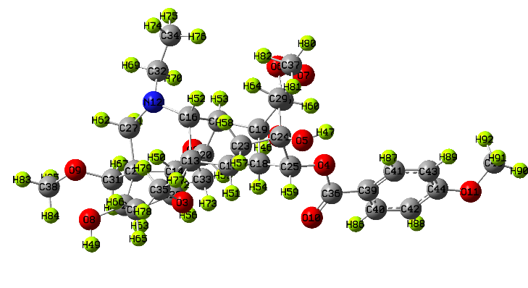
6-Acetylheteratisine | CHEMSPIDER:10246449 | 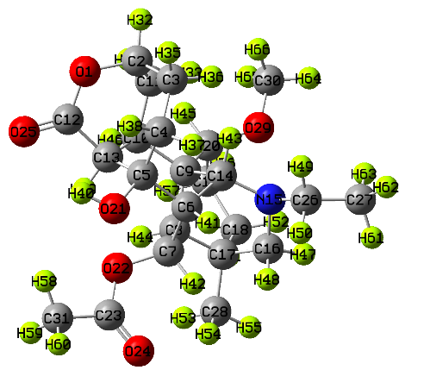
6-Benzoylheteratisine | CID:5487064 | 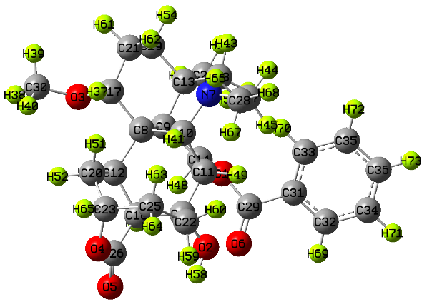
Aconitine | CID:118705467 | 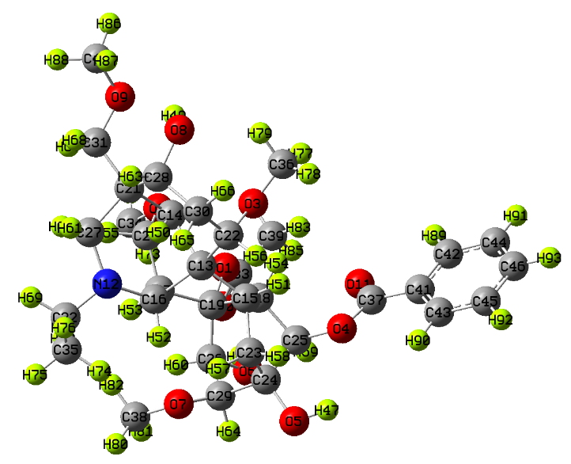
Atidine | CID:12299861 | 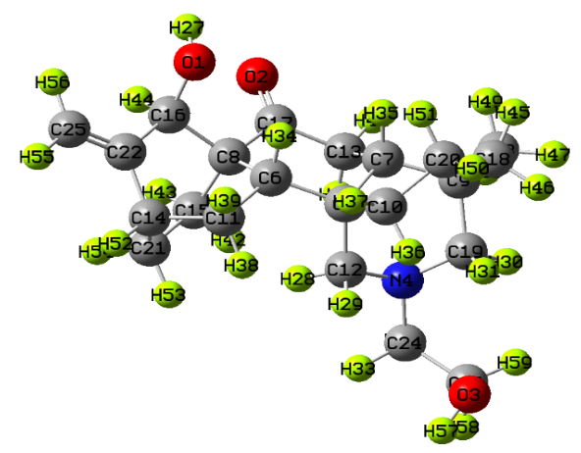
Atisine | CID:118701194 | 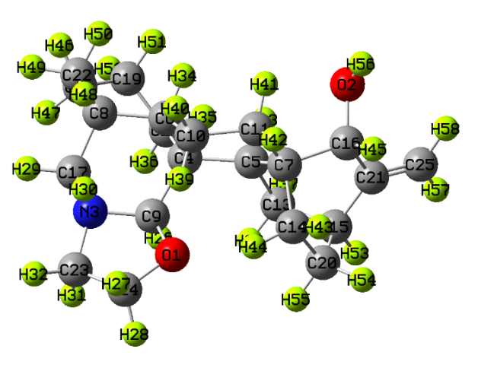
Benzoylmesaconine | CID:102004490 | 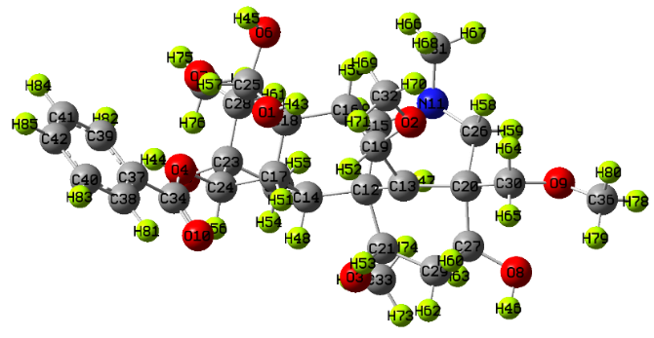
Dihydroatisine | CID:21606634 | 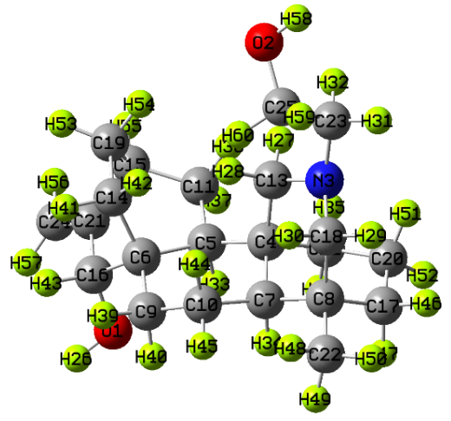
Heterophyllisine | CID:101289617 | 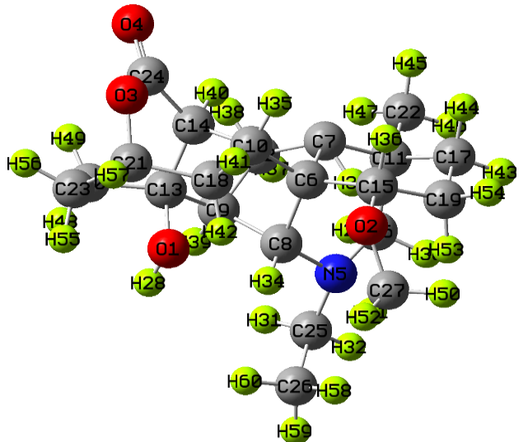
heterophylloidine | CASID:78174-97-7 | 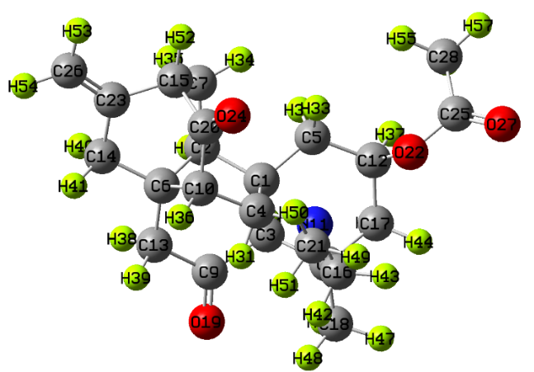
Hetidine | CID:101685340 | 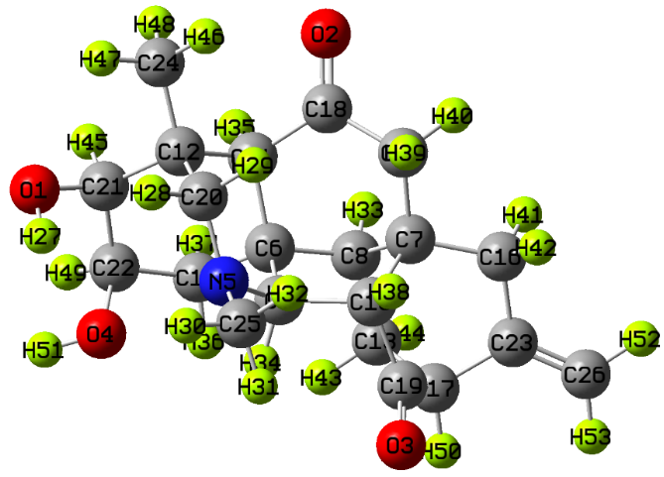
Hetisine | CID:101930091 | 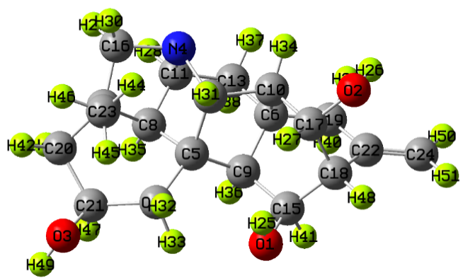
Hetisinone | CID:101930090 | 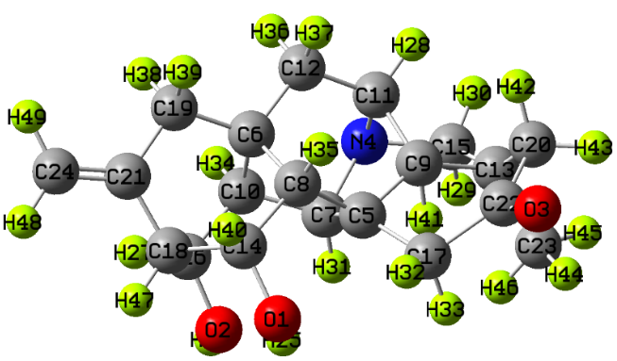
Isoatisine | CID:122212724 | 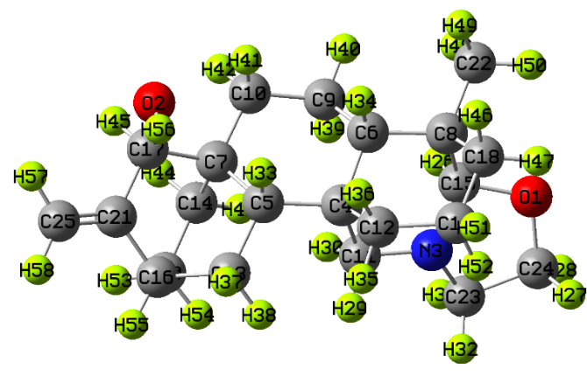
Jesaconitine | CID:118701203 | 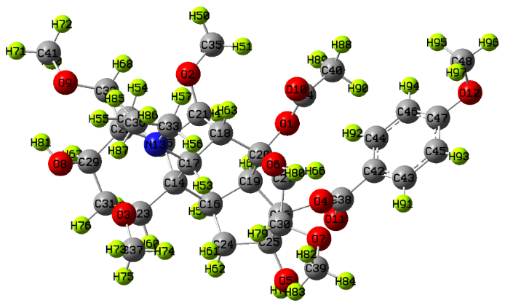
lappaconitine | CID:115161 | 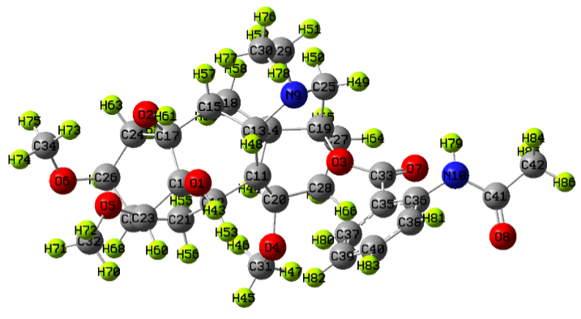
Mesaconitine | CID:102004423 | 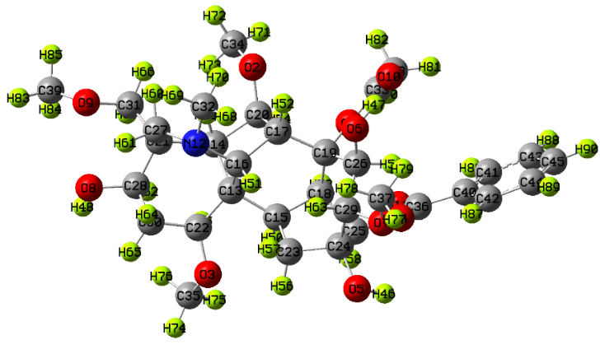
Phytosterols | CID:12303662 | 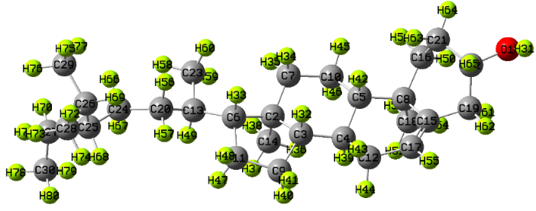
Aricine | CID:251575 | 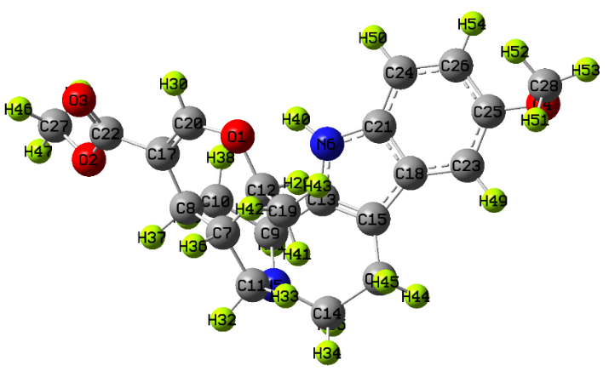
beta-carotene | CID:5280489 | 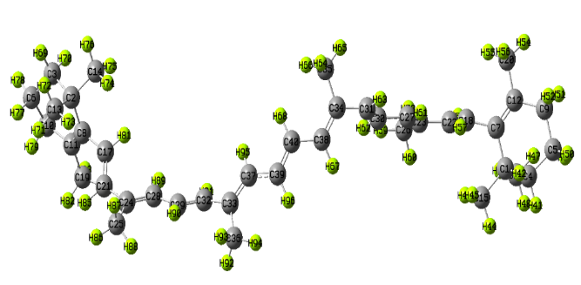
Delphatines | CID:185591 | 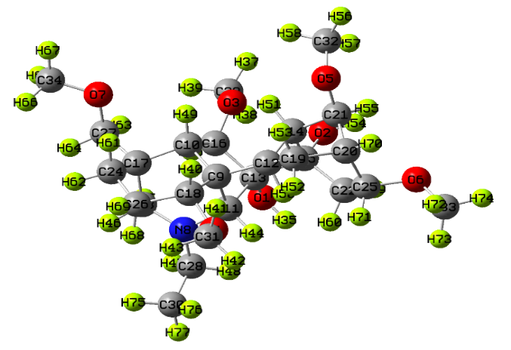
Hypaconitine | CID:10008952 | 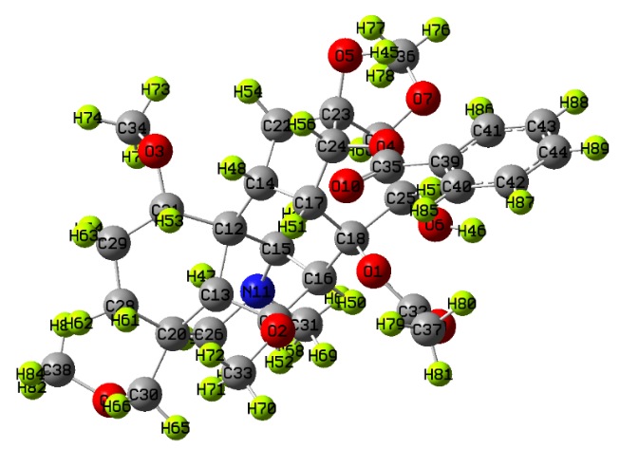
lactone atisenol | CASID:84743-53-3 | 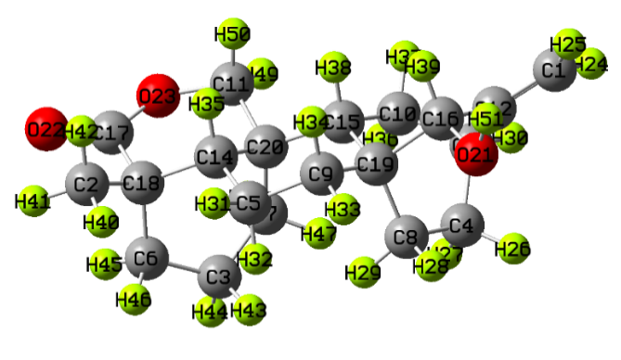
Lycoctonine | CID: 99924 | 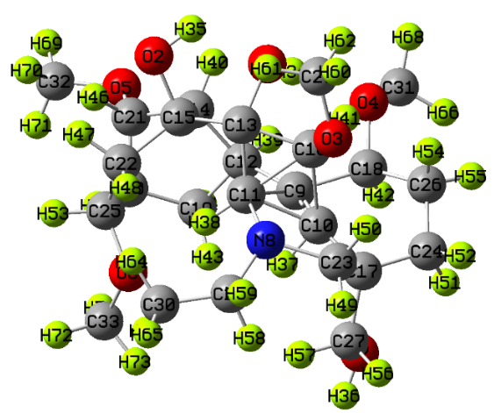
veratridine | CID: 6280 | 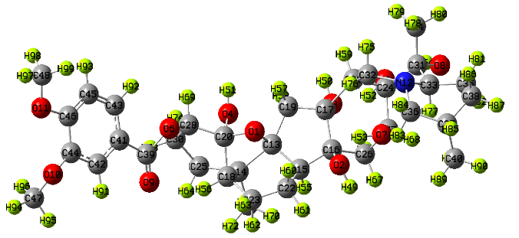

SD. 2. Docking scores of all the selected phytochemicals.

COVID (7QNW) +Aconitum heterophyllum
Phytochemical name | Docking score kcal/mol
14-Anisoylaconine | -7.2
6-Acetylheteratisine | -7.8
6-Benzoylheteratisine | -8.1
Aconitine | -6.8
Atidine | -7.6
Atisine | -7.6
Benzoylmesaconine | -7.3
Dihydroatisine | -7.1
Heterophyllisine | -7.3
heterophylloidine | -8.0
Hetidine | -7.6
Hetisine | -8.0
Hetisinone | -7.6
Isoatisine | -8.1
Jesaconitine | -7.3
lappaconitine | -7.4
Mesaconitine | -7.0
Phytosterols | -7.6
Aricine | -7.7
beta-carotene | -7.6
Delphatines | -7.0
Hypaconitine | -6.9
lactone atisenol | -7.1
Lycoctonine | -6.2
veratridine | -8.4

SD. 3. Pharmacokinetic properties of the selected phytochemicals of the Aconitum heterophyllum plant derived from SwissADME database.
Phytoconstituents | ADMET properties
Phytoconstituents | Lipinski | Ghose | Veber | Egan | Mugge | PAINS | GI Ab. | BBB
6-Benzoylheteratisine | Yes; 0 violation | No; 3 violations: MW>480, MR>130, #atoms>70 | Yes | Yes | Yes | 0 alert | High | No
Heterophylloidine | Yes | Yes | Yes | Yes | Yes | 0 alert | High | Yes
Hetisine | Yes | Yes | Yes | Yes | Yes | 0 alert | High | No
Isoatisine | Yes | Yes | Yes | Yes | Yes | 0 alert | High | Yes
Veratridine | No; 3 violations: MW>500, NorO>10, NHorOH>5 | No; 3 violations: MW>480, MR>130, #atoms>70 | No; 1 violation: TPSA>140 | No; 1 violation: TPSA>131.6 | No; 5 violations: MW>600, TPSA>150, #rings>7, H-acc>10, H-don>5 | 0 alert | Low | No

SD. 4. Interaction details of the best pose of Isoatisine bonded with Omicron protein 7QNW.

Protein | Binding affinity  (kcal/mol) | Interaction (donor: acceptor, distance in A)  [Type of bond]
7QNW | -8.1 | E:ASN439:HD21 - :UNL1:O, 2.91048 [Conventional Hydrogen Bond]  A:TYR55:HH - :UNL1:O, 2.48399 [Conventional Hydrogen Bond]  UNL1:H - E:GLN506:OE1 , 2.08219 [Conventional Hydrogen Bond]  E:LYS440 - :UNL1, 5.39001 [Hydrophobic-Alkyl]  A:ARG33 - :UNL1, 5.28301 [Hydrophobic-Alkyl]

SD. 5. Location of ligand Isoatisine bonded with Omicron protein 7QNW.

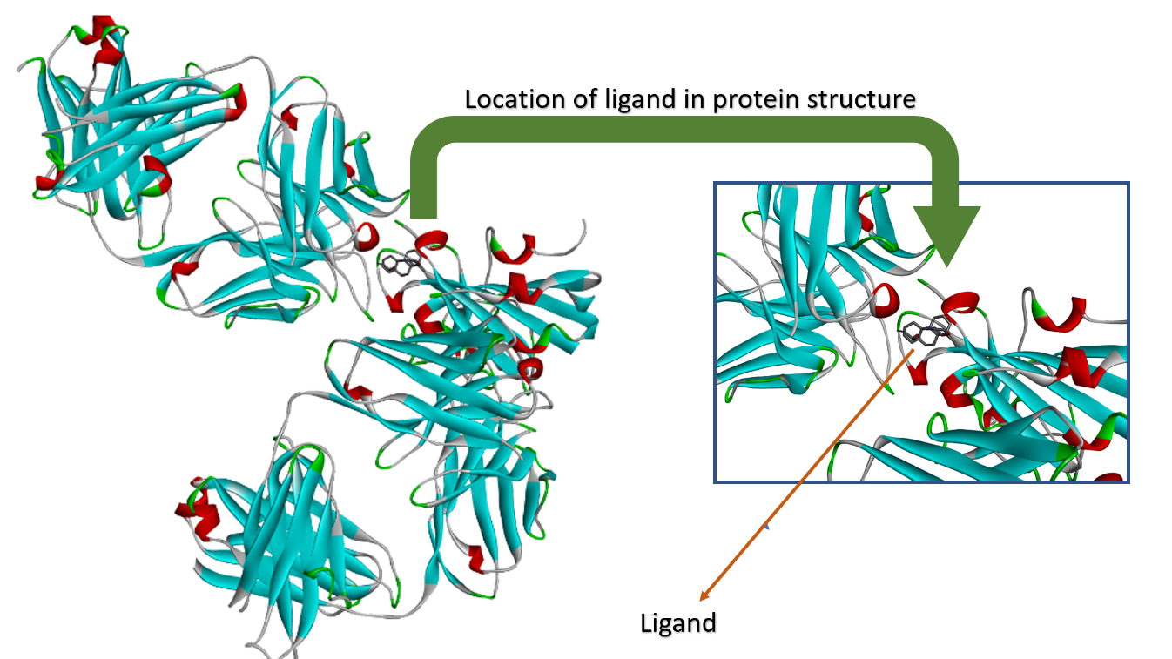

SD. 6. 3D view of protein-ligand interaction of docked complex Isoatisine + protein 7QNW within the surface due to hydrogen bonds.
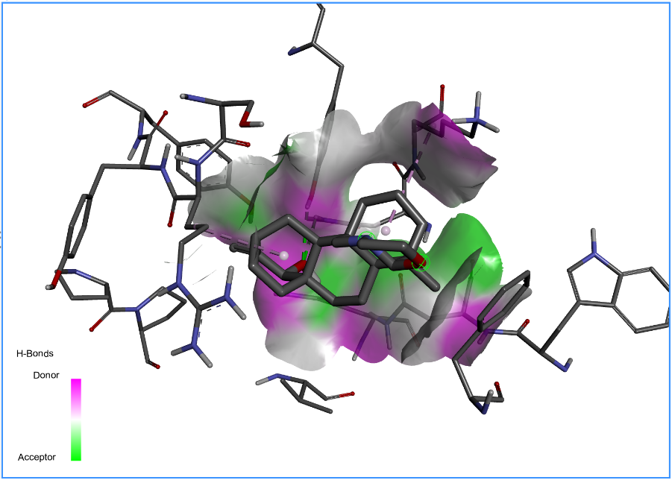

SD. 7. HOMO-LUMO parameters computed using Koopman’s equations.
S No. | Molecular property | Values
1. | HOMO | -5.659
2. | LUMO | -0.224
3. | Energy gap (ΔE) | 5.435
4. | Ionization potential (IP) | 5.659
5. | Electron affinity (EA) | 0.224
6. | Chemical potential (CP) | -2.941
7. | Electronegativity (χ) | 2.941
8. | Hardness (η) | 2.717
9. | Softness (S) | 0.367

SD. 8. UV-Vis’s absorption data of Isoatisine molecule.

Absorption | Theoretical
Absorption | Transition | λ (nm) | E (eV) | (f)
Absorption | S₀ →S₁ | 247.69 | 5.0056 | 0.0044
Absorption | S₀ → S₂ | 222.63 | 5.5691 | 0.0147
Absorption | S₀ → S₃ | 210.42 | 5.8922 | 0.0383

