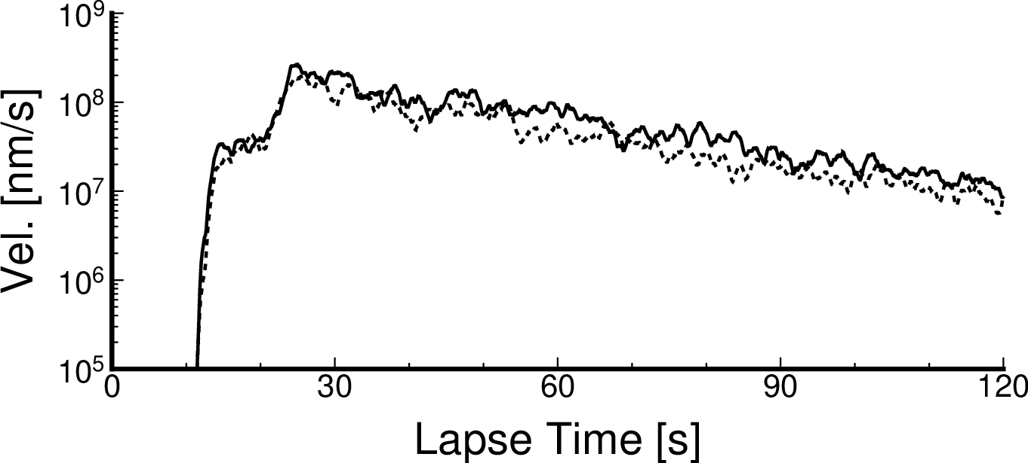
Figure S1. Simulated horizontal envelopes at N.KISF using model regions from Figure 2. The frequency range of these envelopes is 2.0 to 4.0 Hz. Solid and dashed horizontal envelopes are derived from model regions of blue solid and dashed rectangles from Figure 2.

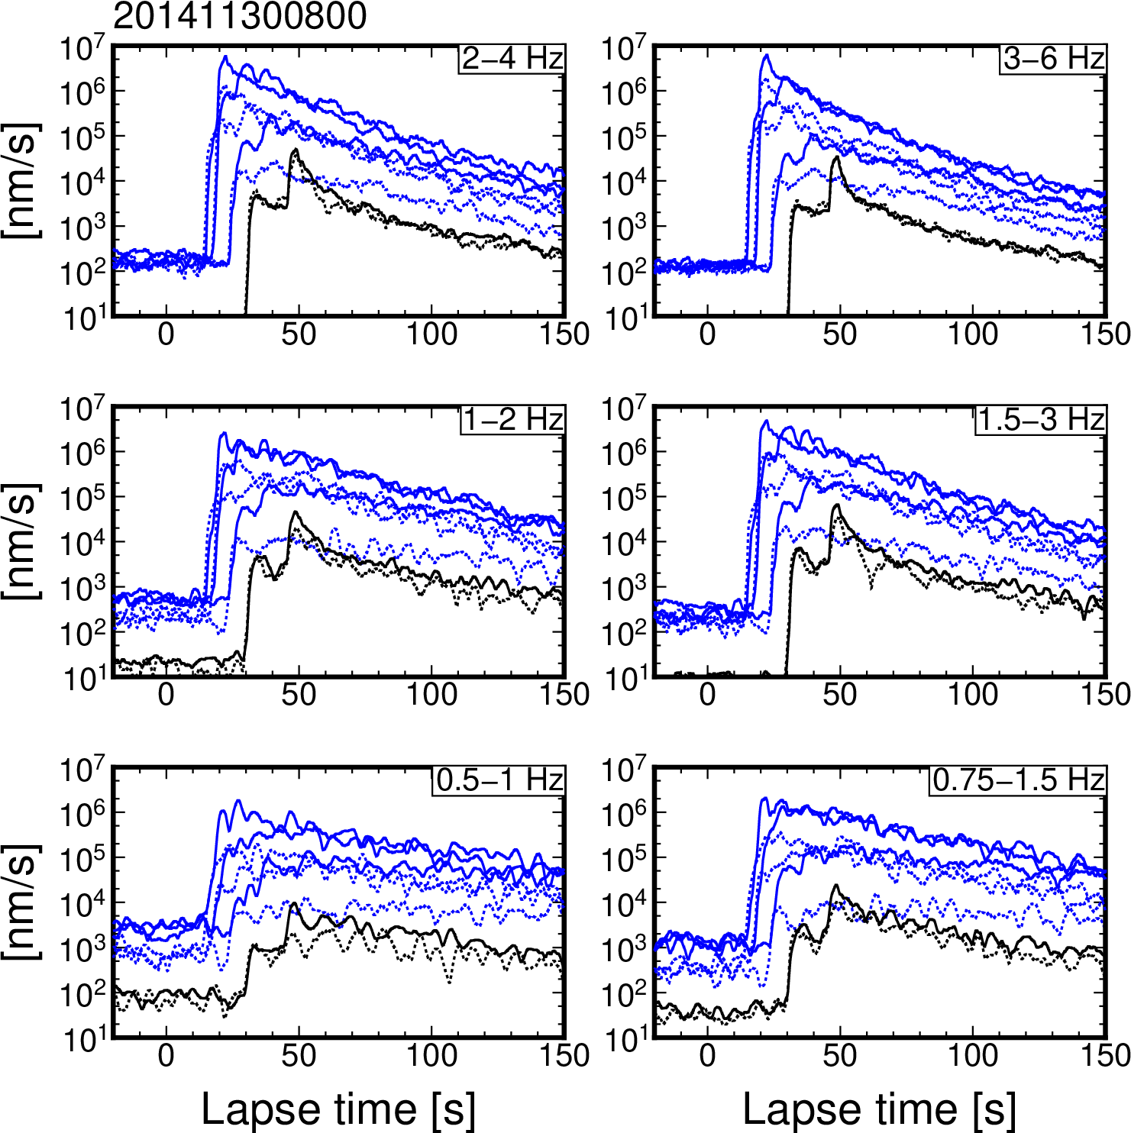
Figure S2. Horizontal and vertical envelopes at DONET and F-net stations for an earthquake that occurred at 8:00 on 30 November 2014 (JST). Horizontal and vertical envelopes are illustrated by solid and dashed lines, respectively. Blue and black envelopes were those observed at DONET (KMA03, KMB06, and KMC09) and F-net (N.KISF and N.WTRF) stations, respectively.
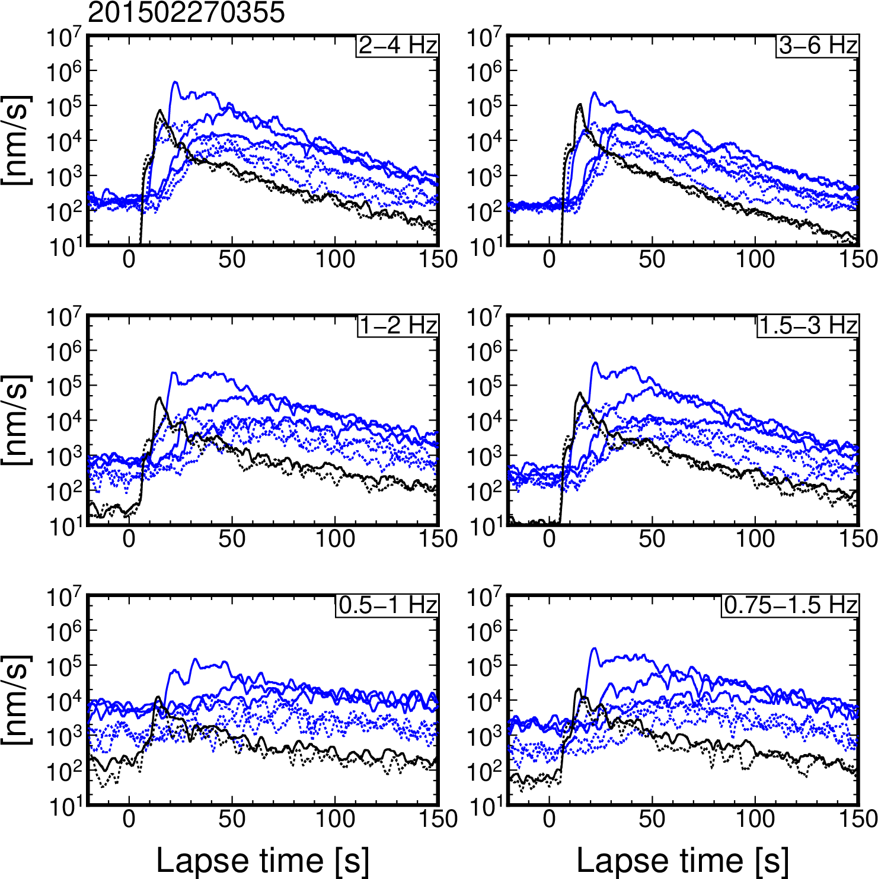

Figure S3. Horizontal and vertical envelopes at DONET and F-net stations for an earthquake that occurred at 3:55 on 27 February 2015 (JST).
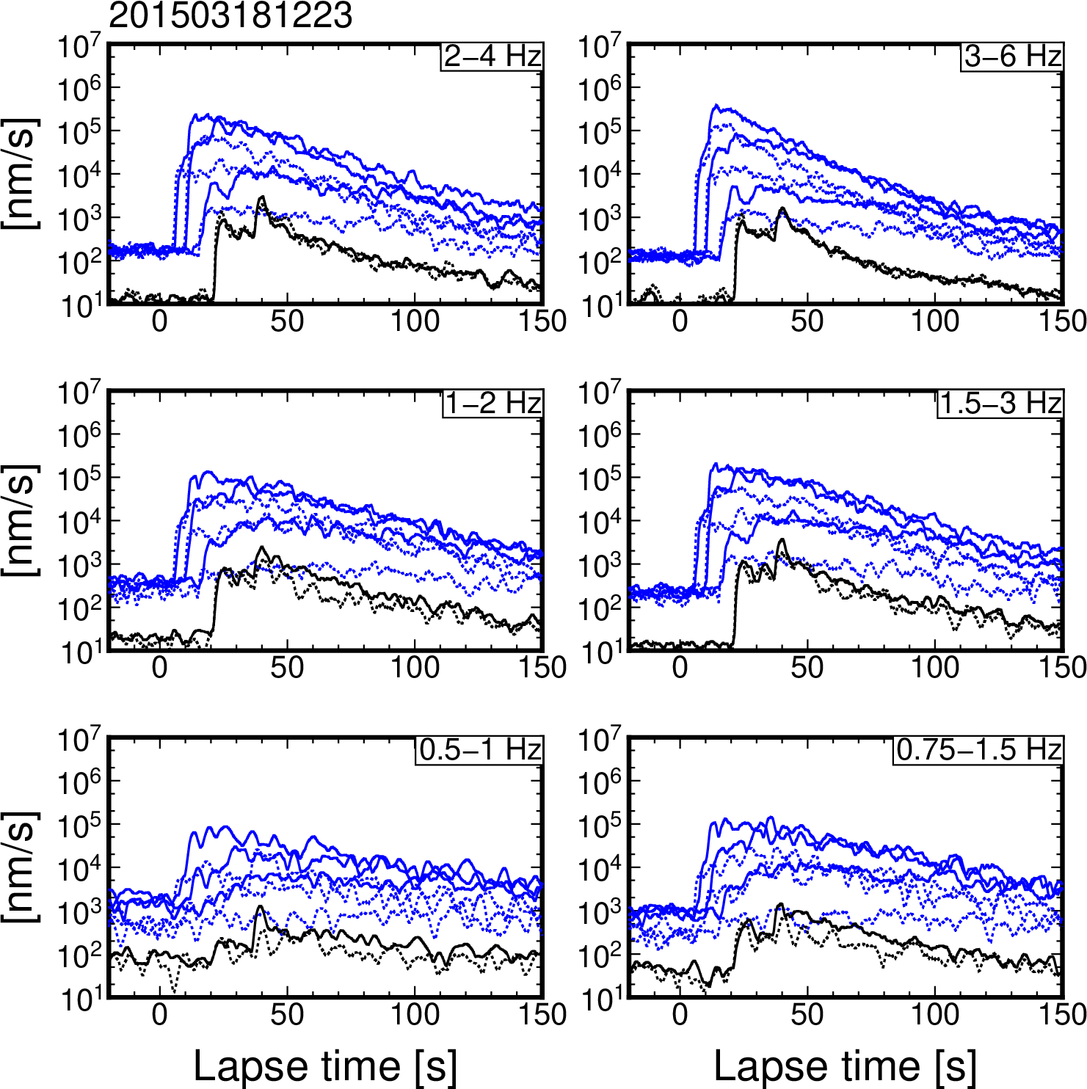
Figure S4. Horizontal and vertical envelopes at DONET and F-net stations for an earthquake that occurred at 12:23 on 18 March 2015 (JST).

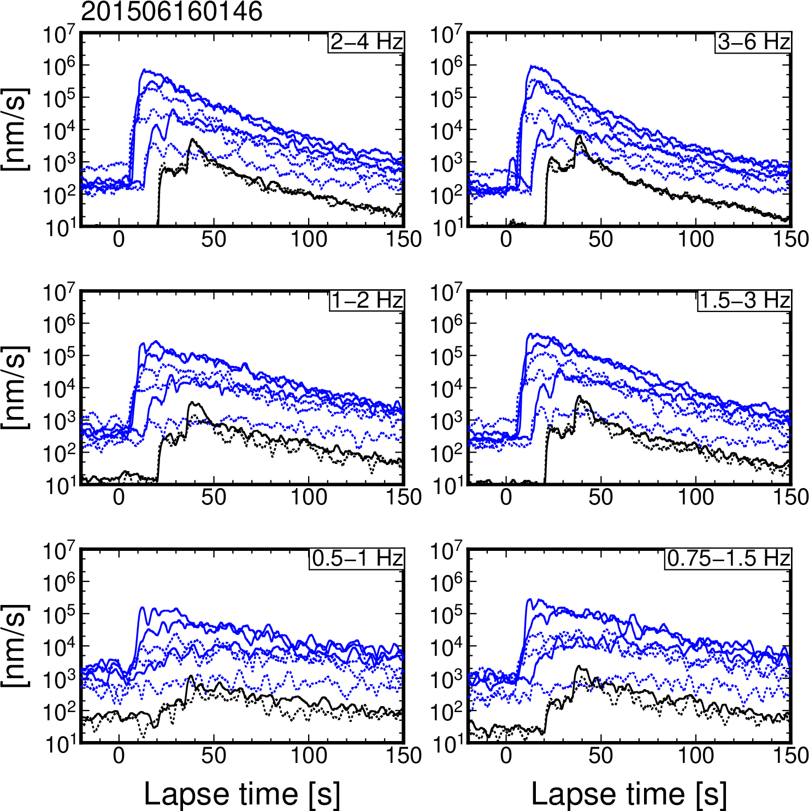
Figure S5. Horizontal and vertical envelopes at DONET and F-net stations for an earthquake that occurred at 01:46 on 16 June 2015 (JST).

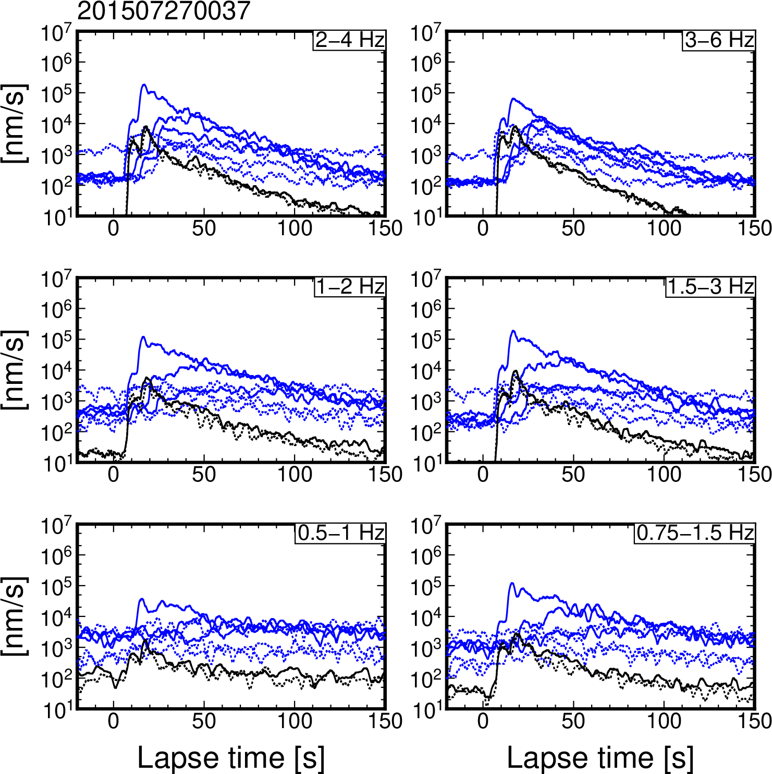
Figure S6. Horizontal and vertical envelopes at DONET and F-net stations for an earthquake that occurred at 00:37 on 27 July 2015 (JST).

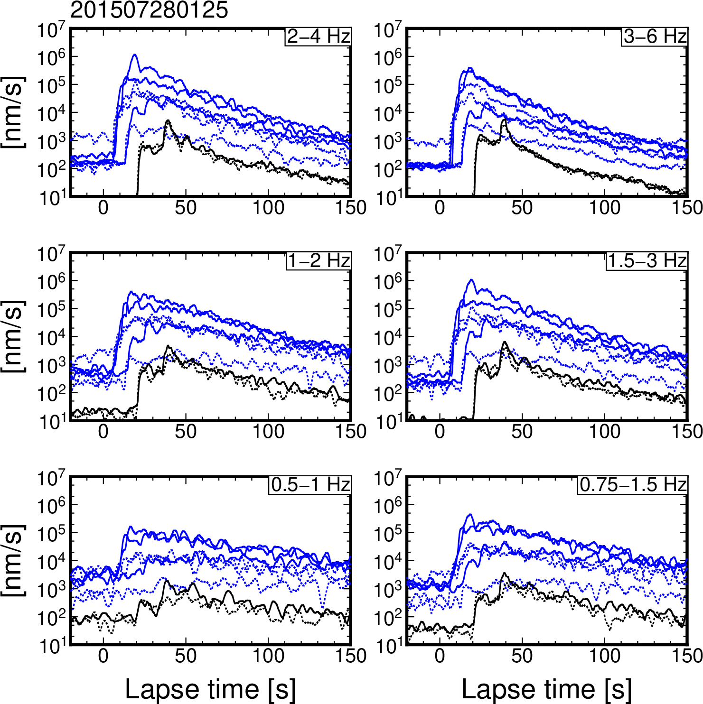
Figure S7. Horizontal and vertical envelopes at DONET and F-net stations for an earthquake that occurred at 01:25 on 28 July 2015 (JST).

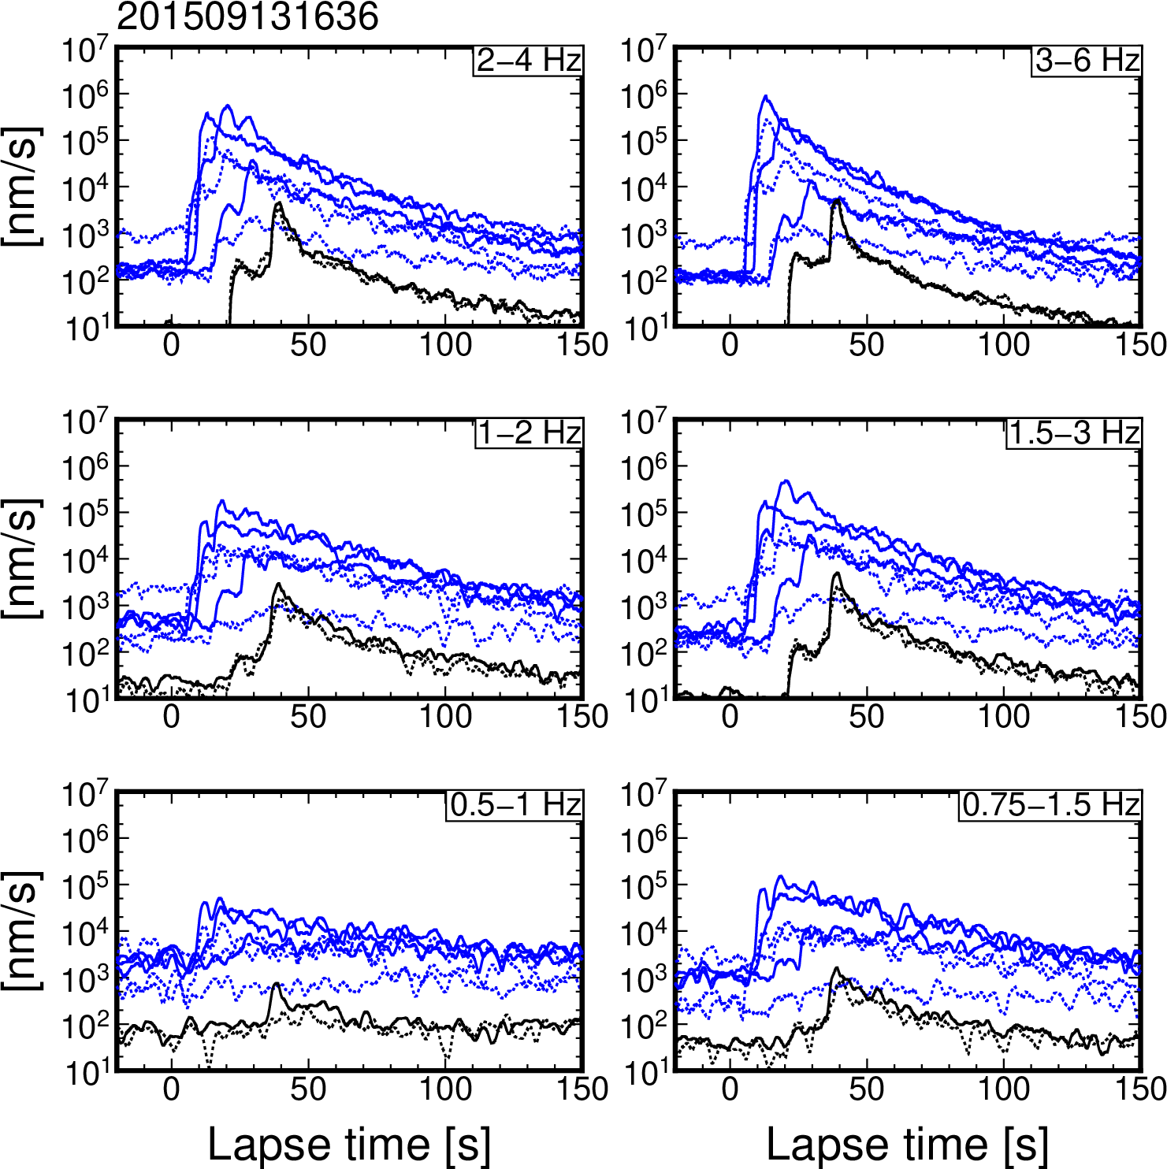
Figure S8. Horizontal and vertical envelopes at DONET and F-net stations for an earthquake that occurred at 16:36 on 13 September 2015 (JST).

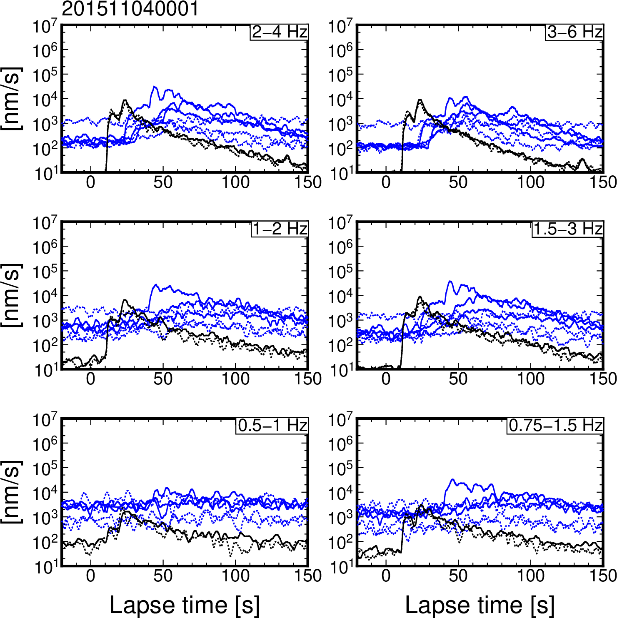
Figure S9. Horizontal and vertical envelopes at DONET and F-net stations for an earthquake that occurred at 00:01 on 4 November 2015 (JST).

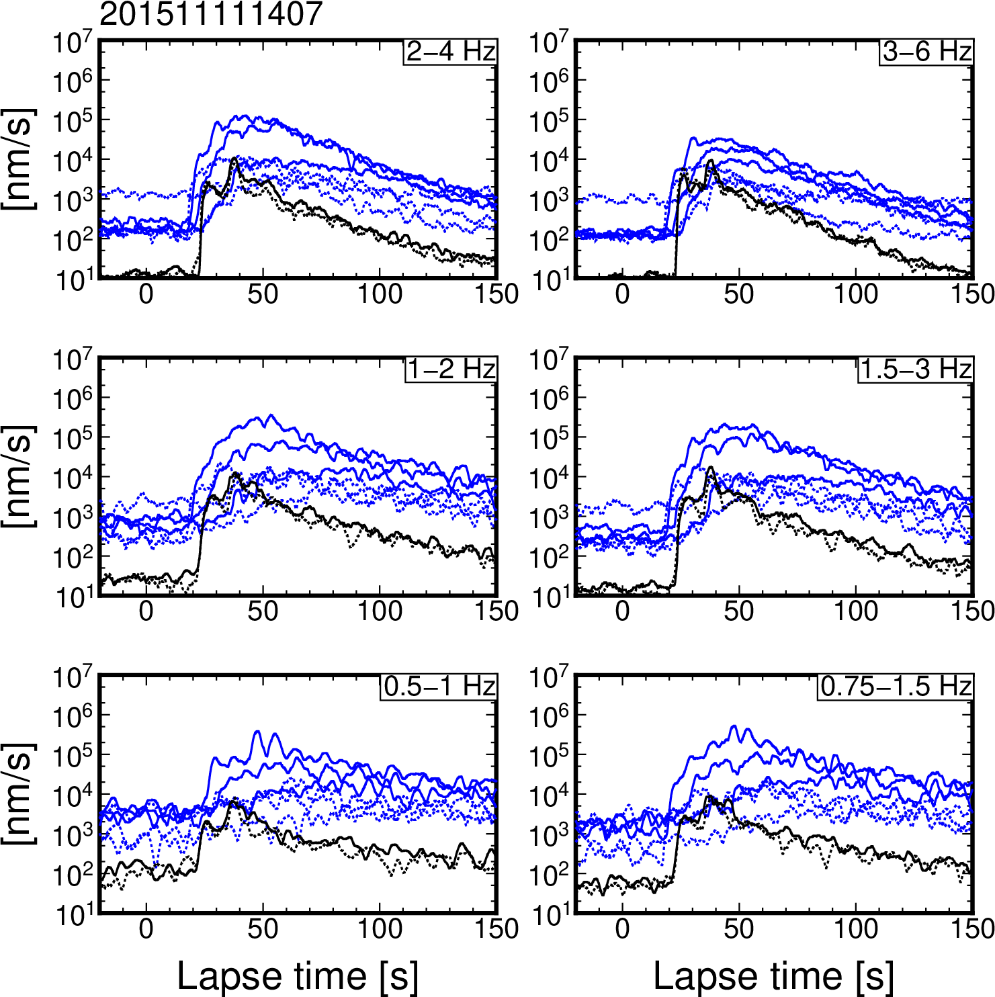
Figure S10. Horizontal and vertical envelopes at DONET and F-net stations for an earthquake that occurred at 14:07 on 11 November 2015 (JST).

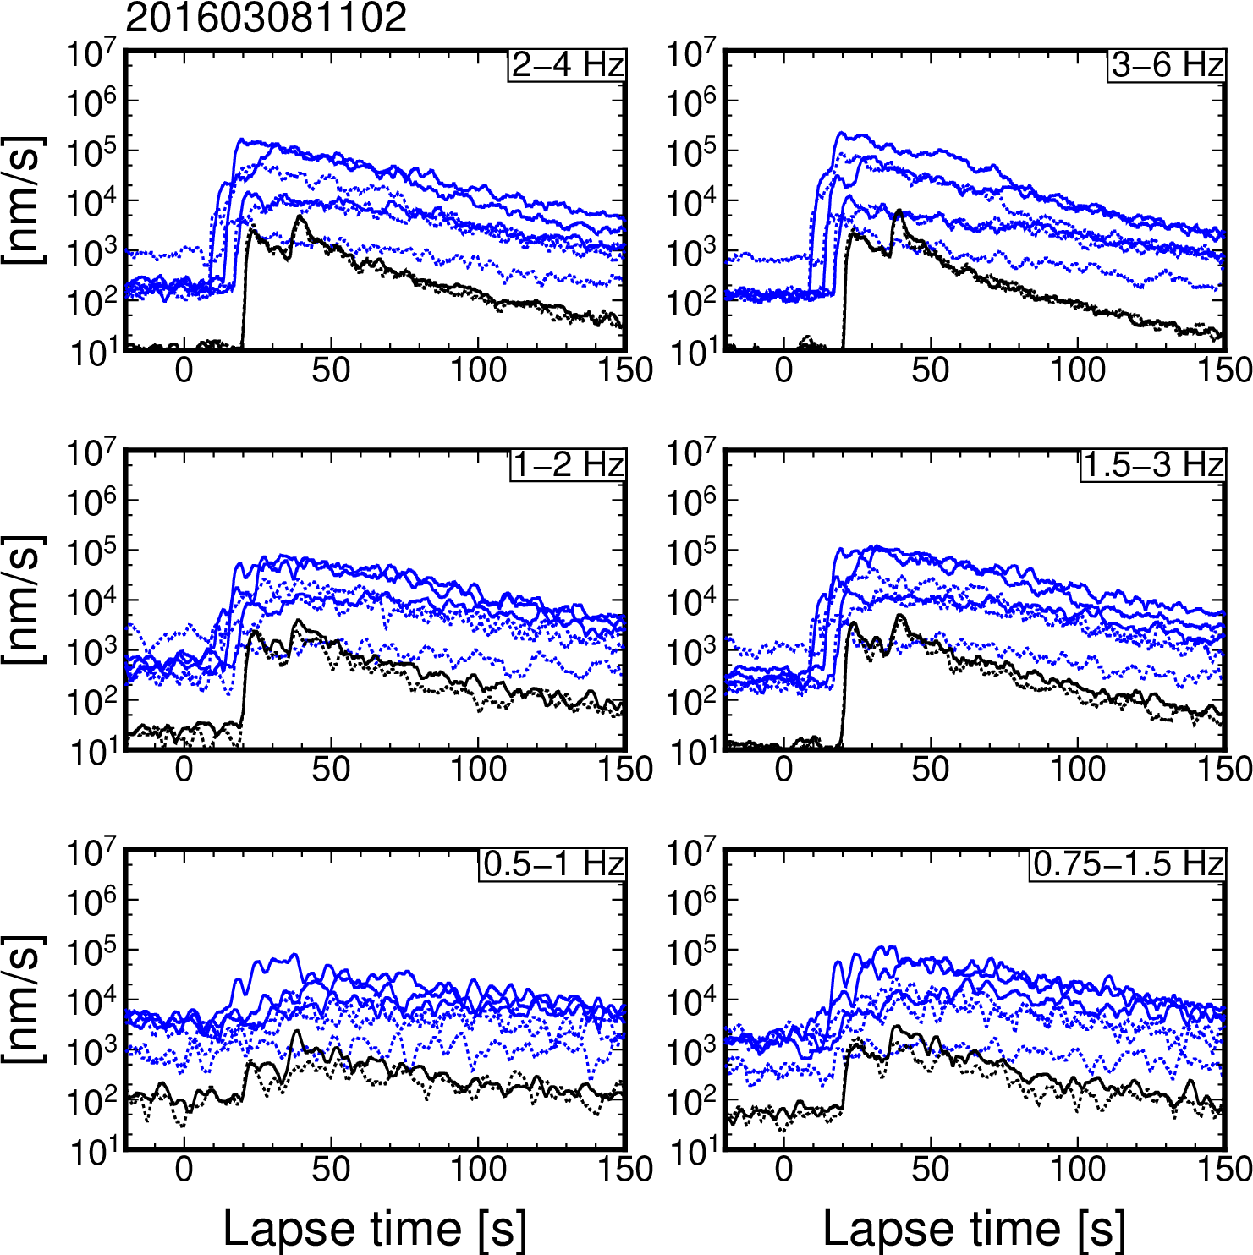
Figure S11. Horizontal and vertical envelopes at DONET and F-net stations for an earthquake that occurred at 11:02 on 8 March 2016 (JST).

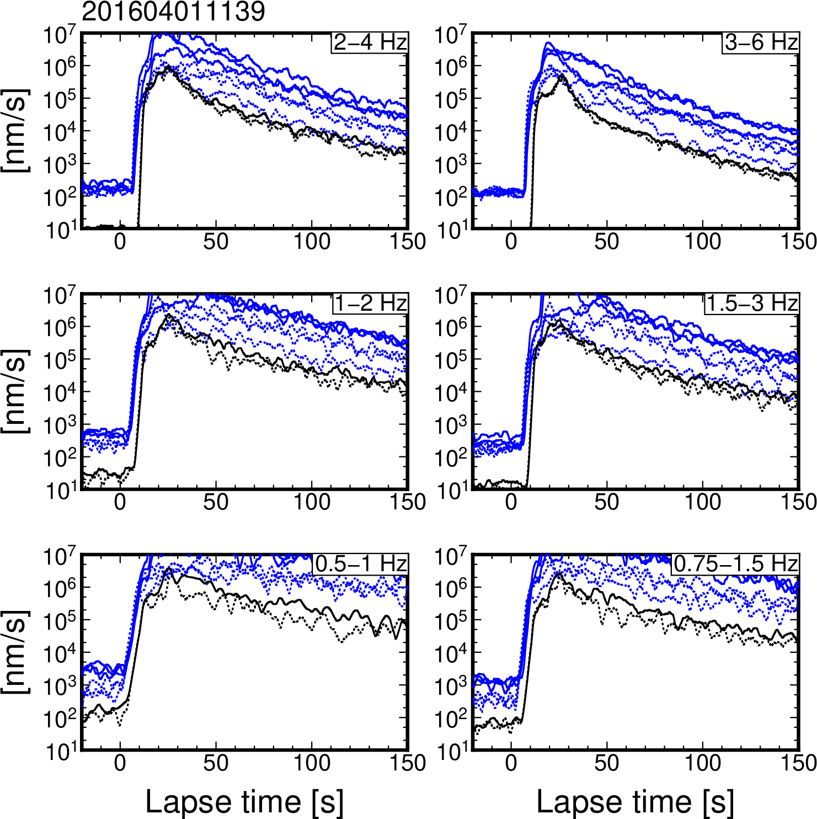
Figure S12. Horizontal and vertical envelopes at DONET and F-net stations for an earthquake that occurred at 11:39 on 1 April 2016 (JST).

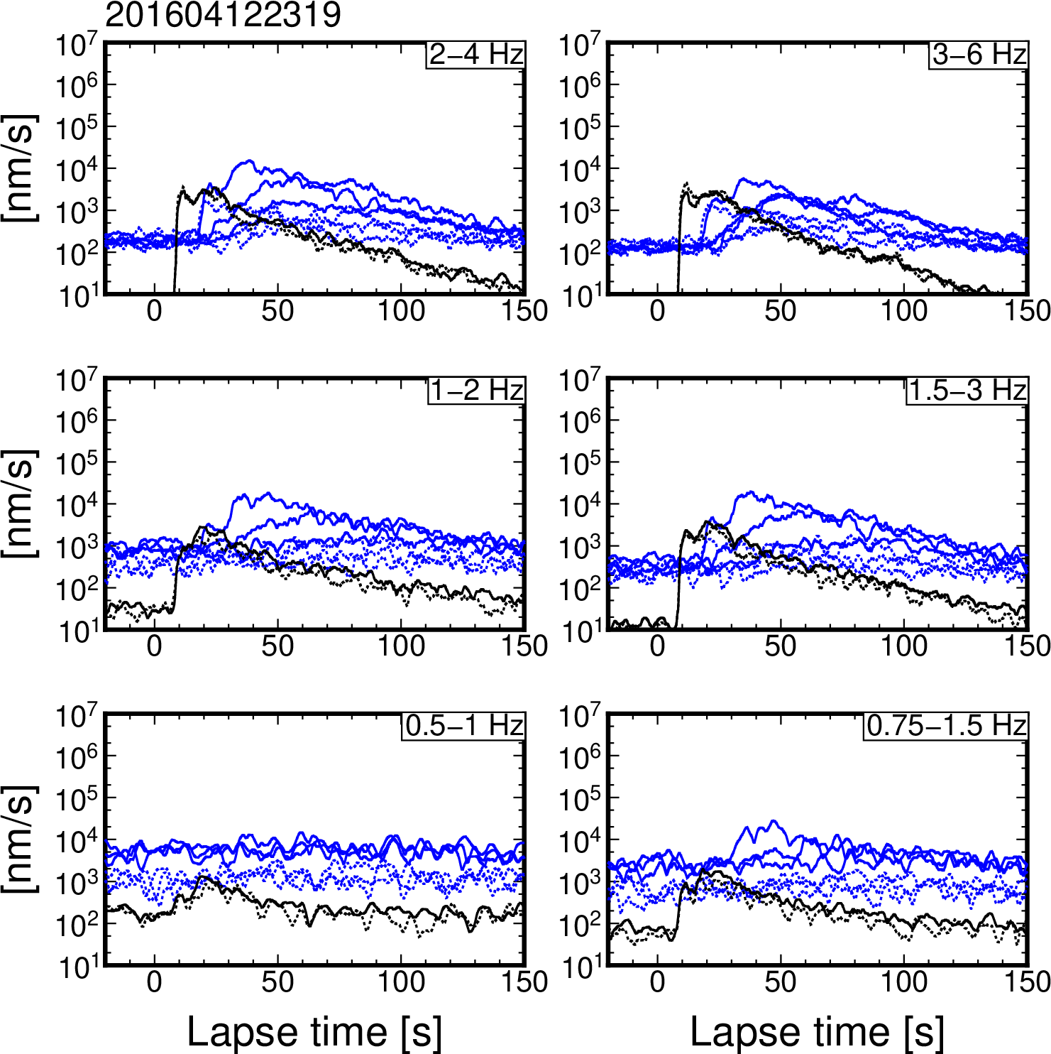
Figure S13. Horizontal and vertical envelopes at DONET and F-net stations for an earthquake that occurred at 23:19 on 12 April 2016 (JST).

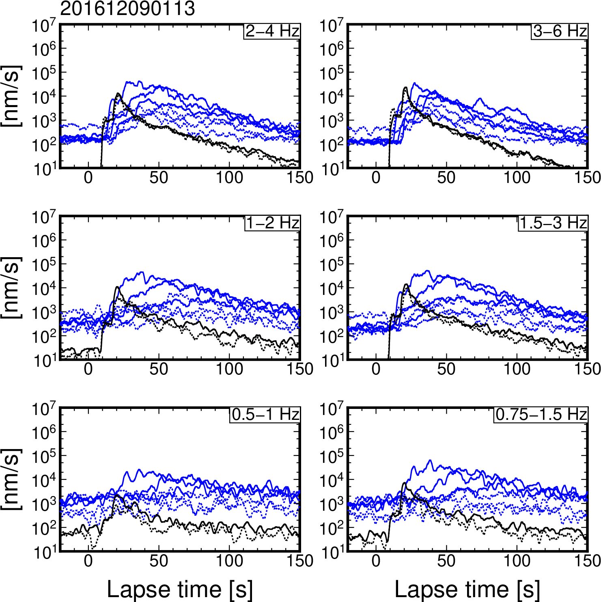
Figure S14. Horizontal and vertical envelopes at DONET and F-net stations for an earthquake that occurred at 1:13 on 9 December 2016 (JST).

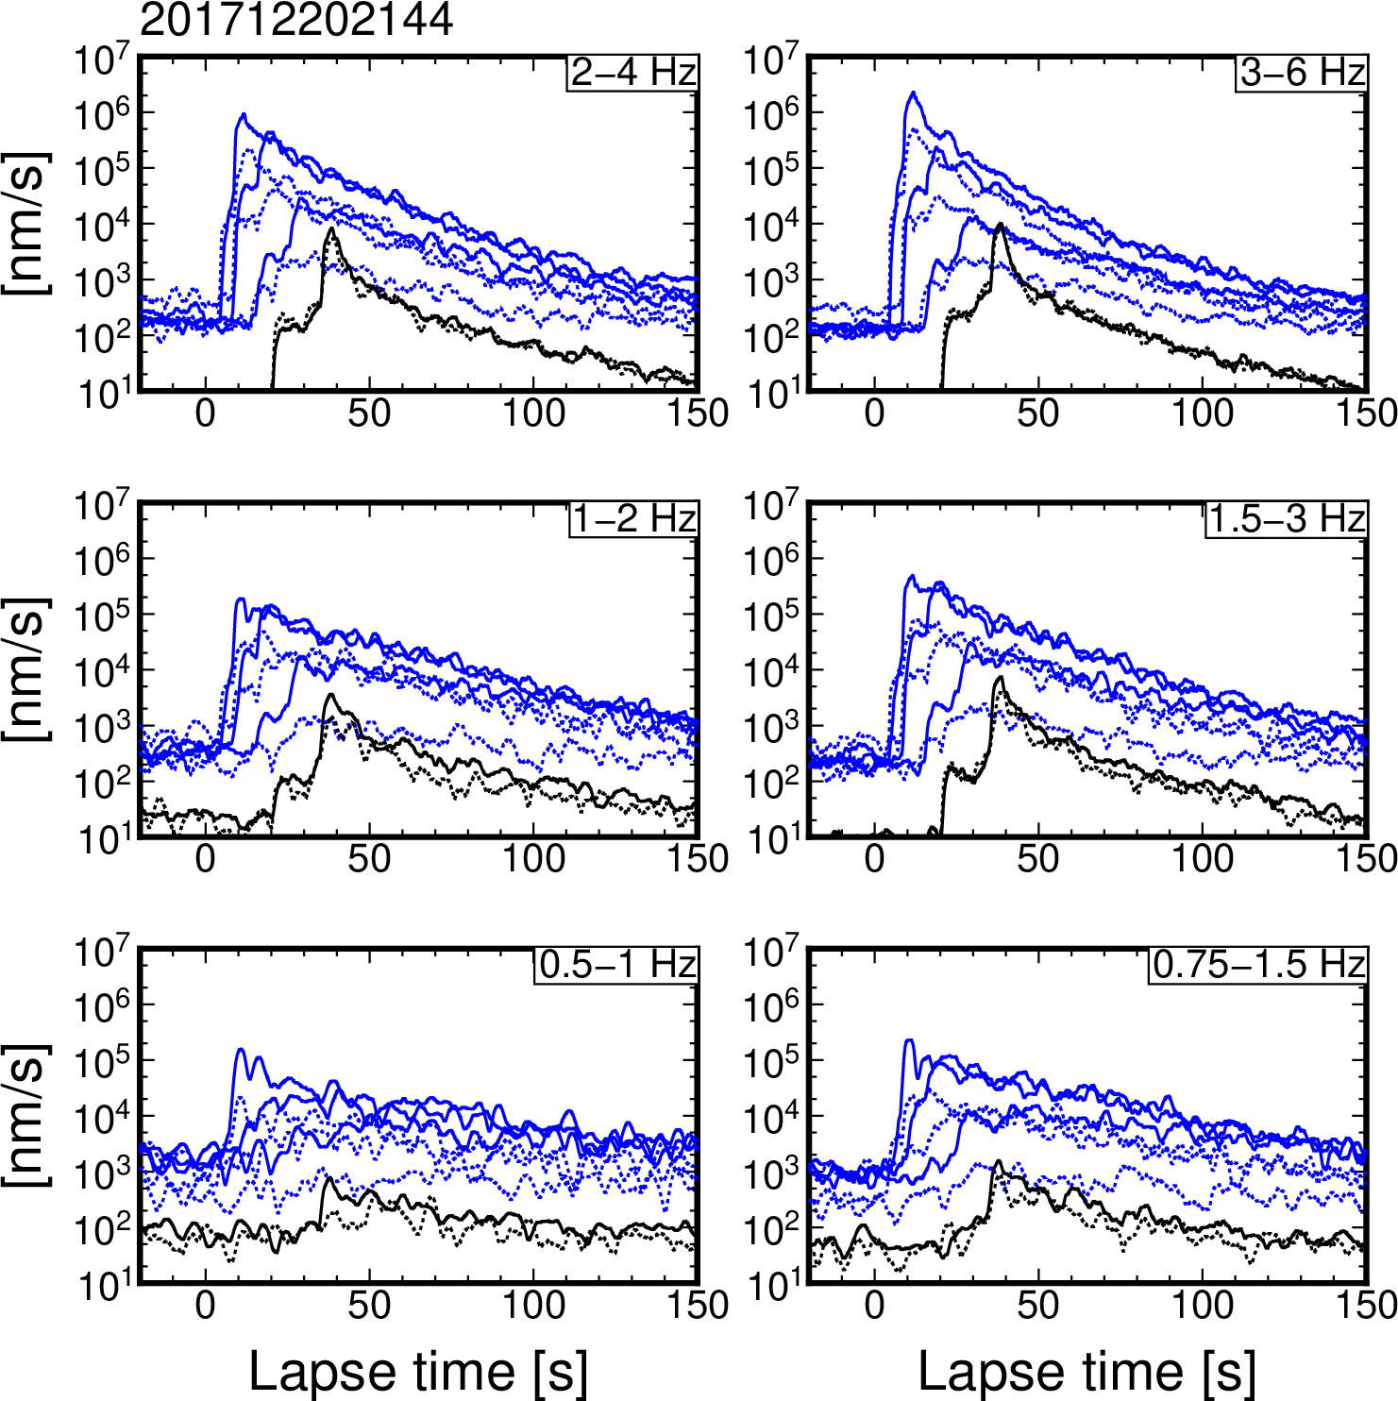
Figure S15. Horizontal and vertical envelopes at DONET and F-net stations for an earthquake that occurred at 21:44 on 20 December 2017 (JST).

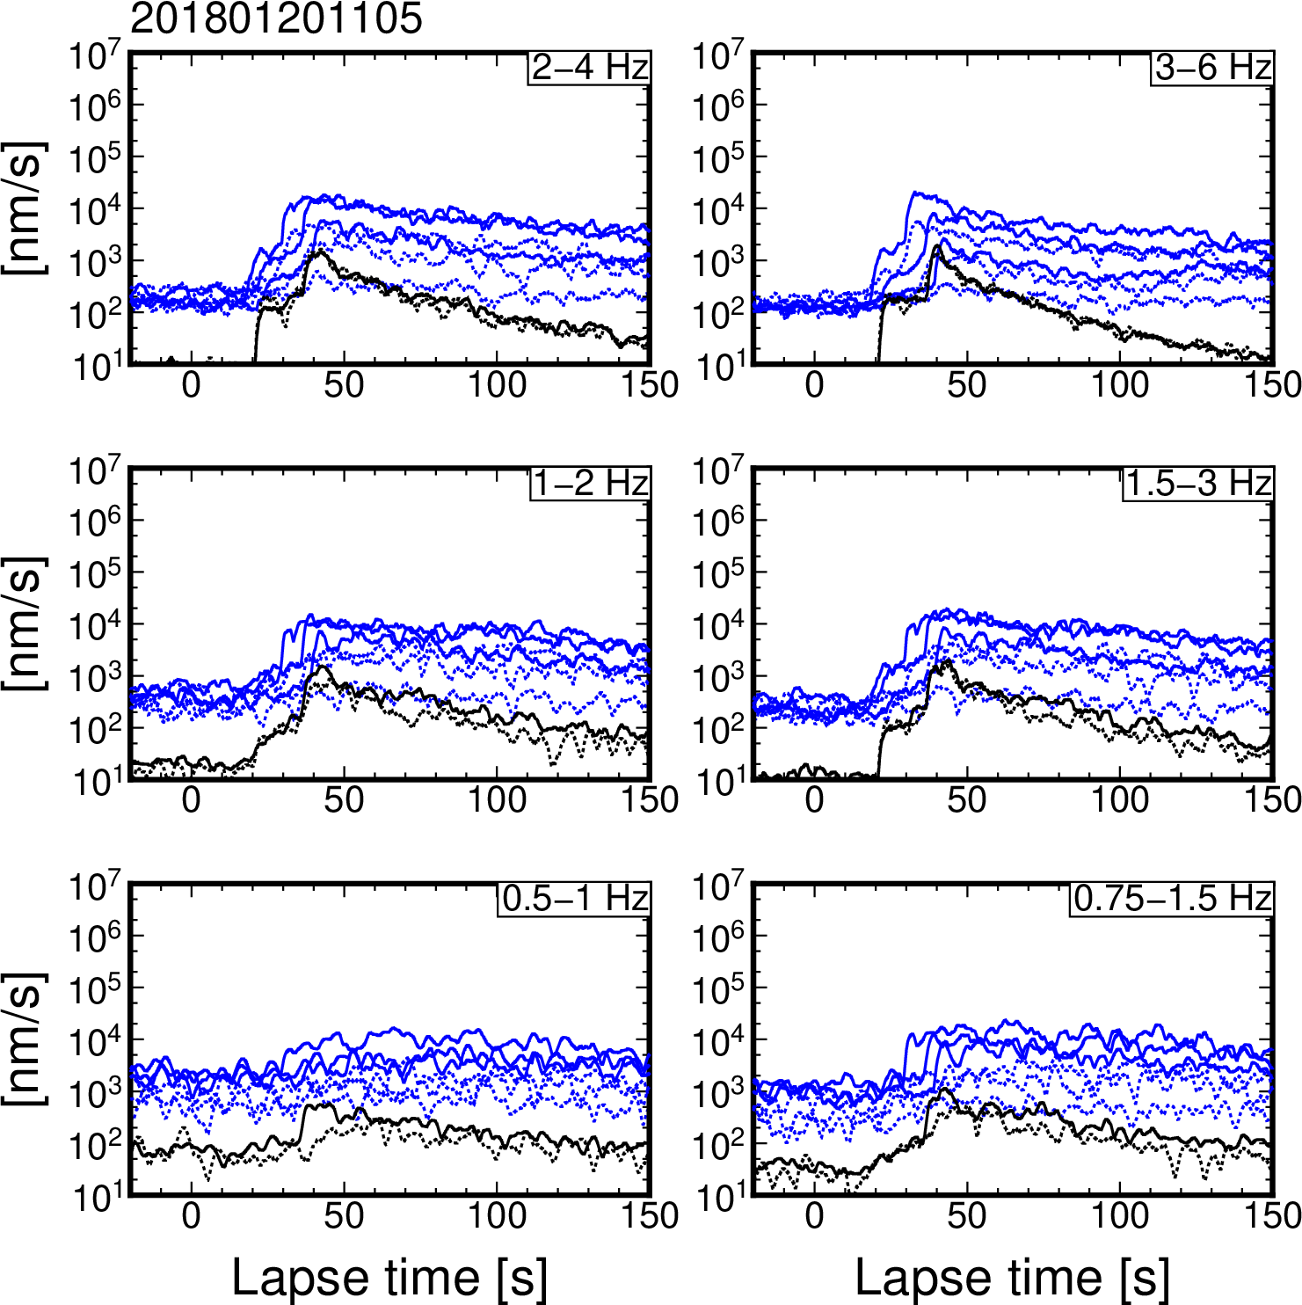
Figure S16. Horizontal and vertical envelopes at DONET and F-net stations for an earthquake that occurred at 11:05 on 20 January 2018 (JST).
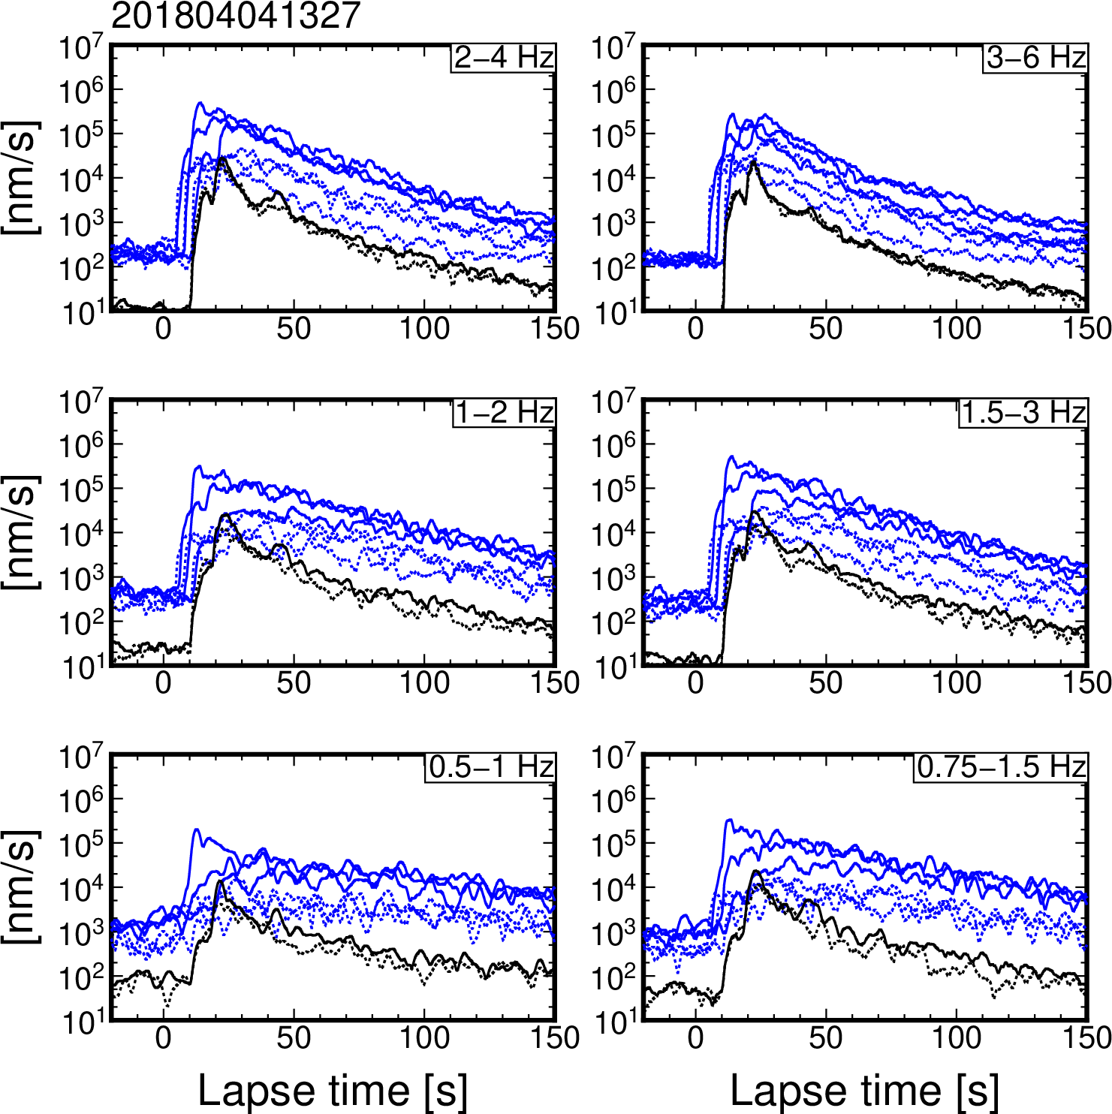
Figure S17. Horizontal and vertical envelopes at DONET and F-net stations for an earthquake that occurred at 13:27 on 4 April 2018 (JST).

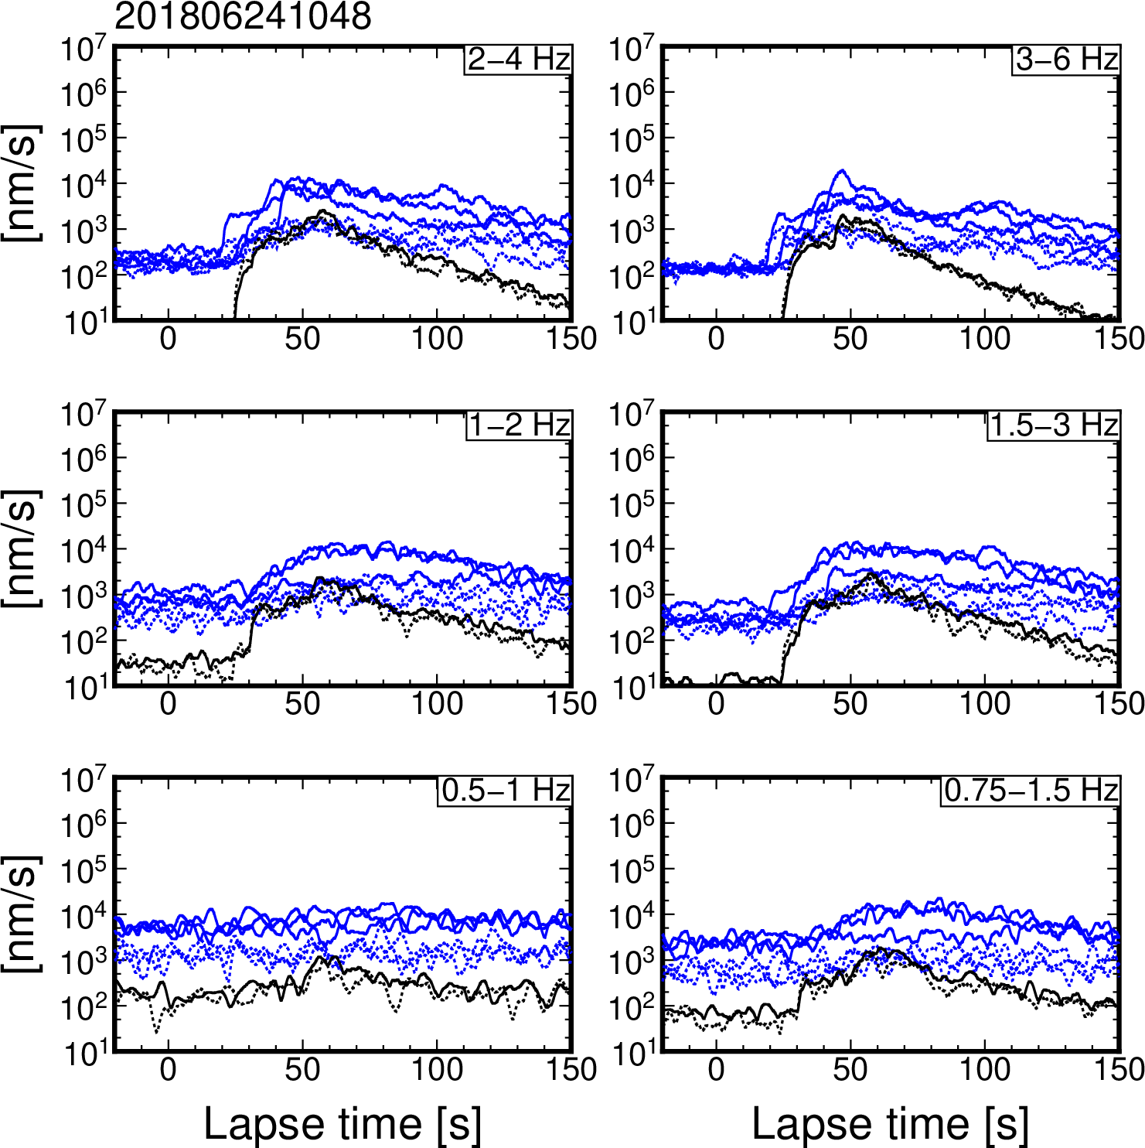
Figure S18. Horizontal and vertical envelopes at DONET and F-net stations for an earthquake that occurred at 10:48 on 24 June 2018 (JST).

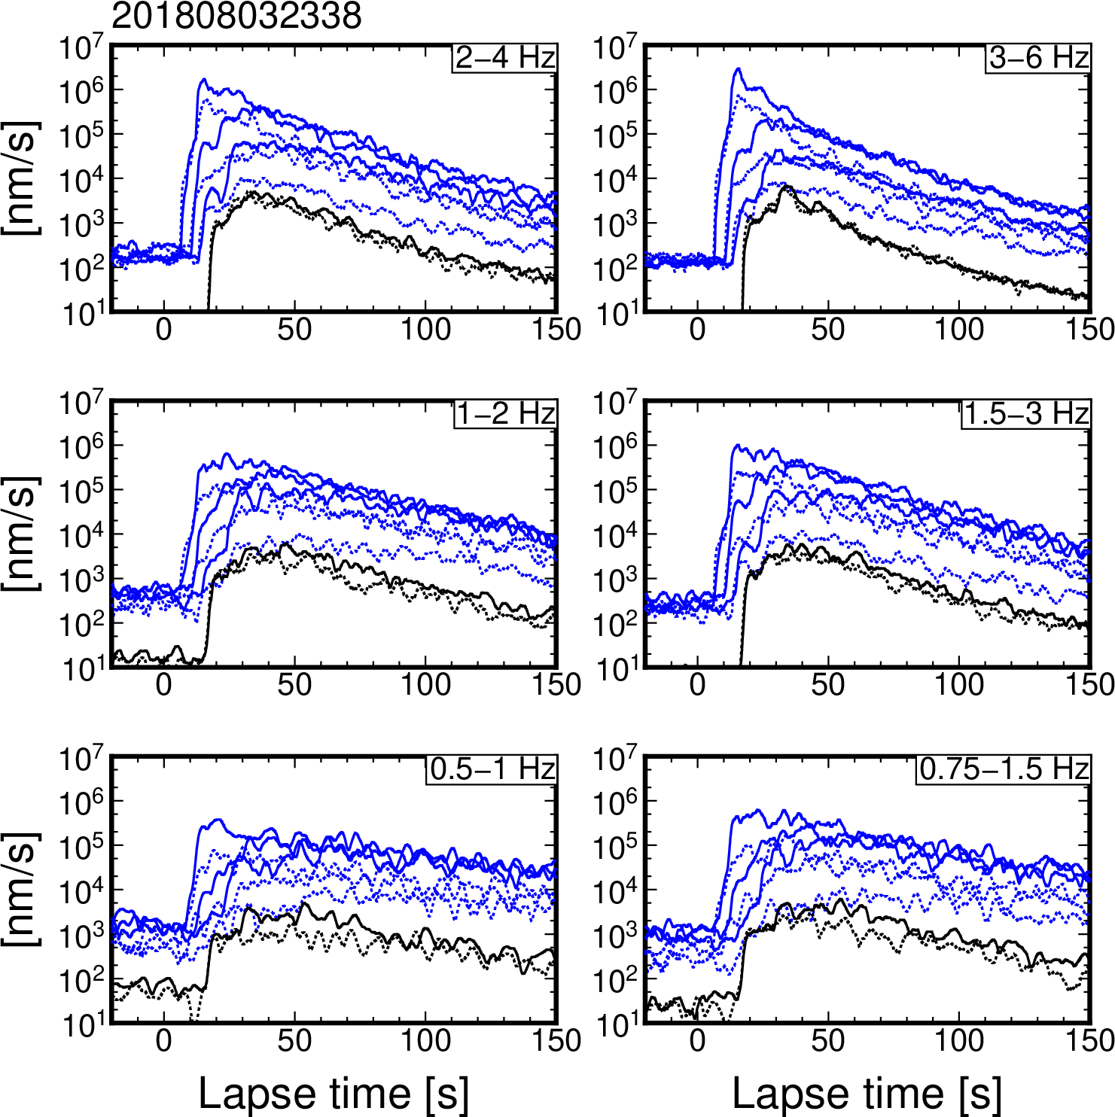
Figure S19. Horizontal and vertical envelopes at DONET and F-net stations for an earthquake that occurred at 23:38 on 3 August 2018 (JST).

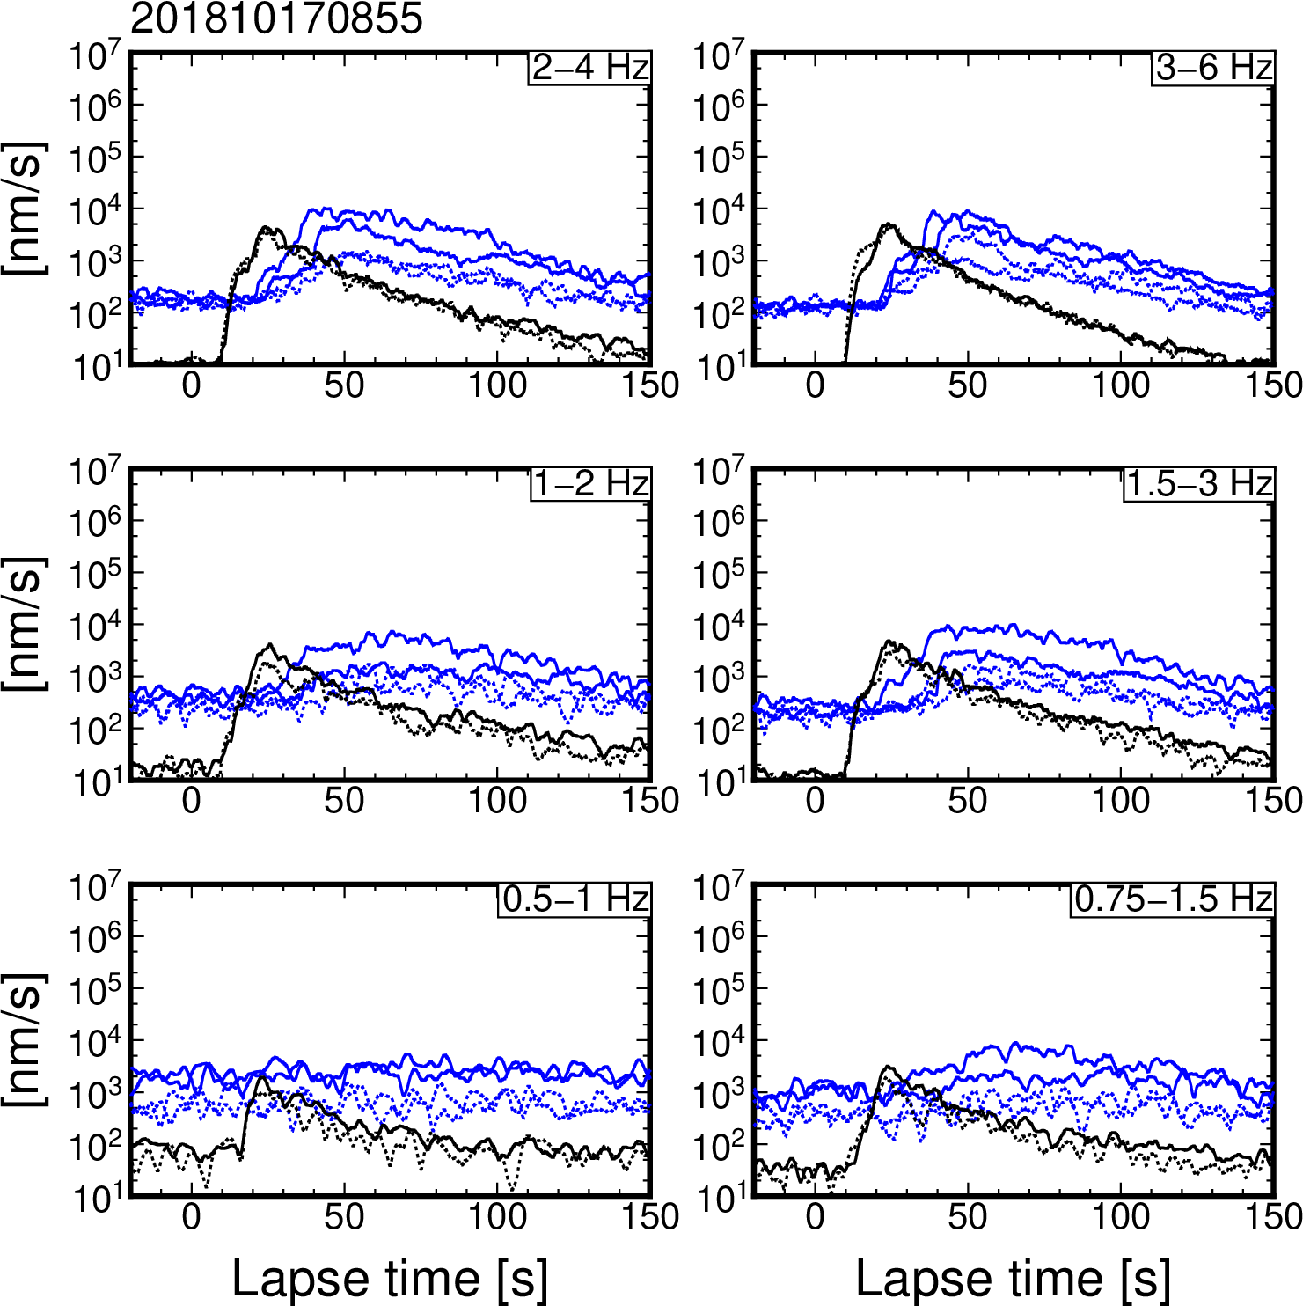
Figure S20. Horizontal and vertical envelopes at DONET and F-net stations for an earthquake that occurred at 8:55 on 17 October 2018 (JST).

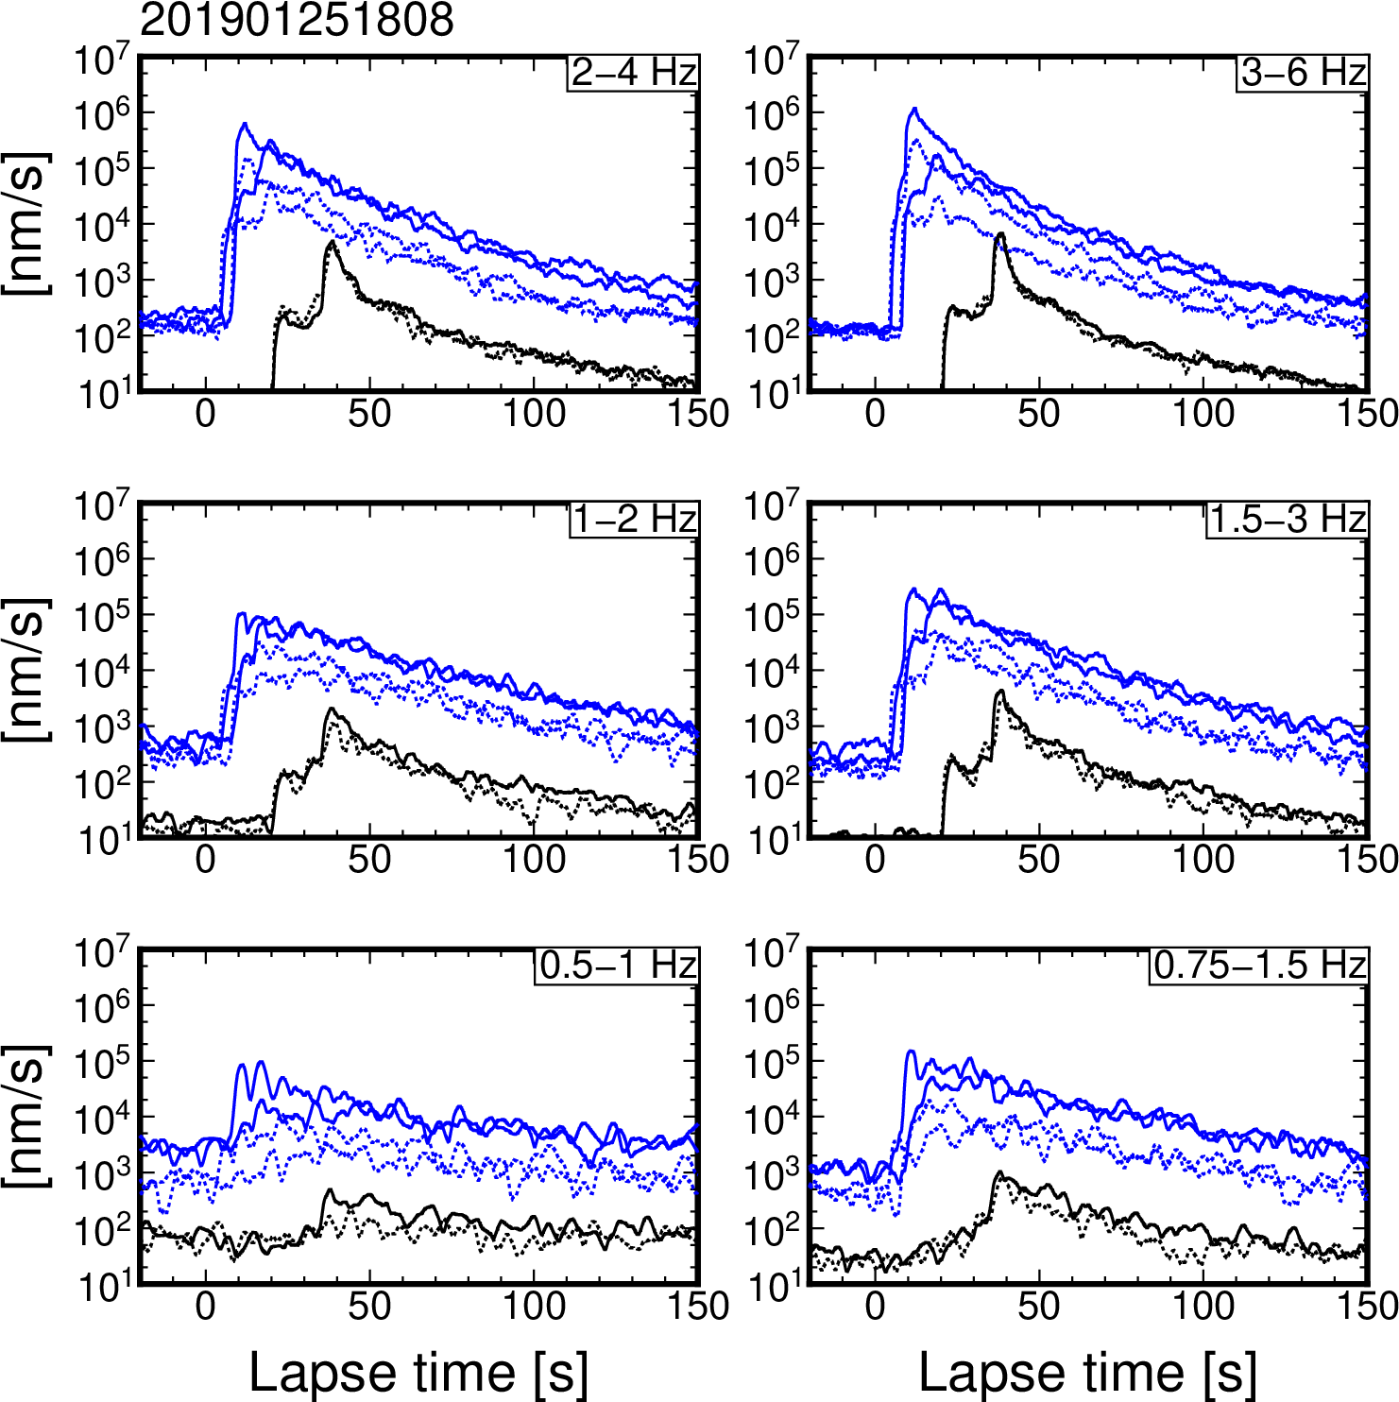
Figure S21. Horizontal and vertical envelopes at DONET and F-net stations for an earthquake that occurred at 18:08 on 25 January 2019 (JST).

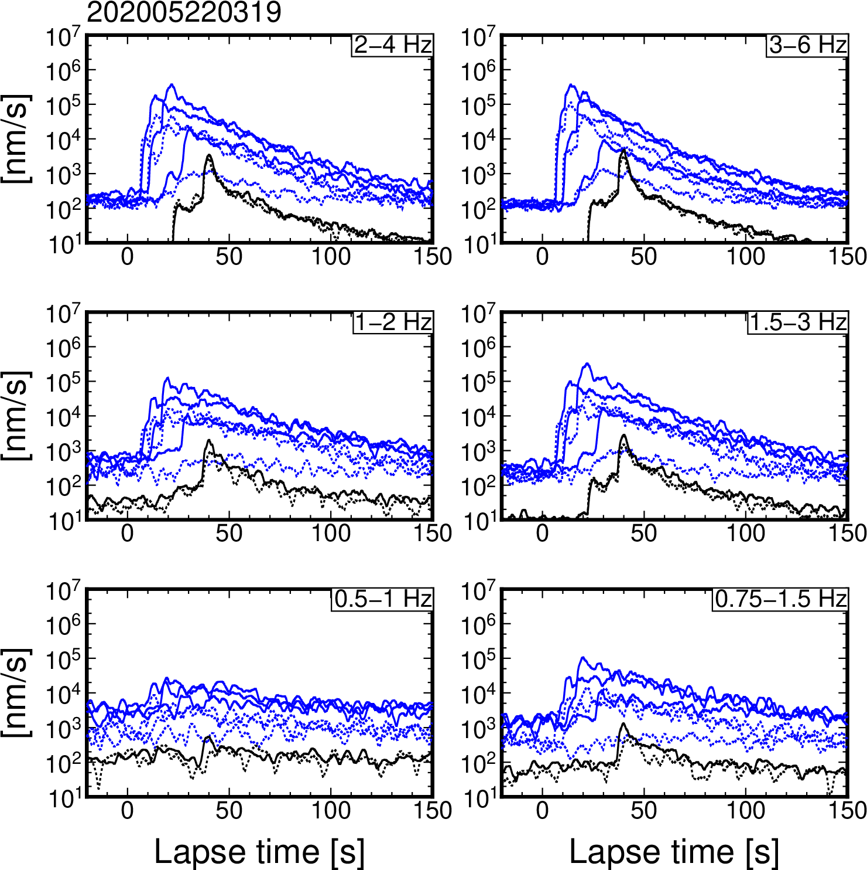
Figure S22. Horizontal and vertical envelopes at DONET and F-net stations for an earthquake that occurred at 3:19 on 22 May 2020 (JST).

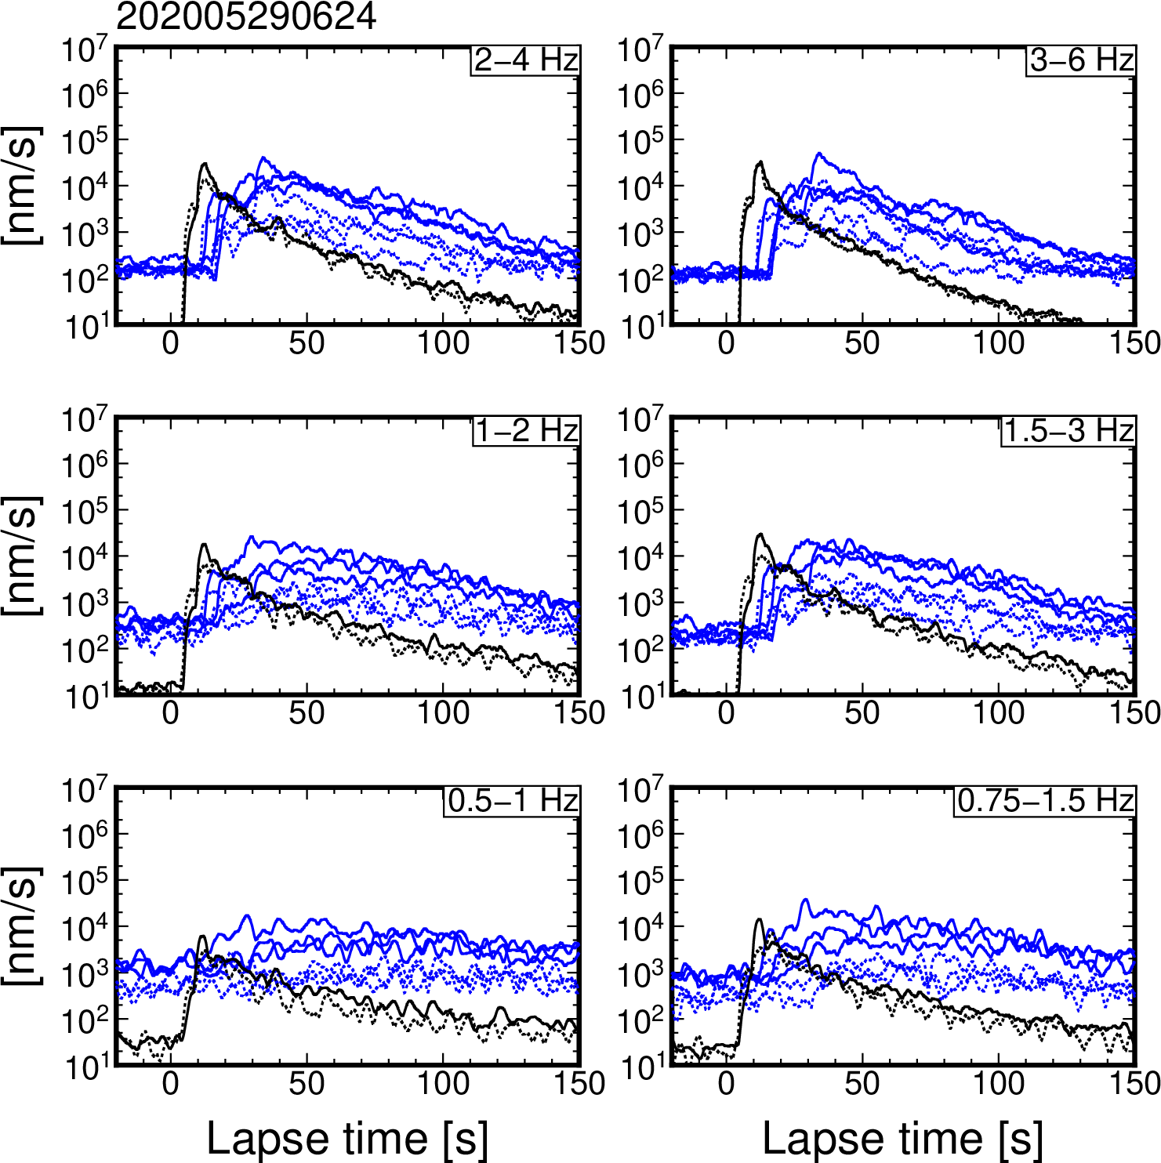
Figure S23. Horizontal and vertical envelopes at DONET and F-net stations for an earthquake that occurred at 6:24 on 29 May 2020 (JST).

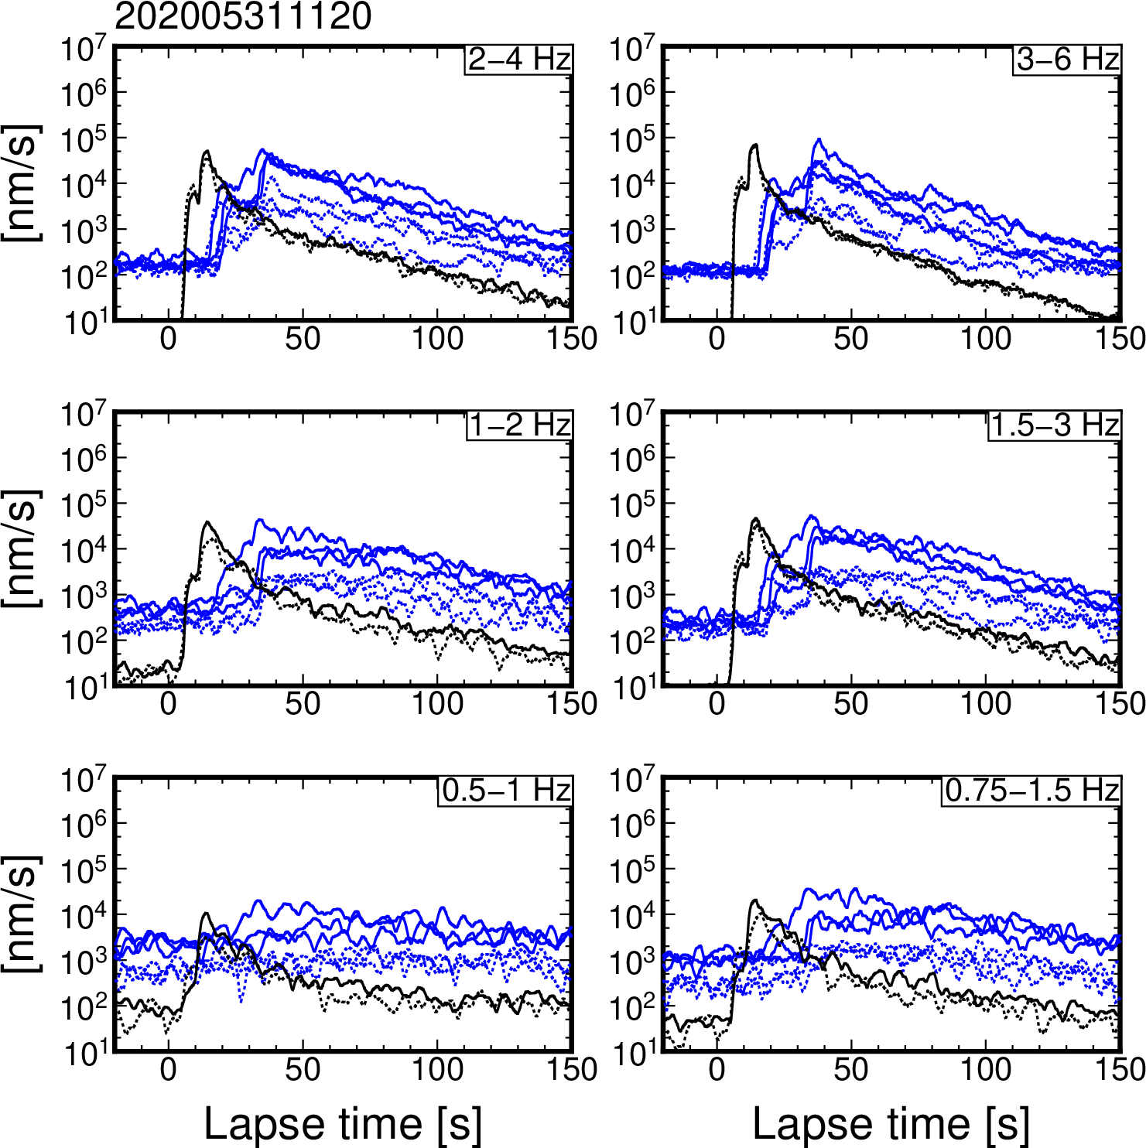
Figure S24. Horizontal and vertical envelopes at DONET and F-net stations for an earthquake that occurred at 11:20 on 31 May 2020 (JST).

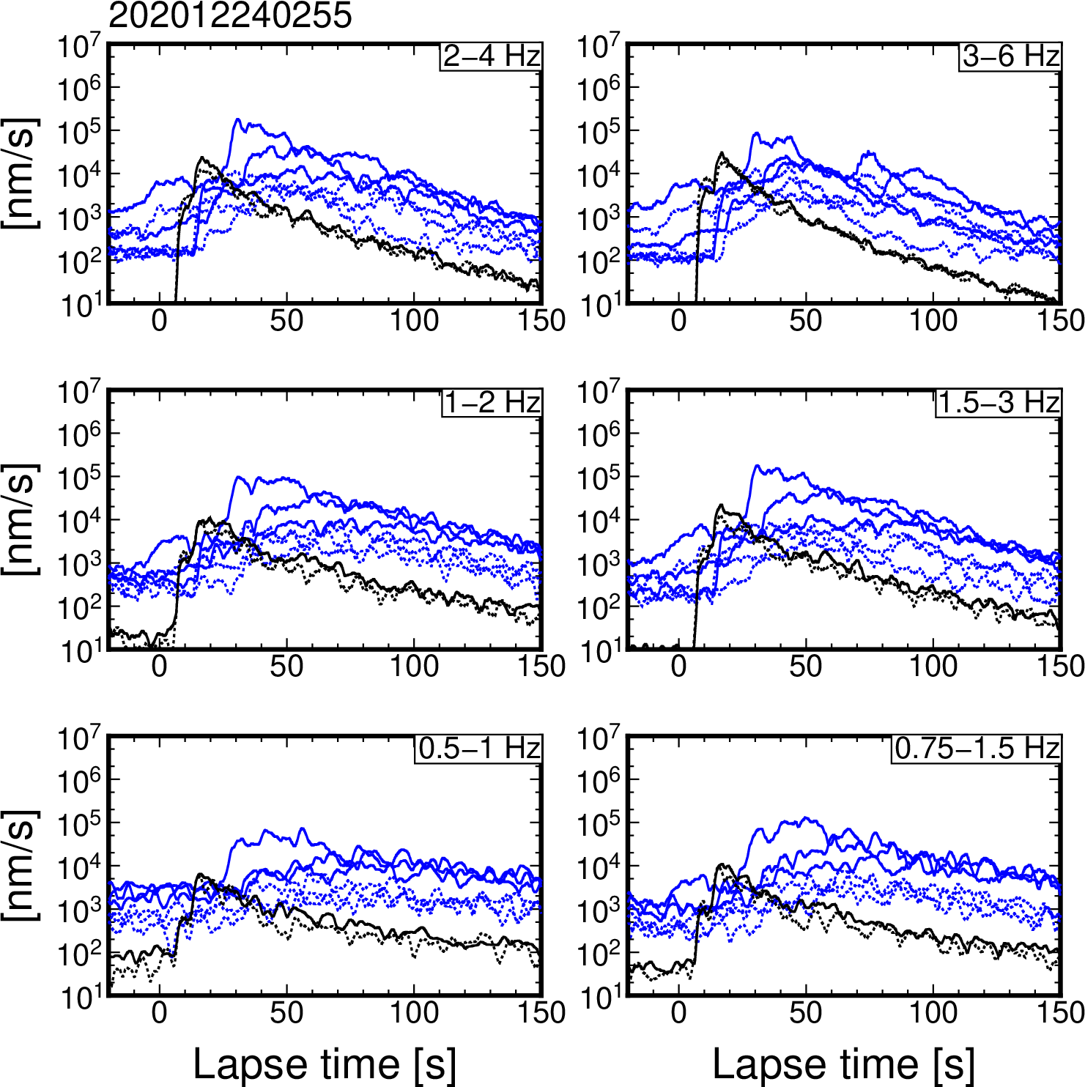
Figure S25. Horizontal and vertical envelopes at DONET and F-net stations for an earthquake that occurred at 2:55 on 24 December 2020 (JST).

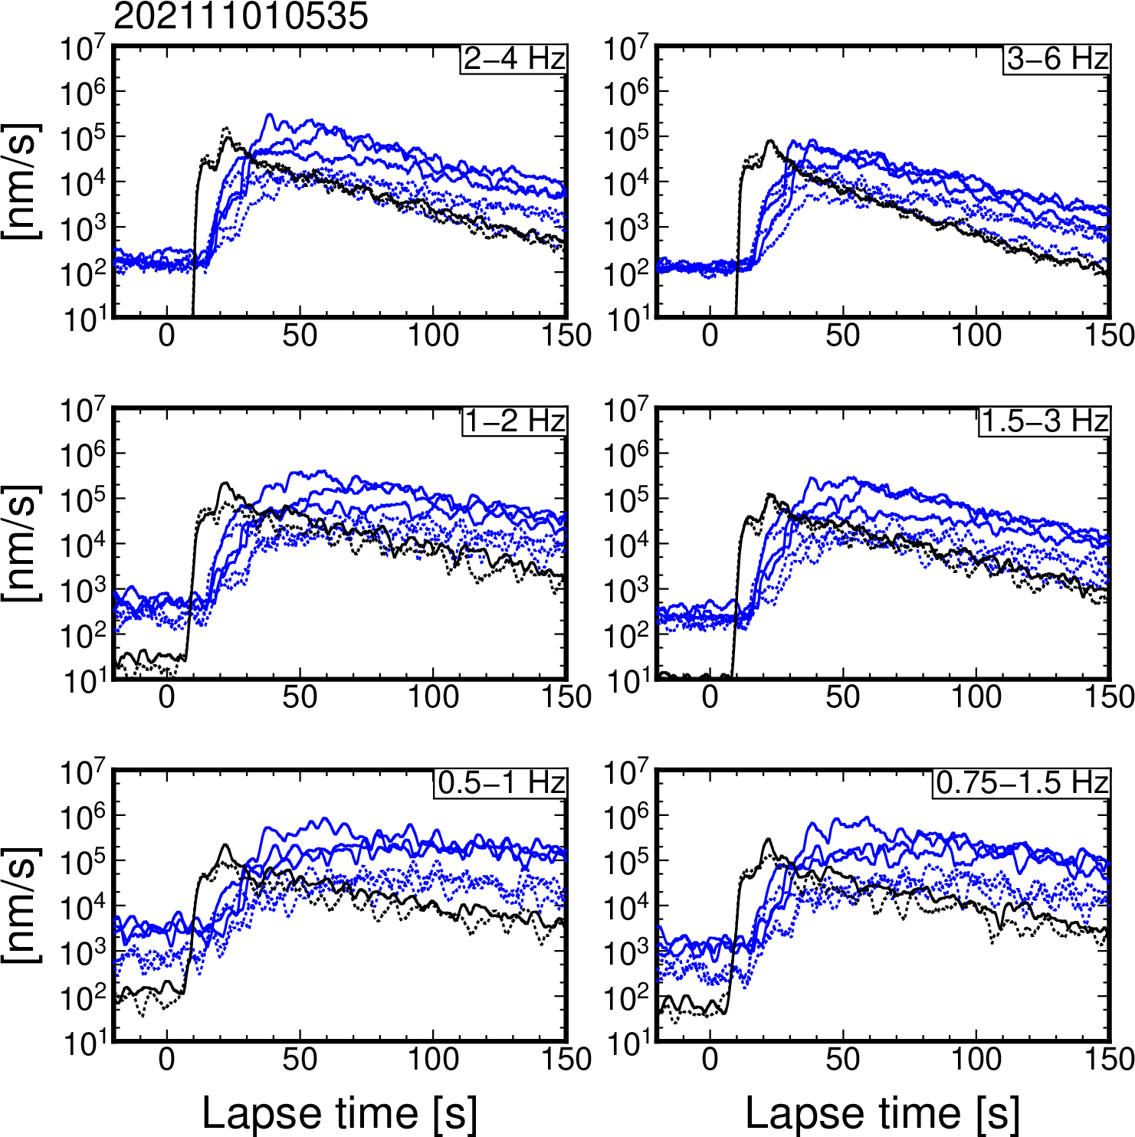
Figure S26. Horizontal and vertical envelopes at DONET and F-net stations for an earthquake that occurred at 5:35 on 1 October 2021 (JST).

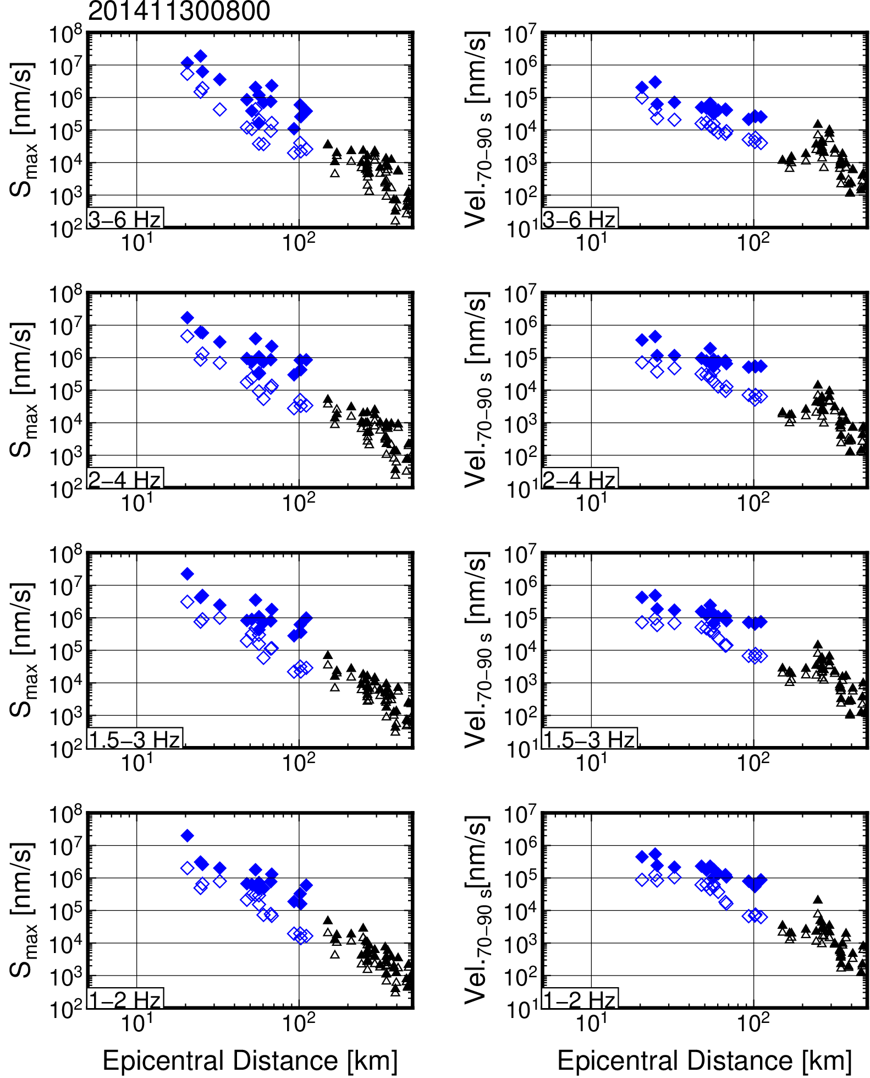
Figure S27. Frequency-dependent S_{max} and S-coda wave amplitude attenuations for an earthquake that occurred at 8:00 on 30 November 2014 (JST).

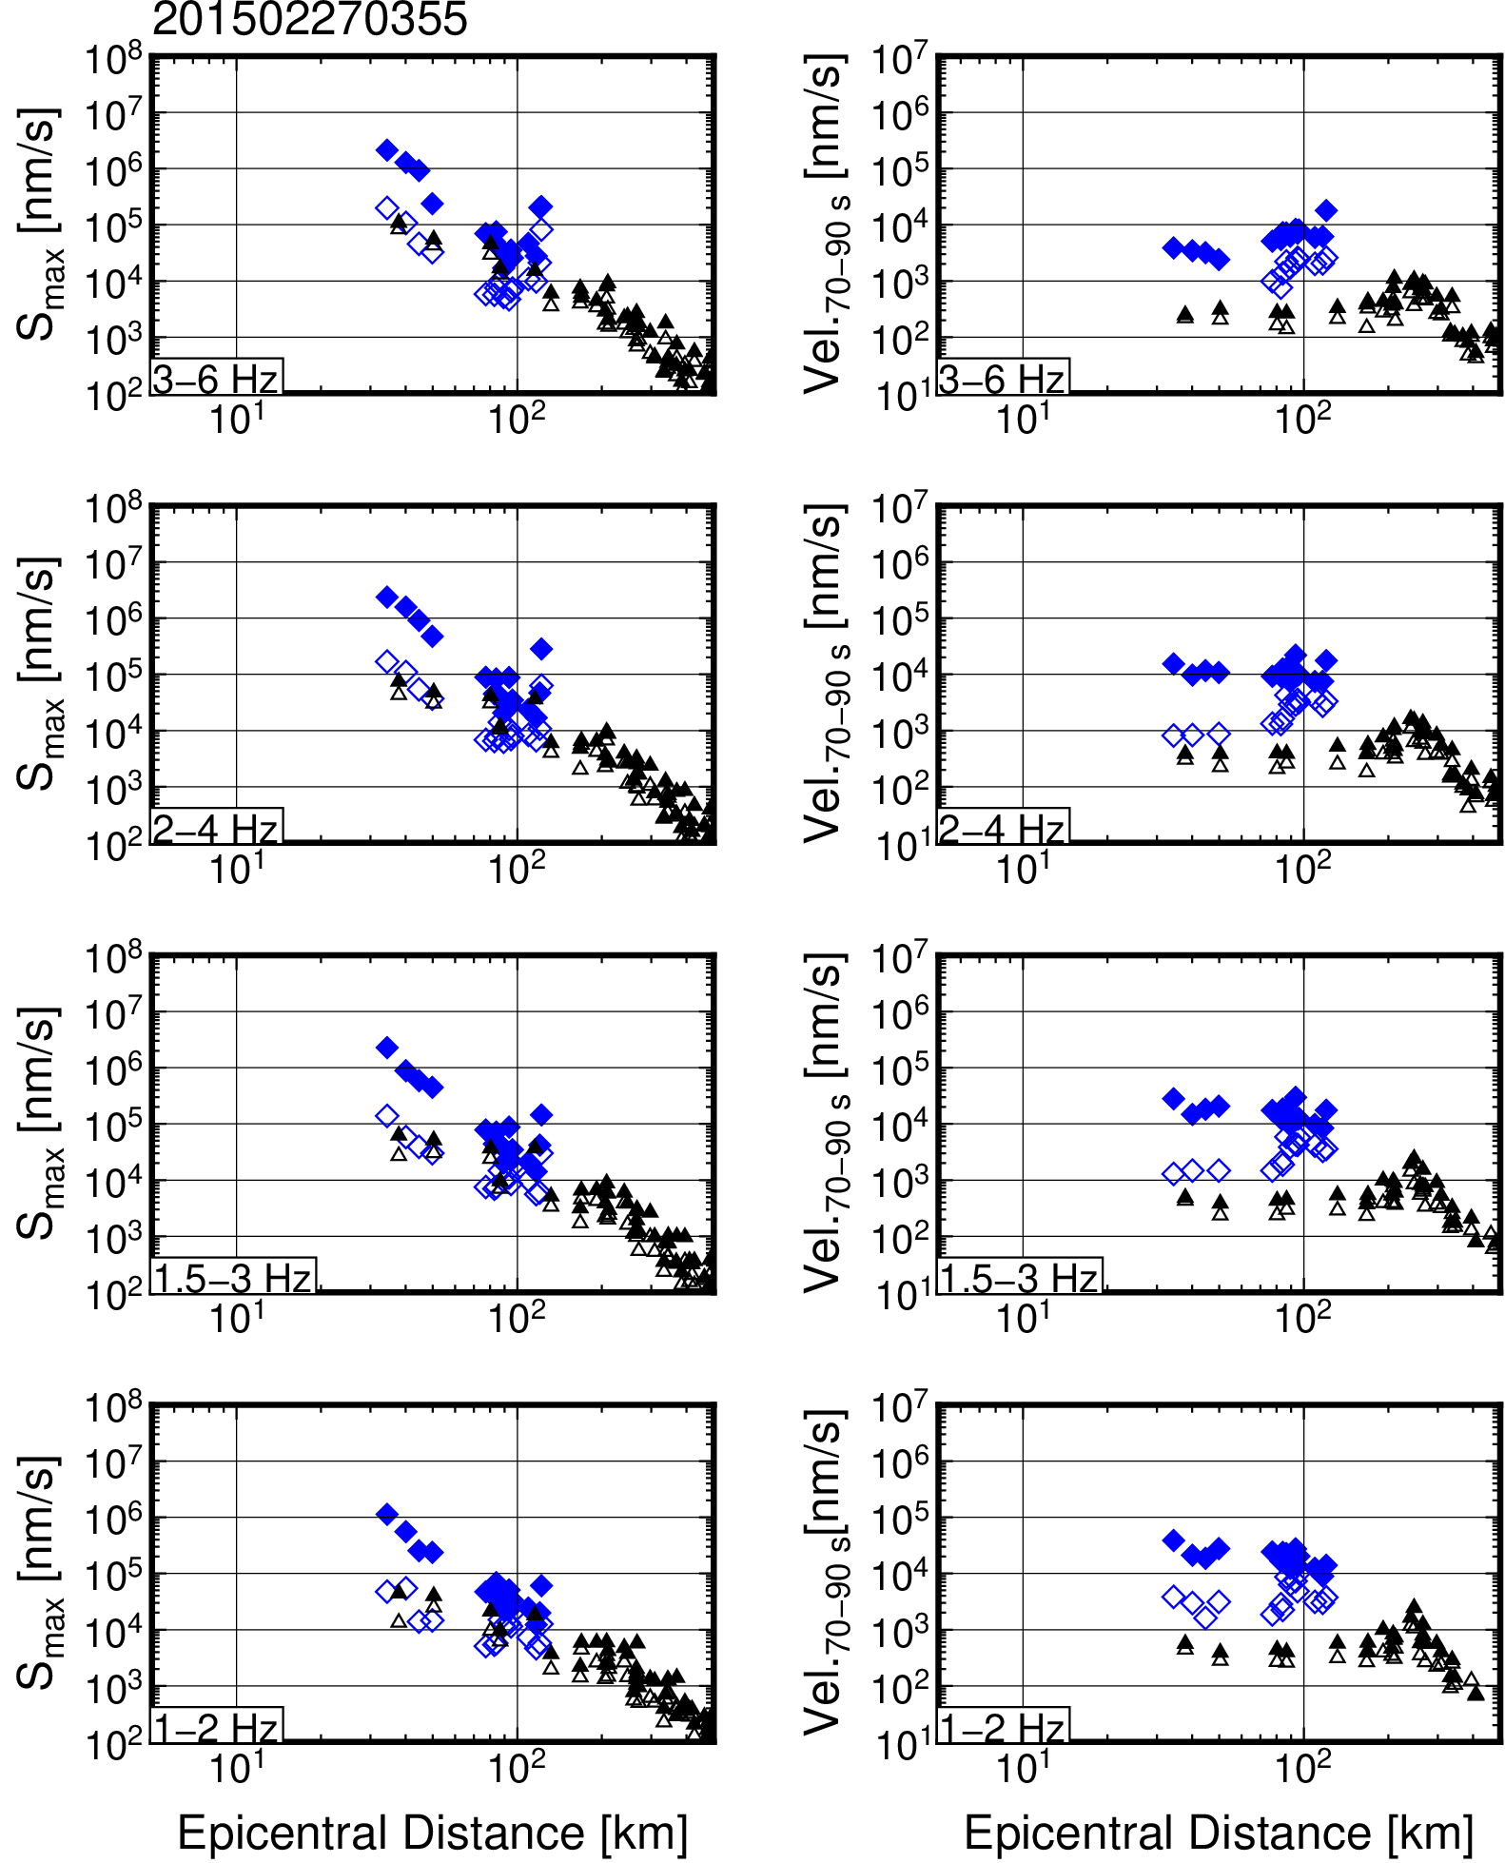
Figure S28. Frequency-dependent S_{max} and S-coda wave amplitude attenuations for an earthquake that occurred at 3:55 on 27 February 2015 (JST).

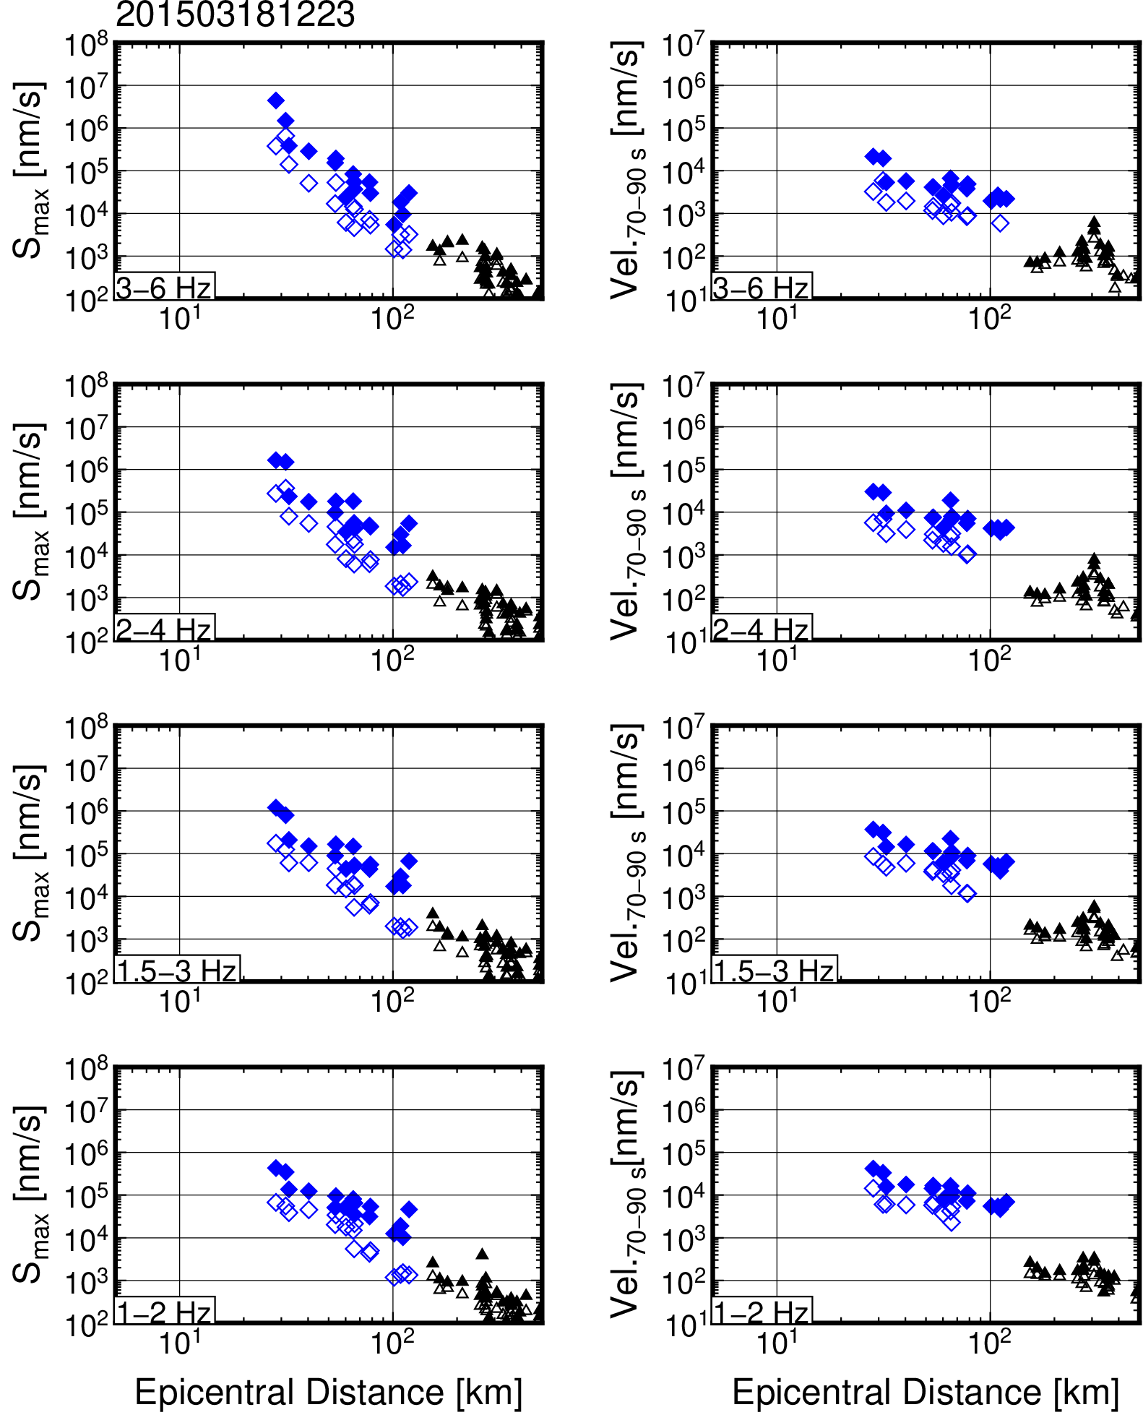
Figure S29. Frequency-dependent S_{max} and S-coda wave amplitude attenuations for an earthquake that occurred at 12:23 on 18 March 2015 (JST).

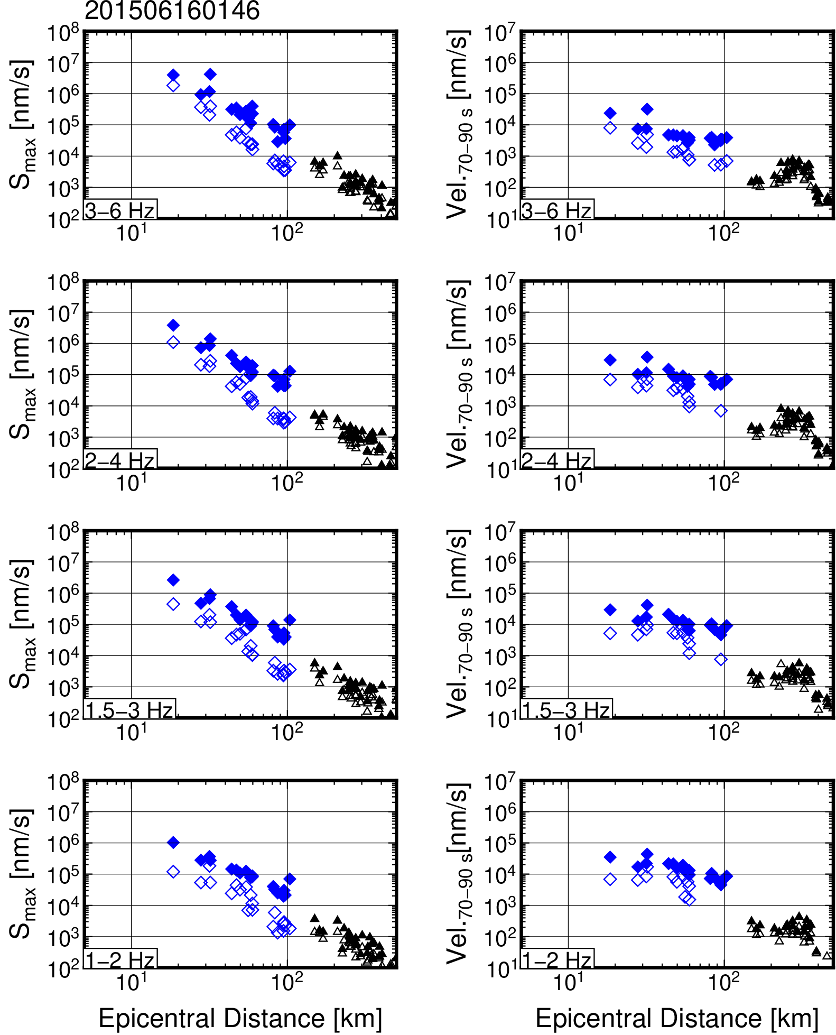
Figure S30. Frequency-dependent S_{max} and S-coda wave amplitude attenuations for an earthquake that occurred at 1:46 on 16 June 2015 (JST).

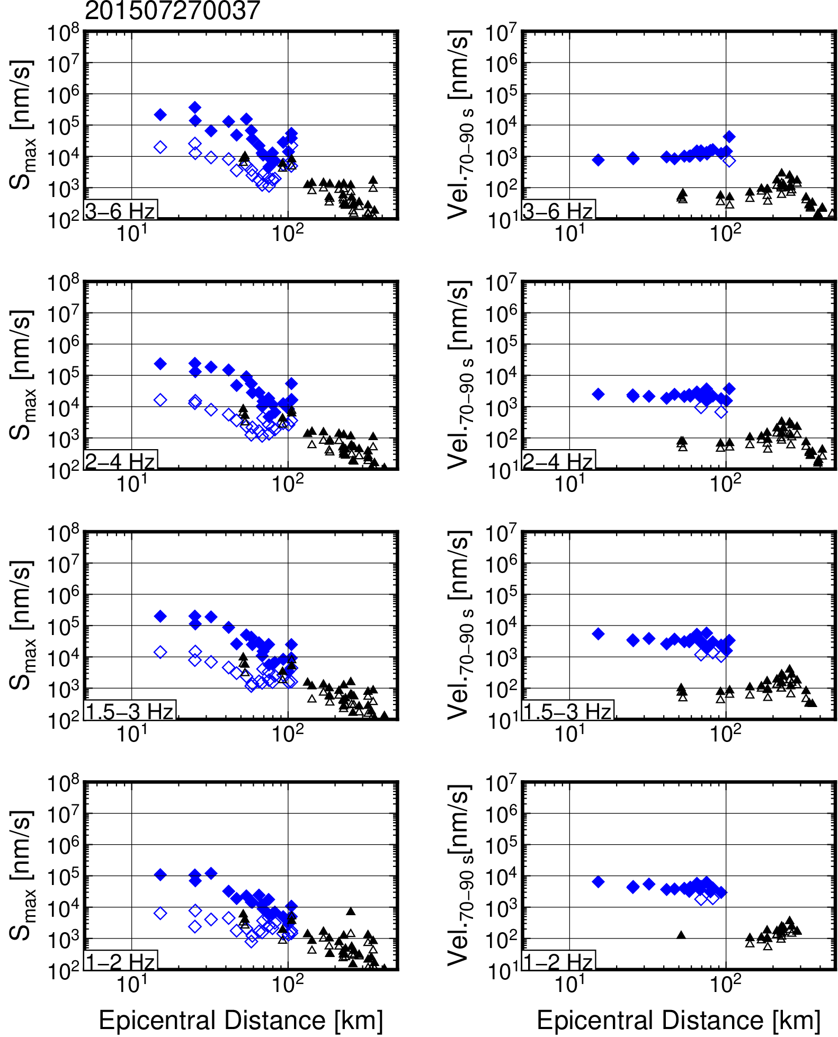
Figure S31. Frequency-dependent S_{max} and S-coda wave amplitude attenuations for an earthquake that occurred at 00:37 on 27 July 2015 (JST).

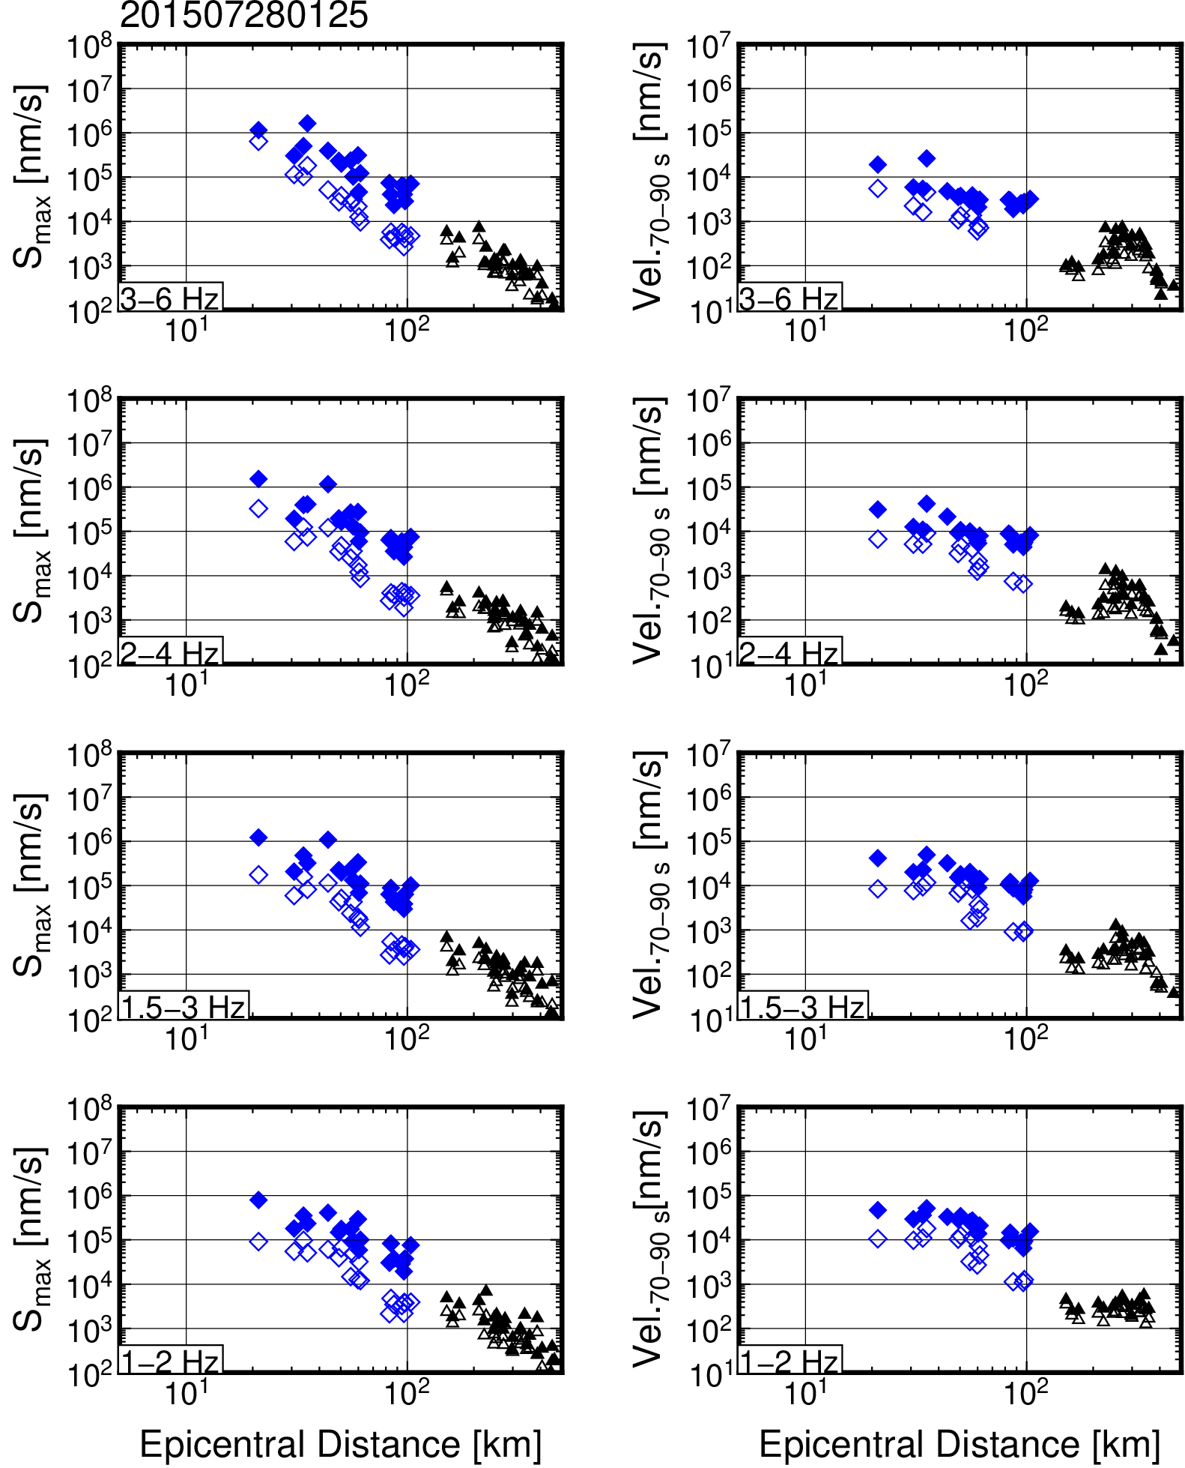
Figure S32. Frequency-dependent S_{max} and S-coda wave amplitude attenuations for an earthquake that occurred at 1:25 on 28 July 2015 (JST).

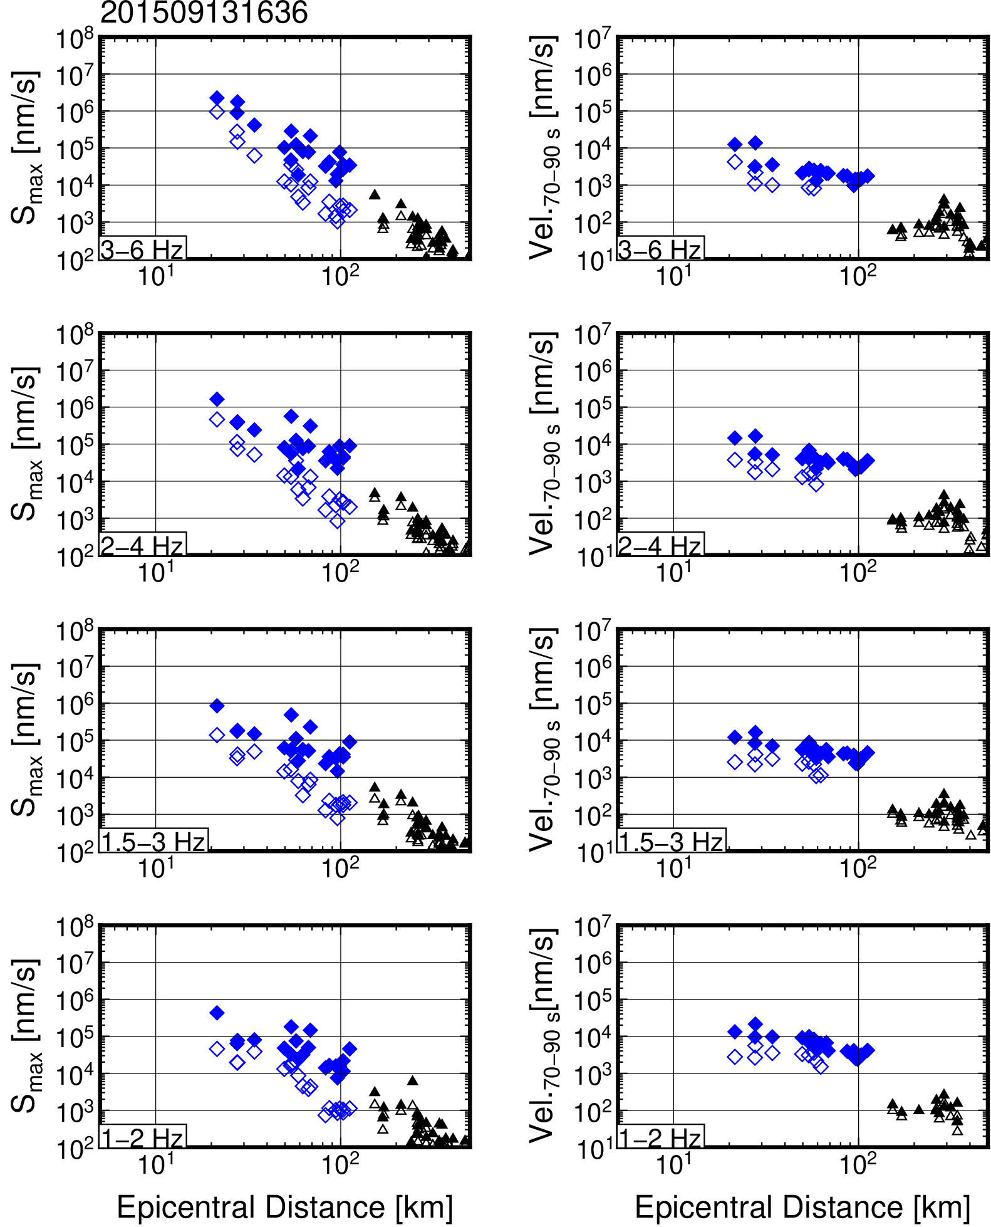
Figure S33. Frequency-dependent S_{max} and S-coda wave amplitude attenuations for an earthquake that occurred at 16:36 on 13 September 2015 (JST).

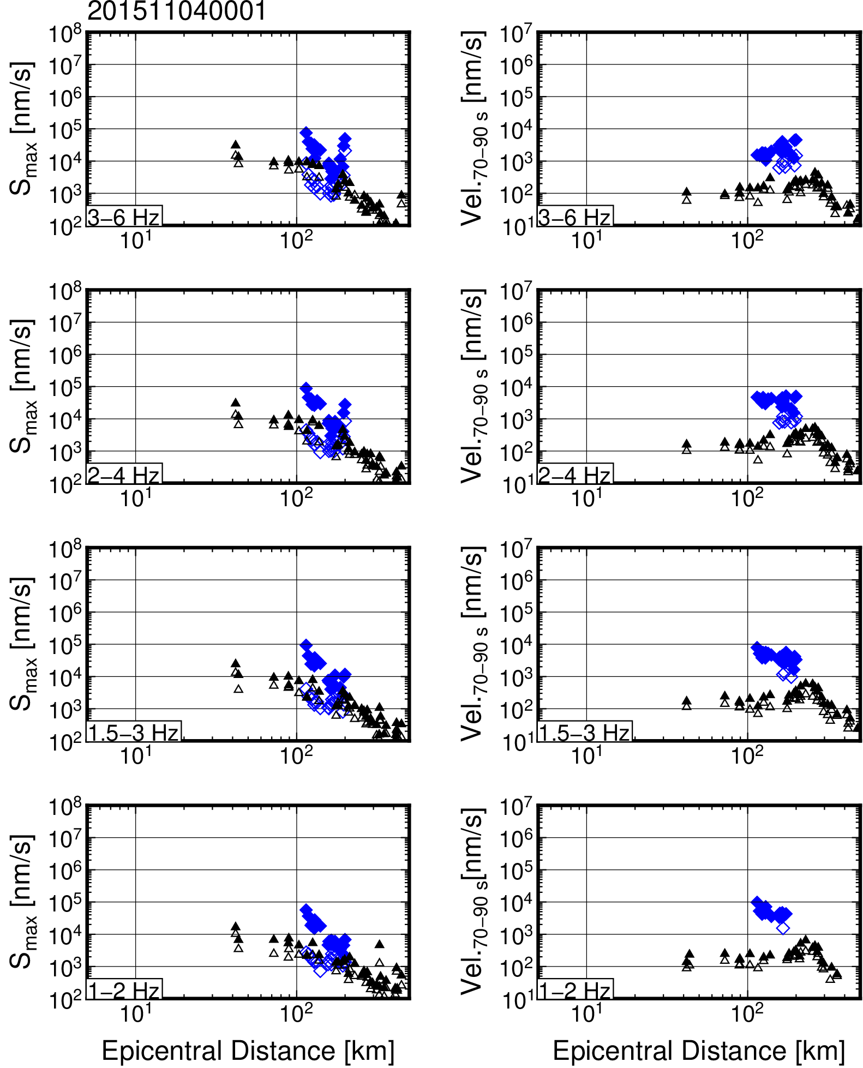
Figure S34. Frequency-dependent S_{max} and S-coda wave amplitude attenuations for an earthquake that occurred at 00:01 on 4 November 2015 (JST).

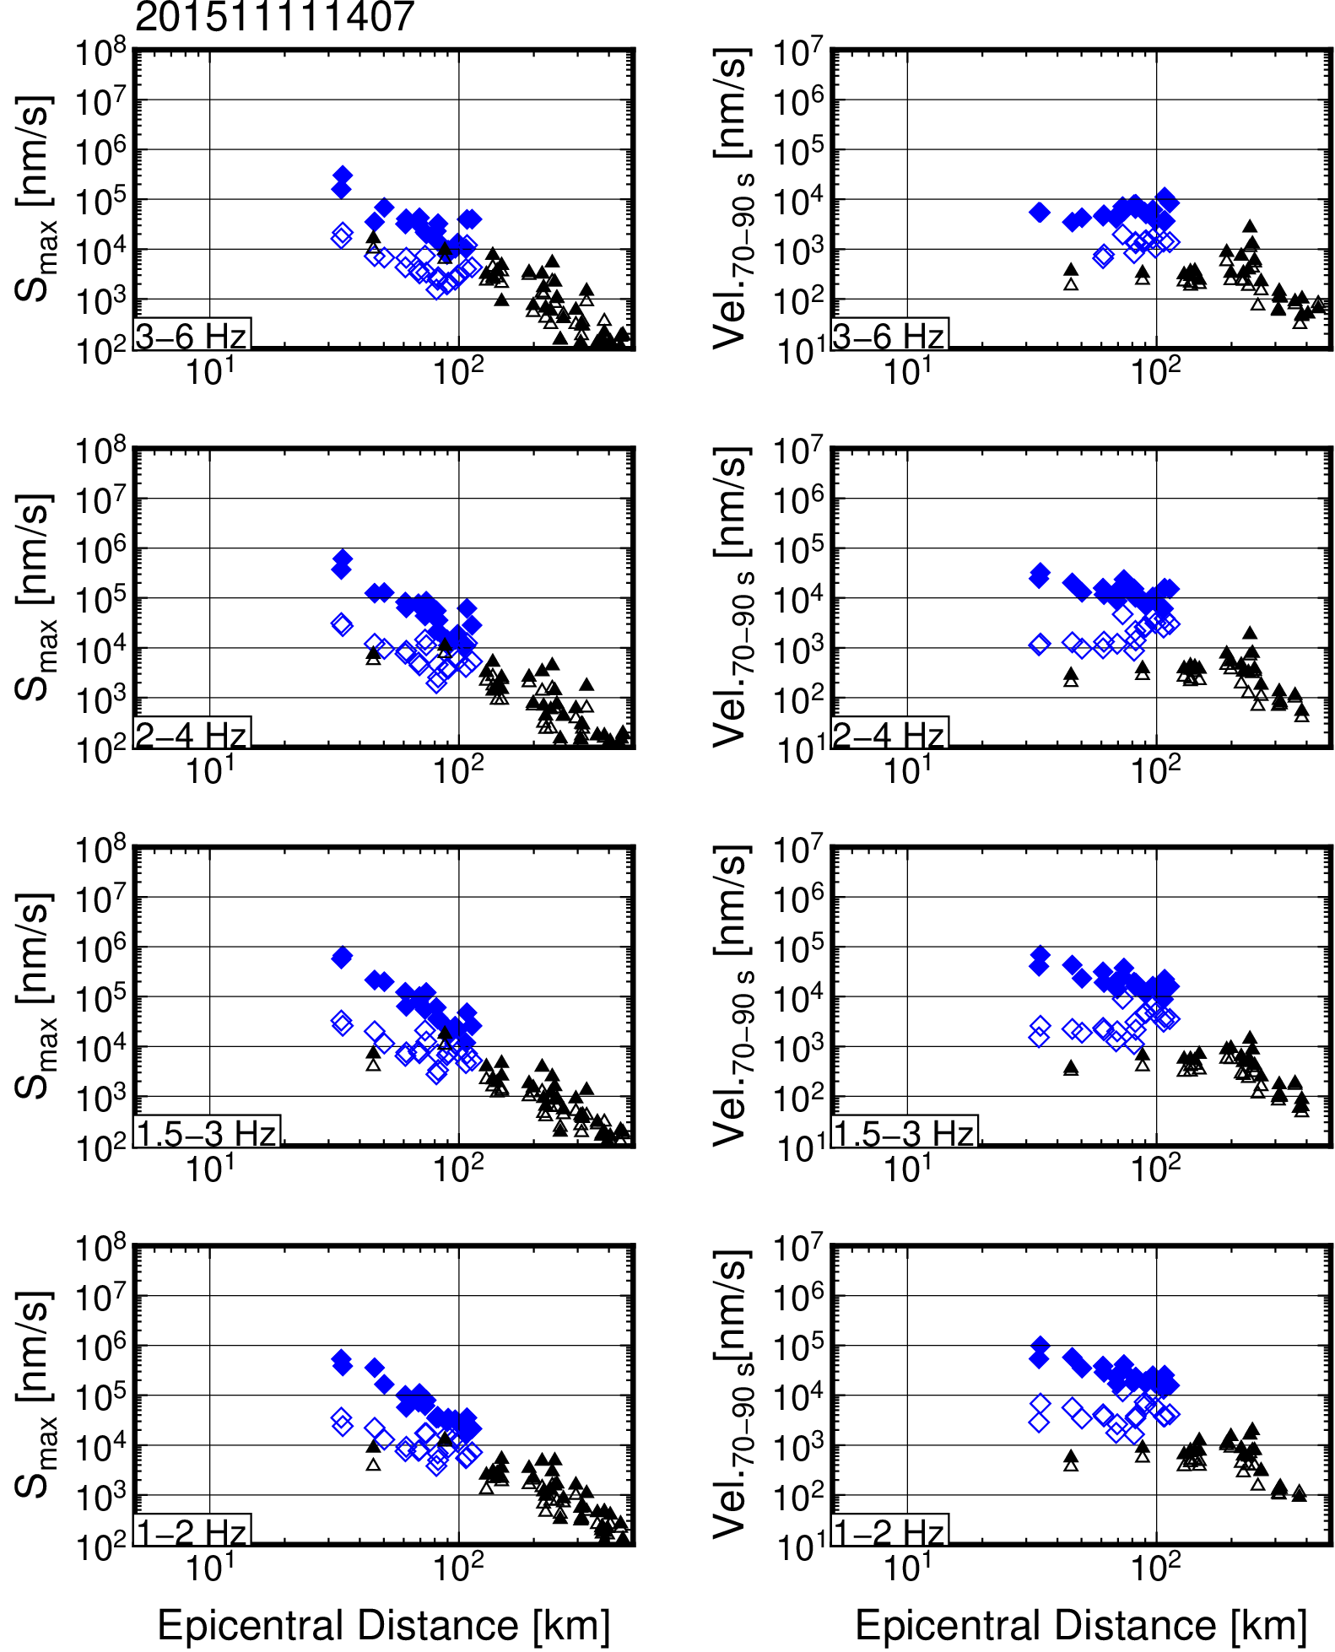
Figure S35. Frequency-dependent S_{max} and S-coda wave amplitude attenuations for an earthquake that occurred at 14:07 on 11 November 2015 (JST).

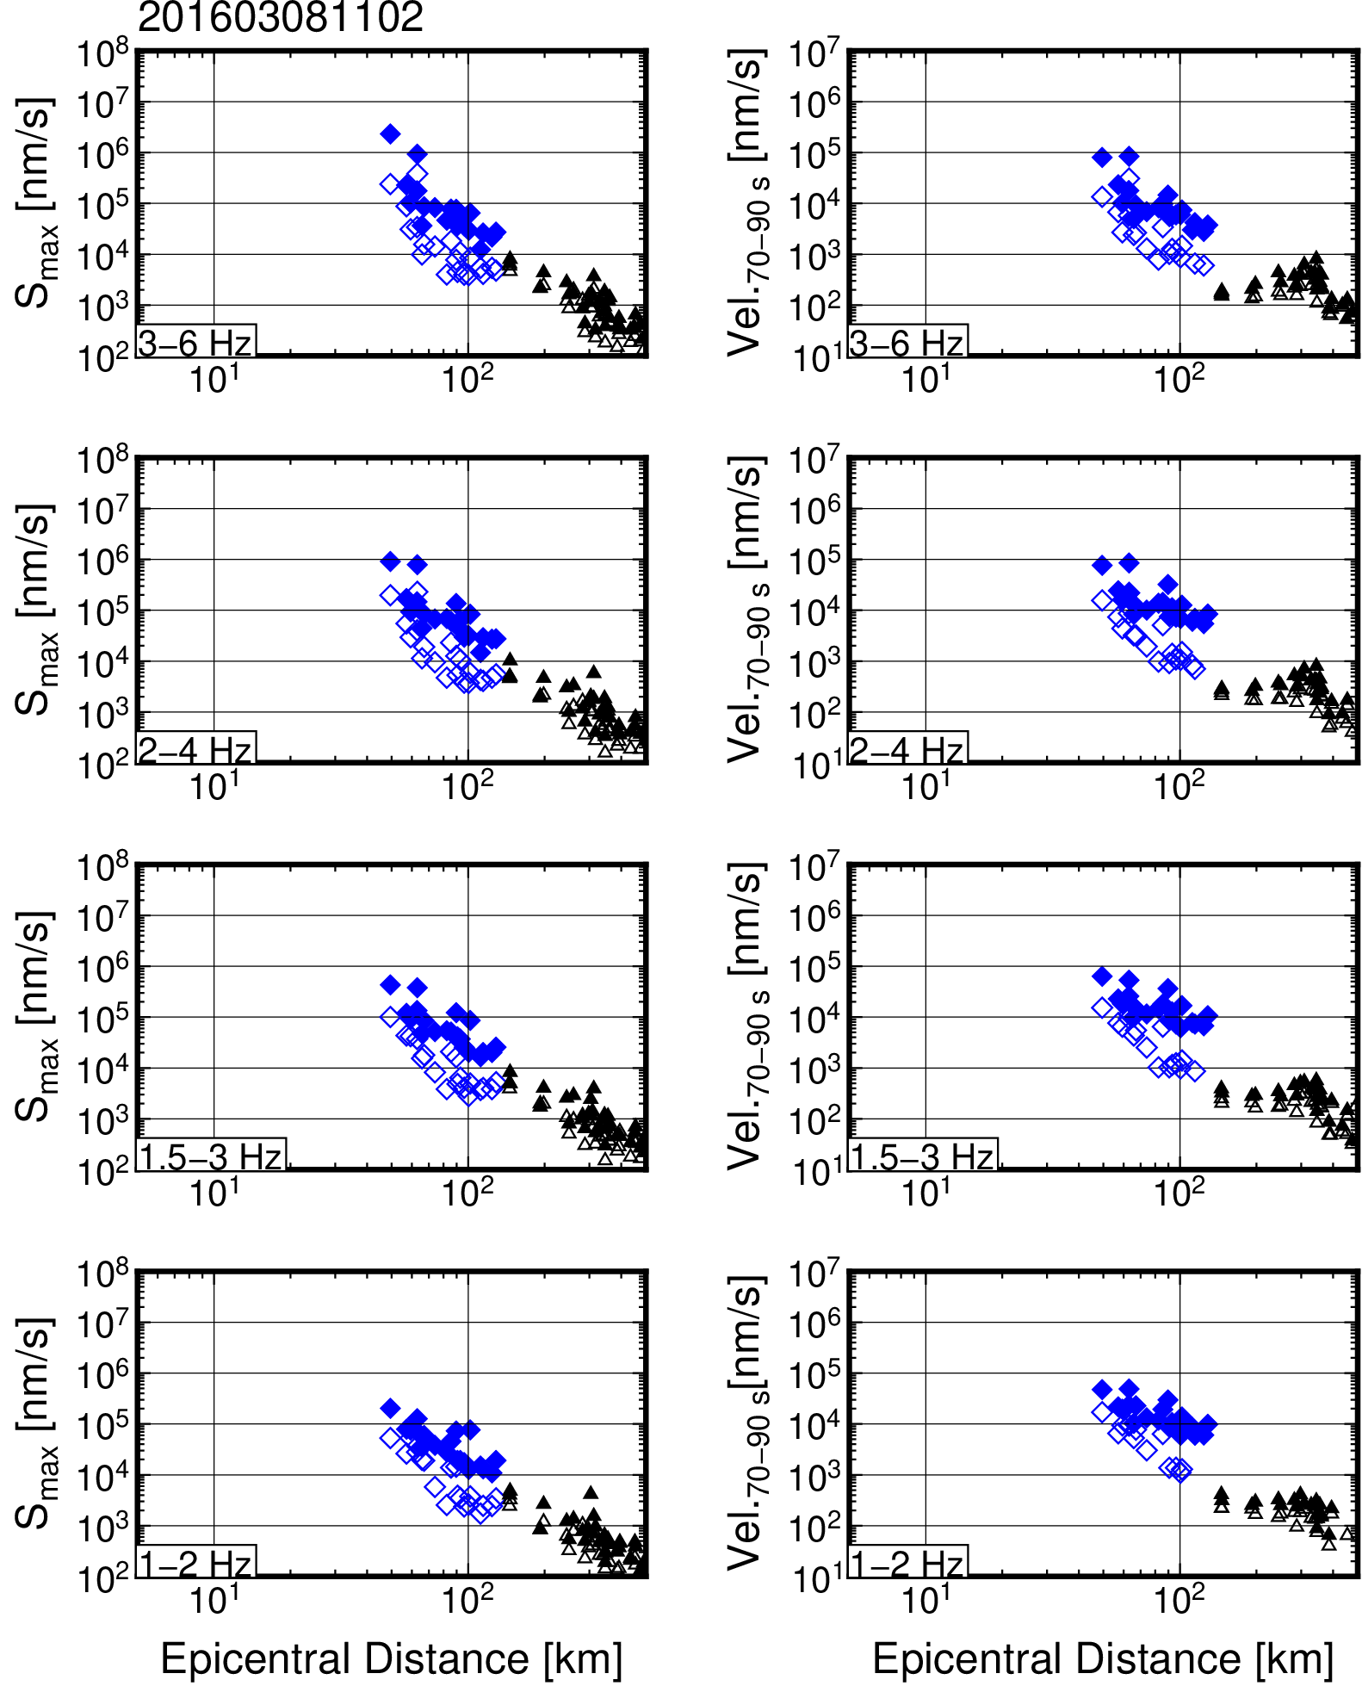
Figure S36. Frequency-dependent S_{max} and S-coda wave amplitude attenuations for an earthquake that occurred at 11:02 on 8 March 2016 (JST).

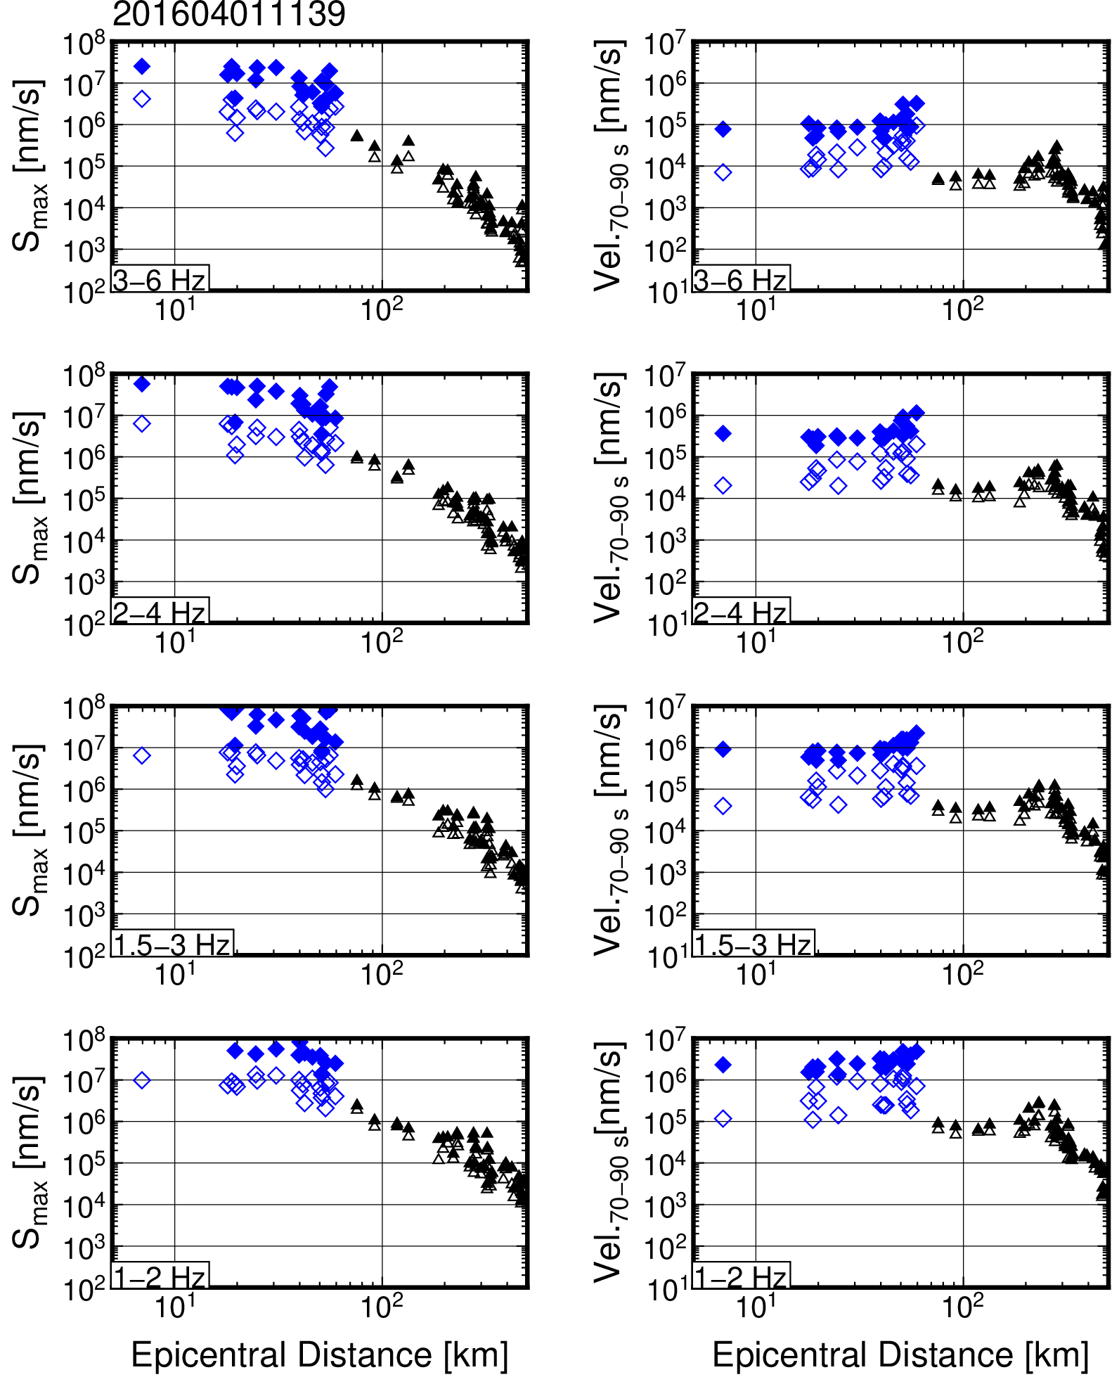
Figure S37. Frequency-dependent S_{max} and S-coda wave amplitude attenuations for an earthquake that occurred at 11:39 on 1 April 2016 (JST).

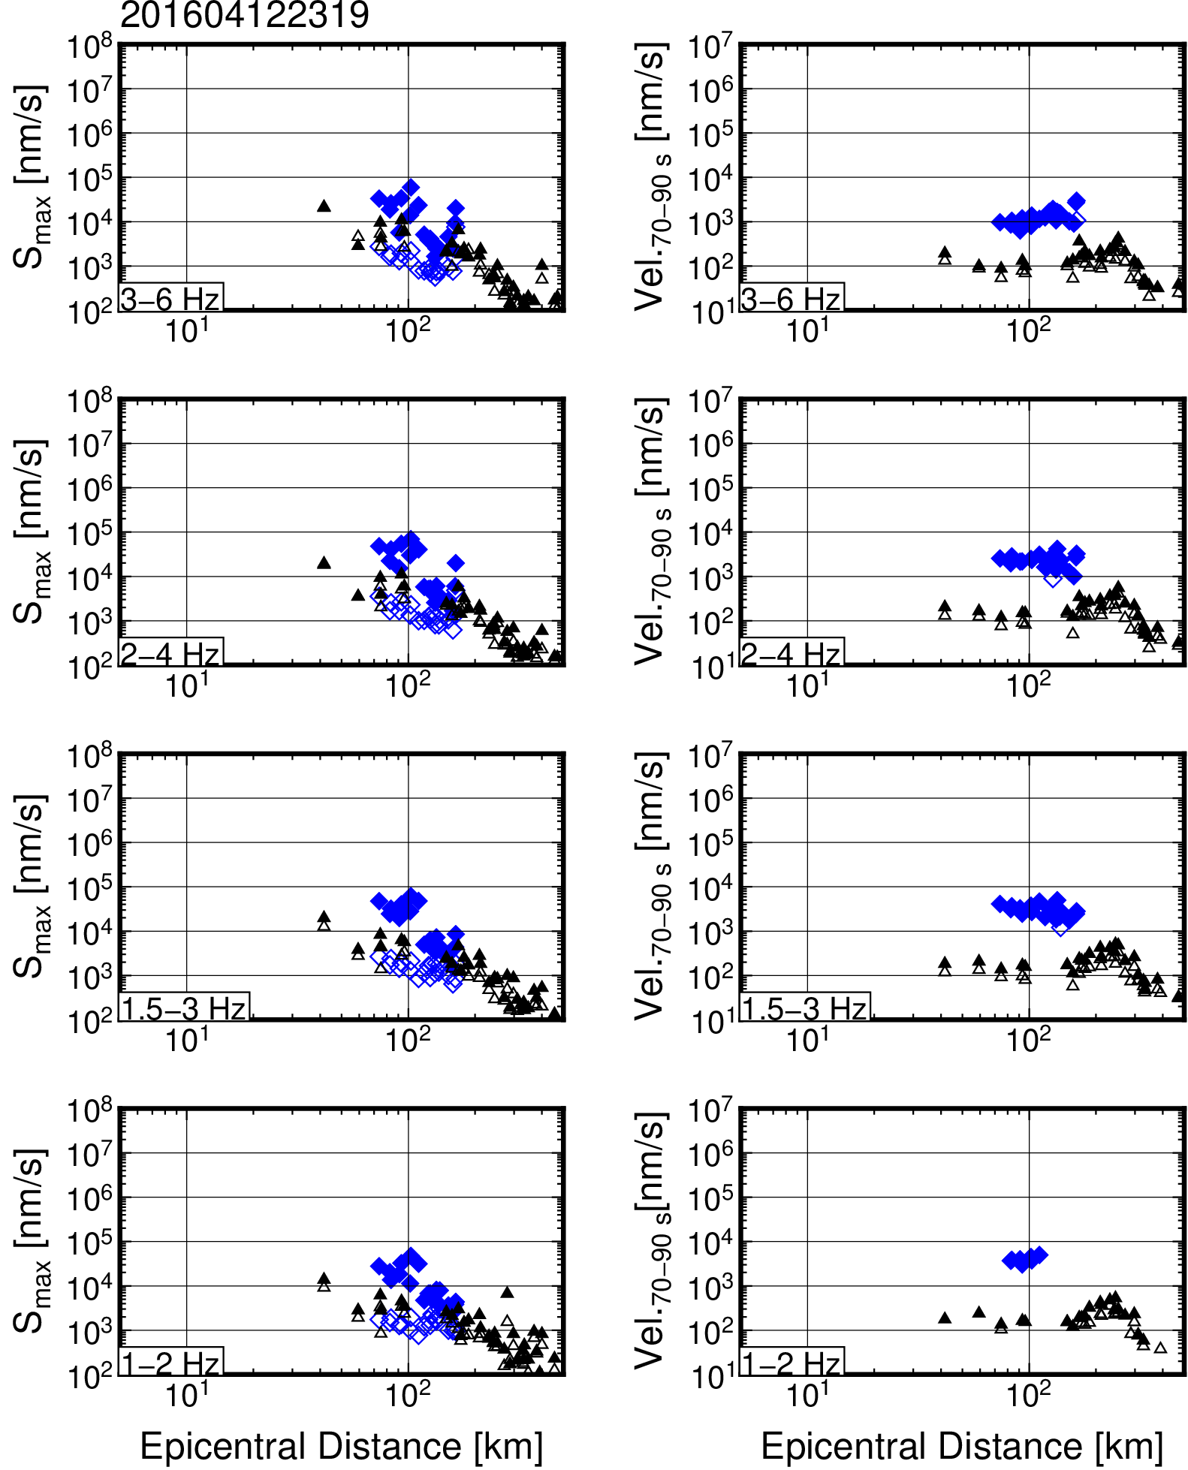
Figure S38. Frequency-dependent S_{max} and S-coda wave amplitude attenuations for an earthquake that occurred at 23:19 on 12 April 2016 (JST).

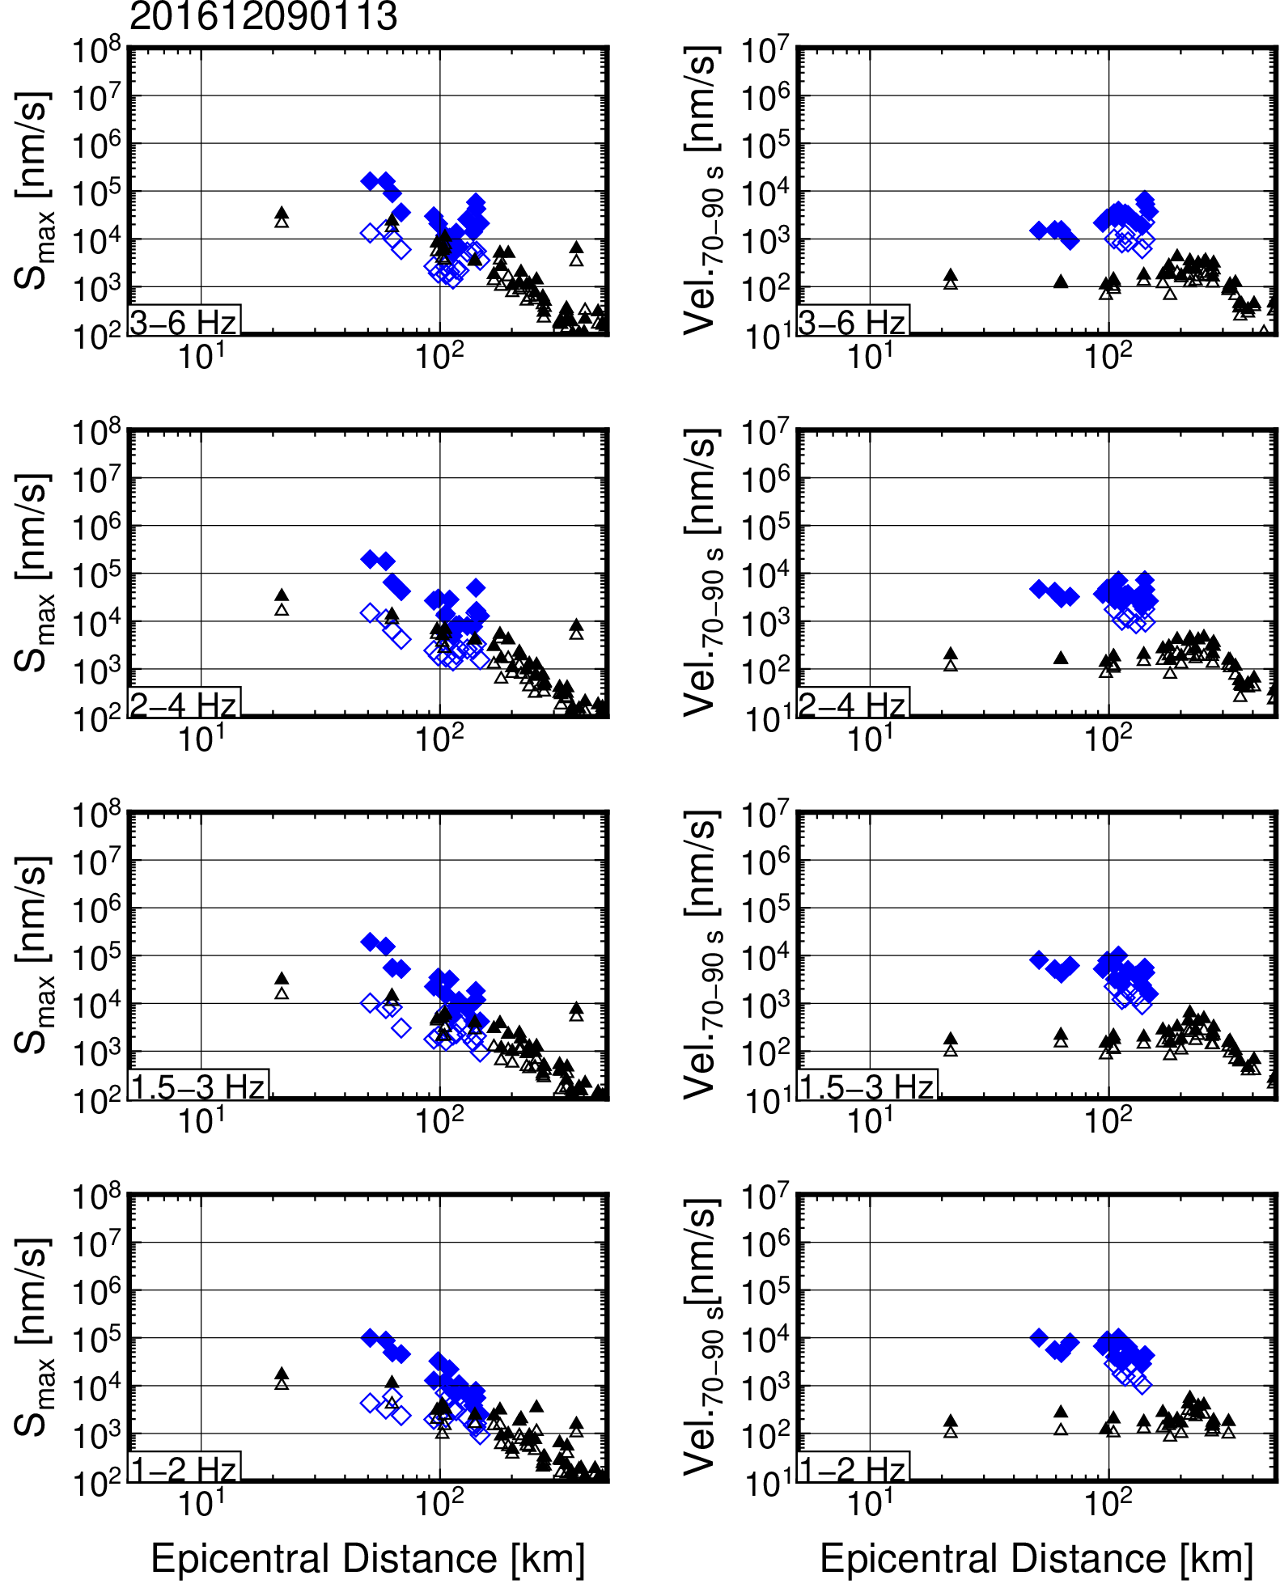
Figure S39. Frequency-dependent S_{max} and S-coda wave amplitude attenuations for an earthquake that occurred at 1:13 on 9 December 2016 (JST).

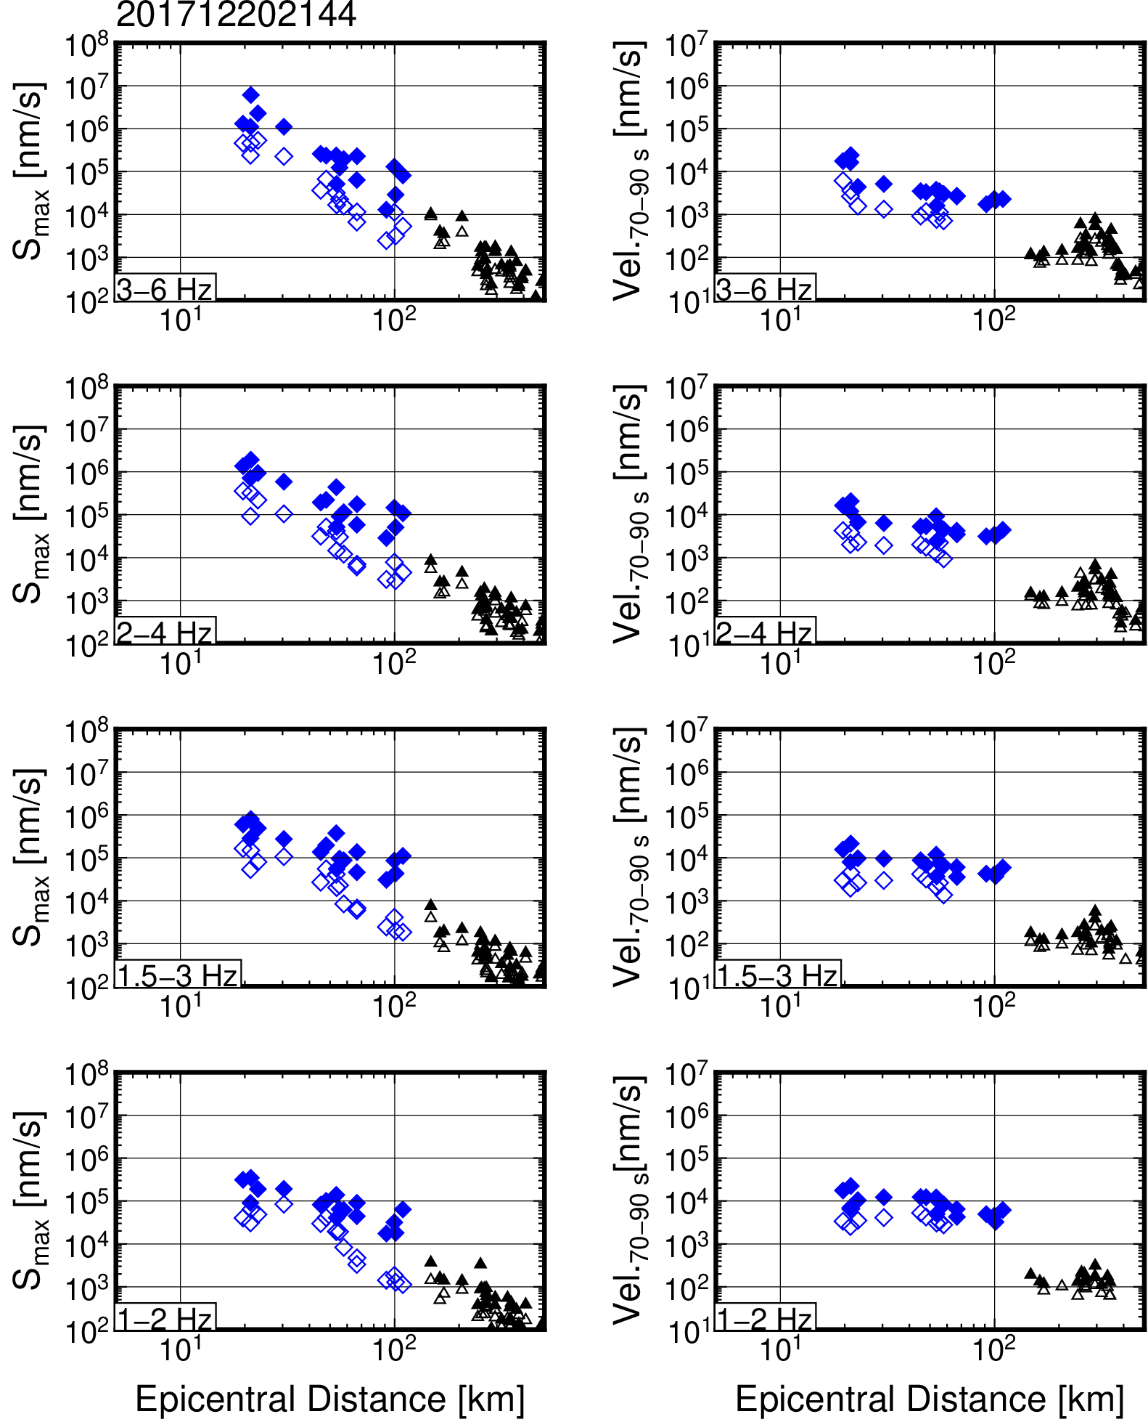
Figure S40. Frequency-dependent S_{max} and S-coda wave amplitude attenuations for an earthquake that ocurred at 21:44 on 20 December 2017 (JST).

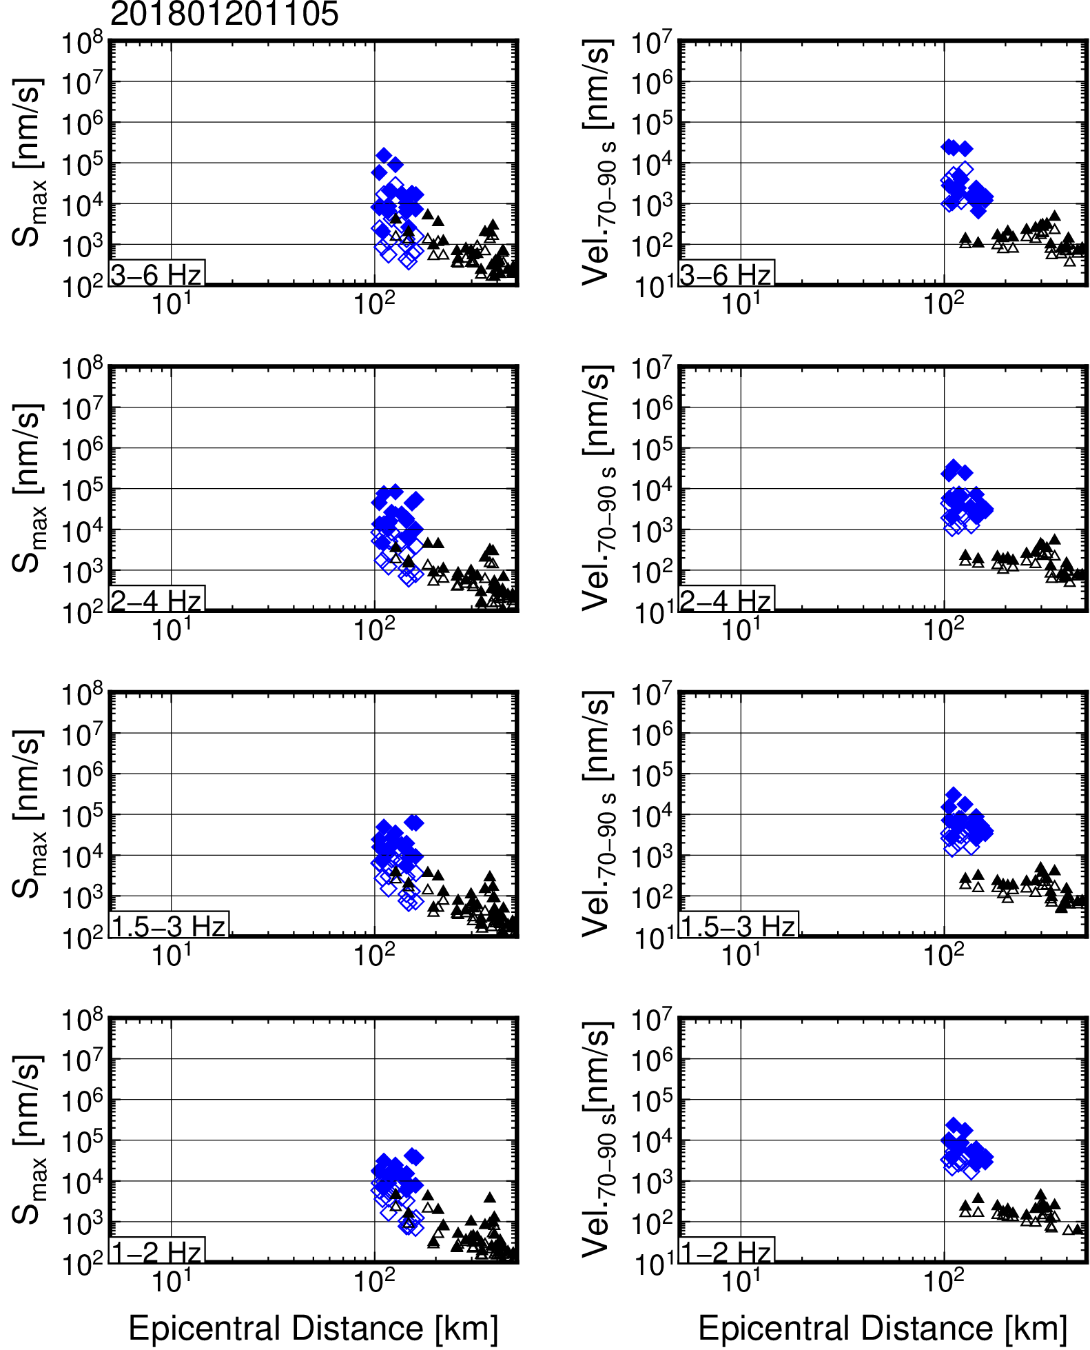
Figure S41. Frequency-dependent S_{max} and S-coda wave amplitude attenuations for an earthquake that occurred at 11:05 on 20 January 2018 (JST).

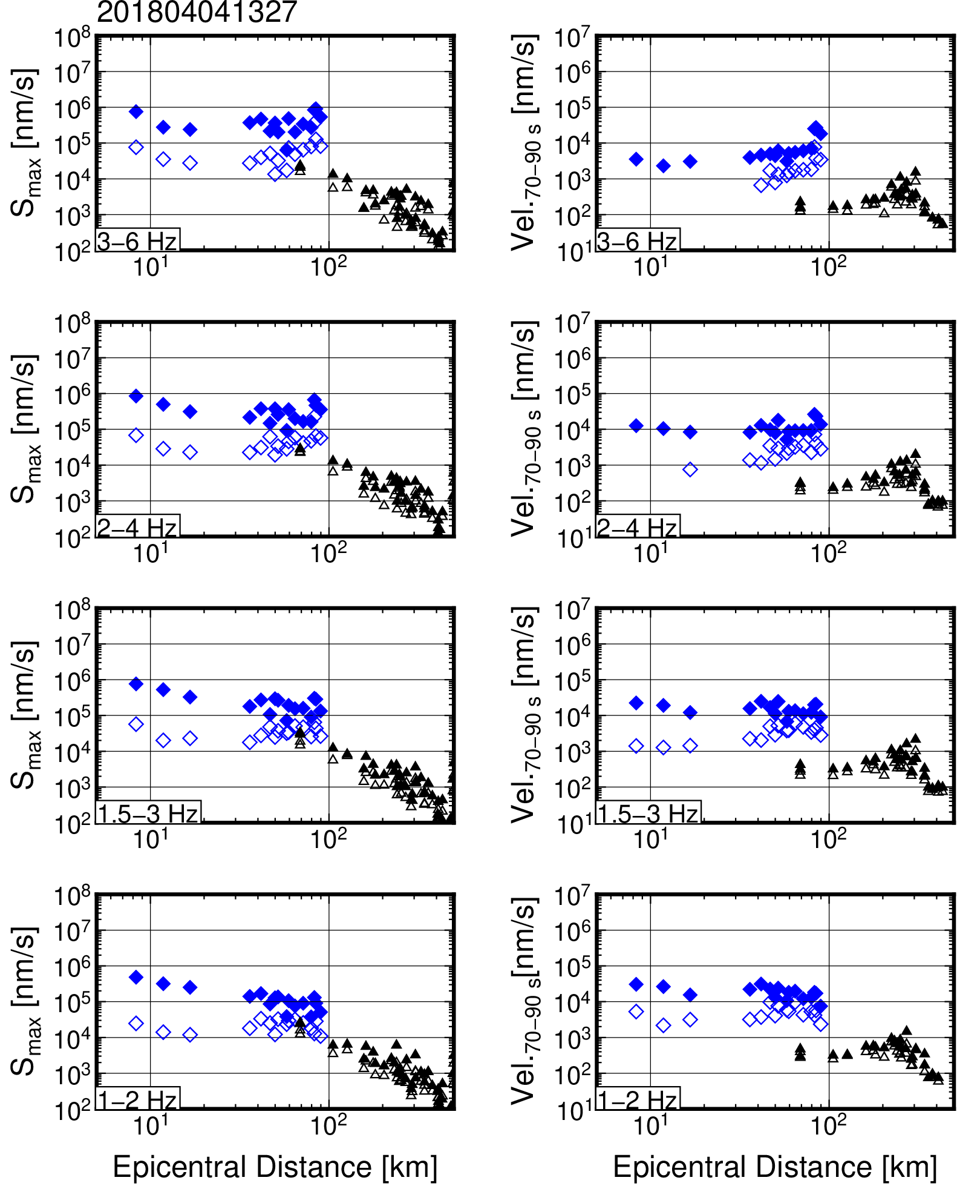
Figure S42. Frequency-dependent S_{max} and S-coda wave amplitude attenuations for an earthquake that occurred at 13:27 on 4 April 2018 (JST).

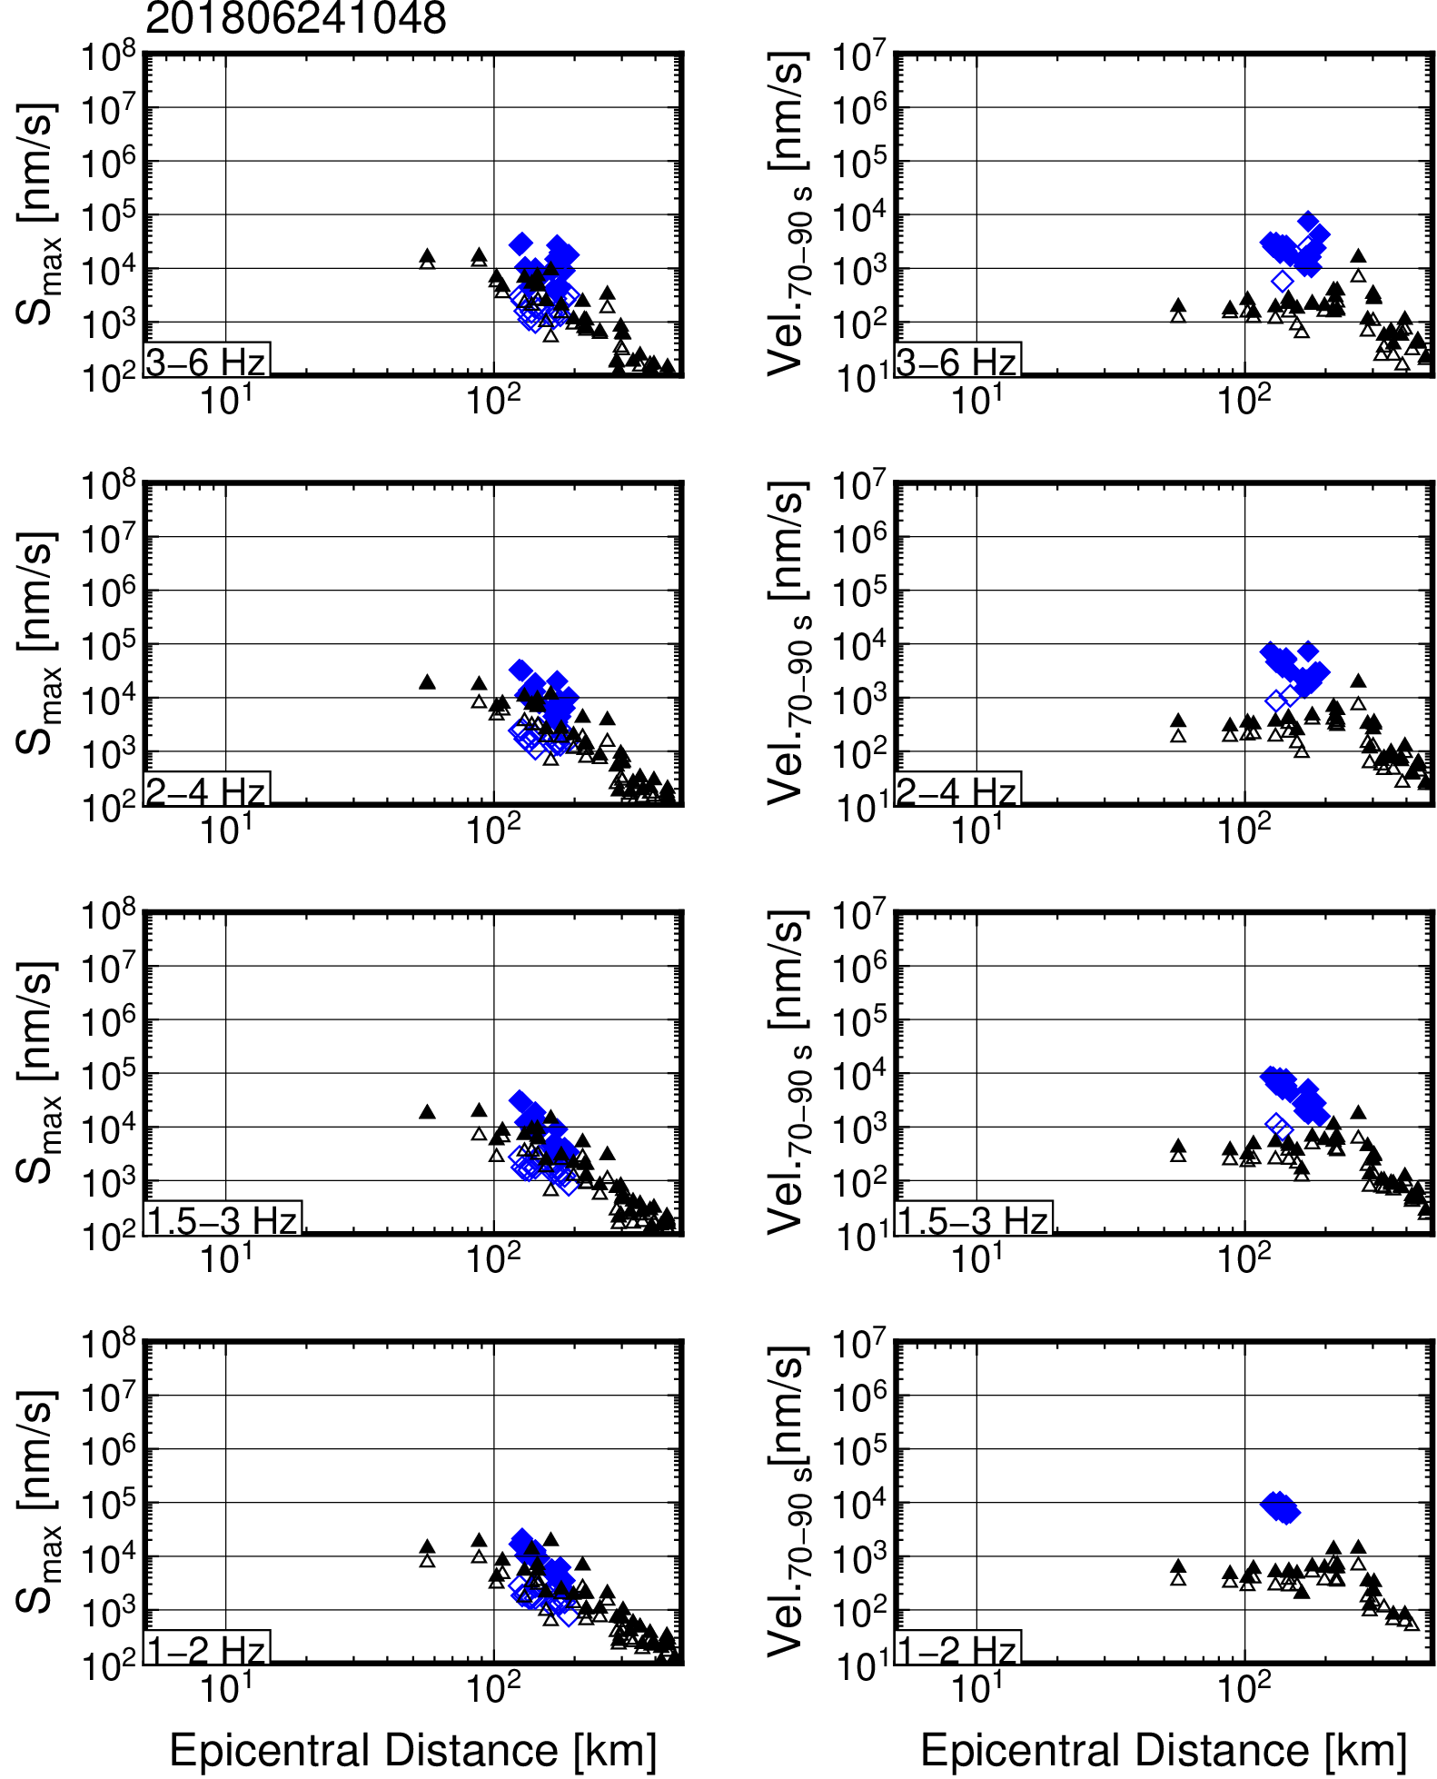
Figure S43. Frequency-dependent S_{max} and S-coda wave amplitude attenuations for an earthquake that occurred at 10:48 on 24 June 2018 (JST).

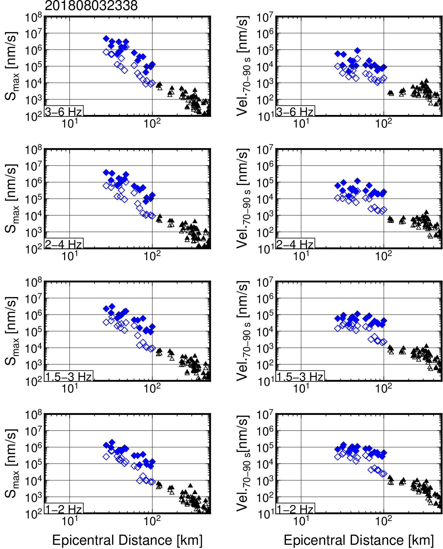
Figure S44. Frequency-dependent S_{max} and S-coda wave amplitude attenuations for an earthquake that occurred at 23:38 on 3 August 2018 (JST).

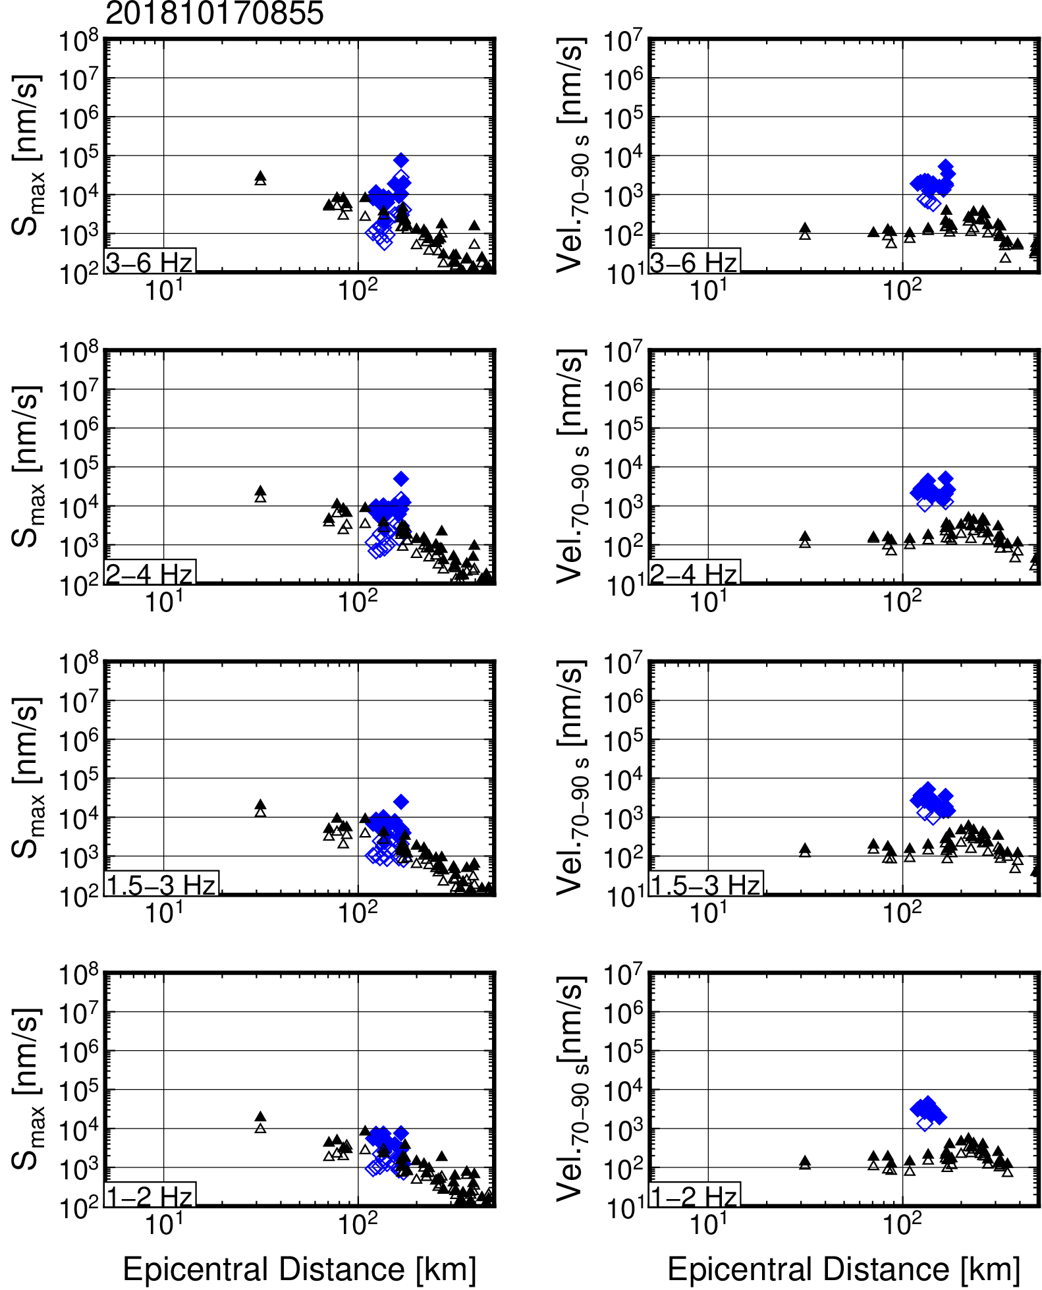
Figure S45. Frequency-dependent S_{max} and S-coda wave amplitude attenuations for an earthquake that occurred at 8:55 on 17 October 2018 (JST).

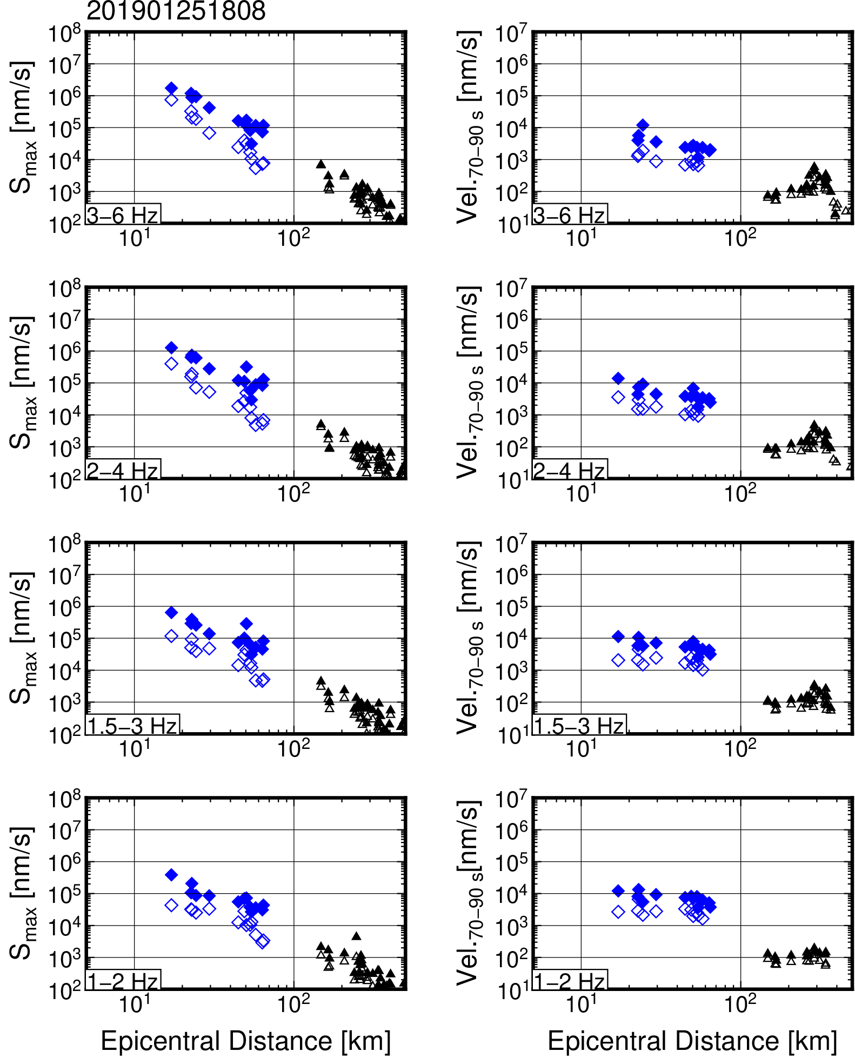
Figure S46. Frequency-dependent S_{max} and S-coda wave amplitude attenuations for an earthquake that occurred at 18:08 on 25 January 2019 (JST).

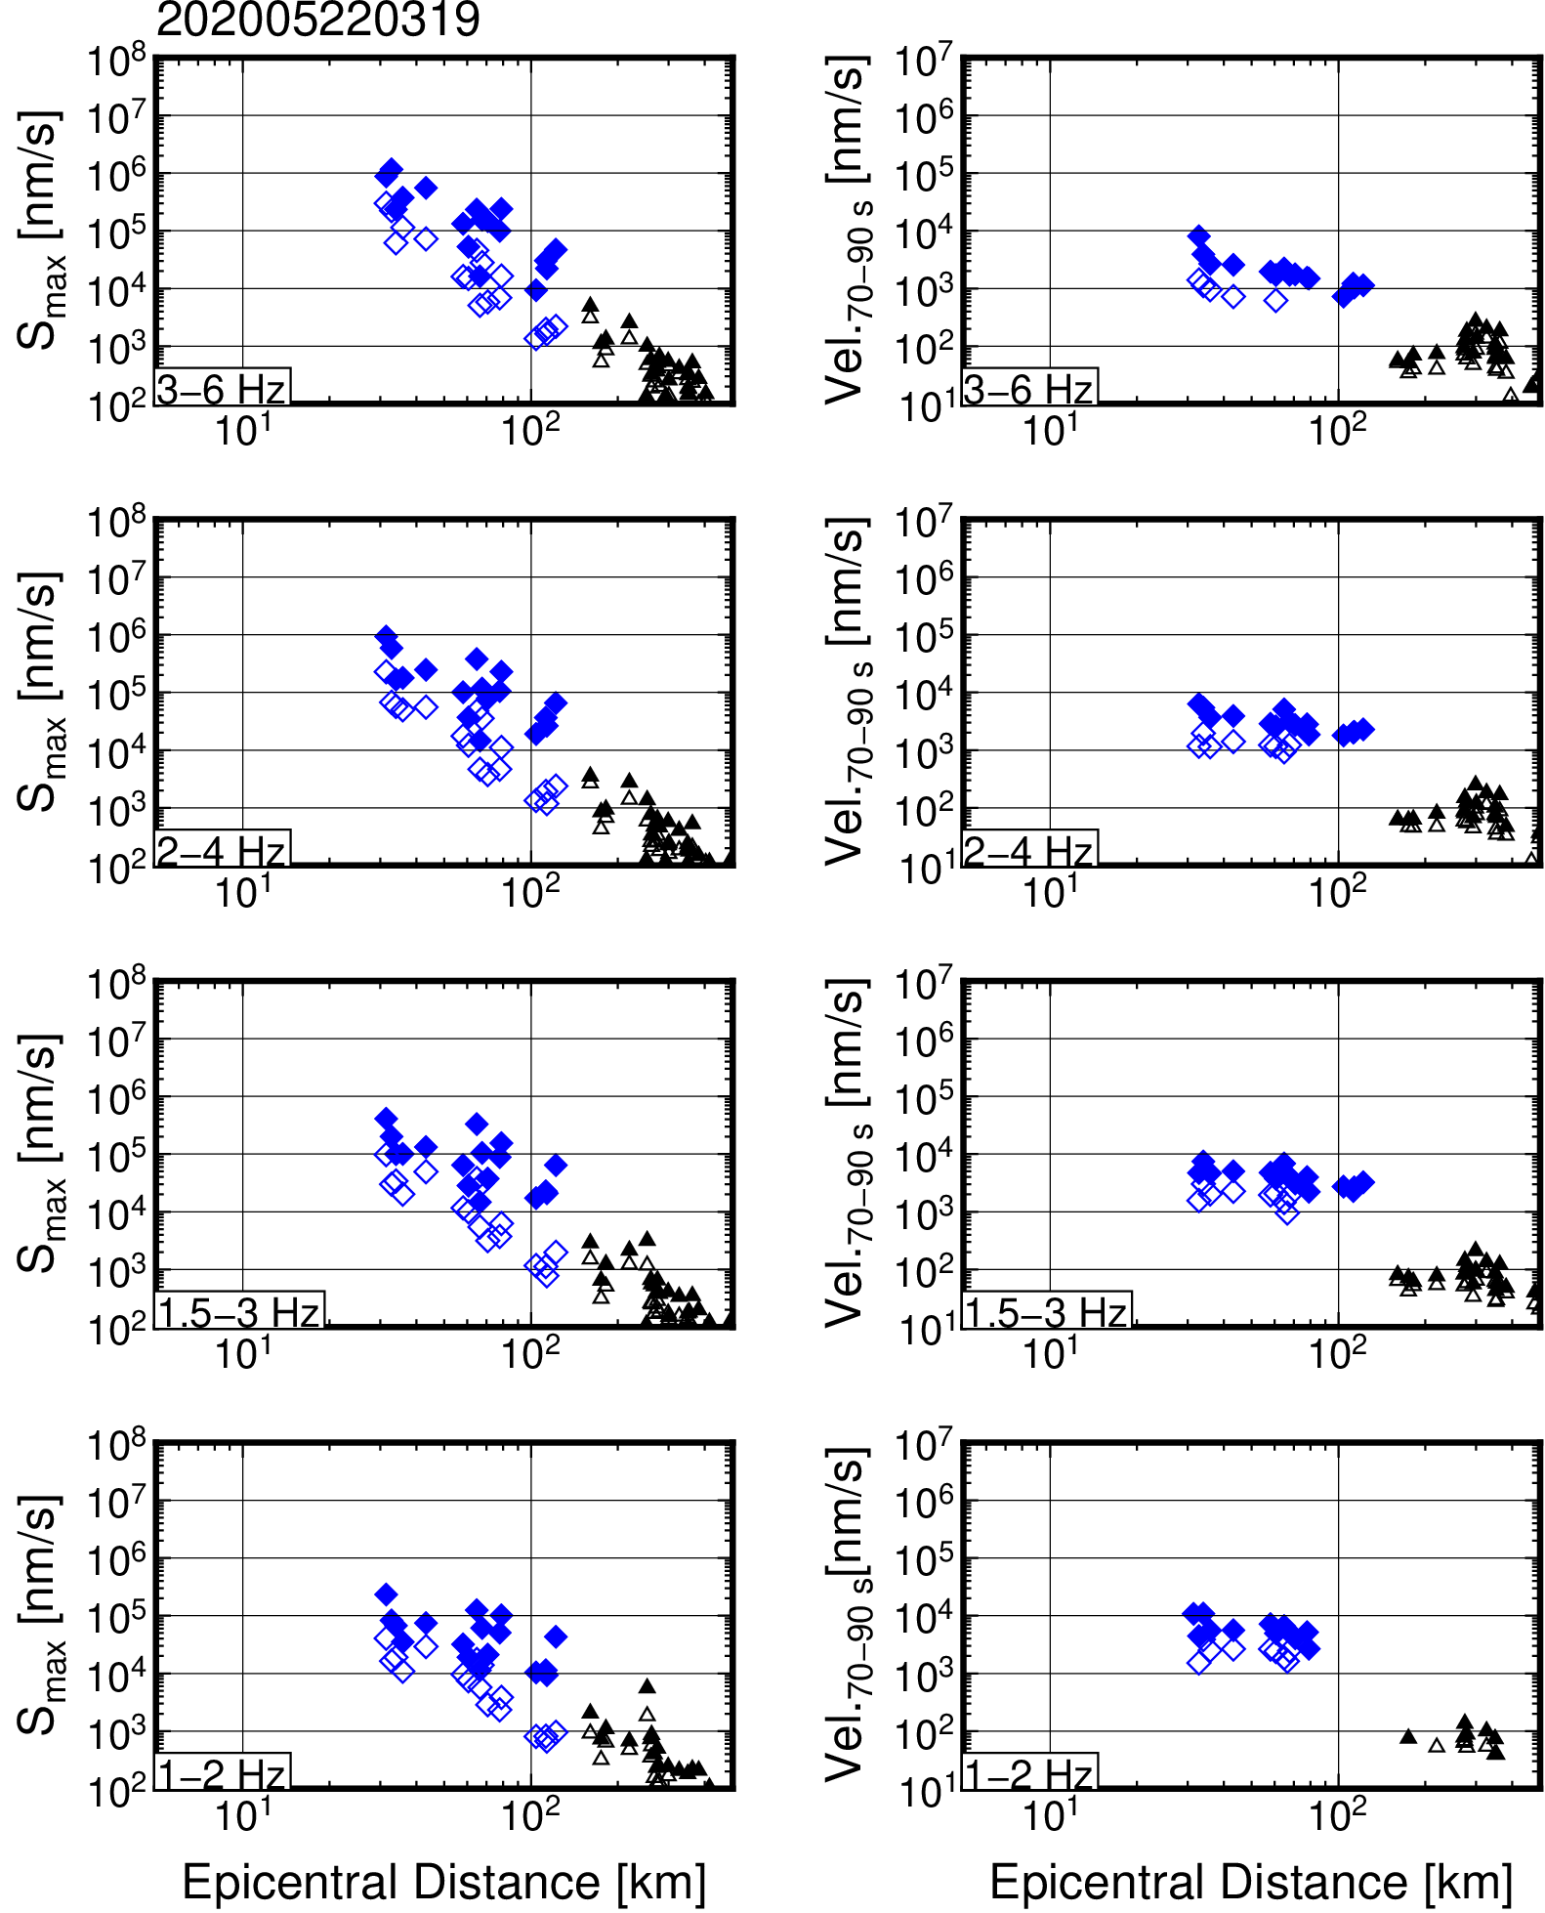
Figure S47. Frequency-dependent S_{max} and S-coda wave amplitude attenuations for an earthquake that occurred at 3:19 on 22 May 2020 (JST).

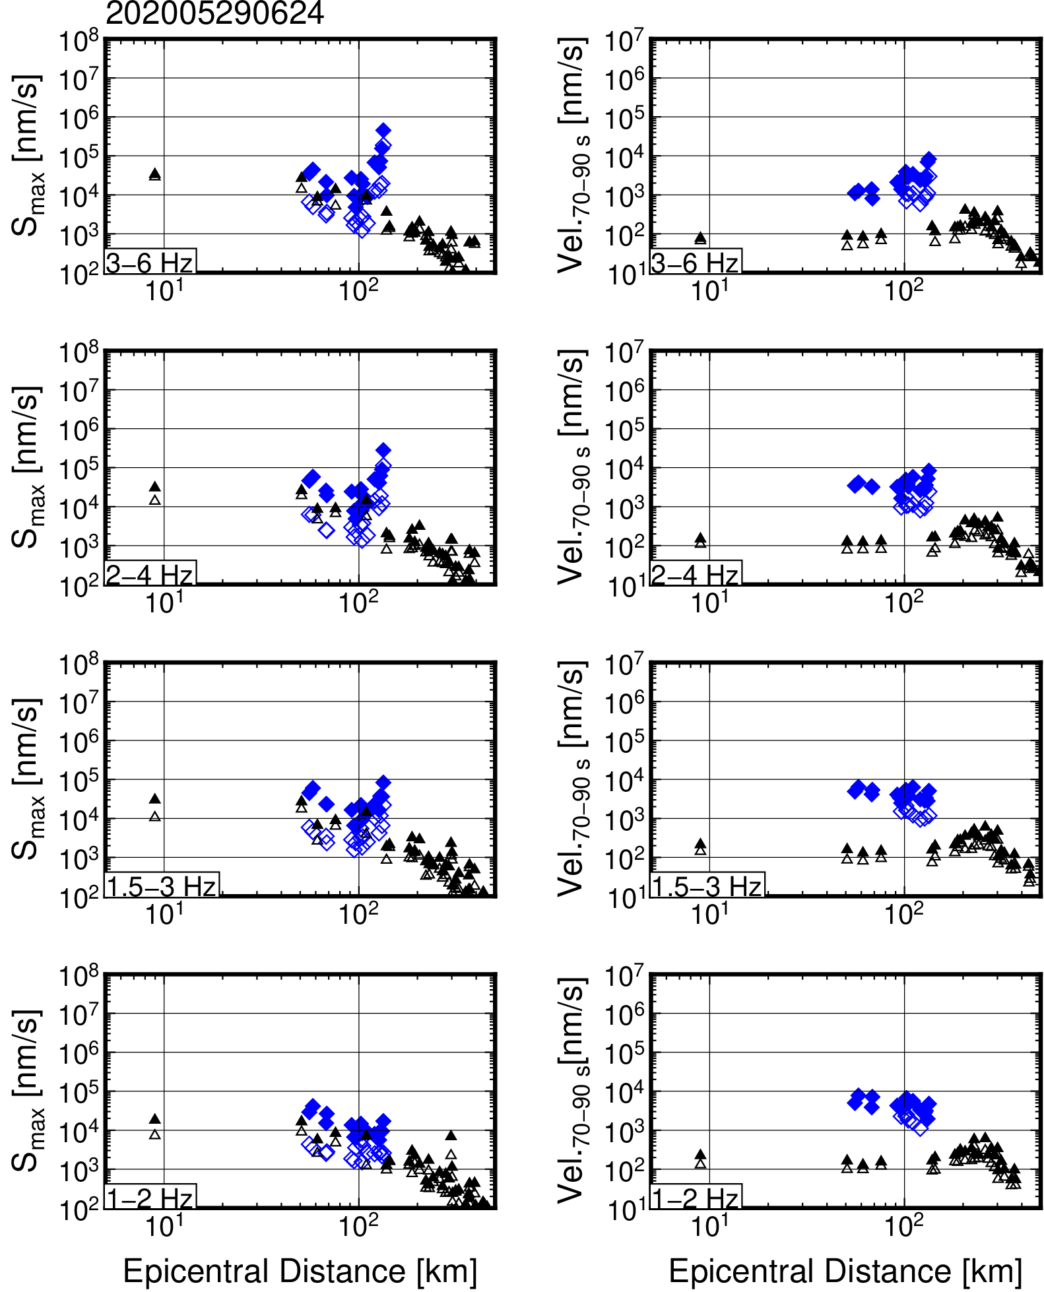
Figure S48. Frequency-dependent S_{max} and S-coda wave amplitude attenuations for an earthquake that occurred at 6:24 on 29 May 2020 (JST).

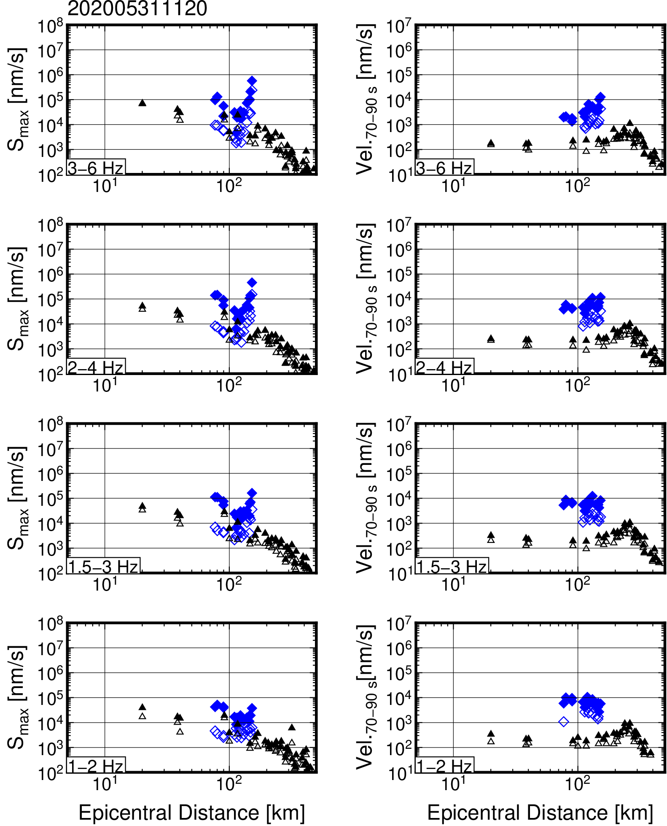
Figure S49. Frequency-dependent S_{max} and S-coda wave amplitude attenuations for an earthquake that occurred at 11:20 on 31 May 2020 (JST).

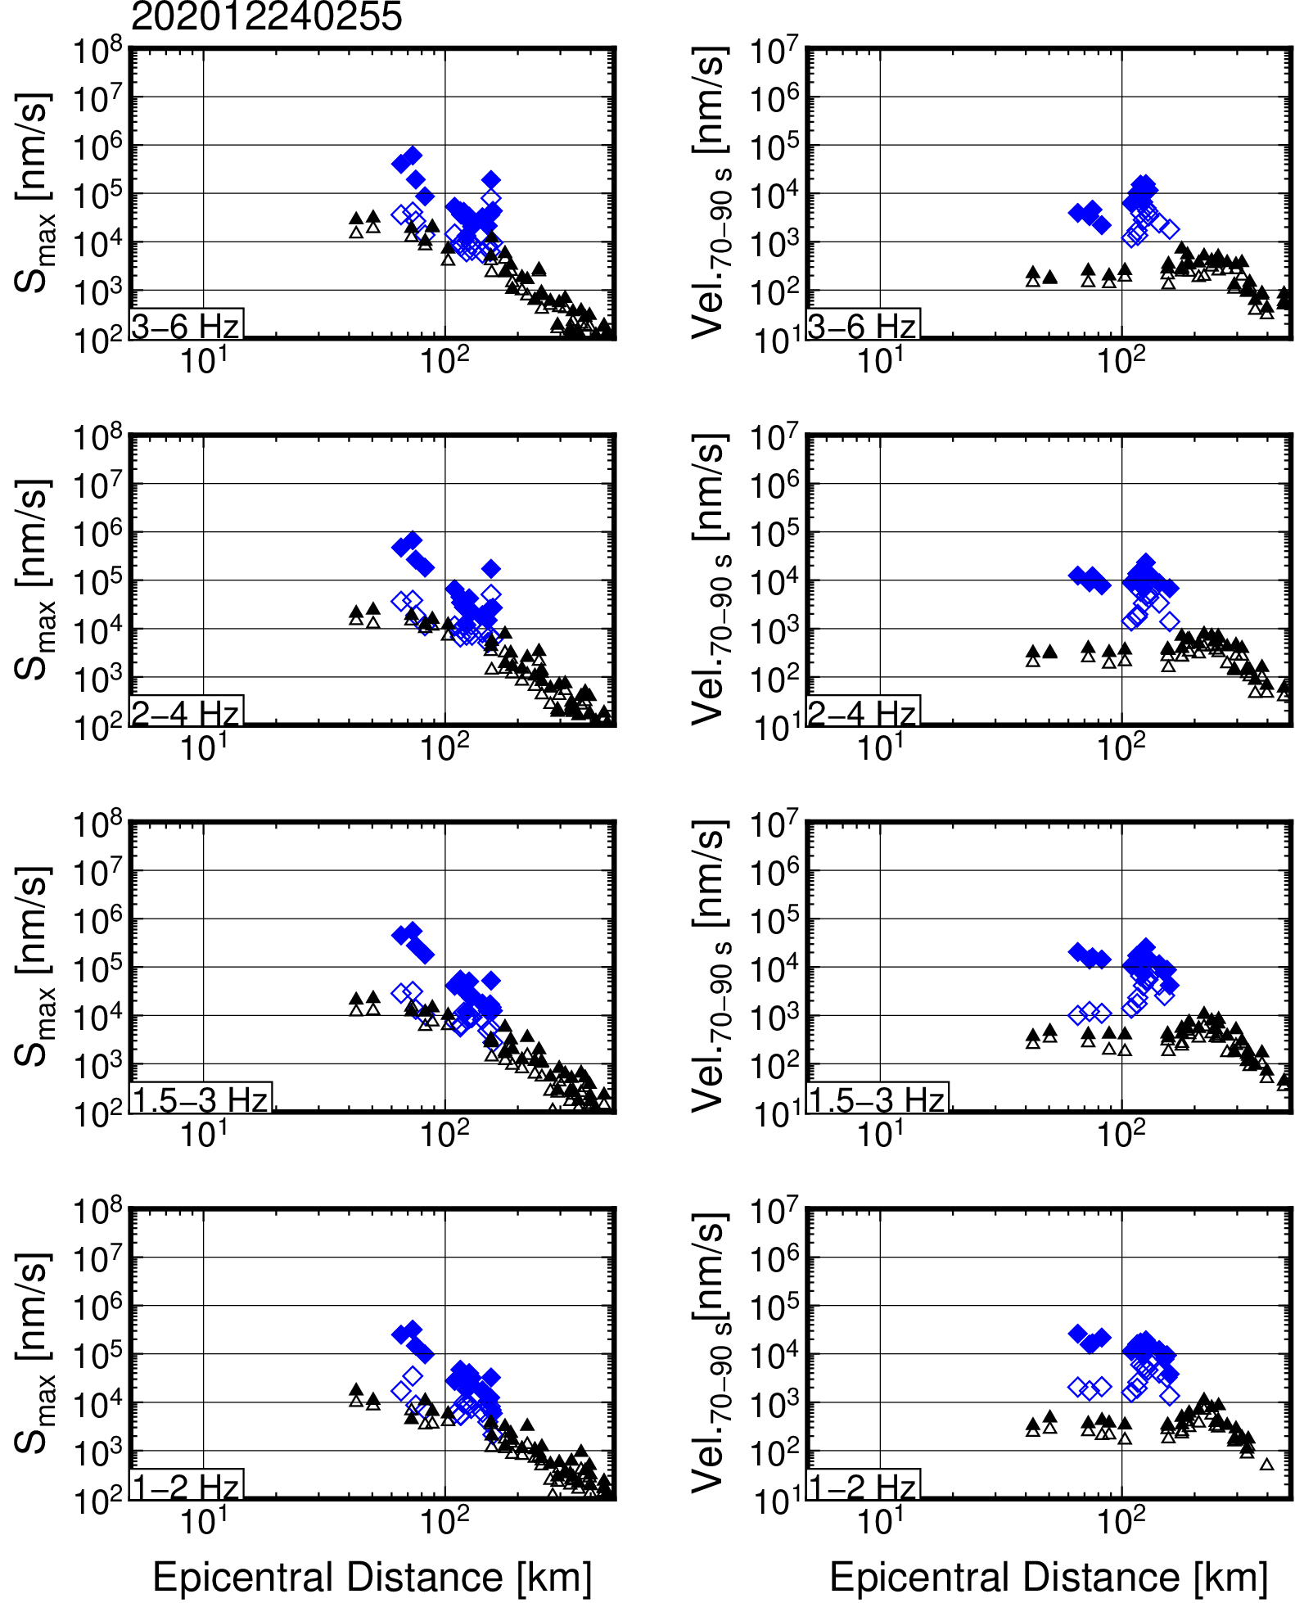
Figure S50. Frequency-dependent S_{max} and S-coda wave amplitude attenuations for an earthquake that occurred at 2:55 on 24 December 2020 (JST).

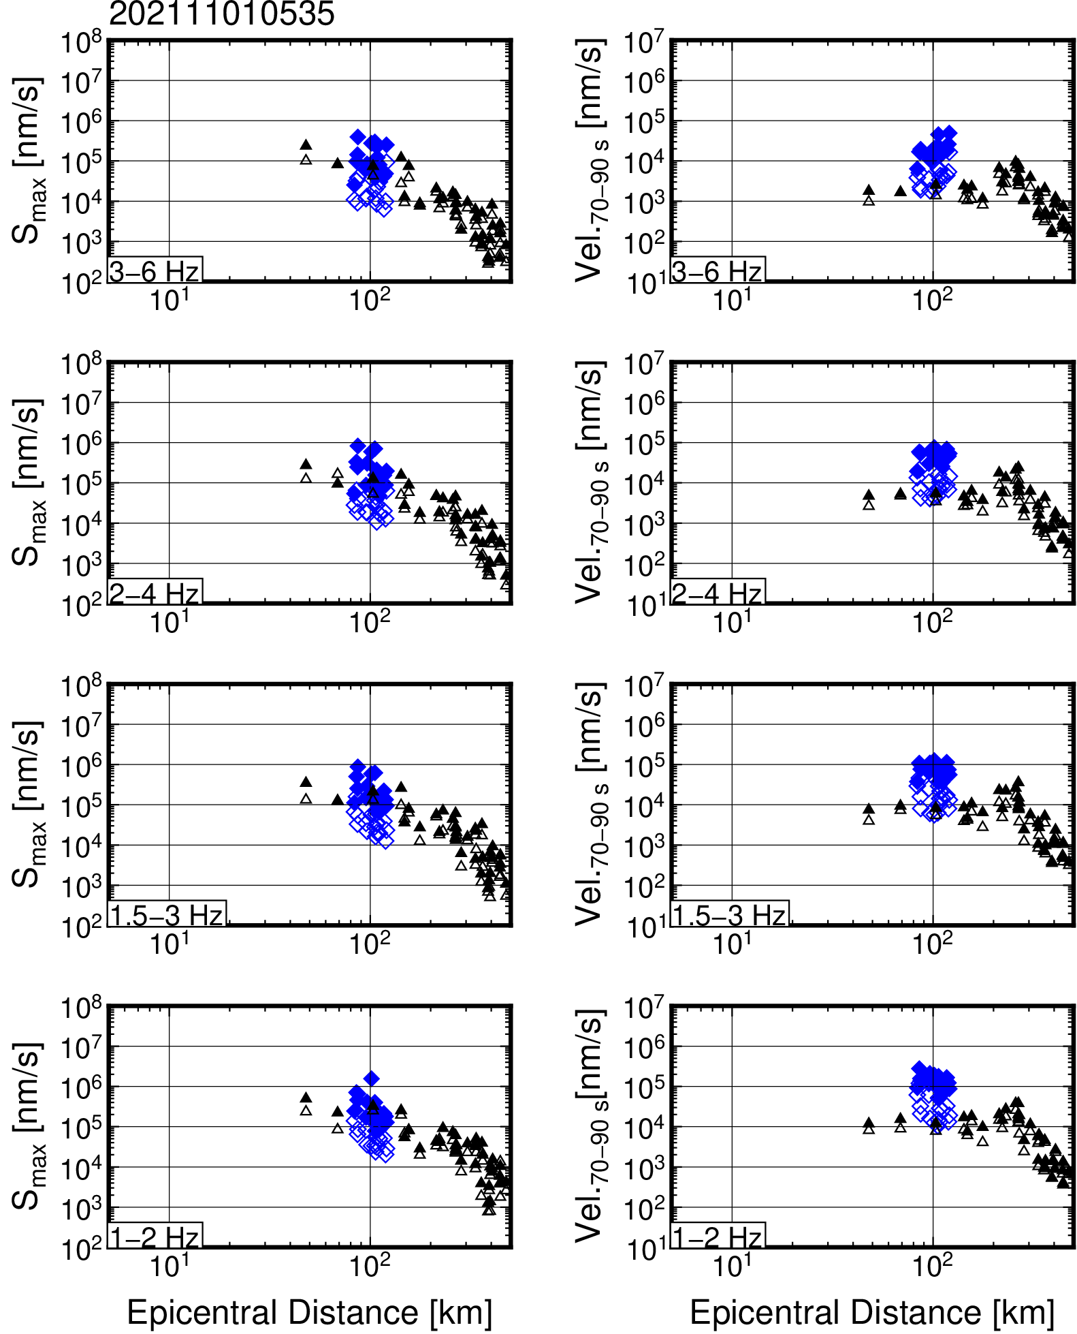
Figure S51. Frequency-dependent S_{max} and S-coda wave amplitude attenuations for an earthquake that occurred at 5:35 on 1 November 2021 (JST).

Table S1. List of parameters used for earthquakes.
Origin (JST) | Lon. [ºE] | Lat. [ºN] | Depth [km] | M_{JMA}
2014/11/30 08:00:18.72 | 136.9960 | 32.8760 | 33.82 | 4.2
2015/02/27 03:55:27.86 | 136.2670 | 33.9990 | 32.34 | 3.9
2015/03/18 12:23:18.13 | 136.9035 | 32.7710 | 36.85 | 3.8
2015/06/16 01:46:02.89 | 137.1218 | 32.9993 | 36.69 | 3.5
2015/07/27 00:37:48.32 | 136.4475 | 33.9077 | 29.49 | 3.5
2015/07/28 01:25:53.32 | 137.1568 | 33.0163 | 39.43 | 4.0
2015/09/13 16:36:12.49 | 137.0370 | 32.8808 | 35.17 | 3.5
2015/11/04 00:01:31.55 | 135.6107 | 34.4728 | 11.39 | 3.5
2015/11/11 14:07:16.28 | 136.8218 | 34.0202 | 23.69 | 3.6
2016/03/08 11:02:49.99 | 136.4643 | 32.6462 | 39.77 | 3.9
2016/04/01 11:39:07.85 | 136.3832 | 33.3233 | 28.71 | 6.5
2016/04/12 23:19:11.23 | 136.1227 | 34.3638 | 8.38 | 3.7
2016/12/09 01:13:10.67 | 136.3970 | 34.2450 | 33.94 | 3.5
2017/12/20 21:44:09.01 | 136.9515 | 32.8773 | 32.12 | 3.9
2018/01/20 11:05:06.25 | 135.7225 | 32.5497 | 38.40 | 3.7
2018/04/04 13:27:00.14 | 136.6228 | 33.7537 | 40.47 | 3.8
2018/06/24 10:48:53.40 | 137.6803 | 34.4748 | 19.33 | 3.5
2018/08/03 23:38:45.78 | 136.4502 | 32.9072 | 31.68 | 3.9
2018/10/17 08:55:48.37 | 136.2402 | 34.4333 | 28.58 | 3.6
2019/01/25 18:08.03.52 | 136.9972 | 32.9090 | 33.89 | 3.5
2020/05/22 03:19:12.47 | 137.0295 | 32.7815 | 39.61 | 3.7
2020/05/29 06:24:36.14 | 135.9475 | 33.9307 | 42.34 | 3.5
2020/05/31 11:20:13.91 | 135.7135 | 33.9690 | 46.66 | 3.6
2020/12/24 02:55:53.42 | 136.1243 | 34.2545 | 28.26 | 3.6
2021/11/01 05:35:41.08 | 135.6688 | 33.2753 | 19.64 | 5.0
Each parameter was referred from the Japan Meteorological Agency unified hypocenter catalog. According to centroid moment tensor analysis and travel times from DONET records, the depth of an earthquake that occurred at 11:39 on 1 April 2016 should be ~10 km (Wallace et al. 2016a; Takemura et al. 2020a).

