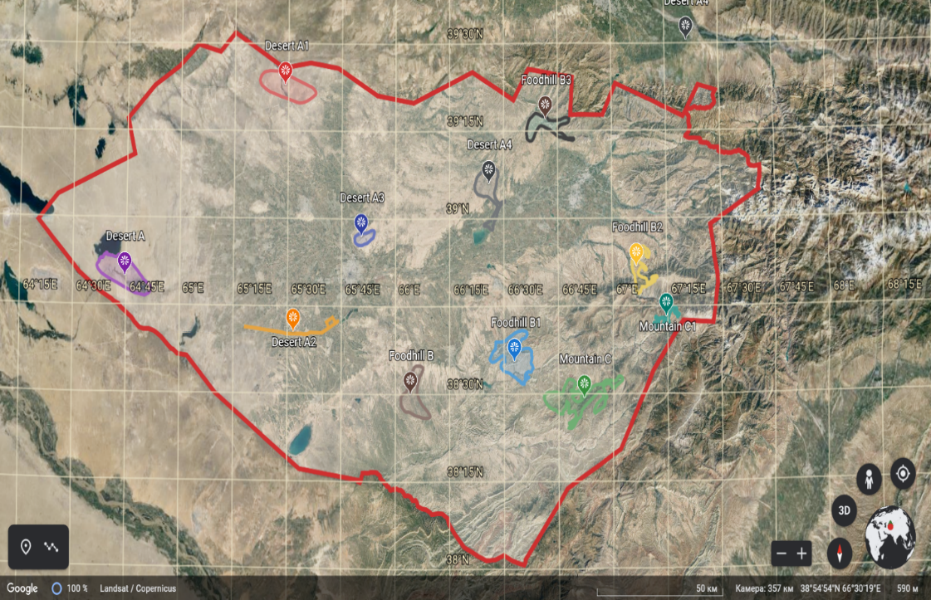
Picture-1. Map of Kashkadarya region with research areas

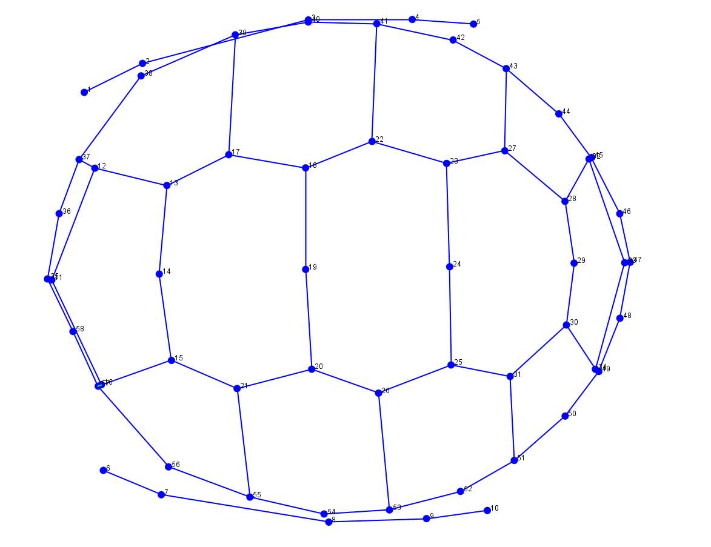  Picture-2a. Primary model of tortoise carapace | 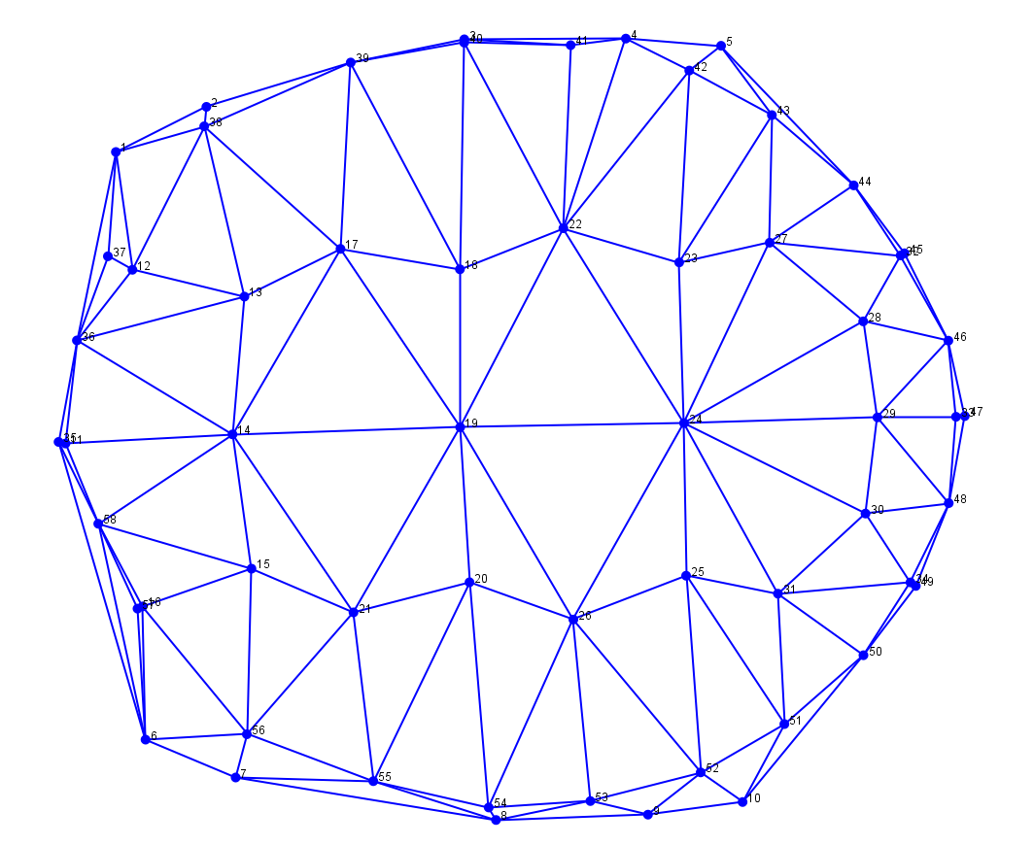  Picture 2b. Secondary model of tortoise carapace

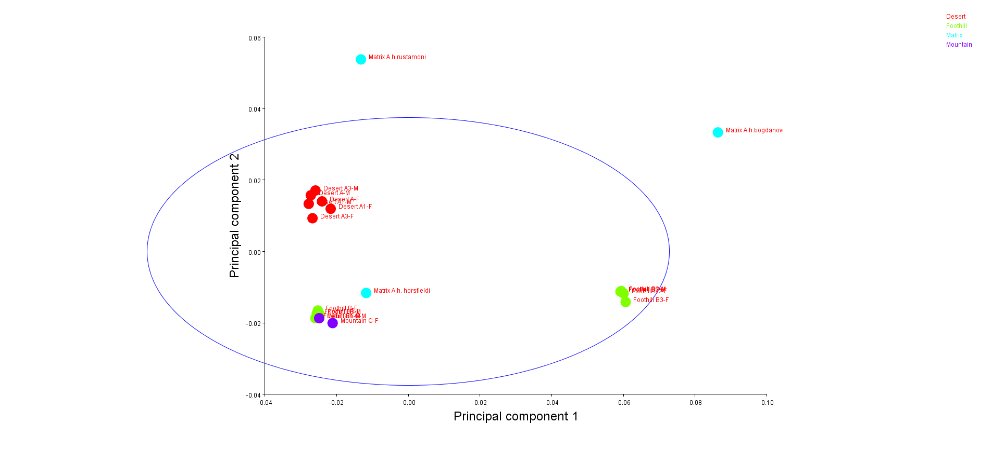
Picture-3. Result of PCA analysis

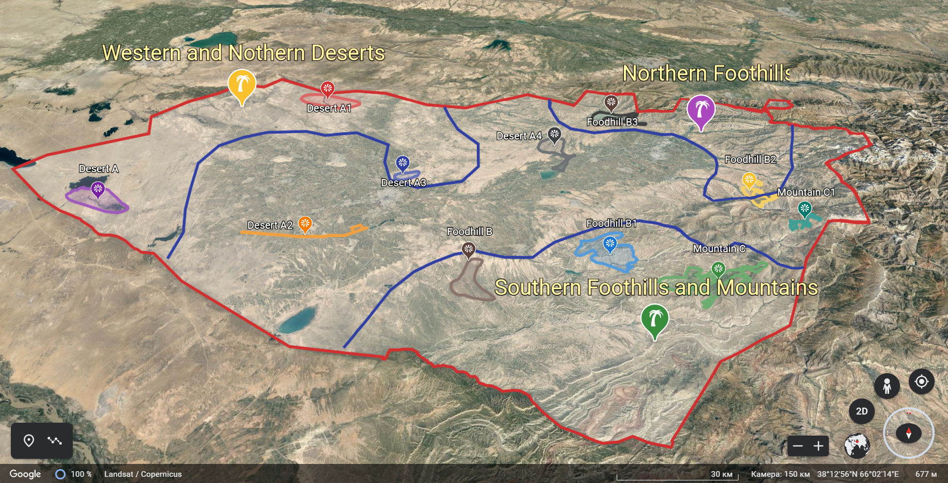
Picture-4. Map of biocenoses in Kashkadarya region

