Supplementary Materials and Methods

Preparation of purified, high-titer phage stocks

Preparation of purified, high-titer phage stocks was based on Bonilla and Barr (2016)’s “Phage on tap” protocol. The bacterial host was incubated overnight in ~25 mL of nutrient broth (ATCC Medium 129) at 37°C for E. coli, 25°C for P. syringae, and shaking at 80 RPM for both. A ~20-mL aliquot of the overnight culture was spiked into 250 mL of nutrient broth and incubated at the same conditions for 1 hour, after which 200 μL of phage stock (~10⁸ phage/mL) was added. The mixture was left for 5 hours at the same incubation conditions, then stored overnight at 4°C. The next day, the mixture was aliquoted into sterile 50-mL Falcon tubes. Tubes were centrifuged at 3,200 rcf for 20 minutes, after which the supernatant was removed and passed through an 0.2 μm syringe filter. For φ6, the supernatants were immediately combined. For T4, an additional bacterial lysis step was performed: 0.1 volume of chloroform was added to each tube, tubes were incubated for 10 minutes at room temperature, tubes were centrifuged at 3,200 rcf for 5 minutes, and the resulting supernatants were then combined. The combined supernatants were concentrated by transferring 15 mL of solution at a time to the upper reservoir of a 100 kDa Amicon® Ultra-15 Centrifugal Filter Unit and centrifuging at 3,200 rcf for 5 minutes. A wash step was performed by adding an additional 15 mL of Tris-EDTA (TE) buffer to the upper reservoir. The washed retentate was then reserved.

Phage stock quantification via plate-based culturing

100 mm x 15 mm plates were prepared with 15 mL of nutrient agar (ATCC Medium 129) each, and glass tubes were prepared with 7 mL of soft agar “stabs”; plates and stabs were stored at 4°C. 10x dilutions of the phage stocks were prepared in TE buffer, and overnight host cultures were prepared as described above. During plating, plates were allowed to come to room temperature, and stabs were melted in a 100°C water bath for at least 2 hours. Stabs were immersed in room-temperature water until cool to touch, after which 200 μL of host and 100 μL of stock dilution were immediately added. Stabs were vortexed gently, poured onto plates, allowed to set at room temperature, and incubated at temperature overnight without shaking. Three replicates of each dilution were plated. Stock titers were determined as plaque-forming units (PFU)/mL by counting visually distinct plaques, averaging replicate results, and performing appropriate back-calculations.

Phage stock quantification via qPCR/RT-qPCR
We diluted the initial stocks to an appropriate concentration in TE buffer, then extracted the diluted stock using the PureLinkTM Viral RNA/DNA Mini Kit (InvitrogenTM), per the manufacturer’s instructions but without the use of carrier RNA. Extracts were then analyzed using qPCR for the DNA phage T4 and one-step RT-qPCR for the RNA phage φ6. qPCR/RT-qPCR amplifications were performed on StepOnePlus qPCR thermocyclers (Applied Biosystems). For the T4 qPCR assay, each 12-μL reaction contained the following components: 0.5 μM forward and reverse primers, 0.2 μM probe, 0.48 μL RNAse-free water, 6 μL TaqMan Universal PCR Master Mix (Applied Biosystems), and 5 μL sample extract. For the φ6 RT-qPCR assay, each 25-μL reaction contained the following components: 1 μM forward and reverse primers, 0.15 μM probe, 0.625 μL bovine serum albumin (BSA; 25 mg/mL), 12.5 μL RNAse-free water, 2.5 μL 10x Multiplex Enzyme Mix from the Path-IDTM Multiplex One-Step Kit (Applied Biosystems), 12.5 μL of 2x Multiplex RT-PCR Buffer from the Path-IDTM kit, and 5 μL sample extract. Mastermix preparation and plating were carried out in a separate location from sample loading to avoid contamination. Each stock was assayed in triplicate, and titers were determined as gene copies (gc)/mL using six-point standard curves constructed from serially diluted plasmids. Table S8 summarizes primers, probes, and cycling conditions for the two qPCR assays performed as part of this work and Table S9 details the master standard curves used for each target.

Supplementary figures
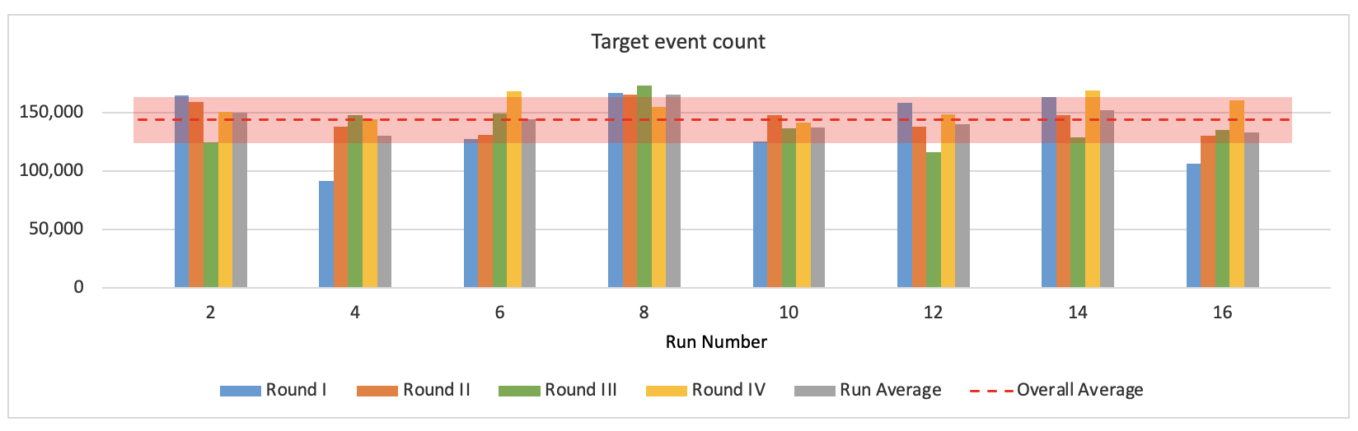

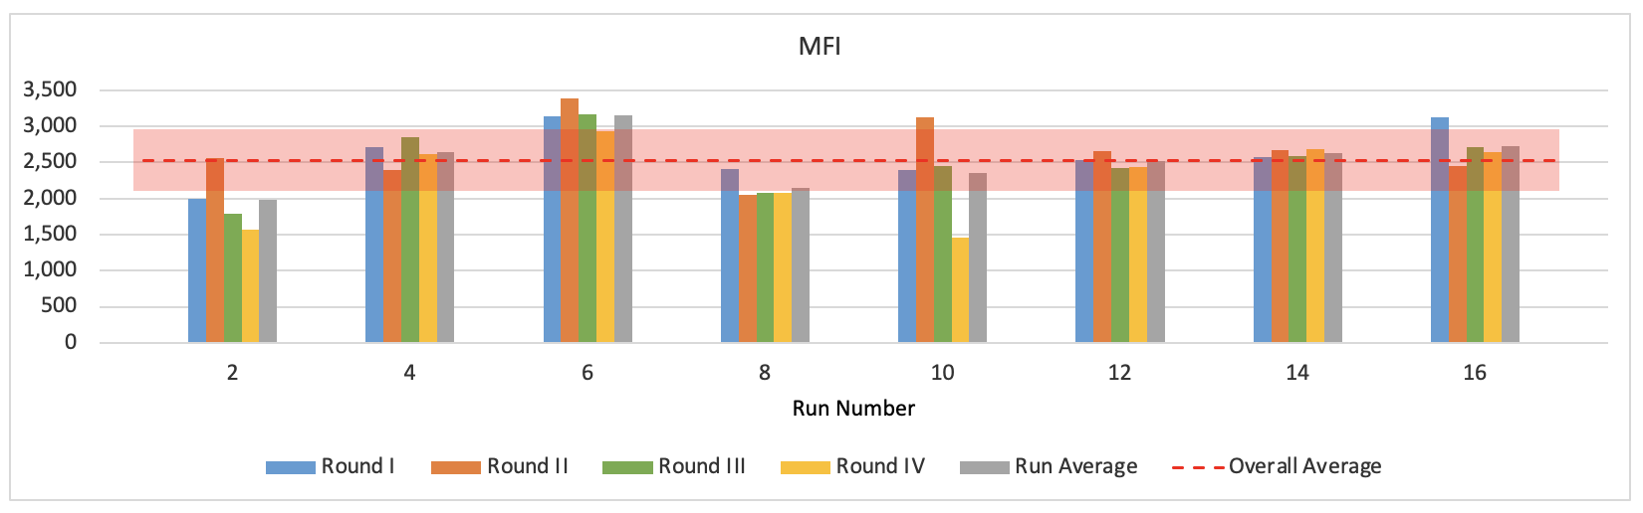

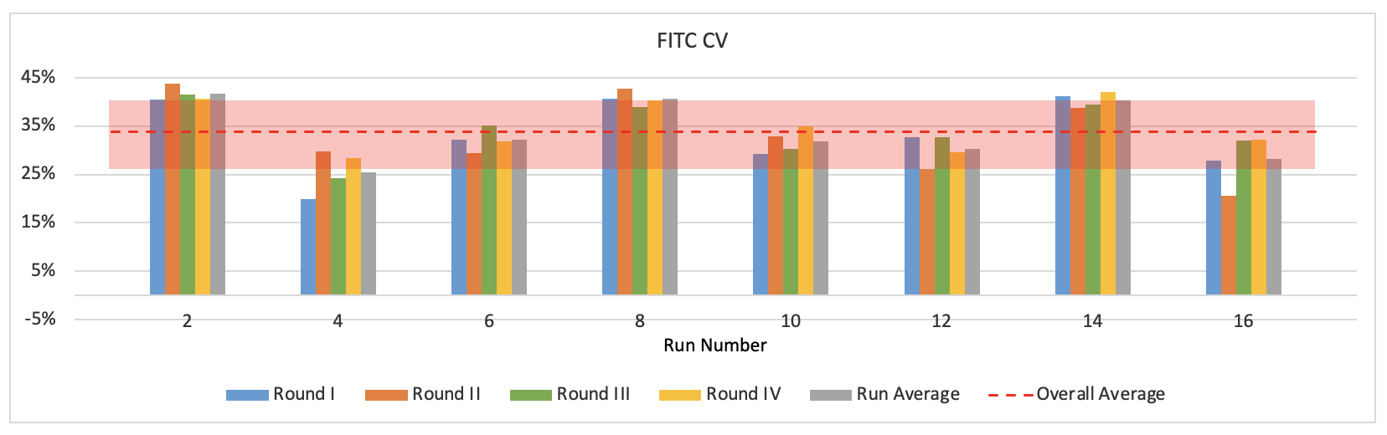
Figure S1. Graphical comparison of optimization results for glutaraldehyde-treated runs in the T4 optimization. Shaded red region denotes one standard deviation of average.

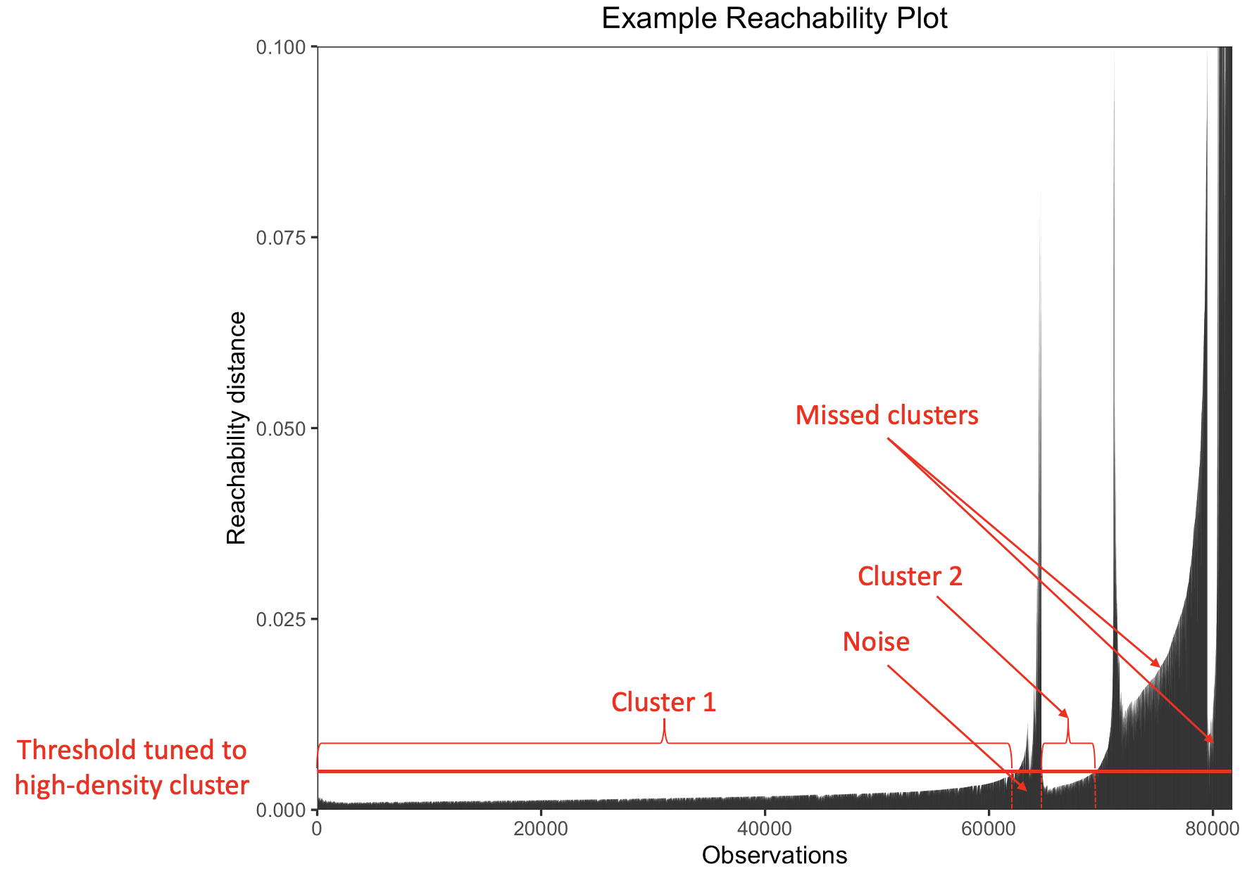

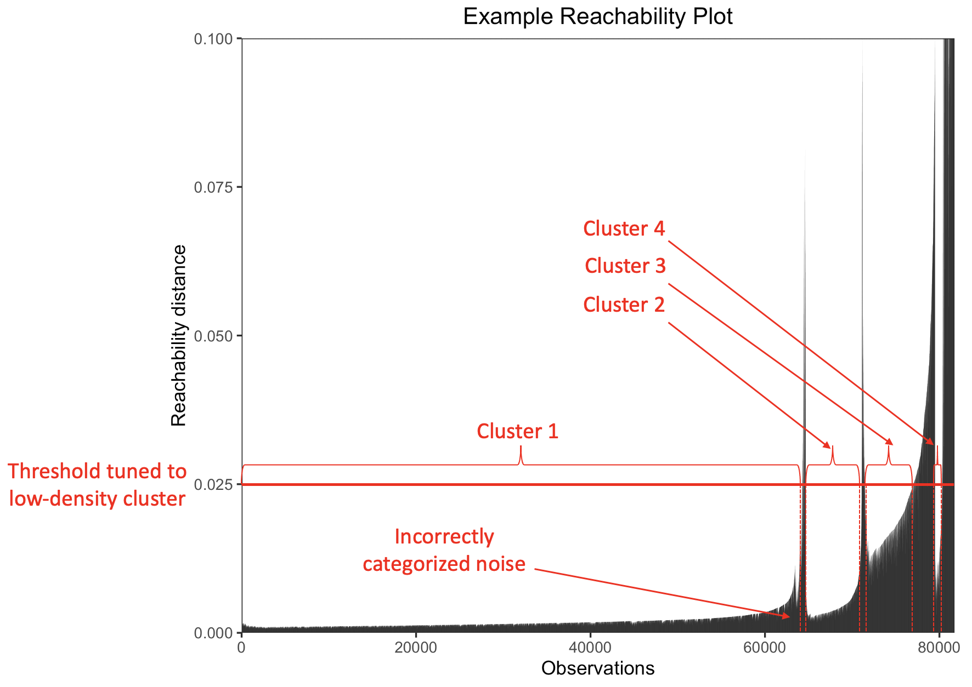
Figure S2. Illustration of pitfalls of setting a single global threshold to extract clusters from OPTICS-ordered data. For samples containing clusters of varying densities, setting a single global threshold results in either missed clusters (top plot) and/or noise points incorrectly categorized as clusters (bottom plot).

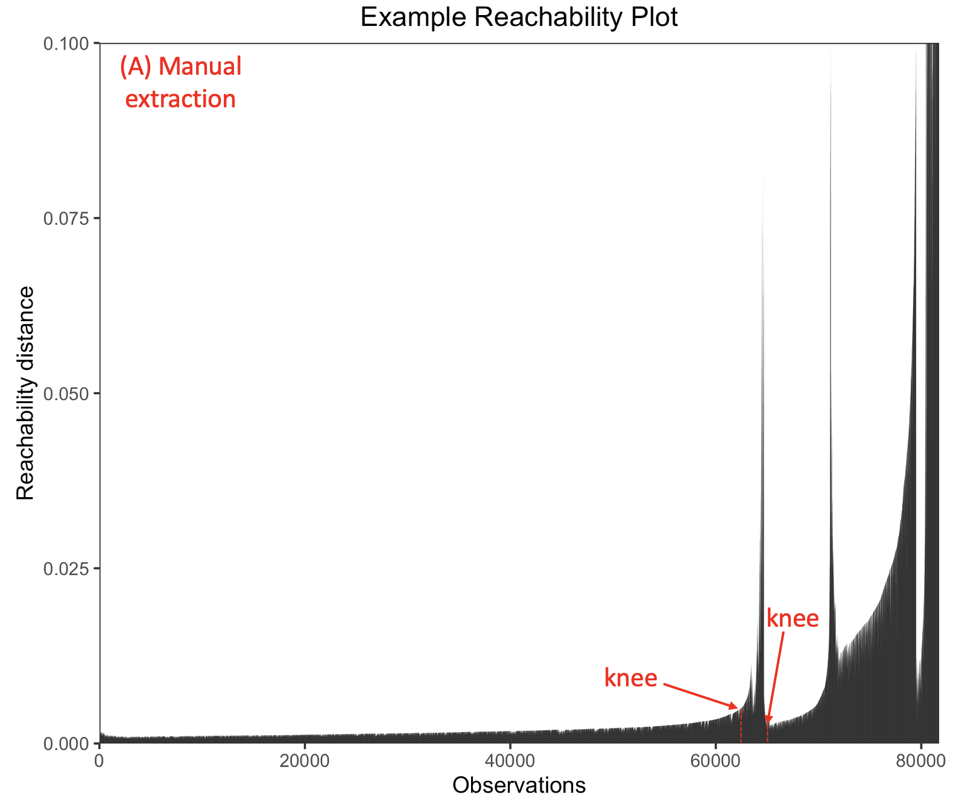

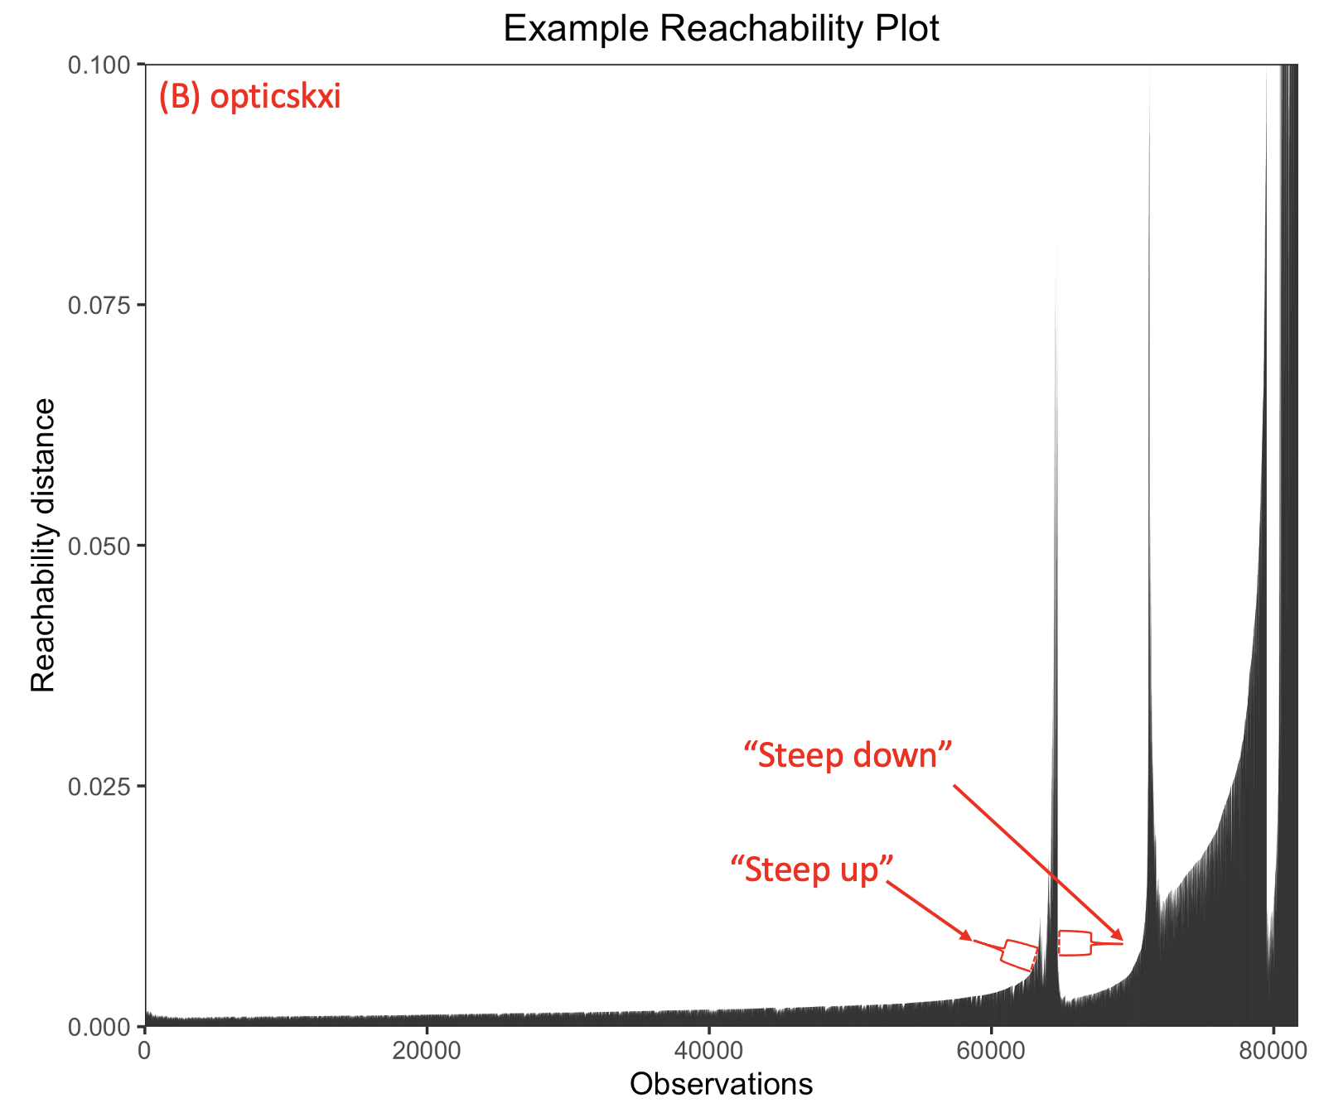
Figure S3. Two options for extracting clusters from OPTICS-ordered data. In manual extraction (A), clusters are designated by selecting “knees” in the reachability plot curves through visual inspection. In opticskxi-based extraction (B), an algorithm defines up to x (a user-defined parameter) clusters by searching for “steep up” and “steep down” regions of the reachability plot—regions identified by examining the relative reachability distances between consecutive points.

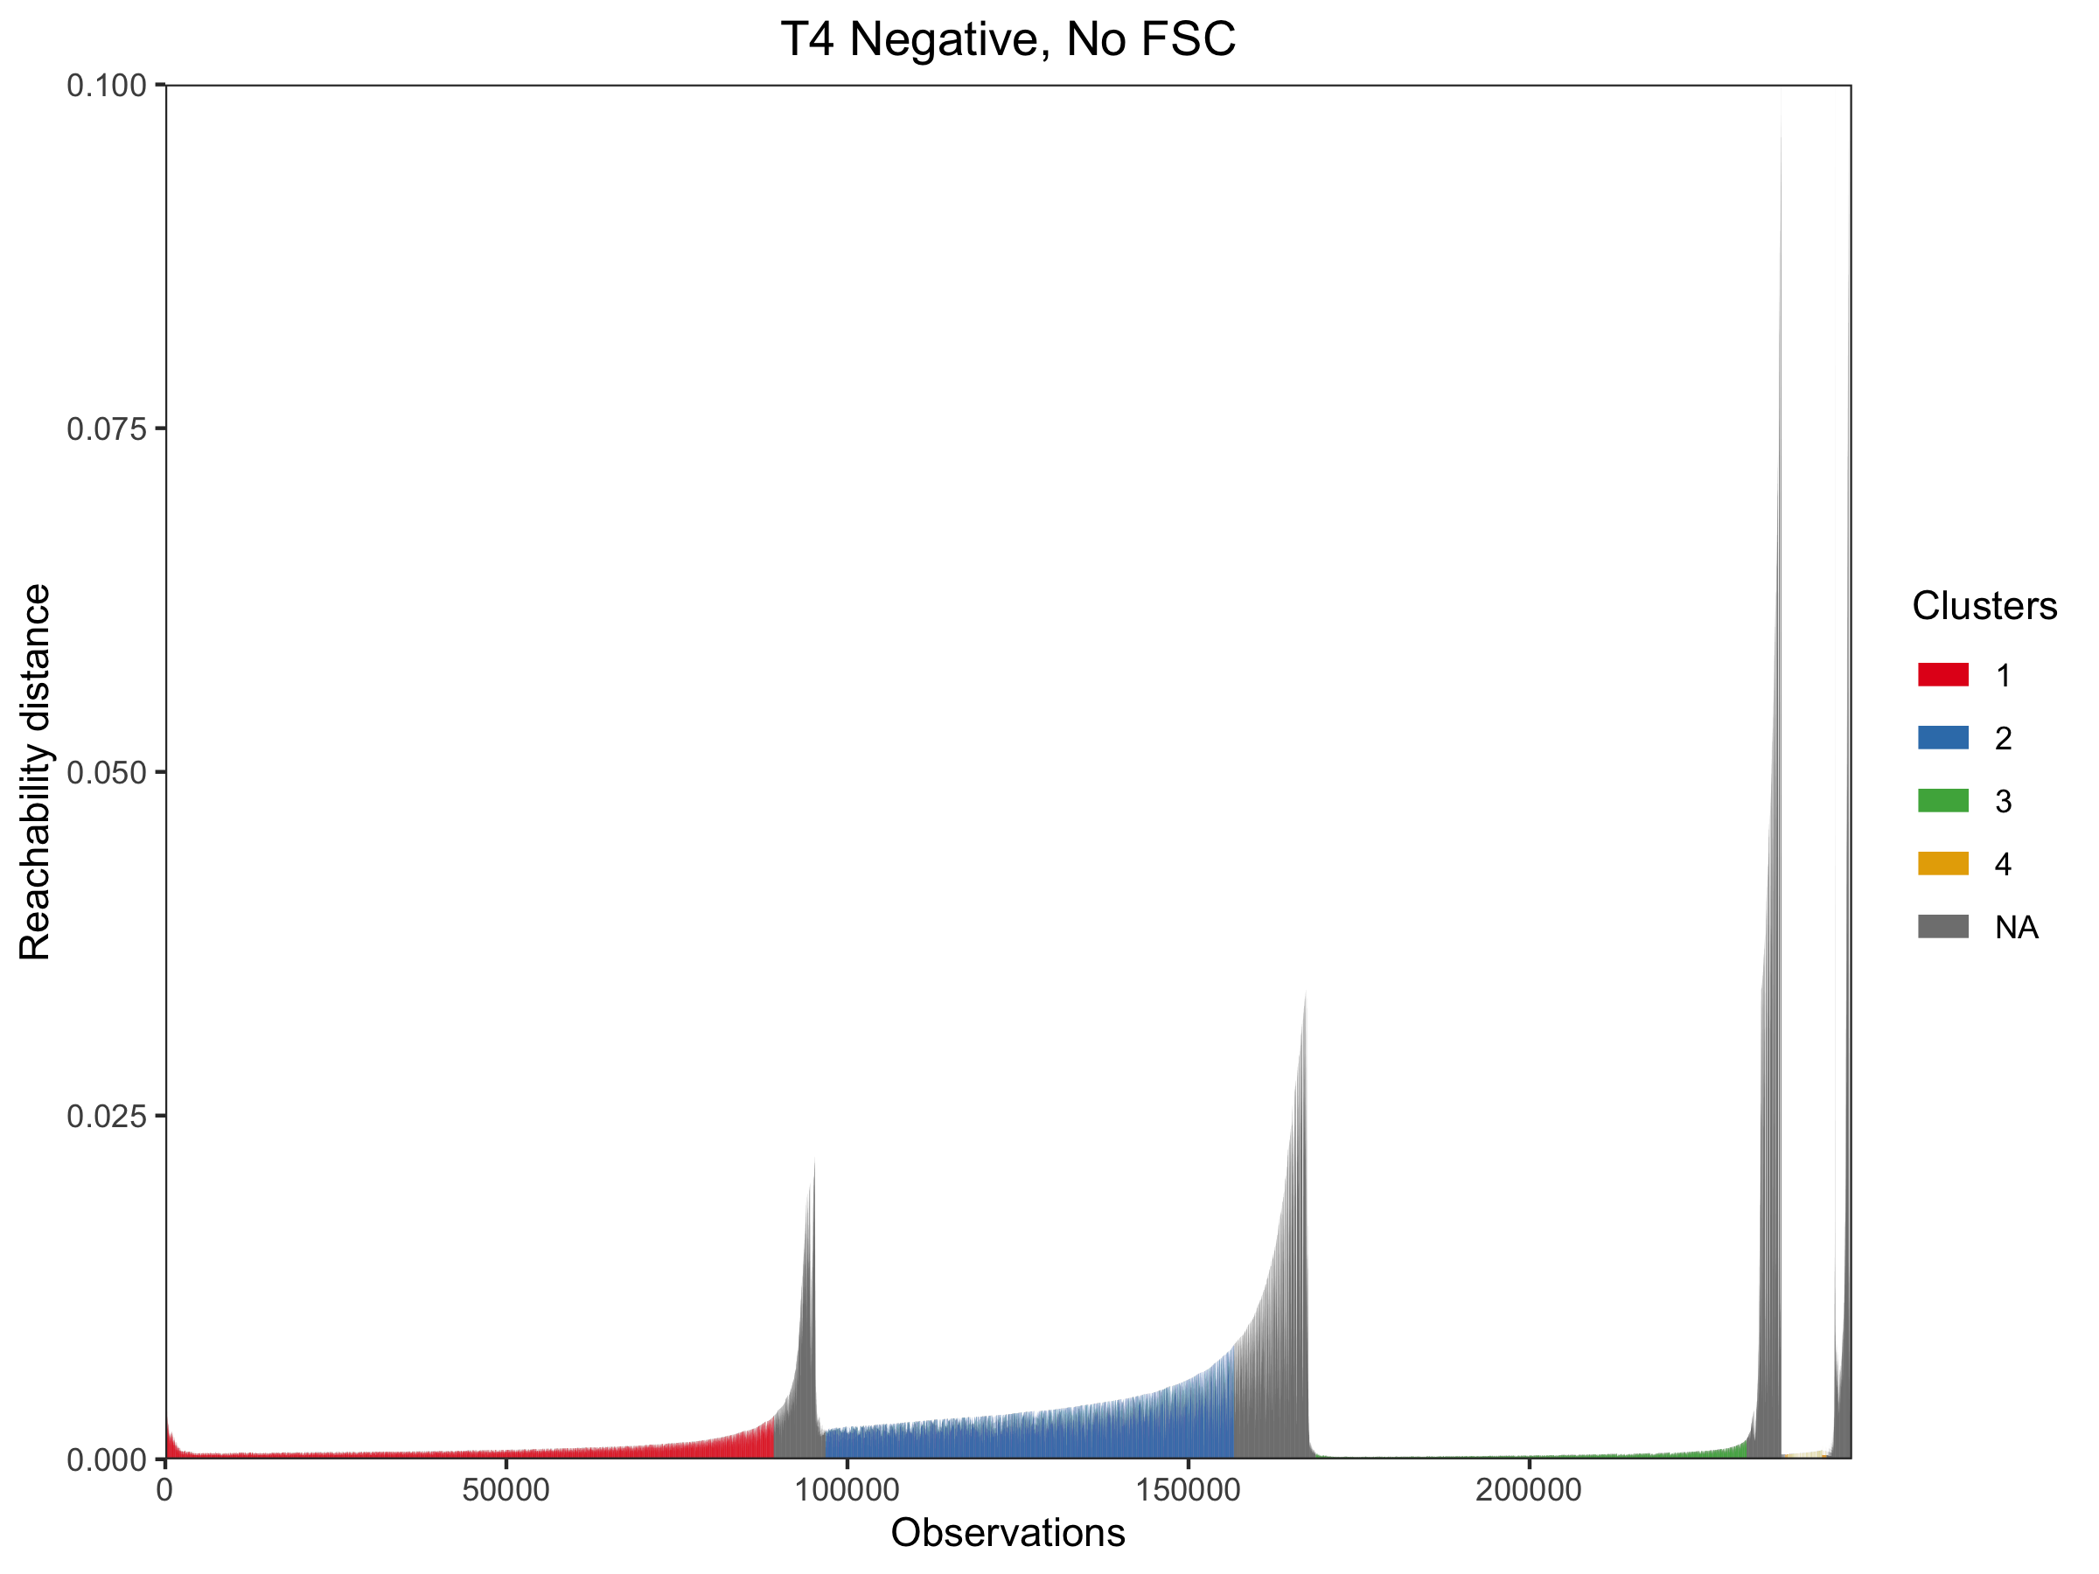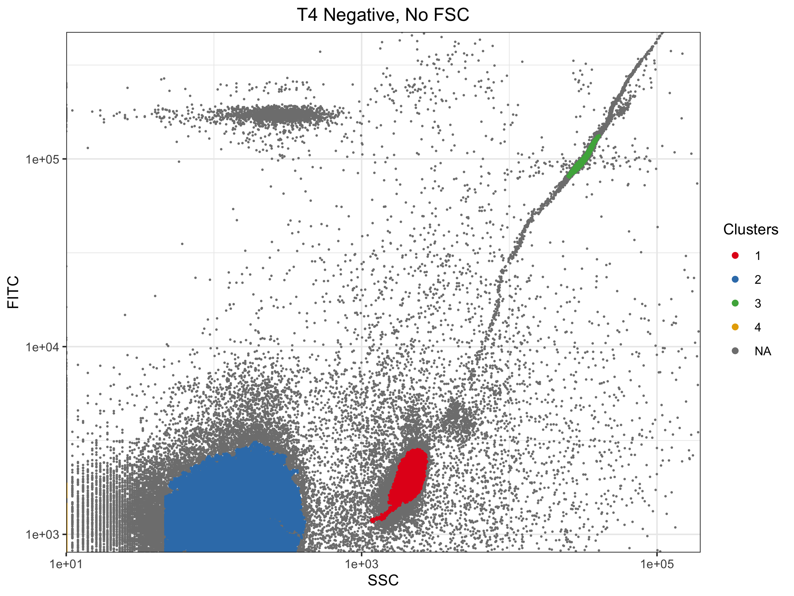

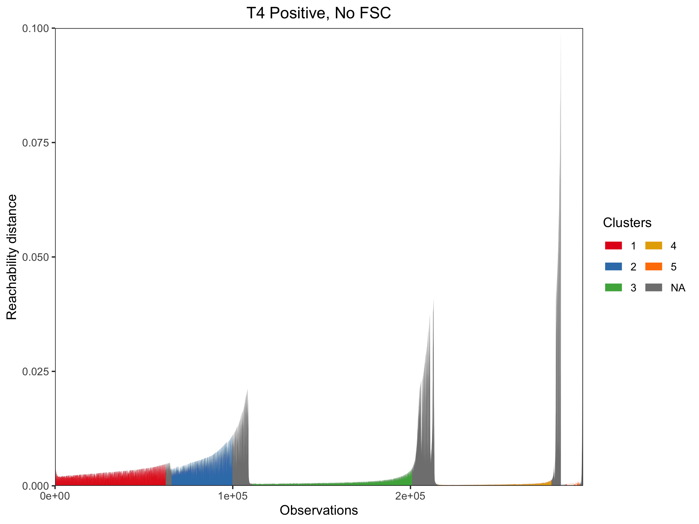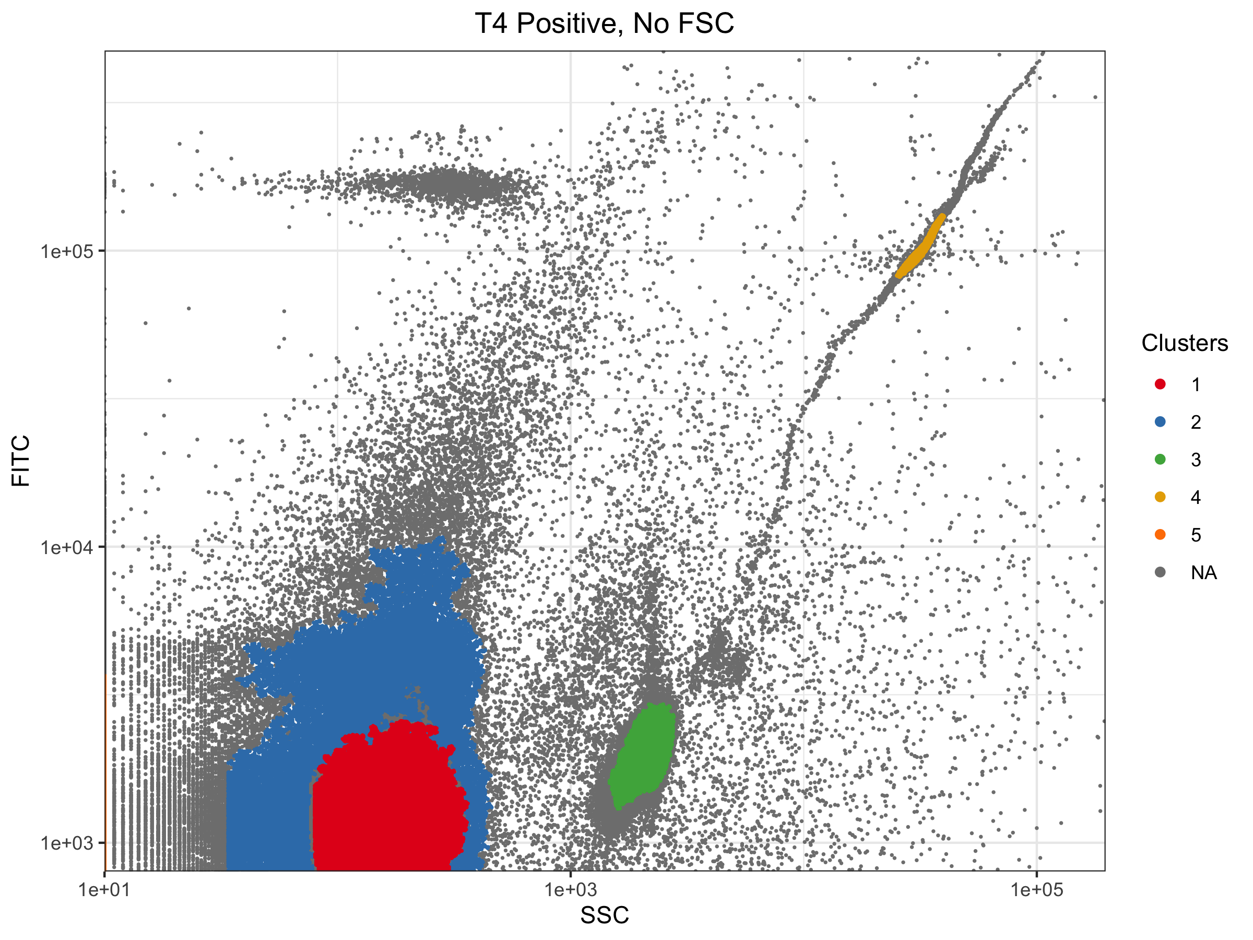
Figure S4. Representative plots showing output from manual identification/extraction of clusters from OPTICS-ordered data collected from environmental-spike experiments, not including the FSC dimension. Cluster colors are not necessarily consistent across plots. Some clusters are not visually apparent on the scatterplots because they include low-SSC points collapsed onto the y-axis.

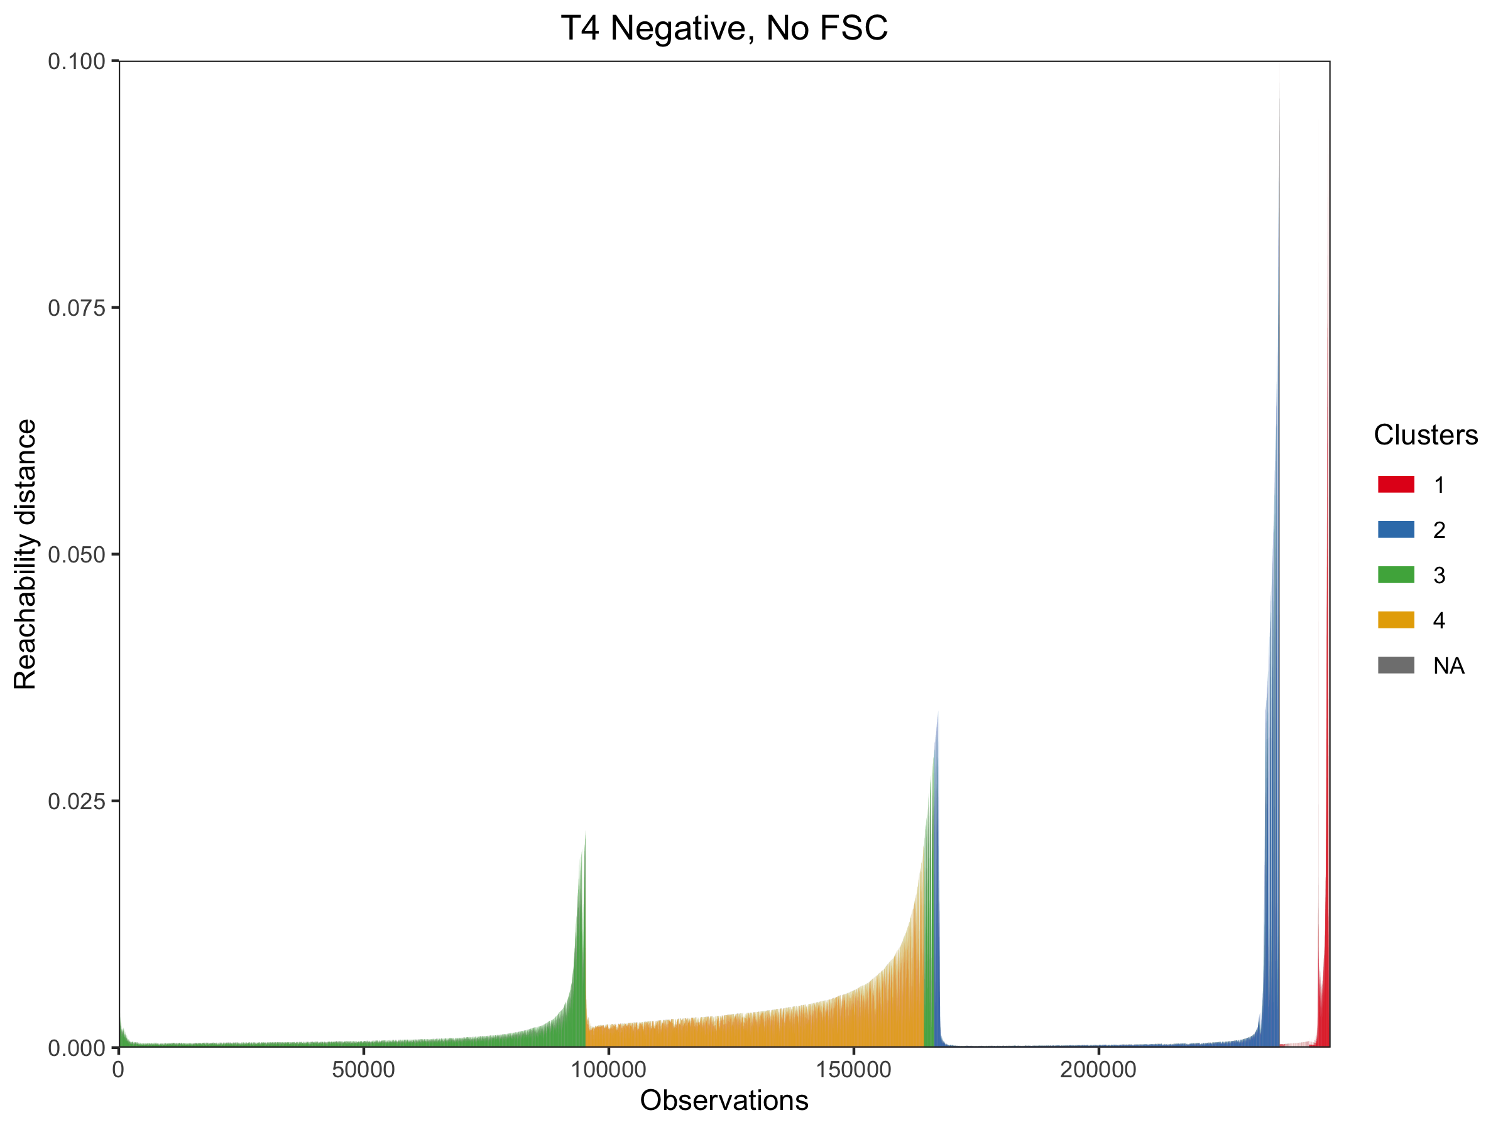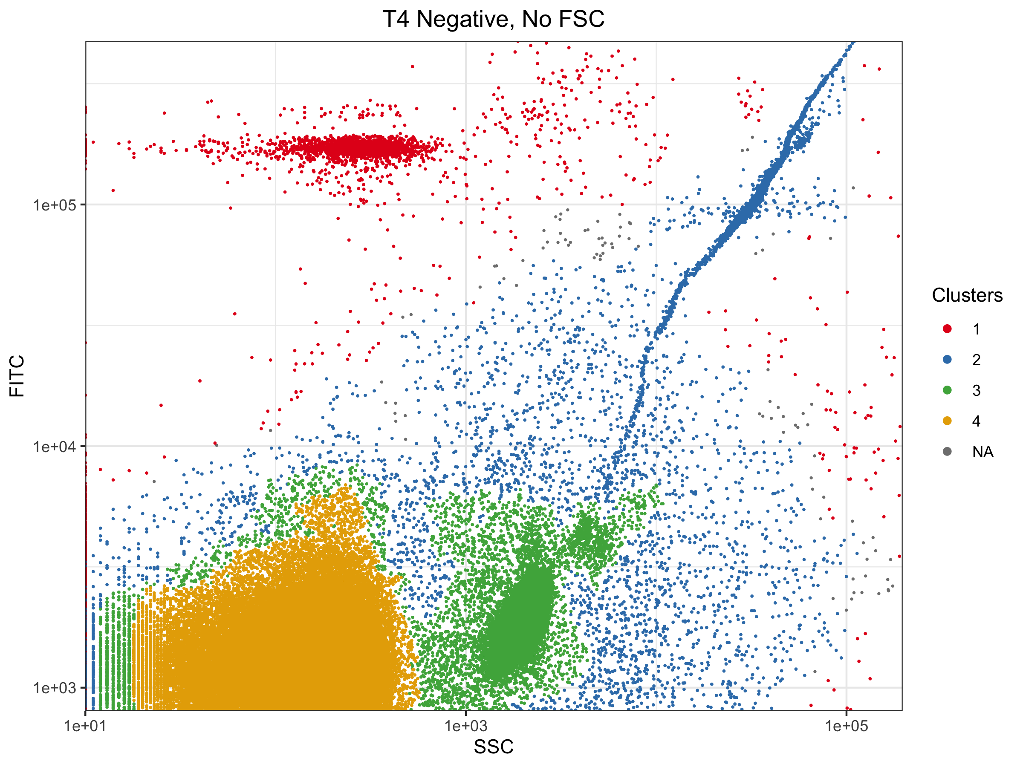

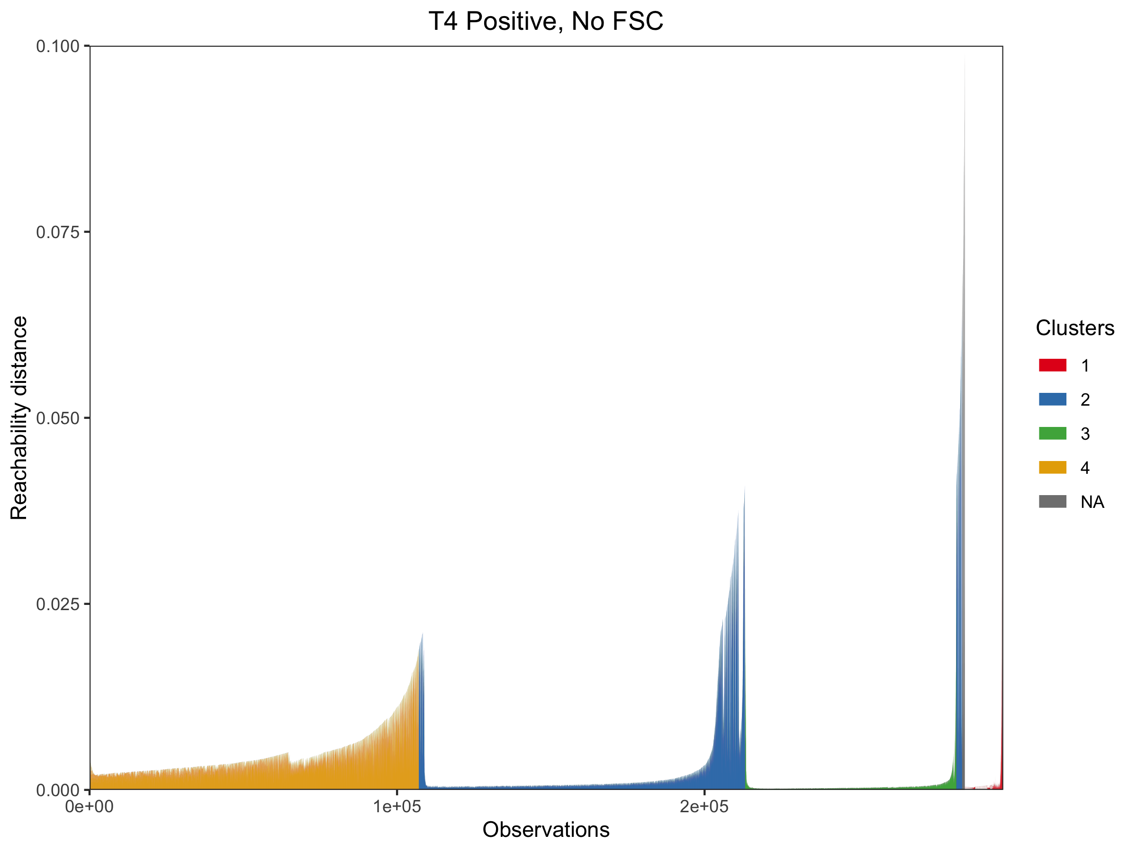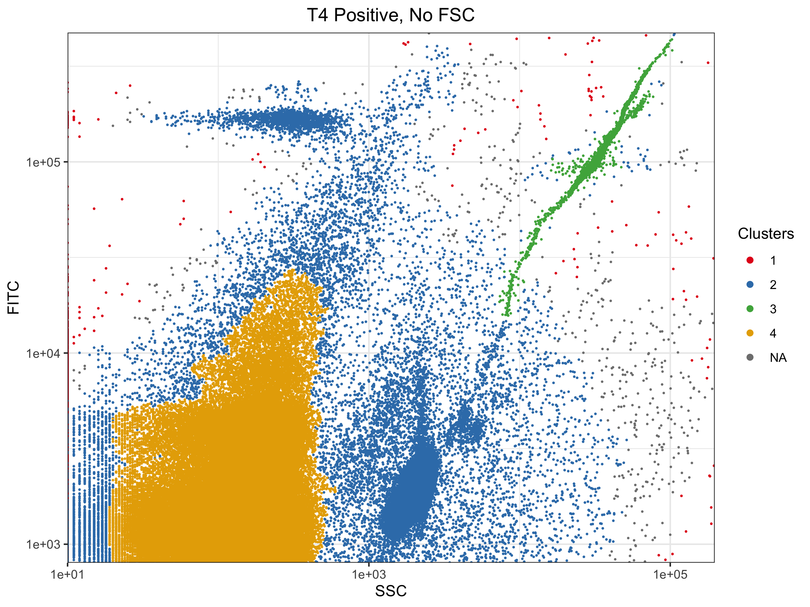
Figure S5. Representative plots showing output from opticskxi-based identification/extraction of clusters from the same OPTICS-ordered data shown in Figure S4. Cluster colors are not necessarily consistent across plots.

Supplementary tables

Table S1. Main and two-way effects estimation from optimization experiments.
Factor | All runs |  |  | Glutaraldehyde-treated runs
Factor | Effect on total event count  (p-value) | Effect on MFI  (p-value) | Effect on FITC CV  (p-value) | Effect on target event count  (p-value) | Effect on MFI  (p-value) | Effect on FITC CV  (p-value)
Glutaraldehyde | 65,402  (0.000)*** | 360  (0.000)*** | -9.0  (0.000)*** | — | — | —
Staining temperature | 868  (0.696) | -47  (0.058)† | 0.0  (0.988) | -1,860  (0.570) | -38  (0.635) | -2.7  (0.000)***
Stain type | 10,330  (0.000)*** | 14  (0.568) | 5.9  (0.000)*** | 4,576  (0.169) | -116  (0.156) | 1.5  (0.011)*
Staining time | -3,040  (0.175) | 13  (0.597) | -1.9  (0.005)** | -3,286  (0.319) | -11  (0.890) | -1.2  (0.044)*
Stain concentration | -3,052  (0.173) | -54  (0.029)* | -0.5  (0.441) | 2,325  (0.478) | -64  (0.424) | 1.8  (0.004)**
Diluent | 1,999  (0.370) | 64  (0.010)* | -1.2  (0.059)** | -7,807  (0.023)* | 122  (0.135) | -4.4  (0.000)***
Glutaraldehyde/  Staining temperature | -5,290  (0.020)* | 62  (0.013)* | -2.3  (0.001)*** | — | — | —
Glutaraldehyde/  Stain type | -1,924  (0.388) | 28  (0.258)* | -2.6  (0.000)*** | — | — | —
Glutaraldehyde/  Stain time | -320  (0.885) | 51  (0.039)* | 0.3  (0.632) | — | — | —
Glutaraldehyde/  Stain concentration | 624  (0.778) | -84  (0.001)*** | 0.5  (0.447) | — | — | —
Glutaraldehyde/  Diluent | -3,895  (0.084) | 113  (0.000)*** | -0.8  (0.205) | — | — | —
Staining temperature/  Staining time | -428  (0.847) | 2  (0.938) | -0.3  (0.639) | -2,309  (0.481) | -56  (0.485) | -0.8  (0.173)
Staining temperature/  Diluent | -181  (0.935) | 3  (0.886) | -0.4  (0.555) | -2,734  (0.405) | 85  (0.293) | 0.1  (0.888)
Significance levels: † = 0.05–0.1; * = 0.01–0.05; ** = 0.001–0.01; *** = 0–0.001

Table S2. Expected event counts for targets in mixed-target and environmental-spike experiments, per effective volume (10 μL) analyzed via FCM.
Target | Approximate expected event counts
Target | Mixed target |  |  |  |  | Environmental spike
Target | 1x | 2x | 4x | 8x | 16x | Positive | Negative
φ6* | 100,000 | 50,000 | 25,000 | 12,500 | 6,250 | – | –
T4* | 20,000 | 10,000 | 5,000 | 2,500 | 2,500 | 20,000 | –
0.2 μm beads** | 20,000 | 10,000 | 5,000 | 2,500 | 1,250 | 20,000 | 20,000
0.5 μm beads** | 40,000 | 20,000 | 10,000 | 5,000 | 625 | – | –
0.8 μm beads** | 80,000 | 80,000 | 80,000 | 80,000 | 80,000 | 80,000 | 80,000
* Based on qPCR titer; ** Based on manufacturer-provided bead concentration

Table S3. Comparison of results from different clustering approaches applied to mixed-target FCM data.
Bucket | Clustering approach | Average event count by dilution  (standard deviation)
Bucket | Clustering approach | 1x | 2x | 4x | 8x | 16x
Viruses (T4 + φ6 + VLPs) | MG | 29,209  (2,124) | 9,677  (467) | 4,466  (153) | 3,313  (160) | 952  (82)
Viruses (T4 + φ6 + VLPs) | O:ME | 12,291  (1,866) | 1,973  (1,727) | 591  (673) | 729  (440) | 0  (–)
Viruses (T4 + φ6 + VLPs) | O:kxi | 26,432  (1,738) | 8,409  (516) | 3,187  (344) | 2,573  (237) | 51  (162)
0.2 μm beads | MG | 105,224  (4,191) | 55,563  (2,589) | 29,325  (725) | 15,393  (641) | 9,115  (382)
0.2 μm beads | O:ME | 89,204  (5,604) | 46,821  (2,777) | 25,180  (2,172) | 12,459  (3,525) | 4,990  (502)
0.2 μm beads | O:kxi | 96,874  (6,284) | 50,992  (2,148) | 27,235  (440) | 14,108  (660) | 8,005  (732)
0.5 μm beads | MG | 99,845  (4,167) | 52,933  (2,429) | 27,925  (732) | 15,225  (537) | 6,363  (283)
0.5 μm beads | O:ME | 94,462  (3,901) | 50,640  (2,667) | 26,022  (940) | 13,851  (557) | 4,953  (439)
0.5 μm beads | O:kxi | 100,249  (4,526) | 53,040  (2,467) | 28,022  (652) | 15,199  (542) | 6,509  (702)
0.8 μm beads | MG | 67,433  (2,755) | 48,199  (2,190) | 61,898  (1,488) | 54,264  (2,141) | 62,755  (2,853)
0.8 μm beads | O:ME | 63,818  (2,513) | 46,438  (2,128) | 60,642  (1,968) | 53,339  (2,195) | 62,224  (2,897)
0.8 μm beads | O:kxi | 79,279  (3,058) | 48,993  (2,395) | 63,197  (1,761) | 55,281  (2,158) | 63,832  (2,839)
MG = manual gating; O:ME = OPTICS: manual extraction; O:kxi = OPTICS: kxi-based extraction

Table S4. Results from application of manual gating to environmental-spike FCM data.
Gate | Average event count by sample  (standard deviation)
Gate | Positive | Negative
T4 | 31,203  (1,871) | 9,017  (1,104)
0.2 μm beads | 94,700  (3,308) | 95,073  (1,925)
0.8 μm beads | 66,742  (2,405) | 66,732  (1,619)

Table S5. Approximate positive phage stock titers determined by different methods.
 | T4 | φ6
Plate-based culturing (PFU/mL) | 10⁷–10⁸ | 10⁹–10¹⁰
qPCR/RT-qPCR (gc/mL) | 10⁸–10⁹ | 10¹⁰–10¹¹

165
Table S6. Experiments included in fractional factorial design for staining optimization. Factor levels are detailed in Table 1.
Aliases | A | B | C | D | E | F
Factors | Glutaraldehyde | Staining temperature | Stain type | Staining time | Stain concentration | Diluent
Run order | Factor levels
1 | 1 | 1 | 1 | 1 | 1 | 1
2 | 2 | 1 | 1 | 1 | 2 | 1
3 | 1 | 2 | 1 | 1 | 2 | 2
4 | 2 | 2 | 1 | 1 | 1 | 2
5 | 1 | 1 | 2 | 1 | 2 | 2
6 | 2 | 1 | 2 | 1 | 1 | 2
7 | 1 | 2 | 2 | 1 | 1 | 1
8 | 2 | 2 | 2 | 1 | 2 | 1
9 | 1 | 1 | 1 | 2 | 1 | 2
10 | 2 | 1 | 1 | 2 | 2 | 2
11 | 1 | 2 | 1 | 2 | 2 | 1
12 | 2 | 2 | 1 | 2 | 1 | 1
13 | 1 | 1 | 2 | 2 | 2 | 1
14 | 2 | 1 | 2 | 2 | 1 | 1
15 | 1 | 2 | 2 | 2 | 1 | 2
16 | 2 | 2 | 2 | 2 | 2 | 2
166

Table S7. Confounding structures and different main and two-way effects present for the T4 optimization fractional factorial experimental design.
Estimation factor | Confounding structure | Main and two-way effects present
I₁ | A + ABCE + ABCDF + DEF | Glutaraldehyde
I₂ | B + ACE + CDF + ABDEF | Staining temperature
I₃ | C + ABE + BDF + ACDEF | Stain type
I₄ | D + ABCDE + BCF + AEF | Staining time
I₅ | E + ABC + BCDEF + ADF | Stain concentration
I₆ | F + ABCEF + BCD + ADE | Diluent
I₇ | AB + CE + ACDF + BDEF | Glutaraldehyde/Staining temperature  Stain type/Stain concentration
I₈ | AC + BE + ABDF + CDEF | Glutaraldehyde/Stain type  Staining temperature/Stain concentration
I₉ | AD + BCDE + ABCF + EF | Glutaraldehyde/Stain time  Stain concentration/Diluent
I₁₀ | AE + BC + ABCDEF + DF | Glutaraldehyde/Stain concentration  Staining temperature/Stain type  Staining time/Diluent
I₁₁ | AF + BCEF + ABCD + DE | Glutaraldehyde/Diluent  Staining time/Stain concentration
I₁₂ | BD + ACDE + CF + ABEF | Staining temperature/Staining time  Stain type/Diluent
I₁₃ | BF + ACEF + CD + ABDE | Staining temperature/Diluent  Stain type/Staining time
I₁₄ | ABD + CDE + ACF + BEF | N/A
I₁₅ | ACD + BDE + ABF + CEF | N/A
I₁₆ | I + ABCE + BCDF + ADEF | N/A

Table S8. qPCR/RT-qPCR primers, probes, and cycling conditions used in Chapter 3.
Target | Primer/probe sequences (5’-3’) |  | Cycling conditions | Source/Reference
T4; gp18 tail protein gene | Forward | AAGCGAAAGAAGTCGGTGAA | 50°C for 2 min; 95°C for 10 min; 45 cycles of 95°C for 15s and 60°C for 1 min | Gerriets et al. (2008)
T4; gp18 tail protein gene | Reverse | CGCTGTCATAGCAGCTTCAG |  | Gerriets et al. (2008)
T4; gp18 tail protein gene | Probe | CY5-CCACGGAAATTTCTTCATCT  TCCTCTGGCCGTGG-BHQ2 |  | Gerriets et al. (2008)
φ6; P8 protein gene | Forward | TGGCGGCGGTCAAGAG | 50°C for 30 min; 95°C for 10 min; 40 cycles of 95°C for 15s and 60°C for 60s | Based on Gendron et al. (2010)*,
φ6; P8 protein gene | Reverse | GGATGATTCTCCAGAAGCTGCT |  | Based on Gendron et al. (2010)*,
φ6; P8 protein gene | Probe | MGB-GTCGCAGGTCTGACACT-BHQ1 |  | Based on Gendron et al. (2010)*,
*Slight modifications made by removing several nucleotides from the primer and probe sequences and by changing the probe to MGB. These changes were made based on the advice of specialists at the UC Davis Real-time PCR Research and Diagnostics Core Facility based on needed applications for our lab.

Table S9. Master standard curves for each target.
Target | Standard curve | R² | Efficiency | Limit of detection  (gene copies /reaction)*
T4 | y = -3.627x + 42.146 | 0.99 | 88.67% | 0.4
φ6 | y = -3.038x + 43.79 | 0.99 | 113.39% | 0.3
*Reported at a 99% confidence level.

Bonilla, N. et al. Phage on tap–a quick and efficient protocol for the preparation of bacteriophage laboratory stocks. PeerJ 4 (2016).
Gerriets, J. E., Greiner, T. C. and Gebhart, C. L. Implemenntation of a T4 extraction control for molecular assays of cerebrospinal fluid and stool specimens. J. Mol. Diagn. 10, 28–32 (2008).
Gendron, L., Verreault, D., Veillette, M., Moineau, S. & Duchaine, C. Evaluation of Filters for the Sampling and Quantification of RNA Phage Aerosols. Aerosol Sci. Tech. 44, 893–901 (2010).

