Supplementary information
for

Finding stable multicomponent materials by combining cluster expansion with crystal structure predictions

Adam Carlsson*, Johanna Rosen, Martin Dahlqvist*
Materials Design, Department of Physics, Chemistry and Biology (IFM),
Linköping University, SE-581 83 Linköping, Sweden
Corresponding authors: adam.carlsson@liu.se, martin.dahlqvist@liu.se

The CE formalism
The energetics of a particular sublattice system may be evaluated using the cluster expansion formalism, in which the energetics of an alloy is represented in terms of collections of clusters of lattice sites. The formalism relies on equation 1, the correlation functions which in this case denotes how the phase energy of a certain configuration is determined by certain occupation variables
$$E\left(σ\right)= \sum_{α}{m_{α}J_{α}〈\prod_{i∈α^{'}}{σ_{i}}〉}. (1)$$
The sum in Eq. 1 is taken over all considered nonequivalent symmetry clusters, whereas a cluster is denoted by $α$ (a set of sites $i$). $m_{α}$ is the cluster multiplicity and $σ_{i}$ being the configuration variables which denotes the occupancy of site $i$ by taking values $± 1$ within a pseudo-binary case. The effective cluster interactions (ECIs), $J_{α}$, relates the configuration of cluster $α$ with a certain energy. Once sufficient ECIs are determined using DFT computations, the energy of a particular configuration may be determined by applying Eq. 1. In general, a generalized Ising-Hamiltonian may thus be constructed by considering all n-body ECI. The ECIs may further be determined by the structure inversion method suggested by Conolly and Williams [49].
The CE formalism relies in practice on a training set based on energies obtained through DFT calculations. The energies are stored in the arbitrarily vector $E$. In addition, $m_{α}〈\prod_{i∈α^{'}}{σ_{i}}〉$ which makes up a pool of clusters are stored in matrix $X$ and all ECIs are defined in vector $J$ which allows for the formularize to be made
$$E=XJ. (2)$$
However, the interactions coefficient $J$ still remains unknown and needs to be determined. In order to increase the precision of the CE model, one aims to find the interaction coefficients which minimizes the energy between the training set and the predicted. Namely the minimization of the ordinate least square
$$\begin{matrix}min \\ J\end{matrix} {\left\|E_{DFT}- XJ\right\|}_{2}. (3)$$
Alternative regularization schemes are the l₁- and l₂-norms which both minimizes Eq. 3 by implementing a weight parameter $λ$ to promote sparsity. The l₂-norm is the herein selected technique as CE models designed based on both regularization schemas show no significant impact on the model’s accuracy in prediction but with a better CV score as compared to l₁. Comparison of predicted stabilities for the two regularization schemes are shown in Figure S1.
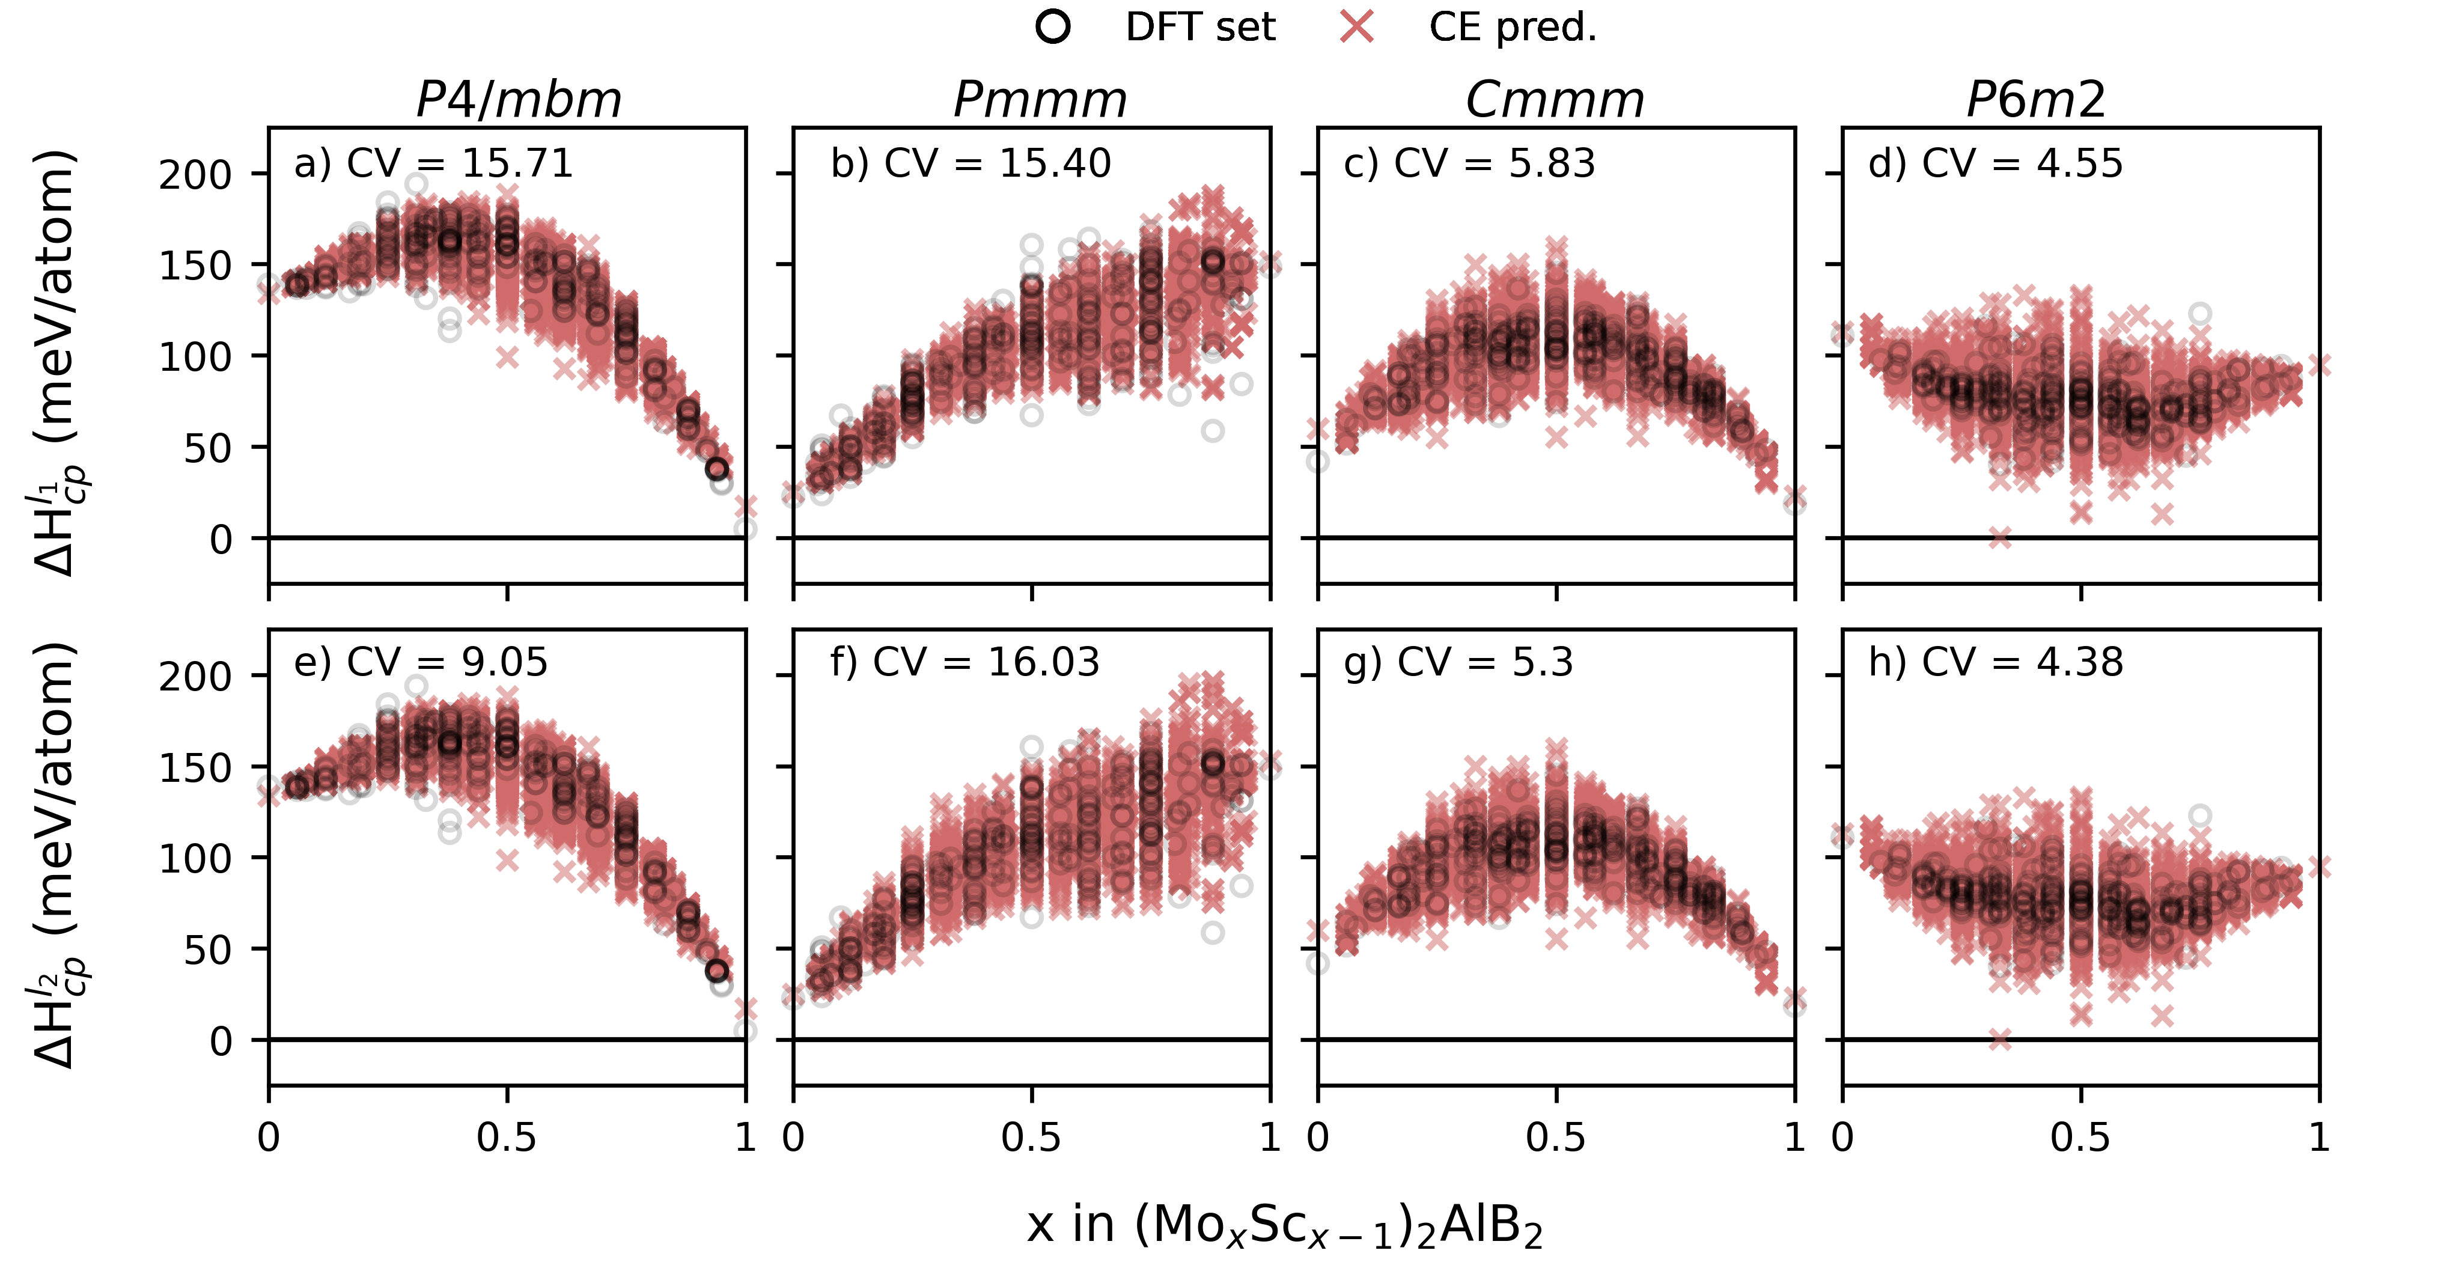
Figure S1. Stability calculations for (a-d) l₁ regularization and (e-h) l₂ regularization.
The accuracy of the models was determined by the cross-validation (CV) technique, or specifically by the leave-one-out CV (LOOCV)
$$CV= {\left(\frac{1}{N_{σ}}\sum_{i=1}^{N_{σ}}{{\left(E_{i}^{DFT}-E_{i}^{CE}\right)}^{2}}\right)}^{½}, (31)$$
where $N_{σ}$ is the number of predefined training configurations, $E_{i}^{DFT}$ is the calculated energy and $E_{i}^{CE}$ the predicted energy of phase $i$. The CLEASE code also offered training procedures to be conducted by the k-fold CV score. The k-fold CV score selects k randomly distributed subsets of the training set which each are used as test data whereas the remaining k-1 are used as training set.

Set of competing phases
Table S1. The set of competing phases considered within the Mo – Sc – Al – B system with their respectively energy. The phases are obtained from open databases such as OQMD [40, 41], Materials Project [42] and Springer materials [43]
Phase | Energy (eV)
Sc | -6.333
Mo | -10.850
Al | -3.745
B | -6.678
AlB₂ | -17.232
Mo₅AlB₂ | -73.670
Mo₄AlB₆ | -91.416
Mo₃AlB₄ | -66.369
MoAlB | -22.621
MoAl₁₂ | -57.303
MoAl₅ | -31.001
Mo4Al₁₇ | -112.563
Mo₃Al₈ | -66.170
Mo₃Al | -37.228
MoB₃ | -32.114
Mo₂B₅ | -54.585
MoB₂ | -25.031
MoB₂ | -25.507
MoB₂ | -25.502
MoB | -18.505
MoB | -18.527
Mo₃B₂ | -47.755
Mo₂B | -29.313
Sc₂Al | -17.458
ScAl | -10.973
ScAl₂ | -15.277
ScAl₃ | -19.383
ScB₂ | -22.199
ScB₁₂ | -89.210
Sc₅AlB₂ | -51.304
Sc₄AlB₆ | -77.258
Sc₃AlB₄ | -55.086
ScAlB | -18.059

Table S2. The set of most competing phases within the (Mo_{x}Sc_{1-x})₂AlB₂ system for every considered number of x.
x | Set of most competing phases | Energy (eV/atom) | x | Set of most competing phases | Energy (eV/atom)
0 | ScAl, ScB₂ | -6.634 | 0.64 | Mo₃Al, ScB₂, Mo₃Al₈, MoB | -7.692
0.06 | ScAl, Mo₃Al, ScB₂, ScAl₂ | -6.742 | 0.67 | Mo₃Al, ScB₂, Mo₃Al₈, MoB | -7.728
0.07 | ScAl, Mo₃Al, ScB₂, ScAl₂ | -6.758 | 0.69 | Mo₃Al, ScB₂, Mo₃Al₈, MoB | -7.760
0.08 | ScAl, Mo₃Al, ScB₂, ScAl₂ | -6.778 | 0.7 | Mo₃Al, ScB₂, Mo₃Al₈, MoB | -7.779
0.1 | ScAl, Mo₃Al, ScB₂, ScAl₂ | -6.807 | 0.71 | Mo₃Al, ScB₂, Mo₃Al₈, MoB | -7.801
0.11 | ScAl, Mo₃Al, ScB₂, ScAl₂ | -6.826 | 0.72 | Mo₃Al, ScB₂, Mo₃Al₈, MoB | -7.813
0.12 | ScAl, Mo₃Al, ScB₂, ScAl₂ | -6.850 | 0.75 | Mo₃Al, ScB₂, Mo₃Al₈, MoB | -7.855
0.14 | ScAl, Mo₃Al, ScB₂, ScAl₂ | -6.881 | 0.78 | Mo₃Al, ScB₂, Mo₃Al₈, MoB | -7.898
0.17 | ScAl, Mo₃Al, ScB₂, ScAl₂ | -6.922 | 0.79 | Mo₃Al, ScB₂, Mo₃Al₈, MoB | -7.910
0.19 | ScAl, Mo₃Al, ScB₂, ScAl₂ | -6.957 | 0.8 | Mo₃Al, ScB₂, Mo₃Al₈, MoB | -7.932
0.2 | ScAl, Mo₃Al, ScB₂, ScAl₂ | -6.979 | 0.81 | ScB₂, Mo₃Al₈, MoB | -7.951
0.21 | ScAl, Mo₃Al, ScB₂, ScAl₂ | -7.004 | 0.83 | MoAlB, ScB₂, Mo₃Al₈, MoB | -7.982
0.22 | ScAl, Mo₃Al, ScB₂, ScAl₂ | -7.017 | 0.86 | MoAlB, ScB₂, Mo₃Al₈, MoB | -8.017
0.25 | ScAl, Mo₃Al, ScB₂, ScAl₂ | -7.065 | 0.88 | MoAlB, ScB₂, Mo₃Al₈, MoB | -8.044
0.28 | ScAl, Mo₃Al, ScB₂, ScAl₂ | -7.113 | 0.89 | MoAlB, ScB₂, Mo₃Al₈, MoB | -8.065
0.29 | ScAl, Mo₃Al, ScB₂, ScAl₂ | -7.127 | 0.9 | MoAlB, ScB₂, Mo₃Al₈, MoB | -8.081
0.3 | Mo₃Al, ScB₂, ScAl₂ | -7.151 | 0.92 | MoAlB, ScB₂, Mo₃Al₈, MoB | -8.106
0.31 | Mo₃Al, ScB₂, Mo₃Al₈, ScAl₂ | -7.171 | 0.93 | MoAlB, ScB₂, Mo₃Al₈, MoB | -8.124
0.33 | Mo₃Al, ScB₂, Mo₃Al₈, ScAl₂ | -7.205 | 0.94 | MoAlB, ScB₂, Mo₃Al₈, MoB | -8.137
0.36 | Mo₃Al, ScB₂, Mo₃Al₈, ScAl₂ | -7.243 | 1 | MoAlB, MoB | -8.230
0.38 | Mo₃Al, ScB₂, Mo₃Al₈, ScAl₂ | -7.272
0.39 | Mo₃Al, ScB₂, Mo₃Al₈, ScAl₂ | -7.294
0.4 | Mo₃Al, ScB₂, Mo₃Al₈, ScAl₂ | -7.312
0.42 | Mo₃Al, ScB₂, Mo₃Al₈, ScAl₂ | -7.339
0.43 | Mo₃Al, ScB₂, Mo₃Al₈, ScAl₂ | -7.358
0.44 | Mo₃Al, ScB₂, Mo₃Al₈, ScAl₂ | -7.372
0.5 | Mo₃Al, ScB₂, Mo₃Al₈ | -7.473
0.56 | Mo₃Al, ScB₂, Mo₃Al₈, MoB | -7.569
0.58 | Mo₃Al, ScB₂, Mo₃Al₈, MoB | -7.600
0.6 | Mo₃Al, ScB₂, Mo₃Al₈, MoB | -7.626
0.61 | Mo₃Al, ScB2, Mo3Al₈, MoB | -7.643
0.62 | Mo₃Al, ScB₂, Mo₃Al₈, MoB | -7.664

CV convergence CE models
The convergence of CV score versus the increased number of considered DFT structures within the training set for different cross validation techniques, k-fold with 25, 10 and 5 different iterations as well the leave-one-out-CV (LOOCV) score for three different databases denoted as d1, d2 and d3. The convergence test is conducted for both the $P\overline{6}m2$ and $Cmmm$ symmetries. This is shown Figure S2. Both symmetries are observed to converge after including 300 structures within the training set for all considered validation techniques. The $P\overline{6}m2$ and $Cmmm$ symmetries converged towards a CV score of ~7 and ~5 meV/atom, respectively.
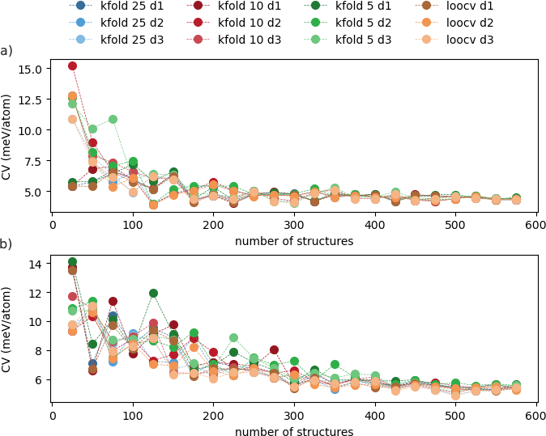
Figure S2. The convergence of the CV score for (a) $P\overline{6}m2$ and (b) Cmmm symmetries. The considered validation techniques are k-fold with 25, 10 and 5 iterations and the LOOCV score for three different databases d1, d2 and d3. The score is converged to 5 meV after including 300 structures within the training set.

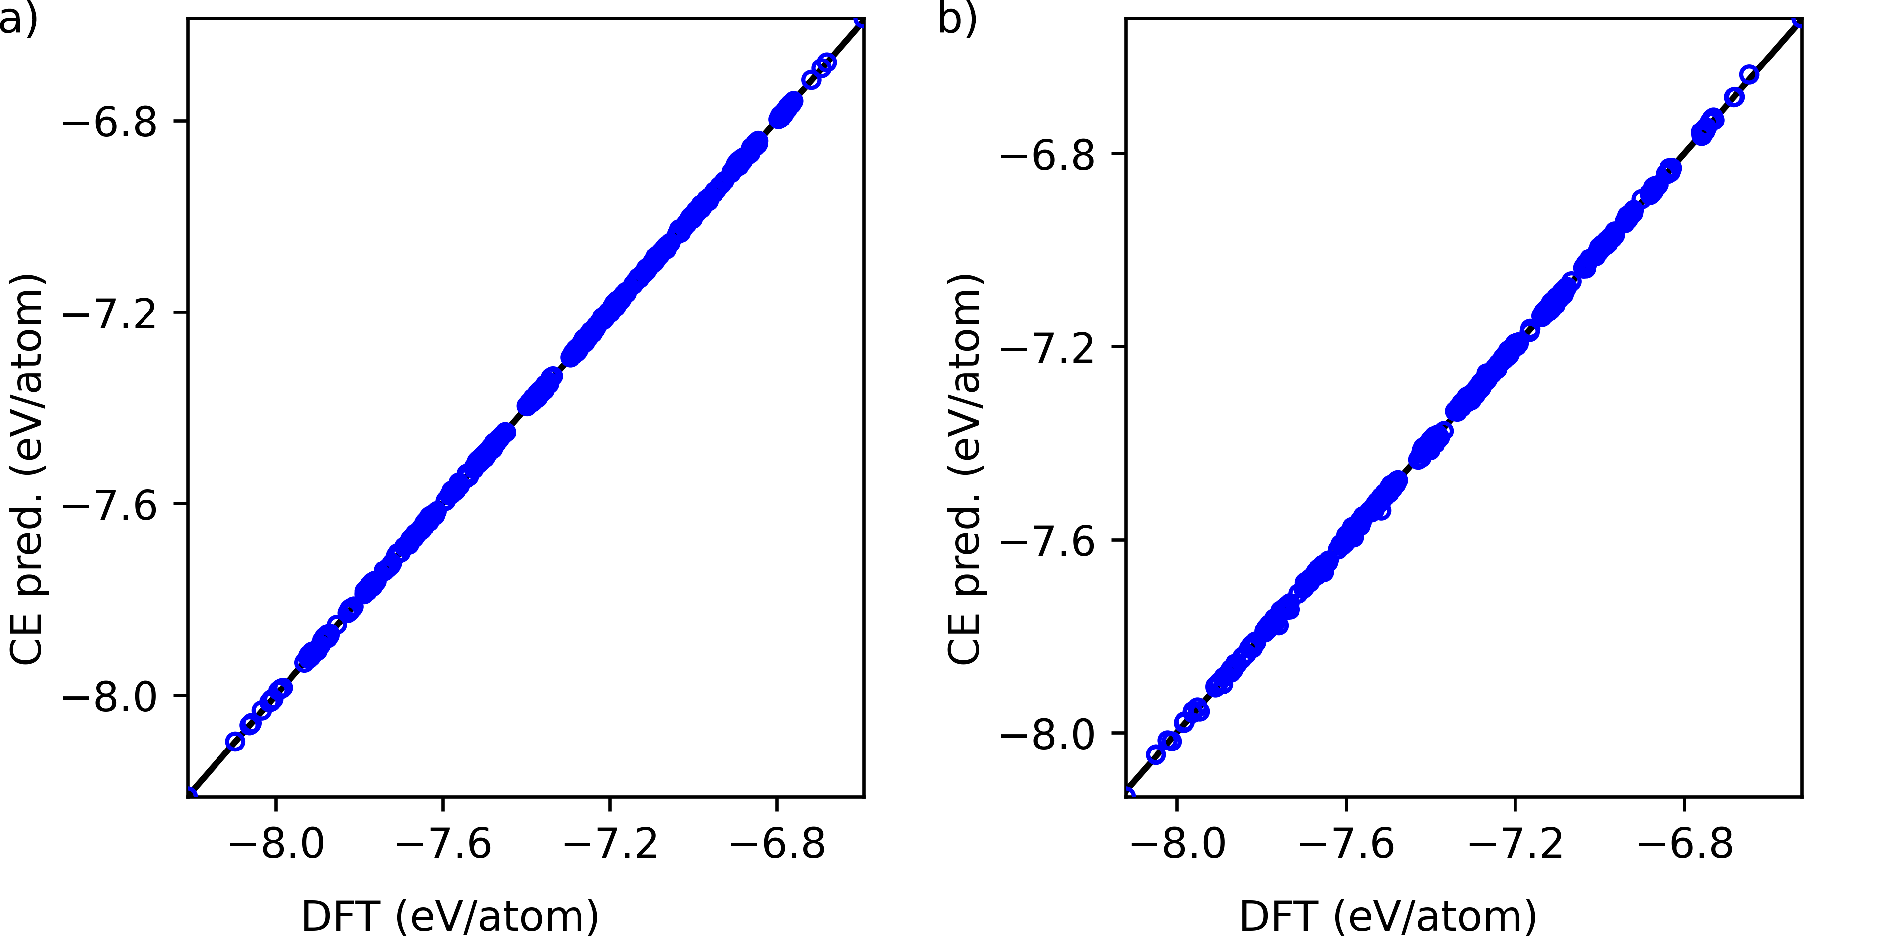
Figure S3 The calculated DFT energies as a function of the predicted energies of the CE model for the training set governing (a) the Cmmm and (b) P$\overline{6}$m2 symmetries.

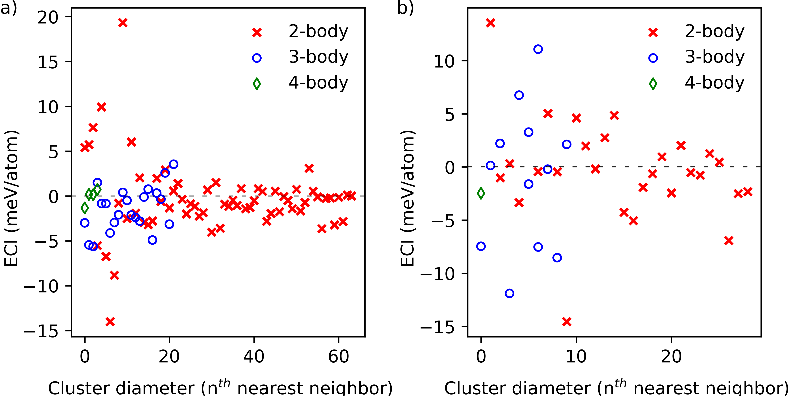
Figure S4 The ECIs for the 2-, 3- and 4-body interactions for the (a) Cmmm and the (b) P$\overline{6}$m2 symmetries.

Variational composition CSP search with increased limits.
The energy limits increased to 300 meV/atom is illustrated in Figure S5 to further illustrate the predicted energies of the variational composition search using USPEX. Red crosses represent calculated stability of individual phases whereas blue circles represent the stability of the best individual. The convex hull is illustrated with a dashed line.
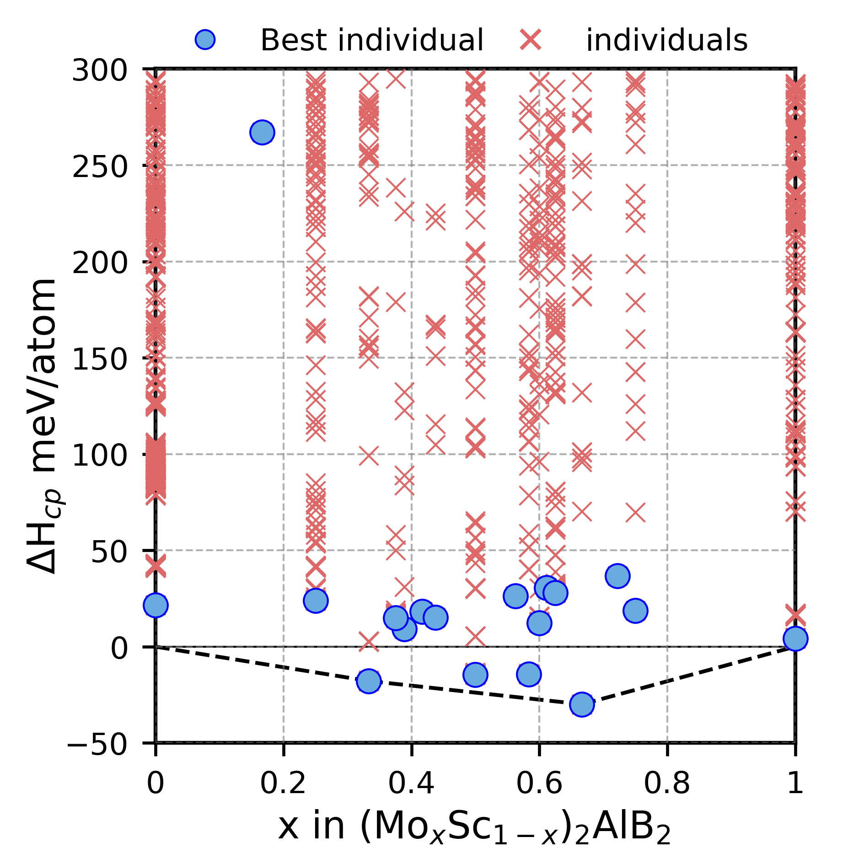
Figure S5. $∆H_{cp}$ as function of x in (Mo_{x}Sc_{1-x})₂AlB₂ for predicted low-energy structures at selected compositions.

Low energy structures from the CSP
Figure S6 demonstrates three crystal structures obtained from the CSP search. The initial structure illustrated in Figure S6a is the lowest energy symmetry found when running CSP search for the (Mo_{x}Sc_{1-x})₂AlB₂ system where x = 0.67 without any seed structures. Figure S6b-c shows the structures obtained from the variational composition search with negative formation enthalpies ($∆H_{cp}<0$). Blue denotes Mo, red Sc, grey Al, and green B.
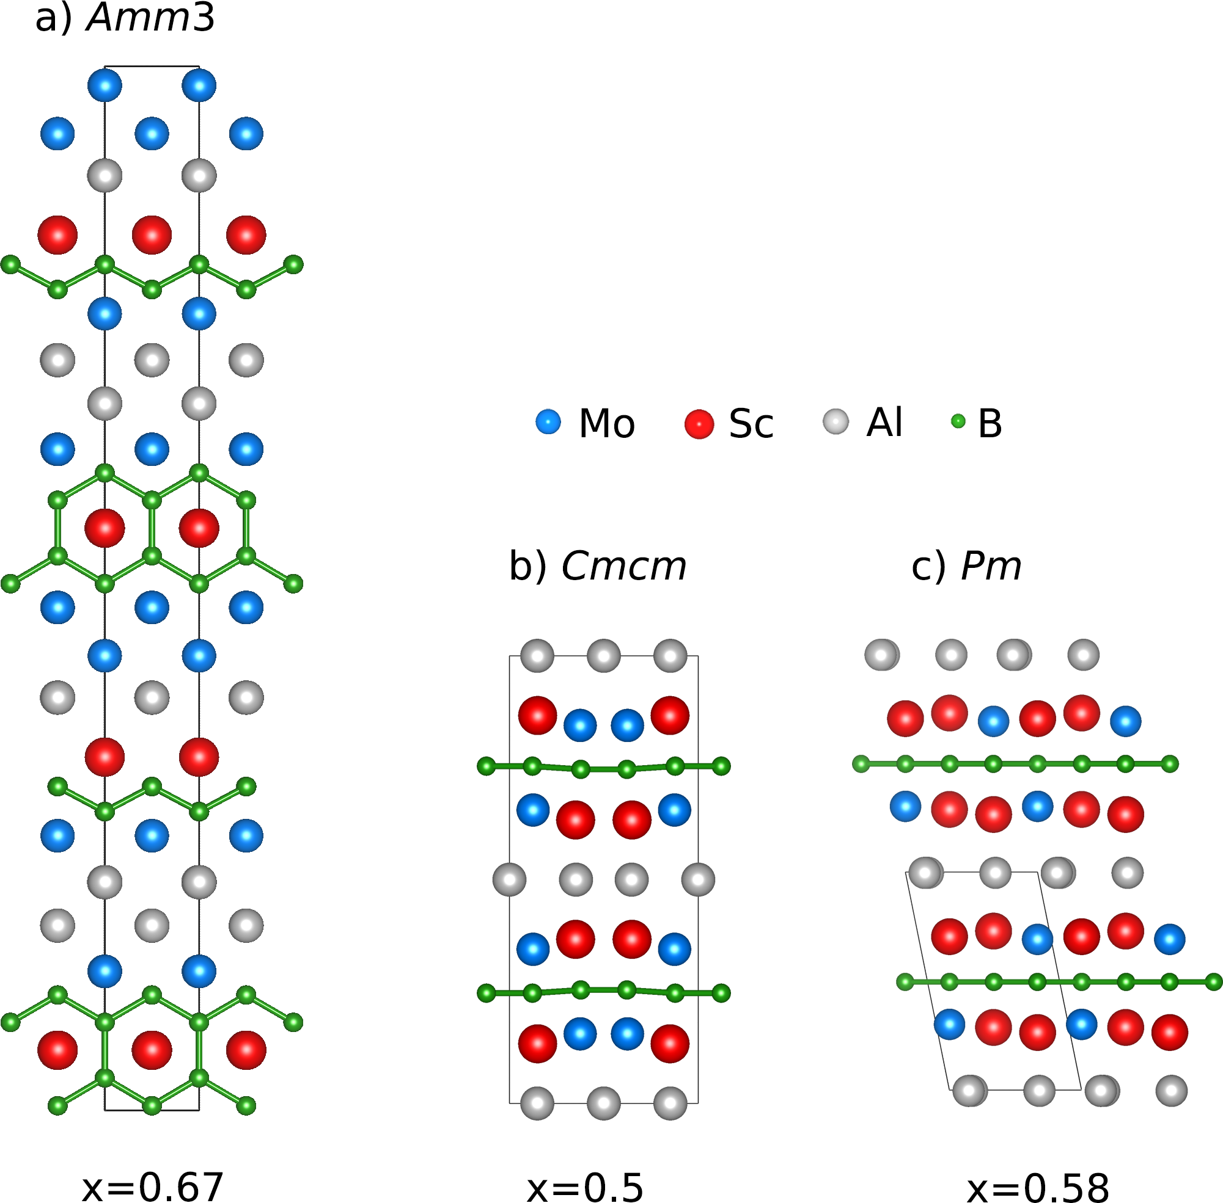
Figure S6. Schematic illustrations of the nonstable low energy predicted crystal structures. (a) shows the crystal structure obtained by the CSP of for the (Mo_{x}Sc_{1-x})₂AlB₂ system where x = 0.67 without seeds. (b) and (c) illustrates the structures obtained from the variational composition search with $∆H_{cp}<0$.
The crystal structure displayed in Figure S6a illustrates a stoichiometry resembling a combination of a MAB and M₄AB₄ compositions considered in [50] with a mixture of double layered A-layers and M-layers. In addition, the symmetry belongs to the orthorhombic family of crystal structure in contrast to the i-MAB Mo_{4/3}Sc_{2/3}AlB₂ which belongs to the trigonal family. Additional structural information of illustrated structure in Figure 7a is given in Table S3. Furthermore, the predicted low energy structures with both $∆H_{cp}<0$ meV/atom but not located on the convex hull are displayed in Figure S6b-c for x = 0.5 and 0.58 in (Mo_{x}Sc_{1-x})₂AlB_{2.}
Table S3. Structural information for the predicted low energy structure using USPEX without any seed structures applied for the (Mo_{x}Sc_{1-x})₂AlB₂ system.
x | Compound | Space group | $∆H_{cp}$ (meV/atom) | Lattice parameters (Å) | Atom  (Wyckoff site) | Fractional coordinates
x | Compound |  | $∆H_{cp}$ (meV/atom) | Lattice parameters (Å) | Atom  (Wyckoff site) | x | y | z
2/3 | Mo₄Sc₂Al₃B₆ | Amm2 | 29 | a = 3.25412  b = 3.13846  c = 34.78349 | Mo1 (2b)  Mo2 (2b)  Mo3 (2a)  Mo4 (2a)  Sc1 (2b)  Sc2 (2a)  Al1 (2b)  Al2 (2a)  Al3 (2a)  B1 (2b)  B2 (2b)  B3 (2b)  B4 (2b)  B5 (2a)  B6 (2a) | 0.50000 0.50000 0.00000 0.00000 0.50000 0.00000 0.50000 0.00000 0.00000 0.50000 0.50000 0.50000 0.50000 0.00000 0.00000 | 0.00000 0.00000 0.00000 0.00000 0.00000 0.00000 0.00000 0.00000 0.00000 0.00000 0.00000 0.00000 0.00000 0.00000 0.00000 | 0.76311 0.43545 -0.01829 0.13319 0.33839 0.55767 0.67702 0.89537 0.21864 0.03118 0.50449 0.08435 0.61056 0.28620 0.81020

