Identification of Lilium ledebourii antiproliferative compounds against skin, bone, and oral cancer cells
Medicinal Chemistry Research
Nastaran Partovi¹, Hassan Hassani Kumleh¹*, Ebrahim Mirzajani², Mohsen Farhadpour³
Plant Biotechnology Department, Faculty of Agricultural Sciences, University of Guilan, Rasht 4199613776, Iran
2 Department of Biochemistry, Faculty of Medicine, Guilan University of Medical Sciences, Rasht, Iran
³ Medicinal Plants and Drugs Research Institute, Shahid Beheshti University, G.C., Evin, Tehran, Iran

*Corresponding author
Hassan Hassani Kumleh
E-mail: kumleh@guilan.ac.ir

 | Cell lines
 | HGF-1 | A431 | G292 | KB
Control | 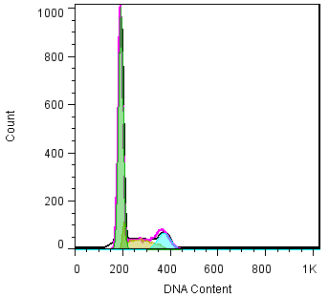 | 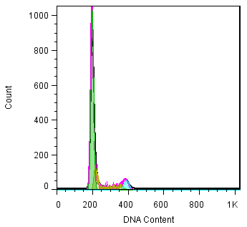 | 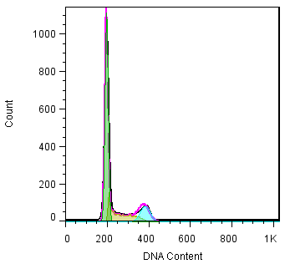 | 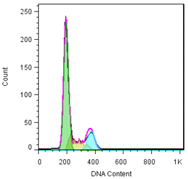
Lm | 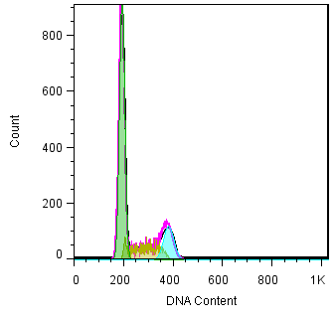 | 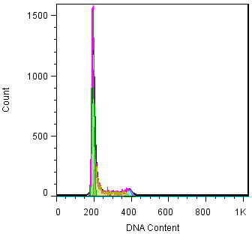 | 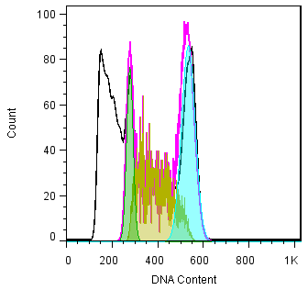 | 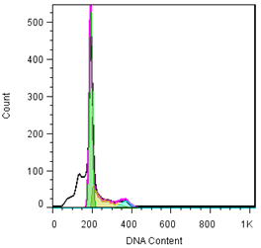
Pe | 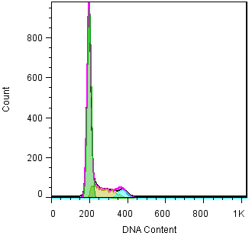 | 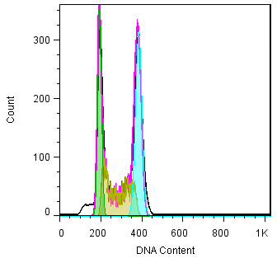 | 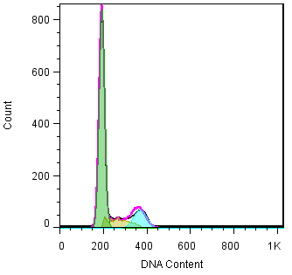 | 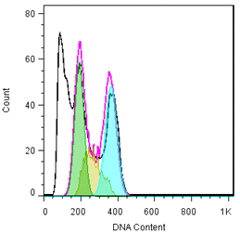
Loe | 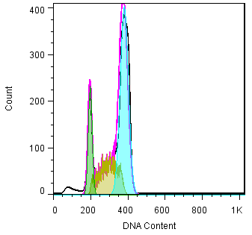 | 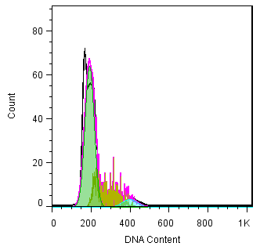 | 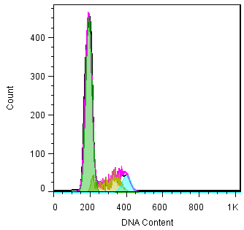 | 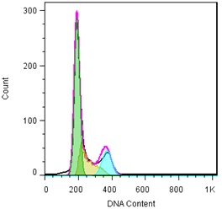
Ce | 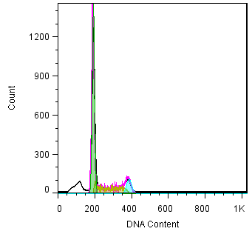 | 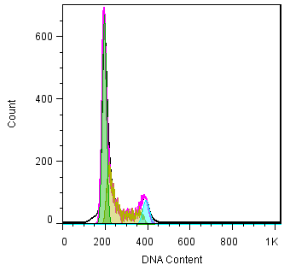 | 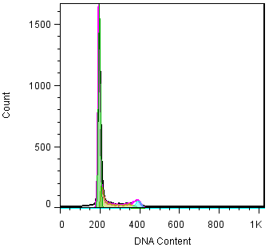 | 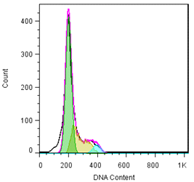

Fig. S2 Cell cycle analysis by flow cytometry on cancer (MCF-7, A431 and U87-MG) and normal (HGF-1) cell lines. Different phases of cell cycle were determined. Lm: Methanolic extract of L. ledebourii bulbs; Pe: Ethanolic extract of P. quinquefolia leaves; Loe: Ethanolic extract of L. nummularifolia leaves; Ce: Ethanolic extract of C. radicans leaves.

