Supplementary material for the article

“Natural inhibitors for severe acute respiratory syndrome coronavirus 2 main protease from Moringa oleifera, Aloe vera and Nyctanthes arbor-tristis: Molecular docking and ab initio fragment molecular orbital calculations”

Divya Shaji¹, Ryo Suzuki¹, Shohei Yamamoto¹, Daisuke Orihashi¹, and Noriyuki Kurita^{1,}*

¹Department of Computer Science and Engineering, Toyohashi University of Technology,
Tempaku-cho, Toyohashi, Aichi, 441-8580, Japan.

*Corresponding author
Noriyuki Kurita, Associate professor, Ph.D.
Department of Computer Science and Engineering
Toyohashi University of Technology
Tempaku-cho, Toyohashi, Aichi, 441-8580, Japan
E-mail: kurita@cs.tut.ac.jp
Tel. & Fax.: +81-532-44-6875

Contents

Table S1. Chemical properties of the 12 compounds extracted from Moringa oleifera [23]. Their PubChem ID, molecular weight (MW), number of rotatable bonds (RB), number of H-bond acceptors (HBA), number of H-bond donors (HBD), octanol-water partition coefficient (LogP), and total polar surface area (TPSA) calculated by SwissADME web tool [33]. The number of rotatable bonds (RB) is counted by omitting the bonds connected to the hydrogen atoms.

Table S2. This table lists the PubChem ID and chemical properties of the compounds extracted from Aloe vera, including the molecular weight (MW), number of rotatable bonds (RB), number of H-bond acceptors (HBA), number of H-bond donors (HBD), octanol-water partition coefficient (LogP), and total polar surface area (TPSA) calculated by SwissADME web tool [33]. The RB number omits the bonds connected to the hydrogen atoms.

Table S3. This table lists the PubChem ID and chemical properties of the compounds extracted from Nyctanthes arbor-tristis, including the molecular weight (MW), number of rotatable bonds (RB), number of H-bond acceptors (HBA), number of H-bond donors (HBD), octanol-water partition coefficient (LogP), and total polar surface area (TPSA) calculated using the SwissADME web tool [33]. The RB number omits the bonds connected to the hydrogen atoms.

Table S4. Lowest binding energy (BE: kcal/mol), number of poses, and Mpro residues involved in H-bonds for each compound extracted from Moringa oleifera [23] for the selected clusters obtained by the AutoDock4.2.6 program [40]. The created 256 poses were classified into several clusters based on their structural similarity, and each cluster was ranked in the order of BE between Mpro and each compound. We selected three clusters with the largest number of poses and evaluated their total inter fragment interaction energy (IFIE: kcal/mol) between each compound and all Mpro residues using the FMO method. These values are listed in the last column.

Table S5 The total inter-fragment interaction energy (IFIE; kcal/mol) between each proposed compound based on M12 and all Mpro residues using the FMO method. The proposed compounds are defined as the compounds M12a−M12f, based on the site to be replaced by a hydroxyl group. For example, in compound M12a, the hydrogen atom in the a-site of compound M12 was replaced by a hydroxyl group.

Figure S1. Chemical structures of the 12 compounds extracted from Moringa oleifera [23].

Figure S2. (a) Inter fragment interaction energies (IFIEs) between Mpro residues and M12. The difference in IFIEs between (b) compounds M12 and M12c, and (c) compounds M12 and M12d. The red bars indicate the residues with IFIE difference, the size of which is larger than 5 kcal/mol. These residues interact more strongly with the compounds M12c/M12d compared with that of the compound M12.

Figure S3. The interaction structures between compounds M12/M12c/M12d (ball-and-stick models) and the important Mpro residues (stick models): (a) M12, (b) M12c, and (c) M12d. The red and blue lines indicate the hydrogen bond and electrostatic interactions, respectively. The replaced hydroxyl group in the M12c and M12d is indicated by a green circle.

Table S1. Chemical properties of the 12 compounds extracted from Moringa oleifera [23]. Their PubChem ID, molecular weight (MW), number of rotatable bonds (RB), number of H-bond acceptors (HBA), number of H-bond donors (HBD), octanol-water partition coefficient (LogP), and total polar surface area (TPSA) calculated by SwissADME web tool [33]. The number of rotatable bonds (RB) is counted by omitting the bonds connected to the hydrogen atoms.

Compound | PubChem  ID | MW  (g/mol) | RB | HBA | HBD | LogP | TPSA  ( Å²)
(M1) Morphine | 5288826 | 285.3 | 0 | 4 | 2 | 1.41 | 52.93
(M2) Kaempferol | 5280863 | 286.2 | 1 | 6 | 4 | 1.58 | 111.13
(M3) Quercetin | 5280343 | 302.2 | 1 | 7 | 5 | 1.23 | 131.36
(M4) Pterygospermin | 72201063 | 406.5 | 4 | 2 | 0 | 3.75 | 89.12
(M5) Benzoic acid | 243 | 122.1 | 1 | 2 | 1 | 1.44 | 37.30
(M6) Gallic acid | 370 | 170.1 | 1 | 5 | 4 | 0.21 | 97.99
(M7) Benzyl isothiocyanate | 2346 | 149.2 | 2 | 1 | 0 | 2.91 | 44.45
(M8) Niazirin | 129556 | 279.3 | 3 | 6 | 3 | 0.20 | 102.94
(M9) Niaziminin | 10023860 | 399.5 | 9 | 7 | 3 | 1.47 | 138.57
(M10) Niazinin | 10088810 | 343.4 | 6 | 6 | 4 | 0.59 | 132.50
(M11) O-Ethyl N-carbamothioate | 10247749 | 357.4 | 7 | 6 | 4 | 0.97 | 132.50
(M12) Niazirinin | 10426197 | 321.3 | 5 | 7 | 2 | 0.82 | 109.01

Table S2. This table lists the PubChem ID and chemical properties of the compounds extracted from Aloe vera, including the molecular weight (MW), number of rotatable bonds (RB), number of H-bond acceptors (HBA), number of H-bond donors (HBD), octanol-water partition coefficient (LogP), and total polar surface area (TPSA) calculated by SwissADME web tool [33]. The RB number omits the bonds connected to the hydrogen atoms.

Compound | PubChem  ID | MW  (g/mol) | RB | HBA | HBD | LogP | TPSA  (Å²)
(A1) anthranol | 10731 | 194.2 | 0 | 1 | 1 | 3.41 | 20.23
(A2) chrysophanol | 10208 | 254.2 | 0 | 4 | 2 | 2.38 | 74.6
(A3) emodin | 3220 | 270.2 | 0 | 5 | 3 | 1.87 | 94.83
(A4) aloesaponarin_II | 3085033 | 254.2 | 0 | 4 | 2 | 2.08 | 74.6
(A5) aloe_emodin | 10207 | 270.2 | 1 | 5 | 3 | 1.5 | 94.83
(A6) aloesaponarin_I | 11098986 | 312.3 | 2 | 6 | 2 | 2.28 | 100.9
(A7) eupatorin | 97214 | 344.3 | 4 | 7 | 2 | 2.53 | 98.36
(A8) feralolide | 5317333 | 344.3 | 3 | 7 | 4 | 2.06 | 124.29
(A9) caffeic_acid | 689043 | 180.2 | 2 | 4 | 3 | 0.93 | 77.76
(A10) ferulic_acid | 445858 | 194.2 | 3 | 4 | 2 | 1.36 | 66.76
(A11) umbelliferone | 5281426 | 162.1 | 0 | 3 | 1 | 1.51 | 50.44
(A12) esculetin | 5281416 | 178.1 | 0 | 4 | 2 | 1.12 | 70.67
(A13) salicylic_acid | 338 | 138.1 | 1 | 3 | 2 | 1.24 | 57.53
(A14) uric_acid | 1175 | 168.1 | 0 | 3 | 4 | -0.72 | 114.37

Table S3. This table lists the PubChem ID and chemical properties of the compounds extracted from Nyctanthes arbor-tristis, including the molecular weight (MW), number of rotatable bonds (RB), number of H-bond acceptors (HBA), number of H-bond donors (HBD), octanol-water partition coefficient (LogP), and total polar surface area (TPSA) calculated using the SwissADME web tool [33]. The RB number omits the bonds connected to the hydrogen atoms.

Compound | PubChem  ID | MW  (g/mol) | RB | HBA | HBD | LogP | TPSA  (Å²)
(N1) Decanal | 8175 | 156.26 | 8 | 1 | 0 | 2.70 | 17.07
(N2) Pelargonic acid | 8158 | 158.24 | 7 | 2 | 1 | 2.28 | 37.30
(N3) Myristic acid | 11005 | 228.37 | 12 | 2 | 1 | 3.69 | 37.30
(N4) Eucarvone | 136330 | 150.22 | 0 | 1 | 0 | 2.10 | 17.07
(N5) Methyl salicylate | 4133 | 152.15 | 2 | 3 | 1 | 1.32 | 46.53
(N6) Methyl anthranilate | 8635 | 151.16 | 2 | 2 | 1 | 1.32 | 52.32
(N7) Dibutyl phthalate | 3026 | 278.34 | 10 | 4 | 0 | 3.43 | 52.60
(N8) Anthocyanin | 145858 | 207.25 | 1 | 1 | 0 | 3.28 | 13.14
(N9) Apigenin | 5280443 | 270.24 | 1 | 5 | 3 | 0.52 | 90.90

Table S4. Lowest binding energy (BE: kcal/mol), number of poses, and Mpro residues involved in H-bonds for each compound extracted from Moringa oleifera [23] for the selected clusters obtained by the AutoDock4.2.6 program [40]. The created 256 poses were classified into several clusters based on their structural similarity, and each cluster was ranked in the order of BE between Mpro and each compound. We selected three clusters with the largest number of poses and evaluated the total inter fragment interaction energy (IFIE: kcal/mol) between each compound and all Mpro residues using the FMO method. These values are listed in the last column.

Compound | Cluster | BE | Poses | Residues involved in H-bonds | IFIE
M1 | 2 | −5.18 | 141 | Glu166 | −41.4
M1 | 3 | −5.13 | 77 | Gln189 | −67.0
M1 | 5 | −4.82 | 33 | Thr24, Thr26 | −66.3
M2 | 1 | −4.65 | 52 | Thr24, Thr26, Asn142, His163 | −55.0
M2 | 2 | −4.58 | 131 | Thr26, Leu141, Gly143, Ser144, His164 | −64.6
M2 | 3 | −4.56 | 42 | Leu141, Gly143, Ser144, Cys145, Glu166 | −94.6
M3 | 2 | −3.95 | 31 | Thr25, Thr26, Thr45, Ser144 | −86.8
M3 | 7 | −3.87 | 60 | Thr26, Leu141, Gly143, Ser144, Glu166 | −83.3
M3 | 10 | −3.61 | 37 | Thr24, Thr26, Leu141, Asn142, Gly143 | −58.7
M4 | 1 | −6.64 | 193 | No H-bond | −72.9
M4 | 2 | −6.46 | 25 | No H-bond | −73.1
M4 | 4 | −5.74 | 18 | Glu166 | −83.9
M5 | 1 | −3.49 | 85 | Glu166 | −25.9
M5 | 2 | −3.46 | 94 | Leu141, Gly143, Ser144 | −50.5
M5 | 3 | −3.38 | 77 | Glu166, Gln189 | −19.5
M6 | 1 | −3.12 | 62 | Leu141, Gly143, His163, Glu166 | −112.0
M6 | 2 | −2.81 | 41 | Asn142, Glu166 | −95.0
M6 | 3 | −2.76 | 69 | Thr24, Thr26, Cys44, Thr45, Ser46 | −57.4
M7 | 1 | −4.25 | 181 | No H-bond | −35.7
M7 | 2 | −4.17 | 50 | No H-bond | −37.1
M7 | 3 | −3.99 | 25 | No H-bond | −30.6
M8 | 2 | −4.39 | 28 | Glu166, His172 | −105.1
M8 | 3 | −4.11 | 22 | Glu166 | −94.7
M8 | 10 | −3.83 | 57 | Thr26, Phe140, Gly143, Glu166 | −66.5
M9 | 1 | −4.95 | 28 | Thr26, Gln189 | −108.2
M9 | 3 | −4.78 | 24 | His41, Asn142, His164, Glu166, Gln189 | −92.3
M9 | 6 | −4.02 | 30 | Gly143, Glu166, Gln189 | −136.5
M10 | 2 | −4.58 | 67 | Asn142, His164, Glu166, Gln189 | −106.1
M10 | 9 | −3.85 | 25 | Thr26, Gly143, Gln189 | −77.3
M10 | 14 | −3.67 | 24 | Thr26, Gly143, His164 | −75.1
M11 | 1 | −4.33 | 36 | His164, Glu166 | −97.0
M11 | 2 | −4.28 | 40 | Asn142, His164, Glu166, Gln189 | −63.7
M11 | 5 | −3.81 | 40 | Thr26, Gly143, Gln189 | −72.5
M12 | 1 | −5.41 | 37 | Gly143, Glu166, Gln189, Thr190 | −111.0
M12 | 2 | −5.11 | 42 | Asn142, Glu166 | −119.0
M12 | 3 | −4.87 | 29 | Asn142, Gly143, Glu166, Gln189 | −107.1

Table S5. The total inter-fragment interaction energy (IFIE; kcal/mol) between each proposed compound based on M12 and all Mpro residues evaluated using the FMO method. The proposed compounds are defined as the compounds M12a−M12f, based on the site to be replaced by a hydroxyl group. For example, in compound M12a, the hydrogen atom in the a-site of compound M12 was replaced by a hydroxyl group.

Compound | Total IFIE
M12 | −125.6
M12a | −113.8
M12b | −116.8
M12c | −145.9
M12d | −142.1
M12e | −111.8
M12f | −120.1

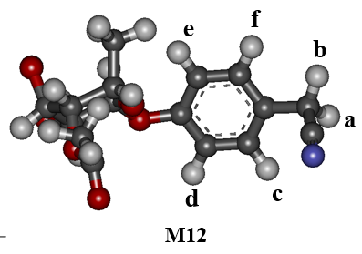

Figure S1. Chemical structures of the 12 compounds extracted from Moringa oleifera [23].
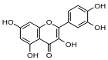
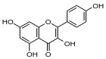
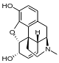
(M1) Morphine (M2) Kaempferol (M3) Quercetin
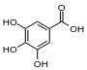
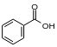
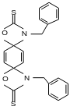
(M4) Pterygospermin (M5) Benzoic acid (M6) Gallic acid
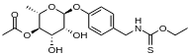
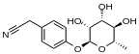
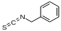

(M7) Benzyl isothiocyanate (M8) Niazirin (M9) Niaziminin

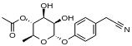
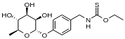
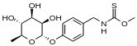

(M10) Niazinin (M11) O-Ethyl N-carbamothioate (M12) Niazirinin

Figure S2. (a) Inter fragment interaction energies (IFIEs) between Mpro residues and M12. The difference in IFIEs between (b) compounds M12 and M12c, and (c) compounds M12 and M12d. The red bars indicate the residues with IFIE difference, the size of which is larger than 5 kcal/mol. These residues interact more strongly with the compounds M12c/M12d compared with that of the compound M12.

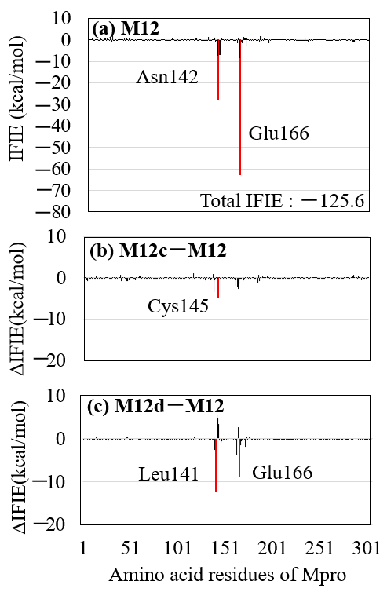

Figure S3. The interaction structures between the compounds M12/M12c/M12d (ball-and-stick models) and the important Mpro residues (stick models): (a) M12, (b) M12c, and (c) M12d. The red and blue lines indicate the hydrogen bond and electrostatic interactions, respectively. The replaced hydroxyl group in the compounds M12c and M12d is indicated by a green circle.

