Supplementary information
Heteroployacid stabilized on the composite of boehmite and polyionic liquid as a versatile catalyst for alcohol oxidation and tandem alcohol oxidation /Knoevenagel condensation reactions
Neda Abedian-Dehaghani¹, Samahe Sadjadi^{2*}, Majid M. Heravi^{*1}

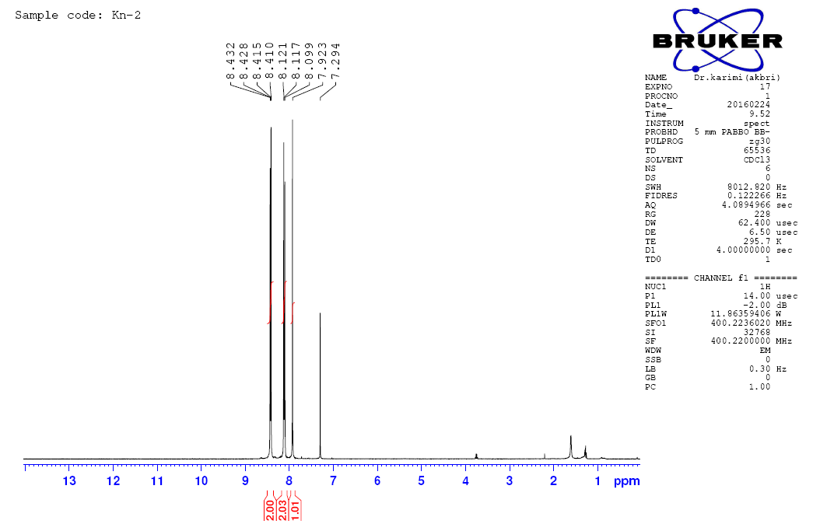

Figure S1. ¹HNMR spectrum of 2-(4-nitrobenzylidene)malononitrile
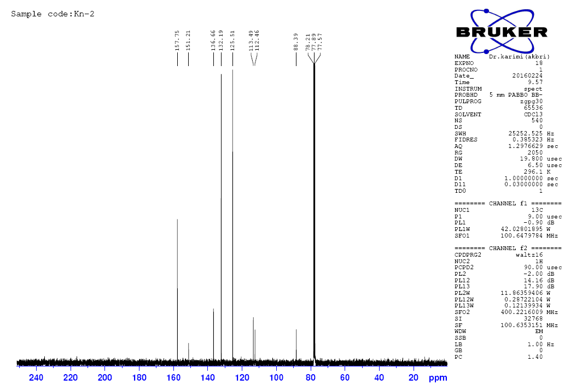

Figure S2. ¹³CNMR spectrum of 2-(4-nitrobenzylidene)malononitrile

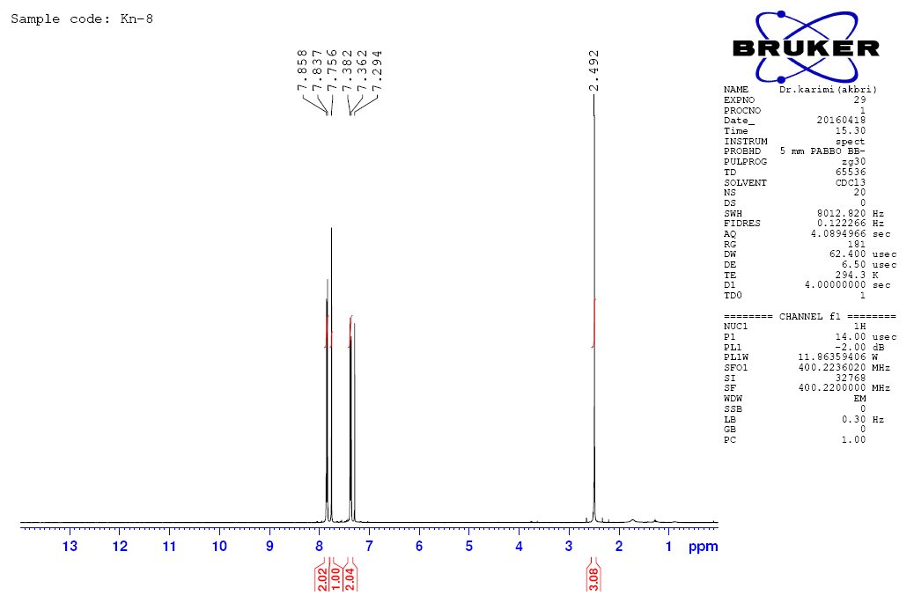

Figure S3. ¹HNMR spectrum of 2-(4-methylbenzylidene)malononitrile

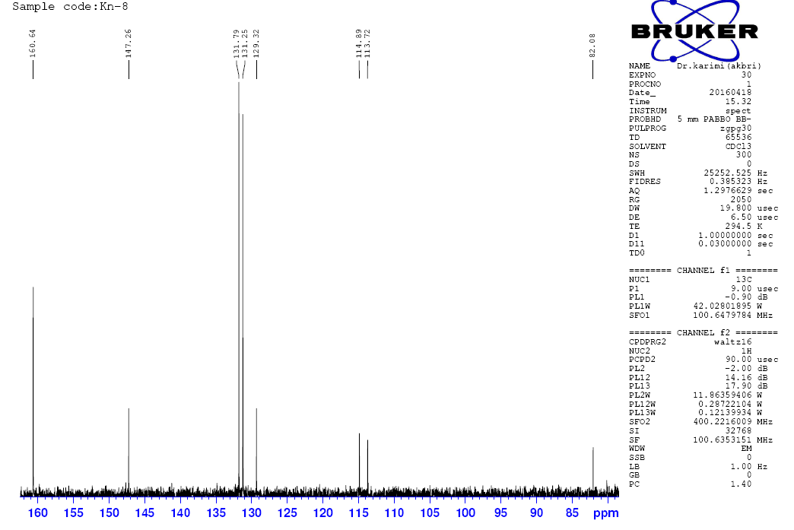
Figure S4. ¹³CNMR spectrum of 2-(4-methylbenzylidene)malononitrile

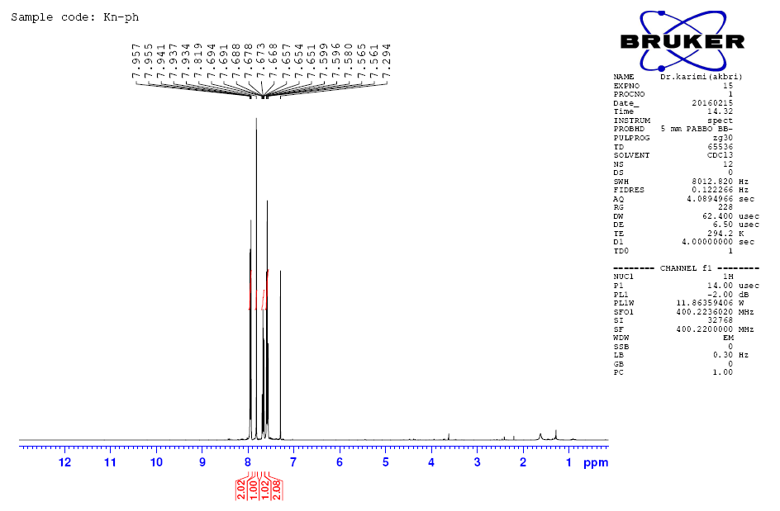

Figure S5. ¹HNMR spectrum of 2-benzylidenemalononitrile

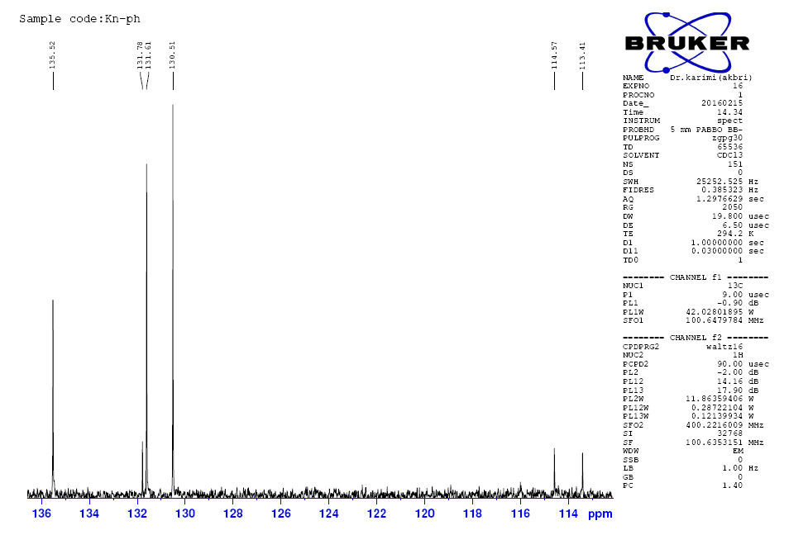
Figure S6. ¹³CNMR spectrum of 2-benzylidenemalononitrile

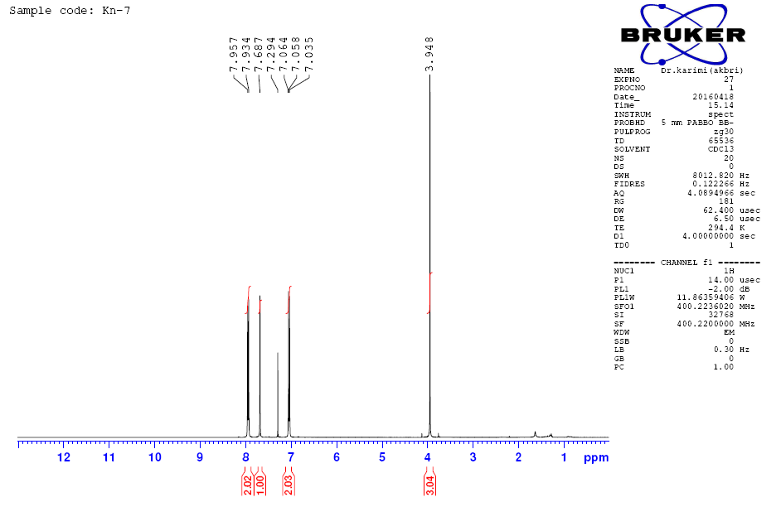
Figure S7. ¹HNMR spectrum of 2-(4-methoxybenzylidene)malononitrile

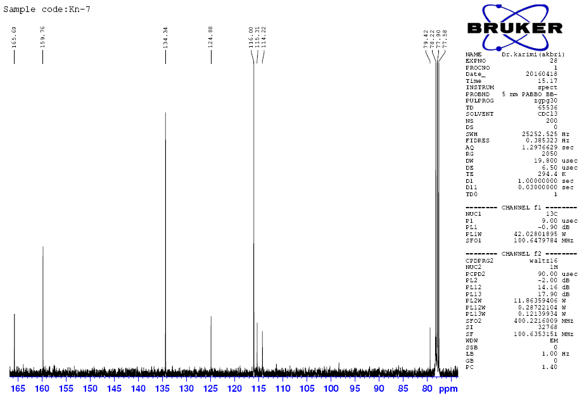
Figure S8. ¹³CNMR spectrum of 2-(4-methoxybenzylidene)malononitrile

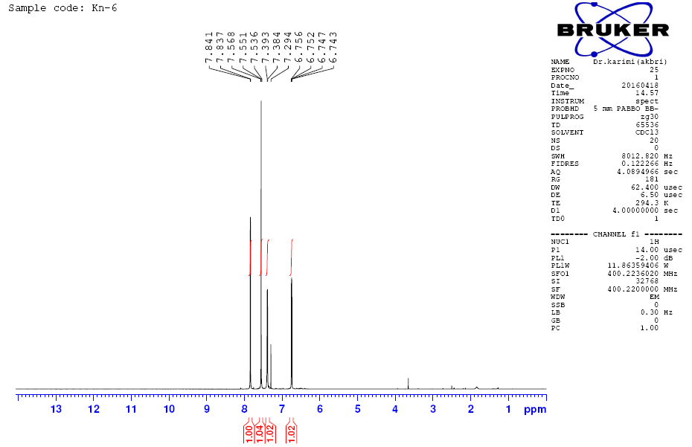

Figure S9. ¹HNMR spectrum of 2-(furan-2-ylmethylene)malononitrile

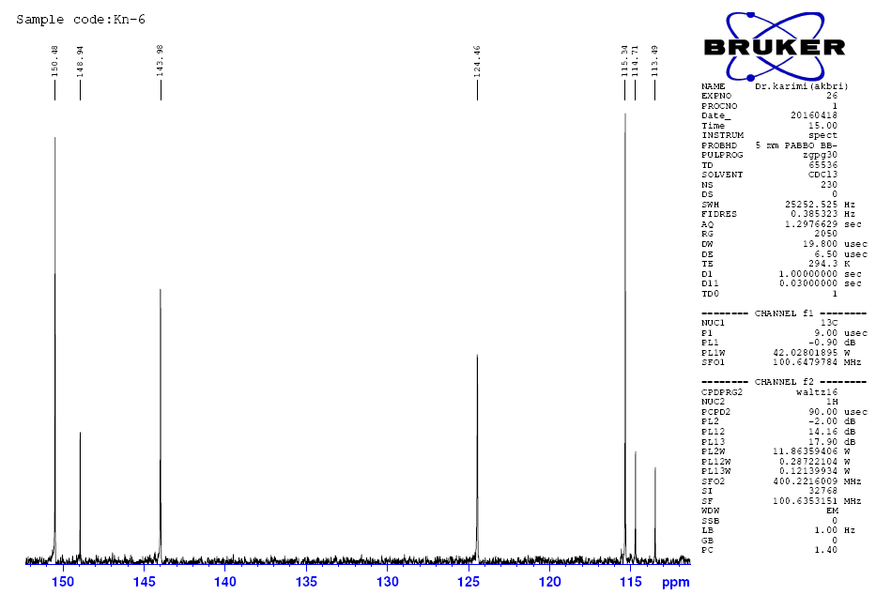

Figure S10. ¹³CNMR spectrum of 2-(furan-2-ylmethylene)malononitrile

