Table 1: All measurements taken for each CT phantom trial on GS, PACS, and Hologram
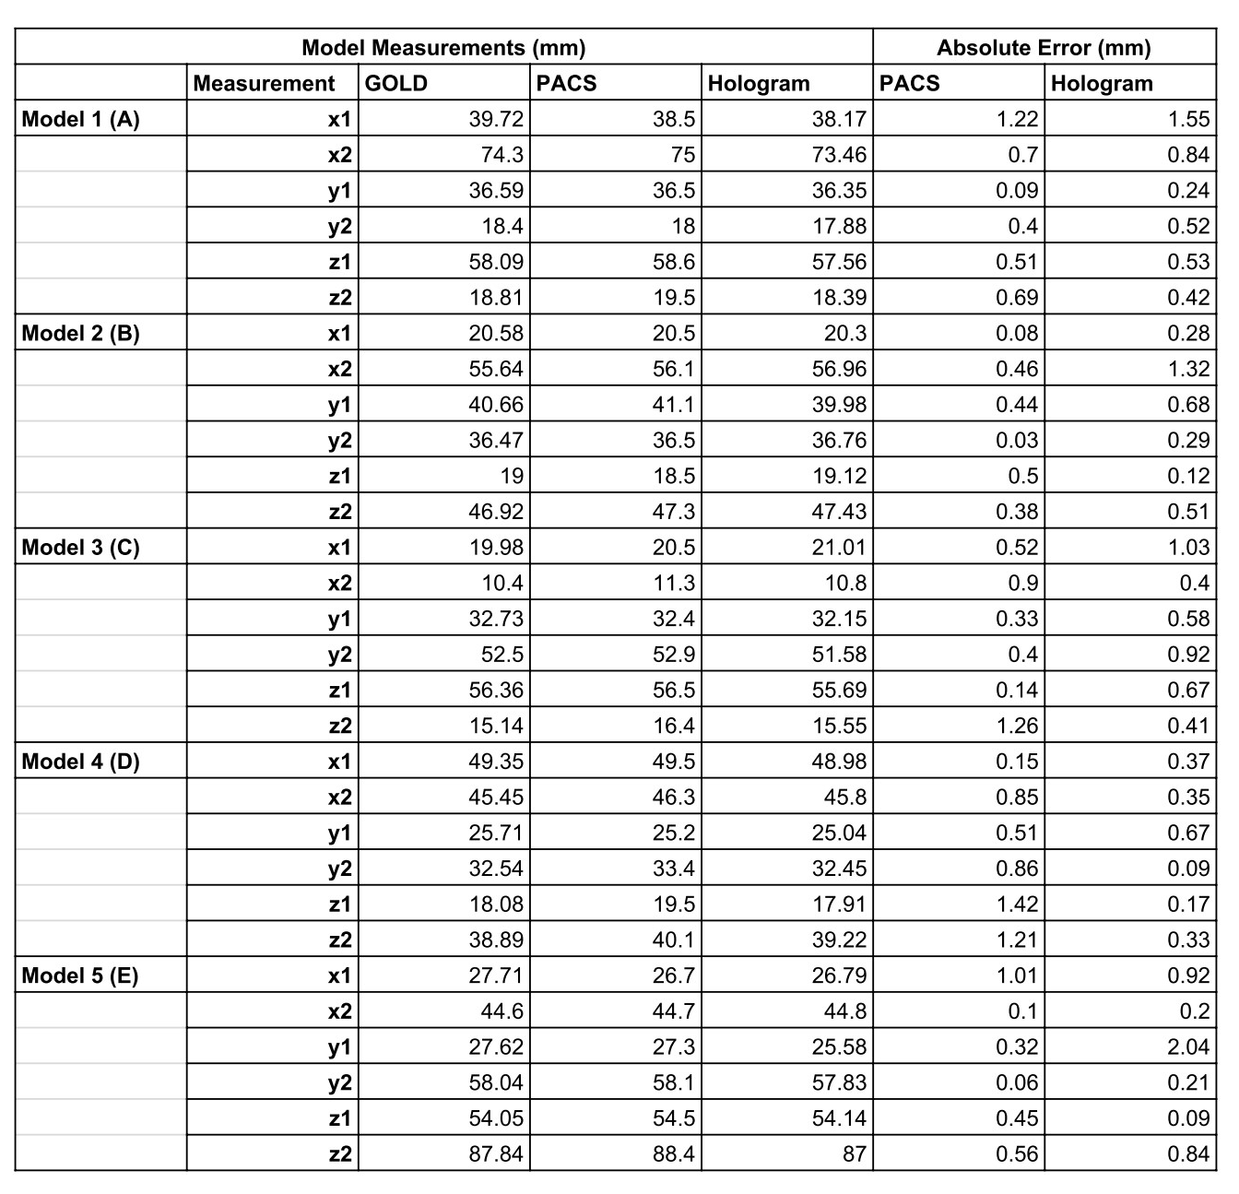
Table 2: Comparison of absolute error between PACS and hologram measurements.

