Supplementary Materials
Assessment the effect of graphene and graphene oxide on antibiotic resistance genes during copper-contained swine manure anaerobic digestion.

Authors:
Ranran Zhang^{a,b,c,*}, Jimin Li^{b} , Liuyuan Zhouª, Haifeng Zhuang^{a,c}, Sihan Shenª, YuhengWang^{b,**}

Affiliations and addresses:
ªSchool of Environmental and Natural Resource, Zhejiang University of Science and Technology, Hangzhou, Zhejiang 310023,China.
^{b}School of Ecology and Environment, Northwestern Polytechnical University, Xi’an, Shaanxi 710129, China.
^{c}Recycling and Eco-treatment of Waste Biomass of Zhejiang Provincial Key Laboratory, Zhejiang University of Science and Technology, Hangzhou, Zhejiang 310023,China.

Corresponding Author: Ranran Zhang, YuhengWang
Correspondence to: Y. Wang, School of Ecology and Environment, Northwestern Polytechnical University, Xi’an, Shaanxi710129, China.
Email addresses: rrzhang2109@163.com(R. Zhang), yuheng.wang@nwpu.edu.cn(Y.Wang)

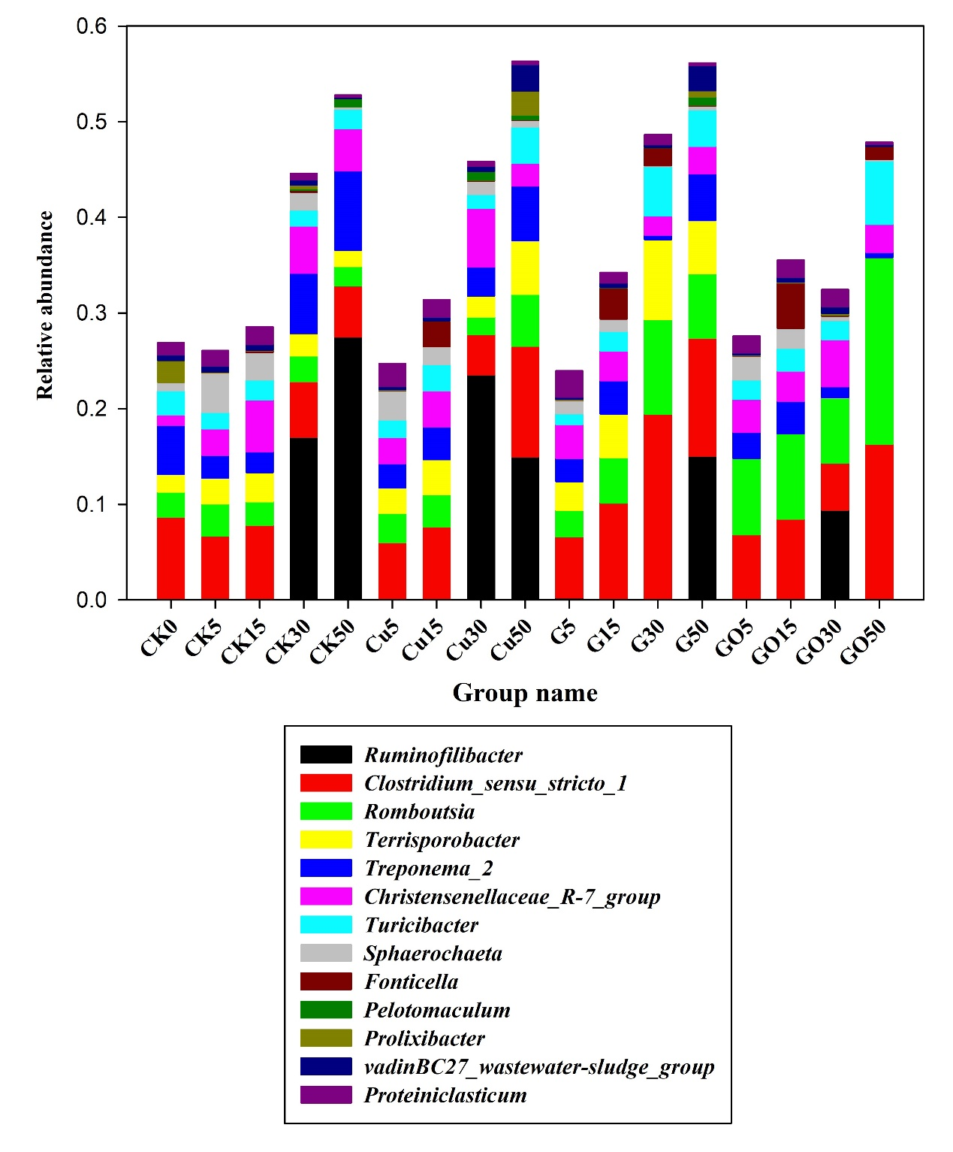
Fig. S1Changes in the 13 genus in the bacterial communities in different treatments during anaerobic digestion.

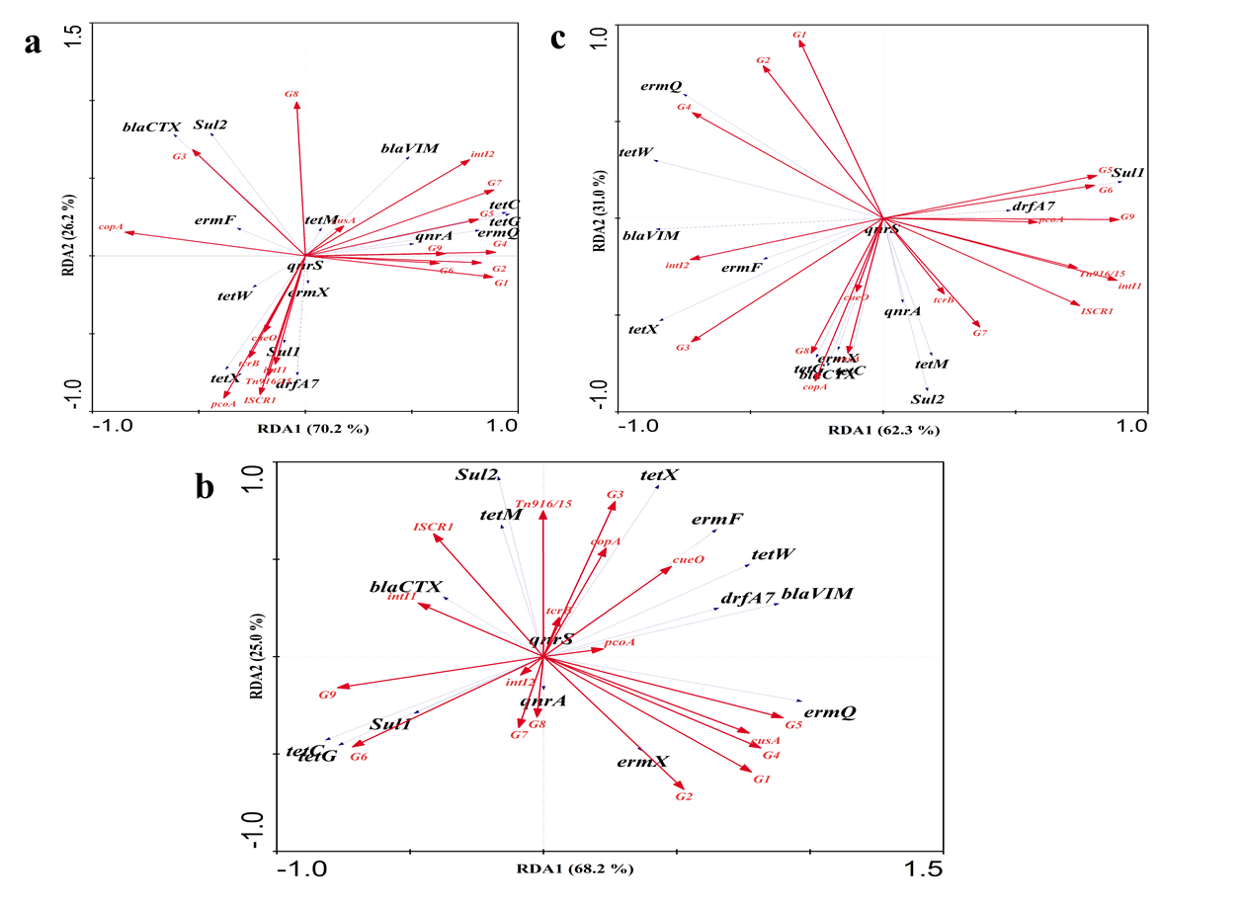
Fig.S2. Redundancy analysis results showing the relationships between bacterial community (9 genus in network), five HMRGs, and four MGEs with ARGs in anaerobic digestion of (a) Cu, (b)G and (c)GO treatments.
Note: G1: Clostridium_sensu_stricto_1; G2:Turicibacter; G3:Christensenellaceae_R-7_group; G4:Romboutsia; G5:Terrisporobacter; G6:Prolixibacter; G7: vadinBC27_wastewater-sludge_group; G8:Ruminofilibacter; G9:Treponema_2.

Table S1 PCR primers
Gene  name | Primer | Size ( bp ) | Annealing temperature (°C) | source
copA | F:TGCACCTGACVGGSCAYAT  R: GVACTTCRCGGAACATRCC | 324 | 60 | Li et al., 2012
pcoA | F: GCTGCAGATGGCCAGTATGTAAA  R: CCCTCGAGCGTAACCGGTCC | 147 | 60 | Xiong et al., 2015
cueO | F: ATGGATATGGAACGGATGAA  R: ATTGCTACAGATGGTGGTT | 420 | 50 | Zhang et al., 2016
cusA | F: ATGCSACVGGYGTTGGCTGG  R: CCRTTCAGYTCGGCRATRCC | 410 | 60 | Besaury et al., 2013
tcrB | F:CATCACGGTAGCTTTAAGGAGATTTTC  R: ATAGAGGACTCCGCCACCATTG | 663 | 55 | Hasman et al., 2006
tetC | F: GCGGGATATCGTCCATTCCG | 207 | 59 | Aminov et al., 2002
tetC | R: CCYGCAAGAGAAGCCAGAAG | 207 | 59 | Aminov et al., 2002
tetG | F: GCAGAGCAGGTCGCTGG  R: CCYGCAAGAGAAGCCAGAAG | 134 | 54 | Aminov et al., 2001
tetM | F: ACAGAAAGCTTATTATATAAC | 171 | 52 | Aminov et al., 2001
tetM | R: TGGCGTGTCTATGATGTTCAC | 171 | 52 | Aminov et al., 2001
tetW | F: GAGAGCCTGCTATATGCCAGC | 168 | 56 | Aminov et al., 2001
tetW | R: GGGCGTATCCACAATGTTAAC | 168 | 56 | Aminov et al., 2001
tetX | F: CAATAATTGGTGGTGGACCC | 468 | 55 | Ng et al., 2001
tetX | R: TTCTTACCTTGGACATCCCG | 468 | 55 | Ng et al., 2001
sul1 | F: CGGCGTGGGCTACCTGAACG | 433 | 60 | Frank et al., 2007
sul1 | R: GCCGATCGCGTGAAGTTCCG | 433 | 60 | Frank et al., 2007
sul2 | F: GCGCTCAAGGCAGATGGCATT | 293 | 59 | Frank et al., 2007
sul2 | R: GCGTTTGATACCGGCACCCGT | 293 | 59 | Frank et al., 2007
dfrA7 | F: AAATGGCGTAATCGGTAATG | 304 | 51 | Frank et al., 2007
dfrA7 | R: GTGAACAGTAGACAAATGAAT | 304 | 51 | Frank et al., 2007
intI 1 | F: CTGGATTTCGATCACGGCACG | 473 | 60 | Frank et al., 2007
intI 1 | R: ACATGCGTGTAAATCATCGTCG | 473 | 60 | Frank et al., 2007
intI2 | F: GTTATTTTATTGCTGGGATTAGGC  R: TTTTACGCTGCTGTATGGTGC | 166 | 55 | He et al., 2014
Tn916  /1545 | F: TCCTACAGCGACAGCCAGTGA  R: TGCGTTGCTTTGGTCTGCTGGT | 174 | 54 | Liu et al. 2014
ISCR1 | F: CGCCCACTCAAACAAACG  R: GAGGCTTTGGTGTAACCG | 452 | 54 | Liu et al. 2014
ermQ | F:CACCAACTGATATGTGGCTAG  R:CTAGGCATGGGATGGAAGTC | 154 | 60 | Mu et al., 2015
ermF | F: CGACACAGCTTTGGTTGAAC  R: GGACCTACCTCATAGACAAG | 309 | 56 | Chen et al., 2007
ermX | F: GAGATCGGRCCAGGAAGC  R: GTGTGCACCATCGCCTGA | 488 | 61 | Chen et al., 2007
qnrS | F: CCCCATGCCCGAAGTTATCA  R: ACTGCTTGGAGTGTGTTGGT | 457 | 53 | Xu et al. 2015
qnrA | F: AGAGGATTTCTCACGCCAGG  R: GCAGCACTATKACTCCCAAGG | 619 | 58 | Chen et al. 2012
blaVIM | F:CAGATTGCCGATGGTGTTTGG  R: AGGTGGGCCATTCAGCCAGA | 523 | 55 | Sonia et al., 2006
blaCTX-M | F:SCSATGTGCAGYACCAGTAA  R:CCGCRATATGRTTGGTGGTG | 450 | 55 | Sonia et al., 2006
16S V3 | F: CCTACGGGAGGCAGCAG | 193 | 55 | Aminov et al., 2002
16S V3 | R: ATTACCGCGGCTGCTGG | 193 | 55 | Aminov et al., 2002

References:
Aminov R I, Chee-Sanford J C, Garrigues N, et al. Development, validation, and application of PCR primers for detection of tetracycline efflux genes of gram-negative bacteria. Applied and Environmental Microbiology, 2002, 68, 1786–1793.
Aminov R N, Garrigues-Jeanjean N, Mackie R I. Molecular ecology of tetracycline resistance: development and validation of primers for detection of tetracycline resistance genes encoding ribosomal protection proteins. Applied and Environmental Microbiology, 2001, 67, 22–32.
Besaury, L., Bodilis, J., Delgas, F., Andrade, S., Iglesia, R.D.L., Ouddane, B., Quillet, L., 2013. Abundance and diversity of copper resistance genes cus A and cop A in microbial communities in relation to the impact of copper on Chilean marine sediments. Mar. Pollut. Bull. 67, 16-25.
Chen, J., Yu, Z., Michel, F.C., Wittum, T., Morrison, M., 2007. Development and application of real-time PCR assays for quantification of erm genes conferring resistance to macrolides-lincosamides-streptogramin b in livestock manure and manure management systems. Appl. Environ. Microbiol. 73(14), 4407-4416.
Chen X, Zhang W, Pan W, Yin J, Pan Z, Gao S, Jiao X. Prevalence of qnr, aac (6′)-Ib-cr, qepA, and oqxAB in Escherichia coli isolates from humans, animals, and the environment. Antimicrobial Agents and Chemotherapy, 2012, 56(6): 3423-3427.
Frank T, Gautier V, Talarmin A, Bercion R, Arlet G. Characterization of sulphonamide resistance genes and class 1 integron gene cassettes in Enterobacteriaceae, Central African Republic (CAR). Journal of Antimicrobial Chemotherapy, 2007, 59, 742–745.
Hasman, H., Kempf, I., Chidaine, B., Cariolet, R., Ersbøll, A.K., Houe, H., Bruun Hansen, H.C., Aarestrup, F.M., 2006. Copper resistance in Enterococcus faecium, mediated by the tcrB gene, is selected by supplementation of pig feed with copper sulfate. Appl. Environ. Microbiol. 72, 5784-5789.
He L Y, Liu Y S, Su H C, Zhao J L, Liu S S, Chen J, Liu W R, Ying G G. Dissemination of antibiotic resistance genes in representative broiler feedlots environments: identification of indicator ARGs and correlations with environmental variables. Environmental Science Technology, 2014, 48(22): 13120-13129.
Liu M, Ding R, Zhang Y, Gao Y, Tian Z, Zhang T, Yang M. Abundance and distribution of Macrolide-Lincosamide-Streptogramin resistance genes in an anaerobic-aerobic system treating spiramycin production wastewater. Water Research, 2014, 63: 33-41.
Li, X.F., Yin, H.B., Su, J.Q., 2012. An Attempt to Quantify Cu-Resistant Microorganisms in a Paddy Soil from Jiaxing, China. Pedosphere. 22, 201-205.
Mu, Q., Li, J., Sun, Y., Mao, D., Wang, Q., Luo, Y., Occurrence of sulfonamide-, tetracycline-, plasmid-mediated quinolone- and macrolide-resistance genes in livestock feedlots in northern china. Environmental Science & Pollution Research, 2015, 22(9), 6932-40.
Ng, L.K., Martin, I., Alfa, M., Mulvey, M., 2001. Multiplex PCR for the detection of tetracycline resistant genes. Mol. Cell. Probes 15(4), 209-215.
Sonia Ktari, Guillaume Arlet, BasmaMnif, Valérie Gautier, FouziaMahjoubi, Mounir Ben Jmeaa. (2006). Emergence of multidrug-resistant klebsiella pneumoniae isolates producing vim-4 metallo-β-lactamase, ctx-m-15 extended-spectrum β-lactamase, and cmy-4 ampc β-lactamase in a tunisian university hospital. Antimicrobial Agents & Chemotherapy, 50(12), 4198.
Xu Y, Yu W, Ma Q, Zhou H. Occurrence of (fluoro) quinolones and (fluoro) quinolone resistance in soil receiving swine manure for 11 years. Science of the Total Environment, 2015, 530: 191-197.
Xiong, W., Zeng, Z., Zhang, Y., Ding, X., Sun, Y., 2015. Fate of metal resistancegenes in arable soil after manure application in a microcosm study. Ecotoxicol.Environ. Saf. 113, 59-63.
Zhang J, Chen M, Sui Q, et al. Impacts of addition of natural zeolite or anitrification inhibitor on antibiotic resistance genes during sludge composting.[J].Water Research, 2016, 91(9):1286-91.

