Supplementary Materials for

High Resolution Cryo-TEM Structure of Fiber-like Micelles with a Crystalline Core
Jia Tian,^{1,5} Song-Hai Xie,³ Ufuk Borucu⁴, Shixing Lei,¹ Yifan Zhang,¹ and Ian Manners^{1,2}*
Affiliations:
*Correspondence to: imanners@uvic.ca

This PDF file includes:

Materials and Methods
Polymer Synthesis and Characterization
Block Copolymer Self-Assembly
Supplementary Figs. 1 to 17
References

Materials and Methods
All reagents and solvents used for polymers syntheses were of reagent grade unless otherwise stated were used as received. Solvents for self-assembly were of HPLC grade and filtered using 0.2 µm syringe filters prior to use.

Nuclear magnetic resonance (NMR)
¹H NMR spectra were recorded using Varian VNMR 400 MHz and JEOL ECS 400 MHz instruments. Chemical shifts are given in ppm and referenced to the residual protio solvent peaks as internal standards.

Gel permeation chromatography (GPC)
GPC was performed on a Viscotek GPCmax chromatograph using THF containing [n-Bu₄N]Br (0.1% w/w) as the eluent at a flow rate of 1 mL/min. Samples were prepared at 1 mg/mL in the eluent and filtered using Ministart SRP 15 polytetrafluoroethylene membrane filters (0.45 µm pore size). Fractionation was achieved using two T5000 columns (Malvern, UK) at a temperature of 35°C. The molecular weights were calculated based on signals from refractive index (RI) detectors, and using a calibration curve prepared from nine monodisperse polystyrene standards (2,330 – 994,000 g mol⁻¹).

Atomic-force microscopy (AFM)
AFM analyses were performed in ambient conditions using a Bruker Multimode VIII atomic force microscope equipped with a ScanAsyst-HR fast scanning module and a ScanAsyst-Air-HR probe (tip radius, 2 nm), utilizing peak force feedback control. Samples for AFM were prepared by drop casting 7 µL of micelle colloidal solution onto ultra-flat silicon wafer from Electron Microscopy Sciences before drying with a gentle stream of nitrogen.

X-ray diffraction
X-ray diffraction for structural analysis was carried out on an AXS D8 Discover (Bruker) diffractometer with a Si low background sample holder, equipped with a LynxEye strip detector and a Ge (111) focusing monochromator, providing CuKα1 (λ = 1.5406 Å) radiation. Reciprocal space maps were collected with a Pixcel 3D detector on an Empyrean diffractometer (Panalytical) equipped with a Cu Kα1 (λ = 1.5406 Å) source powered at 45 kV and 40 mA, and a primary Barthels monochromator.

Cryo-TEM image analysis using DigitalMicrograph
The cryo-TEM image analysis were performed using the Gatan DigitalMicrograph software (Gatan Inc. ver 2.3.1, 64bit free). A typical procedure to obtain the lattice spacing of PFS core or the adjacent strand distance of P4VP corona was described briefly below: (1) a high resolution cryo-TEM image was calibrated according to the known length of the scale bar; (2) a specific region of interest was selected in the image and a fast Fourier transform (FFT) was processed to obtain the reflection points of ordered structures; (3) a spot or an array was applied on the reflection points to remove the noise signals, and then a filtered FFT pattern was obtained; (4) the “Inverse FFT” function was applied to the filtered FFT pattern to obtain a computational simulation of the ordered structure; (5) the line profile of the simulated pattern was analyzed to give the lattice spacing of the PFS core or the adjacent strand distance of the P4VP corona.

Polymer Synthesis and Characterization
The synthesis of PFS₂₄ and PFS₂₄-b-P4VP₁₉₂ has been reported¹ and is not described here.
Synthesis of P4VP₁₇₃ homopolymer
To a solution of PMVS173 homopolymer (100 mg, 6.0 μmol) in dry THF (2 mL) in a Schlenk flask, PMVS173 homopolymer was synthesized according to the reported procedure,² 2,2-dimethoxy-2-phenylacetophenone (DMPA) (2.0 mg, 7.8 μmol) and 4-pyridylethylmercaptan (321 mg, 2.3 mmol) was added under N₂ atmosphere. After freeze-pump-thaw three times, the reaction mixture was irradiated by Luzchem LZC-ICH2 photoreactor with 16 UV lamps centered at approx. 350nm (8 Watt each) for 3 h at 23 °C. The reaction solution was dried and washed by diethyl ether (5 × 30 mL). The product was dried under vacuo to afford the polymer as a transparent viscous oil (214 mg, 84%). ¹H NMR (500 MHz, Chloroform-d): δ 8.48 (d, 346H, PyH), 7.16 – 6.89 (m, 346H, PyH), 2.85 – 2.52 (m, 1039H, CH2-S-CH2-CH2), 0.87 (t, 346H, CH3Si-CH2CH2-S), 0.57 (d, 2H, CH₃CH₂CH₂CH₂-Si), 0.49 (d, 3H, CH₃CH₂CH₂CH₂-Si), 0.11 (s, 520H, CH3Si-CH2CH2-S). GPC (1% v/v Triethylamine/THF, PS standard): Mn = 63,430 g/mol, PDI = 1.28.
Block Copolymer Self-Assembly
Preparation of polydisperse nanofibers from PFS₂₄-b-P4VP₁₉₂
To 0.2 mL of a solution of PFS₂₄-b-P4VP₁₉₂ copolymer (2.0 mg/mL in THF) was dropwise added 1.8 ml of isopropanol (IPA), resulting in a solution with a final concentration of 0.2 mg/ml (THF/IPA = 1:9). This was then shaken by a vortex agitator for 10 s and aged for 24 h at 23 °C to yield the polydisperse PFS₂₄-b-P4VP₁₉₂ nanofibers (Supplementary Fig. 3).
Preparation of seed micelles of PFS₂₄-b-P4VP₁₉₂
A solution of polydisperse PFS₂₄-b-P4VP₁₉₂ micelles (0.2 mg/mL, THF:IPA =1:9) was sonicated at 0 °C for 2.5 h (five 30-min periods) using an ultrasonic bath (Bandelin Sonorex Digitec DT 225H, 35 kHz, 160 W output). The solution was then aged at 23 °C for 24 h. This resulted in monodisperse seeds micelles (L_{n} = 29 nm, L_{w}/L_{n} = 1.09) (Supplementary Fig. 4b).
Formation of length-controlled PFS₂₄-b-P4VP₁₉₂ nanofibers by seeded growth
A specified amount of the solution of the seed micelles derived from PFS₂₄-b-P4VP₁₉₂ with an average length of 29 nm (100 μL, 50 μL, 33.3 μL, 25 μL, 16.7 μL, 0.2 mg/mL) was firstly diluted by isopropanol to 0.9 mL in a screw-cap vial. After the solution was manually shaken for a few seconds, PFS₂₄-b-P4VP₁₉₂ in THF (100 μL, 1 mg/ml) was quickly added, followed by manual shaking for another 20 s. The solutions were then allowed to age at 23 °C for 1 day resulting in solutions of PFS₂₄-b-P4VP₁₉₂ nanofibers of various lengths (Supplementary Fig. 4).

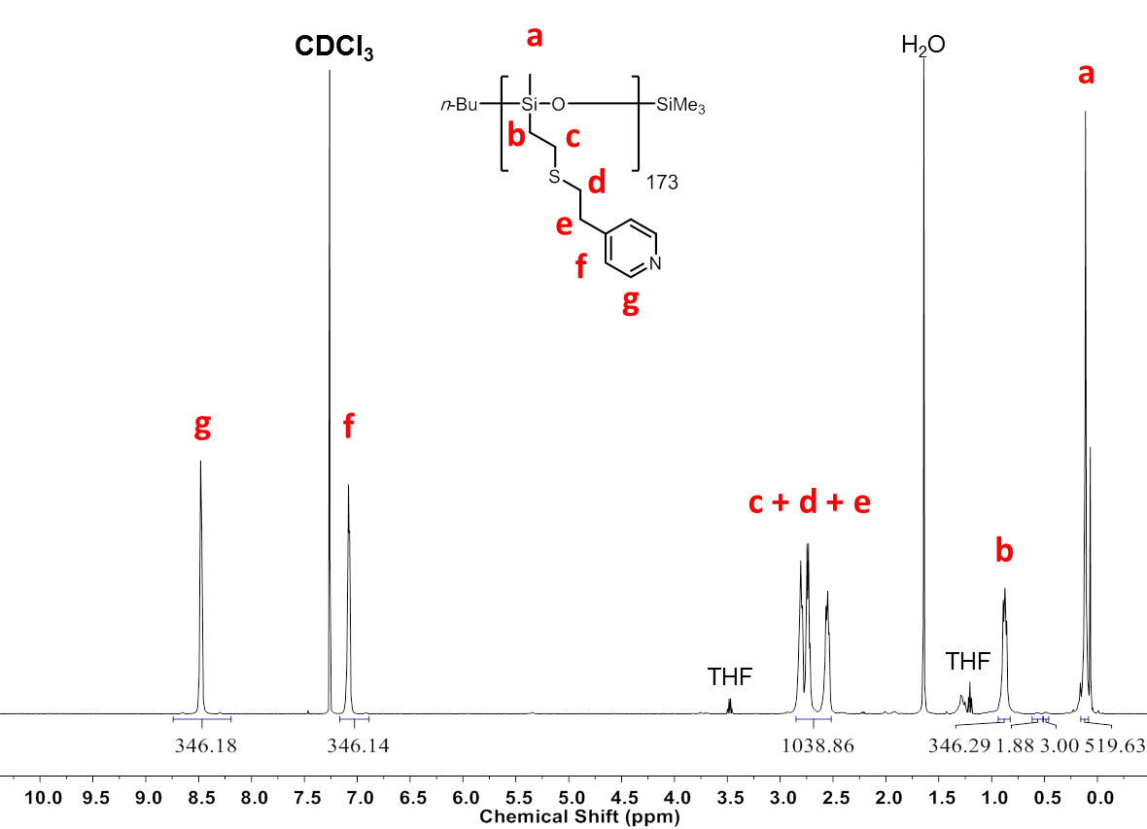
Supplementary Fig. 1. ¹H NMR spectrum of the “P4VP₁₇₃” homopolymer (a polysiloxane with grafted P4VP groups) in CDCl₃. By comparing the proton integrals of CH₃ of the n-Bu group (δ = 0.49 ppm, integration of 3.00) to the unique protons g (δ = 8.48 ppm, integration of 346.18) on the pyridine units, the degree of polymerization (DP) of the P4VP was estimated to be 173.

Supplementary Fig. 2. GPC chromatograms of P4VP₁₇₃ using a refractive index detector and THF containing Triethylamine (1% v/v) as the eluent.

Supplementary Fig. 3. TEM image of polydisperse PFS₂₄-b-P4VP₁₉₂ nanofibers formed by homogeneous nucleation in THF: IPA (1:9) over 24 h at 23°C after solvent evaporation.

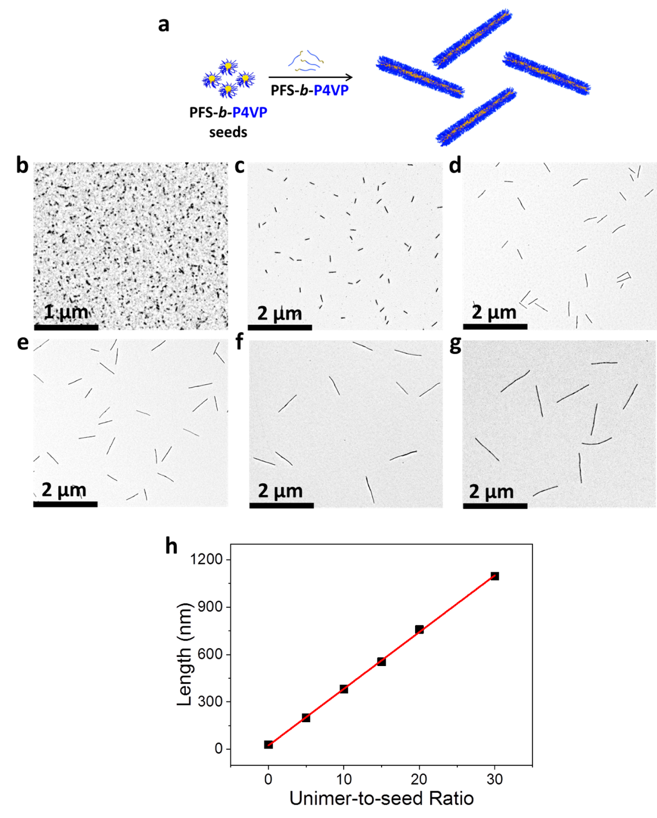
Supplementary Fig. 4. Uniform nanofibers of controlled length prepared by seeded growth of PFS₂₄-b-P4VP₁₉₂. (a) Schematic representation of the generation of length-controlled PFS₂₄-b-P4VP₁₉₂ nanofibers by seeded growth. (b) TEM images of uniform PFS₂₄-b-P4VP₁₉₂ seed micelles (L_{n} = 29 nm). TEM images of PFS₂₄-b-P4VP₁₉₂ nanofibers with (c) m_{unimer}/m_{seed} values of 5:1 (L_{n} = 199 nm), (d) 10:1 (L_{n} = 381 nm), (e) 15:1 (L_{n} = 555 nm), (f) 20:1 (L_{n} = 759 nm), (g) 30:1 (L_{n} = 1096 nm). Further details are given in Supplementary Fig. 5. (h) Dependence of the L_{n} on m_{unimer}/m_{seeds}.
Supplementary Fig. 5. Contour length distributions for PFS₂₄-b-P4VP₁₉₂ nanofibers of controlled length (PDI = L_{w}/L_{n}; standard deviation = σ).

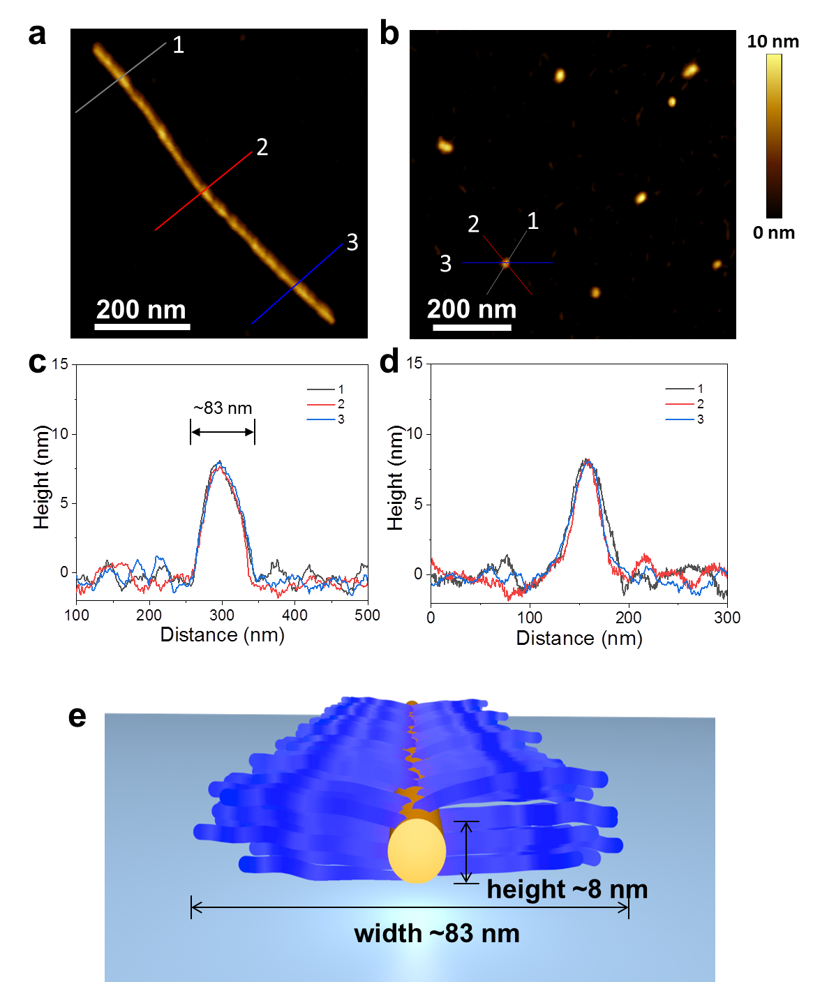
Supplementary Fig. 6. AFM images of (a) nanofibers (L_{n}= 759 nm, Ð_{L} = 1.03) and (b) seeds (L_{n}= 29 nm, Ð_{L} = 1.09) of PFS₂₄-b-P4VP₁₉₂ and the AFM height profiles of (c) nanofibers and (d) seeds of PFS₂₄-b-P4VP₁₉₂. The ultra-flat silicon wafers were used as substrate for sample preparation. (e) Graphical representation of a nanofiber of PFS₂₄-b-P4VP₁₉₂ on a ultra-flat silicon wafer substrate. The much larger overall width (~83 nm) for the nanofibers was observed by AFM in (c) compared to that (~62 nm) determined by cryo-TEM (Fig. 2b) is believed to be caused by image drift during the movement of AFM probe. Widths measurements are often subject to significant errors in AFM experiments.

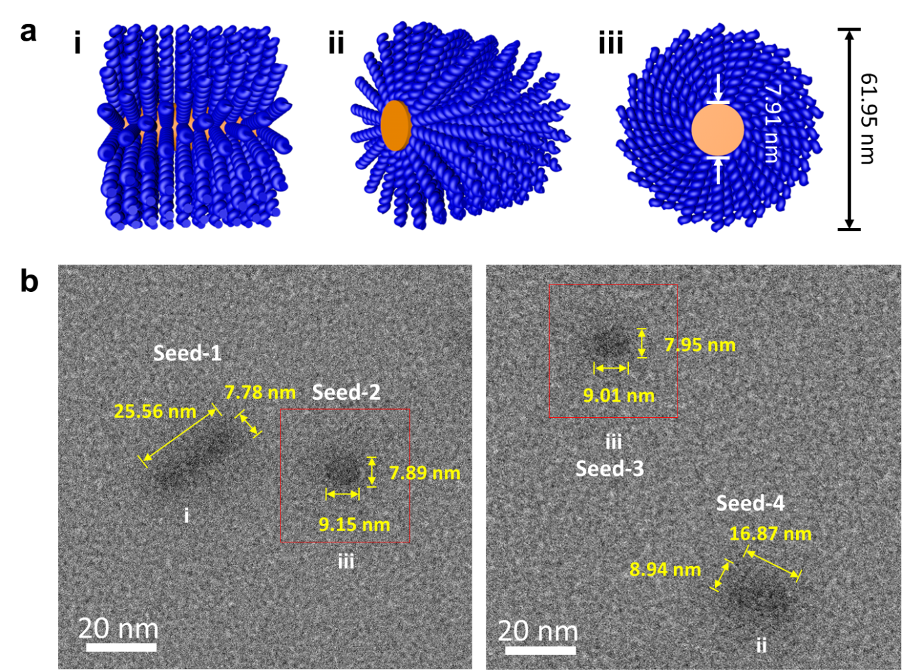
Supplementary Fig. 7. (a) A schematic model to display three possible orientations of the seeds in the frozen IPA solution (i, ii and, iii) of PFS₂₄-b-P4VP₁₉₂ seed micelles in the Cryo-TEM experiments. (b) The Cryo-TEM images of the seed micelles of PFS₂₄-b-P4VP₁₉₂ (L_{n} = 29 nm, L_{w}/L_{n} = 1.09) in frozen isopropanol on an ultra-thin (< 3 nm) supported carbon film. It was difficult to observe the corona domain of the seed micelles as the contrast is low with respect to the supported carbon film. As the TEM images are projections of the PFS₂₄-b-P4VP₁₉₂ seed micelles the goniometer (stage) tilt angle was optimized to provide the cross-section of seed-2 and seed-3 in orientation (iii). The results gave an oval shape for the PFS core cross-section (major axis = ca. 9.1 nm and a minor axis = ca. 7.9 nm).

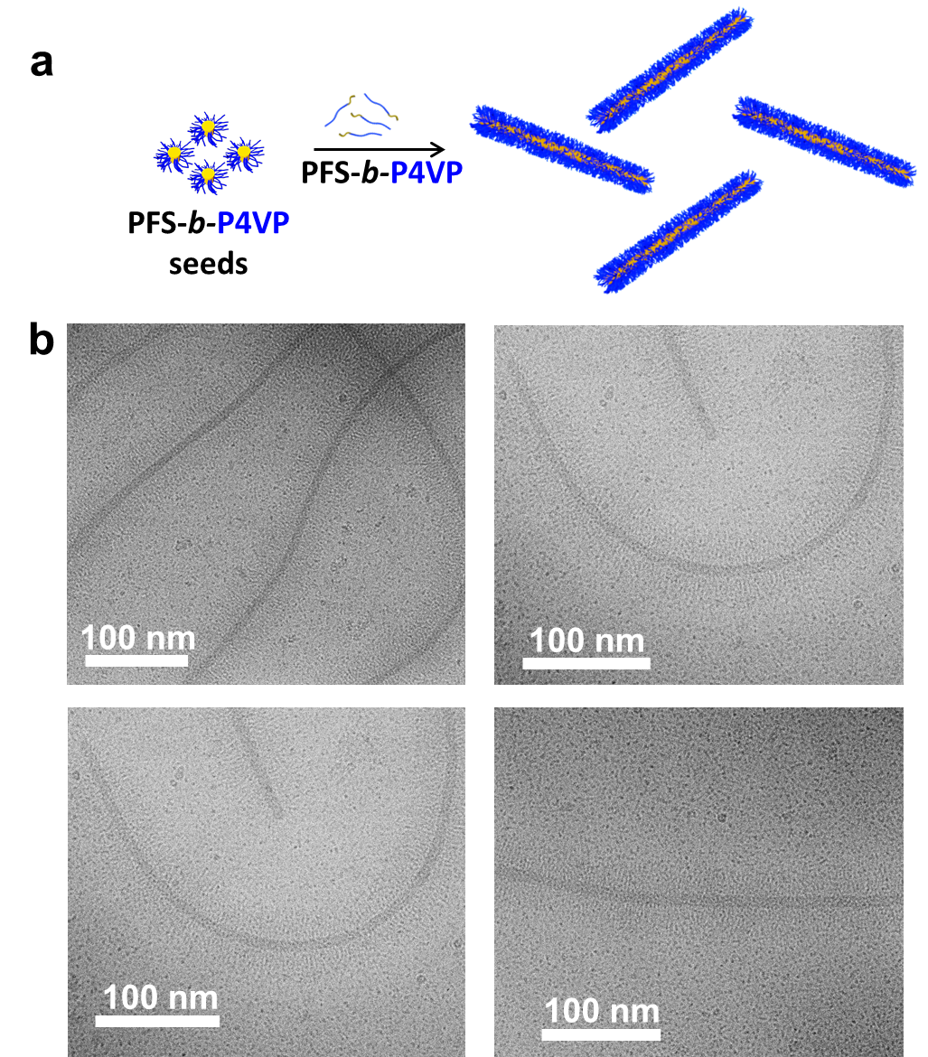
Supplementary Fig. 8. (a) A schematic of the formation of PFS₂₄-b-P4VP₁₉₂ nanofibers by seeded growth. (b) The Cryo-TEM images of the PFS₂₄-b-P4VP₁₉₂nanofibers (L_{n}= 759 nm, Ð_{L} = 1.03) in frozen isopropanol.

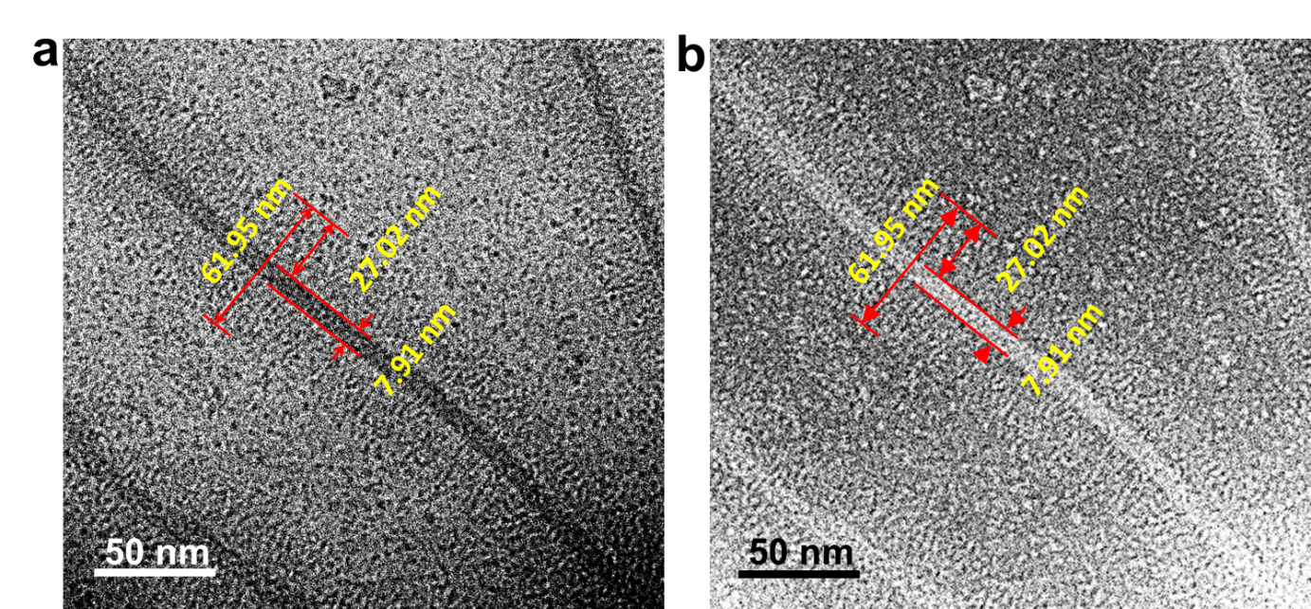
Supplementary Fig. 9. (a) Contrast-enhanced cryo-TEM image of the PFS₂₄-b-P4VP₁₉₂ nanofiber (L_{n}= 759 nm, Ð_{L} = 1.03) in solution of isopropanol. (b) The color-inverted image of (a).

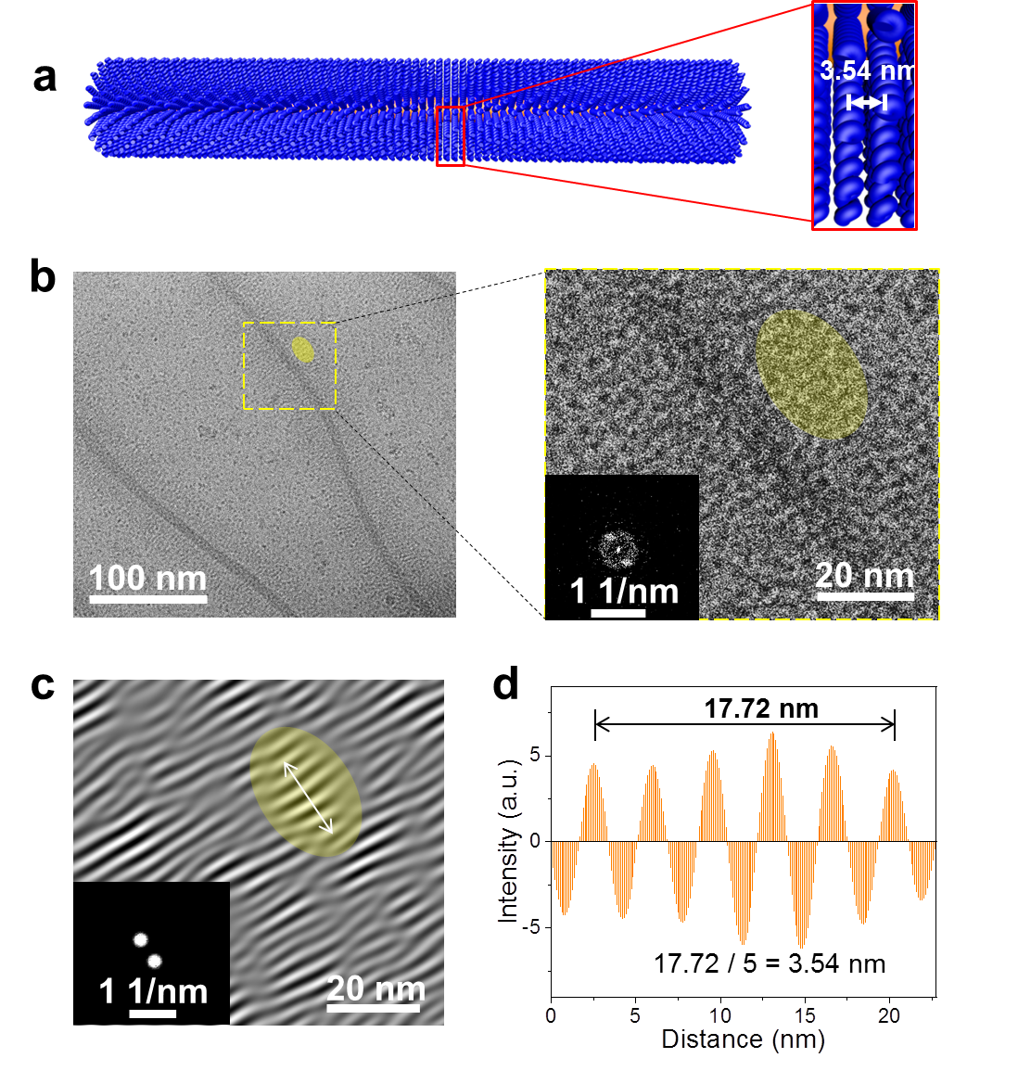
Supplementary Fig. 10. (a) Model of the nanofiber (left) and corona (right) to show the gap between two strands of corona-forming block of PFS₂₄-b-P4VP₁₉₂. (b) High resolution cryo-TEM images of PFS₂₄-b-P4VP₁₉₂ nanofibers (L_{n}= 759 nm, Ð_{L} = 1.03 in a frozen solution of isopropanol at ~90 K. Right: Magnified image with a selected coronal area highlighted by yellow. Inset: FFT image of the selected square-area highlighted by dashed line. (c) Inverse-FFT image obtained from the selected square area in (b) to display the gap between two strands of the P4VP corona-forming block. Inset: FFT pattern of (c). (d) Intensity profile obtained from the yellow highlighted area in (c) to measure the gap between two strands of the corona-forming block of PFS₂₄-b-P4VP₁₉₂. The corresponding area was also highlighted in (b).

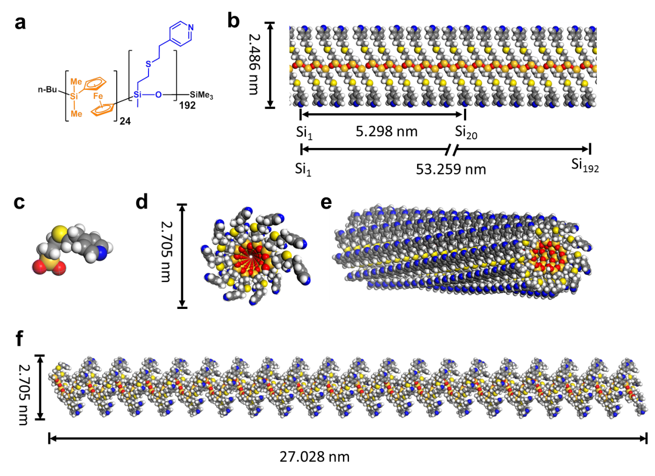
Supplementary Fig. 11. (a) The chemical structure of PFS₂₄-b-P4VP₁₉₂ in this study. (b) The fully-extended chain length demonstrated by modeling of P4VP₁₉₂ homopolymer. (c) The energy-minimized model of the monomer of P4VP₁₉₂ homopolymer. (d) A cross-section view, (e) a perspective view and (f) a side-on view of the P4VP₁₉₂ corona strand based on the simulated model of the P4VP₁₉₂ corona chain. (Atom coloring: gray = C, white = H, red = O, blue = N, yellow = S, dark yellow = Si).

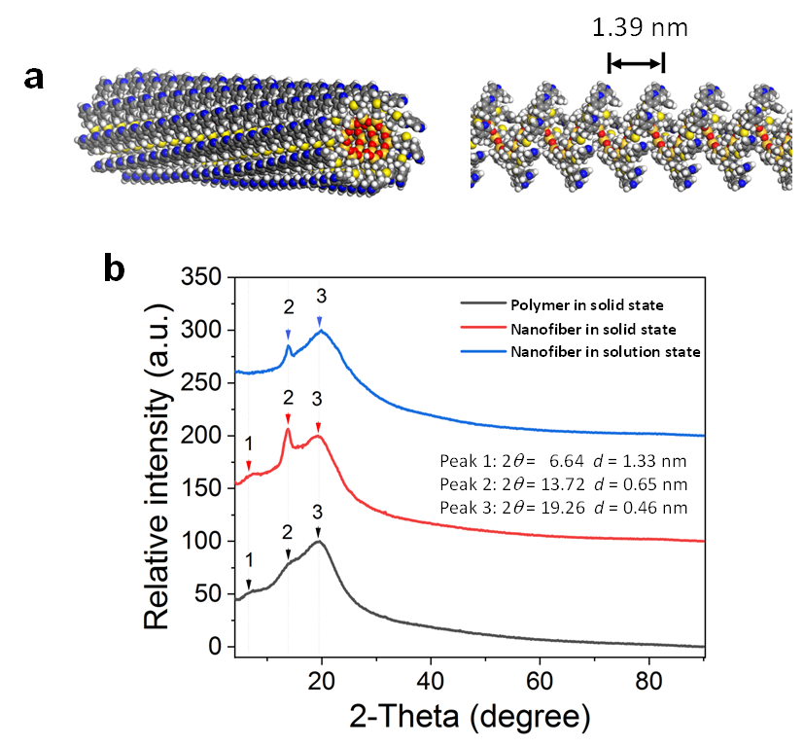
Supplementary Fig. 12. (a) The simulated model of P4VP corona chains of PFS₂₄-b-P4VP₁₉₂ nanofibers (b) X-ray diffraction profiles of a powder sample of PFS₂₄-b-P4VP₁₉₂ block copolymer in the bulk state (black line), a PFS₂₄-b-P4VP₁₉₂ nanofiber film prepared by drop-casting the nanofibers (L_{n}= 759 nm, Ð_{L} = 1.03) in isopropanol solution (80 mg/mL) on a low-background Si wafer substrate (red line), and a solution of PFS₂₄-b-P4VP₁₉₂ nanofibers in isopropanol (80 mg/mL) (blue line).

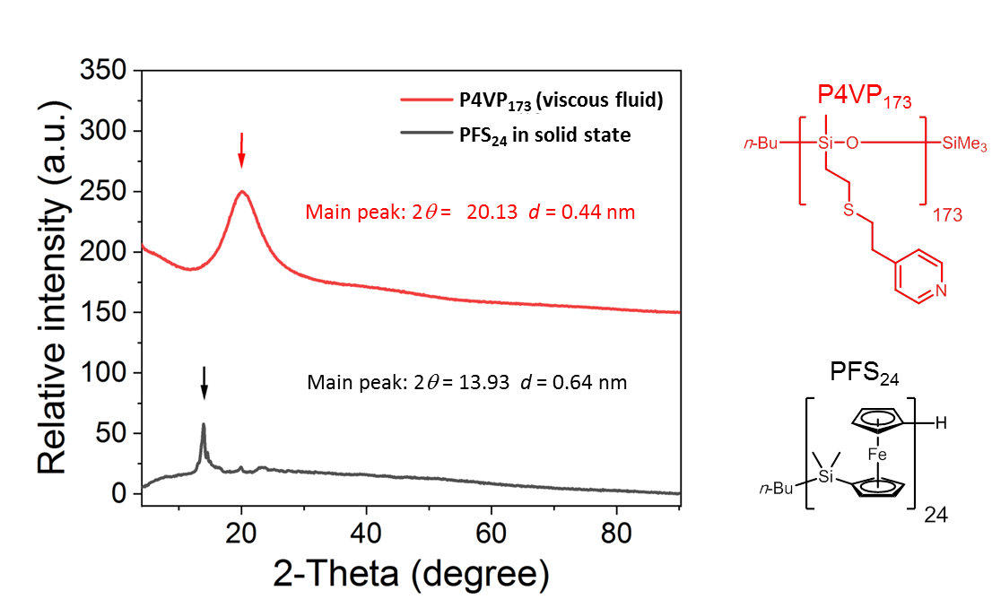
Supplementary Fig. 13. X-ray diffraction profiles of PFS₂₄ and P4VP₁₇₃ homopolymers. A powder sample of PFS₂₄ (black line) and a viscous fluid sample of P4VP₁₇₃ (red line) were studied in the bulk state on a low-background Si wafer substrate.
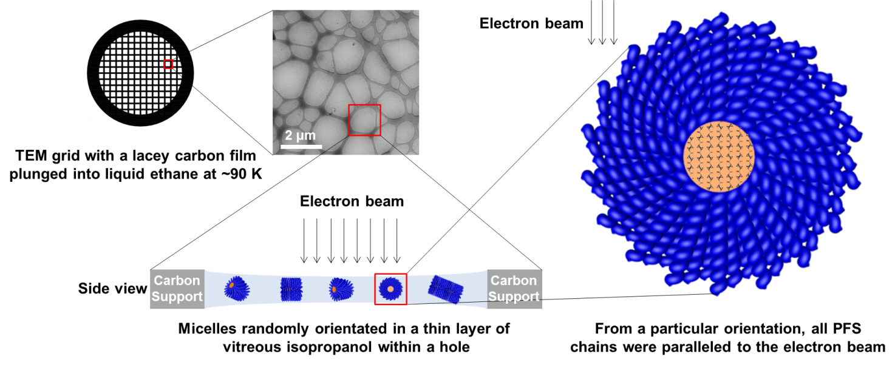
Supplementary Fig. 14. An overview of cryo-TEM sample preparation and an illustration of the orientation of the selected PFS₂₄-b-P4VP₁₉₂ nanofibers within the thin layer of vitreous isopropanol. The corona chains are included here for completeness, and their depiction is not intended to represent their likely arrangement relative to the PFS chains in the core or in 3D space in the frozen solution.

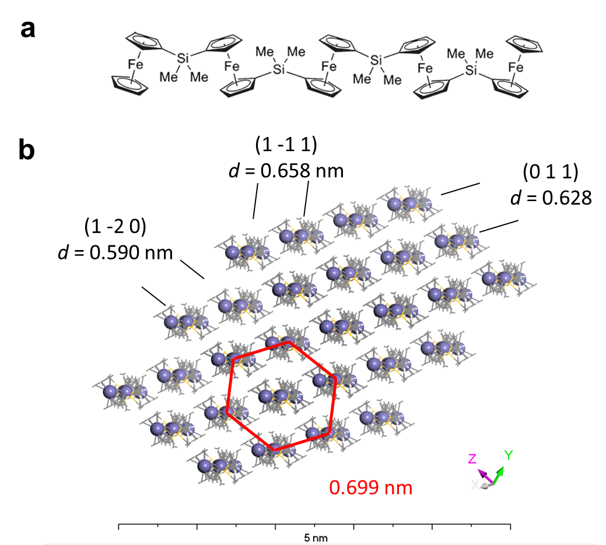
Supplementary Fig. 15. (a) The chemical structure of the linear pentamer of PFS.³ (b) Pseudo-hexagonal packing viewed parallel to the linear pentamer chains in the crystal lattice of the linear pentamer of PFS.³

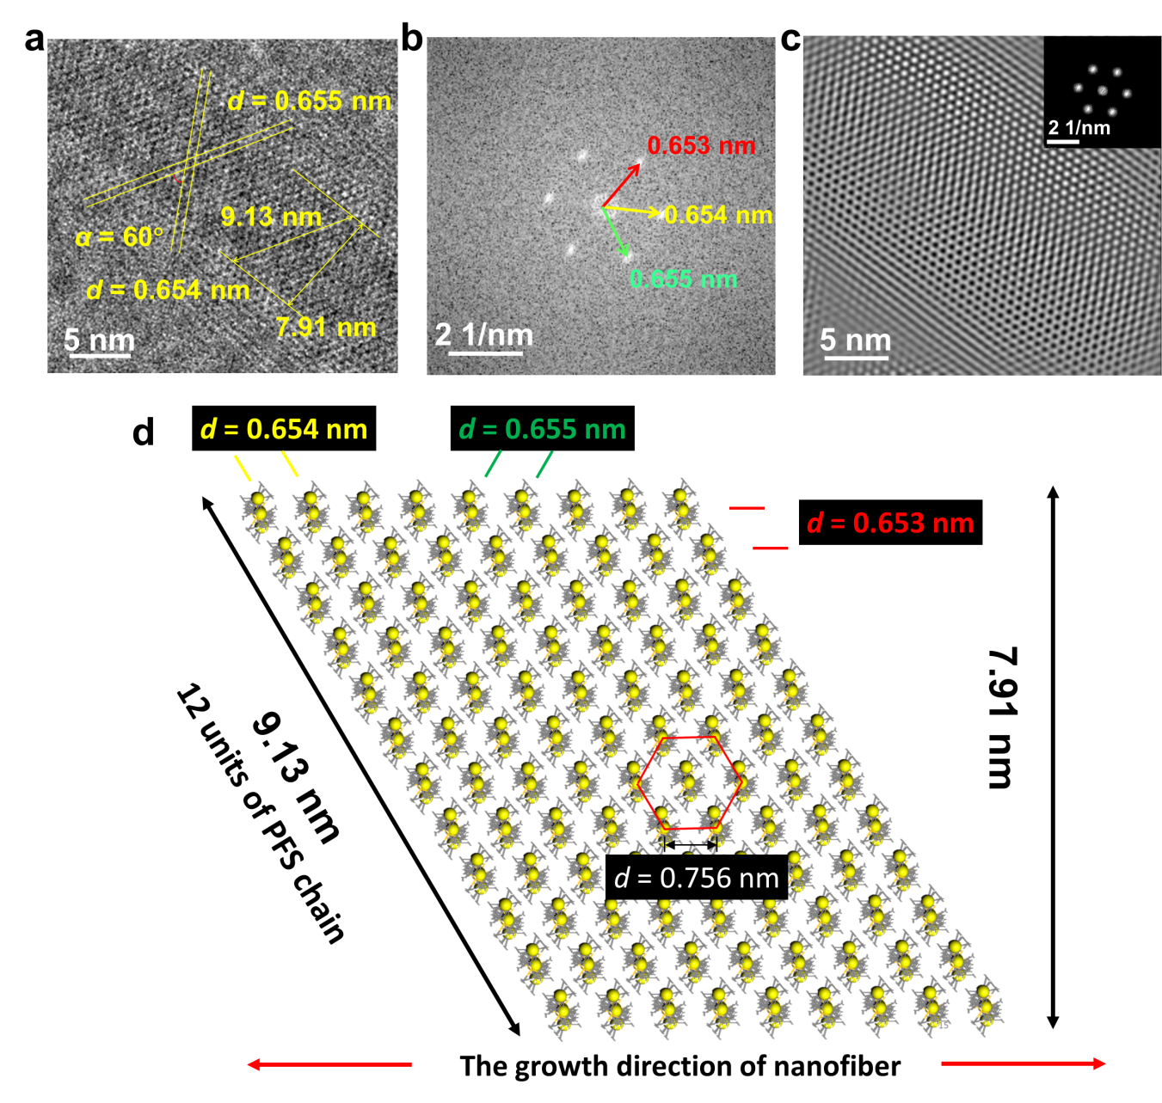
Supplementary Fig. 16. (a) High-resolution Cryo-TEM image of a selected nanofiber (L_{n}= 759 nm, Ð_{L} = 1.03) of PFS₂₄-b-P4VP₁₉₂ in a frozen solution of isopropanol displaying a highly-ordered core with measurements of the lattice distances. (b) FFT image obtained from (a) showing the hexagonal pattern with labels of the lattice space of the PFS core of the PFS₂₄-b-P4VP₁₉₂ nanofibers. (c) The simulated lattice created by inverse-FFT with an mask applied on the reflection points of the pattern in (b). (Inset: FFT pattern of the simulated lattice). The PFS polymer chains in the core region are oriented perpendicular to the horizontal plane of the image. (d) The proposed PFS chains in the core of PFS₂₄-b-P4VP₁₉₂ nanofibers that are packed in a 2D lattice with pseudo-hexagonal symmetry, perpendicular to the growth direction of the nanofiber (long axis of the nanofiber). The lattice parameters from (a) and (b) are labeled on the model structure of the PFS core.

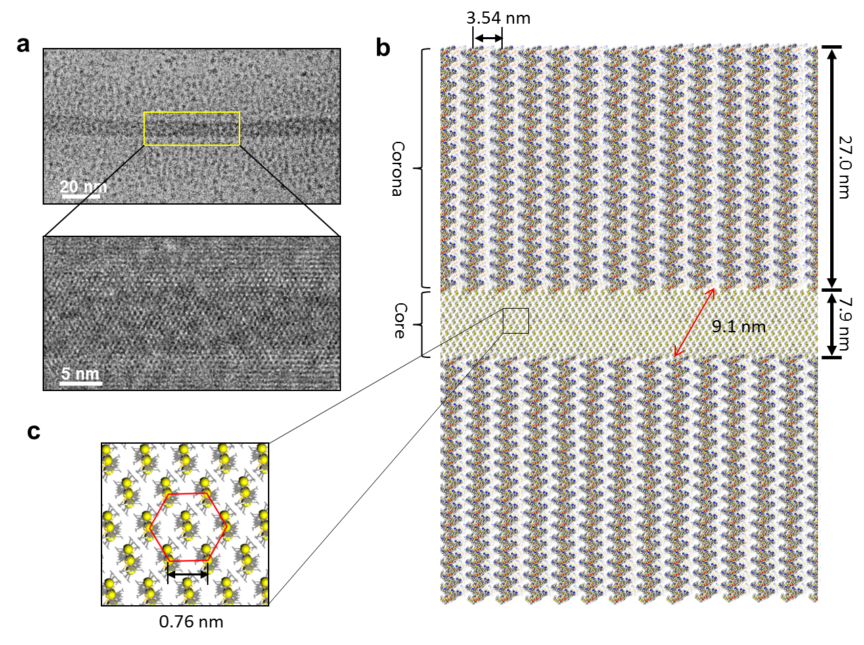
Supplementary Fig. 17. (a) High-resolution Cryo-TEM of PFS₂₄-b-P4VP₁₉₂ nanofibers (L_{n}= 759 nm, Ð_{L} = 1.03) in a frozen solution of isopropanol displaying a highly-ordered core. The PFS polymer chains in the core region are arranged perpendicular to the horizontal plane of the image. (b) A proposed modeling of the cross-section perpendicular to the long axis of PFS₂₄-b-P4VP₁₉₂ nanofibers. (c) Magnified image of the selected area of (b) and measurements of lattice distances. The PFS polymer chains in the core region are arranged perpendicular to the horizontal plane of the image. The coronal chains shown in (b) actually emanate perpendicular to the plane of the figure from the PFS chain termini at the core surface (as described in Figure 4).

References
1 Tian, J. et al. Tailored self-assembled photocatalytic nanofibres for visible-light-driven hydrogen production. Nat. Chem. 12, 1150-1156 (2020).
2 Boehm, P., Mondeshki, M. & Frey, H. Polysiloxane-Backbone Block Copolymers in a One-Pot Synthesis: A Silicone Platform for Facile Functionalization. Macromol. Rapid Commun. 33, 1861-1867 (2012).
3 Rulkens, R. et al. Linear Oligo(ferrocenyldimethylsilanes) with between Two and Nine Ferrocene Units: Electrochemical and Structural Models for Poly(ferrocenylsilane) High Polymers. J. Am. Chem. Soc. 118, 12683-12695 (1996).

