Supplementary Information

- Supplementary Figures
Figure S1 Ageing trends in G7 economies. Trendlines represent the fraction of the expected population >65 years old between 2005 and 2030. The results clearly show that the Japanese society is expected to experience the most extensive ageing among the different countries. Data from 2005 to 2020 are historical statistics and data from 2021 to 2030 are population projection. Both datasets are collected from OECD statistics, (refer to https://stats.oecd.org/)

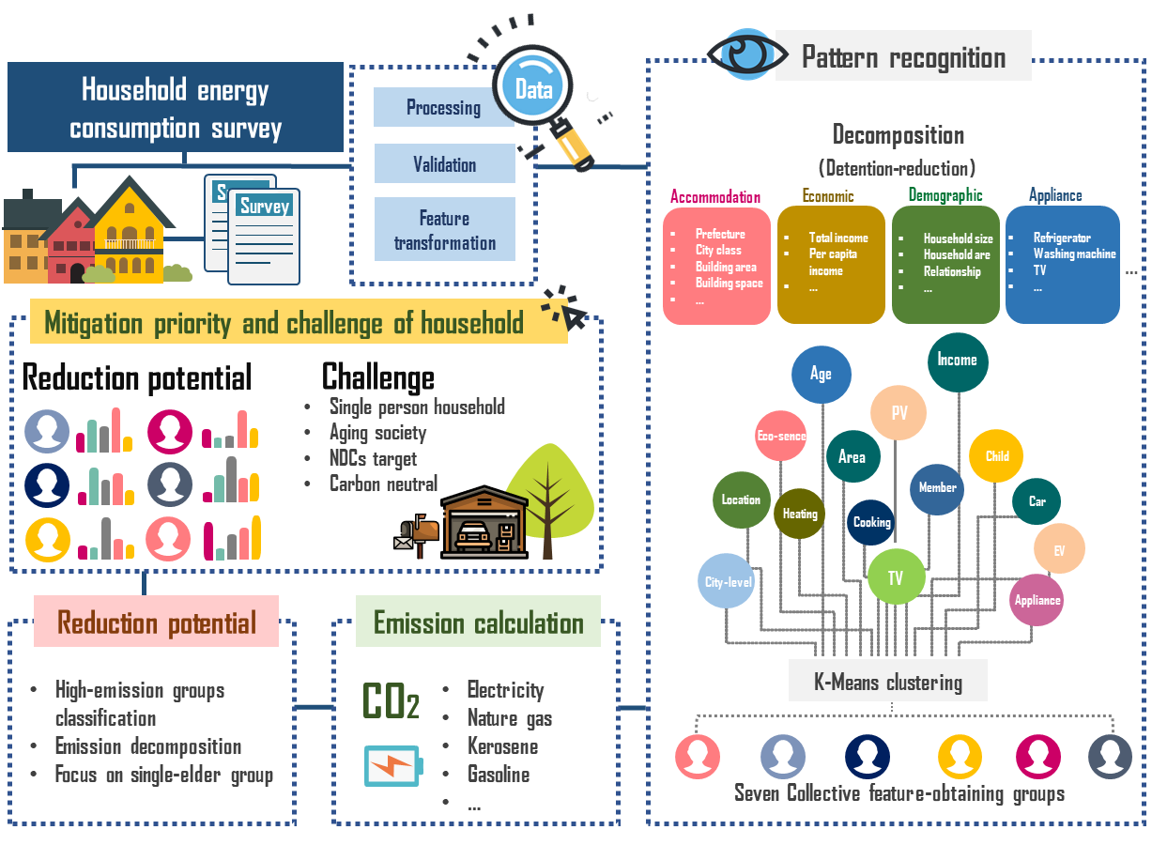
Figure S2 Research approach
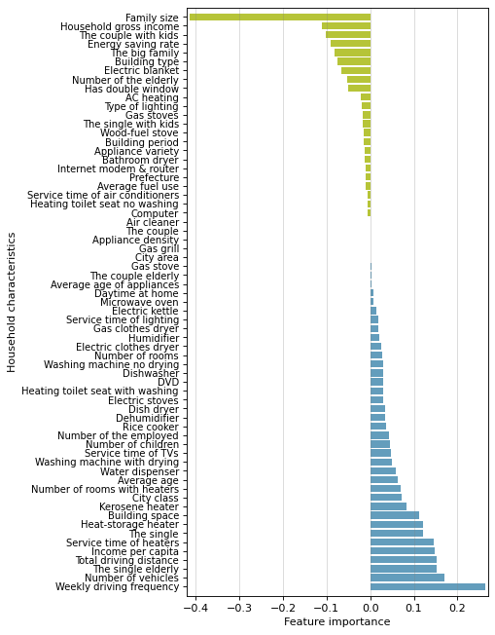
Figure S3 Feature importance of household characteristics in the LASSO model.

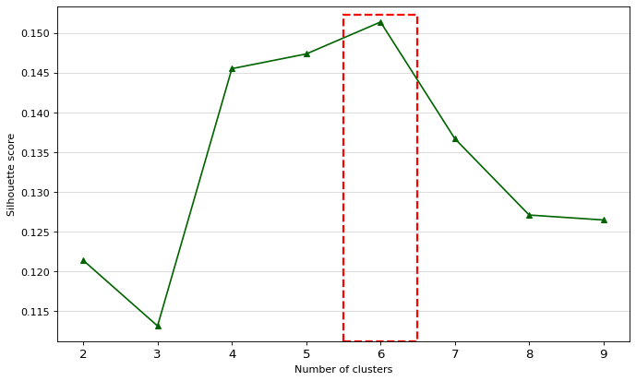
Figure S4 Optimized number of clusters in the LASSO model. The optimized number is based on filtered variables. The optimal number of clusters is marked by the red dashed rectangle.

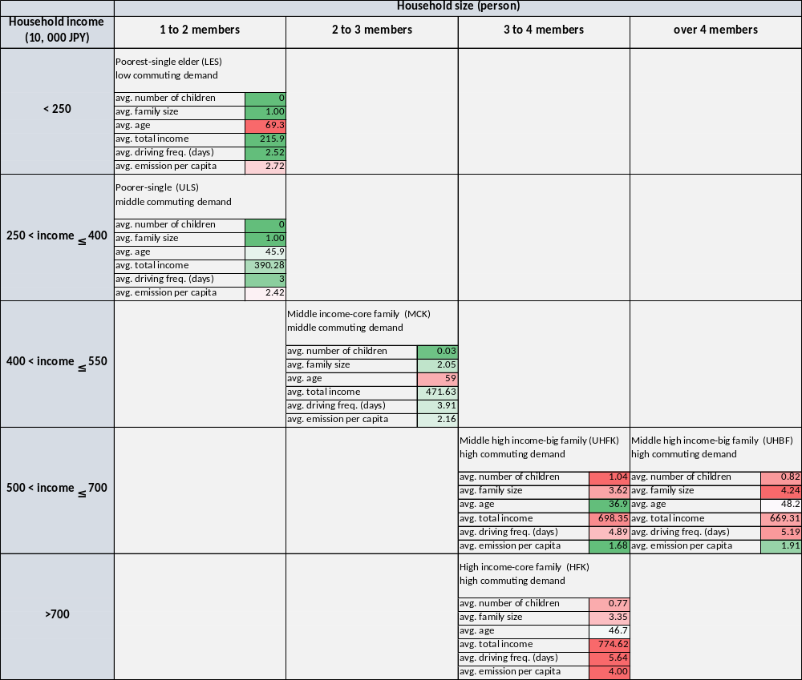
Figure S5 Taxonomy of household groups based on integrated clustering.

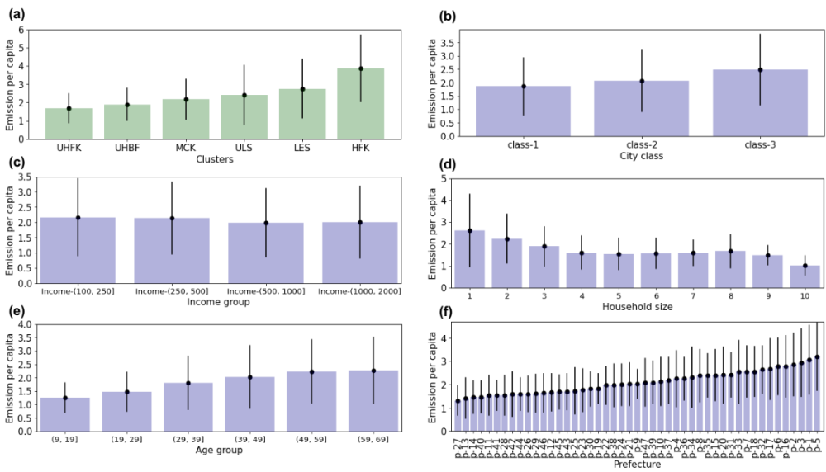
Figure S6 Direct emissions based on different household divisions. divisions for different comparisons including: by groups elicited from the integrated-clustering method (Panel S6a), by type of city (Panel S6b), by income (Panel S6c), by size (S6d), by age (S6e) and by prefecture (S6f).

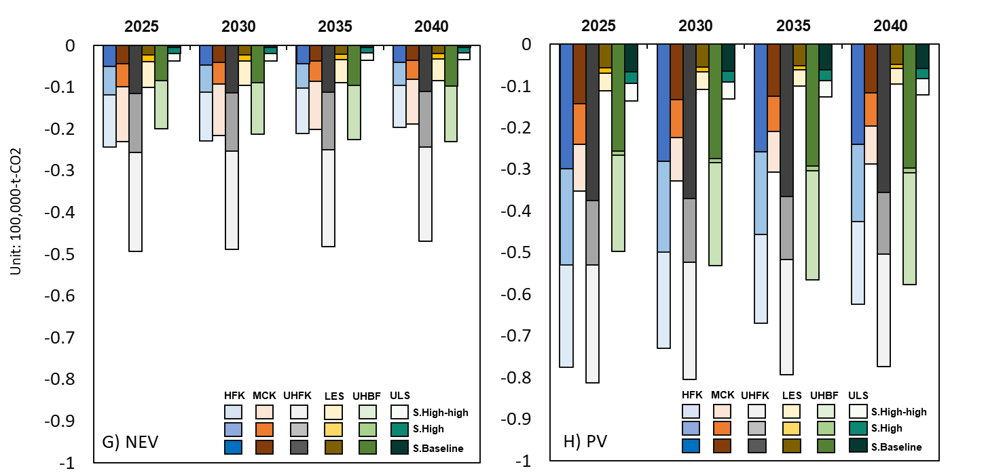
B
A
Figure S7. Emissions reduction potential projection of NEV and PV based on scenarios. Panels S7A and S7B show the reduction potential of PV and NEV in different household groups following the three different adoption scenarios (see “Research Approach” for explanation). Considering that the adoption of PV and NEV varies between groups due to specific characteristics such as their affordability and the actual energy demand between households, generally the results suggest that the higher emission mitigation is achieved in higher-income groups such as (in descending order) UHFK, HFK, MCK and UHBF. Groups characterized by lower income and lower household size have the lowest emission mitigation (i.e. ULS, LES). Currently, the PV only shows its high emissions reduction potential for groups characterized larger household sizes (including with kids). Likewise, NEV adoption does not seem to have high emission mitigation potential for low-income and/or single-person households (e.g. ULS, LES). Notably, although NEV adoption tends to be higher in HFK households compared to UHFK households (baseline: 1.5% and 1.0% respectively), the aggregate emission mitigation potential is a bit lower for HFK households compared to UHFK households, due to the small proportion of the former in the general population (0.73%).

- Supplementary Tables

Table S1 List of normalized variables under each major category
Category | Characteristics
Housing | Building space
Demographic | Average age of family members  Family size
Economic | Annual income  Annual income per capita
Transportation | Average fuel use per vehicle  Average driving frequency  Annual driving distance
Appliance | Average appliance age  Appliance variety  Appliance use intensity
Behavior | Daytime at home  Energy saving rate

Table S2 List of selected variables through LASSO model
Category | Characteristics
Geographic | - City class (1=large city, 2=middle city, 3=small city)
Housing | - Building space  - Number of rooms  - House has double window (1=yes, 2=no)  - Building type (1=apartment, 2=house)
Demographic | - Average age  - Family size
 | - Number of elderly in household
Economic | - Total annual income  - Annual income per capita
Transportation | - Weekly driving frequency  - Annual driving distance  - Number of vehicles
Appliance | - Own washing machine with dryer  - Own toilet with warm water  - Own electric carpet  - Own electric heat storage heater  - Own kerosene stove
Behavior | - Service time of heaters  - Energy saving rate
Family type | - Single-person household (0=no, 1=yes)  - Single-person elderly household (0=no, 1=yes)  - Household with kids (0=no, 1=yes)  - Large family (0=no, 1=yes)

Table S3 Geographic distribution of households types by prefectures in 2017-2018
Prefecture | UHFK | UHBF | MCK | ULS | LES | HFK
Hokkaido | 0.241 | 0.096 | 0.435 | 0.107 | 0.087 | 0.033
Aomori | 0.191 | 0.138 | 0.368 | 0.105 | 0.118 | 0.079
Iwate | 0.213 | 0.176 | 0.338 | 0.125 | 0.096 | 0.051
Miyagi | 0.336 | 0.136 | 0.345 | 0.068 | 0.095 | 0.018
Akita | 0.281 | 0.213 | 0.315 | 0.045 | 0.135 | 0.011
Yamagata | 0.230 | 0.230 | 0.270 | 0.131 | 0.098 | 0.041
Fukushima | 0.192 | 0.231 | 0.346 | 0.077 | 0.122 | 0.032
Ibaraki | 0.333 | 0.131 | 0.369 | 0.107 | 0.060 | 0.000
Tochigi | 0.267 | 0.267 | 0.300 | 0.133 | 0.033 | 0.000
Gumma | 0.388 | 0.179 | 0.313 | 0.030 | 0.090 | 0.000
Saitama | 0.335 | 0.147 | 0.362 | 0.064 | 0.092 | 0.000
Chiba | 0.388 | 0.092 | 0.350 | 0.067 | 0.104 | 0.000
Tokyo | 0.306 | 0.056 | 0.429 | 0.125 | 0.083 | 0.000
Kanagawa | 0.357 | 0.075 | 0.354 | 0.122 | 0.091 | 0.000
Niigata | 0.219 | 0.204 | 0.368 | 0.079 | 0.119 | 0.012
Toyama | 0.297 | 0.228 | 0.310 | 0.070 | 0.095 | 0.000
Ishikawa | 0.370 | 0.160 | 0.284 | 0.093 | 0.093 | 0.000
Fukui | 0.400 | 0.178 | 0.244 | 0.104 | 0.074 | 0.000
Yamanashi | 0.208 | 0.125 | 0.583 | 0.042 | 0.042 | 0.000
Nagano | 0.364 | 0.109 | 0.291 | 0.127 | 0.109 | 0.000
Gifu | 0.316 | 0.197 | 0.291 | 0.094 | 0.103 | 0.000
Shizuoka | 0.265 | 0.158 | 0.388 | 0.082 | 0.107 | 0.000
Aichi | 0.381 | 0.108 | 0.318 | 0.112 | 0.081 | 0.000
Mie | 0.391 | 0.127 | 0.309 | 0.118 | 0.055 | 0.000
Shiga | 0.391 | 0.087 | 0.304 | 0.087 | 0.130 | 0.000
Kyoto | 0.262 | 0.111 | 0.460 | 0.063 | 0.103 | 0.000
Osaka | 0.309 | 0.068 | 0.405 | 0.113 | 0.104 | 0.000
Hyogo | 0.337 | 0.070 | 0.413 | 0.073 | 0.107 | 0.000
Nara | 0.190 | 0.177 | 0.430 | 0.076 | 0.127 | 0.000
Wakayama | 0.314 | 0.029 | 0.457 | 0.086 | 0.114 | 0.000
Tottori | 0.323 | 0.161 | 0.339 | 0.065 | 0.113 | 0.000
Shimane | 0.300 | 0.238 | 0.288 | 0.100 | 0.075 | 0.000
Okayama | 0.386 | 0.169 | 0.285 | 0.072 | 0.087 | 0.000
Hiroshima | 0.344 | 0.098 | 0.385 | 0.082 | 0.091 | 0.000
Yamaguchi | 0.234 | 0.138 | 0.400 | 0.117 | 0.110 | 0.000
Tokushima | 0.280 | 0.238 | 0.336 | 0.077 | 0.070 | 0.000
Kagawa | 0.326 | 0.147 | 0.332 | 0.082 | 0.109 | 0.005
Ehime | 0.336 | 0.142 | 0.317 | 0.104 | 0.101 | 0.000
Kochi | 0.238 | 0.114 | 0.438 | 0.076 | 0.133 | 0.000
Fukuoka | 0.342 | 0.116 | 0.358 | 0.073 | 0.109 | 0.002
Shiga | 0.390 | 0.220 | 0.203 | 0.051 | 0.136 | 0.000
Nagasaki | 0.264 | 0.121 | 0.407 | 0.121 | 0.088 | 0.000
Kumamoto | 0.408 | 0.143 | 0.286 | 0.051 | 0.112 | 0.000
Oita | 0.269 | 0.167 | 0.397 | 0.077 | 0.090 | 0.000
Miyagi | 0.265 | 0.143 | 0.367 | 0.102 | 0.122 | 0.000
Kagoshima | 0.302 | 0.069 | 0.328 | 0.138 | 0.164 | 0.000
Okinawa | 0.364 | 0.086 | 0.345 | 0.124 | 0.081 | 0.000

Table S4 Emission mitigation potential of NEV across household groups
 | Emission (xxxx/cap)
 | Total | Vehicle
UHFK | -0.381  (-2.71) | -0.387  (-5.064)
UHBF | -0.866  (-1.31) | -0.370  (-1.327)
MCK | -0.408  (-2.79) | -0.167  (-2.069)
ULS | 0.728  (-0.778) | 1.008  1.771)
LES | -0.299  (-2.687) | -0.218  (-3.131)
HFK | 0.582  (1.290) | -0.856  (-3.049)
Note: t-values are in parentheses.

Table S5 Emission mitigation potential of PV across household groups
 | Emissions (xxxx/cap)
 | Total ex. vehicles | Appliance | Space heating | Space cooling | Water heating | Cooking
UHFK | -0.402  (-6.922) | -0.183  (-5.928) | -0.129  (-4.443) | -0.004  (-0.625) | -0.067  (-2.939) | -0.019  (-4.528)
UHBF | -0.507  (-2.263) | 0.010  (0.082) | -0.341  (-2.855) | -0.052  (-2.180) | -0.078  (-1.016) | -0.045  (-4.820)
MCK | -0.304  (-5.820) | -0.127  (-4.822) | -0.098  (-3.799) | -0.006  (-1.085) | -0.064  (-2.783) | -0.009  (-2.251)
ULS | -0.830  (-3.027) | -0.093  (-0.791) | -0.542  (-3.339) | -0.006  (-0.717) | -0.181  (-1.456) | -0.008  (-4.752)
LES | -0.280  (-9.699) | -0.120  (-7.467) | -0.087  (-6.321) | -0.003  (-0.827) | -0.060  (-5.126) | -0.010  (-4.426)
HFK | 0.014  (0.049) | 0.168  (0.955) | -0.250  (-2.082) | 0.054  (1.473) | 0.094  (0.845) | -0.052  (-1.823)
Note: t-values are in parentheses.

Supplementary Methods

1. Anomalies detection
Given the raw data, the following exclusion rules are applied to filter the samples:
(1) households without valid records about their houses’ building space (332 excluded)
(2) households with incomes being no greater than JPY 0 per year (0 excluded)
(3) households with the differences between aggregated subset emissions and total emissions >0.01 tCO₂ (676 excluded)

2. Data conversion and normalization
Based on the HEUS survey, some questions are distributed and some are multiple-choice. We apply a processing pipeline to convert the survey questions into dummy, categorical and continuous variables (65 in total).

Dummy variables
Housing (1): Building type
Demographic (9): Single-person household, Two-person household, Single-person household with kids, Two-person household with kids, Single-person elderly household, Two-person elderly household, Large household (>3 people), Other

Categorical variables
Housing (7): Prefecture, City area, City class, Building age, Number of rooms, Number of rooms with heating, Number of double windows
Demographic (4): Family size, Number of children, Number of elderly, Number of employed family members
Transportation (1): Number of vehicles
Appliance (32):
- Ownership of different electric appliances (25):
number of TVs, number of fridges, number of air conditioners, lighting type, number of washing machine without drying, number of washing machine with drying, number of electric clothes dryer, number of gas clothes dryer, number of bathroom dryer, number of dishwasher, number of dish dryer, number of microwave oven, number of gas grill, number of rice cooker, number of gas stove, number of electric kettle, number of water dispenser, number of heating toilet with washing, number of heating toilet without washing, number of humidifier, number of dehumidifier, number of air purifier, number of computer, number of DVD, number of internet router
- Ownership of heaters (7):
number of air conditioner (heating), number of electric stoves, number of electric blanket, number of electric heat storage heater, number of gas stoves, number of kerosene heater, number of stove that uses wood fuel
Behavior (5): Time in home, TV use time, Air conditioner use time, Lighting use time, Heater use time

Continuous variables
Housing (1): Building space
Economic (2): Gross annual income, Annual income per capita
Transportation (3): Average driving frequency, Average fuel use per vehicle, Annual driving distance
Behavior (1): Energy saving rate
3. Population projection by clusters
The population projection data are estimated in 2025, 2030, 2035, and 2040, and organized in tables with age groups as rows and family types as columns (see an example table in Table S4).

Table S4 Sample table structure for population projection data
 | Total | Single | Couple | Couple and child | Single parent and child | Others
Total | - | - | - | - | - | -
Age 15～19 | - | - | - | - | - | -
Age 20～24 | - | - | - | - | - | -
Age 25～29 | - | - | - | - | - | -
Age 30～34 | - | - | - | - | - | -
Age 35～39 | - | - | - | - | - | -
Age 40～44 | - | - | - | - | - | -
Age 45～49 | - | - | - | - | - | -
Age 50～54 | - | - | - | - | - | -
Age 55～59 | - | - | - | - | - | -
Age 60～64 | - | - | - | - | - | -
Age 65～69 | - | - | - | - | - | -
Age 70～74 | - | - | - | - | - | -
Age 75～79 | - | - | - | - | - | -
Age 80～84 | - | - | - | - | - | -
Age over 85 | - | - | - | - | - | -

We use age groups and family types as the basis of identifying the prevalence of the six household groups obtained through the integrated-clustering analysis from the HEUS survey and the projected population data from the National Institute of Population and Social Security for Japan (NIPSSR). Table S5 shows the cross mappings of household age and type between the HEUS survey and the projected population data. Notably, there is not a detailed breakdown of households with ages >75 in the HEUS survey and thus in the cross-mapping. Here, we sum up the population in the age groups (75～79, 80～84, and > 85 groups years old) from the population projections to align with the (75, ∞] group in the HEUS survey. Furthermore, as there are no explicit groups for elderly single and elderly couples in the projected population dataset, we use the average age >60 years as the threshold for elderly households. Extended family is not a distinct group in the population projection data and is thus included into the Others group.

Table S5 Group cross-mapping between the HEUS survey and the population projections from NIPSSR

Groups in the HEUS survey | Groups in the population projections from NIPSSR
Age groups
(14, 19] | Age 15～19
(19, 24] | Age 20～24
(24, 29] | Age 25～29
(29, 34] | Age 30～34
(34, 39] | Age 35～39
(39, 44] | Age 40～44
(44, 49] | Age 45～49
(49, 54] | Age 50～54
(54, 59] | Age 55～59
(59, 64] (elderly) | Age 60～64
(64, 69] (elderly) | Age 65～69
(69, 74] (elderly) | Age 70～74
(75, ∞] (elderly) | Age 75～79, Age 80～84, Age over 85
Family type groups
Single | Single (age <60 years)
Elderly single | Single (age >60 years)
Couple | Couple (age <60 years)
Elderly couple | Couple (age >60 years)
Single and children | Single and children
Couple and children | Couple and children
Extended family | Others
Others | Others

The cross mapping is conducted in four steps:
- In Table S5, we build up mappings between age and family type groups of the HEUS and NIPSSR data and align the age and family type groups in the HEUS with those in the NIPSSR.
- According to the population projections in the NIPSSR data, we infer the population projections by the structure of age and family type groups in the HEUS data.
- We calculate the population proportions of household clusters by the age and family type groups in the HEUS data.
- The projection of the prevalence of the six household groups in the projected population for 2025, 2030, 2035, and 2040 is obtained by multiplying the population projections and the proportion of each combination of age and family type groups in household clusters.

