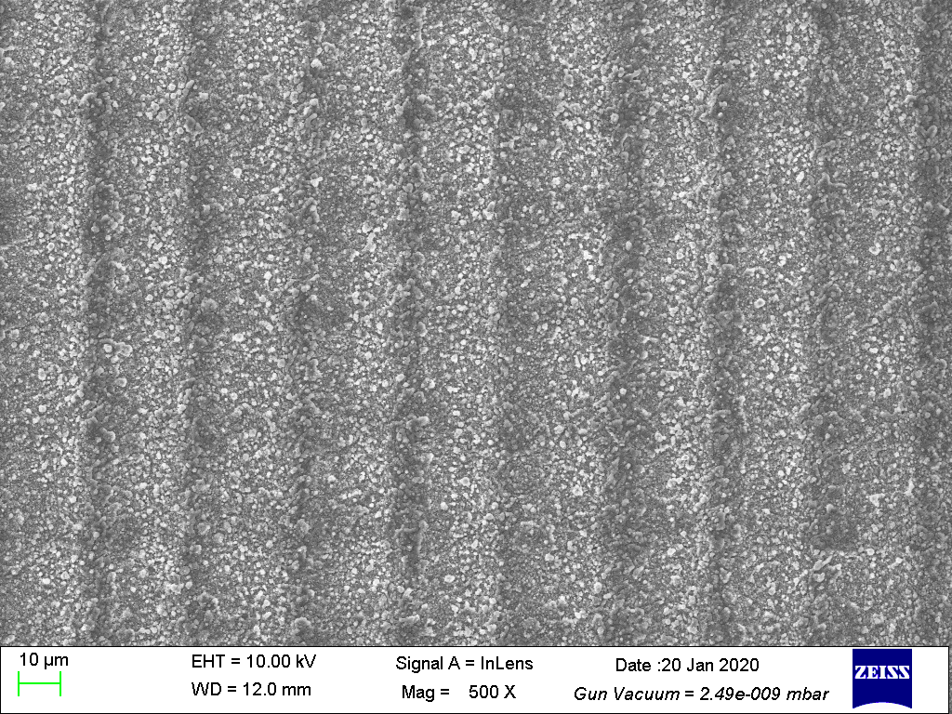
a)
Fig. 3a SEM images with 1000X magnified for Sample A.

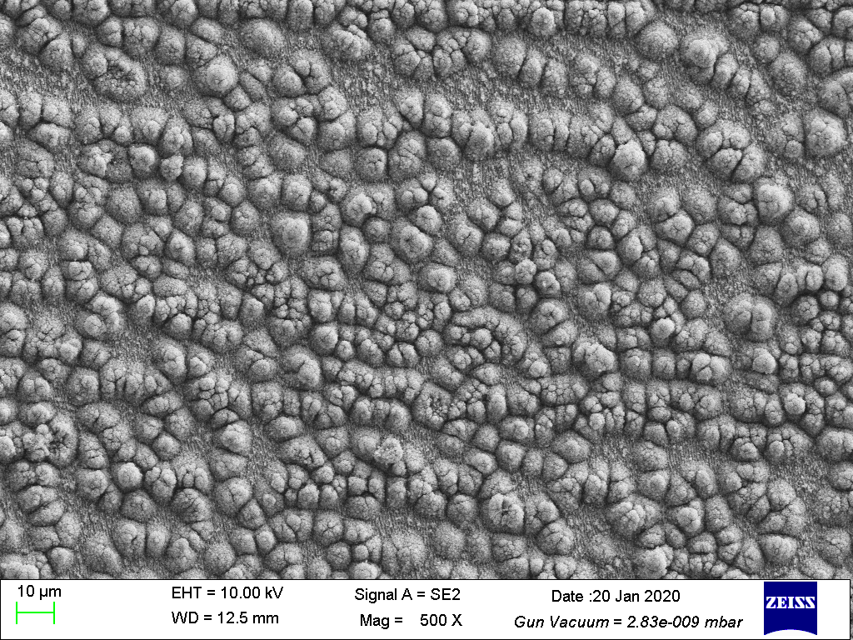
b)
Fig. 3b SEM images with 1000X magnified for Sample B.

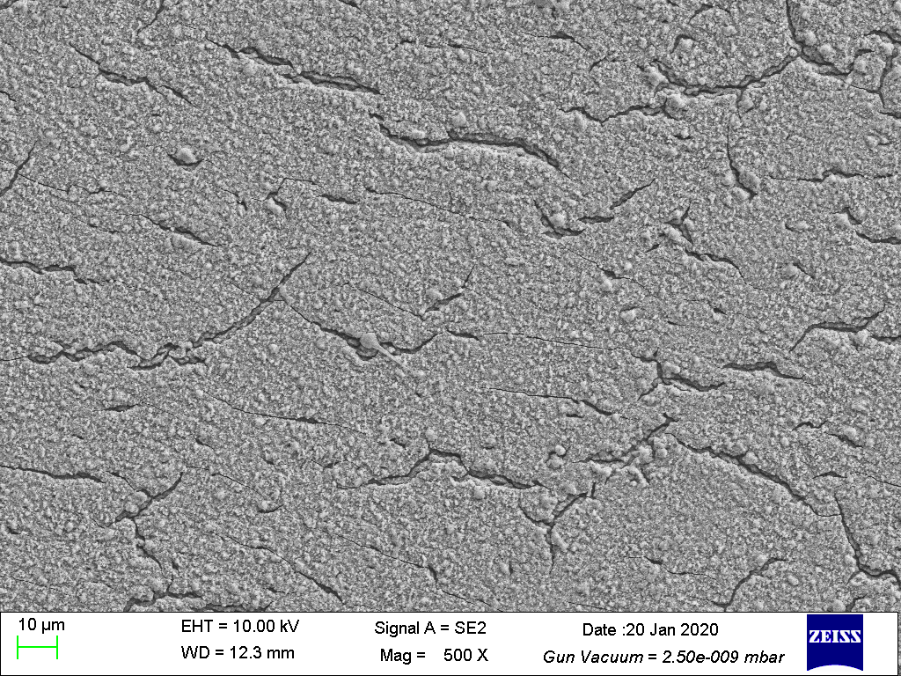
c)
Fig. 3c SEM images with 1000X magnified for Sample C.

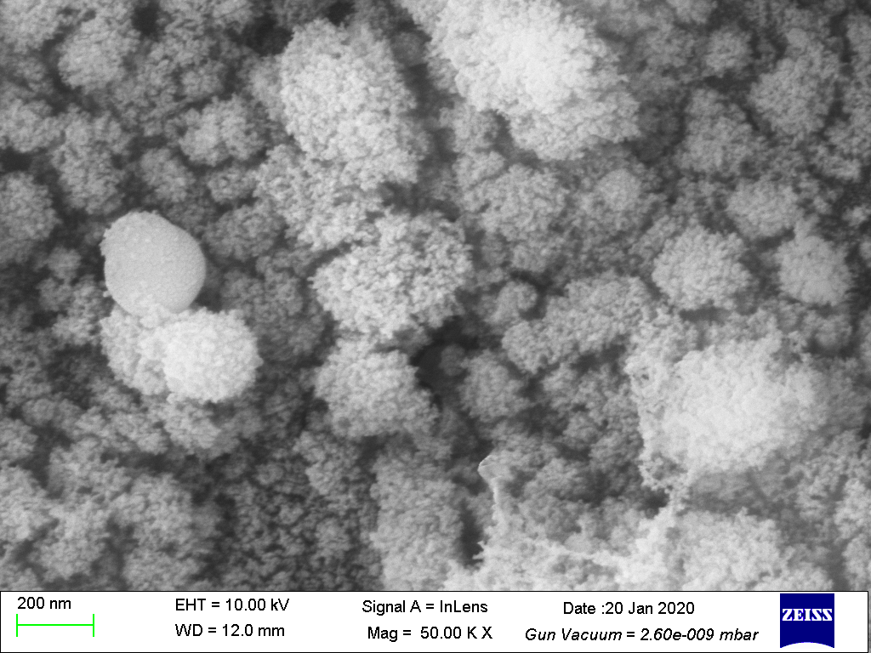
d)
Fig. 3d SEM images with 4000X magnified for Sample A.

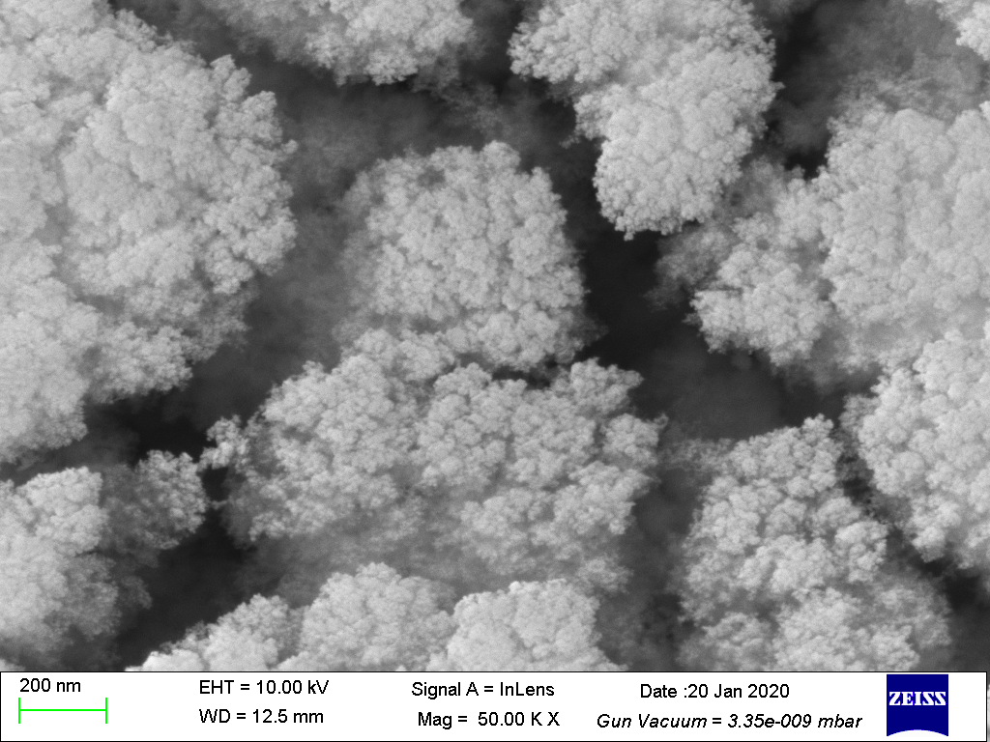
e)
Fig. 3e SEM images with 4000X magnified for Sample B.

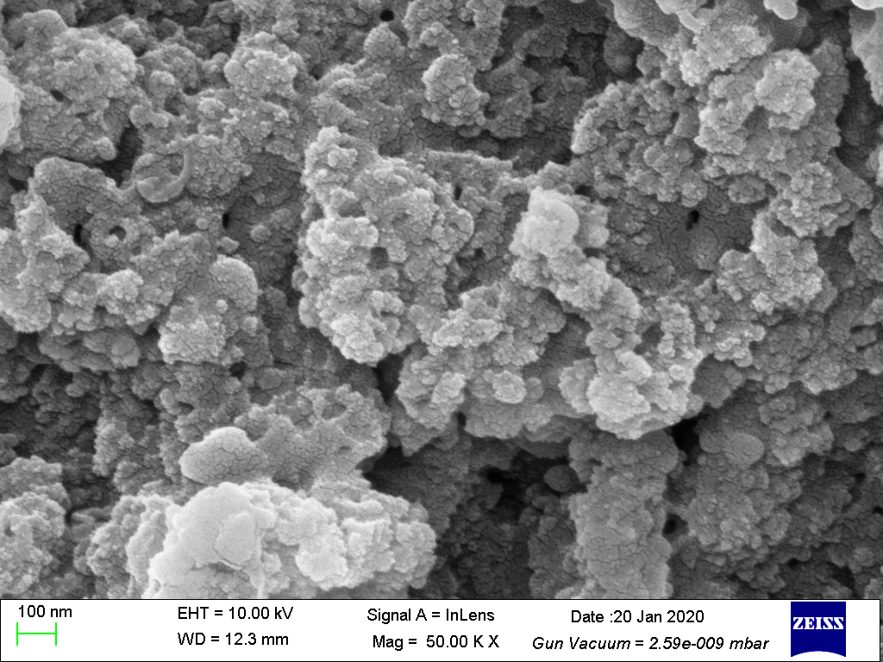
f)
Fig. 3f SEM images with 4000X magnified for Sample C.

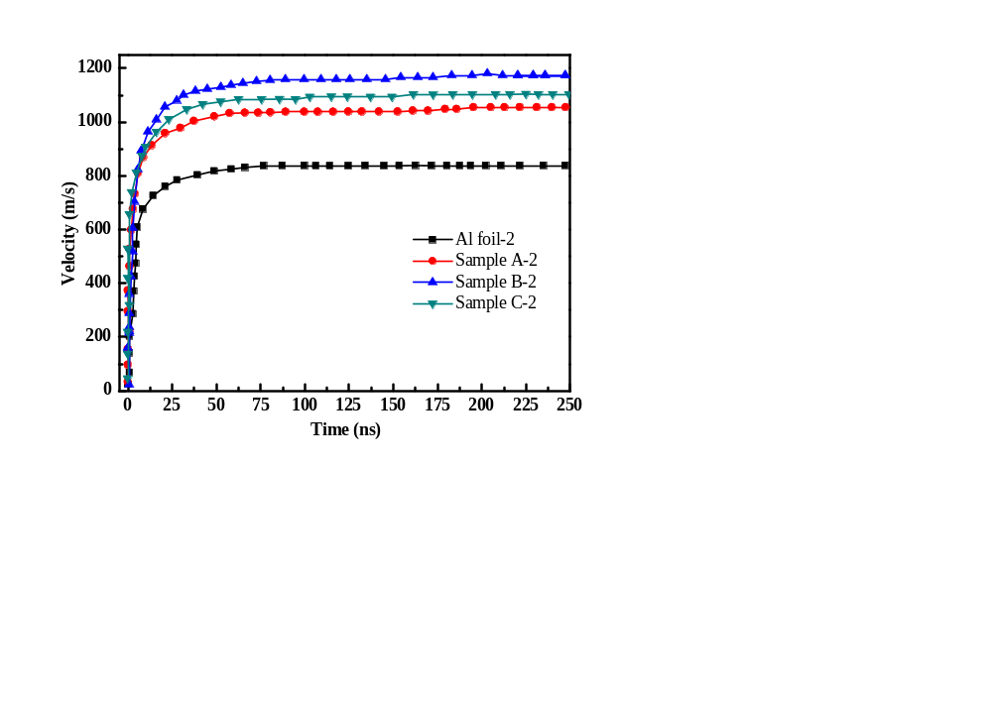
Fig. 5b The flyer velocities of Al foil and Sample A, B and C in the acceleration chamber obtained using PDV (repetitively).

