Supplementary Information

Sustained Inhibition of CC-chemokine Receptor-2 via intra-articular deposition of polymeric microPlates in Post-Traumatic Osteoarthritis

*Huseyin Ozkan¹, *Martina Di Francesco², Helen Willcockson¹, José Valdés-Fernández^{1,3}, Valentina Di Francesco², Froilán Granero-Moltó^{3,4,5,6}, Felipe Prósper^{3,5,6,7,8}, ︎Paolo Decuzzi² and ︎Lara Longobardi¹

¹Division of Rheumatology, Allergy and Immunology and the Thurston Arthritis Research Center, University of North Carolina-Chapel Hill, NC
²Laboratory of Nanotechnology for Precision Medicine, Fondazione Istituto Italiano di Tecnologia, Genova, Italy.
³Cell Therapy Area, Clínica Universidad de Navarra, Pamplona, Spain.
⁴Department of Orthopedic Surgery and Traumatology, Clínica Universidad de Navarra, Pamplona, Spain.
⁵Program of Regenerative Medicine, Center for Applied Medical Research (CIMA), Universidad de Navarra, Pamplona, Spain.
⁶Instituto de Investigacion Sanitaria de Navarra (IdiSNA), Pamplona, Spain
⁷Department of Hematology, Clínica Universidad de Navarra, Pamplona, Spain.
⁸Program of Hemato-Oncology, Center for Applied Medical Research (CIMA), Universidad de Navarra, Pamplona, Spain.

Address all correspondence and requests for reprints to:
Lara Longobardi, PhD, Division of Rheumatology, Allergy and Immunology, University of North Carolina at Chapel Hill, 3300 Thurston Bowels Bldg, Campus Box 7280, Chapel Hill, NC 27599. Phone: (919) 843-4727. Fax: (919) 966-1739. E-mail: lara_longobardi@med.unc.edu. ORCID ID: 0000-0002-0156-847X

* HW and MDF contributed equally to this work
︎ LL and PD share the senior authorship

Supplementary Methods
Histopathologic assessment of arthritis Dissected knees were fixed in 4% paraformaldehyde, overnight at RT. Following removal of fixative and rinsing in PBS, knees were decalcified with Immunocal (StatLab, McKinney, TX) for 5-7 days, embedded in paraffin, and frontal sections (6µm) were cut through the entire joint. Sections at 70µm intervals were stained with Safranin-O/Fast Green and images taken with an Olympus BX51 microscope and a DP71 camera. For OA grading, we used 2 different semiquantitative scoring systems, described by McNulty et al 2007, the Articular Cartilage Structure (ACS) score and the Safranin-O staining score (Saf-O) [20]. Compared to the OARSI score system, designed to rapidly identify the site within the joint that contains the most severe lesions, the combination of ACS and Saf-O scores provide in-depth information regarding changes within the lesions, for both articular cartilage structure and extracellular matrix integrity. The ACS focuses on AC structure, identifying fibrillations and cleft in the structure, while the Saf-O is more tailored at identifying changes within the cell compartment and/or in the extracellular matrix For both scoring systems, two adjacent midcoronal and posterior sections were stained with H & E (for ACS) or Safranin-O and lesions are identified within the 4 compartments (medial and lateral tibial plateau and femoral condyles); In both ACS and Saf-O scores, lesions are scored on a 0-12 scale as described by McNulty et al., where zero is defined as normal, reflecting a smooth articular surface (ACS) or uniform staining throughout the articular cartilage (Saf-O), while 12 reflects fibrillation/cleft/loss of cartilage (ACS) or complete loss of staining in both cells and matrix (Saf-O) involving the full thickness of articular cartilage with an extension higher than two third of the plateau/condyle [20].
Histomorphometric analysis were performed to quantify the area of subchondral bone using Image-J analyses [21]; measurements were performed only on the medial side of the tibia, on the total number of mice used for Saf-O semiquantitative assessments as previously reported [8]. Data were reported in square micrometers (sq µm) as average of 4 slides for each sample.
Specifically, the subchondral plate of each slide stained with Saf-O from all groups was encircled to measure the area. Samples were examined in a blinded fashion with Image-J software [21]. Data were reported in square micrometers (sq µm) as average of 4 slides for each sample.

Osteophyte size and maturity scoring. For osteophyte grading, we used the histological scoring system developed by Little et al, developed to score both osteophyte size (from 1 to 3) and osteophyte maturity (from 1 to 3), with the latter reflecting the osteophyte tissue composition [22]. Osteophyte grading was performed on Safranin-O/Fast-Green sections to obtain the OARSI score. Because osteophytes usually form close to areas of cartilage degradation, in the DMM they are predominately localized on the medial tibial plateau, therefore only sections from this region were used for osteophyte grading. Briefly, an osteophyte size score is obtained on assigning a score based on the size of osteophytes compared to adjacent cartilage (0 = none, 1 = small ~ the same thickness as the adjacent cartilage, 2 = medium ~ 1–3 × the thickness as the adjacent cartilage, 3 = large >3 × the thickness as the adjacent cartilage). The osteophyte maturity score reflects the tissue composition of osteophytes and is assessed by assigning a score as following: 0 = none, 1 = predominantly cartilaginous, 2 = mixed cartilage and bone with active vascular invasion and endochondral ossification, 3 = predominantly bone [22].
Both osteophyte size and maturity scores were obtained from coded digital images of the same location of the anterior-medial tibia in each animal.
We also quantified the area of cartilage within the osteophytes using Image-J [21]. The osteophyte images from samples stained with Saf-O from all groups were encircled and analyzed as a separate images. These new images were used to calculate the total area of the osteophyte as well as the area of Saf-O staining, and measures were expressed as ratio between Saf-O Area/Total area.

Assessment of synovial hyperplasia. H&E stained sections were scored for the synovial hyperplasia based on the scoring system described by Rowe et al. [23]. Only one section from the posterior joint compartments was graded from each mouse using a scale of 0-3, to avoid damage from the DMM incision. Details as follows: 0 (none) = 1 cell layers in synovium, 1 (mild) = 2-3 cell layers, 2 (moderate) = 4-5 cell layers, and 3 (severe) = 5 or more cell layers.

Supplementary Results

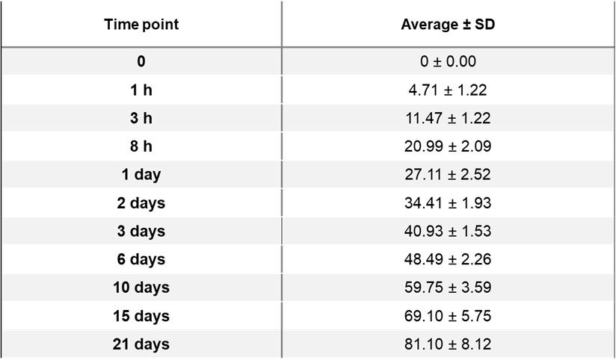

Supplementary Table S1. Average percentage and standard deviation (SD) of RS504393 released from µPLs for each considered time point under confined microenvironment.

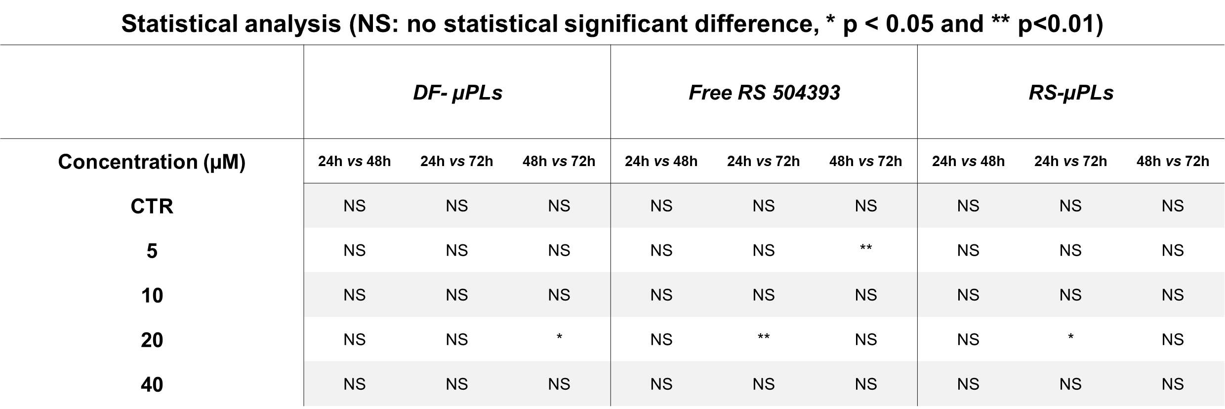
Supplementary Table S2. Statistically significant differences for all the experimental groups of Fig.2. Significance corresponds to a p-value smaller than 0.05.

Supplementary Table S3. Effect of sustained intra-articular release of RS504393 (4wks and 10wks post-DMM) on OA assessment (N=6) in DMM knee joints. Data presented shows mean differences, 95% CI (in parentheses) between groups at the corresponding time point.
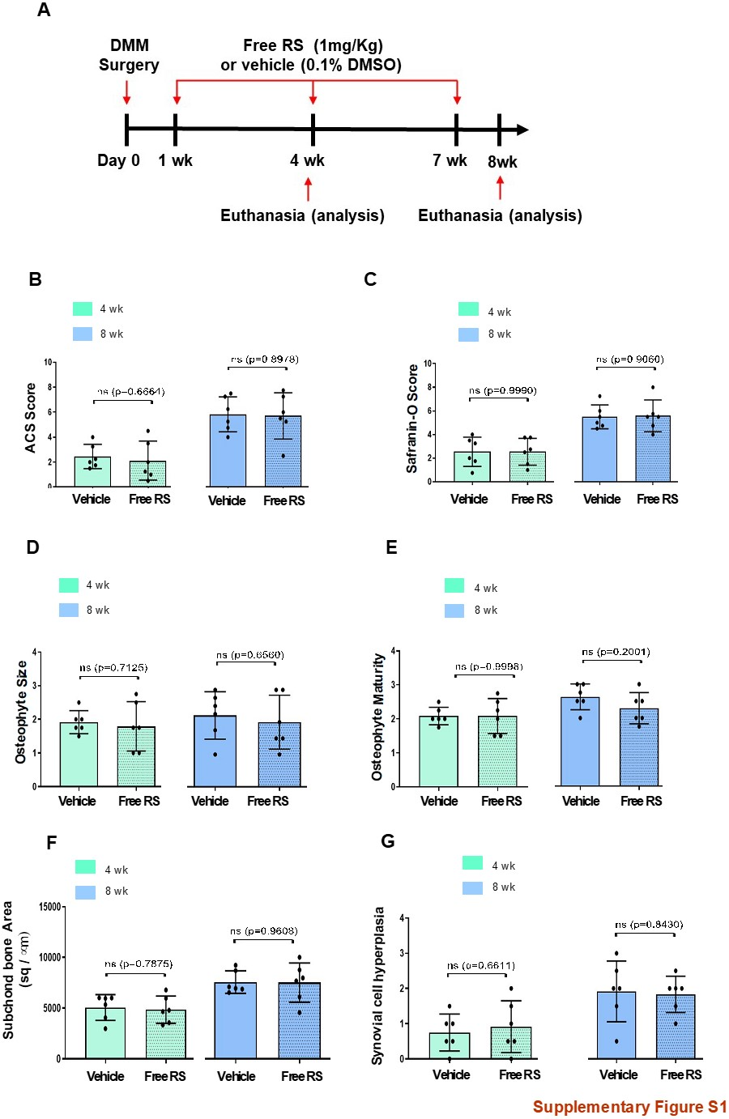

Supplemental Fig. S1. Histopathological evaluation, osteophyte assessment, subchondral bone thickness and synovial hyperplasia evaluation of DMM mouse knees, following intra-articular administration of free RS504393 or vehicle. (A) Schematic view of timeline for treatment and data evaluation. (B) ACS score (0-12 scale) of DMM knees at the time points indicated. Results are expressed as average of 4 quadrants (medial and lateral tibial plateau, medial and lateral femoral condyles); n=6 mice for each experimental point. (C) Safranin-O staining Score (0-12 scale) of DMM knees at the time point indicated. Results are expressed as average of 4 quadrants as described above; n=6 mice for each experimental point. (D) Osteophyte size and (E) osteophyte maturity scores (scale 0-3) at the time point indicated. Results are expressed as average of 4 quadrants (medial and lateral tibial plateau, medial and lateral femoral condyles); n=6 mice for each experimental point. (F) Quantification of the subchondral plate area (sq/ µm) of the tibia medial plateau of DMM knees by histomorphometric analysis at the time point indicated; n=6 mice for each experimental point. (G) Synovial hyperplasia scores (scale 0-3) at the time point indicated. Scores reflect the highest grade of the medial and lateral tibial plateau, medial and lateral femoral condyles.; n=6 mice for each experimental point.
The graphs represent the mean ± standard deviation. Student’s unpaired t-tests is indicated in each graph at each time point.

